21 May

Python Basic - 2

* 1. Q.1.Create two int type variables, apply addition, subtraction, division and multiplications and store the results in variables. Then print the data in the following format by calling the variables:

First variable is 6 & second variable is 5 . Addition: 6+5 = 11

Subtraction: 6 - 5 = Multiplication: 6 * 5 = 30

Division: 6/5 = 1.2

**Answer:** The answers are above inline; code snippet is also attached.

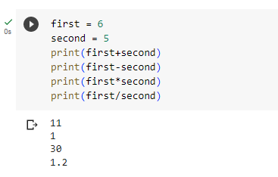

* 1. Q.2.What is the difference between the following operators:

(i) ‘/’ & ‘//’

(ii) ‘**’ & ‘^’

**Answer:**

**‘/’ & ‘//’**

**/** Operator is used to get the values in decimal number post division operation.

**//** operator is used to get the values before the decimal point post division operation.

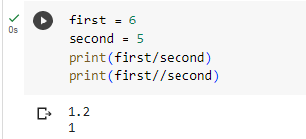

‘**’ & ‘^’

**\*\*** Operator is used to get the exponential values of a particular number, a**b will provide the exponential value of a with respect to b.

**Example**: 2**3 = 8

**^** is an XOR operator which sets each bit to 1 if either of the two bits is 1.

**Example**:

2 – 0000 0010

3 – 0000 0011

2^3 – 0000 0001 – 1

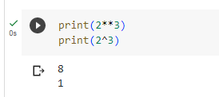

* 1. Q.3.List the logical operators.

**Answer:** The logical operators are AND, OR, NOT, XOR, Right Shift and Left shift operators.

* 1. Q.4.Explain right shift operator and left shift operator with examples.

**Answer:**

**Right Shift operator** shift towards the right by letting the rightmost bit falling off

**Suppose:**

10 🡪 0000 1010

10>>3 🡪 0000 0001 🡪 1

**Left Shift operator** shift towards the left by letting the leftmost bit falling off

**Suppose:**

10 🡪 0000 1010

10<<3 🡪 0101 0000 🡪 01010000 🡪0 + (1*2**6) + 0 + (1*2**4) + 0 + 0 + 0 + 0 + 0 + 0 = 64 + 16 = 80.

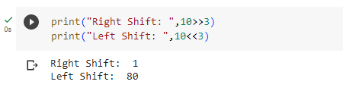

* 1. Q.5.Create a list containing int type data of length 15. Then write a code to check if 10 is present in the list or not.

**Answer:** Below attached is the code snippet.

