**Documentation – Art and Interface**

Miranda Auriemma

**Look and Feel of the Game –** The game will have a “happy”, “feel good” look and feel to it, with bright colors and simple but appealing art and asset designs, which I will be making digitally.

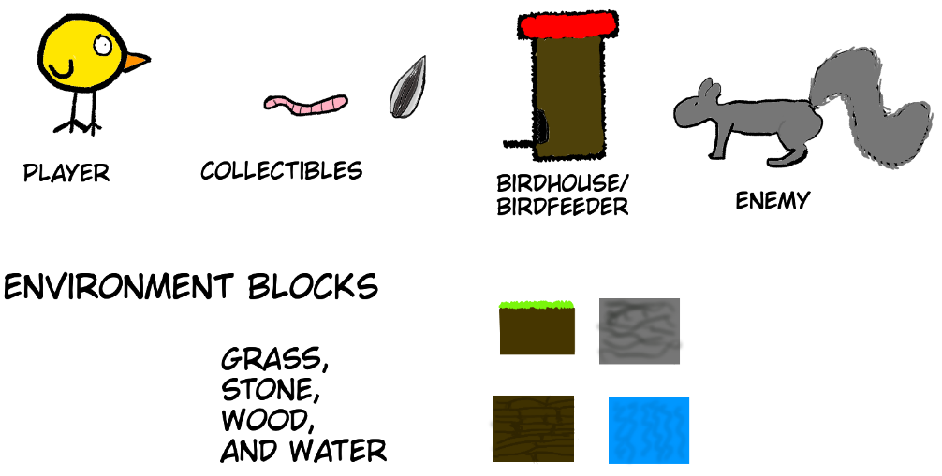

**User Interactions with the Game –** The user will be controlling the game using the W, A, S, and D keys on the keyboard for movement. If we have time, we may implement a control scheme for a game controller as well.

**User Interface Requirements –** The user interface during gameplay will have a three-heart system for health, a power up counter (labeled Dash here), and a level and score counter.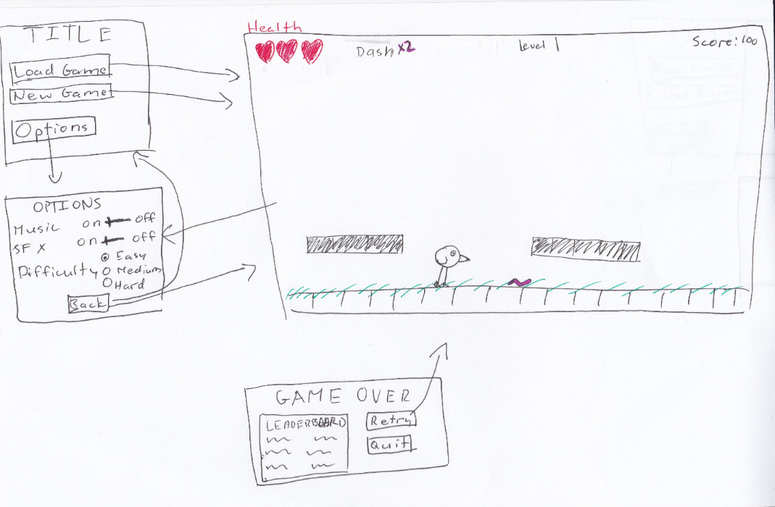

The title screen will have the option to load a game or start a new game, or to go to the options menu. During the game, the player will be able to access the options window by pressing a specific key. The game over screen will display the option to retry or quit, and will implement a leaderboard if there is time remaining at the end of the semester.