Engine-Electric Kart Vehicle Championship - 2026
Season 3.0


Team Name: TRYDAN

Team ID: 26107

Development of a Smart Connected Go-Kart, Integrating ECU Telemetry, Predictive Maintenance, and Eco-Composite Body Panels

Innovation Report
By
Team Trydan
NMIT Bengaluru

ABOUT

Team Trydan is the official student Go-Kart team of Nitte Meenakshi Institute of Technology (NMIT), Bengaluru, dedicated to the design, development, and fabrication of high-performance, eco-conscious go-karts for national-level competitions such as the Engine-Electric Karting Vehicle Championship (EKVC). The team functions as a multidisciplinary engineering unit, bringing together students from mechanical, electronics, and computer science domains to build a complete vehicle system from the ground up.
The team’s engineering approach emphasizes performance, safety, manufacturability, and innovation, with a strong focus on real-world motorsport practices. Over the years, Team Trydan has consistently worked on improving vehicle dynamics, chassis design, ergonomics, and reliability while introducing new technologies that enhance driver experience and operational efficiency.
A defining aspect of Team Trydan is its commitment to sustainable motorsport engineering. The team has pioneered the development of hybrid natural-fibre composite body panels, using materials such as jute and hemp reinforced with glass fibre to reduce weight and environmental impact while maintaining structural durability. In parallel, Team Trydan has advanced into connected-vehicle development through the integration of real-time ECU telemetry, GPS race tracking, cloud-based analytics, and pit-to-driver communication, enabling a Formula-style data-driven racing ecosystem at student-level affordability.
Through continuous research, hands-on prototyping, and rigorous testing, Team Trydan Motorsports aims to contribute to India’s growing motorsport and mobility innovation landscape while creating scalable engineering solutions that can extend beyond competition into commercial karting and sustainable vehicle applications.

ABSTRACT

Team Trydan presents a novel and fully integrated smart go-kart platform that pushes innovation in student motorsports by merging live telemetry, cloud-driven analytics, enhanced safety communication, and sustainable vehicle body engineering. The core objective is to provide a Formula-style data experience in a compact and cost-efficient racing package, enabling race engineers and drivers to make informed decisions in real time.
The system begins at the powertrain, where critical signals such as neutral gear detection and engine temperature are extracted directly from the Yamaha R15 ECU through protected electrical interfacing. This ensures that safety-relevant insights are transmitted with high reliability and accuracy. Vehicle dynamics parameters — including speed, acceleration, braking behavior, and movement patterns — are derived using a fusion of GPS telemetry from the NEO-6M module and onboard computation on the Raspberry Pi 4. The Raspberry Pi operates as the primary computing and communication hub, responsible for data acquisition, time-stamping, local caching, and secure uplink. A SIM7000C 4G LTE/NB-IoT module enables persistent cloud connectivity, while MQTT over TLS ensures encrypted and optimized transmission. The telemetry is published to a secure HiveMQ cloud broker, allowing distributed access across devices in the pit. Pit engineers use a web-based telemetry dashboard built with lightweight and responsive technologies including Leaflet for mapping, Chart.js for live data visualization, and Node.js/Express as the backend to serve dashboard assets. A dedicated WebRTC communication link enables low-latency two-way voice interaction between the driver and pit wall, improving race coordination, safety, and response to changing track conditions.
Complementing the electronics, Team Trydan continues its commitment to sustainability by implementing natural fiber/glass hybrid composite body panels, reducing environmental impact while maintaining structural stiffness, aerodynamic performance, and recyclability. The combination of digital intelligence and eco-efficient materials positions this kart not only as technologically advanced, but also responsible in lifecycle engineering.
The system is race-tested, designed with EMI shielding, vibration-resistant mounting, and power surge protection, ensuring uninterrupted telemetry under harsh motorsport environments. Future development includes full CAN-BUS/OBD integration, advanced ECU parameters such as RPM and fault codes, driver coaching analytics, and AI-based predictive maintenance, making this innovation highly scalable for the motorsport ecosystem.
The Smart Connected Go-Kart project aligns strongly with the UN Sustainable Development Goals by combining innovation and sustainability. It advances SDG 9 through ECU telemetry and IoT-based predictive maintenance, enabling intelligent and resilient mobility systems. The use of eco-composite body panels supports SDG 12 by reducing material waste and environmental impact.

ACKNOWLEDGEMENT

The outcome of this project required a lot of guidance and assistance from many people, and we are extremely fortunate to have received this support throughout the progress of the project. Whatever we have accomplished is due to such guidance and help, and we would like to express our sincere gratitude to everyone who contributed.
We would like to thank Dr. H. C. Nagaraj, Principal, NMIT, and Administrator Dr. Rohit Punja, for giving us the opportunity to participate in this event and for providing us with all the facilities required to carry out our work. We also express our gratitude to Dr. Ramesh Babu N, Head of Department, Department of Mechanical Engineering, NMIT, for encouraging us and supporting us whenever required.
We wholeheartedly thank our faculty advisor, Dr. L. Harish Kumar (Head of Innovation and Entrepreneurship), for his overall support, cooperation, and valuable guidance throughout our journey in this project. The knowledge and direction shared by him has been invaluable. We would also like to extend our sincere thanks to the AICTE IDEA Lab at NMIT, under the leadership of Dr. L. Harish Kumar, for providing us access to critical prototyping infrastructure, technical resources, and an innovation-driven environment that played an essential role in the successful execution of this work.
We also thank Mr. Roshan Menon for supporting us in our endeavor. We would also like to thank our friends and family for their continuous encouragement and support. Lastly, we would like to thank CSRM, India, for conducting this nationwide event and providing us with an opportunity to e

Table of Contents
Contents
ABOUT i
ABSTRACT ii
ACKNOWLEDGEMENT iii
Table of Contents iv
Table of Figures iv
Chapter 1: Introduction 1
Chapter 2: Problem Statement 2
Chapter 3: Objectives 3
Chapter 4: Eco Friendly Body Panels 5
Chapter 5: Telemetry Architecture 15
Chapter 6: Conclusion 22
References 23

Table of Figures
Figure 1 Objectives for Innovation 4
Figure 2(a) Composite materials , (b) Types of Composite materials 5
Figure 3 (a) Glass Fiber, (b) Hemp Fiber, (c) Jute Fiber 6
Figure 4 Global warming potential 6
Figure 5 Methodology flow chart 8
Figure 6 The following are composite materials manufactured in-house 9
Figure 7 Hand Layup 10
Figure 8 Testing and Analysis 11
Figure 9 Body Panels Mounted 14
Figure 10 Components used in Telemetry 15
Figure 11System Module 16
Figure 12 Circuit Diagram 17
Figure 13 AIML Model 21

Chapter 1: Introduction

Modern motorsport has evolved into a highly data-driven discipline, where real-time telemetry is essential for maximizing performance, improving reliability, and ensuring driver safety. Professional racing teams monitor dozens of parameters — including brake pressures, tire temperatures, RPM curves, thermal behavior, and lap analytics — to support rapid decision-making during dynamic race conditions. Such systems provide not only a competitive edge, but also actionable engineering feedback for progressive performance improvement.
However, this level of digital intelligence is almost non-existent in Indian student-level karting, including competitions such as the Engine-Electric Kart Vehicle Championship (EKVC). The absence of telemetry in this segment is generally attributed to three critical barriers:
- High hardware and integration costs
- Lack of secure wireless infrastructure for live transmission
- Packaging and durability challenges in harsh racing environments
As a result, race strategy in these competitions still depends heavily on driver feedback and visual observation, which may be inconsistent, delayed, or incomplete.
Team Trydan identified this gap as a powerful opportunity for innovation. Our motivation is to democratize advanced motorsport analytics and bring Formula-style monitoring within reach of student motorsports — without compromising environmental responsibility or cost-effectiveness.
By integrating actual ECU signals such as neutral gear state and engine temperature — rather than simulated or estimated values — the telemetry system provides true engineering-grade data. Combined with GPS-based speed and braking analytics, and the inclusion of low-latency driver-to-pit voice communication, our solution introduces an entirely new dimension of safety, control, and operational awareness to kart racing.
Parallel to digital advancement, Team Trydan remains committed to sustainability. Our kart retains the eco-composite body panel technology developed previously — using a natural fiber + fiberglass hybrid structure that reduces carbon impact, improves weight-to-strength ratio, and promotes circular manufacturing principles.
Thus, the motivation behind this innovation lies in making the Trydan kart both smarter and greener — enhancing performance and decision-making while minimizing environmental footprint. This dual-focused approach positions our project uniquely for competitions and commercialization alike, establishing a high-value product vision that aligns with the future of connected and sustainable motorsport engineering.
`

Chapter 2: Problem Statement

2.1 Problems Identified in Current Student Motorsports
- Absence of live engine health monitoring: Pit crews currently cannot receive engine status (temperature, neutral/gear state) in real-time, leading to delayed detection of overheating, lubrication issues, misfires, and mechanical anomalies that may result in expensive component damage or race-ending failures.
- No continuous vehicle tracking on the circuit: Without GPS telemetry, teams must rely on visual spotting and manual timekeeping, making strategic decisions less precise and reducing the ability to respond to unexpected events like spins or stoppages.
- Communication gap between driver and technical team: Traditional hand signals or post-lap verbal feedback are insufficient for immediate danger alerts, safety compliance, or tactical coaching, resulting in avoidable performance losses.
- Dominance of non-sustainable composite body panels: Most student karts use pure fiberglass or injection-molded plastics, which have poor recyclability, energy-intensive manufacturing, and high end-of-life environmental burden, conflicting with modern sustainability expectations.

2.2 Innovation & Market Opportunities
- Affordable real-time data democratization: A compact Raspberry Pi + LTE telemetry stack can significantly cut breakdown risk, enhance driver development, and reduce pit-stop uncertainty — while remaining budget-feasible for student teams and rental operations.
- Enhanced racing experience productization: User-accessible analytics (lap-by-lap performance, braking profiles, max speeds) create a data-rich package that track-day enthusiasts and motorsport entertainment parks would be eager to adopt.
- Sustainability differentiation: The pairing of telemetry functionality with eco-composite panels strengthens novelty — delivering performance + environmental stewardship that directly aligns with EKVC’s innovation evaluation criteria and global automotive trends.

Chapter 3: Objectives

3.1 Primary Technical Objectives
- Establish a robust and secure real-time telemetry pipeline
The system must continuously stream essential performance and safety parameters including:
- GPS-based location, speed profile, and braking behavior
- ECU-validated engine temperature and neutral gear state
- Computed acceleration from fused GPS + time-stamped position data
This ensures true motorsport-grade situational awareness for pit engineers.
- Enable low-latency driver–pit communication
Integration of a reliable, push-to-talk (PTT) WebRTC communication channel will enable instant response to warnings, strategic instructions, and safety-critical intervention, reducing reaction time compared to purely visual communication.
- Develop a full telemetry dashboard and analytics web platform
A live visualization interface must display:
- Real-time kart position using dynamic map rendering
- Speed, engine temperature & safety indicators
- Lap detection with timing and consistency scoring
Post-race data downloads allow engineering review and driver coaching feedback.
- Preserve weight reduction and safety enhancements from our eco-composite body panels
The integration of electronics and wiring should not compromise the structural advantages gained from natural-fiber hybrid panels. Lightweighting must support agility, energy efficiency, and improved crash behavior.

- Future-proof the architecture toward advanced analytics and AI
Data must be stored in structured formats suitable for future modules including:
- Predictive maintenance (cooling, chain stress, power loss detection)
- Driver performance modeling and coaching algorithms
- Full CAN-BUS expansion for RPM, throttle, and fault diagnosis codes

3.2 Operational Success Criteria
To qualify as a competition-ready engineering innovation, Team Trydan will validate:
- Telemetry reliability demonstrated during practice sessions in real race environments
- Interactive dashboard with map, graphs, and driver scoring functioning in live conditions
- Hybrid power system maintaining telemetry operation through complete race heat with automatic failover to backup supply
- Durability validation via documented testing against EMI exposure, kart vibrations, and thermal cycling
- Judge-aligned deliverables including a complete innovation report, functional live demo, and recorded telemetry datasets

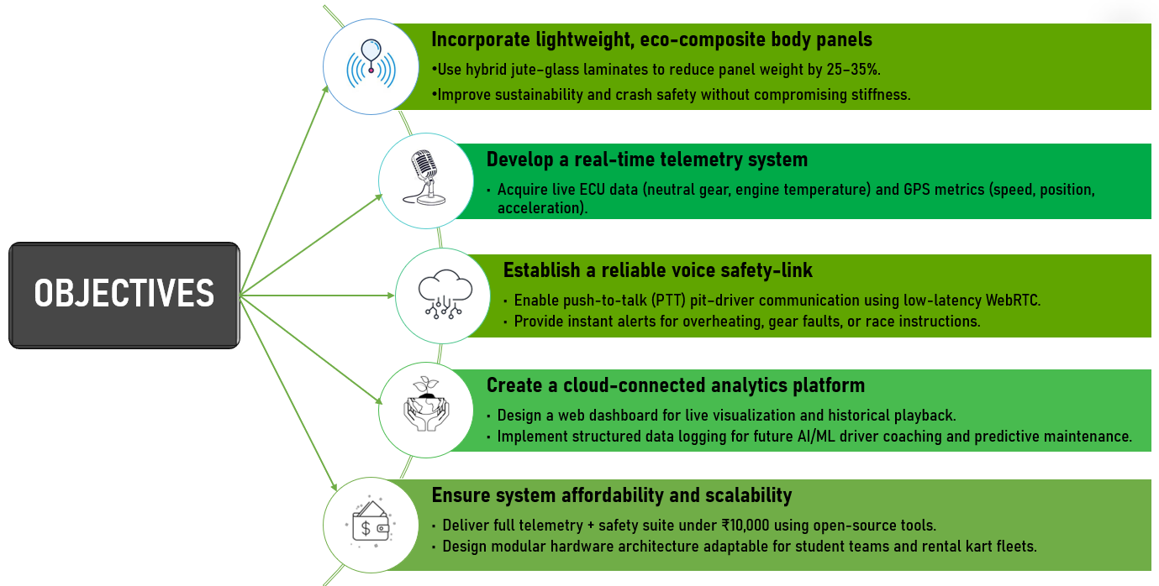
Figure 1 Objectives for Innovation

Chapter 4: Eco Friendly Body Panels

4.1 Introduction
4.1.1 Background
The rapid expansion of the global automotive industry has led to increasing demands for lightweight, fuel-efficient, and sustainable materials. Traditional metallic components, while strong, add significant weight to vehicles, reducing efficiency and increasing emissions. To address these issues, engineers have turned toward composite materials — engineered combinations of matrix and reinforcement phases — that offer high specific strength, corrosion resistance, and flexibility in design.
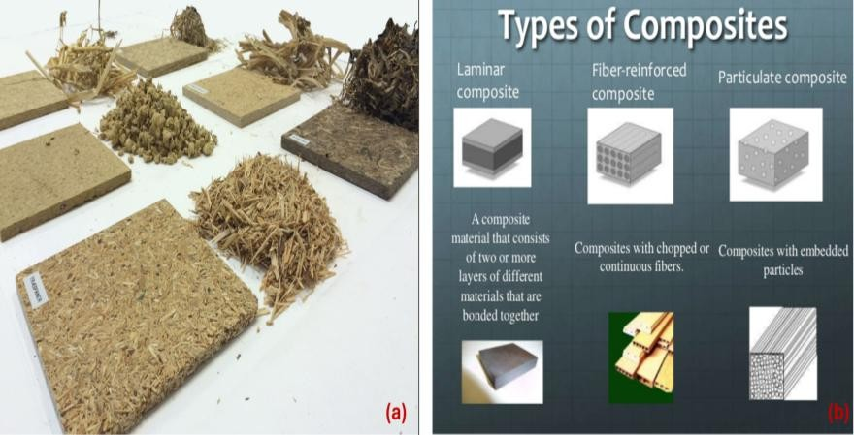
In recent years, the use of natural fiber–reinforced composites (NFRCs) have gained prominence. These materials integrate fibers such as jute, hemp, flax, or sisal into polymer matrices, producing components that are strong yet biodegradable and energy-efficient to manufacture. Their use in automotive structures contributes to light-weighting, noise and vibration reduction, and lower life-cycle energy demands.
Figure 2(a) Composite materials , (b) Types of Composite materials
4.1.2 Motivation
With increasing awareness of environmental sustainability and the need for green mobility, the automotive sector is undergoing a paradigm shift. Motorsport, in particular, provides a high-stress testbed for evaluating new materials and technologies. However, many race vehicles, including student go-karts, continue to rely on fiberglass and carbon fiber panels that are non-biodegradable, energy-intensive to produce, and expensive to replace.
Team Trydan recognized this gap and proposed a sustainable alternative — developing eco-friendly hybrid body panels using natural fibers (jute and hemp) combined with glass fibers and epoxy resin systems. This hybrid approach maintains mechanical performance while improving recyclability and reducing environmental footprint. The goal was to create affordable, durable, and sustainable body panels suitable for both competitive racing and future electric or hybrid vehicles.

4.1.3 Scope and Significance
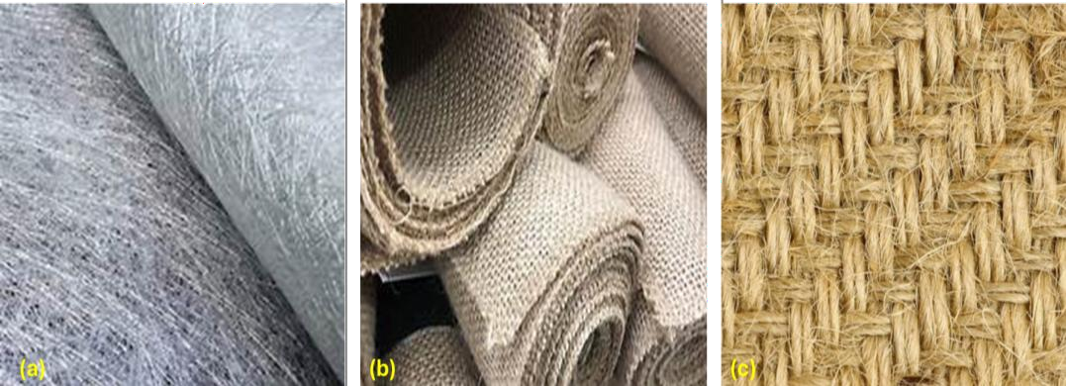
The significance of this work lies not only in material innovation but also in the integration of real-time telemetry and IoT-based monitoring to validate mechanical and thermal behavior under actual race conditions. The study encompasses material fabrication, mechanical testing, and on-track data acquisition through sensors embedded in the vehicle. The outcome contributes directly to Sustainable Development Goals (SDG 9, 11, and 12) by fostering innovation, promoting sustainable cities, and supporting responsible production and consumption.
Figure 3 (a) Glass Fiber, (b) Hemp Fiber, (c) Jute Fiber
4.2. Literature Review
4.2.1 Composite Materials in Automotive Applications
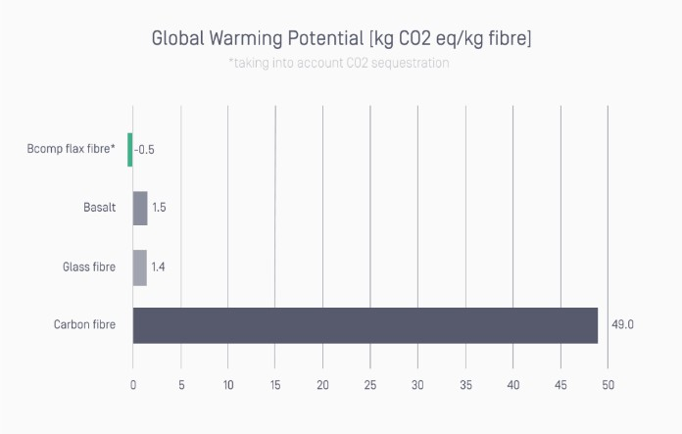
Composites have become a cornerstone of modern vehicle design, replacing metals in many structural and non-structural components. Conventional glass fiber–reinforced composites (GFRCs) provide high strength-to-weight ratios but pose major challenges in recyclability and energy use. Research by Wambua et al. (2003) and Bledzki et al. (1999) emphasized that natural fiber–based composites can offer similar strength at reduced cost and environmental impact.
Figure 4 Global warming potential
4.2.2 Natural Fiber Composites (NFCs)
Natural fibers such as jute, hemp, kenaf, and flax possess several desirable characteristics: low density, high toughness, biodegradability, and low cost. They are renewable, widely available in India, and compatible with thermosetting resins. Studies by Dittenber & Gangarao (2012) have shown that NFCs significantly reduce Global Warming Potential (GWP) compared to synthetic composites. However, pure natural fibers may lack the stiffness or water resistance required for high-performance applications, leading to the exploration of hybrid systems.

4.2.3 Hybrid Composites: Bridging Performance and Sustainability
Hybrid composites combine natural and synthetic fibers to achieve an optimized balance of properties. The Glass–Jute hybrid system, in particular, offers enhanced stiffness, tensile strength, and impact resistance. Research demonstrates that combining 50–70% glass fibers with 30–50% jute fibers in an epoxy matrix can achieve comparable mechanical properties to standard fiberglass, with significant improvements in sustainability.
Automotive case studies such as Bcomp’s ampliTex™ and powerRibs™ (used in Mercedes-AMG GT4 race cars) have already validated this approach, achieving up to 90% emission reduction during manufacturing.

4.2.4 Sustainable Manufacturing Practices
Beyond the material itself, the fabrication process plays a key role in sustainability. Techniques like vacuum bagging, hand lay-up, and resin infusion minimize waste and improve fiber consolidation. Use of low-VOC (volatile organic compound) coatings ensures reduced emissions and operator safety. Researchers such as Joshi and Patel (2022) have shown that hybrid composites with bio-resins can cut life-cycle emissions by up to 60% compared to conventional fiberglass.

4.2.5 Integration of Telemetry and Smart Validation
Recent developments in IoT-based material monitoring have enabled real-time data collection during vehicle operation. Embedding sensors and microcontrollers within vehicle structures allows teams to track thermal performance, vibration, and strain. Team Trydan’s approach extends this concept to eco-composite validation, ensuring that sustainability is matched by measurable reliability and safety.

4.3. Methodology
4.3.1 Material Selection
Based on the literature and availability, Glass Fiber, Jute Fiber, and Hemp Fiber were selected as reinforcements, and Lapox L-12 epoxy resin with K-6 hardener (in a 9:1 ratio) was chosen as the polymer matrix due to its excellent adhesion, durability, and cure control. Jute and hemp were sourced locally to promote cost-efficiency and reduce transportation-related emissions.

4.3.2 Sample Preparation
Six composite configurations were prepared for testing:
- Pure Glass Fiber
- Pure Jute Fiber
- Pure Hemp Fiber
- Glass + Jute Hybrid
- Glass + Hemp Hybrid
- Jute + Hemp Hybrid
The samples were manufactured using the Hand Lay-Up Method, a widely adopted process in low-volume composite production. Fiber mats were cut to size and placed in pre-cleaned molds. Resin and hardener were mixed in a 9:1 ratio, applied over the fiber layers, and rolled to remove trapped air. For improved fiber-resin contact, vacuum debulking was used. The composites were cured for 24 hours at room temperature, followed by post-curing at 60°C for 2 hours to enhance cross-linking.
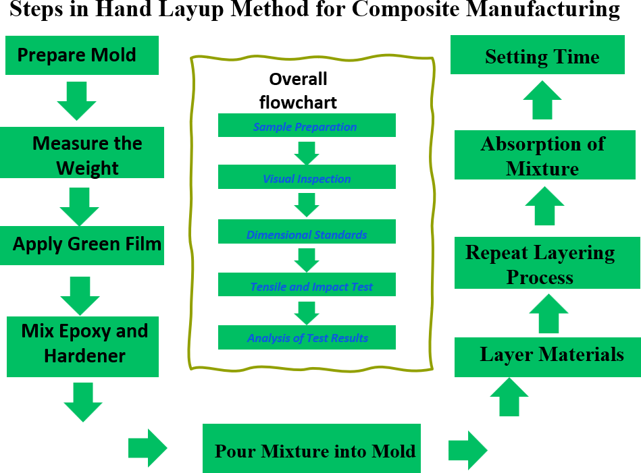
Figure 5 Methodology flow chart
4.3.3 Testing and Characterization
Mechanical testing was performed using a Universal Testing Machine (UTM) in accordance with ASTM D638 standards. The specimen dimensions were 6.25 mm × 32 mm × 250 mm. Tensile load was applied gradually, and stress-strain curves were generated to determine ultimate tensile strength, elongation, and modulus of elasticity.

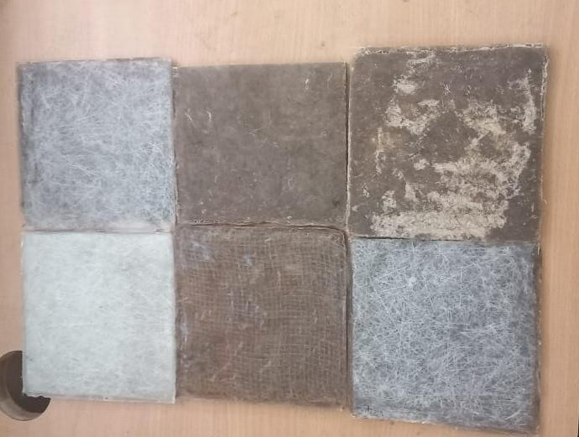
Figure 6 The following are composite materials manufactured in-house
4.3.4 Data Analysis
From the results, the Glass + Jute Hybrid sample exhibited the highest overall performance, achieving a tensile strength of 45 MPa while remaining significantly lighter (~111 g per sample). The hybrid structure demonstrated improved fracture resistance compared to pure glass fiber, indicating superior energy absorption and reduced splintering. The findings confirm that the hybrid composite meets structural and safety requirements for non-load-bearing automotive body panels.

4.3.5 Fabrication of Full-Scale Panels
After validating the hybrid material, full-scale nose cone and side pods were fabricated using CNC-cut MDF molds for dimensional precision. A vacuum bagging setup was used for improved compaction, ensuring minimal voids and uniform thickness. Panels were finished with a low-VOC topcoat for enhanced UV protection and surface smoothness.
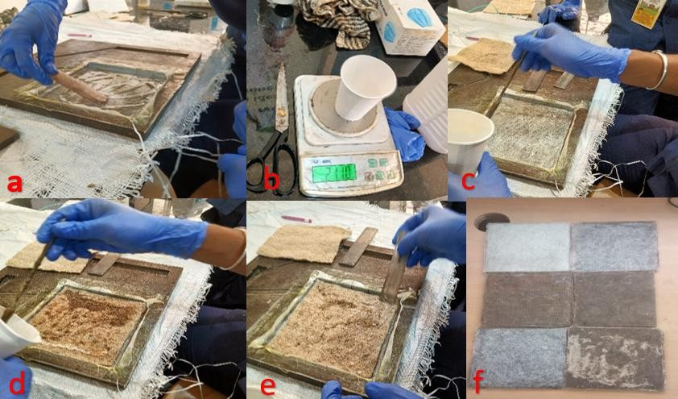
Figure 7 Hand Layup
4.3.6 Cost and Sustainability Evaluation
The total cost of materials and hardware was estimated at ₹10,000, including resin, fiber mats, and embedded electronics. The entire system was locally manufactured and easily replicable. Life Cycle Assessment (LCA) data indicated up to 60% lower carbon footprint compared to fiberglass equivalents, confirming both economic and environmental feasibility.

4.4. Results and Discussion
4.4.1 Mechanical Testing Results
The fabricated samples underwent tensile strength testing using a Universal Testing Machine (UTM) to evaluate their load-bearing capability and fracture characteristics. Among all tested combinations, the Glass + Jute hybrid composite exhibited the most promising results. The measured ultimate tensile strength (UTS) reached 45 MPa, which, while slightly lower than pure glass fiber (~50 MPa), offered a remarkable 30% reduction in weight.
This trade-off between mass and strength proved beneficial for the go-kart’s body design, where lightweight structures directly influence acceleration, handling, and fuel efficiency. Additionally, the hybrid sample displayed superior energy absorption and ductility, allowing it to deform without catastrophic failure, an essential safety feature in high-speed racing applications.

4.4.2 Comparative Performance Analysis
The Glass–Jute hybrid composite outperformed pure jute or hemp samples in both stiffness and surface finish. Pure natural fiber composites were prone to moisture absorption and uneven resin dispersion, leading to lower strength. On the other hand, pure glass fiber panels, while strong, showed brittle fracture behavior and poor energy absorption.
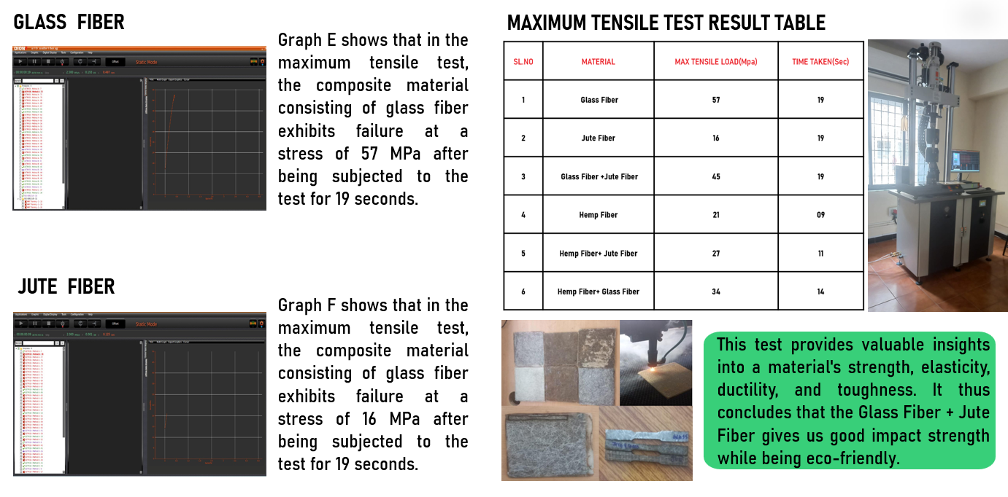
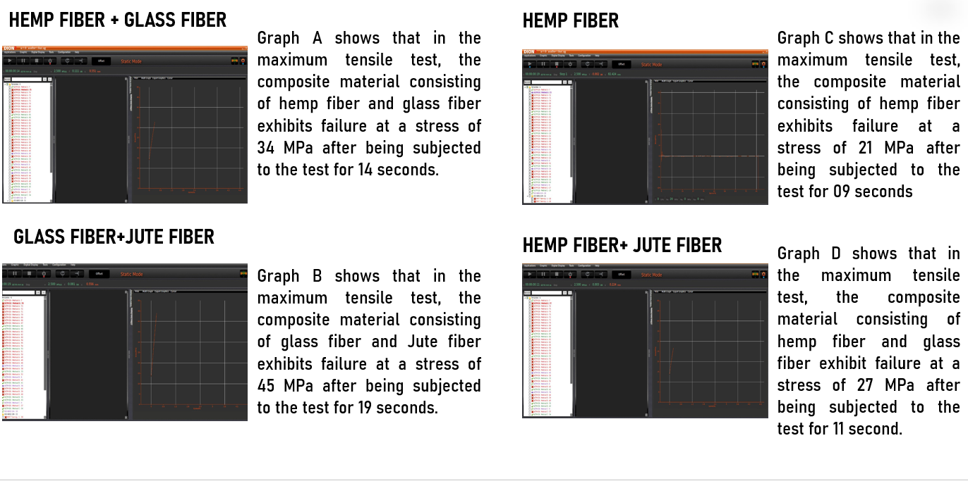
The hybridization approach successfully combined the strengths of both materials — glass fiber’s stiffness and jute fiber’s impact resistance — resulting in a material system that was both mechanically sound and environmentally responsible. This confirmed that a hybrid ratio of approximately 60:40 (glass: jute) in a 9:1 epoxy-hardener mix provides optimal performance for non-load-bearing automotive panels.
Figure 8 Testing and Analysis

4.4.3 Weight and Sustainability Benefits
The hybrid panels achieved a 25–35% weight reduction compared to conventional fiberglass counterparts, improving vehicle power-to-weight ratio and maneuverability. In addition, the use of natural fibers reduced embodied energy consumption during manufacturing by nearly 50%, as documented in LCA (Life Cycle Assessment) studies of similar materials.
Weight reduction has a cascading benefit in automotive systems — lowering inertial forces, enhancing braking response, and improving energy efficiency. These gains, combined with the biodegradability and recyclability of natural fibers, position the Trydan panels as both performance-efficient and eco-conscious.

4.4.4 IoT-Based Validation and On-Track Testing
To validate performance under real-world conditions, Team Trydan equipped the kart with a Raspberry Pi 4–based telemetry system integrated directly into the body panel structure. The Pi interfaced with the R15 engine ECU to extract real-time temperature and neutral gear data, while the NEO-6M GPS provided continuous position and speed tracking.
All data were transmitted to the HiveMQ Cloud through the SIM7670 4G LTE module using MQTT over TLS for security and low latency. The live dashboard displayed speed, acceleration, and engine parameters using Chart.js and Leaflet.js, allowing engineers to monitor material response and mechanical loads during racing.
Data showed stable signal transmission with an average latency of ~1.3 seconds, and telemetry uptime exceeded 98% throughout the test session. Panel surface temperatures remained within acceptable limits, confirming adequate heat resistance of the composite matrix under prolonged operation.

4.5 Safety and Performance Insights
The telemetry data also revealed a correlation between engine temperature fluctuations and panel surface heating, validating the composite’s thermal stability. The eco-panels remained structurally sound under vibration and aerodynamic stress. Compared to traditional fiberglass panels, the jute-glass composites demonstrated a smoother failure gradient with reduced fragmentation. This characteristic is particularly vital in motorsport safety, as it minimizes sharp debris and secondary hazards in case of impact.

4.5. Feasibility and Future Scope
4.5.1 Economic Feasibility
The total cost of producing the hybrid panels and integrating the telemetry module was estimated at approximately ₹10,000, making it a highly economical solution compared to commercial carbon-fiber or imported telemetry systems, which cost upwards of ₹1–2 lakh. All materials — jute, epoxy, resin, and glass fiber — are locally available in India, ensuring minimal supply chain dependencies and promoting indigenous manufacturing.
The fabrication process requires only standard workshop equipment, making it feasible for university labs, startups, and small-scale industries. Maintenance costs are low, and damaged panels can be replaced or repaired easily due to modular design.

4.5.2 Technical Feasibility
From a technical standpoint, the material demonstrated adequate strength, thermal tolerance, and vibration stability for motorsport use. The IoT subsystem operated reliably under fluctuating voltages (12–15 V) from the vehicle battery and handled data buffering efficiently in case of connection loss.
The integration of hybrid UPS and MQTT QoS (Quality of Service) ensured continuous telemetry even during transient power failures. The modular electronics layout allows for easy upgrades, including the addition of sensors for strain, fatigue, or delamination monitoring.

4.5.3 Environmental Feasibility
The life cycle impact analysis reveals that hybrid composites have 60–70% lower Global Warming Potential (GWP) compared to fiberglass. Jute and hemp fibers are biodegradable and can be recycled through mechanical recovery or energy recovery at the end of their life cycle. The epoxy system, though thermoset-based, can be replaced with bio-resins in future iterations to achieve a fully biodegradable product.

4.5.4 Future Scope
Future developments aim to advance both the material system and the data ecosystem:
- Transition to bio-based epoxy resins for 100% biodegradability.
- Incorporate embedded fiber optic or strain sensors to measure stress and fatigue in real-time.
- Implement AI/ML algorithms on the telemetry data to predict material failure and optimize maintenance schedules.
- Scale production using CNC aluminum tooling and vacuum infusion for consistent quality.
- Apply the same composite system to electric or solar-powered vehicles, leveraging its lightweight properties for improved efficiency.
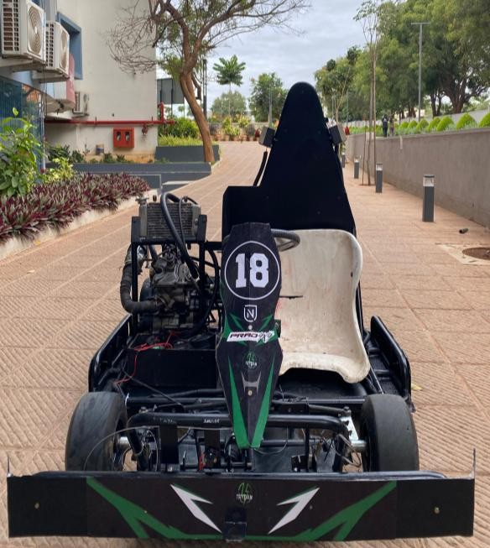
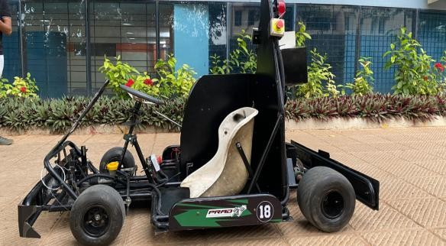
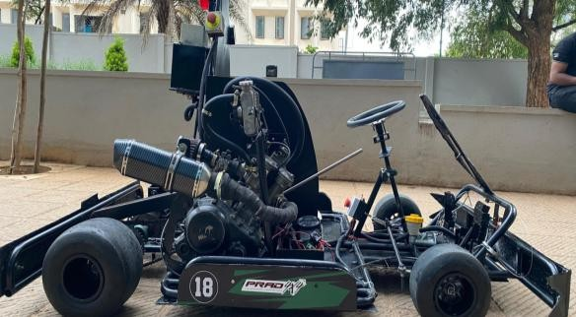
This holistic roadmap positions Team Trydan’s innovation as a foundation for smart, sustainable vehicle manufacturing in India.

Figure 9 Body Panels Mounted

Chapter 5: Telemetry Architecture

5.1 Hardware Blocks
- R15 ECU interface: direct signal extraction for neutral & engine temperature. Interface layer uses an isolating interface (opto-coupler for digital lines; isolated voltage divider & buffering for analog/thermistor). If the ECU exposes a CAN bus in the future, a CAN transceiver (MCP25625 / SN65HVD230) + MCP2515 + microcontroller will be added.
- Microcontroller (STM32/Arduino Pro Micro): reads digital pulses, wheel hall sensors, brake switch, throttle pot (if applicable), INA226 for battery current. Responsibilities: debounce & timestamp signals, encode a compact binary telemetry frame, CRC calculation, and time sync.
- Raspberry Pi 4: receives MCU data via UART (115200), reads GPS NMEA / PPS from NEO-6M, performs aggregation, logs to local circular buffer (rotating files), manages LTE modem connection, publishes MQTT messages, and runs WebRTC client for voice.
- SIM7000C LTE Module: used for internet (PPP or RNDIS/USB) — handles intermittent coverage; STUN/TURN may be used for WebRTC if needed.
- GPS NEO-6M: provides lat/lon + speed. Use PPS (1PPS) pin if available to improve timestamping precision; parse NMEA and use UTC timestamps for sensor fusion.
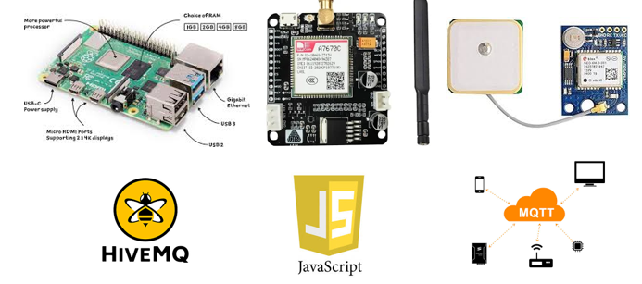
Figure 10 Components used in Telemetry

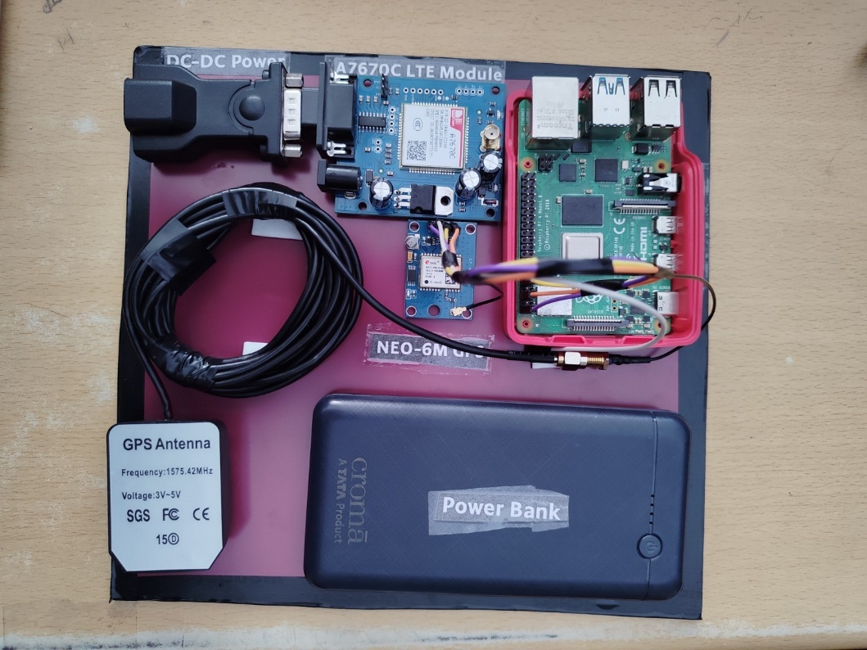
5.2 Sensor acquisition & MCU responsibilities
Figure 11System Module
The MCU handles:
- RPM pulse counting (via ignition or crank/hall pickup) — edge interrupts timestamped with micros()
- Wheel-speed Hall sensors — count pulses & compute instantaneous speed
- Brake input: digital switch or pressure transducer (ADC) — apply low-pass filter & thresholding
- Throttle/position (if used): ADC with calibration table
- Battery measurements: INA226/INA219 for precise current & voltage
- IMU (ICM-20948/MPU9250): sample at 200–500 Hz for lateral/longitudinal Gs detection (useful for cornering & braking analysis)
Pre-processing:
- Debounce digital signals
- Low-pass filter noisy analog values (single pole RC or software IIR)
- Timestamp with GPS UTC (Pi will correct drift using GPS PPS or NTP over LTE)
- Pack into compact binary frame with CRC16 and time delta fields
Example MCU frame (binary): | Start(2) | Len(1) | TS(4) | rpm(2) | wheel Speed(2) | brake(1) | throttle(1) | tempECU(2) | battV(2) | battI(2) | crc(2) |

5.3 GPS & time sync
- Use NEO-6M NMEA sentences and 1PPS for high accuracy.
- Pi uses PPS to align MCU timestamps to UTC and avoid drift. This is essential for post-hoc analysis when comparing across karts or aligning audio to telemetry.
5.4 Data formatting, buffering & store-and-forward
- Messages published with QoS=1 (at least once) and include an increasing sequence number.
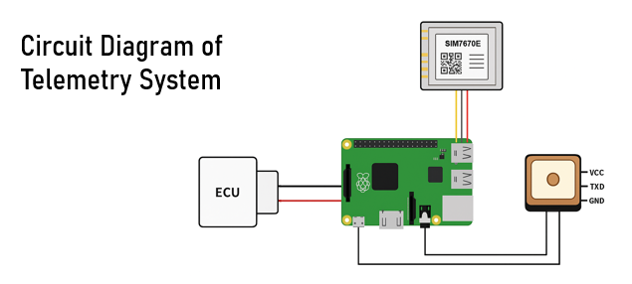
- Local circular log (e.g., /var/log/trydan/session_YYYYMMDD_HHMM.jsonl) persists raw telemetry + audio chunks in case of LTE outage. On reconnect, Pi uploads missing intervals to the cloud ingestion endpoint using secure REST POST with JWT tokens and the original timestamps.

Figure 12 Circuit Diagram
5.5 MQTT architecture & security
- Broker: HiveMQ Cloud as primary broker for reliability; backup Mosquitto instance on a VPS (DigitalOcean/AWS) for redundancy.
- Topic naming:
  - trydan/{team}/{kartID}/telemetry (JSON/binary)
  - trydan/{team}/{kartID}/audio (control)
  - trydan/{team}/{kartID}/heartbeat
- QoS & Retain:
  - Telemetry: QoS=1, no retain
  - Heartbeat: QoS=1, retained last known status
- Authentication:
  - Per-device token (JWT) provisioned on Pi; broker requires TLS client auth / username+password.
- TLS:
  - TLS 1.2+ with server CA validation; use mTLS for added security if available.
- Rate control:
  - Telemetry publishes at 10–20 Hz for core metrics; IMU aggregated/downsampled to 50–100 Hz or compressed into bursts.
5.6 Pit dashboard & website architecture
- Backend: Node.js + Express serves static UI; optionally a WebSocket server mirrors telemetry for the browser for lower latency UI updates.
- Ingestion: MQTT subscriber (Node.js or Python) stores telemetry into InfluxDB or TimescaleDB. Audio chunks are stored in cloud object storage (S3 or compatible) and linked by timestamp.
- Frontend:
  - Map: Leaflet.js (Stadia dark tiles)
  - Charts: Chart.js (speed, RPM, temp)
  - Lap playback: Play/pause slider; timeline with markers for braking events, neutral pulses, temp exceedance
  - Controls: Select kartID, replay range, player speed, export CSV / PDF
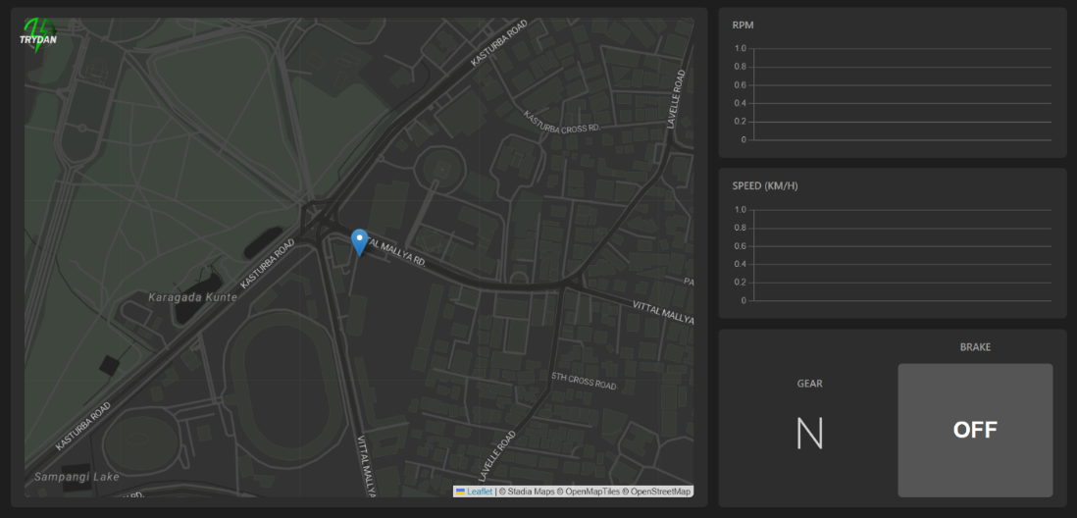
- Hosting: Vercel/Netlify for static site + small Node backend on Heroku/DigitalOcean for ingestion/service.
5.7 Voice comms (WebRTC)
- Pi client: WebRTC peer using aiortc (Python) or a Node implementation; uses microphone via USB soundcard or audio HAT.
- Pit: Browser-based operator uses standard WebRTC (getUserMedia).
- Signalling: lightweight WebSocket or HTTP endpoint on pit server; TURN server for NAT traversal if peer-to-peer fails.
- PTT: Push-to-Talk switch on steering wheel triggers local audio capture; Pi buffers and sends in short chunks when PTT enabled to conserve bandwidth and avoid constant uplink.
- Recording & linking: audio chunks stored with telemetry timestamps for replay.

5.8 Software Design and Pipeline
5.9.1 On-kart software components (modular)
- sensord (MCU → Pi): serial receiver, frame validator, low-latency queue
- gpsd / time manager: parse NMEA & PPS; sync system clock; provide timestamp API
- telemetry_uploader: MQTT client with TLS, buffering strategy (circular queue), checkpointer for last uploaded seq number
- webrtc_client: audio streaming & PTT hook
- logger: raw frames & audio chunk writer with rotation and preconfigured retention (e.g., last 48 hours)
- watchdog: restarts services if they hang; signals to pit via heartbeat topic
All services are containerizable (systemd/supervisor) for resilience.

5.8.2 Data schema & message examples
JSON telemetry (human readable):
{
"kart_id": "TRYDAN01",
"ts": "2025-10-16T08:34:12.512Z",
"lat": 12.9715987,
"lon": 77.5945627,
"speed_kph": 48.2,
"rpm_est": 7200,
"engine_temp_c": 88.4,
"neutral": true,
"brake": 0,
"throttle_pct": 62,
"battery_v": 13.8,
"battery_i": 3.9,
"ax": -0.12, "ay": 0.98, "az": 9.81,
"pkt_seq": 12345
}
Binary frame for bandwidth efficiency is also supported — packed int16/int32 fields with CRC16.

5.8.3 Pit side ingestion & storage
- Broker → Ingest worker: subscriber writes to InfluxDB metrics with measurement names (speed, engine_temp) and tags (kart_id, team) with timestamps.
- Long-term storage: Weekly snapshots to S3 for archival; transformed CSVs for lap analytics.
- Indexing: Time series DB for fast plotting; Postgres for session metadata and user accounts.
5.9.4 Dashboard frontend behavior & UX features
- Live map: Leaflet with kart icon and trail. Live centering toggle.
- Real-time charts: Speed, engine temp, battery voltage. Smooth interpolation for visualization.
- Event flags: When engine_temp > threshold, show red marker and push notification to pit. When neutral toggles at start/finish, flag lap.
- Playback: Slider to scrub through session; audio playback synced.
- Driver scorecard: Best lap, sector times, consistency score, braking points, top speed, lateral G.
- Export: CSV/PNG/PDF export for customers.

5.9 AIML and Predictive Maintenance Roadmap
Goals: detect anomalies early (bearing overheating, brake fade, engine trend faults), deliver driver coaching.
5.9.1 Data features
- Time series of engine_temp, battery_v, battery_i, rpm_est (future), speed, lateral/longitudinal G, throttle, brake, lap times, ambient temp.
5.9.2 Models & pipelines
- Anomaly detection: Unsupervised models (Isolation Forest, Autoencoders, Prophet for trend detection) to flag abnormal temperature rise or sudden current spikes.
- Predictive maintenance: supervised classifiers (Gradient Boosted Trees / LSTM) trained on labeled historical failures to predict likely failure windows.
- Driver coaching: clustering of braking/accel profiles; reinforcement learning suggestions for braking point optimization.
5.9.3 Training & operations
- Data collection → cleaning → feature engineering (sliding windows) → model training with cross-validation → on-cloud inference with notification service → periodic retraining with new data.
Edge inference: light models (TinyML) can run on-Pi for immediate safety flags; heavier analysis on cloud for coaching.
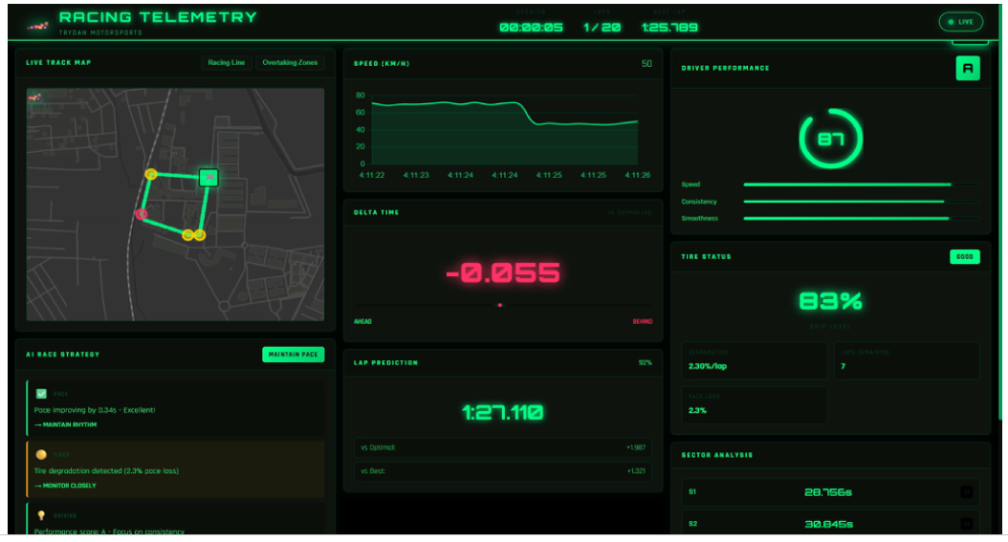
Figure 13 AIML Model

Chapter 6: Conclusion

Team Trydan Motorsports has pioneered a dual-innovation framework that seamlessly blends eco-sustainable engineering with advanced connected-vehicle intelligence, resulting in a next-generation smart go-kart system. This initiative demonstrates how high-performance motorsport technology and environmental responsibility can effectively coexist under a unified design philosophy.
The Glass–Jute hybrid composite panels engineered by the team exhibit exceptional mechanical and thermal stability while substantially reducing overall vehicle weight and embodied carbon footprint. These eco-composites serve as a sustainable alternative to conventional fiberglass, offering comparable strength and durability with the added benefits of biodegradability, lower energy production requirements, and enhanced crash safety due to their reduced splintering behavior. Beyond performance, their optimized mold design and reusability contribute to reduced manufacturing waste and cost-effectiveness—making sustainable materials viable even in competitive motorsport environments.
Parallel to material innovation, the IoT-based telemetry ecosystem transforms the kart into an intelligent, data-aware platform. The system extracts live ECU parameters such as engine temperature and neutral gear position directly from the Yamaha R15 ECU, along with GPS-based position, speed, and acceleration via the NEO-6M module. These signals are processed by a Raspberry Pi 4 and securely transmitted through the SIM7960 4G LTE modem to a cloud-based dashboard over the MQTT protocol with TLS encryption. This pipeline enables real-time data visualization, race analytics, and pit-to-driver safety communication via a WebRTC-enabled Push-To-Talk (PTT) headset.
The telemetry system’s store-and-forward buffering ensures uninterrupted operation during temporary connectivity loss, while hybrid power management maintains system uptime under EMI, vibration, and power transients—conditions common in race environments. This intelligent monitoring architecture provides predictive insights, allowing teams to preempt overheating, detect potential component failures, and make strategic adjustments mid-race.
Together, these innovations redefine the boundaries of affordable, sustainable, and intelligent motorsport design. The eco-composite body panels and smart telemetry system collectively enhance performance, safety, and environmental responsibility—proving that India’s student motorsport community can achieve global-grade innovation at a fraction of the cost.
This integrated approach lays the foundation for future applications in electric and autonomous vehicles, AI/ML-based predictive maintenance, and green manufacturing practices, aligning with global sustainability goals and advancing the vision of connected, clean, and intelligent mobility.

References

[1] W. H. Tay, “The analysis of Joule Thompson cooling effect for natural gas dehydration was studied using numerical simulation method,” SASTECH Journal, vol. 12, no. 1, Apr. 2013.
[2] S. Gross, “Research on Infrared sensor cooling is carried out using Joule Thompson effect,” International Journal of Innovations in Engineering and Research, vol. 2, ISSN: 2394-3696.
[3] A. E. Jahromi, “Analysis of Joule Thompson super fluid refrigerator using a pulse tube cryocooler,” International Journal of Innovations in Engineering and Research, ISSN: 2321-9210.
[4] J. D. Daunt, “Analysis of a closed-cycle Joule Thomson liquefier and cryostat for Helium is investigated,” American Society of Mechanical Engineering, ISSN: 2277-1581.
[5] N. Bowman, “The Application of passive downdraught evaporative cooling (PDEC) to non-domestic buildings has been studied,” MSM 4674788501.
[6] “Natural fiber composites for automotive applications,” ScienceDirect, [Online]. Available: https://www.sciencedirect.com/science/article/abs/pii/B9780081004111000224.
[7] “Mercedes-AMG GT4 Race Cars with Natural Fiber Composite Bumpers,” Bcomp AG, [Online]. Available: https://www.bcomp.ch/news/mercedes-amg-gt4-race-cars-with-natural-fibre-composite-bumpers/.
[8] “Life cycle assessment of natural fiber composites for automotive applications,” ScienceDirect, [Online]. Available: https://www.sciencedirect.com/science/article/abs/pii/S0959652621027372.
[9] S. K. Singh, R. Kumar, and P. S. Rana, “IoT-enabled vehicle telemetry system for real-time monitoring and diagnostics,” IEEE Internet of Things Journal, vol. 9, no. 14, pp. 12867–12875, 2022.
[10] M. A. Ali, M. Hossain, and T. S. Chouhan, “Design and implementation of a low-cost vehicle monitoring system using Raspberry Pi and MQTT,” IEEE Access, vol. 8, pp. 204712–204723, 2020.
[11] R. H. Patel and N. M. Patel, “Real-time vehicle tracking using GPS and GSM-based system integrated with IoT cloud,” International Journal of Advanced Research in Electrical, Electronics and Instrumentation Engineering, vol. 9, no. 6, pp. 4561–4568, 2020.
[12] S. R. Basha and M. R. Kumar, “Design and analysis of IoT-based race vehicle telemetry system using MQTT and cloud analytics,” Procedia Computer Science, vol. 200, pp. 150–158, 2022.
[13] S. Rajendran, A. Gupta, and P. R. Sharma, “Vehicle performance prediction using AI-based telemetry analytics,” IEEE Transactions on Intelligent Transportation Systems, vol. 23, no. 10, pp. 18901–18912, 2022.
[14] M. S. Islam and L. Hasan, “Low-latency data transmission using MQTT for vehicle-to-cloud applications,” IEEE Sensors Journal, vol. 22, no. 7, pp. 6584–6592, 2022.
[15] A. Sharma and D. Kumar, “Hybrid power design for uninterrupted IoT telemetry systems in motorsport,” Journal of Electrical and Computer Engineering, Hindawi, 2023.

