Practical No 1

Aim : Demonstrate various program on Structure Tag
<!DOCTYPE html>
<html>
<head>
<title >Html Basic Structures</title>
</head>
<body bgcolor="d0f4de">
<h1 align="center"> Welcome to Html </h1>
<p> This is a basic Structure of an Html document </p>
<p>HTML stands for Hypertext Markup Language. It defines the content and structure of web content.</p>
<hr>
<b> This is a Bold Tag </b>
<br>
<i> This is an Italic Tag </i>
<br>
<u> This is an Underline Tag </u>
<hr>
</body>
</html>
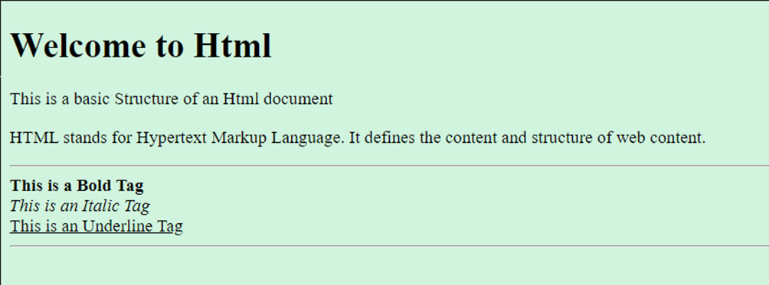

Practical No 2

Aim : Explain various list Tag Formatting.
A. Ordered List(Numbered)
<!DOCTYPE html>
<html>
<head>
<title>Document</title>
</head>
<title>List Example</title>
</head>
<body bgcolor="cbc0d3">
<h1> Html List Example</h1>

<h2> Ordered List (Numbered)</h2>
<ol>
<li> First item </li>
<li> Second item </li>
<li> Third item </li>
<li> Fourth item </li>
<li> Fifth item </li>
</ol>
</body>
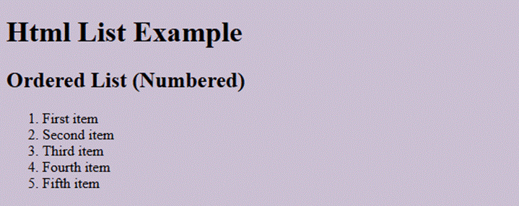
</html>

B. Unordered List(Bulleted)
<!DOCTYPE html>
<html>
<head>
<title> Unordered List </title>
</head>
<body bgcolor="a2d6f9">
<h1> Unordered List (Bulleted)</h1>
<ul>
<li> First item </li>
<li> Second item </li>
<li> Third item </li>
<li> Fourth item </li>
<li> Fifth item </li>
</ul>
</body>
</html>
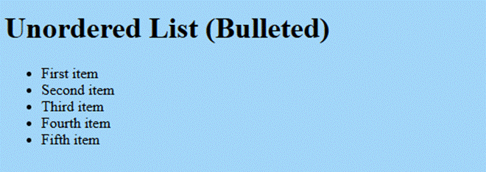

C. Nested List
<!DOCTYPE html>
<html>
<head>
<title>Nested List</title>
</head>
<body bgcolor="fcd5ce">
<h1> Example of Nested List</h1>
<ul>
<li> Coffee
<ol>
<li> Espresso </li>
<li> Americano </li>
<li> Cappuccino </li>
</ol>
</li>
<li> Tea
<ol>
<li> Milk Tea </li>
<li> Black Tea </li>
<li> Green Tea </li>
</ol>
</li>
</ul>
</body>
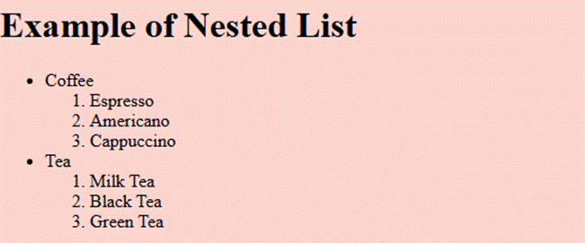
</html>

Practical No 3

Aim : Explain tag formatting with Marquee
<!DOCTYPE html>
<html>
<head>
<title>Marquee Tag</title>
</head>
<body bgcolor="a8dadc">
<h1 align="center"> Marquee Tag Example</h1>
<h1> <marquee> Welcome to the World of Computer Science! </marquee> </h1>
<h3> <pre align="center"> Marquee is one of the important tags introduced in HTML to support such scrollable texts and images within a web page.
The marquee tag is a container tag of HTML that is implemented for creating scrollable text or images within
a web page from either left to right or vice versa, or top to bottom or vice versa.
</pre></h3>
</body>
</html>
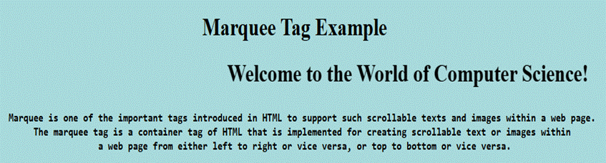

Practical No 4

Aim : Demonstrate anchor Tag ,Image and mapping.
A. Image tag:
<!DOCTYPE html>
<html lang="en">
<head>
<title>Insert Image Example</title>
</head>
<body>
<img src="C:\Users\dhanshree salunkhe\OneDrive\Documents\html\books.webp" alt="Smiley face" width="120" height="120" style="vertical-align:bottom">
</body>

</html>

B. Image tag within same folder.
<!DOCTYPE html>
<html lang="en">
<head>
<title>Insert Image Example</title>
</head>
<body>
<img src="C:\html\books.webp" alt="Smiley face" height="200" style="vertical-align:bottom">
</body>
</html>


C. Anchor Tag
<html>
<body bgcolor="azure">
<center>
<p<h1> Welcome to Google</h1></p>
</center>
<center><p><i>Google LLC American multirational corporation and technology
company focusing on online <br> advertising, search engine technology, cloud
computing <br> computer software, quantum computing, e-commerce,<br> consumer
electronics, and artificial intelligence (Ai)<br><br><br></h3>
</center>
<center><img src="C:\Users/VC-15/Downloads/google.jpg" width="500" height="300">
</center>
<a href = "https://www.google.com"><br><br><br>
<center>clickhere
</center></a>
</body>
</html>
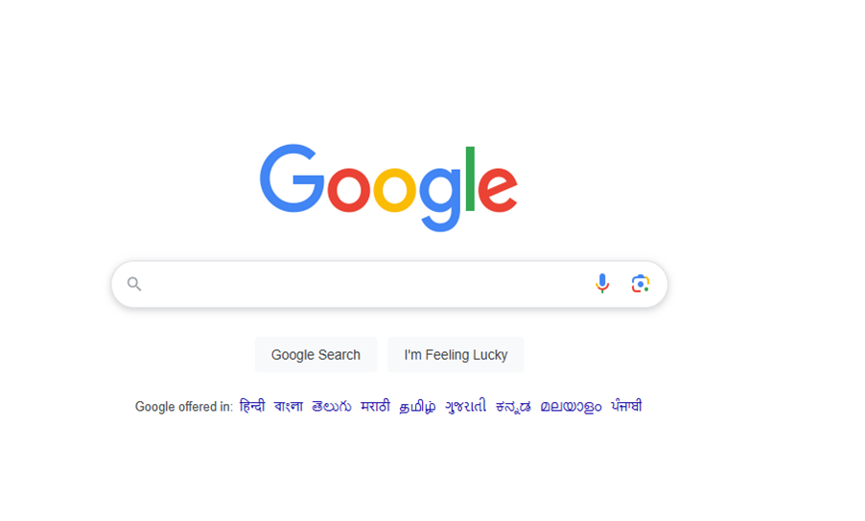
D. Image Maping
<HEAD>
<TITLE> IMAGE MAP </TITLE>
</HEAD>
<BODY>
<IMG SRC="worldmap.webp" alt="WORLD MAP" USEMAP= "#WORLDMAP" WIDTH="800" HEIGHT="376">
<map name="WORLDMAP">
<area shape="rect" coords="0,0,82,126"alt="NORTH AMERICA" href="NORTH_AMERICA.HTML">
<area shape="circle"coords= "90,58,20 " alt="greenland" href="greenland.HTML">
<area shape="poly" coords="124,115,190,172,233,122,294,188,345,345,133"alt=" AFRICA" href="AFRICA.HTML">
</map>
</BODY>
</HTML>

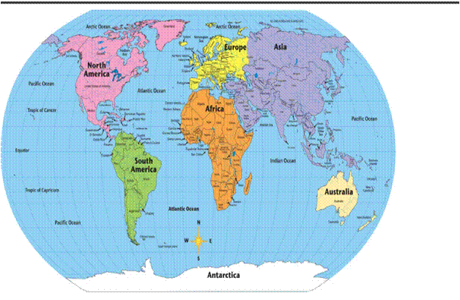
Note : <area shape="rect" coords="0,0,82,126"alt="NORTH AMERICA" href="NORTH_AMERICA.HTML">
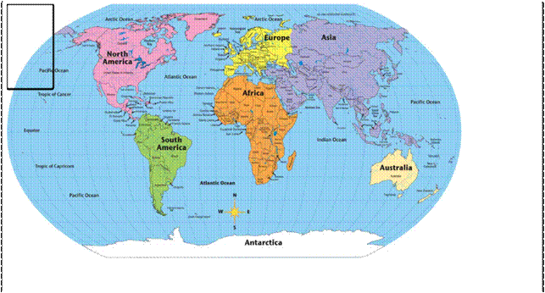
Note: <area shape="circle"coords= "90,58,20 " alt="greenland" href="greenland.HTML">
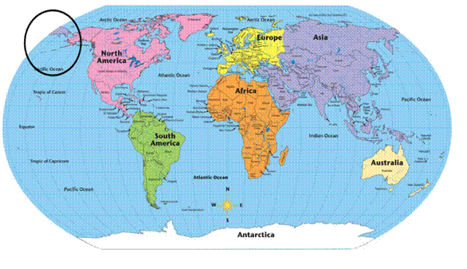
Note : <area shape="poly" coords="124,115,190,172,233,122,294,188,345,345,133"alt=" AFRICA" href="AFRICA.HTML">
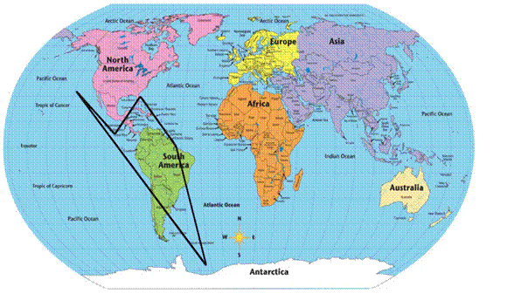
1. North America
<html>
<body>
<img src="North america.jpg">
</body>
</html>
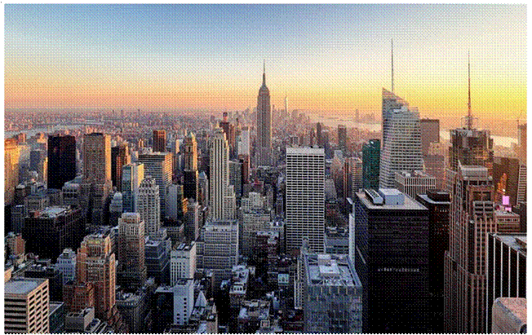

2. Greenland
<html>
<body>
<img height="900" src="greenland.jpg">
</body>
</html>
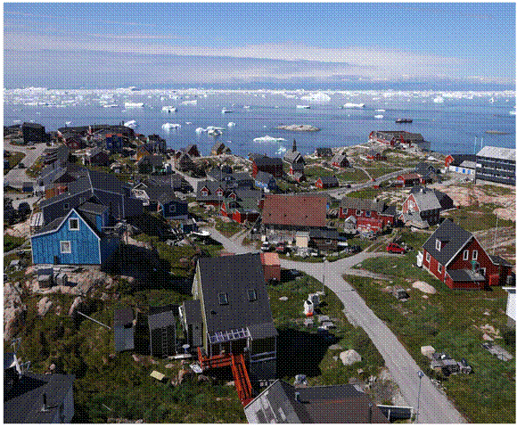

Practical No 5

Aim : Table Tags
<!DOCTYPE html>
<html>
<head>
<title>Timetable</title>
</head>

<body>
<table border="1" align="center" cellpadding="10" cellspacing="0">
<tr>
<td colspan="7" align="center" bgcolor="lightblue">
<b>
<font color="darkblue">Time Table</font>
</b>
</td>
</tr>
<tr bgcolor="lightgreen">
<th>Time</th>
<th>Monday</th>
<th>Tuesday</th>
<th>Wednesday</th>
<th>Thursday</th>
<th>Friday</th>
<th>Saturday</th>
</tr>
<tr align="center">
<td>8:00 to 9:00</td>
<td>science</td>
<td>maths</td>
<td>arts</td>
<td>maths</td>
<td>arts</td>
<td>science</td>
</tr>
<tr align="center">
<td>9:00 to 10:00</td>
<td>maths</td>
<td>science</td>
<td>hindi</td>
<td>arts</td>
<td>maths</td>
<td>hindi</td>
</tr>
<tr align="center">
<td colspan="7" align="center" bgcolor="lightcoral">
<b>
<font color="white">Lunch (10:00 to 10:30)</font>
</b>
</td>
</tr>
<tr align="center">
<td>10:30 to 11:30</td>
<td>hindi</td>
<td>arts</td>
<td>science</td>
<td>maths</td>
<td>science</td>
<td>maths</td>
</tr>
<tr align="center">
<td>11:30 to 12:30</td>
<td>science</td>
<td>maths</td>
<td>arts</td>
<td>hindi</td>
<td>arts</td>
<td>hindi</td>
</tr>
</table>
</body>
</html>
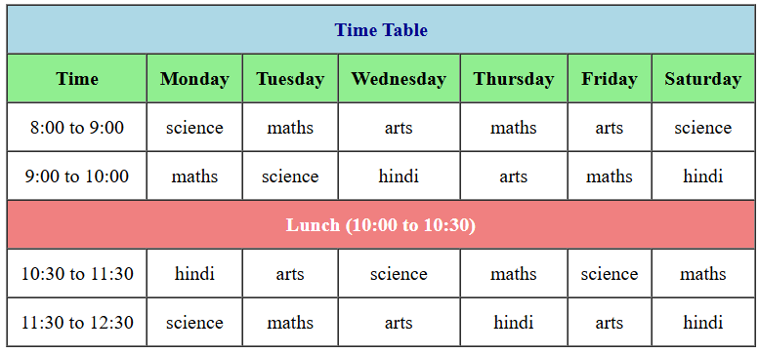

Practical No 6

Aim: Write a program in HTML to display Audio & Video.
A. Audio
<html>
<head>
<title>Audio</title>
</head>
<body bgcolor="black">
<h1><font size="12"><font color="red"><b><marquee>Audio
</marquee></b></font></font></h1>
<!-- Audio Section -->
<h2 style="color: white;">Audio Example 1</h2>
<audio controls autoplay>
<source src="/Users/yadnesh vasta/Downloads/sample-
6s.mp3">
</audio>
<h2 style="color: white;">Audio Example 2</h2>
<audio controls autoplay>
<source src="C:\Users\yadnesh vasta\Downloads\sample-
9s.mp3">
</audio>
</body>
</html>
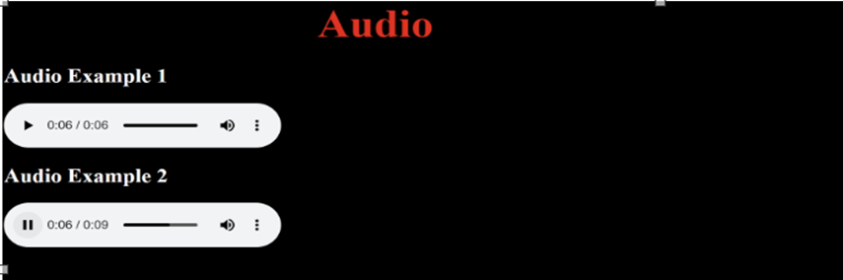

B. Video
<html>
<head>
<title>Video</title>
</head>
<body bgcolor="black">
<h1><font size="12"><font color="red"><b><marquee>Video</marquee></b>
</font></font></h1>
<!-- Video Section -->
<h2 style="color: white;">Video Example 1</h2>
<video width="400" height="300"controls autoplay>
<source src="/Users/yadnesh vasta/Downloads/dna.mp4">
</video>
<h2 style="color: white;">Video Example 2</h2>
<video width="400" height="300"controls autoplay>
<source src="C:\Users\yadnesh
vasta\Downloads\file_example_MP4_1280_10MG.mp4">
</video>
</body>
</html>
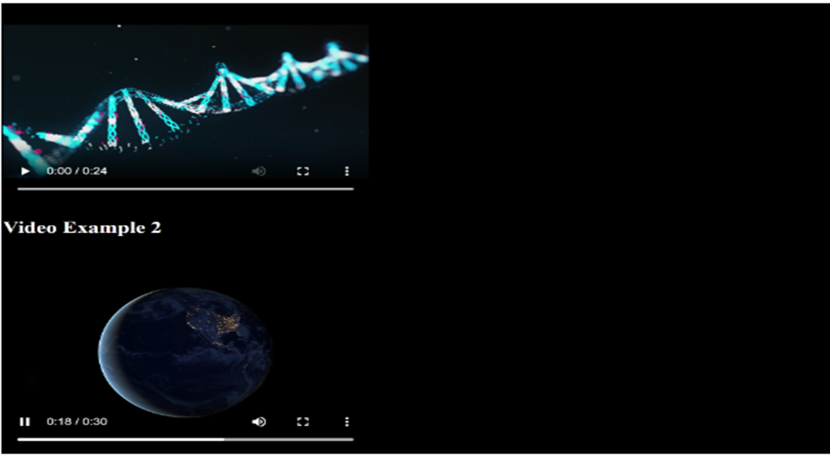

Practical No 7

Aim: Demonstrate various tags in HTML regarding forms and frame-set.

A. HTML Formatting
1 . Input Text Field (input type=”text”)
<form>
<label for="fname">First name:</label><br>
<input type="text" id="fname" name="fname" value="John"><br>
</form>
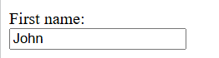
2. Radio Buttons (input type = “radio”)
<form>
<input type="radio" id="html" name="fav_language" value="HTML">
<label for="html">HTML</label><br>
</form>

3. Checkbox (input type="checkbox")
<form action="/action_page.php">
<input type="checkbox" id="vehicle1" name="vehicle1" value="Bike">
<label for="vehicle1"> I have a bike</label><br>
</form>
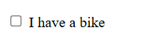
4. Submit Button (input type="submit")
<form action="/action_page.php">
<input type="submit" value="Submit">
</form>

The following are form attributes in HTML
1. Action Attributes
<form action="/action_page.php">
<label for="lname">Last name:</label><br>
<input type="text" id="lname" name="lname" value="Doe"><br><br>
<input type="submit" value="Submit">
</form>
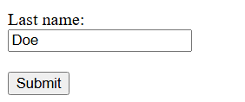

2. Target Attribute
<form action="/action_page.php" target="_blank">
<label for="fname">First name:</label><br>
<input type="text" id="fname" name="fname" value="John"><br>
<input type="submit" value="Submit">
</form>
Opens in another tab
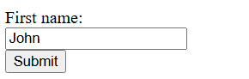
3. Get Method Attributes
<form action="/action_page.php" target="_blank" method="get">
<label for="fname">First name:</label><br>
<input type="text" id="fname" name="fname" value="John"><br>
<input type="submit" value="Submit">
</form>
Sends data as URL
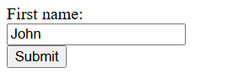
4. Post Method Attributes
<form action="/action_page.php" target="_blank" method="post">
<label for="fname">First name:</label><br>
<input type="text" id="fname" name="fname" value="John"><br>
<input type="submit" value="Submit">
</form>
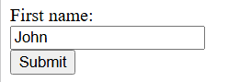

B. HTML Frameset
<iframe src="index.html" title="W3Schools Free Online Web Tutorials">
</iframe>
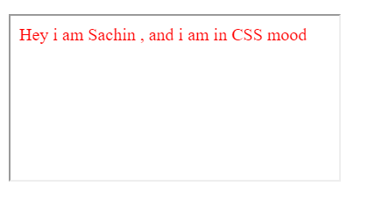

C. Demonstrate Frameset
<!DOCTYPE html>
<html lang="en">

<head>
<meta charset="UTF-8">
<meta name="viewport" content="width=device-width, initial-scale=1.0">
<title>Frameset</title>
<frameset rows="50%,50%">
<frameset cols="10%,8%,10%">
<frame name="top" src="Captain Levi Sir.gif" />
<frame name="main" src="globe.gif" />
<frame name="bottom" src="Computer Image.png" />
</frameset>

<frameset cols="10%,8%,10%">
<frame name="right" src="Greenland img.jpg" />
<frame name="another" src="north america.jpg"/>
<frame name="yes" src="" />
</frameset>

</frameset>
</head>
<body>
