Practical No 1

Aim : Basic Of CSS
<!DOCTYPE html>
<html lang="en">

<head>
<meta charset="UTF-8">
<meta name="viewport" content="width=device-width, initial-scale=1.0">
<title>Syntax Of CSS</title>
<style>
body {
background: aliceblue;
color: blueviolet;
}
h1 {
text-align: center;
}
p{
text-align: center;
font-size: large;
}
</style>
</head>

<body>
<h1> Syntax Of CSS</h1>
<p>Lorem ipsum dolor sit amet consectetur adipisicing elit. Eum blanditiis, est voluptatum culpa labore unde, iusto
dolores explicabo in perferendis tenetur repudiandae iste.
</p>
</body>

</html>
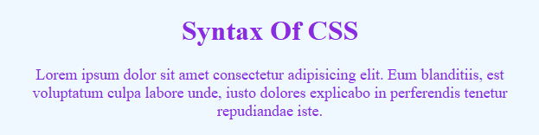

Practical No 2

Aim : Inserting CSS In An HTML Document
1. selectorCSS.html :
<!DOCTYPE html>
<html lang="en">
<head>
<meta charset="UTF-8">
<meta name="viewport" content="width=device-width, initial-scale=1.0">
<title>CSS Selector</title>
<link rel="stylesheet" href="selectoCSS.css">
<style>
body {
background: aliceblue;
color: blueviolet;
}

h1 {
text-align: center;
}

div{
margin: 8px 16px;
padding: 8px 16px;
font: bold 14px sans-serif;
border: 2px solid black;
border-radius: 4px;
}
.internal-css {
background: #3c6e7c;
}

.internal-css-h {
color: rgb(128, 70, 0);
}

.internal-css-p {
color: blue;
}

</style>
</head>
<body>
<h1>CSS Selector</h1>
<div style="background: #3c7c48;">
<h2 style="color: red;">inline CSS</h2>
<p style="color: yellow;">Lorem ipsum, dolor sit amet consectetur adipisicing elit. Eaque aliquid doloremque placeat!</p>
</div>
<div class="internal-css">
<h2 class="internal-css-h">Internal CSS</h2>
<p class="internal-css-p">Lorem ipsum, dolor sit amet consectetur adipisicing elit. Eaque aliquid doloremque
placeat!</p>
</div>
<div class="external-css">
<h2 class="external-css-h">External CSS</h2>
<p class="external-css-p">Lorem ipsum, dolor sit amet consectetur adipisicing elit. Eaque aliquid doloremque placeat!</p>
</div>
</body>

</html>
2. selectorCSS.css
.external-css {
background: #326a94;
}

.external-css-h {
color: rgb(238, 0, 255);
}

.external-css-p {
color: rgb(0, 255, 136);



