Practical No 4

Aim : CSS Properties To Work With Fonts And Text Styles

1. Font Style
<!DOCTYPE html>
<html lang="en">
<head>
<meta charset="UTF-8">
<meta name="viewport" content="width=device-width, initial-scale=1.0">
<title>Font And Text Style</title>
<style>
body {
background: aliceblue;
color: blueviolet;
}

h1,h2,h3 {
text-align: center;
}
</style>
</head>
<body>
<h1>Font And Text Style</h1>
<h2>Font Styling</h2>
<h3>Font Family</h3>
<p style="font-family: 'Courier New', Courier, monospace;">Lorem ipsum, dolor sit amet consectetur adipisicing
elit. Eaque aliquid doloremque placeat!</p>
<h3>Font Italic</h3>
<p style="font-style: italic;">Lorem ipsum, dolor sit amet consectetur adipisicing elit. Eaque aliquid
doloremque placeat!</p>
<h3>Font Size</h3>
<p style="font-size: 20px;">Lorem ipsum, dolor sit amet consectetur adipisicing elit. Eaque aliquid doloremque
placeat!</p>
<h3>Font Weight</h3>
<p style="font-weight: bold;">Lorem ipsum, dolor sit amet consectetur adipisicing elit. Eaque aliquid doloremque
placeat!</p>
<h3>Font Small Caps</h3>
<p style="font-variant: small-caps;">Lorem ipsum, dolor sit amet consectetur adipisicing elit. Eaque aliquid
doloremque placeat!</p>
</body>
</html>
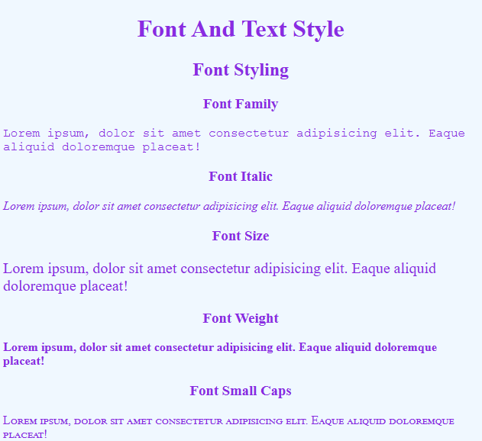

2. Text Style
<!DOCTYPE html>
<html lang="en">

<head>
<meta charset="UTF-8">
<meta name="viewport" content="width=device-width, initial-scale=1.0">
<title>Font And Text Style</title>
<style>
body {
background: aliceblue;
color: blueviolet;
}

h1,
h2,
h3 {
text-align: center;
}
</style>
</head>

<body>
<h1>Font And Text Style</h1>
<h2>Text Styling</h2>

<h3>Text Align</h3>
<p style="text-align: center;">Lorem ipsum, dolor sit amet consectetur adipisicing elit. Eaque aliquid doloremque
placeat!</p>
<h3>Text Decoration</h3>
<p style="text-decoration: underline;">Lorem ipsum, dolor sit amet consectetur adipisicing elit. Eaque aliquid
doloremque placeat!</p>
<h3>Text Transform</h3>
<p style="text-transform: uppercase;">Lorem ipsum, dolor sit amet consectetur adipisicing elit. Eaque aliquid
doloremque placeat!</p>

<h3>Text Color</h3>
<p style="color: red;">Lorem ipsum, dolor sit amet consectetur adipisicing elit. Eaque aliquid doloremque placeat!
</p>
<p style="color: #3c7c48;">Lorem ipsum, dolor sit amet consectetur adipisicing elit. Eaque aliquid doloremque
placeat!</p>

<h3>Text Decoration</h3>
<p style="text-decoration: underline;">Lorem ipsum, dolor sit amet consectetur adipisicing elit. Eaque aliquid
doloremque placeat!</p>

<h3>Text Transform</h3>
<p style="text-transform: uppercase;">Lorem ipsum, dolor sit amet consectetur adipisicing elit. Eaque aliquid
doloremque placeat!</p>

<h3>Text Indent</h3>
<p style="text-indent: 50px;">Lorem ipsum, dolor sit amet consectetur adipisicing elit. Eaque aliquid doloremque
placeat!</p>

<h3>Letter Spacing</h3>
<p style="letter-spacing: 10px;">Lorem ipsum, dolor sit amet consectetur adipisicing elit. Eaque aliquid doloremque
placeat!</p>

<h3>Line Height</h3>
<p style="line-height: 2;">Lorem ipsum, dolor sit amet consectetur adipisicing elit. Eaque aliquid doloremque
placeat! Lorem, ipsum dolor sit amet consectetur adipisicing elit. Amet quaerat sapiente temporibus?</p>

<h3>Word Spacing</h3>
<p style="word-spacing: 10px;">Lorem ipsum, dolor sit amet consectetur adipisicing elit. Eaque aliquid doloremque
placeat!</p>
</body>

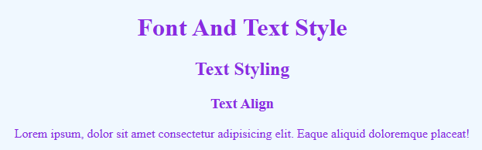
</html>
