Practical No 5

Aim : CSS Properties For Positioning An Element
<!DOCTYPE html>
<html lang="en">
<head>
<meta charset="UTF-8">
<meta name="viewport" content="width=device-width, initial-scale=1.0">
<title>CSS Position Properties</title>
<style>
*{
margin: 0;
padding: 0;
}
.body{
background: aliceblue;
color: blueviolet;
}
div{
width: 400px;
height: 200px;
margin: 8px;
padding: 8px 16px;
font: bold 14px sans-serif;
border: 2px solid black;
border-radius: 4px;
}
.static{
position: static;
background: #45836f;
}
.relative{
position: relative;
background: #355366;
}
.absolute{
position: absolute;
background: #50996c;
height: 150px;
top: 100px;
left: 150px;
}
.fixed{
position: fixed;
background: #8d4848;

}
</style>
</head>
<body>
<div class="static">
<h1>Static</h1>
<p>The element is not positioned in any special way</p>
</div>
<div class="relative">
<h1>Relative</h1>
<p>The element is positioned relative to the normal flow of the document</p>
</div>
<div class="absolute">
<h1>Absolute</h1>
<p>The element is positioned relative to the nearest positioned ancestor</p>
</div>
<div class="fixed">
<h1>Fixed</h1>
<p>The element is positioned relative to the viewport</p>
</div>
</body>
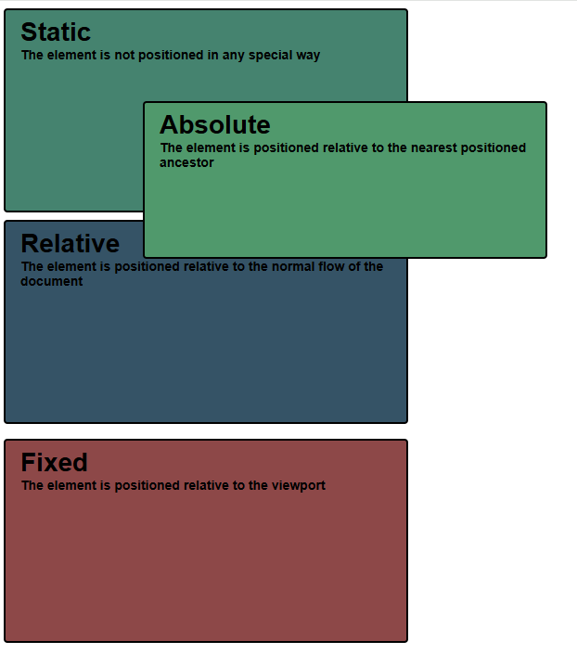
</html>

