Practical No 4

Aim : JavaScript Object

A. String Object
<!DOCTYPE html>
<html lang="en">
<head>
<meta charset="UTF-8">
<meta name="viewport" content="width=device-width, initial-scale=1.0">
<title>String Object</title>
<style>
body {
background: aliceblue;
color: blueviolet;
}

h1 {
text-align: center;
}
</style>
</head>
<body>
<h1>JavaScript String Object</h1>
<script>
// JavaScript String Object
// String Object Is Used For String Manipulation
let a = new String("Hello World");
let str = "Hello World";

document.write("Through New Keyword = ", a,"<br>");
document.write("Through String Literal = ", str,"<br>");
document.write("<br>");

// String Object Methods
// charAt() Method Is Used For Returning The Character At Specified Index
document.write("charAt() Method Is Used For Returning The Character At Specified Index<br>");
document.write("string = ", str,"<br>");
document.write("index = 0 = ", a.charAt(0),"<br>");
document.write("index = 1 = ", a.charAt(1),"<br>");
document.write("<br>");

// concat() Method Is Used For Concatenating Two Or More Strings
document.write("concat() Method Is Used For Concatenating Two Or More Strings<br>");
document.write("string1 = ", str,"<br>");
document.write("string2 = ", str.concat(" How Are You"),"<br>");
document.write("<br>");

// indexOf() Method Is Used For Returning The Index Of The First Occurrence Of A Substring
document.write("indexOf() Method Is Used For Returning The Index Of The First Occurrence Of A Substring<br>");
document.write("string =", str,"<br>");
document.write("substring = How = ", str.indexOf("How"),"<br>");
document.write("<br>");

// lastIndexOf() Method Is Used For Returning The Index Of The Last Occurrence Of A Substring
document.write("lastIndexOf() Method Is Used For Returning The Index Of The Last Occurrence Of A Substring<br>");
document.write("string = ", str,"<br>");
document.write("substring = How = ", str.lastIndexOf("How"),"<br>");
document.write("<br>");

// length() Method Is Used For Returning The Length Of A String
document.write("length() Method Is Used For Returning The Length Of A String<br>");
document.write("string = ", str,"<br>");
document.write("length = ", str.length,"<br>");
document.write("<br>");

// slice() Method Is Used For Returning A Section Of A String
document.write("slice() Method Is Used For Returning A Section Of A String<br>");
document.write("string = ", str,"<br>");
document.write("start = 0 end = 5 = ", str.slice(0, 5),"<br>");
document.write("<br>");

// toLowerCase() Method Is Used For Converting A String To Lowercase
document.write("toLowerCase() Method Is Used For Converting A String To Lowercase<br>");
document.write("string = ", str,"<br>");
document.write("string = ", str.toLowerCase(),"<br>");
document.write("<br>");

// toUpperCase() Method Is Used For Converting A String To Uppercase
document.write("toUpperCase() Method Is Used For Converting A String To Uppercase<br>");
document.write("string = ", str,"<br>");
document.write("string = ", str.toUpperCase(),"<br>");
document.write("<br>");

// trim() Method Is Used For Removing Whitespace From Both Ends Of A String
document.write("trim() Method Is Used For Removing Whitespace From Both Ends Of A String<br>");
let unTrim = " Hello World ";
document.write("string = ", unTrim,"<br>");
document.write("string = ", unTrim.trim(),"<br>");
document.write("<br>");

</script>
</body>
</html>

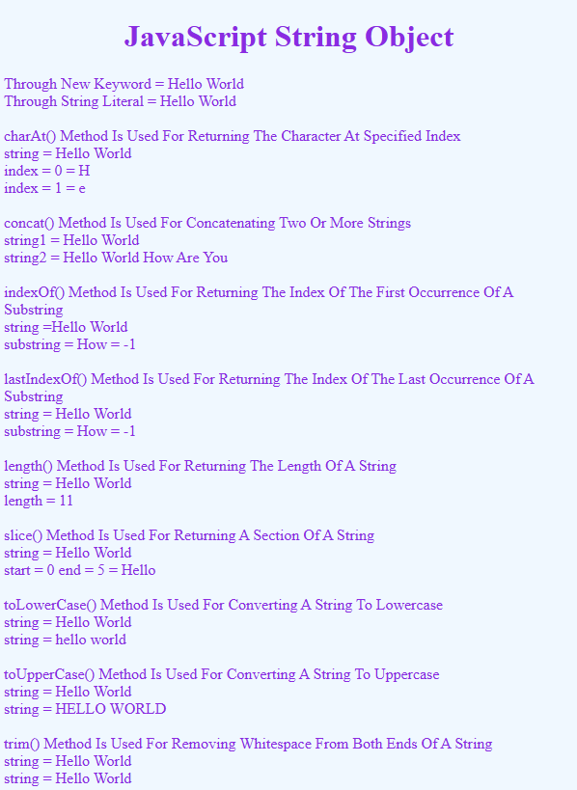

B. RegEx Object
<!DOCTYPE html>
<html lang="en">

<head>
<meta charset="UTF-8">
<meta name="viewport" content="width=device-width, initial-scale=1.0">
<title>RegEx Object</title>
<style>
body {
background: aliceblue;
color: blueviolet;
}

h1 {
text-align: center;
}
</style>
</head>

<body>
<h1>JavaScript RegEx Object</h1>
<script>
// JavaScript RegEx Object
// RegEx Object Is Used For Pattern Matching
let a = "This Is An Example Of JavaScript RegEx";
let reg = /JavaScript/i;
document.write("String : ", a, "<br>")

// test() Method Is Used For Checking If A String Matches A Pattern
document.write("test() Method Is Used For Checking If A String Matches A Pattern<br>");
document.write("RegEx : ", reg, "<br>");
document.write("test() Method Result = ", reg.test(a), "<br>");
document.write("<br>");
</script>
</body>

</html>
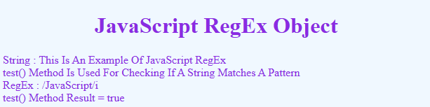

C. Math Object
1. Math Object Demo
<!DOCTYPE html>
<html lang="en">

<head>
<meta charset="UTF-8">
<meta name="viewport" content="width=device-width, initial-scale=1.0">
<title>Math Object Demo</title>
<style>
body {
background: aliceblue;
color: blueviolet;
}

h1 {
text-align: center;
}
</style>
</head>

<body>
<h1>JavaScript Math Object Demo</h1>
<script>
// JavaScript Math Object
// Math Object Is Used For Mathematical Operations
document.write("Math Object Is Used For Mathematical Operations");
document.write("<br>");
document.write("<br>");

// abs() Method Is Used For Returning The Absolute Value Of A Number
document.write("abs() Method Is Used For Returning The Absolute Value Of A Number<br>");
document.write("abs(-10.81) = ", Math.abs(-10.81));
document.write("<br>");
document.write("<br>");

// round() Method Is Used For Returning The Value Of A Number Rounded To The Nearest Integer
document.write("round() Method Is Used For Returning The Value Of A Number Rounded To The Nearest Integer<br>");
document.write("round(10.81) = ", Math.round(10.81));
document.write("<br>");
document.write("<br>");

// ceil() Method Is Used For Returning The Smallest Integer Greater Than Or Equal To A Number
document.write("ceil() Method Is Used For Returning The Smallest Integer Greater Than Or Equal To A Number<br>");
document.write("ceil(10.81) = ", Math.ceil(10.81));
document.write("<br>");
document.write("<br>");

// floor() Method Is Used For Returning The Largest Integer Less Than Or Equal To A Number
document.write("floor() Method Is Used For Returning The Largest Integer Less Than Or Equal To A Number<br>");
document.write("floor(10.81) = ", Math.floor(10.81));
document.write("<br>");
document.write("<br>");

// max() Method Is Used For Returning The Largest Of Two Or More Numbers
document.write("max() Method Is Used For Returning The Largest Of Two Or More Numbers<br>");
document.write("max(10, 20, 30, 40) = ", Math.max(10, 20, 30, 40));
document.write("<br>");
document.write("<br>");

// min() Method Is Used For Returning The Smallest Of Two Or More Numbers
document.write("min() Method Is Used For Returning The Smallest Of Two Or More Numbers<br>");
document.write("min(10, 20, 30, 40) = ", Math.min(10, 20, 30, 40));
document.write("<br>");
document.write("<br>");

// pow() Method Is Used For Returning The First Number Raised To The Power Of The Second Number
document.write("pow() Method Is Used For Returning The First Number Raised To The Power Of The Second Number<br>");
document.write("pow(2, 3) = ", Math.pow(2, 3));
document.write("<br>");
document.write("<br>");

// sqrt() Method Is Used For Returning The Square Root Of A Number
document.write("sqrt() Method Is Used For Returning The Square Root Of A Number<br>");
document.write("sqrt(9) = ", Math.sqrt(9));
document.write("<br>");
document.write("<br>");

// random() Method Is Used For Returning Random Number Between 0 to 1
document.write("random() Method Is Used For Returning Random Number Between 0 to 1<br>");
document.write("random() = ", Math.random());
document.write("<br>");
document.write("<br>");

</script>
</body>

</html>

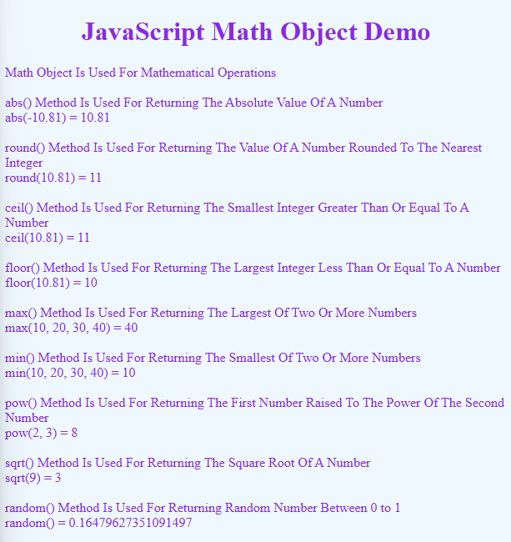

2. Math Object Properties
<!DOCTYPE html>
<html lang="en">

<head>
<meta charset="UTF-8">
<meta name="viewport" content="width=device-width, initial-scale=1.0">
<title>Math Object Properties</title>
<style>
body {
background: aliceblue;
color: blueviolet;
}

h1 {
text-align: center;
}
</style>
</head>

<body>
<h1>JavaScript Math Object Properties</h1>
<script>
// Math Object Properties
// PI Property Is Used For Returning The Value Of PI
document.write("PI Property Is Used For Returning The Value Of PI<br>");
document.write("PI = ", Math.PI);
document.write("<br>");
document.write("<br>");

// E Property Is Used For Returning The Value Of E
document.write("E Property Is Used For Returning The Value Of E<br>");
document.write("E = ", Math.E);
document.write("<br>");
document.write("<br>");

// LN2 Property Is Used For Returning The Value Of LN2
document.write("LN2 Property Is Used For Returning The Value Of LN2<br>");
document.write("LN2 = ", Math.LN2);
document.write("<br>");
document.write("<br>");

// LN10 Property Is Used For Returning The Value Of LN10
document.write("LN10 Property Is Used For Returning The Value Of LN10<br>");
document.write("LN10 = ", Math.LN10);
document.write("<br>");
document.write("<br>");

// LNG2E Property Is Used For Returning The Value Of LNG2E
document.write("LNG2E Property Is Used For Returning The Value Of LNG2E<br>");
document.write("LNG2E = ", Math.LNG2E);
document.write("<br>");
document.write("<br>");

// LOG2E Property Is Used For Returning The Value Of LOG2E
document.write("LOG2E Property Is Used For Returning The Value Of LOG2E<br>");
document.write("LOG2E = ", Math.LOG2E);
document.write("<br>");
document.write("<br>");

// SQRT1_2 Property Is Used For Returning The Value Of SQRT1_2
document.write("SQRT1_2 Property Is Used For Returning The Value Of SQRT1_2<br>");
document.write("SQRT1_2 = ", Math.SQRT1_2);
document.write("<br>");
document.write("<br>");

// SQRT2 Property Is Used For Returning The Value Of SQRT2
document.write("SQRT2 Property Is Used For Returning The Value Of SQRT2<br>");
document.write("SQRT2 = ", Math.SQRT2);
document.write("<br>");
document.write("<br>");

</script>
</body>

</html>
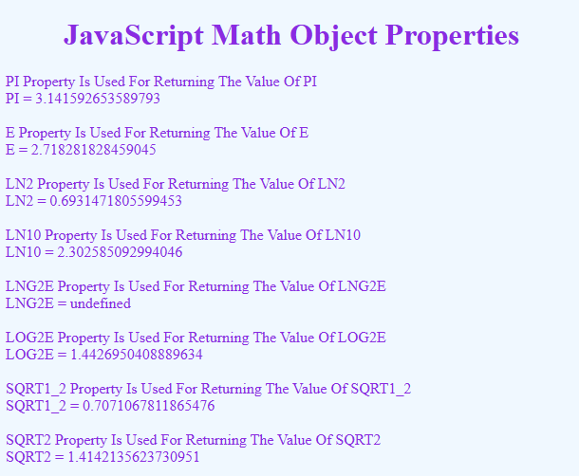

D. Date Object
<!DOCTYPE html>
<html lang="en">

<head>
<meta charset="UTF-8">
<meta name="viewport" content="width=device-width, initial-scale=1.0">
<title>Date Object</title>
<style>
body {
background: aliceblue;
color: blueviolet;
}

h1 {
text-align: center;
}
</style>
</head>

<body>
<h1>JavaScript Date Object</h1>
<script>
// JavaScript Date Object
// Date Object Is Used For Working With Dates
let d = new Date();
document.write(d);
document.write("<br>");

// Date Methods
document.write("For Full Year : ")
document.write(d.getFullYear());
document.write("<br>");

document.write("For Month : ")
document.write(d.getMonth());
document.write("<br>");

document.write("For Date : ")
document.write(d.getDate());
document.write("<br>");

document.write("For Day : ")
document.write(d.getDay());
document.write("<br>");

document.write("For Hours : ")
document.write(d.getHours());
document.write("<br>");

document.write("For Minutes : ")
document.write(d.getMinutes());
document.write("<br>");

document.write("For Seconds : ")
document.write(d.getSeconds());
document.write("<br>");

document.write("For Milliseconds : ")
document.write(d.getMilliseconds());
document.write("<br>");

document.write("For Time : ")
document.write(d.getTime());
document.write("<br>");

document.write("For Timezone Offset : ")
document.write(d.getTimezoneOffset());
document.write("<br>");

document.write("For Date String : ")
document.write(d.toDateString());
document.write("<br>");

document.write("For Time String : ")
document.write(d.toTimeString());
document.write("<br>");

document.write("For Locale Date String : ")
document.write(d.toLocaleDateString());
document.write("<br>");

document.write("For Locale Time String : ")
document.write(d.toLocaleTimeString());
</script>
</body>

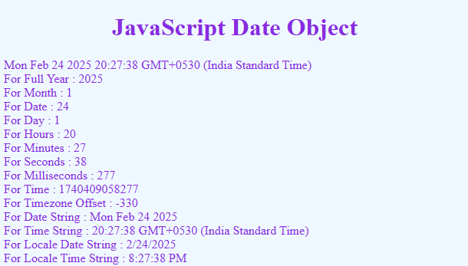
</html>

