Practical No 7

Aim: Write A Program To Implement Tkinter In Python.
1. GUI
import tkinter

m = tkinter.Tk(className = "BlackAsh")
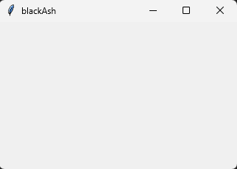
m.mainloop()

2. File Open And Color Selector
from tkinter.filedialog import askopenfile
from tkinter.colorchooser import askcolor
from tkinter import *

root = Tk(className = " File Open And Choose Color")

root.geometry("750x500")

def showFile():
filename = askopenfile()
print(filename)

def showColor():
color = askcolor()
print(color)

btn = Button(root,text = "Open File",command = showFile)
btnColor = Button(root,text = "Choose Color",command = showColor)

btn.place(x = 50,y = 50)
btnColor.place(x = 50,y = 100)

root.mainloop()
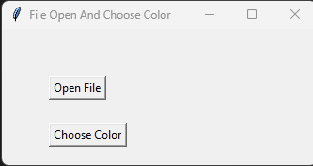

<_io.TextIOWrapper name='C:/Users/Administrator/Downloads/HTMLFinal.docx' mode='r' encoding='cp1252'>
((0, 0, 128), '#000080')

3. Button
from tkinter import *

root = Tk()

root.title("I Am Ashif Shaikh")

button = Button(root,text = "Close", width = 25 ,height = 10, command = root.destroy)
button.pack()

root.mainloop()
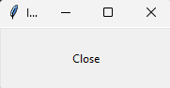

4. Canvas
from tkinter import *

root = Tk(className = " Canvas")
root.geometry("750x500")

c = Canvas (root,bg = "grey",height = 600 , width = 750)

# Body
body = c.create_oval(10,150,200,350,fill = "#0f51ff" )

# Head
headOutside = c.create_oval(10,10,200,200,fill = "#0f51ff")
headInside = c.create_oval(30,50,180,200,fill = "white")
nose = c.create_oval(95,90,110,105,fill = "red")

# Eye One
eye11 = c.create_oval(60,45,95,95,fill = "black")
eye12 = c.create_oval(61,43,95,93,fill = "white")
eye13 = c.create_oval(70,67,85,90,fill = "black")
eye13 = c.create_oval(73,70,81,86,fill = "white")

# Eye Two
eye11 = c.create_oval(110,45,142,95,fill = "black")
eye12 = c.create_oval(111,43,142,93,fill = "white")
eye13 = c.create_oval(118,65,133,90,fill = "black")
eye13 = c.create_oval(120,68,130,86,fill = "white")

# mouth
mouth = c.create_oval(65,135,145,170,fill = "red")
mouthInside = c.create_oval(75,155,135,170,fill = "#c62d42")

# noseLine
noseLine = c.create_line(103,106,103,135,fill = "black")
n11 = c.create_line(60,100,95,110)
n12 = c.create_line(60,115,95,115)
n13 = c.create_line(60,130,95,120)
n21 = c.create_line (115,110,145,100)
n22 = c.create_line (115,115,145,115)
n23 = c.create_line (115,120,145,130)

c.pack()

root.mainloop()
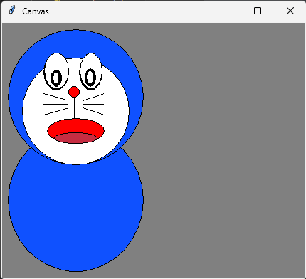

5. List
import tkinter as tk

root = tk.Tk()
root.title("place layout example")
root.geometry("300x300+50+100")

def display_selection(event):
selection= cities_listbox.curselection()
print(cities_listbox.get(selection))

tk.Label(
root,
text="which of the following cities would you like to travel to?",
wraplength = 200,
).place(x=50, y=20)

cities_listbox =tk.Listbox(root,selectmode = tk.BROWSE,width=24)
cities_listbox.place(x=40, y=65)

cities =["new york","singapore","dubai","mumbai","tokyo"]
for city in cities:
cities_listbox.insert(tk.END,city)

cities_listbox.bind("<<ListboxSelect>>",display_selection)

end_button = tk.Button(root, text="End",command=quit)
end_button.place(x=125,y=250)

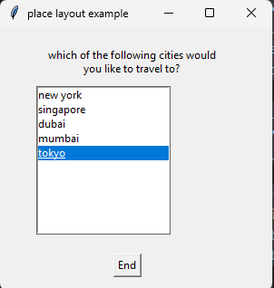
root.mainloop()

new york
singapore
dubai
mumbai
tokyo

6. Frame
from tkinter import*
from tkinter.ttk import*
import tkinter as tk

root = Tk()
root.geometry("200x100")

def pressed2(event):
print('Button-2 pressed at x = %d, y= %d' %(event.x, event.y))

def pressed3(event):
print('Button-3 pressed at x = %d, y= %d' %(event.x, event.y))

def double_click(event):
print('Double clicked at x = %d, y= %d' %(event.x, event.y))

frame1 =Frame(root, height =100, width = 200)

frame1.bind('<Button-1>',pressed2)
frame1.bind('<Double 1>', double_click)

frame1.pack()

mainloop()
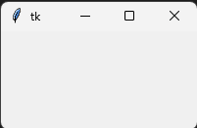

Button-2 pressed at x = 34, y= 14
Button-2 pressed at x = 79, y= 21
Button-2 pressed at x = 159, y= 33
Button-2 pressed at x = 114, y= 74
Button-2 pressed at x = 70, y= 70
Double clicked at x = 70, y= 70
Button-2 pressed at x = 100, y= 26
Double clicked at x = 100, y= 26
Button-2 pressed at x = 37, y= 56
Double clicked at x = 37, y= 55
Button-2 pressed at x = 139, y= 59
Double clicked at x = 136, y= 58

