Practical No 7

Aim : Write A Code To Open And Read A File In C++.
#include <iostream>
#include <fstream>
using namespace std;
int main()
{
char msg[20];
ofstream o;
o.open("create.txt", ios::out);
o << "Hello friends !!" << endl;
o << "bye!!" << endl;
o.close();
cout << "New File Created" << endl;

ifstream i;
i.open("create.txt", ios::in);
i >> msg;
cout << msg << endl;
i >> msg;
cout << msg << endl;
i >> msg;
cout << msg << endl;
return 0;
}
New File Created
Hello
friends
!!

Practical No 8

Aim : Write A Program To Implement Pointer And Reference.
#include <iostream>
using namespace std;

void swap(int &a, int &b)
{
int temp = a;
a = b;
b = temp;
}
int main()
{
int a, b;
a = 10;
b = 20;
cout << "The Value Of a,b Before Swap : " << a << "," << b << endl;
swap(a,b);
cout << "The Value Of a,b After Swap : " << a << "," << b << endl;

return 0;
}

The Value Of a,b Before Swap : 10,20
The Value Of a,b After Swap : 10,20

Practical No 9

Aim : Write A Program To Concatenation Of File In C++.
#include <iostream>;
#include <fstream>;

using namespace std;

int main()
{
string file1, file2;
ofstream concatFile("concat.txt");

// File 1
ifstream MyReadFile1("test0.txt");
while (getline(MyReadFile1, file1))
{
concatFile << file1 << "\n";
}
MyReadFile1.close();

// File 2
ifstream MyReadFile2("test1.txt");
while (getline(MyReadFile2, file2))
{
concatFile << file2 << "\n";
}
MyReadFile2.close();

// Concatinf File
concatFile.close();
cout << "New File Created ";
return 0;
}
Input File Output File
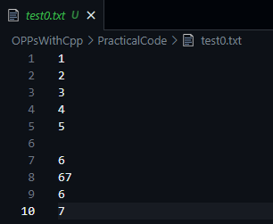
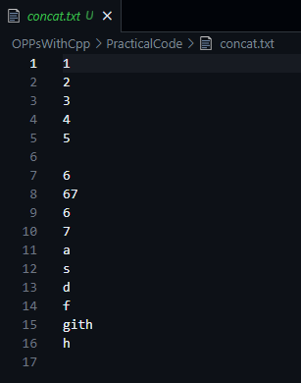

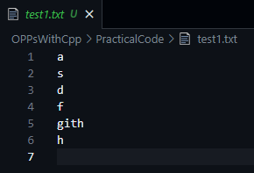

Practical No 10

Aim : Write A Program A To Separate A File.
#include <iostream>;
#include <fstream>;
using namespace std;
int main()
{
string letter;
char ch;
ofstream small("small.txt");
ofstream capital("capital.txt");
int count = 1;

// File 1
ifstream MyReadFile1("input.txt");
while (getline(MyReadFile1, letter))
{
if (count <= 5)
{
small << letter << "\n";
}
else
{
capital << letter << "\n";
}
count ++;
}
MyReadFile1.close();

// Concating File
small.close();
capital.close();
cout << "New File Created ";
return 0;
}
Input File Output File
