Practical No 9

Aim : Write A Program To Show Different Data Science Tools.
1. NumPy
import numpy as np

x = np.array([1,2,3,4,5,6,7,8,9,10])
print("Array X : ",x)

y = np.array([[1,2,3],[4,5,6],[7,8,9]])
print("Array Y : ",y)

# Array Properties
print("Shape : ",y.shape)
print("Size : ",y.size)
print("Dimension : ",y.ndim)

num = np.arange(1,11,2)
print("Array By Range : ",num)
Array X : [ 1 2 3 4 5 6 7 8 9 10]
Array Y : [[1 2 3]
[4 5 6]
[7 8 9]]
Shape : (3, 3)
Size : 9
Dimension : 2
Array By Range : [1 3 5 7 9]

2. Matplotlib
import matplotlib.pyplot as plt

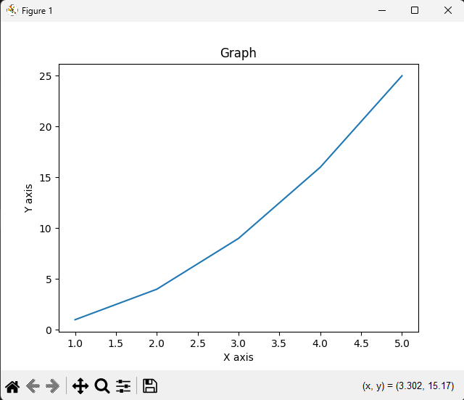
x = [1, 2, 3, 4, 5]
y = [1, 4, 9, 16, 25]

plt.plot(x, y)
plt.xlabel("X axis")
plt.ylabel("Y axis")
plt.title("Graph")
plt.show()

With Marker
import matplotlib.pyplot as plt
import numpy as np

xcoordinates = np.array([1,2,3,4,5,6])
ycoordinates = np.array([1,4,9,16,25,36])

plt.title("This is a graph ")

plt.plot(xcoordinates , ycoordinates)

plt.plot(xcoordinates ,ycoordinates , marker = 'o')
plt.plot(ycoordinates ,xcoordinates , marker = 'x')
plt.xlabel("Line 1 ")
plt.ylabel("Line 2")
plt.show()
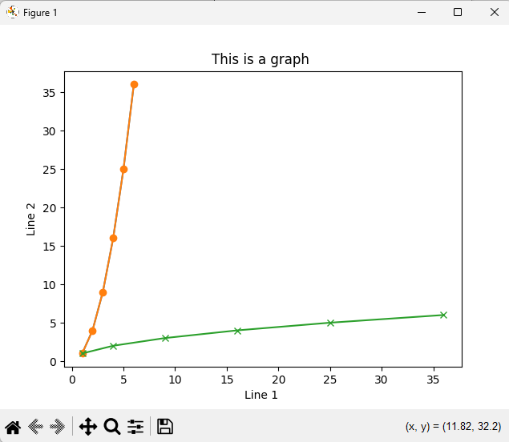

3. Pandas
a. Reading A CSV File.
import pandas as pd

df = pd.read_csv("dummyData.csv")
print(df)
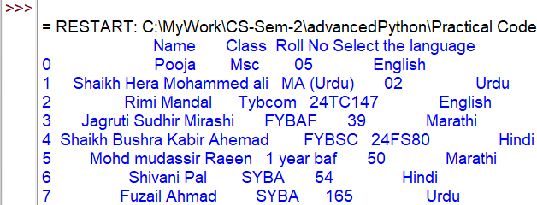

b. DataFrames.
import pandas as pd

df = pd.DataFrame({"Name":["A","B","C","D"],"Age":[20,21,22,23],"Gender":["M","F","M","F"]})
print(df)
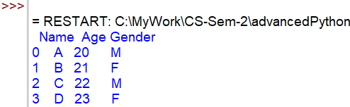

4. SciPy
a. Double Integral
from scipy import integrate
a = lambda y, x: x*y**2
b = lambda x: 1
c = lambda x: -1
print(integrate.dblquad(a, 0, 2, b, c))
(-1.3333333333333335, 1.4802973661668755e-14)

b. Trimmed Standard Deviation
from scipy import stats
import numpy as np

# array elements ranging from 0 to 19
x = np.arange(20)

print("Trimmed Standard Deviation : ", stats.tstd(x))
print("\nTrimmed Standard Deviation by setting limit : ", stats.tstd(x,(2,10)))
Trimmed Standard Deviation : 5.916079783099616

Trimmed Standard Deviation by setting limit : 2.7386127875258306

