Practical No 1

Aim : Using JavaScript In A HTML Document
A. Internal JavaScript
internalJS.html :
<!DOCTYPE html>
<html lang="en">

<head>
<meta charset="UTF-8">
<meta name="viewport" content="width=device-width, initial-scale=1.0">
<title>Using JavaScript In HTML</title>
<style>
body {
background: aliceblue;
color: blueviolet;
}
h1{
text-align: center;
}
h2{
text-align: center;
}
</style>
</head>

<body>
<h1>Using JavaScript In HTML</h1>
<h2>Internal JavaScript</h2>
<script>
document.write("Hello World");
document.write("<br>");
document.write(Date());
</script>
</body>

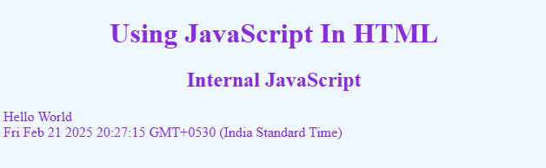
</html>
B. External JavaScript
Index.html :
<!DOCTYPE html>
<html lang="en">
<head>
<meta charset="UTF-8">
<meta name="viewport" content="width=device-width, initial-scale=1.0">
<title>External JavaScript</title>
<style>
body {
background: aliceblue;
color: blueviolet;
}
h1{
text-align: center;
}
h2{
text-align: center;
}
</style>
</head>
<body>
<h1>Using JavaScript In HTML</h1>
<h2>External JavaScript</h2>
<script src="script.js"></script>
</body>
</html>
script.js :
document.write("<b>Now I am using External JavaScript</b>");
document.write("<br>");
document.write("Hello World");
document.write("<br>");
// Comment In JavaScript
// Date Module Gives Current Date
document.write(Date());
