Practical No 2

Aim : Programing Fundamental Of JavaScript
A. Variables
<!DOCTYPE html>
<html lang="en">

<head>
<meta charset="UTF-8">
<meta name="viewport" content="width=device-width, initial-scale=1.0">
<title>Variable In JavaScript</title>
<style>
body {
background: aliceblue;
color: blueviolet;
}

h1 {
text-align: center;
}
</style>
</head>

<body>
<h1>JavaScript Variable</h1>
<script>
// Variable In JavaScript
// var, let, const Keyword In JavaScript For Declaring Variable
// var Keyword Is Used For Declaring Variable In JavaScript But It Has Some Limitations And Not Recommended To Use It
// let Keyword Is Used For Declaring Variable In JavaScript
// const Keyword Is Used For Declaring Constant In JavaScript
// When We Declare Variable In JavaScript, We Can Assign Value To It If Not Assigned, It Will Return Undefined

// Declaring Variable
var name;
let age;
let salary;
const country = "India";

// Assigning Value To Variable
name = "John Doe";
age = 30;

// Accessing Variable
document.write("Name : " + name);
document.write("<br>");
document.write("Age : " + age);
document.write("<br>");
document.write("Salary : " + salary);
document.write("<br>");
document.write("Country : " + country);
</script>
</body>

</html>
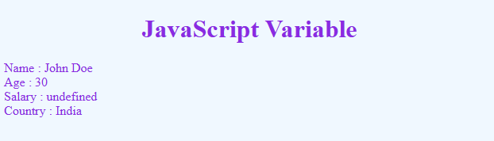
B. Operators
1. Arithmetic Operators
<!DOCTYPE html>
<html lang="en">

<head>
<meta charset="UTF-8">
<meta name="viewport" content="width=device-width, initial-scale=1.0">
<title>Arithmetic Operator</title>
<style>
body {
background: aliceblue;
color: blueviolet;
}

h1 {
text-align: center;
}
</style>
</head>

<body>
<h1>JavaScript Arithmetic Operator</h1>
<script>
// Arithmetic Operator In JavaScript
// +, -, *, /, %, **, ++, -- Keyword In JavaScript For Arithmetic Operation
// + Keyword Is Used For Addition In JavaScript
// - Keyword Is Used For Subtraction In JavaScript
// * Keyword Is Used For Multiplication In JavaScript
// / Keyword Is Used For Division In JavaScript
// % Keyword Is Used For Modulus In JavaScript
// ** Keyword Is Used For Exponent In JavaScript
// ++ Keyword Is Used For Increment In JavaScript
// -- Keyword Is Used For Decrement In JavaScript

// Addition In JavaScript
document.write("Addition In JavaScript");
document.write("<br>");
let a = 10;
let b = 20;
let c = a + b;
document.write("10 + 20 = ", c);
document.write("<br>");

// Subtraction In JavaScript
document.write("Subtraction In JavaScript");
document.write("<br>");
let d = 10;
let e = 20;
let f = d - e;
document.write("10 - 20 = ", f);
document.write("<br>");

// Multiplication In JavaScript
document.write("Multiplication In JavaScript");
document.write("<br>");
let g = 10;
let h = 20;
let i = g * h;
document.write("10 * 20 = ", i);
document.write("<br>");

// Division In JavaScript
document.write("Division In JavaScript");
document.write("<br>");
let j = 10;
let k = 20;
let l = j / k;
document.write("10 / 20 = ", l);
document.write("<br>");

// Modulus In JavaScript
document.write("Modulus In JavaScript");
document.write("<br>");
let m = 10;
let n = 20;
let o = m % n;
document.write("10 % 20 = ", o);
document.write("<br>");

// Exponent In JavaScript
document.write("Exponent In JavaScript");
document.write("<br>");
let p = 3;
let q = 3;
let r = p ** q;
document.write("3 ** 3 = ", r);
document.write("<br>");

// Increment & Decrement In JavaScript
document.write("Increment & Decrement In JavaScript");
document.write("<br>");
document.write("Intial Value = 10");
document.write("<br>");
let s = 10;
s++;
document.write("Increment = ", p);
document.write("<br>");
s--;
document.write("Decrement = ", q);
document.write("<br>");

</script>
</body>

</html>
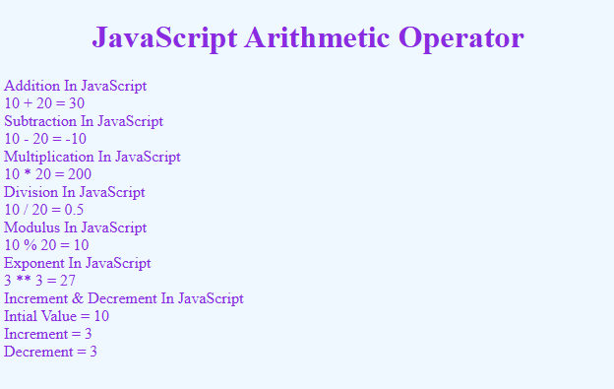
2. Comparison Operators
<!DOCTYPE html>
<html lang="en">
<head>
<meta charset="UTF-8">
<meta name="viewport" content="width=device-width, initial-scale=1.0">
<title>Comparison Operator</title>
<style>
body {
background: aliceblue;
color: blueviolet;
}

h1 {
text-align: center;
}
</style>
</head>
<body>
<h1>JavaScript Comparison Operator</h1>
<script>
// JavaScript Comparison Operator
// ==, ===, !=, !==, >, <, >=, <=
// == Is Used For Checking If Two Values Are Equal
// === Is Used For Checking If Two Values Are Equal And Of The Same Type
// != Is Used For Checking If Two Values Are Not Equal
// > Is Used For Checking If The First Value Is Greater Than The Second Value
// < Is Used For Checking If The First Value Is Less Than The Second Value
// >= Is Used For Checking If The First Value Is Greater Than Or Equal To The Second Values
// <= Is Used For Checking If The First Value Is Less Than Or Equal To The Second Values

// == Is Used For Checking If Two Values Are Equal
document.write("== Is Used For Checking If Two Values Are Equal");
document.write("<br>");
let a = 10;
let b = 20;
let c = a == b;
document.write("10 == 20 = ", c);
document.write("<br>");

// === Is Used For Checking If Two Values Are Equal And Of The Same Type
document.write("=== Is Used For Checking If Two Values Are Equal And Of The Same Type");
document.write("<br>");
let d = 10;
let e = "10";
let f = d === e;
document.write("10 === 10 = ", f);
document.write("<br>");

// != Is Used For Checking If Two Values Are Not Equal
document.write("!= Is Used For Checking If Two Values Are Not Equal");
document.write("<br>");
let g = 10;
let h = 20;
let i = g != h;
document.write("10 != 20 = ", i);
document.write("<br>");

// > Is Used For Checking If The First Value Is Greater Than The Second Value
document.write("> Is Used For Checking If The First Value Is Greater Than The Second Value");
document.write("<br>");
let j = 10;
let k = 10;
let l = j > k;
document.write("10 > 10 = ", l);
document.write("<br>");

// < Is Used For Checking If The First Value Is Less Than The Second Value
document.write("< Is Used For Checking If The First Value Is Less Than The Second Value");
document.write("<br>");
let m = 10;
let n = 20;
let o = m < n;
document.write("10 < 20 = ", o);
document.write("<br>");

// >= Is Used For Checking If The First Value Is Greater Than Or Equal To The Second Values
document.write(">= Is Used For Checking If The First Value Is Greater Than Or Equal To The Second Values");
document.write("<br>");
let p = 10;
let q = 10;
let r = p >= q;
document.write("10 >= 10 = ", r);
document.write("<br>");

// <= Is Used For Checking If The First Value Is Less Than Or Equal To The Second Values
document.write("<= Is Used For Checking If The First Value Is Less Than Or Equal To The Second Values");
document.write("<br>");
let s = 10;
let t = 20;
let u = s <= t;
document.write("10 <= 20 = ", u);
document.write("<br>");
</script>
</body>
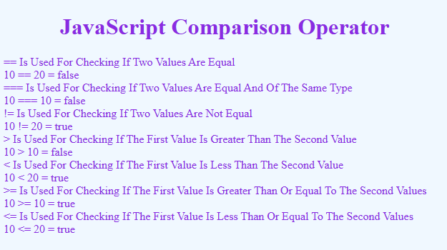
</html>
3. Logical Operators
<!DOCTYPE html>
<html lang="en">

<head>
<meta charset="UTF-8">
<meta name="viewport" content="width=device-width, initial-scale=1.0">
<title>Logical Operators</title>
<style>
body {
background: aliceblue;
color: blueviolet;
}

h1 {
text-align: center;
}
</style>
</head>

<body>
<h1>JavaScript Logical Operators</h1>
<script>
// JavaScript Logical Operators
// && Keyword Is Used For Logical And
// || Keyword Is Used For Logical Or
// ! Keyword Is Used For Logical Not

// && Keyword Is Used For Logical And
document.write("&& Keyword Is Used For Logical And");
document.write("<br>");
let a = 10;
let b = 20;
let c = a && b;
document.write("10 && 20 = ", c);
document.write("<br>");

// || Keyword Is Used For Logical Or
document.write("|| Keyword Is Used For Logical Or");
document.write("<br>");
let d = 10;
let e = 20;
let f = d || e;
document.write("10 || 20 = ", f);
document.write("<br>");

// ! Keyword Is Used For Logical Not
document.write("! Keyword Is Used For Logical Not");
document.write("<br>");
let g = 10;
let h = !g;
document.write("!10 = ", h);
</script>
</body>

</html>
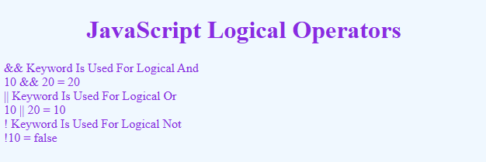
4. Assignment Operators
<!DOCTYPE html>
<html lang="en">
<head>
<meta charset="UTF-8">
<meta name="viewport" content="width=device-width, initial-scale=1.0">
<title>Assignment Operator</title>
<style>
body {
background: aliceblue;
color: blueviolet;
}

h1 {
text-align: center;
}
</style>
</head>
<body>
<h1>JavaScript Assignment Operator</h1>
<script>
// JavaScript Assignment Operator
// = Keyword Is Used For Assigning Value To A Variable
// += Keyword Is Used For Adding Value To A Variable
// -= Keyword Is Used For Subtracting Value From A Variable
// *= Keyword Is Used For Multiplying Value Of A Variable
// /= Keyword Is Used For Dividing Value Of A Variable
// %= Keyword Is Used For Modulo Value Of A Variable

// = Keyword Is Used For Assigning Value To A Variable
document.write("= Keyword Is Used For Assigning Value To A Variable");
document.write("<br>");
let a = 10;
document.write("a = 10 = ", a);
document.write("<br>");

// += Keyword Is Used For Adding Value To A Variable
document.write("+= Keyword Is Used For Adding Value To A Variable");
document.write("<br>");
let b = 10;
b += 20; // b = b + 20
document.write("b += 20 = ", b);
document.write("<br>");

// -= Keyword Is Used For Subtracting Value From A Variable
document.write("-= Keyword Is Used For Subtracting Value From A Variable");
document.write("<br>");
let c = 10;
c -= 20; // c = c - 20
document.write("c -= 20 = ", c);
document.write("<br>");

// *= Keyword Is Used For Multiplying Value Of A Variable
document.write("*= Keyword Is Used For Multiplying Value Of A Variable");
document.write("<br>");
let d = 10;
d *= 20; // d = d * 20
document.write("d *= 20 = ", d);
document.write("<br>");

// /= Keyword Is Used For Dividing Value Of A Variable
document.write("/= Keyword Is Used For Dividing Value Of A Variable");
document.write("<br>");
let e = 10;
e /= 20; // e = e / 20
document.write("e /= 20 = ", e);
document.write("<br>");

// %= Keyword Is Used For Modulo Value Of A Variable
document.write("%= Keyword Is Used For Modulo Value Of A Variable");
document.write("<br>");
let f = 10;
f %= 20; // f = f % 20
document.write("f %= 20 = ", f);
</script>
</body>
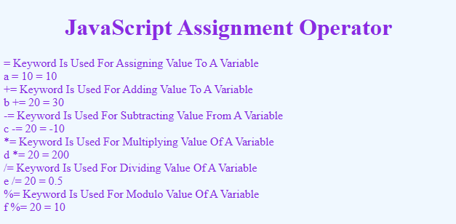
</html>

C. Control Flow Statements
I. Conditional Statement
1. if Condition
<!DOCTYPE html>
<html lang="en">
<head>
<meta charset="UTF-8">
<meta name="viewport" content="width=device-width, initial-scale=1.0">
<title>If Statement</title>
<style>
body {
background: aliceblue;
color: blueviolet;
}
h1 {
text-align: center;
}
</style>
</head>
<body>
<h1>JavaScript If Statement</h1>
<script>
// JavaScript If Statement
// if Statement Is Used For Checking The Condition
// if Statement Is Used For Executing The Statement If The Condition Is True
// if Statement Is Used For Executing The Statement If The Condition Is False

document.write("if Statement Is Used For Checking The Condition");
document.write("<br>");
let a = 10;
let b = 20;
document.write("a = ", a);
document.write("<br>");
document.write("b = ", b);
document.write("<br>");

// if Statement Is Used For Executing The Statement If The Condition Is True
if (a > b) {
document.write("a is greater than b");
document.write("<br>");
}
// if Statement Is Used For Executing The Statement If The Condition Is False
if (a < b) {
document.write("a is less than b");
document.write("<br>");
}
</script>
</body>
</html>
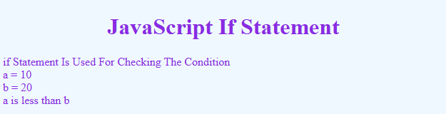

2. if...else statement
<!DOCTYPE html>
<html lang="en">
<head>
<meta charset="UTF-8">
<meta name="viewport" content="width=device-width, initial-scale=1.0">
<title>if...else Statement</title>
<style>
body {
background: aliceblue;
color: blueviolet;
}
h1 {
text-align: center;
}
</style>
</head>
<body>
<h1>if...else Statement</h1>
<script>
// JavaScript if...else Statement
// if...else Statement Is Used For Checking The Condition
// if...else Statement Is Used For Executing The Statement If The Condition Is True
// if...else Statement Is Used For Executing The Statement If The Condition Is False

// if...else Statement Is Used For Checking The Condition
document.write("if...else Statement Is Used For Checking The Condition");
document.write("<br>");
let a = 10;
let b = 20;
document.write("a = ", a);
document.write("<br>");
document.write("b = ", b);
document.write("<br>");

// if...else Statement Is Used For Executing The Statement If The Condition Is True
if (a > b) {
document.write("a is greater than b");
document.write("<br>");
} else {
document.write("a is less than b");
document.write("<br>");
}
</script>
</body>
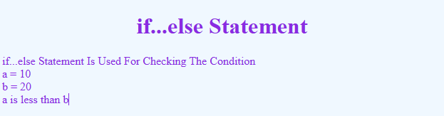
</html>
3. Nested if...else Statement
<!DOCTYPE html>
<html lang="en">
<head>
<meta charset="UTF-8">
<meta name="viewport" content="width=device-width, initial-scale=1.0">
<title>Nested if...else Statement</title>
<style>
body {
background: aliceblue;
color: blueviolet;
}
h1 {
text-align: center;
}
</style>
</head>
<body>
<h1>Nested if...else Statement</h1>
<script>
// JavaScript Nested if...else Statement
// Nested if...else Statement Is Used For Checking The Condition

let a = 10;
let b = 20;
let c = 30;
document.write("a = ", a);
document.write("<br>");
document.write("b = ", b);
document.write("<br>");
document.write("c = ", c);
document.write("<br>");

if (a > b) {
if (a > c) {
document.write("a is greater than b and c");
}
else {
document.write("a is greater than b and less than c");
}
}
else {
document.write("a is less than b and c");
}
</script>
</body>
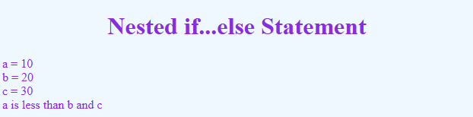
</html>
II. Looping Statement
1. while loops
<!DOCTYPE html>
<html lang="en">
<head>
<meta charset="UTF-8">
<meta name="viewport" content="width=device-width, initial-scale=1.0">
<title>While Statement</title>
<style>
body {
background: aliceblue;
color: blueviolet;
}

h1 {
text-align: center;
}
</style>
</head>
<body>
<h1>While Statement</h1>
<p>Print 0 To 9 Using While Statement</p>
<script>
// JavaScript While Statement
// While Statement Is Used For Iteration
let i = 0;
while (i < 10) {
document.write("The Value Of I Is ", i);
document.write("<br>");
i++;
}
</script>

</body>
</html>
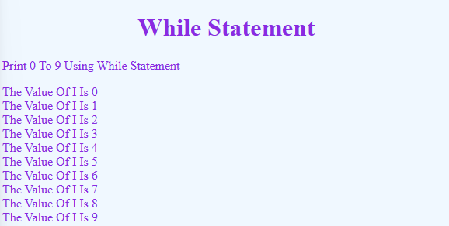
2. do … while loops
<!DOCTYPE html>

<html lang="en">

<head>
<meta charset="UTF-8">
<meta name="viewport" content="width=device-width, initial-scale=1.0">
<title>Do While Statement</title>
<style>
body {
background: aliceblue;
color: blueviolet;
}

h1 {
text-align: center;
}
</style>
</head>

<body>
<h1>Do While Statement</h1>
<script>
// JavaScript Do While Statement
// Do While Statement Is Used For Iteration
let i = 0;
do {
document.write("The Value Of I Is ", i);
document.write("<br>");
i++;
} while (i < 10);
</script>
</body>

</html>
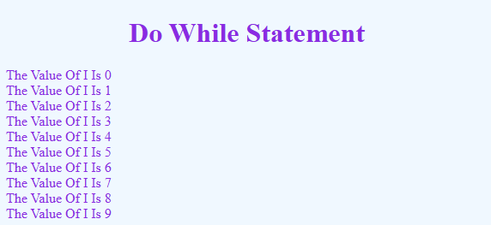
3. for … loops
<!DOCTYPE html>
<html lang="en">

<head>
<meta charset="UTF-8">
<meta name="viewport" content="width=device-width, initial-scale=1.0">
<title>For Statement</title>
<style>
body {
background: aliceblue;
color: blueviolet;
}

h1 {
text-align: center;
}
</style>
</head>

<body>
<h1>For Statement</h1>
<p>Printing Table Using For Statement</p>
<script>
// JavaScript For Statement
// For Statement Is Used For Iteration
for (let i = 1; i <= 10; i++) {
document.write("2 X ", i, " = ", 2 * i);
document.write("<br>");
}
</script>
</body>

</html>
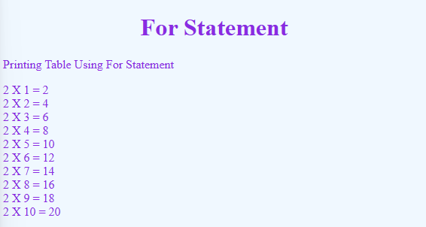
III. Switch Statements
<!DOCTYPE html>
<html lang="en">
<head>
<meta charset="UTF-8">
<meta name="viewport" content="width=device-width, initial-scale=1.0">
<title>Switch Statement</title>
<style>
body {
background: aliceblue;
color: blueviolet;
}
h1 {
text-align: center;
}
</style>
</head>
<body>
<h1>Switch Statement</h1>
<script>
// JavaScript Switch Statement
// Switch Statement Is Used For Checking The Condition
let day = "";
switch (new Date().getDay()) {
case 0:
day = "Sunday";
break;
case 1:
day = "Monday";
break;
case 2:
day = "Tuesday";
break;
case 3:
day = "Wednesday";
break;
case 4:
day = "Thursday";
break;
case 5:
day = "Friday";
break;
case 6:
day = "Saturday";
break;
}
document.write("Today Is " + day);
</script>
</body>

</html>

IV. Jump Statements
1. break
<!DOCTYPE html>
<html lang="en">
<head>
<meta charset="UTF-8">
<meta name="viewport" content="width=device-width, initial-scale=1.0">
<title>Break Statement</title>
<style>
body {
background: aliceblue;
color: blueviolet;
}
h1 {
text-align: center;
}
</style>
</head>
<body>
<h1>Break Statement</h1>
<script>
// JavaScript Break Statement
// Break Statement Is Used For Exiting The Loop
for (let i = 0; i < 7; i++) {
if (i == 3) {
break;
}
document.write("The Value Of I Is ", i);
document.write("<br>");
}
</script>
</body>
</html>
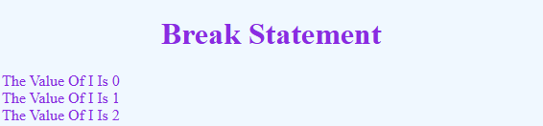

2. continue
<!DOCTYPE html>
<html lang="en">
<head>
<meta charset="UTF-8">
<meta name="viewport" content="width=device-width, initial-scale=1.0">
<title>Continue Statement</title>
<style>
body {
background: aliceblue;
color: blueviolet;
}
h1 {
text-align: center;
}
</style>
</head>
<body>
<h1>Continue Statement</h1>
<script>
// JavaScript Continue Statement
// Continue Statement Is Used For Skipping The Current Iteration
for (let i = 0; i < 7; i++) {
if (i % 2 == 0) {
continue;
}
document.write("The Value Of I Is ", i);
document.write("<br>");
}
</script>
</body>
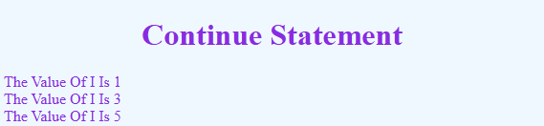
</html>
D. Popup Boxes
1. alert
<!DOCTYPE html>
<html lang="en">
<head>
<meta charset="UTF-8">
<meta name="viewport" content="width=device-width, initial-scale=1.0">
<title>Alert Box</title>
<style>
body {
background: aliceblue;
color: blueviolet;
}
h1 {
text-align: center;
}
.button {
margin: 0 auto;
padding: 8px 16px;
font: bold 14px sans-serif;
color: aliceblue;
background: blueviolet;
border: none;
border-radius: 4px;
}
</style>
</head>
<body>
<h1>Alert Box</h1>
<input class="button" type="button" value="Click Here" onclick="alert('Hello World')">
</body>
</html>


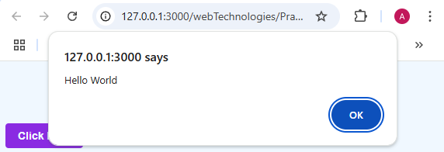

2. confirm
<!DOCTYPE html>
<html lang="en">
<head>
<meta charset="UTF-8">
<meta name="viewport" content="width=device-width, initial-scale=1.0">
<title>Document</title>
<style>
body {
background: aliceblue;
color: blueviolet;
}
h1 {
text-align: center;
}
.button {
margin: 0 auto;
padding: 8px 16px;
font: bold 14px sans-serif;
color: aliceblue;
background: blueviolet;
border: none;
border-radius: 4px;
}
</style>
</head>
<body>
<h1>Confirm Box</h1>
<button class="button" onclick="myFunction()">Click Me</button>
<script>
// JavaScript Confirm Box
function myFunction() {
let person = confirm("Are You Sure?");
if (person == true) {
document.write("You Pressed OK!");
} else {
document.write("You Pressed Cancel!");
}
}
</script>
</body>
</html>

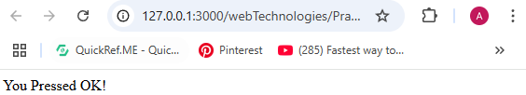
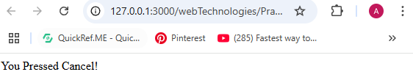
3. prompt
<!DOCTYPE html>
<html lang="en">
<head>
<meta charset="UTF-8">
<meta name="viewport" content="width=device-width, initial-scale=1.0">
<title>Prompt Box</title>
<style>
body {
background: aliceblue;
color: blueviolet;
}

h1 {
text-align: center;
}

.button {
margin: 0 auto;
padding: 8px 16px;
font: bold 14px sans-serif;
color: aliceblue;
background: blueviolet;
border: none;
border-radius: 4px;
}
</style>
</head>
<body>
<h1>Prompt Box</h1>
<button class="button" onclick="myFunction()">Click</button>
<script>
function myFunction() {
var person = prompt("Please enter your name", "Harry Potter");
if (person != null) {
document.write("Hello " + person + "! How are you today?");
}
}
</script>
</body>
</html>

