Practical No 3

Aim : Function In JavaScript
A. Defining And Invoking A Function
<!DOCTYPE html>
<html lang="en">
<head>
<meta charset="UTF-8">
<meta name="viewport" content="width=device-width, initial-scale=1.0">
<title>Defining A Function</title>
<style>
body {
background: aliceblue;
color: blueviolet;
}
h1 {
text-align: center;
}
.button {
margin: 0 auto;
padding: 8px 16px;
font: bold 14px sans-serif;
color: aliceblue;
background: blueviolet;
border: none;
border-radius: 4px;
}
</style>
</head>
<body>
<h1>Defining A Function</h1>
<input type="button" value="Click Here" class="button" onclick="showMsg()">
<script>
function showMsg() {
alert("Hello World");
}
</script>
</body>
</html>

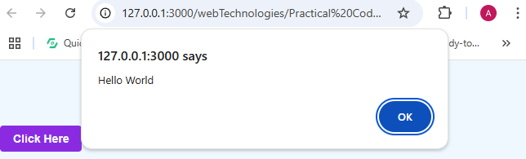

B. Defining Function Argument
<!DOCTYPE html>
<html lang="en">

<head>
<meta charset="UTF-8">
<meta name="viewport" content="width=device-width, initial-scale=1.0">
<title>Function Argument</title>
<style>
body {
background: aliceblue;
color: blueviolet;
}

h1 {
text-align: center;
}

.button {
margin: 0 auto;
padding: 8px 16px;
font: bold 14px sans-serif;
color: aliceblue;
background: blueviolet;
border: none;
border-radius: 4px;
}
</style>
</head>

<body>
<h1>JavaScript Function Argument</h1>
<input type="button" value="Click Here" class="button" onclick="showCube(7)">
<script>
function showCube(num) {
alert(num*num*num); }
</script>
</body>

</html>

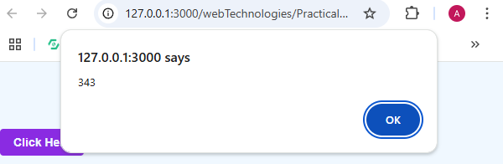
C. Defining A Return Statement
<!DOCTYPE html>
<html lang="en">
<head>
<meta charset="UTF-8">
<meta name="viewport" content="width=device-width, initial-scale=1.0">
<title>Return Statement</title>
<style>
body {
background: aliceblue;
color: blueviolet;
}
h1 {
text-align: center;
}
.button {
margin: 0 auto;
padding: 8px 16px;
font: bold 14px sans-serif;
color: aliceblue;
background: blueviolet;
border: none;
border-radius: 4px;
}
</style>
</head>
<body>
<h1>JavaScript Return Statement</h1>
<p>This Code Does A Calcution And Returns The Result</p>
<script>
// JavaScript Return Statement
// Return Statement Is Used To Exit From A Function
function add(a, b) {
return a + b;
}
document.write(add(2, 3));
document.write("<br>");
document.write(add(4, 5));
document.write("<br>");
document.write(add(6, 7));
document.write("<br>");
document.write(add(8, 9));
</script>
</body>
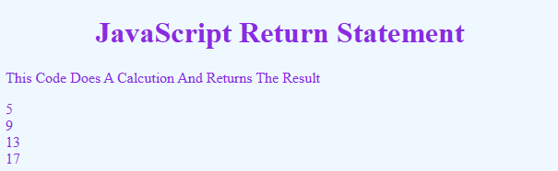
</html>
D. Calling Function With Timer
1. setTimeout
<!DOCTYPE html>
<html lang="en">
<head>
<meta charset="UTF-8">
<meta name="viewport" content="width=device-width, initial-scale=1.0">
<title>Set Timeout</title>
<style>
body {
background: aliceblue;
color: blueviolet;
}
h1 {
text-align: center;
}
.button {
margin: 0 auto;
padding: 8px 16px;
font: bold 14px sans-serif;
color: aliceblue;
background: blueviolet;
border: none;
border-radius: 4px;
}
</style>
</head>
<body>
<h1>Set Timeout</h1>
<button class="button" onclick="myFunction()">Click Me</button>
<script>
function myFunction() {
setTimeout(function() { alert("Hello World") }, 2000);
}
</script>
</body>
</html>

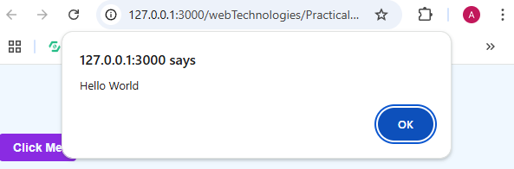
2. setInterval
<!DOCTYPE html>
<html lang="en">
<head>
<meta charset="UTF-8">
<meta name="viewport" content="width=device-width, initial-scale=1.0">
<title>Set Interval</title>
<style>
body {
background: aliceblue;
color: blueviolet;
}
h1 {
text-align: center;
}
.button {
margin: 0 auto;
padding: 8px 16px;
font: bold 14px sans-serif;
color: aliceblue;
background: blueviolet;
border: none;
border-radius: 4px;
}
</style>
</head>
<body>
<h1>Set Interval</h1>
<button class="button" onclick="myFunction()">Click Me</button>
<script>
let count = 0;
function myFunction() {
setInterval(function () {
alert("Hello World " + count)
count++;
}, 3000);

}
</script>
</body>
</html>

