Practical No 5

Aim : JavaScript Browser Object

1. JavaScript Document Object Model
HTML :
<!DOCTYPE html>
<html lang="en">

<head>
<meta charset="UTF-8">
<meta name="viewport" content="width=device-width, initial-scale=1.0">
<link rel="stylesheet" href="style.css">
<title>Basic Of DOM Manupalation</title>
</head>

<body>
<div class="nav">
<h1>Basic Of DOM Manupalation</h1>
</div>

<div>
<p class="demoClass">Selecting Element Using DOM By Class Name</p>
</div>

<div>
<p id="demoID">Selecting Element Using DOM By ID</p>
</div>
<div>
<button class="button">Click To See New Paragraph</button>
<button class="button buttonHover">Click To See Hover Effect</button>
</div>

<script src="script.js"></script>
</body>

</html>

CSS :
* {
margin: 0;
padding: 0;
}

body {
background: aliceblue;
color: blueviolet;
}

.nav {
background: rgb(43, 226, 119);
padding: 1rem 2rem;
}

h1 {
text-align: center;
}

.button {
margin: 8px 16px;
padding: 8px 16px;
font: bold 14px sans-serif;
color: aliceblue;
background: blueviolet;
border: none;
border-radius: 4px;
}

div {
margin-bottom: 1rem;
}
JavaScript :
// Printing In JavaScript
console.log("Hello World");

// Selecting An Element Through DOM By Class Name
let demoClass = document.getElementsByClassName("demoClass")[0];
console.log(demoClass);
console.log(demoClass.innerHTML);

// Selecting An Element Through DOM By ID
let demoID = document.getElementById("demoID");
console.log(demoID);
console.log(demoID.innerHTML);

// By Using Query Selector
let demoQuery = document.querySelector(".demoClass");
console.log(demoQuery);
console.log(demoQuery.innerHTML);

// Handling Click Event
let button = document.querySelector("button");
button.addEventListener("click", function () {
let newParagraph = document.createElement("p");
newParagraph.innerHTML = "This Is New Paragraph By Click";
document.body.appendChild(newParagraph);
});

// Handling Hover Event
let buttonHover = document.querySelector(".buttonHover");
buttonHover.addEventListener("mouseover", function () {
let newParagraph = document.createElement("p");
newParagraph.innerHTML = "This Is New Paragraph By Hover";
document.body.appendChild(newParagraph);
});
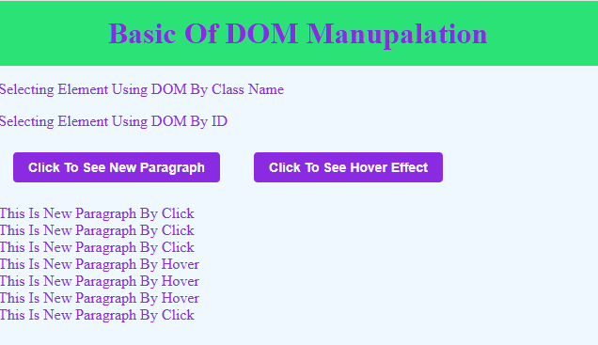
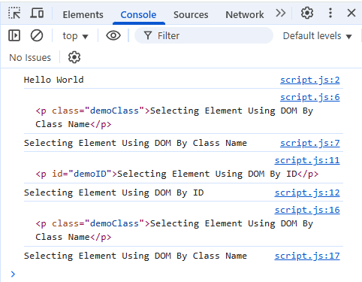

2. Form Validation Using JavaScript
HTML :
<!DOCTYPE html>
<html lang="en">

<head>
<meta charset="UTF-8">
<meta name="viewport" content="width=device-width, initial-scale=1.0">
<link rel="stylesheet" href="style.css">
<title>Form Validation</title>
</head>

<body>
<div class="nav">
<h1>Basic Of Form Validation</h1>
</div>

<form name="myForm" action="handleSubmit">

<div>
<label for="username">Enter Your Name : </label>
<input class="input" type="text" id="username" name="Username" required placeholder="Enter your username">
</div>

<div>
<label for="email">Enter Your Email : </label>
<input class="input" type="email" id="email" name="email" required placeholder="Enter your email address">
</div>

<div>
<label for="password">Enter Your Password : </label>
<input class="input" type="password" id="password" required name="password" placeholder="Enter your password">
</div>
<div>
<label for="password">Confirm Password : </label>
<input class="input" type="password" id="confirmPassword" required name="confirmPassword" placeholder="confirm password">
</div>

<div>
<p>Select your Gender</p>
<input type="radio" id="Male" required name="gender" value="male">
<label for="Male">Male</label>
<input type="radio" id="Female" required name="gender" value="female">
<label for="Female">Female</label>
</div>

<div>
<label for="age">Enter Your Age : </label>
<input class="input" type="number" id="age" name="age" required placeholder="Enter your age">
</div>

<div>
<input class="button" type="submit" value="Submit">
<input class="button" type="button" onclick="print()" value="Print Form">
</div>

</form>
<script src="script.js"></script>
</body>

</html>
CSS :
* {
font-family: 'Courier New', Courier, monospace;
margin: 0;
padding: 0;
}

body {
background: aliceblue;
color: blueviolet;
}

div {
margin-bottom: 1rem;
}

.nav {
background: rgb(43, 226, 119);
padding: 1rem 2rem;
}

h1 {
text-align: center;
}

.button {
margin: 8px 16px;
padding: 8px 16px;
font: bold 14px sans-serif;
color: aliceblue;
background: blueviolet;
border: none;
border-radius: 4px;
}

.input {
padding: .5rem 1rem;
width: 50%;
border: none;
}

form{
width: 70%;
margin: 0 auto;
}
JavaScript :
// handling submit event

// To Check Name
function checkName(name) {
if (name.length < 3) {
alert("Name should be at least 3 characters long");
return false;
}
return true;
}

// To Check Email
function checkEmail(email) {
// RegEx For Email
let re = /^[a-zA-Z0-9._%+-]+@[a-zA-Z0-9.-]+\.[a-zA-Z]{2,}$/;
if (!re.test(email)) {
alert("Invalid Email");
return false;
}
return true;
}

// To Check Password
function checkPassword(password, confirmPassword) {
if (password.length < 6) {
alert("Password should be at least 6 characters long");
return false;
}

if (password !== confirmPassword) {
alert("Passwords do not match");
return false;
}
return true;
}

// To Check Age
function checkAge(age) {
if (age < 14) {
alert("You must be at least 14 years old");
return false;
}
return true;
}

myForm.addEventListener("submit", handleSubmit);
function handleSubmit(e) {
e.preventDefault();
let name = document.querySelector("#username").value;
let email = document.querySelector("#email").value;
let password = document.querySelector("#password").value;
let confirmPassword = document.querySelector("#confirmPassword").value;
let age = document.querySelector("#age").value;

if (checkName(name) && checkEmail(email) && checkPassword(password, confirmPassword) && checkAge(age)) {
alert("Form submitted successfully");
}

// Reset Form
name = "";
email = "";
password = "";
confirmPassword = "";
age = "";
}
