Practical No 1

Aim : To Study Different Algorithm To Calculate Sum Of n Natural Number.

Algorithm 1: Using For Loop
def sum (n):
sum = 0
startTime = time.perf_counter()
for i in range(1,n+1):
sum += i
endTime = time.perf_counter()
timeUsed = endTime - startTime
print("The Sum Of Natural Number From 1 To ",n,"Is ",sum)
print("Time Used ",timeUsed)

Algorithm 2: Using Formula
def sum (n):
startTime = time.perf_counter()
sum = (n*(n+1)/2)
endTime = time.perf_counter()
timeUsed = endTime - startTime
print("The Sum Of Natural Number From 1 To ",n,"Is ",sum)
print("Time Used ",timeUsed)

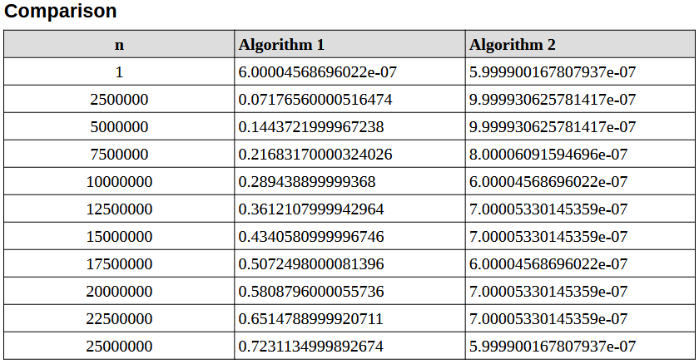

Graph Code :
import time
import matplotlib.pyplot as plt

# Time For Each Algorithm
sumAlgorithm1Time = []
sumAlgorithm2Time = []

plt.plot(inputList, sumAlgorithm1Time, label="Algorithm 1 (Loop)", color='blue')
plt.plot(inputList, sumAlgorithm2Time, label="Algorithm 2 (Formula)", color='red')

plt.xlabel("Value of n")
plt.ylabel("Time (seconds)")
plt.title("Comparison of Sum Algorithms")
plt.legend()
plt.show()
