Practical No 10

Aim : Write A Program To Demonstrate RESTFul API In Expess.js

(GET, POST, PUT, DELETE)

import express from "express"

const port = 4001

const app = express()
app.use(express.json())

let users = [
{
id: "user1",
username: "Ashif Shaikh",
class: "SY CS",
rollNo: 32
},
{
id: "user2",
username: "Arshad Shaikh",
class: "SY CS",
rollNo: 31
},
{
id: "user3",
username: "Farhan Shaikh",
class: "SY CS",
rollNo: 53
},
{
id: "user4",
username: "Raza Shaikh",
class: "SY CS",
rollNo: 49
},
{
id: "user5",
username: "Rounak Pal",
class: "SY CS",
rollNo: 46
},
{
id: "user6",
username: "Harish Pandey",
class: "SY CS",
rollNo: 24
},
{
id: "user7",
username: "Harsh Salvi",
class: "SY CS",
rollNo: 29
},
{
id: "user8",
username: "Sachin D. Jaiswal",
class: "SY CS",
rollNo: 16
},
{
id: "user9",
username: "Vaibhav Soyane",
class: "SY CS",
rollNo: 45
},
{
id: "user10",
username: "Mayur Suryavanshi",
class: "SY CS",
rollNo: 42
},
]

app.get("/", (req, res) => {
res.status(200).send("<h1>Home Page</h1>")
})

app.get("/users", (req, res) => {
res.status(200).json(users)
})

app.post("/users", (req, res) => {
const user = req.body
users.push(user)
res.status(201).json("User Added Successfull.")
})

app.put("/users", (req, res) => {
const user = req.body
users = users.filter((u) => u.id !== user.id)
users.push(user)
res.status(201).json("User Updated Succesfull.")
})

app.delete("/users", (req, res) => {
const id = req.body.id
users = users.filter((u) => u.id !== id)
res.status(201).json("User Deleted Succesfull.")
})

app.listen(port, () => {
console.log("server started")
})

GET
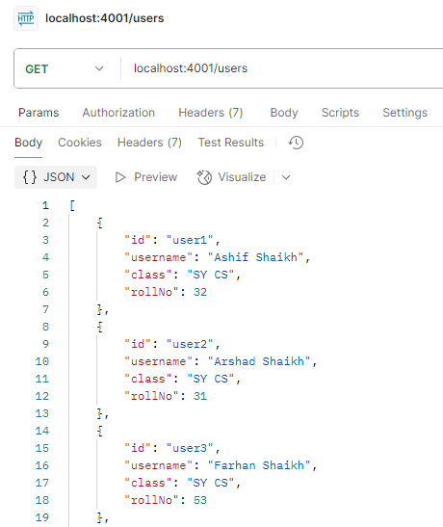
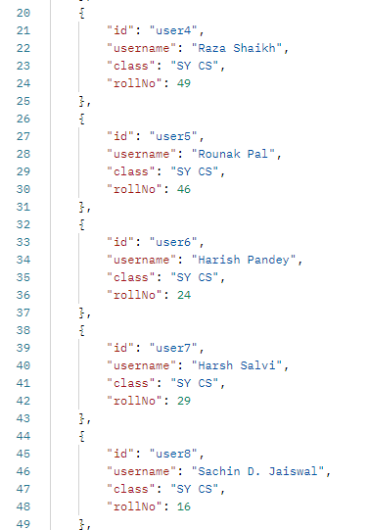

POST

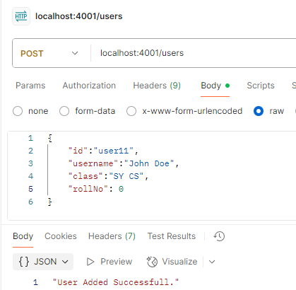
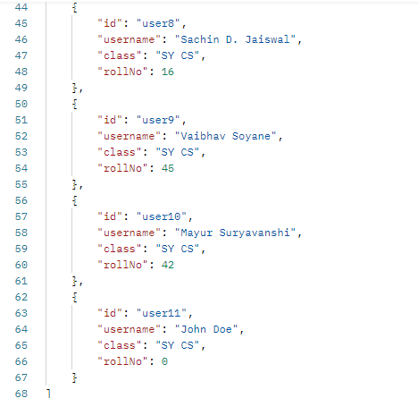

PUT
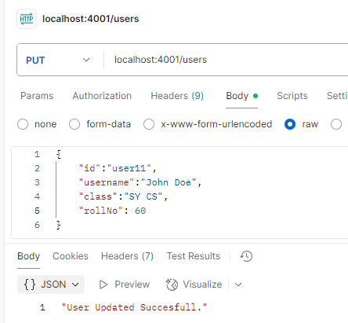
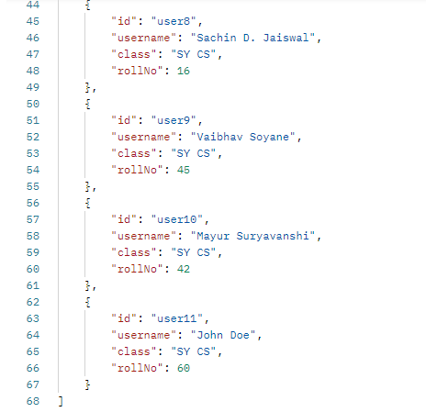

DELETE
