Practical No 14

Aim : To Study And Implement Schema And Models, Perform CRUD Operation And Demonstrate Validation And Indexing Techniques in MongoDB Using Mongoose
insertOne
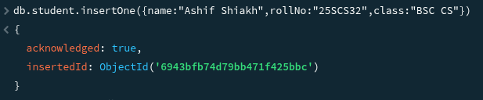
insertMany
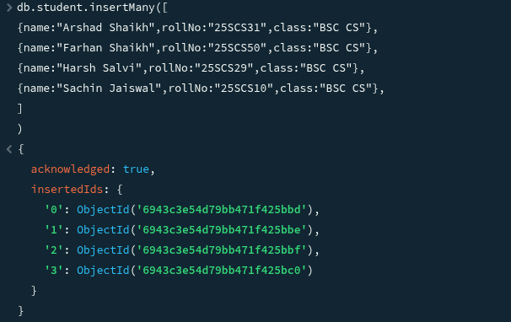
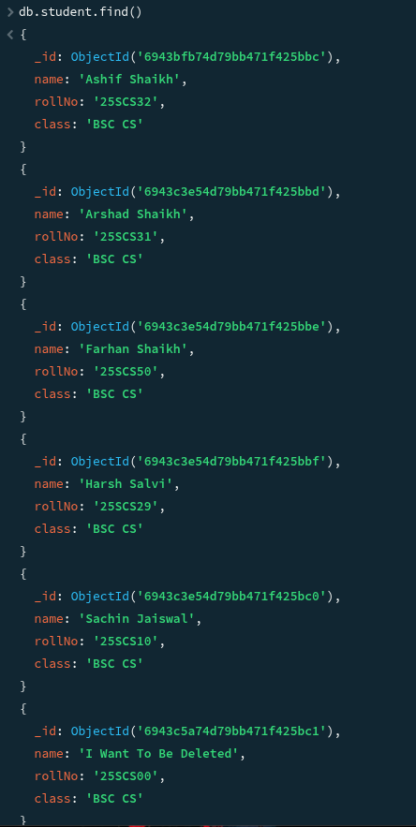
find

updateOne
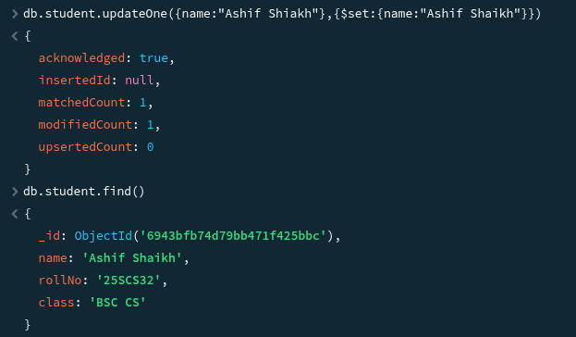
deleteOne
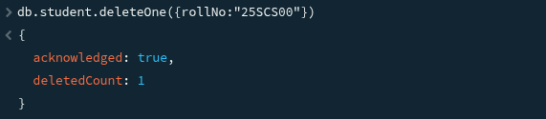
Before After
