Practical No 11

Aim : Write A Program To Demonstrate Organizing Express Application Using Express Router.
Project Structure Package.json
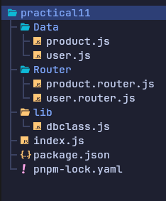
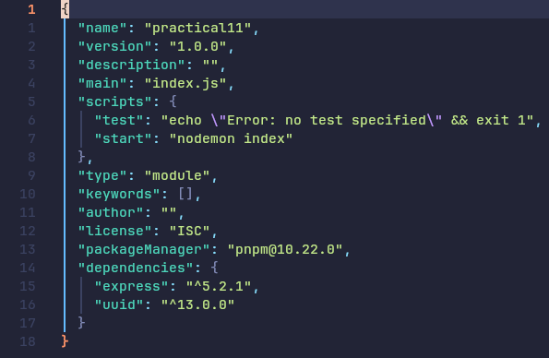

dbclass.js
import { v4 as uuidv4 } from "uuid"

export class Collection {

constructor() {
this.datas = []
}

insert(data) {
const newData = {
_id: uuidv4(),
...data
}
this.datas.push(newData)
return newData
}

findMany() {
return this.datas
}

findById(id) {
return this.datas.filter((e) => e._id === id)[0]
}

delete(id) {
this.datas = this.datas.filter((e) => e._id !== id)
return true
}

update(id, data) {
this.delete(id)
const newData = this.insert(data)
return newData
}
}
product.js
import { Collection } from "../lib/dbclass.js";
export const Product = new Collection;

user.js
import { Collection } from "../lib/dbclass.js";
export const User = new Collection();

product.router.js
import express from "express"
import { Product } from "../Data/product.js"

export const productRouter = express.Router()

// Get All Product
productRouter.get("/all", (req, res) => {
const products = Product.findMany()
res.status(200).json(products)
})

// Get Single Product By id
productRouter.get("/id/:id", (req, res) => {
const id = req.params.id
const data = Product.findById(id)
res.status(200).json(data)
})

// Create Product
productRouter.post("/create", (req, res) => {
const product = req.body
if (!product) return res.status(400).json({ message: "Invalid Data." })
const data = Product.insert(product)
res.status(201).json(data)
})

// Update Product
productRouter.put("/update/:id", (req, res) => {
const product = req.body
const id = req.params.id
const data = Product.update(id, product)
res.status(201).json(data)
})

// Delete Product
productRouter.delete("/id/:id", (req, res) => {
const id = req.params.id
const data = Product.delete(id)
if (data) return res.status(200).json({ message: "Product Deleted Successfully." })
res.status(400).json({ error: "Error Deleting Product." })
})

user.router.js
import express from "express"
import { User } from "../Data/user.js"

export const userRouter = express.Router()

// Get All User
userRouter.get("/all", (req, res) => {
const users = User.findMany()
res.status(200).json(users)
})

// Get Single User By id
userRouter.get("/id/:id", (req, res) => {
const id = req.params.id
const data = User.findById(id)
res.status(200).json(data)
})

// Create User
userRouter.post("/create", (req, res) => {
const user = req.body
if (!user) return res.status(400).json({ message: "Invalid Data." })
const data = User.insert(user)
res.status(201).json(data)
})

// Update User
userRouter.put("/update/:id", (req, res) => {
const user = req.body
const id = req.params.id
const data = User.update(id, user)
res.status(201).json(data)
})

// Delete User
userRouter.delete("/id/:id", (req, res) => {
const id = req.params.id
const data = User.delete(id)
if (data) return res.status(200).json({ message: "User Deleted Successfully." })
res.status(400).json({ error: "Error Deleting User." })
})

index.js
import express from "express"; import { userRouter } from "./Router/user.router.js";
import { productRouter } from "./Router/product.router.js";

const PORT = 4000;

const app = express();

app.use(express.json())

app.use("/api/user", userRouter)
app.use("/api/product", productRouter)

app.listen(PORT, () => {
console.log("Server Started.")
})

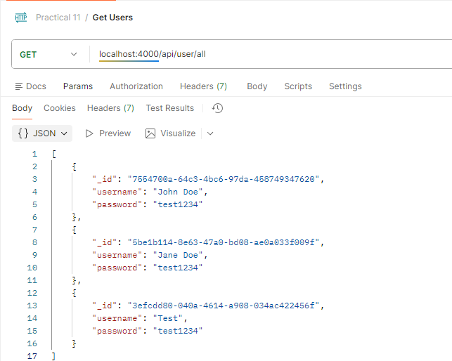
User Router
Get All User

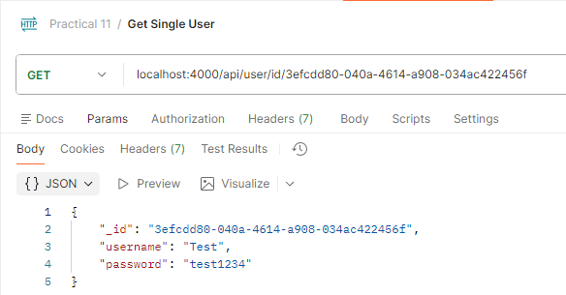
Get Single User

Create User
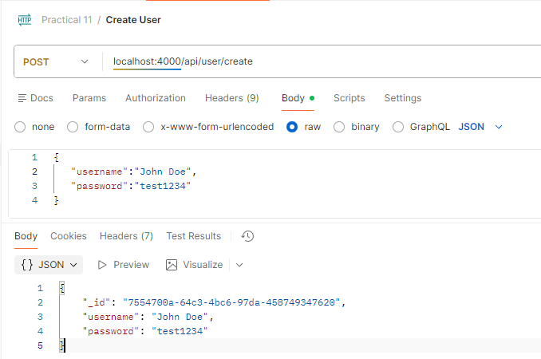
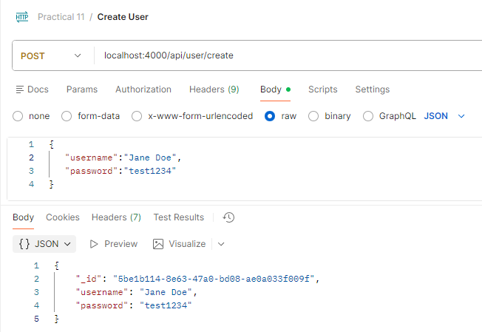

Update User
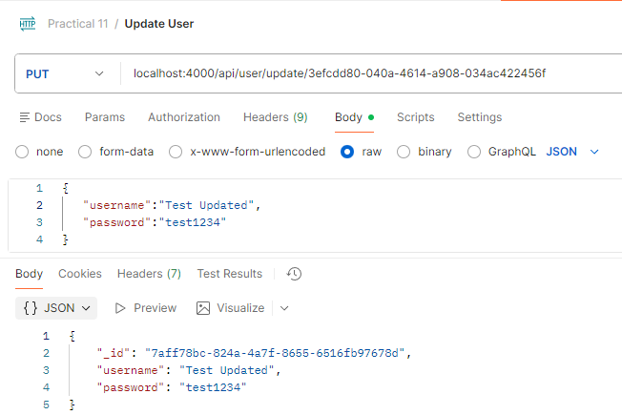
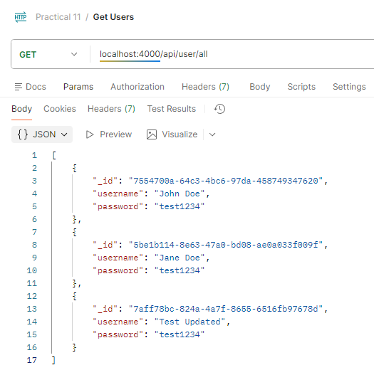

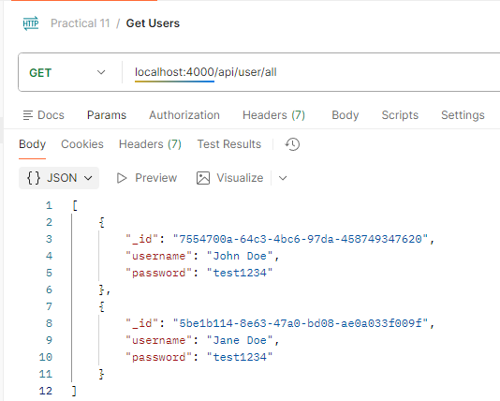
Delete User
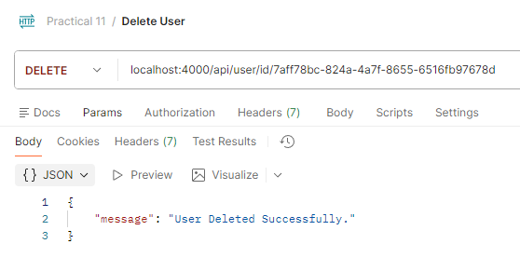

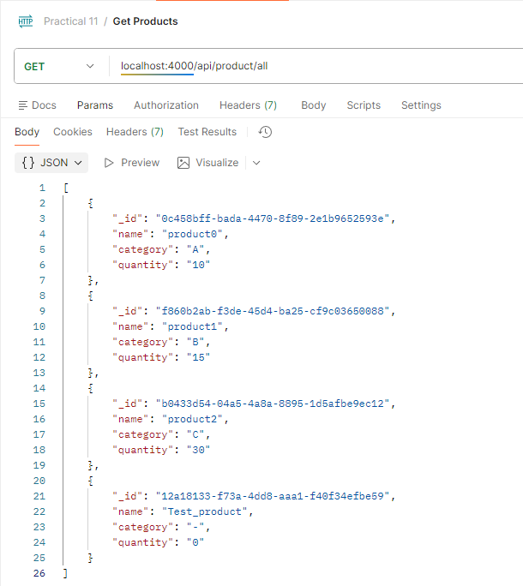
Product Router
Get All Product

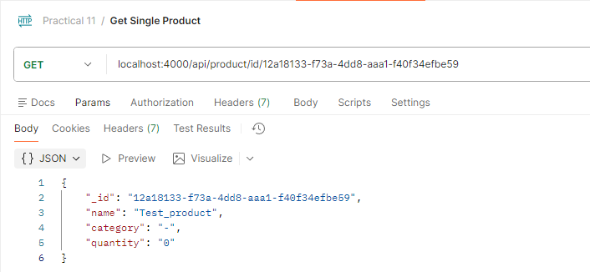
Get Single Product

Create Product
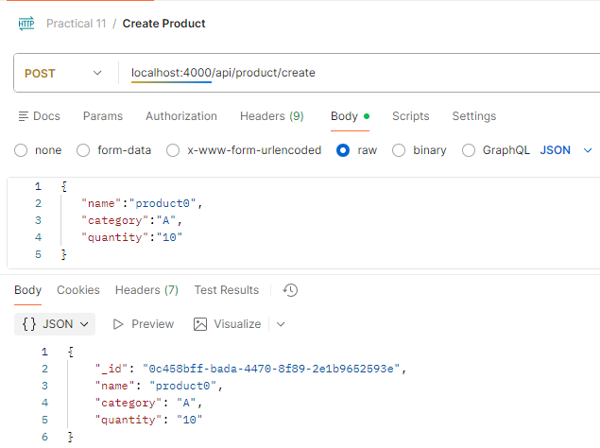
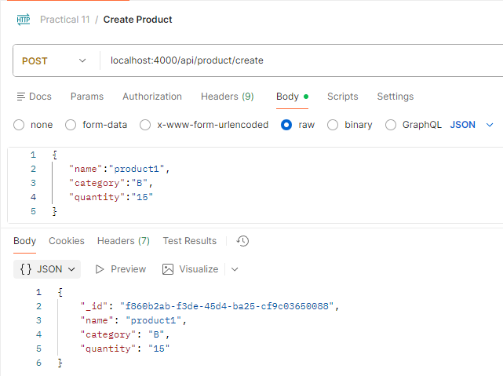
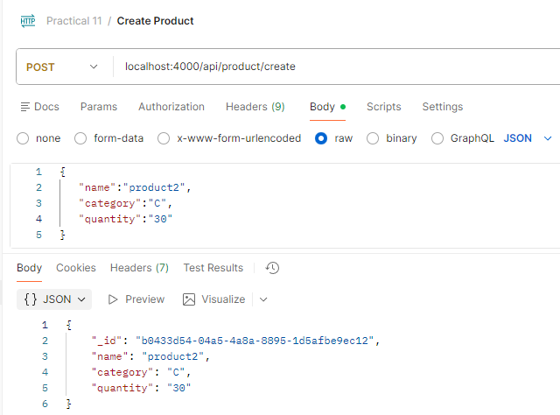

Update Product
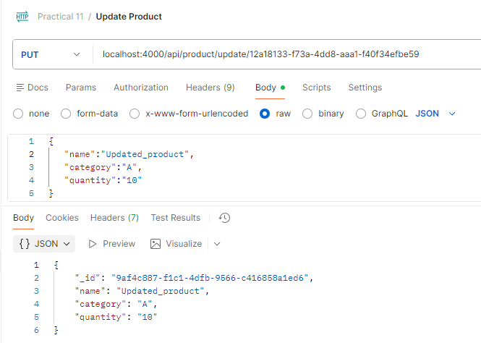
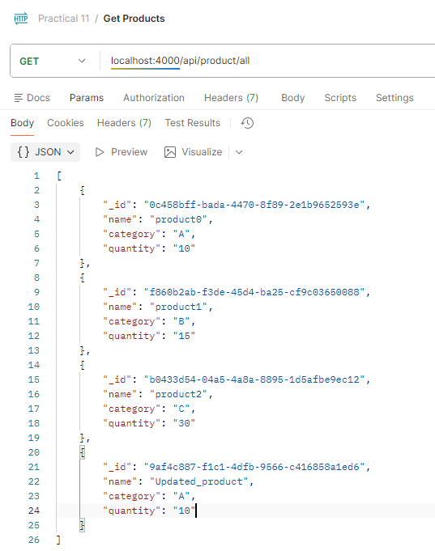

Delete Product
