Practical No 2

Aim : Write a Program to demonstrate creation and understanding of package.json and usage of npm
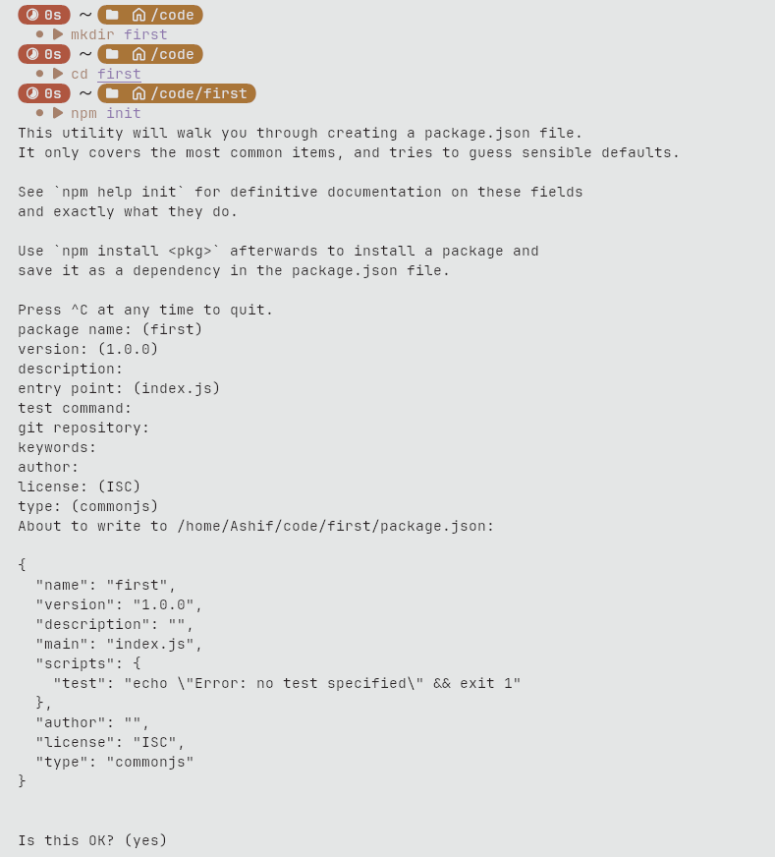
Terminal

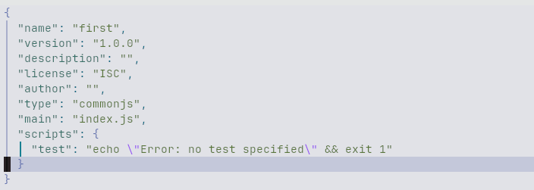
package.json

