Angular Form
Project Structure
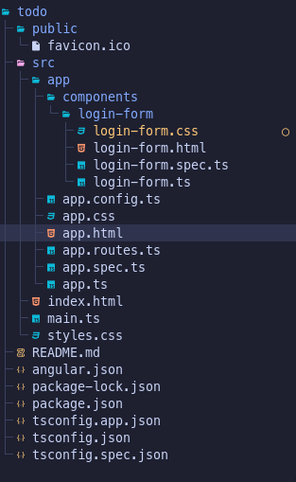

Terminal
ng g c components/login-form

app.html
<app-login-form>
login-form.ts
import { Component } from '@angular/core';
import { FormControl, FormGroup, ReactiveFormsModule } from '@angular/forms';

@Component({
selector: 'app-login-form',
imports: [ReactiveFormsModule],
templateUrl: './login-form.html',
styleUrl: './login-form.css',
})
export class LoginForm {
loginForm = new FormGroup({
firstName: new FormControl(""),
lastName: new FormControl(""),
email: new FormControl(""),
password: new FormControl("")
})

handleSubmit() {
console.log(this.loginForm.value);
alert(`Hey ${this.loginForm.value.firstName}, Your Is Form Submitted Successfully, Details In Console`)
this.loginForm.reset()
}
}
login-form.html
<div class="login-form-container">
<form [formGroup]="loginForm" (ngSubmit)="handleSubmit()">
<h1 class="login-header">LOGIN FORM </h1>
<div>
<label class="login-label" for="firstName">First Name </label>
<input class="login-input" type="text" name="firstName" formControlName="firstName">
</div>
<div>
<label class="login-label" for="lastName">Last Name </label>
<input class="login-input" type="text" name="lastName" formControlName="lastName">
</div>
<div>
<label class="login-label" for="email">Email</label>
<input class="login-input" type="text" name="email" formControlName="email">
</div>
<div>
<label class="login-label" for="password">Password </label>
<input class="login-input" type="password" name="password" formControlName="password">
</div>
<button class="login-submit" type="submit">Submit</button>
</form>

</div>
login-form.css (Optional)
.login-form-container {
border: 1px solid teal;
border-radius: 1rem;
padding: 1rem;
width: 50vh;
height: 70vh;
margin: auto;
background: #f0fdfa;
box-shadow: 4px 4px teal;
}

.login-header {
font-size: 3rem;
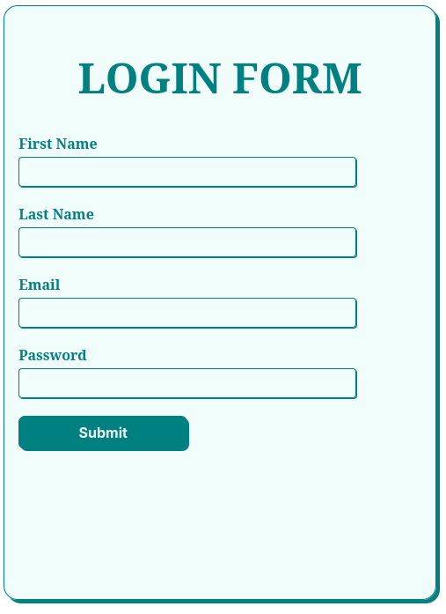
text-align: center;
color: teal;
}

.login-label {
font-weight: 700;
color: teal;
display: block;
margin-top: 1rem;
}

.login-input {
outline: none;
border: 1px solid teal;
border-radius: 4px;
padding: 0.5rem;
margin: 0.25rem 0;
width: 80%;
box-shadow: 1px 1px teal;
background: inherit;
}

.login-submit {
background: teal;
color: aliceblue;
outline: none;
padding: 0.5rem 1rem;
border: 1px solid teal;
border-radius: 0.5rem;
box-shadow: 2px 2px teal;
width: 12rem;
font-weight: 700;
font-size: 1rem;
margin: 1rem auto;
}

