Practical No 1

Aim : Steps For Installing Angular CLI.
1. Node on system
2. npm for downloading angular cli.
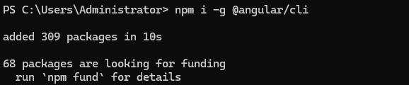

3. check angular cli.
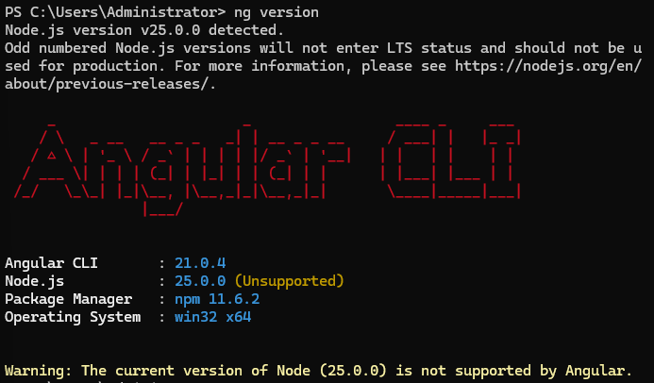
4. creating angular application.
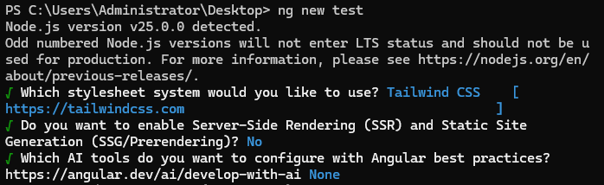
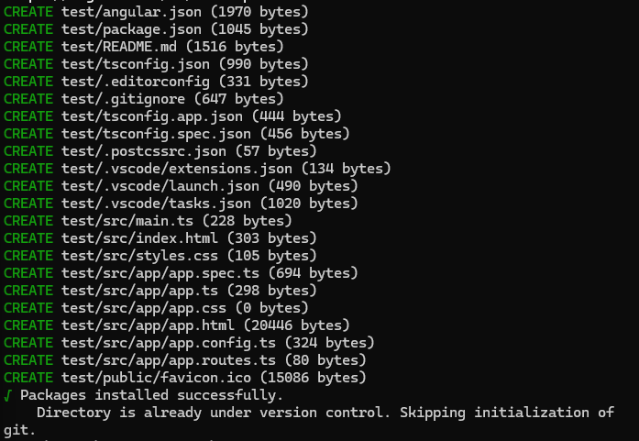
5. angular project structure.
