Practical No 3

Aim : Write A Program To Implement Routing In Angular Using Router Link And Router Outlet.
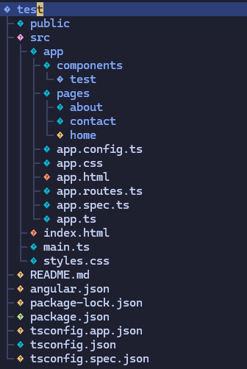

app.route.ts
import { Routes } from '@angular/router';
import { Home } from './pages/home/home';
import { Contact } from './pages/contact/contact';
import { About } from './pages/about/about';

export const routes: Routes = [
{
path: "",
component: Home
},
{
path: "about",
component: About
},
{
path: "contact",
component: Contact
}
];

app.html
<app-test/>
<router-outlet />
test.html
<nav class="flex items-center justify-between p-3">
<p class="text-2xl text-teal-600">Website Name</p>
<ul class="flex gap-3">
<li><a routerLink="/">Home</a></li>
<li><a routerLink="/about">About</a></li>
<li><a routerLink="/contact">Contact</a></li>
</ul>
</nav>

