**LAB-2**

**AIM -** To Create a web-page using HTML , CSS and JavaScript.

**WORKING**:

**STEP-1:** Open Visual Studio Code on Your Desktop and make a new folder of LAB-4, then create a HTML and CSS file there.

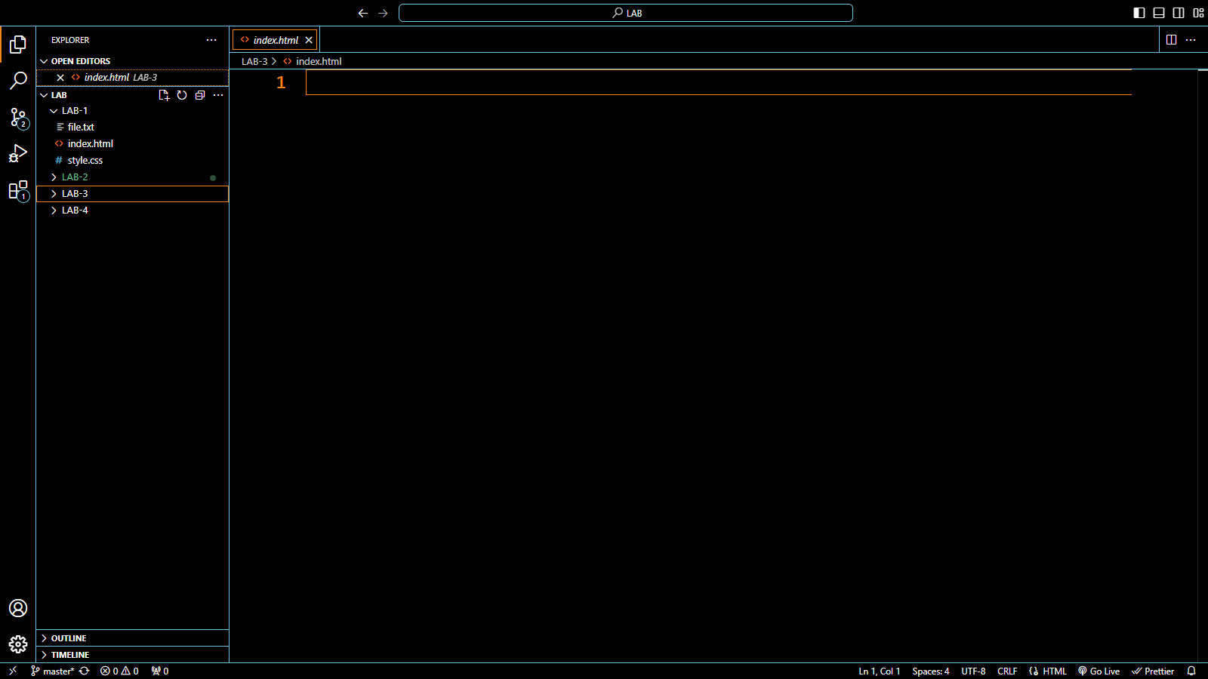

**STEP-2:** Write the HTML code for the navbar on Visual Studio .

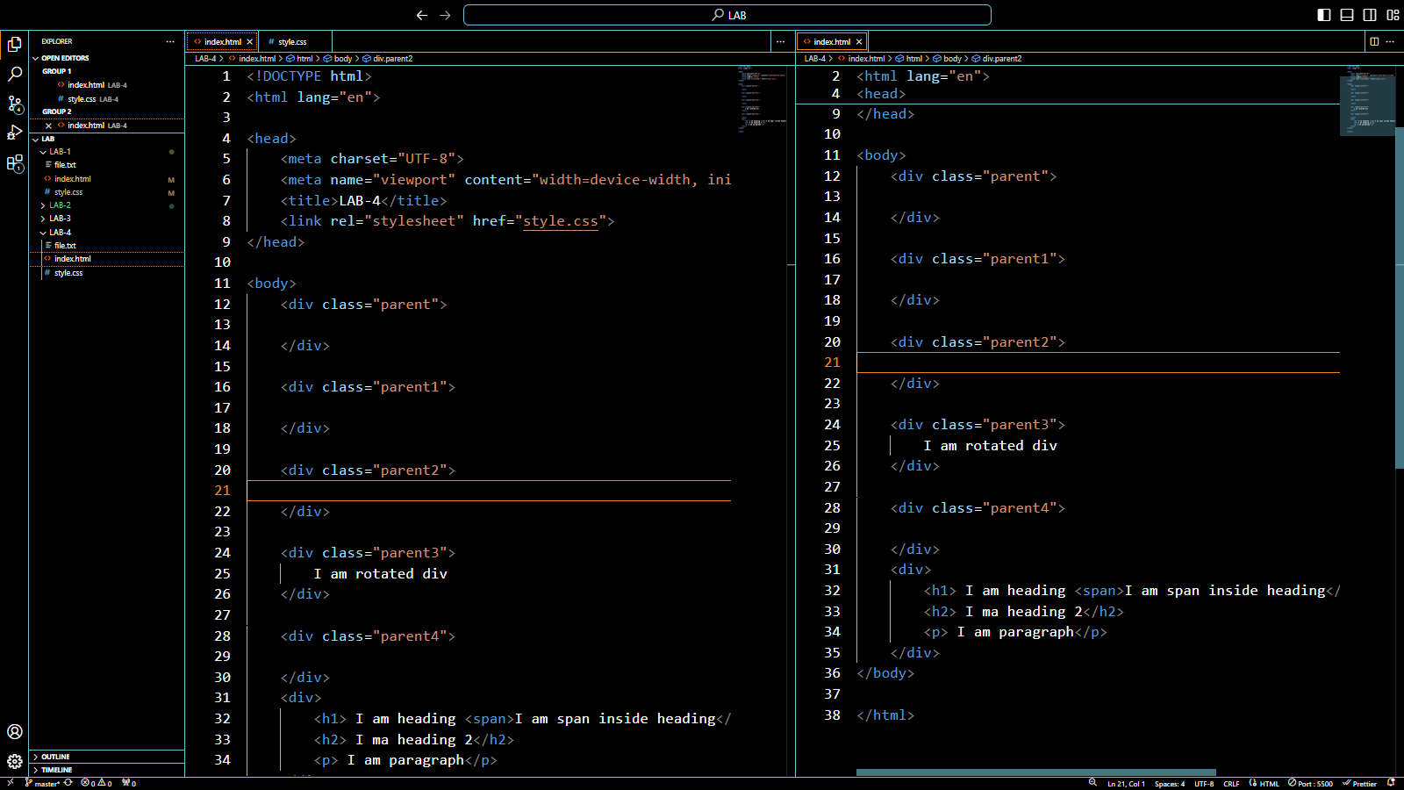

**STEP-3:** Write the CSS code for the same.

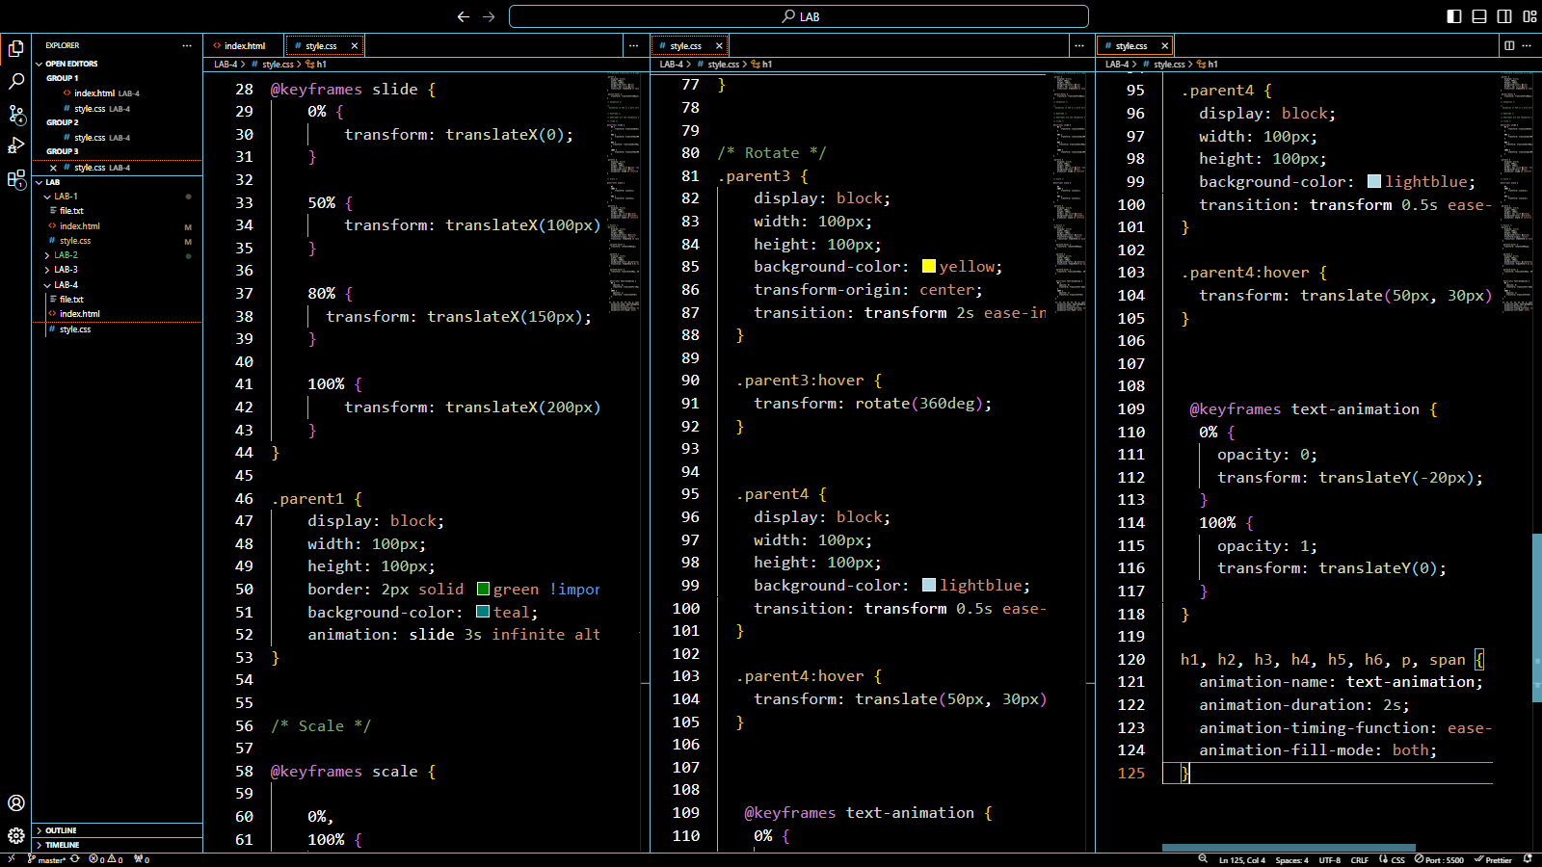

**STEP-4:** Save Both the Code and go live.

