**BLACK-KING**

**FRIENDS, I GREET YOU ALL*!***

**GET INFO: chat or call +234 916 305 3787**

**https://t.me/Black_king207**

**Today I will tell you about the main figures on:** **Order block Vs Supply and demand**

**Let start with:** **order block**

An order block represents a change in the state of delivery in the market. It is not simply every down-closed or up-closed candle. Order blocks act as a bookmark in price. A high probability ob takes liquidity & creates an FVG

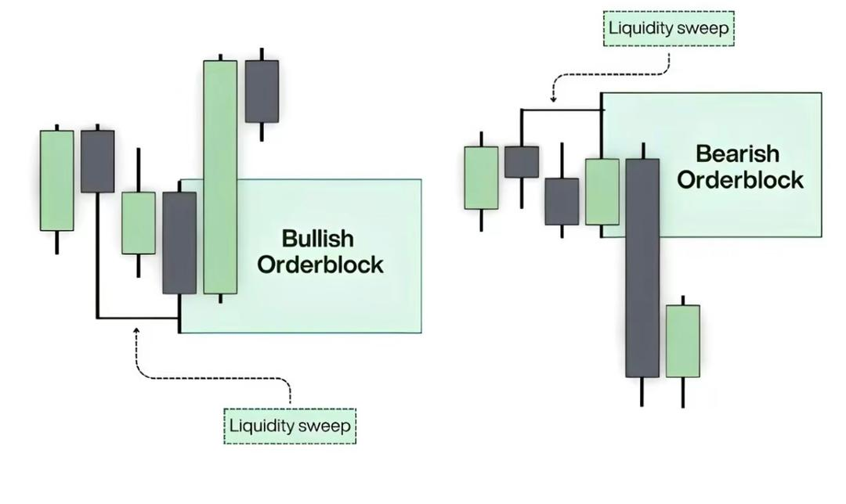

**Supply & Demand:**

Areas where there is excess of Sellers which causes price to drop. This happens when Supply Exceeds Demand. This is where selling interest or potential is the highest.

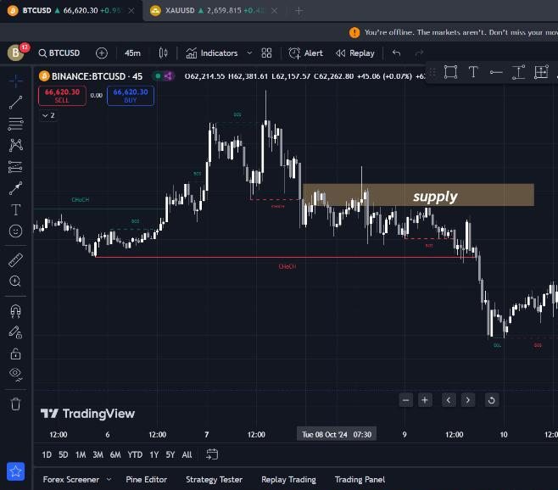

**OR**

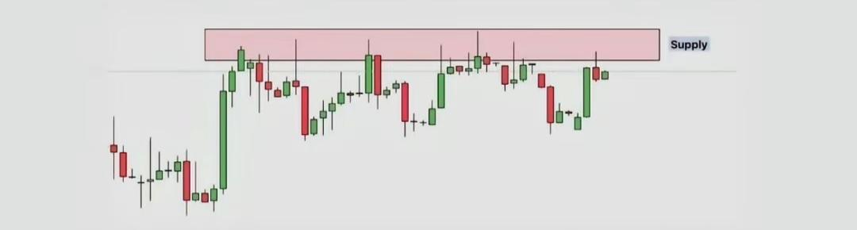

Areas where there is excess of Buyers which causes price to rise. This happens when Demand Exceeds Supply. This is where buying interest or potential is the highest.

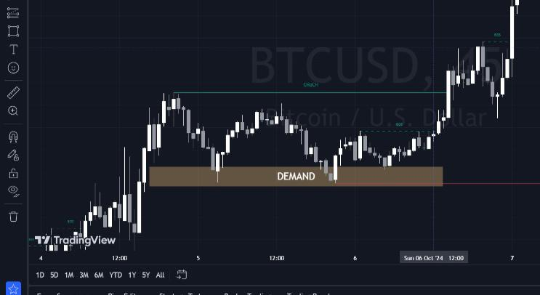

**OR**

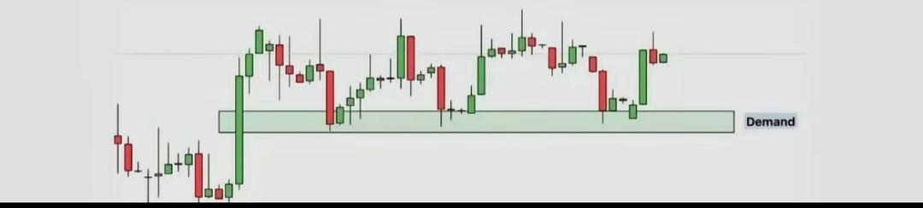

Bullish and bearish order blocks are closely related to the concepts of supply and demand in forex trading because they both represent areas where a significant imbalance between buying and selling pressure exists**.**

**ORDERBLOCK VS SUPPLY**

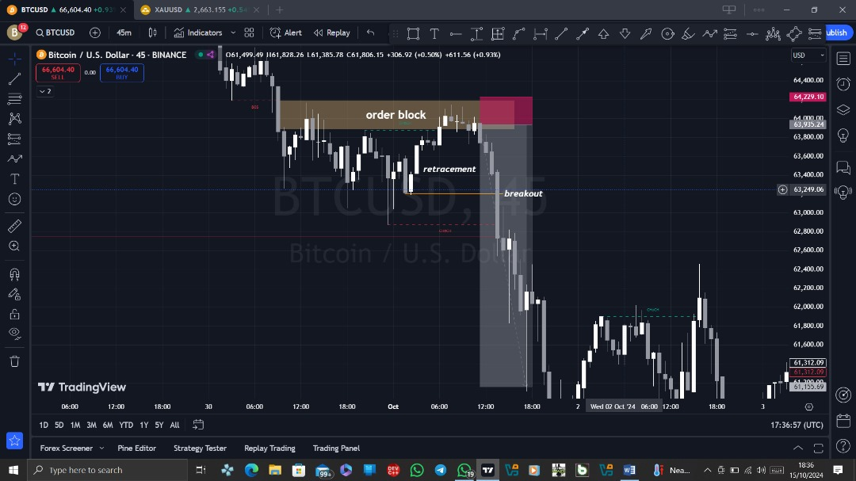

Relationship between Bullish and Bearish Order Blocks and Supply and Demand:

• Both order blocks and supply and demand zones are used to find potential entry and exit points in trading and are based on the idea of price imbalances.

• They can often overlap; a supply zone might contain a bearish order block, and a demand zone might contain a bullish order block

Reasons Why Order Blocks and Supply and Demand Are Not the Same:

Order Block: Identified by certain price patterns, such as large bullish or bearish candles, that signal strong institutional buying or selling. These blocks are often found at the origin of sharp price movements. Used by traders to follow the potential actions of institutions, aiming to align with "smart money." Traders use order blocks to enter trades where they believe institutions are accumulating (buying) or distributing (selling).

• Supply and Demand Zones: Identified by areas where the price has historically turned around or paused, indicating a high level of buying (demand) or selling (supply) pressure.

They are often wider areas on a price chart rather than specific levels.

Used by traders to identify areas where the market might reverse or continue, regardless of who is trading. These zones are considered key support or resistance areas where price reactions are likely.

**HEADANDSHOULDERS**

Head and Shoulders is a candlestick combination that consists of 4 elements-left shoulder, head and right shoulder, formed price highs, and the neckline, which is the support line for them.

In this case, the left and right shoulders are approximately at the same level, the head is above the left and right shoulders.

To make it clearer let's look at it with an example.

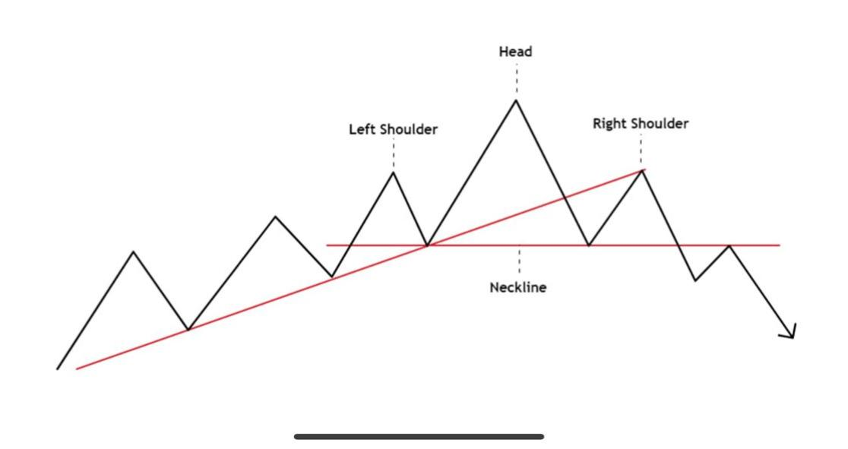

OR

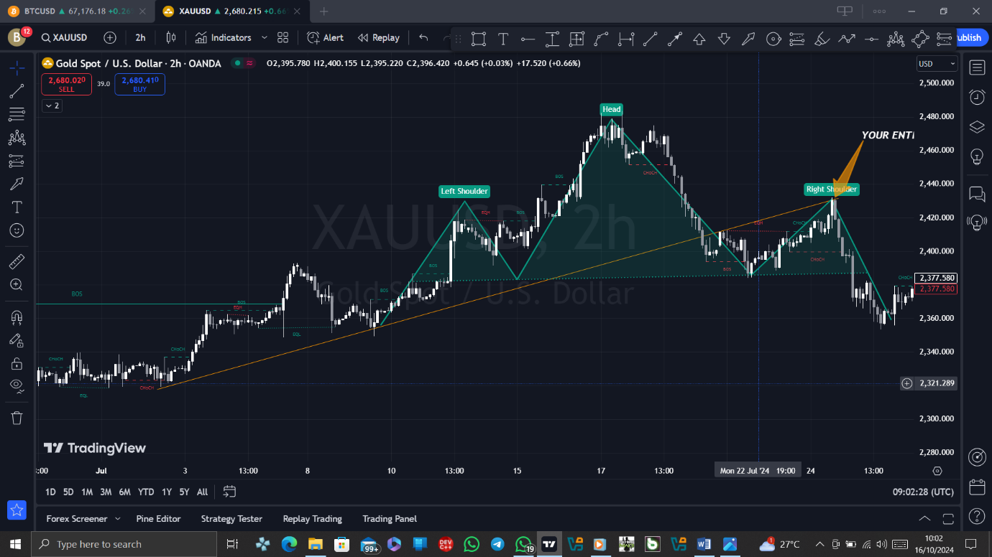

**INVERTED HEAD AND SHOULDERS**

The Inverted Head and Shoulders is a similar formation, but turned upside down. In this case, the head should be below the shoulders.

An inverted H&S is formed on a downtrend and reverses it in an upward direction. All rules for forming and opening positions are saved as a mirror image.

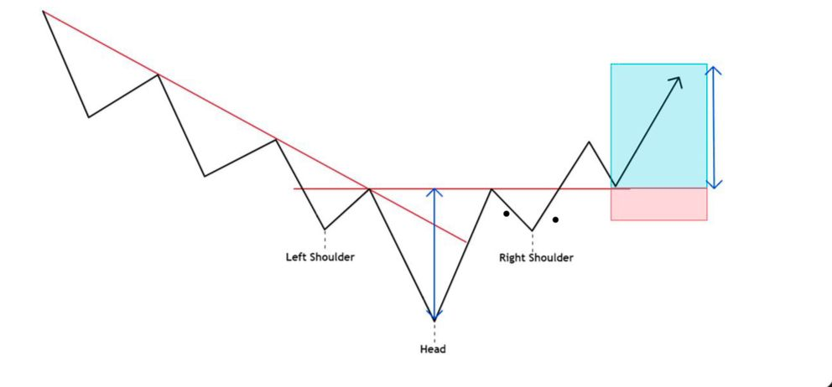

**A *trendline breakout trading strategy**\* is a popular technique used by traders to identify potential price reversals or continuations based on the breaking of trendlines. The basic idea is that a price break through a significant trendline (either upward or downward) signals a shift in market momentum, potentially indicating a strong buying or selling opportunity.

**Key Components of a Trendline Breakout Strategy:**

1. *Identifying the Trendline:*

- A *trendline* is drawn by connecting two or more swing highs (for a downward trendline) or swing lows (for an upward trendline).

- The more points the trendline touches, the more significant it becomes.

- Use higher time frames (like 4-hour or daily charts) to draw trendlines to filter out market noise.

2. *Breakout Confirmation:*

- A *breakout* occurs when the price closes beyond the trendline (either above or below, depending on the trend).

- Look for a *close* beyond the trendline, rather than just a touch or intraday break, to avoid false breakouts.

- Confirm with volume: High trading volume during the breakout adds confidence that the move is legitimate.

3. *Entry Point:*

- After the trendline is broken, you can enter the trade:

- *Aggressive Entry*: Enter immediately after the breakout candle closes.

- *Conservative Entry*: Wait for a retest of the broken trendline, which often acts as a support or resistance level after the breakout.

4. *Stop Loss Placement:*

- Place the *stop loss* just outside the trendline:

- For a *bullish breakout*, place the stop loss below the trendline or the most recent swing low.

- For a *bearish breakout*, place the stop above the trendline or the most recent swing high.

- This protects you from false breakouts and reduces potential losses.

5. *Take Profit Targets:*

- Use a *risk-reward ratio* of at least 1:2 or higher. For example, if you risk $100, aim to make at least $200.

- You can also use previous support/resistance levels or Fibonacci extensions to set your profit targets.

- Some traders use *trailing stops* to lock in profits as the trade moves in their favor.

6. *Additional Confirmation Indicators (optional):*

- To increase the probability of a successful breakout, traders often use additional indicators like:

- *RSI (Relative Strength Index)*: Look for overbought/oversold levels to confirm momentum.

- *MACD (Moving Average Convergence Divergence)*: Signals potential trend reversals.

- *Volume*: A spike in volume can confirm the strength of the breakout.

**Example of a Trendline Breakout Strategy:**

1. *Uptrend Breakout Example (Bullish)*

- Identify a *downward trendline* by connecting swing highs in a corrective move.

- Wait for a strong *bullish breakout candle* to close above the trendline.

- Enter the trade when the candle closes.

- Place a *stop loss* below the broken trendline.

- Set a *profit target* at the next significant resistance level or based on a risk-reward ratio.

2. *Downtrend Breakout Example (Bearish)*

- Identify an *upward trendline* by connecting swing lows in an uptrend.

- Wait for a *bearish breakout* candle to close below the trendline.

- Enter the trade after the candle closes below the trendline.

- Place a *stop loss* just above the broken trendline.

- Set your *profit target* at a previous support level or using a risk-reward ratio.

Key Considerations:

- *False Breakouts*: Be cautious of false breakouts where price temporarily breaches the trendline but then reverses. Confirm breakouts with volume or other indicators.

- *Timeframes*: Higher time frames (4-hour, daily, or weekly) provide stronger and more reliable trendlines, while shorter timeframes may lead to more false signals.

- *Market Conditions*: Trendline breakout strategies work best in trending markets. In a range-bound or sideways market, breakouts may be less reliable.

**Conclusion:**

The trendline breakout strategy is straightforward but powerful, offering clear buy/sell signals based on price action. Combining this method with other technical indicators can improve its reliability and help you better manage risk in your trades.

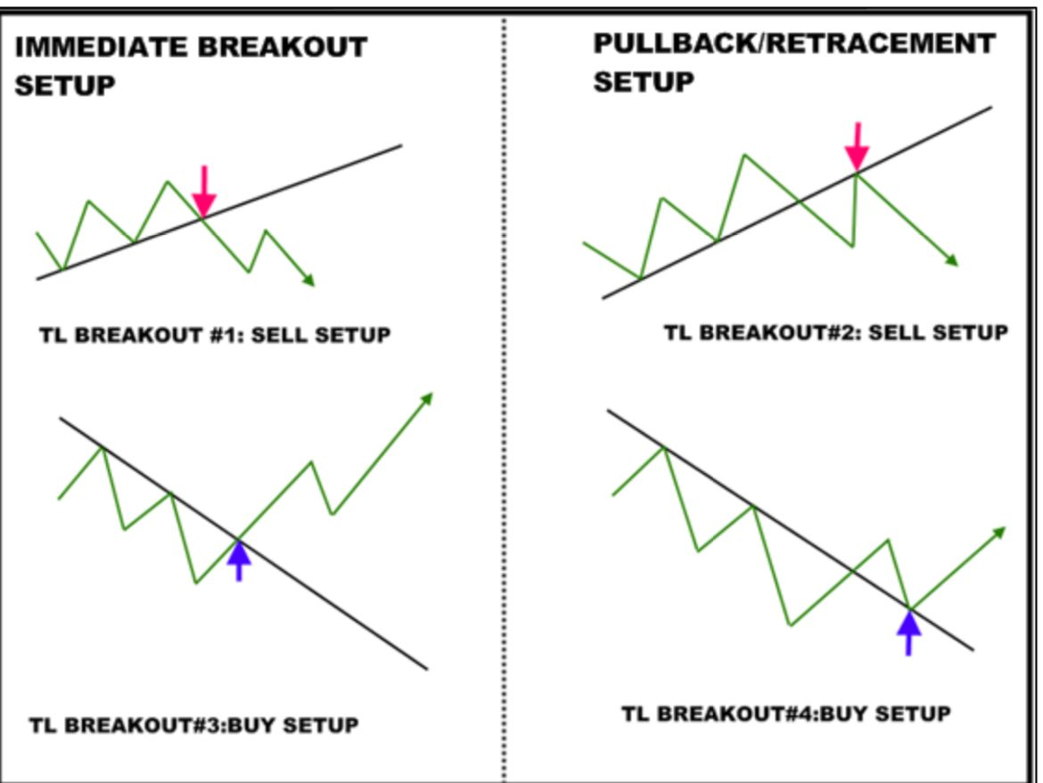

OR

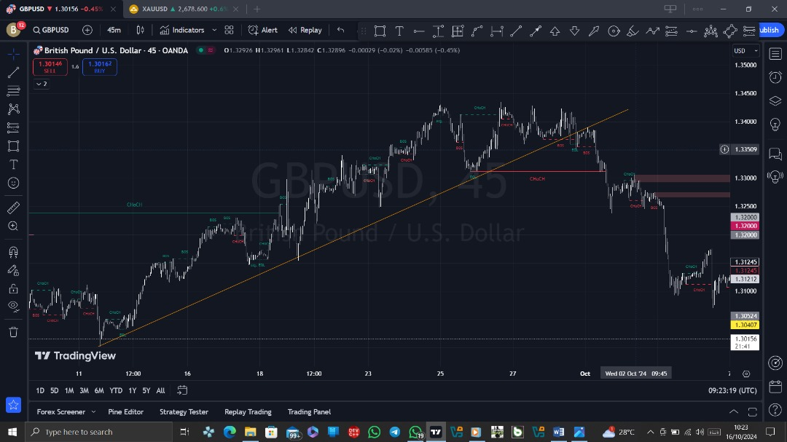

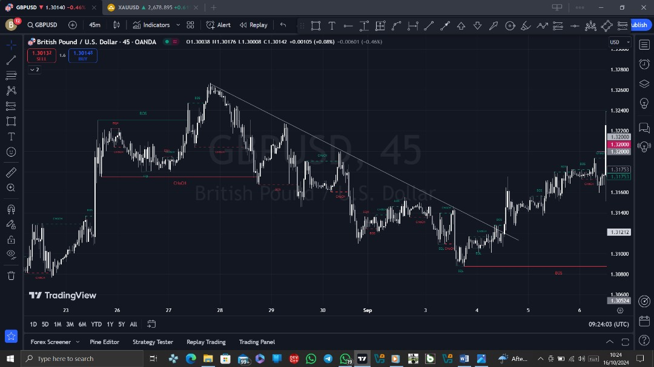

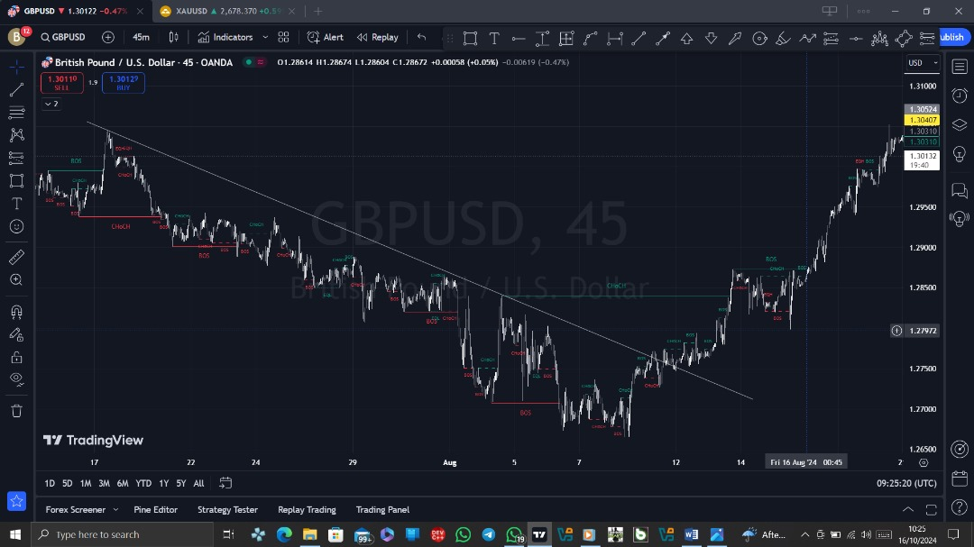

Thank you.