July 2, 2018

CERTIFIED MAIL
RETURN RECEIPT

Mr. Edward Ascione
Wexford County Landfill
990 US Highway 131
Manton, Michigan 49663

Dear Mr. Ascione:

SUBJECT: Groundwater Discharge Permit No. GW1010342
Designated Name: Wexford County Landfill

Enclosed is a copy of the termination statement for Groundwater Discharge Permit No. GW1010342, issued to the Wexford County Landfill, located at 990 US 131, Manton, Michigan 49663. Groundwater Discharge Permit No. GW1010342 was terminated on July 2, 2018. If you have any questions or concerns, please contact me at 616-710-2139; simmonsd@michigan.gov; or at the address below.

Sincerely,
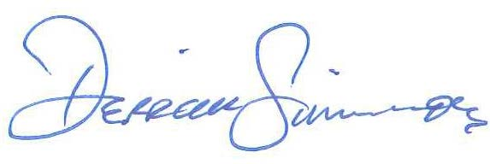
Derrick K. Simmons, R.S., R.E.H.S.
Senior Environmental Quality Analyst

dks/llr

Enclosure: Termination Document

cc: Mr. J.J. Jones – Permits Section, WRD, DEQ (via email)
Ms. Sherry Thelen – Groundwater Permits Unit, WRD, DEQ (via email)

