



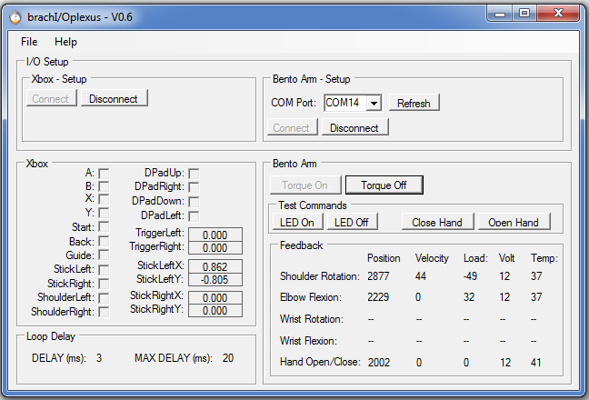

User Manual

Michael R. Dawson

April 17, 2017



Table of Contents

brachI/Oplexus User Manual 3

1.1 Introduction 3

1.2 System Requirements 3

1.3 Installation Instructions 4

1.3.1 Install brachI/Oplexus software 4

1.3.2 Install Xbox Drivers 7

1.3.3 Install USB2dynamixel Drivers 9

1.4 Setup the Bento Arm 10

1.5 Running the Software 10

1.6 Modifying the Software 14

1.6.1 Development Environment 14

1.6.2 Libraries and Interfaces 15

1.6.3 Source code 15

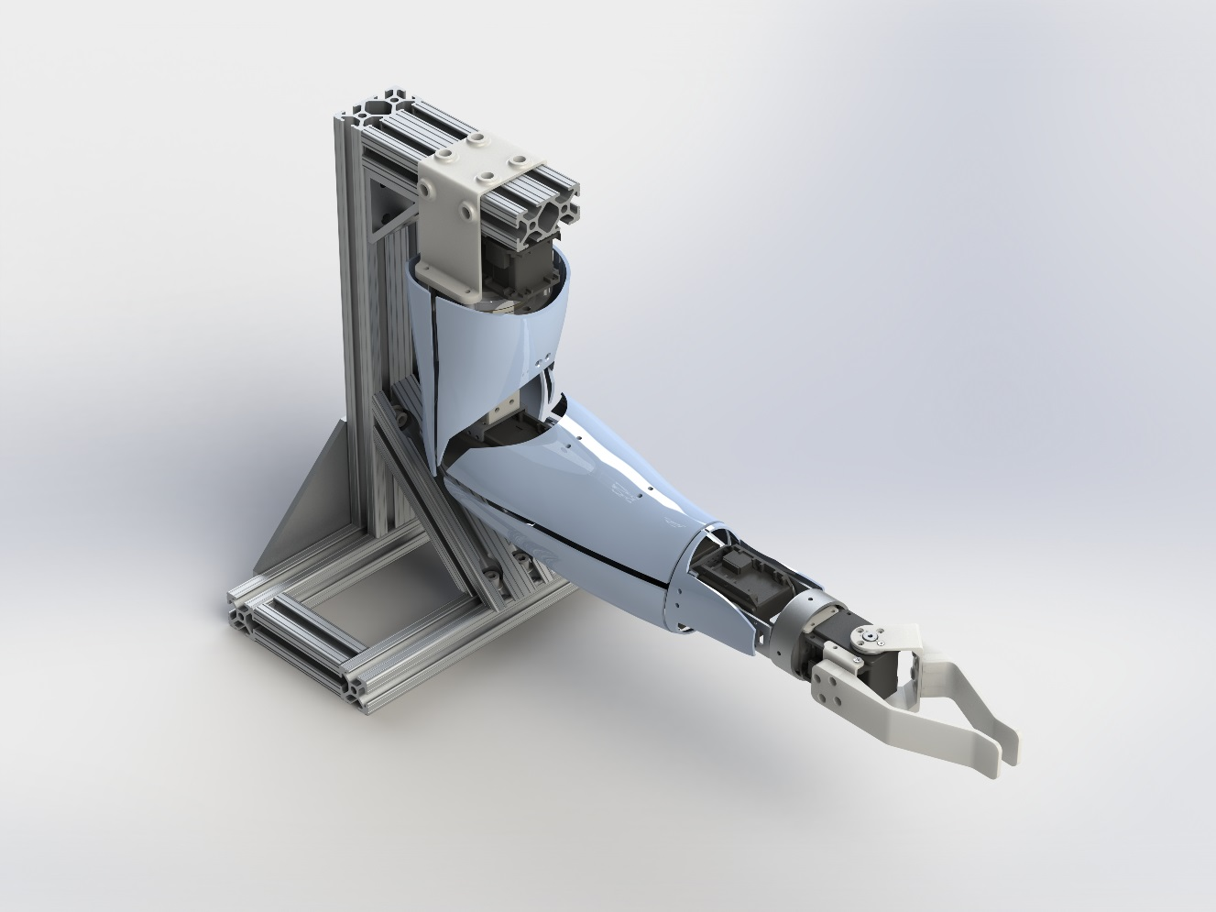

# brachI/Oplexus User Manual

## Introduction

This guide will help you from start to finish with installing and operating the brachI/Oplexus software. The purpose of the software is to act as a digital nerve center for connecting human interfaces to robotic arms. The initial release of this software includes support for controlling our open source robotic platform - [The Bento Arm](https://blincdev.ca/the-bento-arm/overview/) – with an Xbox 360 controller. Future releases will include additional human interfaces and robotic arms.

NOTE: brachI/Oplexus is pronounced 'brack-I-O-plexus' and is inspired by the anatomical term 'brachial plexus' which is the main network of nerves that connects the brain and spinal cord to your arm.

## System Requirements

Supported Operating Systems

* Windows 7
* Windows 10 (untested)

Hardware Requirements

* 1.6 GHz or faster processor
* 2 GB of RAM
* 1 MB of available hard disk space

Required I/O (input/output) devices

* Xbox 360 controller (wired)
  + Rock Candy Wired Controller for Xbox 360 (037-010)
  + Afterglow Wired Controller for Xbox 360 (PL-3702)
* The Bento Arm v3
  + Open source files for 3D printing and assembling the Bento Arm are available here: <https://github.com/blincdev/Bento-Arm-Hardware>
* 12V/12.5A Power Supply
  + Inventus Power [MWA150012A-12A](https://www.digikey.ca/product-detail/en/MWA150012A-12A/EPS437-ND/2000813)
* Power Harness Cable for Dynamixel motors
  + Open source instructions for creating the cables can be found in the [Bento Arm Assembly Guide](https://github.com/blincdev/Bento-Arm-Hardware/blob/master/Bento%20Arm%20-%20Assembly%20Guide.pdf) section 1.5 page 11
* USB Extender Cable
* ROBOTIS USB2dynamixel
  + Manual available [here](http://support.robotis.com/en/product/auxdevice/interface/usb2dxl_manual.htm)

## Installation Instructions

### Install brachI/Oplexus software

1. Download the latest release from github: <https://github.com/blincdev/brachIOplexus>
2. Extract the installation files to a temporary folder
3. Double click on ‘setup.exe’ to start the installation
4. The setup will prompt you to install the ‘Visual C++ 2015 Redistributable Update 3 (x86)’ which is one of the required libraries. Click ‘Install’

download big image png medium image png small image png microsoft 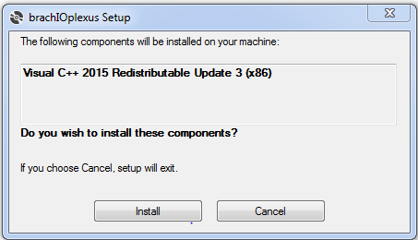

1. The Microsoft Visual Studio C++ 2015 Redistributable (x86) installer will launch and prompt you to either install (if you don’t already have it installed) or repair (if you already have it installed). Click ‘Install” or ‘Repair’ to continue. NOTE: an internet connection is required for this step in order to access the redistributable

download big image png medium image png small image png microsoft 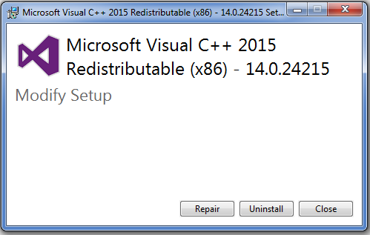

1. If may prompt with a user account control window asking ‘Do you want to allow the following program to make changes to this computer. Program Name: VC_redist.x86.exe’ Click ‘yes’
2. After installing it should say that setup was successful and ask you to restart the computer. Make sure to save and close any other files or programs that may be open and then click ‘Restart’.

download big image png medium image png small image png microsoft 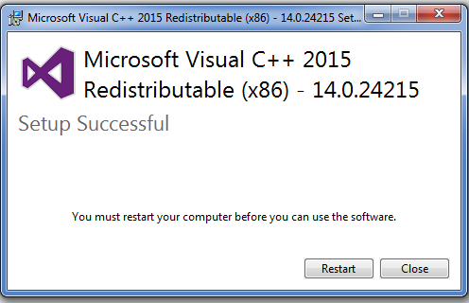

1. After restarting and waiting for everything to boot up the installation should continue. The Microsoft Visual C++ 2015 Redistributable may pop up again. If it does click ‘Repair’
2. If may prompt with a user account control window asking ‘Do you want to allow the following program to make changes to this computer. Program Name: VC_redist.x86.exe’ Click ‘yes”
3. If everything installs correctly it should now prompt you that the redistributable setup has been successful. Click ‘Close’.

download big image png medium image png small image png microsoft 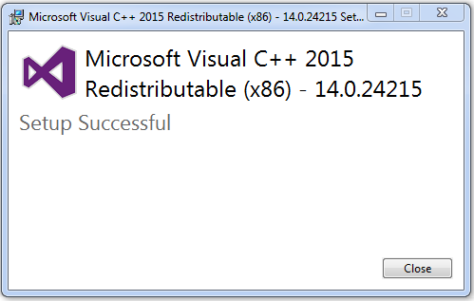

1. The rest of the installation can now resume. A window should pop up with a security warning for the brachI/Oplexus software. This is expected since we are not at this time able to register as a known publisher. Click ‘Install’ to continue.

download big image png medium image png small image png microsoft 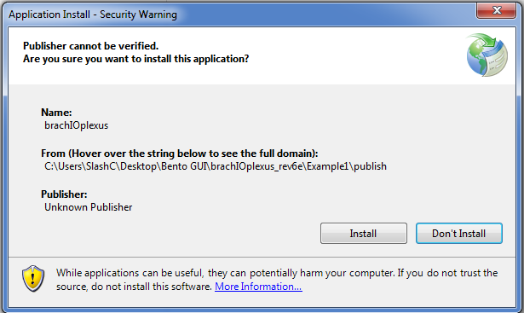

1. The installer should now finish up and launch the program. If the program opens successfully and looks similar to the image below then the installation has completed successfully!

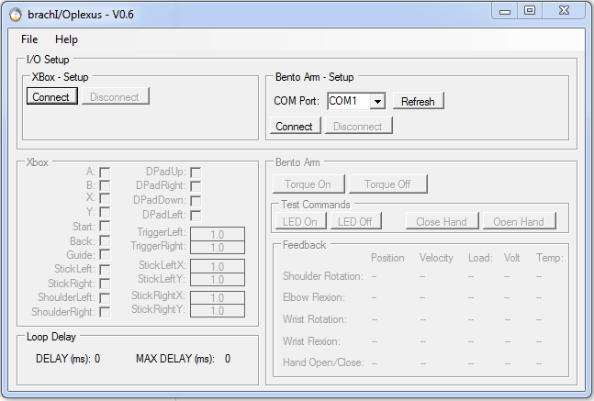

1. To open the brachI/Oplexus program in the future you can either go ‘start 🡪 all programs 🡪 BLINCdev 🡪 brachIOplexus’ or double click on the shortcut on your desktop labelled ‘brachIOplexus’.
2. For instructions on operating the software please see section 2.

### Install Xbox Drivers

1. Plug the Xbox controller into the USB port on your computer
2. Windows should automatically try to install drivers for the controller
3. Open the brachI/Oplexus software and click on the ‘Connect’ button in the ‘Xbox – Setup’ groupbox.
   1. If the ‘Connect’ button greys out and the ‘Xbox’ groupbox becomes active then the drivers have installed correctly and you should be able to press the buttons on the controller and see the feedback in the program. You can skip ahead to installing the USB2dynamixel drivers.
4. If the ‘Connect’ button stays greyed out then the drivers are not pre-installed on your system and you will need to download additional drivers from windows. Go to the following [link](▪%09Go%20to%20Xbox%20360%20Controller%20for%20Windows.%20Select%20Downloads%20under%20the%20product%20listing.%20https:/www.microsoft.com/accessories/en-us/products/gaming/xbox-360-controller-for-windows/52a-00004) and select ‘Downloads’ under the product listing. Detailed instructions for installing the drivers can be found [here](http://support.xbox.com/en-CA/xbox-on-windows/accessories/xbox-controller-for-windows-setup#1f7851269c4b4d0796dda30dff977967) and are summarized below.
5. Under Software & Drivers, select the version of Windows you’re using (i.e. Windows 7 64-bit) and your language from the drop-down lists. For example, if your Region and language setting on your PC is “English (United States),” you’d select English from the list. Alternatively if your operating system and language are the same as listed here you can the driver installation program directly from the following link: [Xbox 360 Accessories Software 1.2](http://download.microsoft.com/download/6/9/4/69446ACF-E625-4CCF-8F56-58B589934CD3/Xbox360_64Eng.exe).

download big image png medium image png small image png microsoft 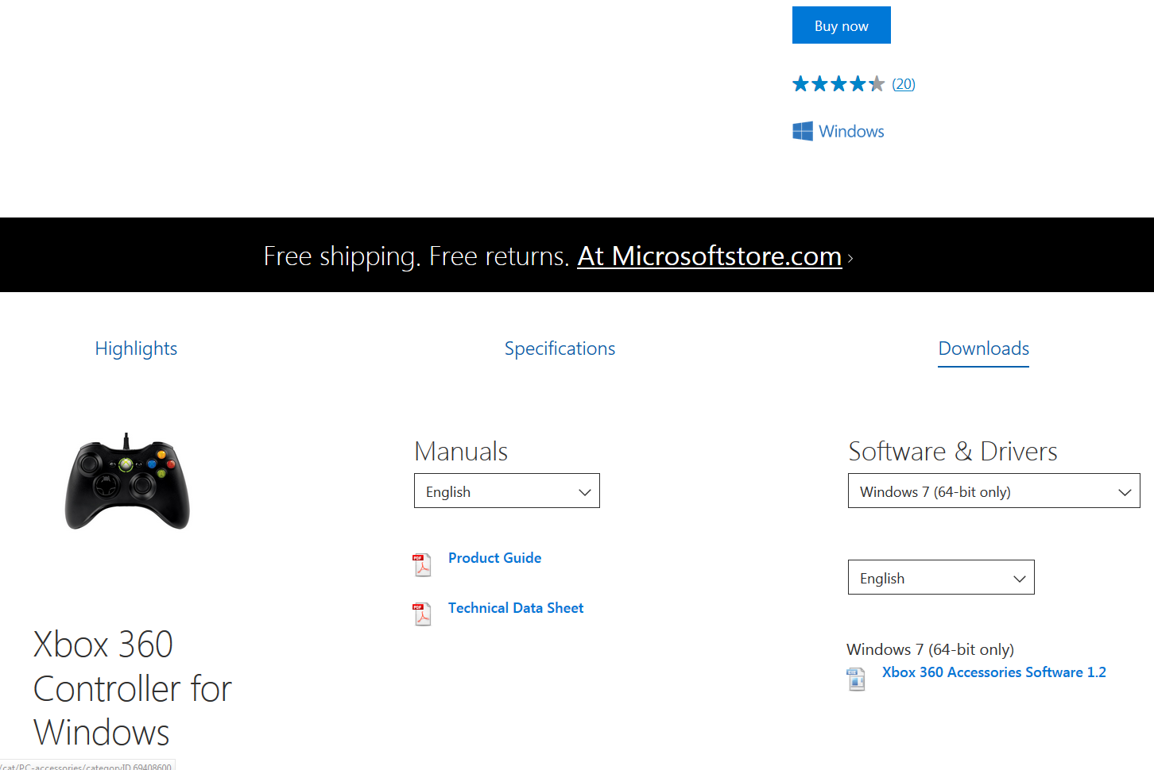

1. Open the downloaded executable and click ‘Yes’ to approve the installation, if asked
2. Click ‘Run’. The Xbox 360 program will install the necessary drivers onto your computer. After it installs it may prompt you to restart the computer.
3. Now try opening up brachI/Oplexus software and see if the xbox controller will connect.
   1. If the controller works then you can skip to the next section
4. If the controller still does not work then run through the following procedure to manually install the driver
   1. Press the windows button in the bottom left of the desktop and typing ‘device manager’ in the search bar. Once it appears click on it to open it.
   2. In device manager right click on ‘rocky candy gamepad for xbox 360’ and select ‘properties’
   3. Click on ‘update driver; and select ‘browse my computer for driver software’
   4. Select ‘Let me pick from a list of device drivers on my computer’
   5. Select ‘Microsoft Common Controller for Windows Class’ and click next
   6. Select ‘XBOX 360 Controller For Windows Version: 6.1.7600.16385 [21/06/2006]’ and click ‘Next’
   7. An Update Driver Warning will pop up asking if you want to continue installing the driver. Click ‘Yes’
   8. It will then let you know that Windows has successfully updated your driver software. Click ‘Close’
   9. The controller should now work!

### Install USB2dynamixel Drivers

1. The easiest way to install the drivers for the USB2dynamixel is to install the latest version of their RoboPlus software. This Dynamixel Wizard part of the RoboPlus software is also used for the initial Bento Arm setup, so it is handy to have. The latest version can be found by going to their [downloads site](http://en.robotis.com/BlueAD/board.php?bbs_id=downloads&scate=SOFTWARE). The lastest version to date is v1.1.3.0 and can be downloaded [here](http://en.robotis.com/BlueAD/board.php?bbs_id=downloads&mode=view&bbs_no=1132559&page=1&key=bbs_subject&keyword=roboplus&sort=&scate)
2. Detailed instructions for installing the RoboPlus software can be found [here](http://support.robotis.com/en/software/roboplus_main.htm)
3. Once the software has installed connect the USB2dynamixel to the computer using a USB extender cable
4. Press the windows button in the bottom left of the desktop and typing ‘device manager’ in the search bar. Once it appears click on it to open it.
5. In device manager click on ‘Ports (COM &LPT)’ and right click on ‘USB Serial Port (COMX)’ where X is some number and select ‘Properties’
6. A properties window should pop up. Click on the ‘Port Settings’ tab and then click on the ‘Advanced…’ button
7. An advanced settings window should pop up. Click on the drop down for ‘Latency Timer (msec)’ and change it from 16 to 1.
   1. Note: You should only have to do this once per computer. When you connect the same USB2dynamixel it should remember the previous settings and keep the setting at 1ms.
8. Click ‘Ok’ to close the advanced settings window then click ‘Ok’ again to close the properties window. You can also close the device manager by clicking on the ‘X’ button in the top right of the window
9. The USB2dynamixel is now ready to go!
10. If you have trouble with any of the above you can refer to the following [youtube video](https://youtu.be/U_dAZ-6L-_k?t=99) by Darren Lee that has a screen cap of the process.

## Setup the Bento Arm

1. Detailed instructions for how to connect the Bento Arm to its power supply and to the computer via the USB2dynamixel can be found in section 1.7 page 16, of [the Bento Arm Assembly Guide](https://github.com/blincdev/Bento-Arm-Hardware/blob/master/Bento%20Arm%20-%20Assembly%20Guide.pdf)
2. In order for the Bento Arm to work with the brachI/Oplexus software ensure that each dynamixel servo is set with the appropriate unique ID and set to a baud rate of 1000000bps. Also ensure that the servos are using the Dynamixel 1.0 protocol.

## Running the Software

1. The Bento Arm hardware and USB2dynamixel should already be connected as described in section 1.4. Just a reminder of the connection order. First connect the USB2dynamixel to the computer via the USB extender cord, then connect the power to the Actuators via the power harness, finally connect the USB2dynamixel to the Actuators via the power harness.
2. Also connect the Xbox controller to a USB port on the computer
3. Open the brachI/Oplexus software by double clicking the shortcut on the desktop or by navigating to it via the windows start menu
4. Click the ‘Connect’ button in the ‘Xbox – Setup’ groupbox in order to connect to the Xbox controller. If the controller is plugged and the drivers are installed then the ‘Xbox’ groupbox should become enabled and you should be able to see feedback from button presses next to their respective button labels.

download big image png medium image png small image png microsoft 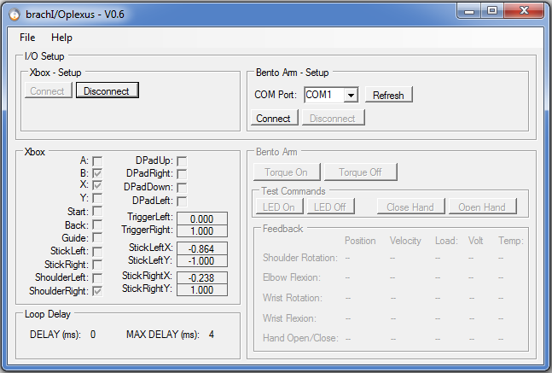

1. Click the ‘Connect’ button in the ‘Bento Arm – Setup’ groupbox in order to connect to the USB2dynamixel. The COM port should auto-select as long as the USB2dynamixel was connected in advance of starting the program. If you connected it afterwards you can manually select it after clicking the ‘Refresh’ button. If at least one Dynamixel Actuator is connected on the bus with an ID between 1 and 5 and bps set to 1000000 bps then the ‘Bento Arm’ groupbox should become enabled and you should be able to see feedback from whichever Actuators are connected in the ‘Feedback’ groupbox. In the following image the Shoulder, Elbow, and Hand Actuators are all sending back feedback. The wrist actuators do not show any feedback because they were physically unplugged.

download big image png medium image png small image png microsoft 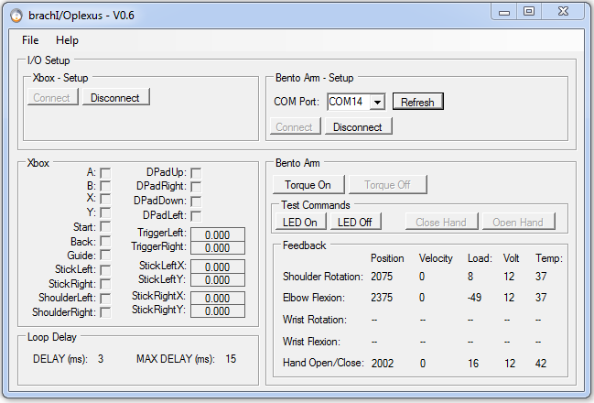

1. The DELAY (ms) in the ‘Loop Delay’ groupbox should be about 2 to 5 ms while you are running the software. This is about how long it takes for a background thread to read from the Xbox controller, query a feedback packet from the actuators, and send a command packet to the actuators. If it is much greater -- then the latency timer may not have been set correctly. Refer to step 4 in section 1.3.3 and try setting it again to 1 ms. Also, we recommend not running any other programs or processes in the background while running brachI/Oplexus as it may effect performance and increase the loop delay.



1. In order to move the arm with the joystick you will need to click on the ‘Torque On’ button in the ‘Bento Arm’ groupbox.

download big image png medium image png small image png microsoft 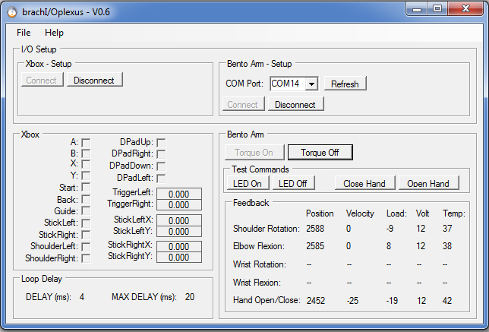

1. Once the torque is turned on you should be able to move the joints of the Bento Arm via velocity joint control using the Xbox controller. Note: While the torque is turned on the Bento Arm will hold its position and will not be able to be moved passively. The image above shows a velocity of -25 for the Hand Actuator since I took the screen shot while it was moving.
2. The mapping of joints is described in the following image and is also available through the ‘Help’ menu at the top of the screen if you select ‘Mapping Graphic’.

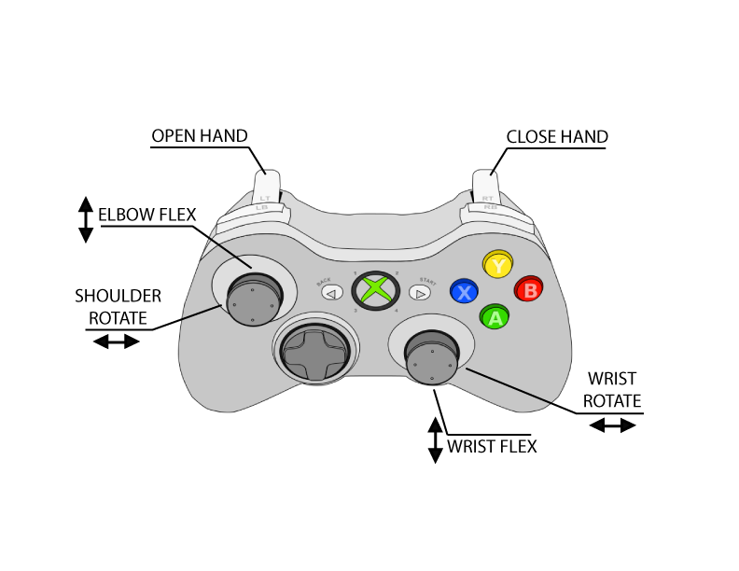

1. If you would like to move the joints passively you can press the ‘Torque Off’ button in the ‘Bento Arm’ groupbox. Be sure to support the arm before pressing this button as otherwise it could fall into whatever surface is below it and be damaged by impact. While the torque is turned off you can move it passively to any position with in its joint limits. Press the ‘Torque On’ button again if you would like it to hold the position against gravity or other loads.

download big image png medium image png small image png microsoft 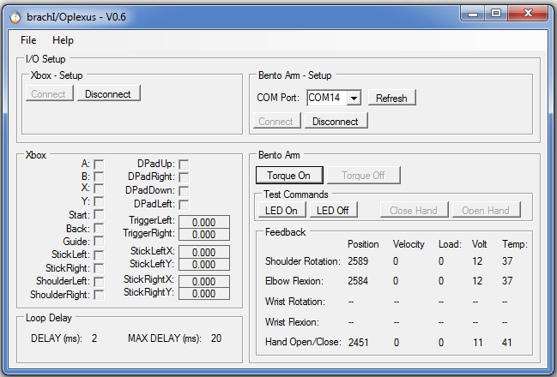

1. Clicking on the ‘LED On’ and ‘LED Off’ buttons in the ‘Test Commands’ groupbox will turn on and off the LED on the Actuator with ID=5 (usually the hand or gripper)



1. Clicking on the ‘Close Hand’ and ‘Open Hand’ buttons in the ‘Test Commands’ groupbox will close and open the Actuator with ID=5 (usually the hand or gripper)



1. When you want to shutdown the program you can click the ‘X’ in the top right corner or go ‘file 🡪 exit’. We recommend supporting the arm and clicking the ‘Torque Off’ button before closing the program otherwise it will continue to hold torque even after the program is closed.
2. The details for disconnecting the Bento Arm are covered in section 1.4. As a reminder: First disconnect the USB2dynamixel from the power harness, then disconnect the power to the Actuators by unplugging them from the power harness, finally disconnect the USB2dynamixel from the USB port on the computer. If this order is not followed it may cause damage to the USB2dynamixel under certain fault conditions.
3. A link to this help manual is also available while using the program by clicking ‘Help’ and then ‘User Manual’

## Modifying the Software

This section describes how you can make changes to the software such as adding additional controllers and robots or modifying the mappings.

### Development Environment

The main development environment used in this project was Visual Studio Express 2015, but the project was also able to load successfully in Visual Studio 2010. Visual Studio Express 2015 for Windows Desktop can be freely downloaded by individual developers, open source contributors, academic researchers, and small organizations from the visual studio website: <https://www.visualstudio.com/vs/visual-studio-express/>

As a first step you will need to download visual studio express in order to view or make changes to the C# project files.

### Libraries and Interfaces

The brachI/Oplexus software uses the following open source libraries and interfaces to communicate with input and output devices. Consider reviewing their documentation if you want to learn more about how these interfaces work:

* XInputDotNet
  + C# wrapper around XInput, works with any Mono or .NET application (eg. Unity3D)
  + Used in brachI/Oplexus to communicate with Xbox controllers
  + <https://github.com/speps/XInputDotNet>
* DynamixelSDK
  + Software development library that builds control and feedback packets to communicate with Dynamixel Actuators
  + Used in brachI/Oplexus to communicate with the Bento Arm
  + <https://github.com/ROBOTIS-GIT/DynamixelSDK>

Note: If you have already followed the installation instructions for brachI/Oplexus you will not need to download these libraries or install additional drivers in order to run the source code

### Source code

1. To download the source code please visit our github page and click the ‘clone or download’ button to download the latest master branch: <https://github.com/blincdev/brachIOplexus>
2. Extract the files to a directory and then double click on ‘MTT GUI.sln’ to open the C# project in Visual Studio Express 2015
3. The project should open and look similar to the following image

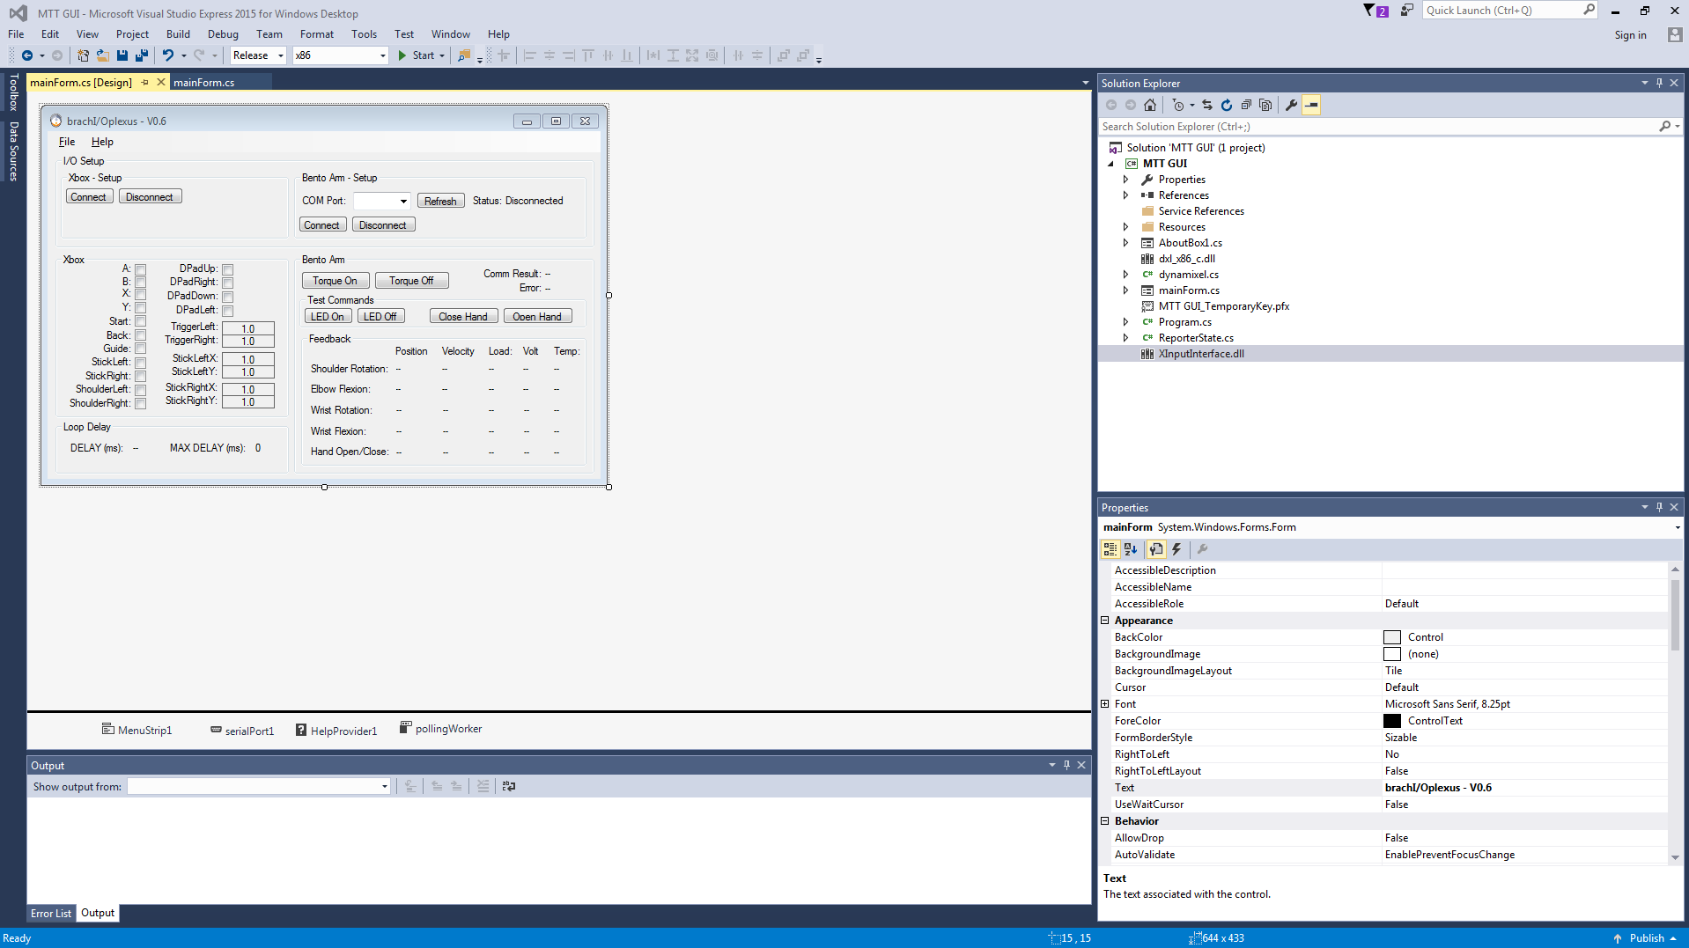

1. If the ‘mainForm.cs’ tabs are not already open you can right click on mainForm.cs in the ‘Solution Explorer’ and select ‘View code’ to view the source code. To view the graphical user interface right click again on mainForm.cs and select ‘View Design’
2. To run the program you can click on the ‘Start’ button at the top of the screen that has a big green play button beside it.
3. If you are interested in contributing to the development of the program or have ideas for future features please contact us through our website: <https://blincdev.ca>

