# BLIV Spaces

Business to Customer Application

Requirements and Solutions.

Table of Contents

BLIV Spaces 1

1. Objective 2

2. Organizational Requirements 2

3. Analysis 3

4. Target Users 4

5. Design. 4

6. Non-Functional Requirements 5

6.2 Performance 5

7. Functional Requirements 6

7.1 Application brief 6

9. Reference Screenshots 8

10. Project Estimates 9

NN Person days 11

# 1. Objective

The BLIV Business to costumer app provides functionality and access to users at their fingertips to avail the best quality services provided with the app, after registration the rewards are provided for every transaction and service taken by the user.

There is a wide array of services provided ranging from room booking, Food, Finances, jobs, part-time Jobs, Healthcare, etc., the user can utilize these services and make his living better at BLIV Spaces.

# 2. Organizational Requirements

High-level analysis of the app.

|  |  |
| --- | --- |
| Requirements | Details |
| Auto Login | After OTP validation by the user, he will be a registered user. |
| ROOM | If there is a click on the room button the basic details of name, phone number followed by the City and Location is shown as a form to fill |
| FOOD | If there is a click on the Food button the Name and phone number are asked followed by the city list and location button to submit. |
| Financial | If there is a click on the Finance button, the Name and phone number are asked followed by the type of Finance the User requires, as a list to submit. |
| JOB | If there is a click on the Job button the information of his Name, phone number followed by the Skills and Education are asked to submit. |
| Part-time Job | If there is a click on the Part-time job button the details like Name, Number followed by Skill and Education are asked to submit. |
| Healthcare | If there is a click on the healthcare button the Name, Number, OTP, after validation there will be a clickable link for doctors on call, Doctors on a visit, Hospital, pharmacy, Diagnostic. After clicking on any of these links the Registration will open with the list of the particular service and a city-wide list of doctors. |
| BLIV Club Registration | After the First time Registration to the BLIV Club, the sign-up page is provided to the user. |
| REWARD-POINTS MANAGEMENT/Bucket/Balance/  Management | A certain amount of reward points is Provided to the customer whenever the user signs up and uses the service and also the management of the points takes place in the wallet. |
| Reward Point Accumulation | A certain number of points are generated and stored in the user’s account wallet whenever the user registers and uses the services provided in the app. |
| Rewards point Redemption. | A certain percent of Rewards points is deducted from the Users account’s wallet and a different amount of the actual fee is asked to pay. |
| Performance/Capacity | The capacity of 50000 users at a given time is handled by the app. |

2

# 3. Analysis

Which applications were analyzed? What features should be added, modified, removed for better usability/performance/security/acceptance?

The App provides a series of features of interaction to the User.

## 4. Target Users

The Application is suitable for all kinds of age groups and ethnicity, and literacy rates as it has support for native languages.

# 5. Design.

User Table.

|  |  |  |  |  |  |  |  |  |  |  |
| --- | --- | --- | --- | --- | --- | --- | --- | --- | --- | --- |
| Phone Number (Primary key) | Name | Age | Date Of birth | Sign-up_Date | Reward Points credit | Reward Points debit | Services type | Services Date | App Start Time | App  Close  Time |
| 12345 | ABC | 23 | DD/MM/YYYY | dd/mm/YYYY | 100 | 100 | Room | Dd/mm/yyyy | Hh:mm:ss | HH:MM: SS |
| 567 | def | 34 | Dd/mm/yyyy | Dd/mm/yyyy | 200 | 300 | Health care | dd/mm/yyyy | HH:MM: ss | HH:MM: SS |

User Transaction Table.

|  |  |  |  |  |  |  |  |  |
| --- | --- | --- | --- | --- | --- | --- | --- | --- |
| User Phone Number (primary key) | Username | Start time | End Time | Type of Service | Points deducted | Points added | Payment  Mode | Amount |
| 0123456789 | AAAA | 12:30 | 13:30 | JOB | 200 | 300 | Online | 4000 |

Rewards_table (Master).

|  |  |  |  |
| --- | --- | --- | --- |
| Rewards_Scheme | Start | End | Reward Points. |
| Dussehra | Dd/mm/yyyy | Dd/mm/yyyy | 200 |
| Holi | Dd/mm/yyyy | Dd/mm/yyyy | 300 |

Rewards Transaction Table.

|  |  |  |  |  |  |
| --- | --- | --- | --- | --- | --- |
| Phone-NO | User-Name | Rewards added | Rewards debited | Date-time | Services |
| 0123456789 | AAAA | 100 | - | Dd/mm/yyyy | room |
| 9849249294 | Bbbb | 200 | - | Dd/mm/yyyy | JOB |
| 4454546673 | CCCC |  | 300 | DD/MM/YYYY | HEALTHCARE |

Registration Table.

|  |  |  |  |  |  |
| --- | --- | --- | --- | --- | --- |
| Phone Number(Primary Key) | User Name | DOB | OTP Validation | Reward Credit | Date Of Joining |
| 234234234 | Aaaa | Dd/mm/yyyy | YES | 300 | Dd/mm/yyyy |

City Table.

|  |  |  |  |
| --- | --- | --- | --- |
| Phone Number | Name | OTP- Validation | Location_list |
| 9834349293 | Massa | Yes | aa |
| 9849844923 | Baasha | Yes | BBB |

Food Table

|  |  |  |  |
| --- | --- | --- | --- |
| Phone Number | Name | OTP-Validation | Location_list |
| 9883628223 | Asia | Yes | aaaaa |

Financial_table

|  |  |  |  |  |  |  |
| --- | --- | --- | --- | --- | --- | --- |
| Phone Number | Name | OTP-Validation | Bank | Loan | Insurance | Savings |
| 9786755444 | Adds | Yes | NO | Yes | NO | NO |

## 6. Non-Functional Requirements

6.1 Security

Standard Otp based Security is Required.

### 6.2 Performance

Standard/Real-time issues are Being Monitored as Development Lifecycle.

6.3 Scalability

Expansion plans and Scalability requirement — Low/Medium/High

6.4 Internationalization

The app provides support of multiple languages like Hindi and English which can be further expanded to a wide range of languages.

## 7. Functional Requirements

### 7.1 Application brief

The app is targeted to the Users taking benefit of the BLIV services, the apps features and functionality provides ease of access to all the services provided by BLIV in one place starting from signing up to inputting details, the person can submit room, food, financial requirements and job Full-time Job application and Part-time Job application up until Healthcare facilities, The app provides the users with special discount points when registered at the start and as well as whenever the user uses any service at BLIV, These points can be later redeemed with the services they avail, and difference amount is shown from the actual amount after deduction.

7.2 Application flow (Wireframes and Use Cases)

* 7.2.3 Home screen

* 7.2.4 Room Icon Flow.

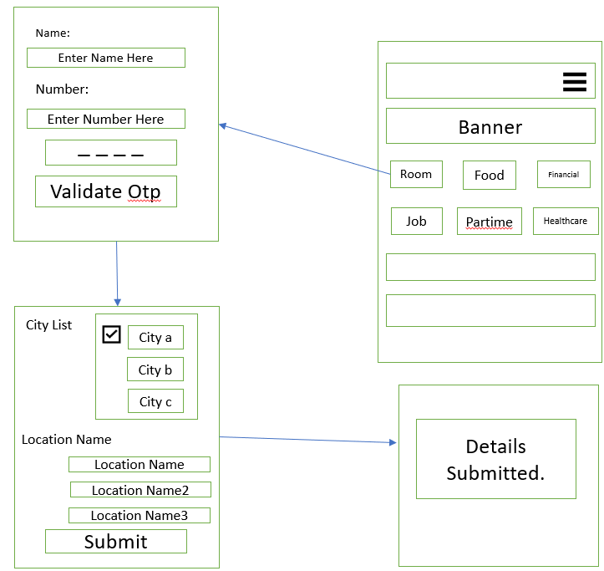

* 7.2.5 Food Icon.

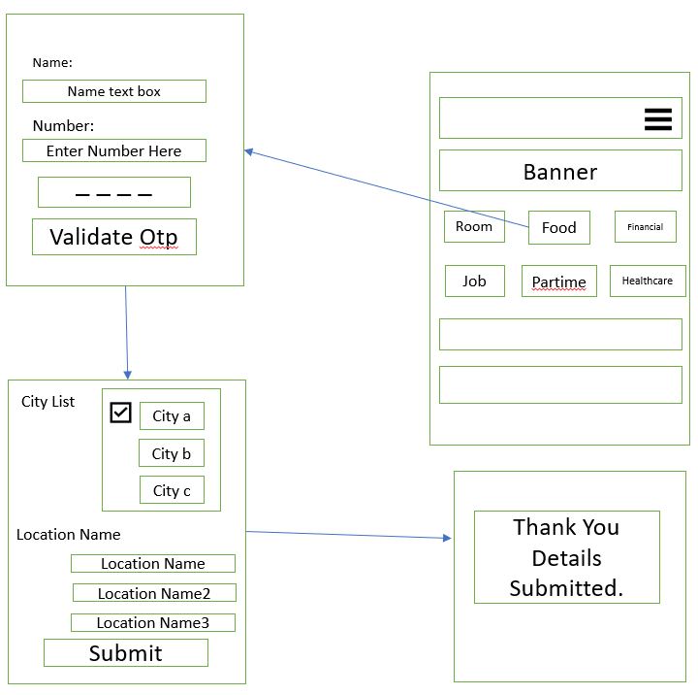

* 7.2.6 Financial

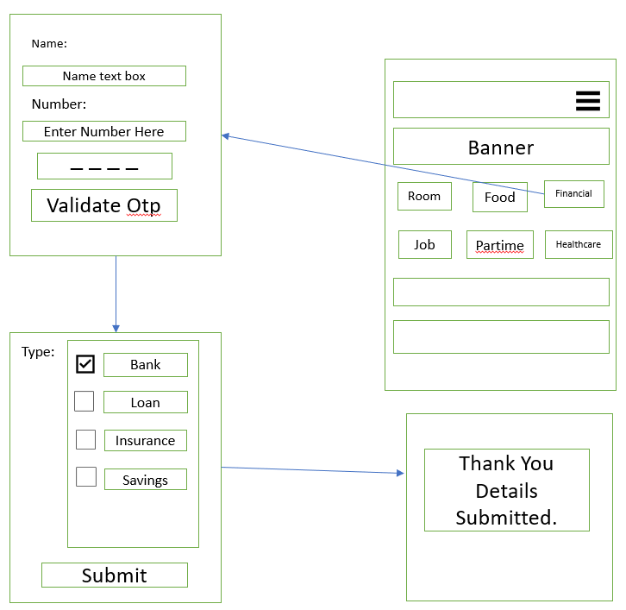

5

* 7.2.7 Job

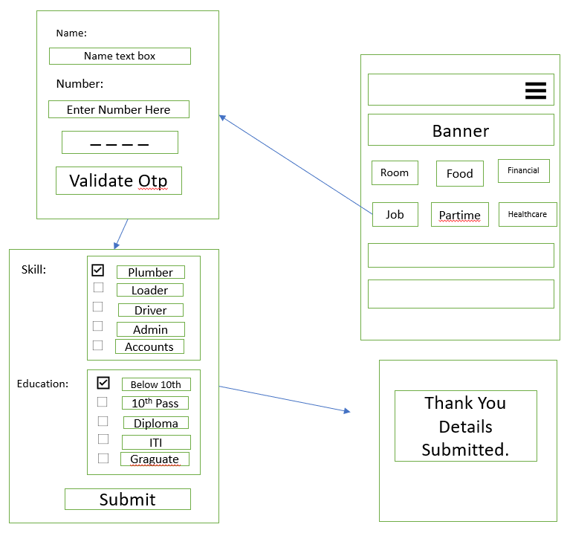

* 7.2.8 Part-time

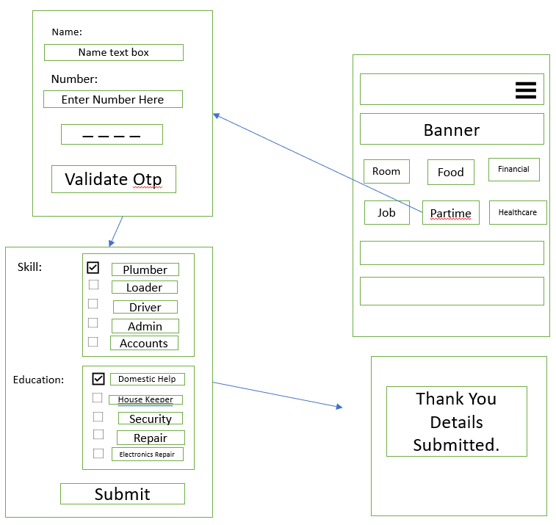

7.2.9 Healthcare

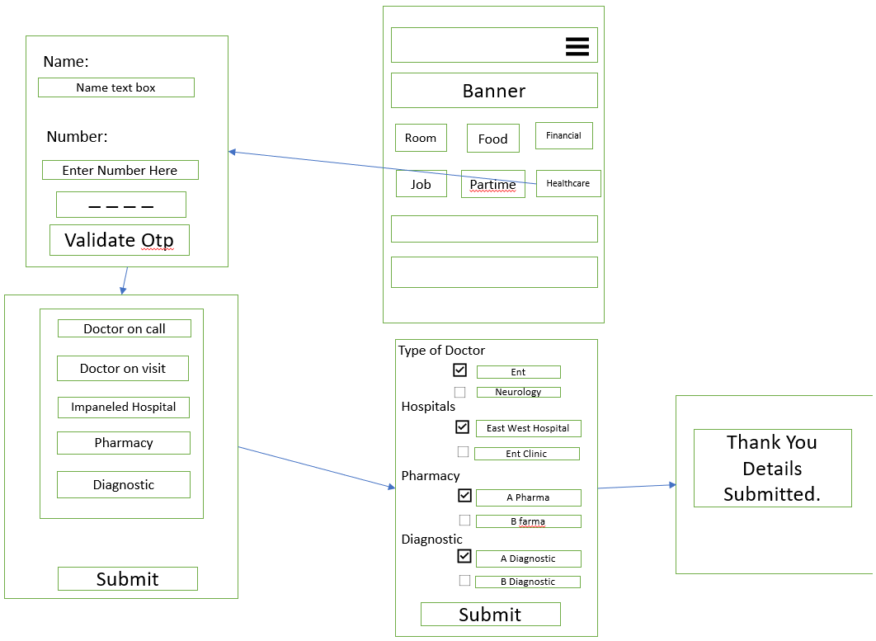

* 7.3.0 BLIV Club

## 10. Project Estimates

The effort estimates as per the given scope in the attached document are discussed in this section. These estimates are also based on assumptions stated in the document.

Following is the module-wise categorization of features for pure development estimates on all mobile platforms. These efforts include only coding and do not include efforts for designing, managing, testing the app: 

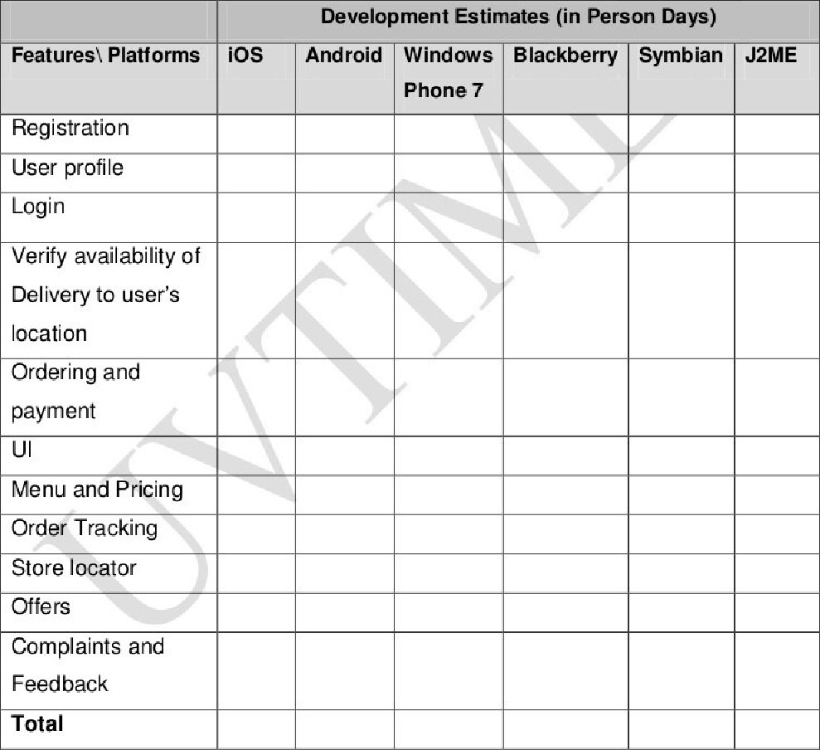

Further adding overheads to the development estimates:

7

|  |  |
| --- | --- |
| Business Analysis — requirement gathering and documentation |  |
| Design/UI creation — Creating design assets |  |
| QA — Testing for functionality, usability, performance |  |
| Project Management - managing the team and taking care of  Information Security, Business Continuity Plan, Traceability matrix,  Project Plan, Release Management, etc. |  |
| Total |  |

Business analysis will be partly common for all platforms X% of maximum effort:

### NN Person days

Based on the aforementioned overheads the total effort estimates per platform will be as follows

|  |  |  |  |  |  |  |
| --- | --- | --- | --- | --- | --- | --- |
|  |  | Complete Effort Estimates (in Person Days) | | | |  |
| Platforms | iOS | Android | Windows Phone 7 | Blackberry | Symbian | J2ME |
| Total |  |  |  |  |  |  |

Final Effort estimates are NNN Person — Days.

Final Cost is USD NNNNNN.

8