HW2 – Testing Data-Screenshot

Stock Data for 2016

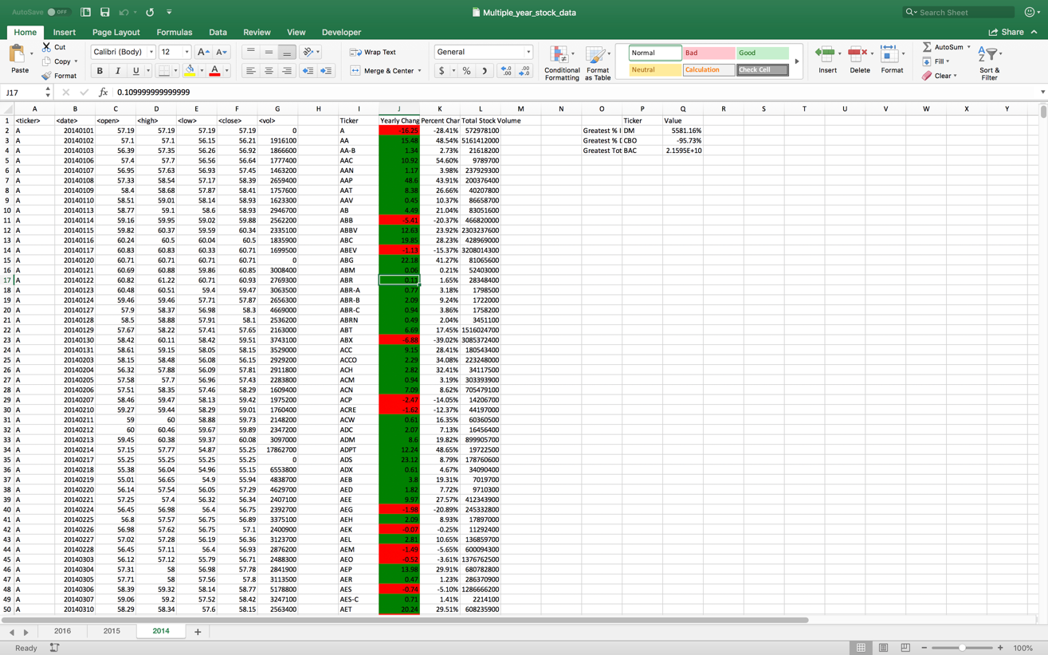

Stock Data for 2015

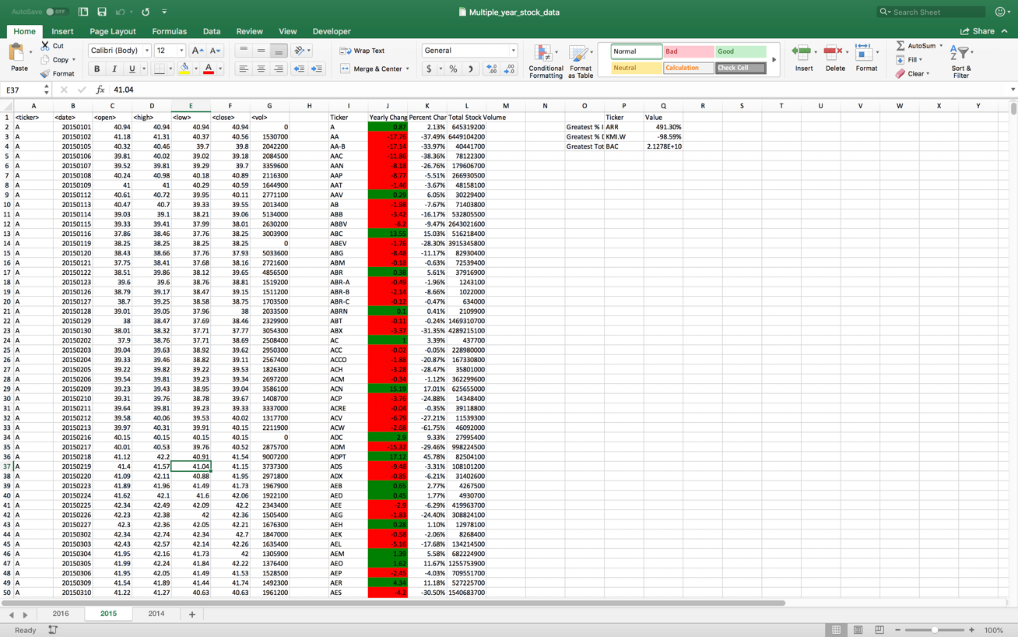

Stock Data For 2014

