Predicting School Attendance Among Children and Youth Aged 5–24 in the Philippines Using APIS 2022 Data
Name: Brien Leij O. Mauricio
Course / Section: DS012 - DSA31S1
Selected UN SDG: SDG 4: Quality Education (Target 4.1)

Executive Summary
School non-attendance among Filipino children and youth is a central concern for SDG 4: Quality Education. This project extends an earlier data-storytelling analysis of the 2022 Philippine Statistics Authority (PSA) Annual Poverty Indicators Survey (APIS) into a predictive tool for the Department of Education (DepEd) and education policymakers. Using 13 characteristics that are known without asking about schooling, the models predict whether a person aged 5–24 is currently attending school. The cleaned dataset holds 72,194 individuals (82.16% attending, 17.84% not attending) after removing 333 exact duplicates.
Three supervised models were compared: Logistic Regression, a Decision Tree and Gaussian Naive Bayes. A household-grouped split kept members of the same household out of both the training and test sets. Model comparison and threshold selection used five-fold grouped cross-validation on the training split only, and the held-out test split was scored once. Logistic Regression is recommended. At the default 0.50 threshold it reached 91.09% test accuracy, 81.71% precision and 64.52% recall for the not-attending class, and the highest not-attending Average Precision (80.30%). The Decision Tree overfit (99.98% training versus 87.76% test accuracy), and Gaussian Naive Bayes flagged almost everyone as not attending (18.00% precision). A threshold of 0.40, chosen on validation data, raises test recall to 70.42% with 76.51% precision.
The models are packaged in a Streamlit application where a user selects a model, enters a profile and receives a prediction with a plain-language interpretation for DepEd. The most important limitation is weak performance for younger children: at threshold 0.40, only 8.2% of non-attending children aged 5–9 were found (n = 182). The tool supports human review and must not be the sole method for identifying children who need support.

1. Project Background and SDG Context

1.1 Problem Context
Access to education is a core commitment of SDG 4, whose Target 4.1 aims to ensure that by 2030 all girls and boys complete free, equitable and quality primary and secondary education (United Nations Department of Economic and Social Affairs, n.d.). The PSA reported that four out of five Filipinos aged 5 to 24 were attending school in school year 2022–2023 (Philippine Statistics Authority, 2023), which means a substantial minority were not.
“Not attending” does not automatically mean a person dropped out. Many people aged 19–24 may have finished their education, while for younger ages non-attendance is more likely to signal a barrier. The original data-storytelling project described how non-attendance differs across regions and demographic groups. This machine-learning extension asks a different, predictive question: can available individual, household, educational and socioeconomic characteristics be used to predict a person’s attendance status, so that attention can be directed to profiles that warrant verification or further investigation?
The model describes patterns in 2022 survey data. It does not show that any characteristic causes non-attendance.

1.2 Stakeholder
Table 1. Stakeholder and decision context
Stakeholder Element | Project-Specific Description
Primary stakeholder | Department of Education (DepEd) and education policymakers.
Decision supported | Where to direct verification, monitoring, further analysis or education-support planning for profiles that resemble non-attending individuals. The model is a decision-support aid, not an automatic decision-maker.
Cost of a false positive / overprediction | An attending person is flagged as not attending. Verification effort and resources may be spent on someone who does not need them, and a profile or group may be wrongly labelled.
Cost of a false negative / underprediction | A non-attending person is predicted to attend and is overlooked, so someone who could benefit from support is not considered. This is the costlier error for the SDG goal, which is why not-attending recall is the primary metric.
Human review required? | Yes. Every flag should be verified (for example through school or local records) before any action, and an “attending” prediction must never be used to rule anyone out.

2. Machine Learning Problem Formulation

2.1 Predictive Objective
Using 13 person-, household- and place-level characteristics available without asking about schooling status, predict school_attendance for one individual aged 5–24 so that DepEd and education policymakers can prioritise where verification, monitoring or education-support planning should be considered.

2.2 Target and Prediction Unit
Table 2. Target definition
Item | Definition
Prediction unit | One row = one individual aged 5–24 from the APIS 2022 member record, merged with household information.
Target variable | school_attendance, derived from “Currently Attending School”: Yes (public, private or home-schooled) = 1; No = 0.
Task type | Binary classification
Positive class | Model coding: 1 = attending. For stakeholder purposes the class of interest is 0 = not attending, so precision, recall, F1 and Average Precision are reported with “not attending” treated as the positive class (and the attending class separately where stated).
Prediction horizon / timing | Cross-sectional. Predictors describe the person and household at the 2022 survey; no future information is used. The prediction answers “does this profile resemble people who were attending?”, not “who will drop out?”.

2.3 Scope and Success Criteria
In scope: ranking and flagging profiles by their estimated probability of non-attendance, with transparent evaluation and stakeholder-oriented interpretation. Out of scope: automated eligibility decisions, causal claims, individual-level labelling without verification, other years or age ranges.
No numeric acceptance targets were set by stakeholders. Success was therefore defined relative to the problem: (1) not-attending recall and Average Precision are prioritised, interpreted with precision and F1 because over-flagging has a cost; (2) the model must generalise (small train–test gap and stable cross-validation); (3) performance must be disclosed by age group, region, sex and urban/rural residence; (4) the model must beat the naive baseline of predicting “attending” for everyone, which scores about 82.2% accuracy but finds no non-attending individuals.

3. Dataset and Data Understanding

3.1 Dataset Source
Table 3. Dataset overview
Attribute | Description
Dataset name | APIS 2022 integrated cleaned dataset (Member, Household and Other Relevant Information records merged by Region and Household ID, limited to ages 5–24)
Source / URL / organization | Philippine Statistics Authority (PSA), Annual Poverty Indicators Survey. https://psada.psa.gov.ph/catalog/APIS/about
Collection period | 2022 survey round. Family income refers to January–June 2022.
Unit of observation | One individual aged 5–24
Original number of rows | 72,527 (72,194 after removing 333 exact duplicate records)
Original number of features | 22 columns in the integrated file: 13 predictors, the target, the Household ID grouping variable, and columns excluded to prevent leakage or because they are not predictors (survey weight, detailed grade, current-schooling variables, age group).
License / access notes | PSA public-use survey files. The raw CSV is not redistributed with the code; data-access instructions are in the repository’s data folder.

3.2 Data Dictionary
Table 4. Data dictionary (targets, grouping variable and the 13 predictors)
Feature | Type | Role | Meaning / Unit | Available at Prediction Time?
school_attendance | binary | Target | 1 = attending, 0 = not attending | N/A
Household ID | identifier | Grouping only | Keeps household members in the same split; never a predictor | N/A
Region | categorical (17) | Predictor | Region of residence | Yes
Relationship to Household Head | categorical (7) | Predictor | Person’s relationship to the household head | Yes
Sex | categorical (2) | Predictor | Sex of the person | Yes
Age as of Last Birthday | numeric | Predictor | Age in years (5–24) | Yes
Marital Status | categorical (6) | Predictor | Marital status of the person | Yes
Highest Grade Completed - Level | categorical (8) | Predictor | Education level completed (Level 0–7) | Yes
Family Size | numeric | Predictor | Number of persons in the household (1–20) | Yes
Head: Sex | categorical (2) | Predictor | Household head’s sex | Yes
Head: Age as of last birthday | numeric | Predictor | Household head’s age in years (10–99) | Yes
Head: Marital Status | categorical (6) | Predictor | Household head’s marital status | Yes
Head: Highest grade completed | categorical (272) | Predictor | Household head’s highest grade or course completed | Yes
Urban / Rural | categorical (2) | Predictor | Residence classification | Yes
Average monthly income of the family January - June 2022 | numeric (PHP) | Predictor | Average monthly family income, PHP 500–700,000 | Yes
Excluded to prevent leakage: Currently Attending School, Why not attending school, Grade/Year currently attending – Code, Mode of learning. Also not used as predictors: Highest Grade Completed (detailed), Final Family Weight and Age Group (age group is used only for subgroup analysis).

3.3 Exploratory Findings Relevant to Modeling
Class imbalance. 82.16% of individuals are attending and 17.84% are not. A model that always predicts “attending” would reach about 82.2% accuracy, so accuracy alone cannot judge usefulness and the not-attending class must be evaluated separately.
Table 5. Attendance by age group (after de-duplication)
Age group | Individuals | Attending | Not attending
5–9 | 16,669 | 94.6% | 5.4%
10–12 | 11,860 | 97.8% | 2.2%
13–15 | 12,143 | 96.6% | 3.4%
16–18 | 11,994 | 89.0% | 11.0%
19–24 | 19,528 | 48.8% | 51.2%
Age dominates the pattern. Attendance is high through age 15 and falls sharply at 19–24, where roughly half are not attending. Much of the model’s ability therefore comes from separating older youth from school-age children, and non-attenders among younger children are rare and harder to find (see the subgroup results in Section 7.2).
Data quality. The 13 predictors have no missing values. Other columns have structural missing values that exist only for some respondents (for example, reasons for not attending), which is one reason they are leakage risks. Valid extreme values (family income up to PHP 700,000, household head age 10–99) were retained. “Head: Highest grade completed” has 272 categories, many of them rare; it is one-hot encoded and unknown categories are ignored at prediction time.

4. Data Preparation and Feature Engineering
Preprocessing is implemented inside each scikit-learn Pipeline, so every transformation is fitted on training data only (and refitted per cross-validation fold) and is reused unchanged on new inputs in the app.
Table 6. Preparation steps
Preparation Step | Variables Affected | Training-Only Fit? | Rationale
Duplicate removal | All columns | N/A (before the split) | 333 exact duplicate records removed so identical rows cannot appear in both train and test.
Missing-value handling | 13 predictors | Yes | Most-frequent imputer for categorical and median imputer for numeric columns. The predictors have no missing values, so this is a safeguard for new inputs.
Encoding | 9 categorical predictors | Yes | One-hot encoding with unknown categories ignored, so unseen values cannot crash prediction.
Scaling / normalization | 4 numeric predictors | Yes | Standardisation (zero mean, unit variance); required for Logistic Regression to behave well, harmless for the other models.
Feature engineering | None for modeling | N/A | Age group is derived only to report subgroup performance; it is not a model input.
Outlier treatment | Income, family size, head age | N/A | No values removed. Extremes are valid survey values, and the app restricts inputs to the range seen in training.

4.1 Leakage Controls
- Target-derived and schooling-status variables are excluded. “Currently Attending School” was used to build the target, and “Why not attending school”, “Grade/Year currently attending – Code” and “Mode of learning” describe current schooling. None are available without already knowing the answer.
- Household-grouped split. Household ID is used as a grouping variable, so people from the same household never appear in both training and test data (0 shared households). Without this, household-level characteristics could let the model “recognise” households.
- Preprocessing fitted without the test data. Imputers, encoders and scalers are part of the Pipeline and fitted on training data, and refitted inside each cross-validation fold.
- Threshold chosen without the test set. The operating threshold was selected from out-of-fold predictions on the training split. The test split was scored once after the models and threshold were fixed.

5. Experimental Design and Validation Strategy

5.1 Data Split / Validation
Table 7. Validation design
Design Element | Project Decision | Rationale
Train/validation/test strategy | Household-grouped split: 57,755 training individuals (25,295 households) and 14,439 test individuals (6,316 households); 0 shared households. Validation is cross-validation inside the training split. | Prevents household leakage and keeps the test set untouched until the end.
Test size | About 20% of individuals (the first fold of a 5-fold grouped split) | Standard hold-out size; large enough to report subgroups.
Stratification | StratifiedGroupKFold: stratified on the target and grouped by household | Keeps the 82/18 class balance in each part while respecting households.
Cross-validation | 5-fold StratifiedGroupKFold on the training split only; out-of-fold probabilities are saved | Measures stability and provides probabilities for choosing a threshold without using the test set.
Random state / reproducibility | random_state = 42 everywhere | Reproducible splits and model fits.
Primary selection metric | Recall for the not-attending class, read with precision, F1 and Average Precision (AP) for that class | Matches the cost of missing non-attending individuals while keeping false flags in view.

5.2 Metric Selection
Accuracy alone is not sufficient because the classes are imbalanced: always predicting “attending” scores about 82.2%. For DepEd, a false negative (a non-attending person not flagged) means a missed opportunity for support, so recall for not attending is the primary metric. Precision shows how many flags are correct, which determines the verification workload caused by false positives. F1 balances the two. Average Precision (AP) summarises precision and recall across all thresholds, so it compares how well each model ranks people independently of the chosen threshold. Confusion matrices show the actual counts of each error. The final model is not chosen on recall alone: a model can reach very high recall simply by flagging everyone.

6. Candidate Models
Three supervised classifiers were evaluated with the same data, split, preprocessing and metrics.
Table 8. Candidate models
Model | Why It Was Chosen | Key Settings / Tuning | Preprocessing Pipeline
Logistic Regression | Interpretable linear baseline that outputs probabilities, which allows threshold analysis. | max_iter = 1000, random_state = 42; no tuning | Imputation → one-hot encoding → scaling → classifier
Decision Tree | Captures non-linear patterns and interactions; rules are easy to communicate, but an unrestricted tree can overfit. | Default (unrestricted depth), random_state = 42; no tuning | Same pipeline
Gaussian Naive Bayes | Simple probabilistic comparison model with different assumptions (Gaussian inputs, conditional independence). | Default settings | Same pipeline
No hyperparameter tuning was performed; all models use library defaults apart from the settings shown. Tuning (for example limiting tree depth) is a possible next step.

7. Model Evaluation and Comparison

7.1 Validation Results
These results come from five-fold household-grouped cross-validation on the training split and were used to compare models and to choose the threshold. The test split is not involved.
Table 9. Cross-validation results (mean across folds; SD in percentage points; all values in %)
Model | Accuracy (mean) | Accuracy (SD, pp) | Precision (mean) | Recall attending (mean) | Recall not attending (mean) | F1 attending (mean)
Logistic Regression | 91.12 | 0.09 | 92.64 | 96.89 | 64.54 | 94.72
Decision Tree | 87.47 | 0.39 | 92.50 | 92.22 | 65.56 | 92.36
Gaussian Naive Bayes | 19.56 | 0.25 | 86.97 | 2.47 | 98.27 | 4.81
Table 10. Cross-validated Average Precision (all values in %)
Model | AP attending (mean) | AP attending (SD, pp) | AP not attending (mean) | AP not attending (SD, pp)
Logistic Regression | 97.89 | 0.13 | 80.95 | 0.45
Decision Tree | 91.70 | 0.14 | 48.58 | 0.99
Gaussian Naive Bayes | 82.29 | 0.03 | 17.96 | 0.03
Accuracy varied by at most 0.39 percentage points across folds for every model, so results are stable, but stability alone does not make a model useful: Gaussian Naive Bayes is consistently poor. Logistic Regression has the highest cross-validated not-attending AP (80.95%). The Decision Tree’s not-attending recall is slightly higher (65.56% versus 64.54%), but its not-attending AP is much lower (48.58%), which shows it ranks non-attenders poorly.

Threshold selection on validation data
Logistic Regression produces a probability of non-attendance, and a threshold turns it into a flag. Using the out-of-fold predictions, thresholds from 0.20 to 0.80 were compared. Threshold with the highest not-attending F1 on out-of-fold predictions of the training split (Logistic Regression); the test split was not used. This gave 0.40: validation recall for not attending rises from 64.54% (at 0.50) to 70.90%, while precision falls from 81.85% to 77.35%. The F1 scores at 0.30 and 0.40 are very close, so the choice depends on how a stakeholder values missed cases versus false flags.
Table 11. Logistic Regression threshold analysis on validation data (out-of-fold, training split; all values in %)
Threshold | Accuracy | Precision (not attending) | Recall (not attending) | F1 (not attending)
0.20 | 87.81 | 61.76 | 83.07 | 70.85
0.30 | 90.26 | 70.87 | 77.08 | 73.84
0.40 | 91.11 | 77.35 | 70.90 | 73.98
0.50 | 91.12 | 81.85 | 64.54 | 72.17
0.60 | 90.51 | 85.65 | 56.19 | 67.86
0.70 | 89.79 | 89.40 | 48.49 | 62.88
0.80 | 88.65 | 92.26 | 39.71 | 55.53
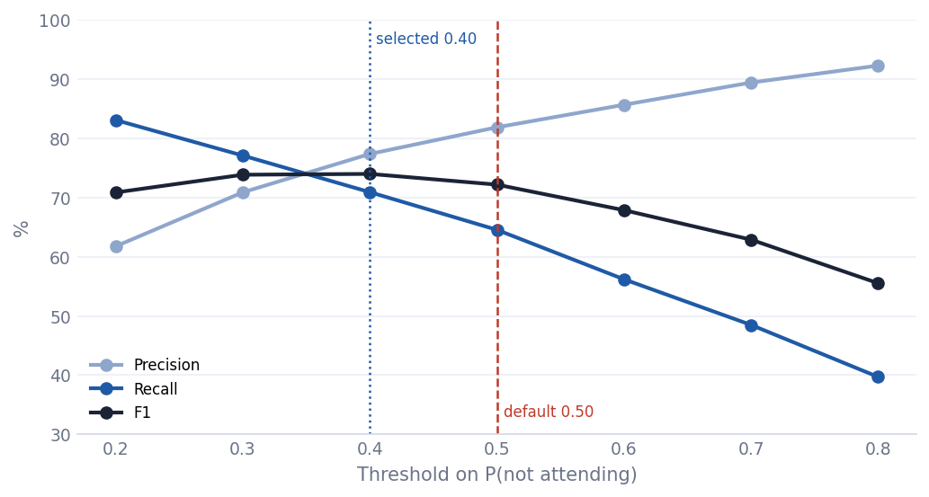
Figure 1. Precision, recall and F1 for the not-attending class across thresholds (validation, out-of-fold).

7.2 Final Held-Out Test Result
The test split (14,439 individuals from 6,316 households) was scored once, after the models and threshold had been fixed. Results below use the default 0.50 threshold unless stated.
Table 12. Test results, not-attending class (all values in %)
Model | Precision (not attending) | Recall (not attending) | F1 (not attending) | AP (not attending) | AP (attending)
Logistic Regression | 81.71 | 64.52 | 72.10 | 80.30 | 97.88
Decision Tree | 65.78 | 65.37 | 65.58 | 49.19 | 91.73
Gaussian Naive Bayes | 18.00 | 98.52 | 30.43 | 18.01 | 82.33
Table 13. Test results, attending class and overall accuracy (all values in %)
Model | Accuracy | Precision (attending) | Recall (attending) | F1 (attending)
Logistic Regression | 91.09 | 92.63 | 96.86 | 94.70
Decision Tree | 87.76 | 92.49 | 92.62 | 92.55
Gaussian Naive Bayes | 19.64 | 88.69 | 2.51 | 4.89
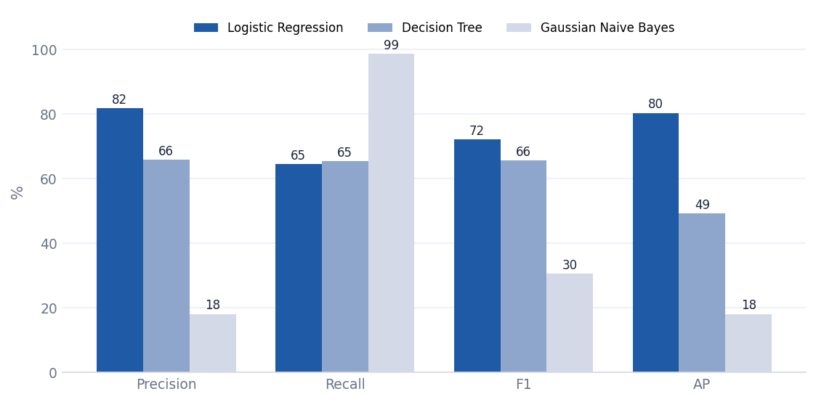
Figure 2. Not-attending class: held-out test metrics for the three models.
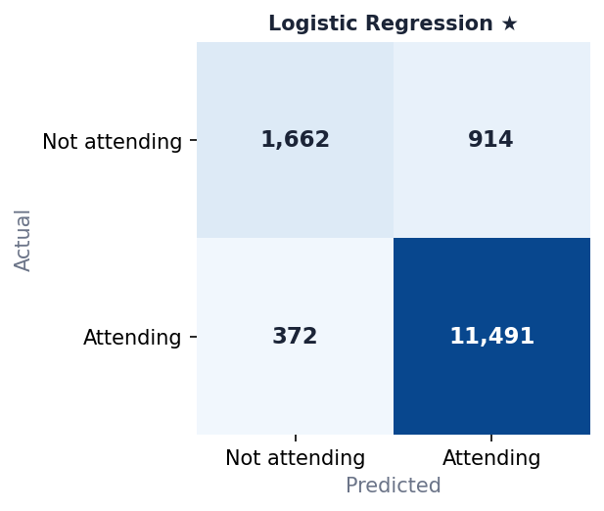 | 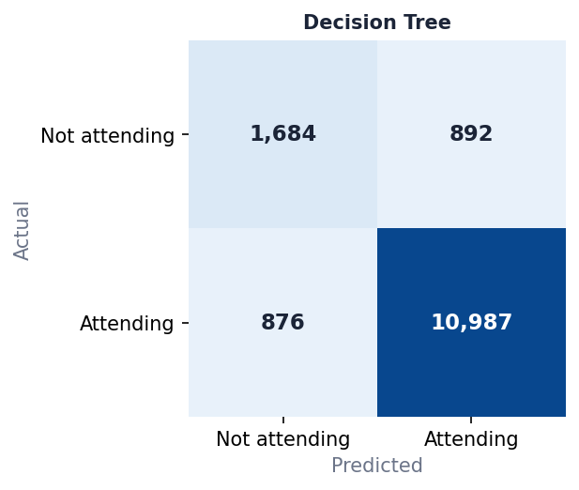 | 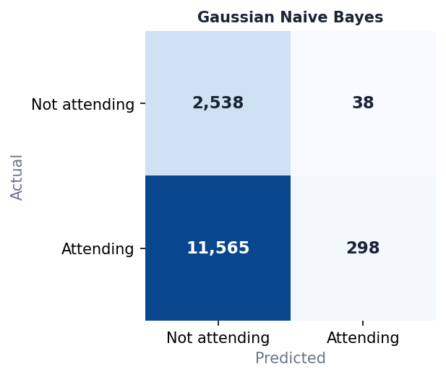
Figure 3. Confusion matrices on the test set (rows = actual, columns = predicted).
Logistic Regression correctly flags 1,662 of 2,576 non-attending individuals and wrongly flags 372 attending ones. Gaussian Naive Bayes catches 2,538 of 2,576 non-attenders only by also labelling 11,565 of 11,863 attending individuals as not attending, which makes it unusable for targeting.
Table 14. Training, cross-validation and test accuracy (all values in %)
Model | Training accuracy | CV accuracy | Test accuracy | Train–test gap (pp)
Logistic Regression | 91.25 | 91.12 | 91.09 | 0.16
Decision Tree | 99.98 | 87.47 | 87.76 | 12.22
Gaussian Naive Bayes | 19.96 | 19.56 | 19.64 | 0.32
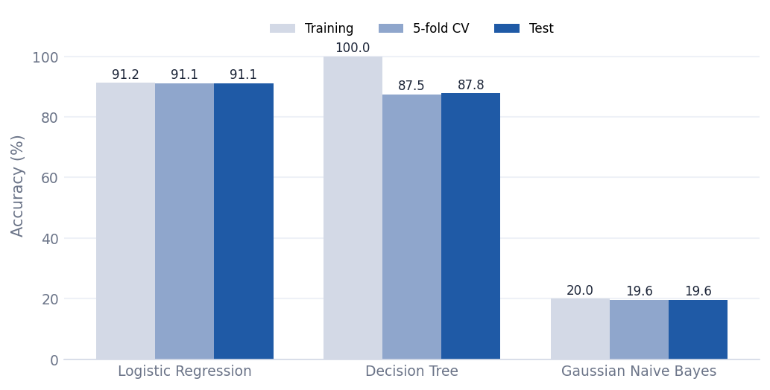
Figure 4. Training versus cross-validation versus test accuracy.
Only the Decision Tree overfits: 99.98% training accuracy against 87.76% test accuracy, a 12.22 percentage-point gap. Logistic Regression’s training, cross-validation and test accuracy agree within 0.20 points.
Logistic Regression at the selected threshold (0.40). On the test split, not-attending recall is 70.42% with 76.51% precision (F1 73.34%), compared with 64.52% recall and 81.71% precision at 0.50. These agree closely with the validation values (70.90% and 77.35%), which supports the threshold choice. The full test-threshold table is in Appendix B for information only; it was not used to choose the threshold.
Subgroup performance. Recall for the not-attending class differs strongly by age group. The groups with few non-attending individuals have wide uncertainty, so their values are signals for investigation rather than precise estimates.
Table 15. Not-attending recall by age group (Logistic Regression, test set; n = actual not-attending individuals)
Age group | n | Not attending (n) | Recall @0.50 | Recall @selected
5–9 | 3,332 | 182 | 3.30 | 8.24
10–12 | 2,369 | 48 | 27.08 | 27.08
13–15 | 2,417 | 76 | 10.53 | 13.16
16–18 | 2,402 | 264 | 35.61 | 39.77
19–24 | 3,919 | 2,006 | 76.82 | 83.30
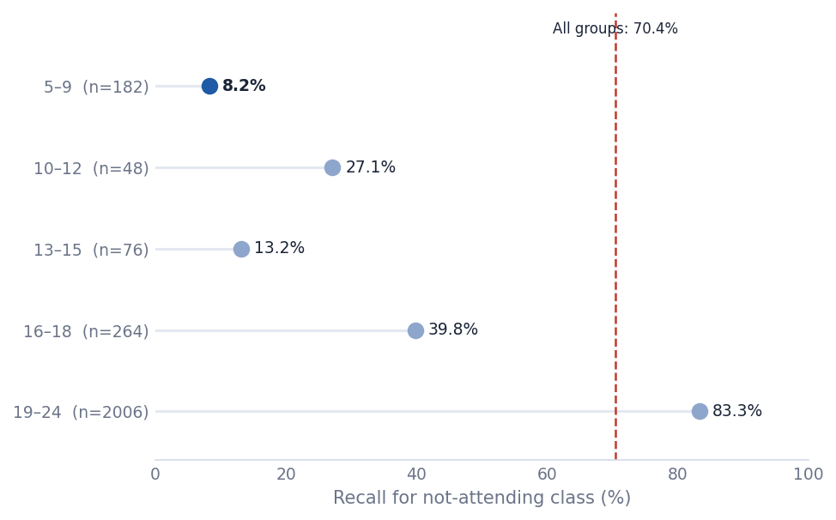
Figure 5. Not-attending recall by age group at threshold 0.40 (sample sizes shown).
Recall rises from 8.2% for ages 5–9 to 83.3% for ages 19–24. Regional recall at 0.40 ranges from 55.6% (Region IX - Zamboanga Peninsula) to 82.4% (Region II - Cagayan Valley); the difference between male and female recall is 3.4 percentage points and between urban and rural 1.3 points. Region, sex and urban/rural tables are in Appendix B.

7.3 Recommended Model
Table 16. Model recommendation
Decision Question | Response
Recommended model | Logistic Regression, as the primary candidate for further validation (not approved for deployment).
Strongest supporting evidence | Highest not-attending AP in validation (80.95%) and on test (80.30%); test accuracy 91.09%; stable folds; train, CV and test accuracy within 0.20 points; interpretable.
Main trade-off | At 0.50 it finds 64.5% of non-attenders with 81.7% precision. Lowering the threshold to 0.40 finds 70.4% (precision 76.5%): more cases found, more false flags.
Why not simply choose the highest Accuracy? | About 82% of individuals attend, so accuracy hides how many non-attenders are missed. The choice weighs not-attending recall, precision, AP and generalisation against the cost of follow-up.
Why not the Decision Tree? | Similar not-attending recall (CV 65.6% vs 64.5%), but a 12.2-point overfitting gap and much lower not-attending AP (49.2% on test).
Why not Gaussian Naive Bayes? | 98.5% not-attending recall but only 18.0% precision and 19.6% accuracy: it flags nearly everyone.
Stakeholder consequence of this choice | Missed non-attenders may not receive support and false flags can waste follow-up effort, so both need human verification. Ages 5–9 need other screening methods (recall only 8.2% at 0.40).

8. Application Design and Deployment

8.1 Application Architecture
The training script produces all artifacts; the Streamlit app only reads them. This keeps the preprocessing used in training identical to the preprocessing used at prediction time.
Table 17. Application components
Component | Role
train_models.py | Loads the dataset, performs the grouped split, trains the three Pipelines on the training split, runs cross-validation and threshold selection, scores the test split once, and writes the artifacts below.
models/*.joblib | The three fitted Pipelines (preprocessing + classifier): logistic_regression, decision_tree, gaussian_nb.
models/metadata.json | Allowed category values, numeric ranges and library versions used to build and validate the input form.
models/evidence.json | All evaluation results shown in the app (cross-validation, threshold analysis, test results, subgroup recall).
app.py | Streamlit interface: overview, evaluation, prediction and limitations pages.
src/prediction.py | Loads artifacts, validates inputs, builds the one-row input frame and calls predict_proba on the selected Pipeline.
src/interpretation.py | Turns a prediction into plain-language stakeholder interpretation and cautions.
src/evidence.py, plots.py, ui.py | Read the evidence file, draw the charts, and apply the visual theme.
export_evidence.py | Exports the evaluation tables (CSV) and figures (PNG) used in this report to assets/evidence.

8.2 Required Application Sections
Table 18. Mapping of app pages to required sections
Application Section | What Your Implementation Contains
Overview / Home | Title, SDG alignment, stakeholder question, core message, a “read before interpreting” note, dataset summary cards, problem and predictor summary, candidate models, and how to use the app.
Models & Evaluation | Design, cross-validation tables, held-out test tables, confusion matrices, generalisation chart, threshold trade-off, subgroup charts (with sample sizes) and the recommendation table. The recommended model is marked, and validation evidence is kept separate from the test result.
Prediction Input | A form with 13 labelled inputs (number inputs and select boxes restricted to valid ranges). A sidebar selector chooses the model and the decision threshold.
Prediction Result | Model used, predicted status, probability of non-attendance, and an optional table comparing all three models on the same input. Shown only after pressing Predict.
Stakeholder Interpretation | Plain-language result, meaning in context, suggested consideration and cautions for every prediction.
Limitations / Responsible Use | Intended and unintended use, known limitations, fairness and privacy notes, project information.

8.3 Model Selection Mechanism
The sidebar lists the three trained models. The selected name determines which saved Pipeline is used: the app loads all three Pipelines once (cached), builds a one-row table with the 13 predictors in the training column order, and calls predict_proba on the chosen Pipeline. The result is flagged as “not attending” when the probability of non-attendance is at or above the chosen threshold. Because each Pipeline contains its own fitted preprocessing, the correct transformation is applied automatically and nothing is refitted on user input. The same input can be run through all three models with the comparison option, which also demonstrates that the selector genuinely changes the model used.

8.4 Deployment
Table 19. Deployment details
Item | Details
Deployment platform | Streamlit Community Cloud
Application URL | https://apis-attendance-predictor.streamlit.app/
Python version | 3.11 or newer
Key dependencies | streamlit ≥ 1.40, scikit-learn 1.8.0 (pinned), pandas, numpy, matplotlib, joblib
Run command | streamlit run app.py
Known deployment constraints | The models folder must be committed so the hosted app can load the artifacts; the raw CSV is not needed to run the app. Artifacts were trained with the pinned scikit-learn version, and the app warns if a different version is installed.

9. Prediction Workflow and Stakeholder Interpretation

9.1 Input Design
Table 20. Prediction inputs
Input Feature | Widget | Allowed Values / Range | Why It Is Available at Prediction Time
Age as of last birthday | Number input | 5–24 years | Basic personal information.
Sex | Select box | Categories in training data | Basic personal information.
Region | Select box | 17 regions | Known place of residence.
Urban / Rural | Select box | Urban, Rural | Known place of residence.
Relationship to household head | Select box | 7 categories | Known household structure.
Marital status | Select box | 6 categories | Basic personal information.
Highest grade completed (level) | Select box | Level 0–7 | Educational attainment, known without asking about current attendance.
Family size | Number input | 1–20 persons | Known household composition.
Average monthly family income, Jan–Jun 2022 (PHP) | Number input | PHP 500–700,000 (range seen in training) | Household income reported in the survey.
Household head’s age | Number input | 10–99 years | Known household-head information.
Household head’s sex | Select box | 2 categories | Known household-head information.
Household head’s marital status | Select box | 6 categories | Known household-head information.
Household head’s highest grade completed | Select box | 272 categories | Known household-head information.
The target (school attendance) and the excluded schooling variables are never requested. The sidebar adds a model selector and a decision threshold selector (0.20–0.80).

9.2 Prediction Output
Screenshots of the Prediction page for the two scenarios in Section 9.4 (form with values entered, selected model, result cards, interpretation and the all-model comparison).
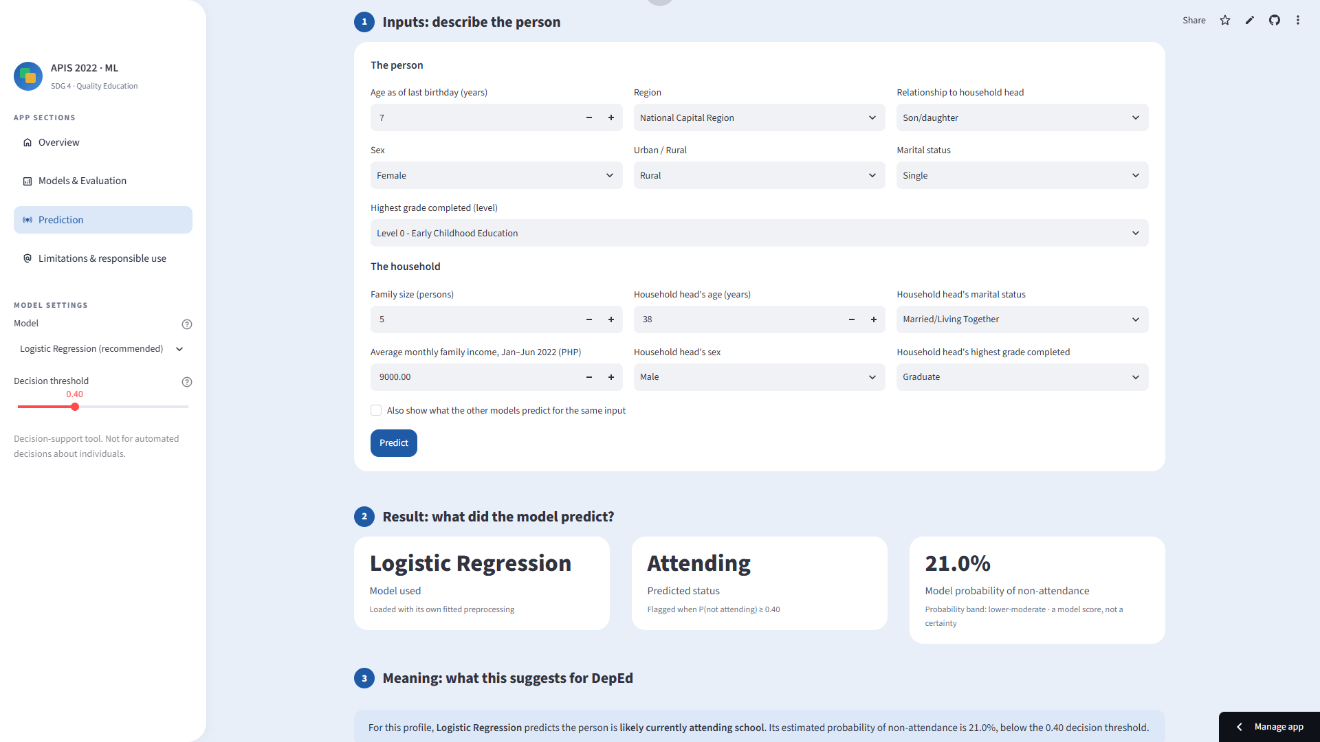
Screenshot 1. Scenario A inputs: a 7-year-old female in a rural area of the National Capital Region, with Logistic Regression and a decision threshold of 0.40 selected.
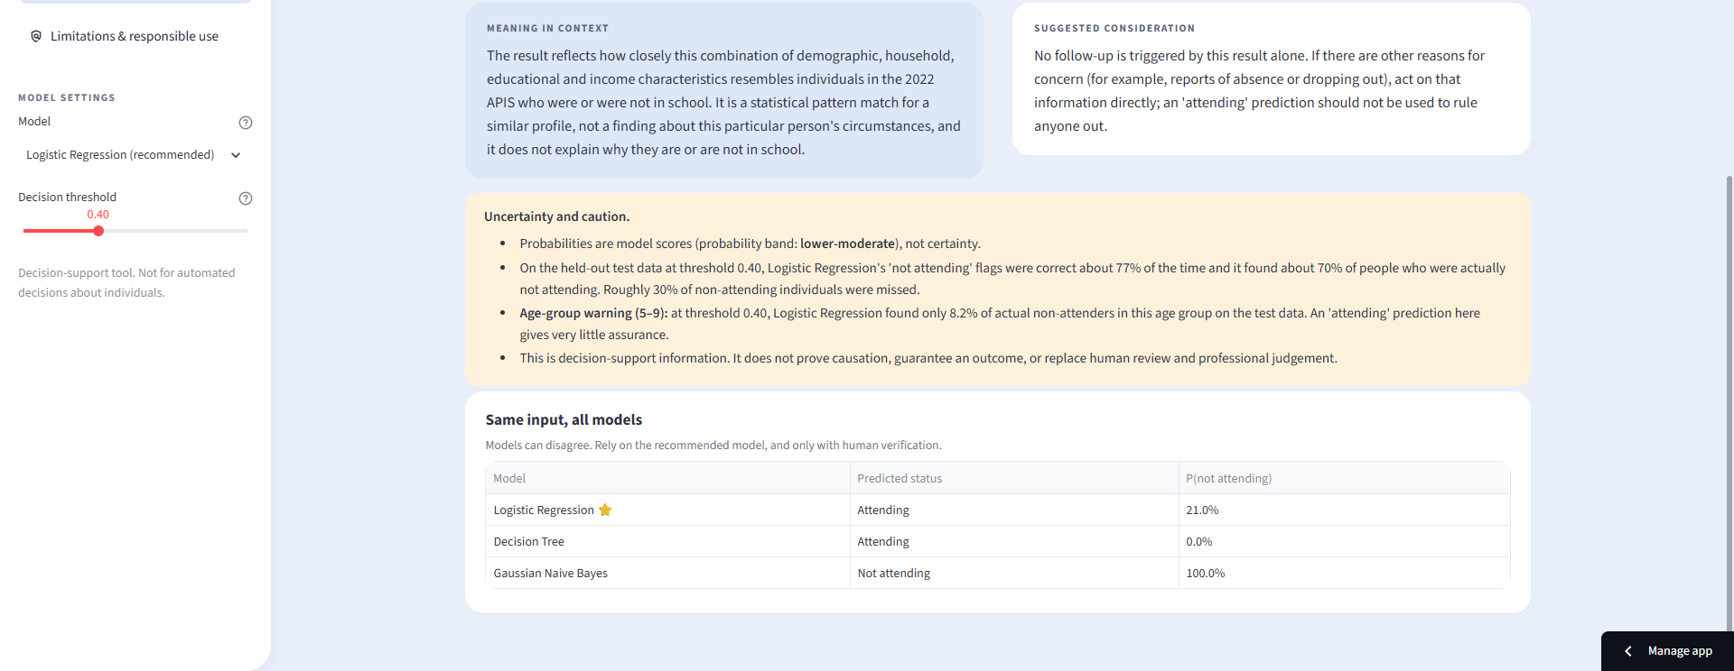
Screenshot 2. Scenario A result: Logistic Regression predicts “Attending” (probability of non-attendance 21.0%), shown with the interpretation, cautions and the all-model comparison.
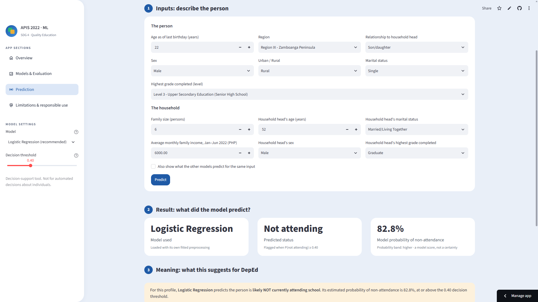
Screenshot 3. Scenario B inputs: a 22-year-old male in a rural area of Region IX – Zamboanga Peninsula, with Logistic Regression and a decision threshold of 0.40 selected.
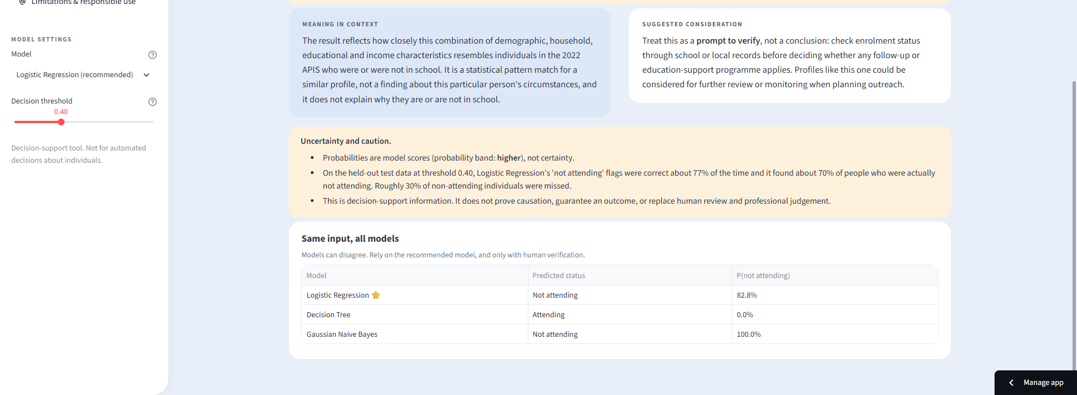
Screenshot 4. Scenario B result: Logistic Regression predicts “Not attending” (82.8%); the comparison shows the Decision Tree predicting “Attending” and Naive Bayes “Not attending”.

9.3 Stakeholder-Oriented Interpretation Logic
Interpretation is generated for every prediction from the predicted class, the probability band, the distance from the threshold, the chosen model and the person’s age group. It is never a generic paragraph.
Table 21. Interpretation design
Interpretation Element | Project Implementation
Plain-language prediction | States whether the person is likely attending or likely not attending, with the model used, the probability of non-attendance and the threshold.
Meaning in stakeholder context | Explains that the result is a pattern match to similar 2022 survey profiles, not a finding about the individual’s circumstances or its causes.
Possible next step / consideration | “Not attending”: treat as a prompt to verify enrolment through school or local records before any follow-up. “Attending”: no follow-up is triggered by the model alone, and other concerns should be acted on directly.
Uncertainty / caution | Probability band (low, lower-moderate, borderline, higher); a warning when the probability is within 0.10 of the threshold; test precision and recall at the chosen threshold; an age-group warning where recall is below 50%; and model-specific warnings for the Decision Tree (overfit) and Gaussian Naive Bayes (not recommended).
Human review / escalation rule | Always required. Predictions are decision support, and they do not prove causation or replace professional judgement.

9.4 Example Prediction Scenarios
Table 22. Example scenarios (decision threshold 0.40; results produced by the trained models in the project environment)
Scenario | Model Selected | Key Inputs | Prediction | Stakeholder Interpretation Summary
A | Logistic Regression | 7-year-old female, son/daughter of the household head; National Capital Region, rural; highest grade: Level 0; family size 5; head aged 38; income PHP 9,000. | Attending (P(not attending) 21.0%) | Likely attending. No follow-up is triggered by the model alone. For ages 5–9 an “attending” prediction gives very little assurance, because the model finds few non-attenders at this age.
A | Decision Tree / Gaussian NB | Same input | Tree: Attending (P(not attending) 0.0%)  Naive Bayes: Not attending (P(not attending) 100.0%) | Models disagree. Naive Bayes flags almost everyone, so its flag is not informative.
B | Logistic Regression | 22-year-old male, son/daughter of the household head; Region IX - Zamboanga Peninsula, rural; highest grade: Level 3; family size 6; head aged 52; income PHP 6,000. | Not attending (P(not attending) 82.8%) | Likely not attending. Treat as a prompt to verify enrolment. For ages 19–24 many people have completed their education, so non-attendance does not necessarily indicate a barrier.
B | Decision Tree / Gaussian NB | Same input | Tree: Attending (P(not attending) 0.0%)  Naive Bayes: Not attending (P(not attending) 100.0%) | The Decision Tree disagrees with the recommended model, which shows why model choice and human review matter.

10. Testing and Quality Assurance
The checks below were run against the trained models with the project’s prediction module. Items marked in yellow still need to be confirmed in the deployed application.
Table 23. Test log
Test | Expected Behavior | Actual Result | Status
Valid typical input | Prediction is generated correctly | Scenarios A and B returned predictions for all three models (A: Logistic Regression 21.0%, B: 82.8% probability of non-attendance). | Pass
Boundary / extreme valid input | App accepts valid range and remains stable | Age 24 and the maximum family size (20) were accepted and produced predictions. | Pass
Missing / invalid input | Clear validation feedback; no crash | The numeric fields enforce their allowed ranges (age 5–24, family size 1–20, income PHP 500–700,000, household head’s age 10–99); a value outside the range is flagged with a red error icon. If a numeric field is cleared, it is automatically filled with the most recent valid value, and the drop-down fields cannot be left blank. The app did not crash. No prediction is produced until the values are corrected. | Pass
Model switching | Selected model is actually used | The same input gave different probabilities for each model (A: 21.0% / 0.0% / 100.0% for Logistic Regression / Decision Tree / Naive Bayes). | Pass
Fresh environment | Project installs/runs from requirements.txt | Created a new virtual environment on Windows, Python 3.12.10; installed with pip install -r requirements.txt; the app launched and produced a prediction. | Pass
Deployment restart | Hosted app reloads model artifacts successfully | The hosted app was rebooted from Streamlit Cloud; models and evidence loaded and a prediction was produced. | Pass

11. Results and Stakeholder Value
What the system can reliably do (measured). On unseen households the recommended model separates attending from not-attending individuals well overall (91.09% accuracy, not-attending AP 80.30%) and finds about 65% of non-attenders at 0.50 (70% at 0.40), with correct flags 82% and 77% of the time respectively. Its recall is high for ages 19–24 (83.3%) and low for ages 5–9 (8.2%).
What decisions it can support (expected, not measured). DepEd and policymakers can use the tool to explore which profiles resemble non-attending individuals, to prioritise where verification or further analysis is worthwhile, and to illustrate how errors trade off at different thresholds. Compared with the original descriptive data story, which showed where and among whom non-attendance is concentrated, this adds an individual-profile view with transparent evidence about its errors.
No return on investment, programme impact or effect on enrolment was measured. Any such benefit is an expectation that would need to be tested in a pilot.

12. Limitations, Ethics, and Responsible Use
Table 24. Risks and limitations
Risk / Limitation | Why It Matters | Mitigation / Responsible-Use Guidance
Dataset coverage / representativeness | Data come from one survey year (2022) and one age range (5–24). Survey weights were not used in training, so results describe the sample rather than the national population. | Do not generalise to other years, populations or ages. Re-validate with new survey rounds.
Bias / fairness concern | Recall differs by age (8.2% to 83.3%) and by region (55.6% to 82.4%). Sex and urban/rural gaps are small (3.4 and 1.3 points). Several groups have few non-attenders (for example n = 48 for ages 10–12), so estimates are noisy. Sex, region and household characteristics may encode existing inequalities. | Report subgroup performance, treat gaps as signals to investigate, and do not use the model as the sole method for younger children. Consider complementary screening.
Prediction uncertainty | At the default threshold about 35% of non-attenders are missed and about 18% of flags are false; at 0.40 about 30% are missed and 23% of flags are false. | Present probabilities as scores, not certainty; flag borderline cases; verify every flag.
Data drift / changing conditions | Relationships between household characteristics and attendance may change after 2022 (policy, economic or pandemic effects). | Retrain and re-validate on new data before any further use.
Misuse / overreliance | Flags could be used to label people or groups, or an “attending” result could be used to rule someone out. | Use only as decision support with human review. Never use to deny assistance or to make causal claims.
Privacy / sensitive data | Inputs include sex, location, marital status, household and income information. | The app does not store inputs or personal identifiers. Any real use should follow the Data Privacy Act and PSA data-use terms.
Predictor definitions | “Head: Highest grade completed” has 272 categories, and the educational-attainment predictor reflects life stage, so the model largely learns age and attainment patterns. | Interpret flags as profile resemblance; consider simplifying categories in future work.

The application must NOT be used to: automatically decide who receives or is denied educational assistance; take action about an individual without human verification; conclude that any characteristic causes school non-attendance; screen young children (ages 5–9) on its own; or make claims about years, populations or age ranges outside the 2022 APIS ages 5–24.

13. Conclusion and Recommendations
Three classifiers were compared under a leakage-safe, household-grouped design. Logistic Regression gave the best balance of ranking quality, generalisation and interpretability and is recommended as the primary candidate for further validation. The Streamlit application exposes the models, the evidence and the prediction workflow, and translates every prediction into guidance for DepEd with explicit cautions. The strongest evidence is the combination of the highest not-attending Average Precision (80.95% in validation, 80.30% on test) with no meaningful train–test gap, and the most important limitation is low recall for ages 5–9.
Recommended next steps:
- Agree an operating threshold with DepEd, based on follow-up capacity and the relative cost of missed cases and false flags, and define a cost ratio so the threshold can be justified formally.
- Re-validate the chosen threshold and the subgroup results on additional data, such as another survey round, and report uncertainty (for example confidence intervals) for small subgroups.
- Develop complementary or age-specific screening for ages 5–12, where the current model finds few non-attenders.
- Try hyperparameter tuning, regularisation, simplified categories for the household head’s education, and tree-based ensemble models, then compare them under the same protocol.
- Pilot the tool with human verification and measure whether it improves the targeting of follow-up before any wider use.

14. References
Pedregosa, F., Varoquaux, G., Gramfort, A., Michel, V., Thirion, B., Grisel, O., … Duchesnay, É. (2011). Scikit-learn: Machine learning in Python. Journal of Machine Learning Research, 12, 2825–2830.
Philippine Statistics Authority. (2023). Four out of five children aged 5 to 24 years were attending school for school year 2022 to 2023. https://psa.gov.ph/content/four-out-five-children-aged-5-24-years-were-attending-school-school-year-2022-2023
Philippine Statistics Authority. (n.d.). Annual Poverty Indicators Survey [Dataset]. https://psada.psa.gov.ph/catalog/APIS/about
Streamlit Inc. (n.d.). Streamlit documentation. https://docs.streamlit.io
United Nations Department of Economic and Social Affairs. (n.d.). Goal 4. https://sdgs.un.org/goals/goal4#overview

Appendices

Appendix A – Reproducibility and Environment
- Python 3.11 or newer; scikit-learn 1.8.0 (pinned), pandas 3.0.2, numpy 2.4.4 used to train the submitted artifacts.
- requirements.txt: streamlit ≥ 1.40, scikit-learn (pinned), pandas ≥ 2.2, numpy ≥ 1.26, matplotlib ≥ 3.8, joblib ≥ 1.3.
- Random seed: random_state = 42 for the split, cross-validation and models.
- To regenerate everything: place APIS_PUF_2022_Integrated_Cleaned.csv in the data folder, run “python train_models.py”, then “python export_evidence.py”, then “streamlit run app.py”.
- Tables and figures in this report were generated from models/evidence.json and are saved in assets/evidence.

Appendix B – Additional Model Evidence
Table 25. Test-set threshold table for Logistic Regression (informational; not used to choose the threshold; all values in %)
Threshold | Accuracy | Precision (not attending) | Recall (not attending) | F1 (not attending)
0.20 | 87.56 | 61.14 | 83.07 | 70.44
0.30 | 90.17 | 70.54 | 77.06 | 73.65
0.40 | 90.87 | 76.51 | 70.42 | 73.34
0.50 | 91.09 | 81.71 | 64.52 | 72.10
0.60 | 90.46 | 85.03 | 56.44 | 67.85
0.70 | 89.63 | 88.67 | 47.98 | 62.27
0.80 | 88.54 | 92.52 | 38.90 | 54.77
Table 26. Not-attending recall by sex (test set)
Sex | n | Not attending (n) | Recall @0.50 | Recall @selected
Male | 7,482 | 1,461 | 66.26 | 71.87
Female | 6,957 | 1,115 | 62.24 | 68.52
Table 27. Not-attending recall by urban/rural residence (test set)
Residence | n | Not attending (n) | Recall @0.50 | Recall @selected
Urban | 6,254 | 1,164 | 64.86 | 71.13
Rural | 8,185 | 1,412 | 64.24 | 69.83
Table 28. Not-attending recall by region (test set)
Region | n | Not attending (n) | Recall @0.50 | Recall @selected
Region II - Cagayan Valley | 535 | 74 | 75.68 | 82.43
Region XI - Davao | 797 | 137 | 74.45 | 78.83
Region IVA - CALABARZON | 729 | 143 | 74.83 | 76.92
Region V- Bicol | 890 | 116 | 67.24 | 75.86
Region I - Ilocos Region | 532 | 98 | 74.49 | 74.49
Region III - Central Luzon | 1,086 | 211 | 68.72 | 73.93
National Capital Region | 1,716 | 337 | 68.25 | 73.29
Region XII - SOCCSKSARGEN | 738 | 139 | 66.91 | 72.66
Region X - Northern Mindanao | 911 | 131 | 67.94 | 71.76
Region VIII - Eastern Visayas | 1,011 | 172 | 67.44 | 71.51
Region VII - Central Visayas | 726 | 150 | 64.67 | 70.67
Cordillera Administrative Region | 789 | 118 | 56.78 | 69.49
Region XIII - Caraga | 804 | 131 | 57.25 | 67.94
MIMAROPA | 728 | 125 | 52.00 | 66.40
Region VI - Western Visayas | 890 | 162 | 53.70 | 61.11
BARMM | 951 | 188 | 55.32 | 60.64
Region IX - Zamboanga Peninsula | 606 | 144 | 54.17 | 55.56
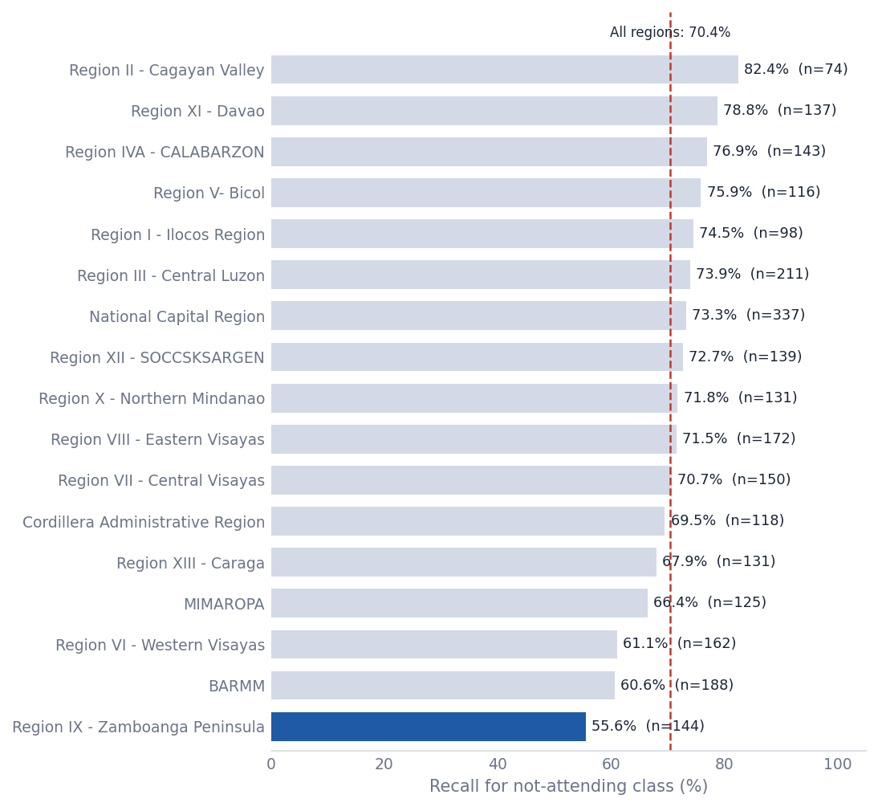
Figure 6. Not-attending recall by region at threshold 0.40.

Appendix C – Streamlit Screenshots
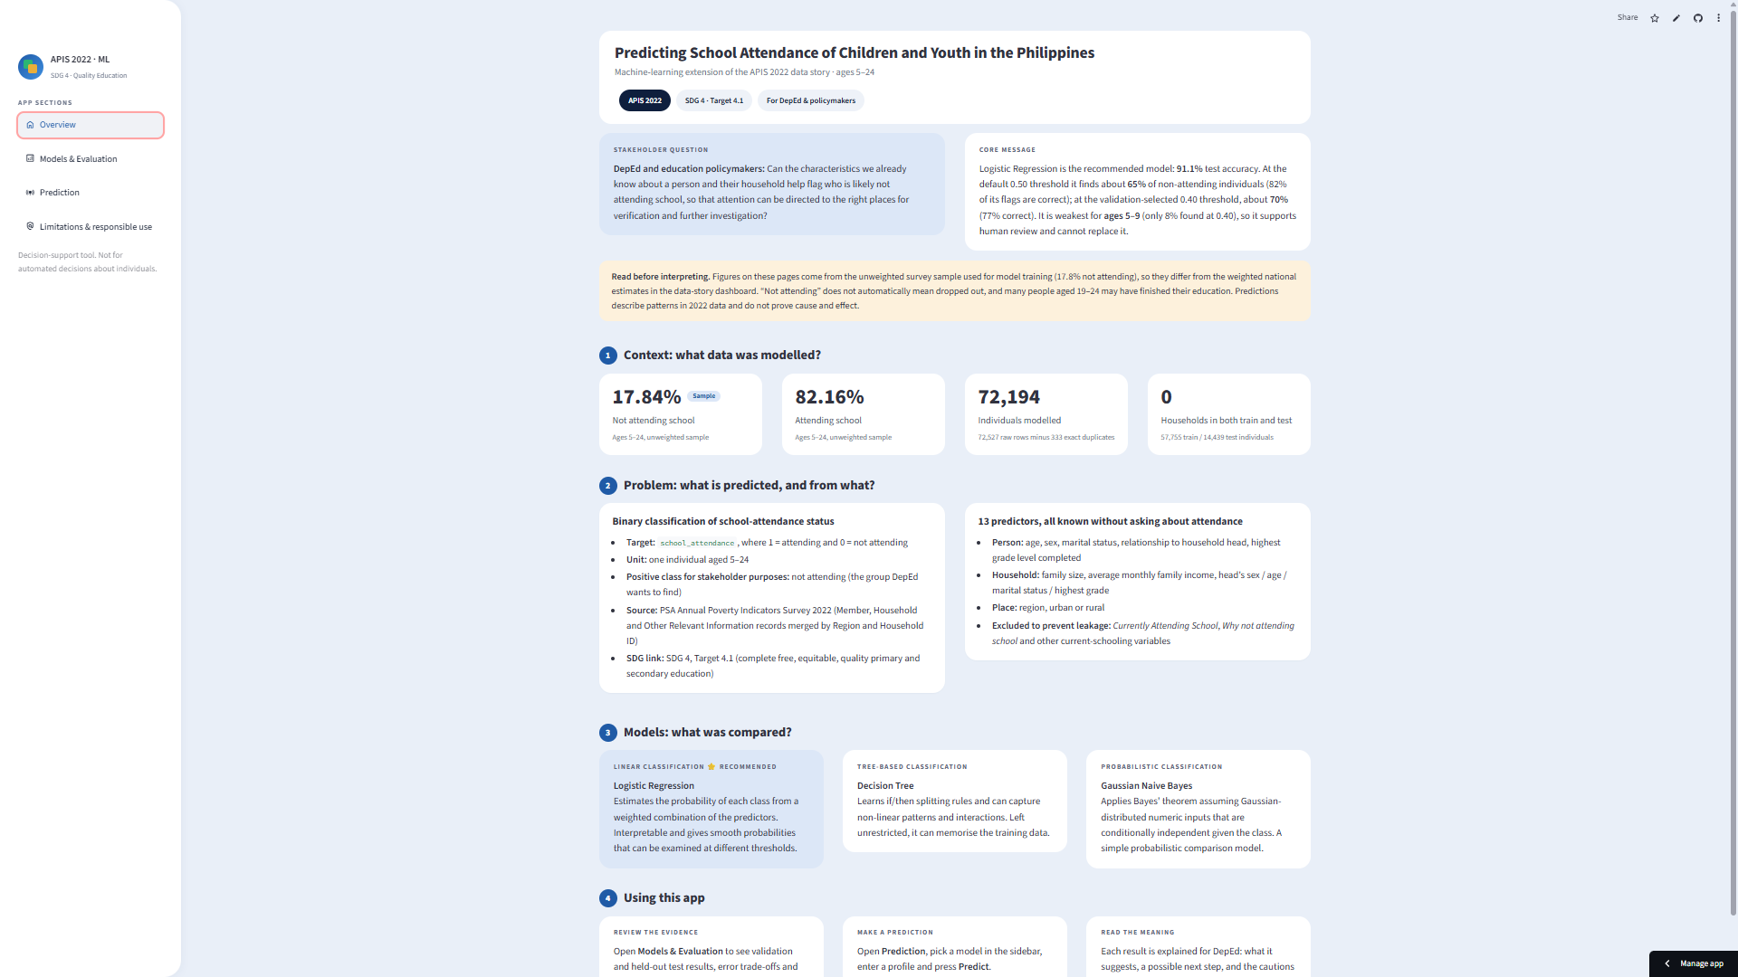
Screenshot 5. Overview page: stakeholder question, core message, dataset summary cards and model overview.
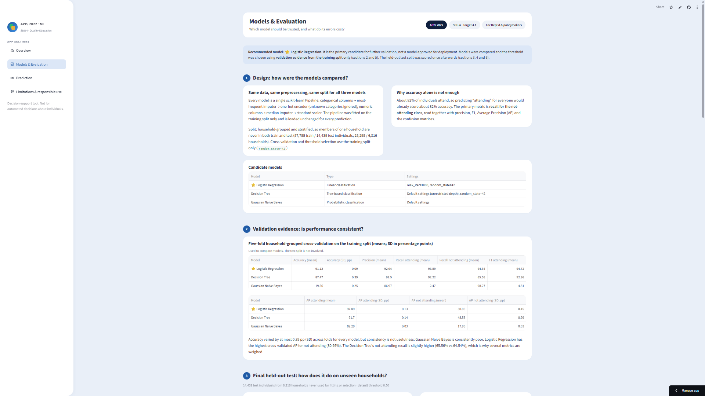
Screenshot 6. Models & Evaluation page: validation and held-out test evidence, confusion matrices, threshold trade-off and subgroup performance.
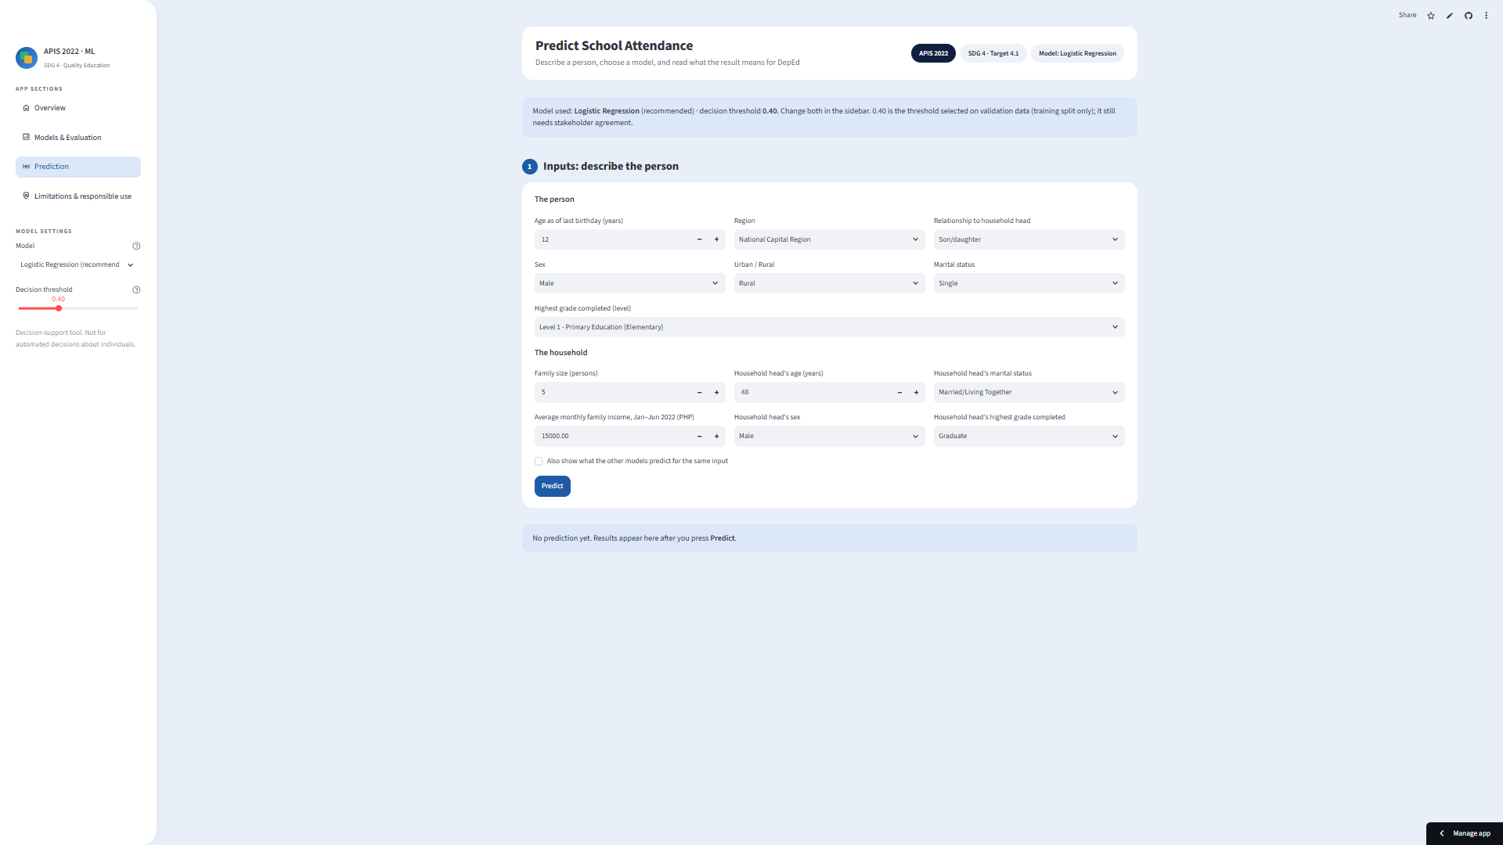
Screenshot 7. Prediction page with a completed form: the model and threshold are chosen in the sidebar and the inputs are restricted to valid ranges.
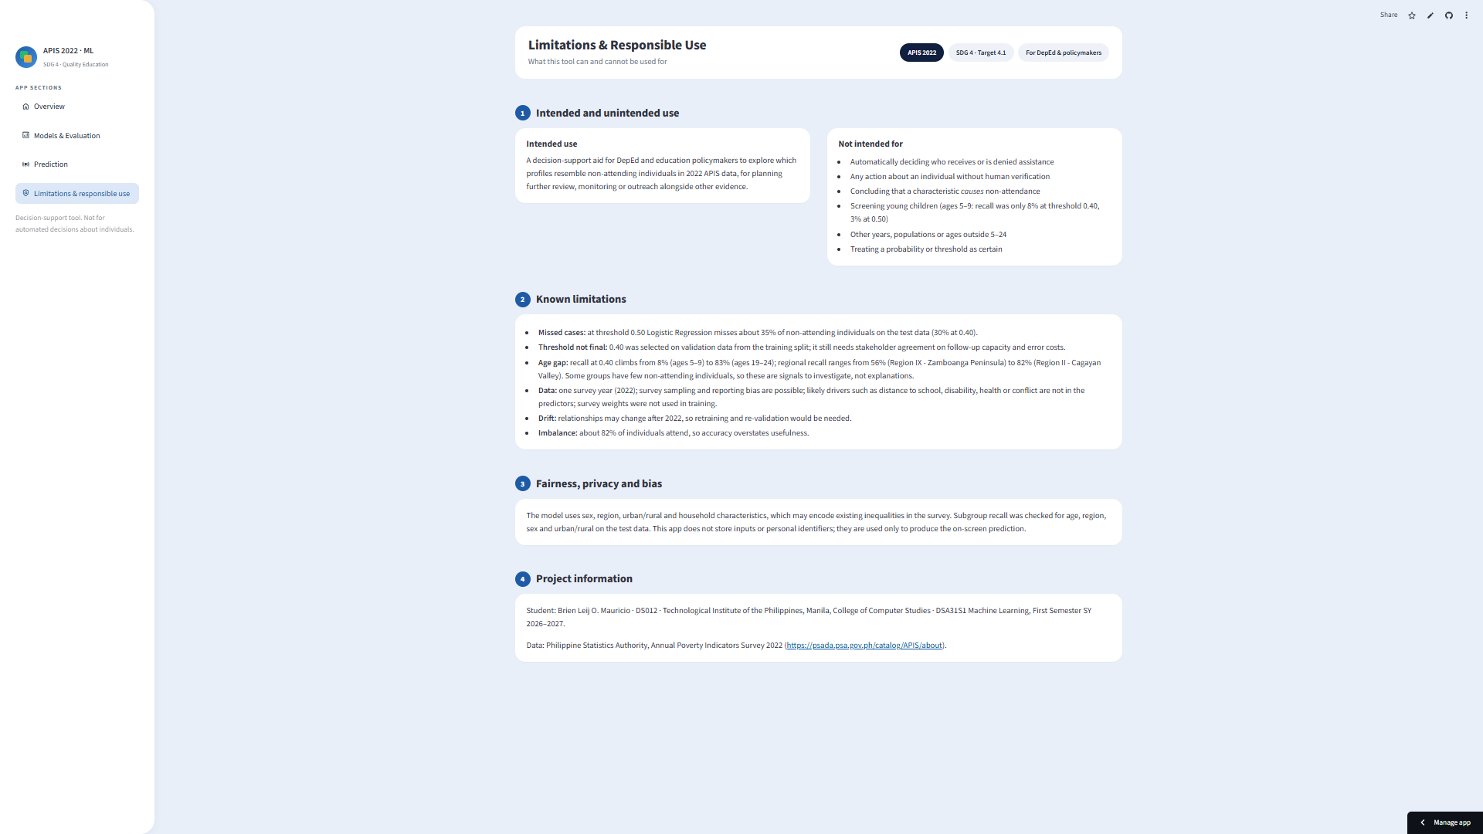
Screenshot 8. Limitations & responsible use page: intended and unintended use, known limitations and fairness notes.

Appendix D – Data Dictionary / Feature Definitions
The full data dictionary appears in Section 3.2. Category counts for the categorical predictors are: Region 17, Relationship to Household Head 7, Sex 2, Marital Status 6, Highest Grade Completed – Level 8, Head: Sex 2, Head: Marital Status 6, Head: Highest grade completed 272, Urban / Rural 2. Allowed values are stored in models/metadata.json.

Appendix E – Additional Technical Notes
- The final results were regenerated with scikit-learn 1.8.0. The group assignment produced by StratifiedGroupKFold can differ between library versions, which is a likely reason for small differences from the Lab 04 report (for example, Logistic Regression test accuracy of 91.09% here versus 91.29% in Lab 04). This report uses the regenerated results throughout.
- The final protocol differs from Lab 04 in one important way: the threshold is now chosen on out-of-fold predictions from the training split, whereas Lab 04 examined thresholds on the test set. The selected threshold (0.40) is the same under both approaches.
- AI tool usage disclosure. AI tools were used as support throughout this project. ChatGPT was used from the early stage of developing the project idea through building the Google Colab notebook: explaining machine learning concepts, assisting with Python and scikit-learn code, helping interpret the model evaluation results, and suggesting ways to organise the analysis. Claude (Anthropic) was then used to turn the notebook into the final project: building the Streamlit application and the model training and evaluation scripts, strengthening the validation approach, and drafting this report from the project’s results. The dataset, the model training and evaluation runs, the deployment of the application and all testing were carried out by the student, who also reviewed and validated the code, the results and the final analysis. The figures and tables in this report were generated from the project’s own outputs. AI tools were used as assistance and not as a substitute for the actual dataset analysis or model evaluation.

