Chemotherapy Toxicity in the Elderly- Statistical Report

Dr. Benjamin Moran MBBS, BMedSci (Hons), MMedStats, FANZCA, FCICM

## Part 1: Methods and Analysis

**Aims/Objectives**

*Primary Objectives*

1. Describe patterns of chemotherapy/immunotherapy use.
2. Describe associated toxicity of chemotherapy/immunotherapy agents

*Secondary Objectives*

1. Evaluate the cancer outcomes for the elderly cohort including Disease-Free Survival (DFS), Progression-Free Survival (PFS) and Overall Survival (OS).

**Methods**

**Statistical Analysis**

Baseline patient characteristics were summarised using standard descriptive statistics. Continuous variables were reported as means with standard deviation and categorical variables reported as number and percentages. All values excluded missing values.

Overall survival (OS), disease-free survival (DFS) and progression-free survival (PFS) were evaluated using the Kaplan-Meier method. Kaplan-Meier survival curves were constructed to estimate the median OS, DFS and PFS. Stratified survival curves were constructed using prespecified subgroups: age, sex, smoking status, Eastern Cooperative Oncology Group (ECOG) performance status and number of comorbidities. Comparison between the subgroups were performed using the log-rank test. Two-sided *p* values <0.05 were considered significant.

Statistical analyses were performed using R Version 4.0.3 (R Core Team, R Foundation for Statistical Computing, Vienna, Austria) and RStudio Version 1.4.1103 (RStudio, PBC, Boston, MA). Packages used for analysis included tidyverse, survival, survminer and gtsummary.

## Part 2: Patient Demographics

| Characteristic | N = 921 |
| --- | --- |
| **Age (Years)** | 80.0 (77.0, 83.0) |
| **Age** |  |
| *75-80* | 49 (53%) |
| *81-85* | 32 (35%) |
| *86-90* | 11 (12%) |
| **Sex** |  |
| *Female* | 42 (46%) |
| *Male* | 50 (54%) |
| **Smoking Status** |  |
| *Current* | 4 (4.8%) |
| *Never* | 27 (32%) |
| *Previous* | 53 (63%) |
| **ECOG Scale** |  |
| *0* | 25 (50%) |
| *1* | 23 (46%) |
| *2* | 2 (4.0%) |
| **Number of Comorbidities** |  |
| *0* | 3 (3.3%) |
| *1* | 25 (27%) |
| *2* | 26 (28%) |
| *3* | 17 (18%) |
| *4* | 21 (23%) |
| **Tumour Stream** |  |
| *Breast* | 6 (6.5%) |
| *Colorectal* | 16 (17%) |
| *Cutaneous SCC* | 1 (1.1%) |
| *Gynaecology* | 3 (3.3%) |
| *Head and Neck* | 3 (3.3%) |
| *Lung* | 28 (30%) |
| *Melanoma* | 8 (8.7%) |
| *Merkel Cell* | 1 (1.1%) |
| *Neurological* | 2 (2.2%) |
| *Prostate* | 4 (4.3%) |
| *Sarcoma* | 2 (2.2%) |
| *Skin* | 3 (3.3%) |
| *Upper GI* | 8 (8.7%) |
| *Urogenital* | 2 (2.2%) |
| *Urological* | 5 (5.4%) |
| 1Median (IQR); n (%) | |

## Part 3: Survival Curves

### Overall Survival

| Quantile | Months | 95% CI1 |
| --- | --- | --- |
| 50% | 27.3 | 18.6, 45.7 |
| 1CI = Confidence Interval | | |

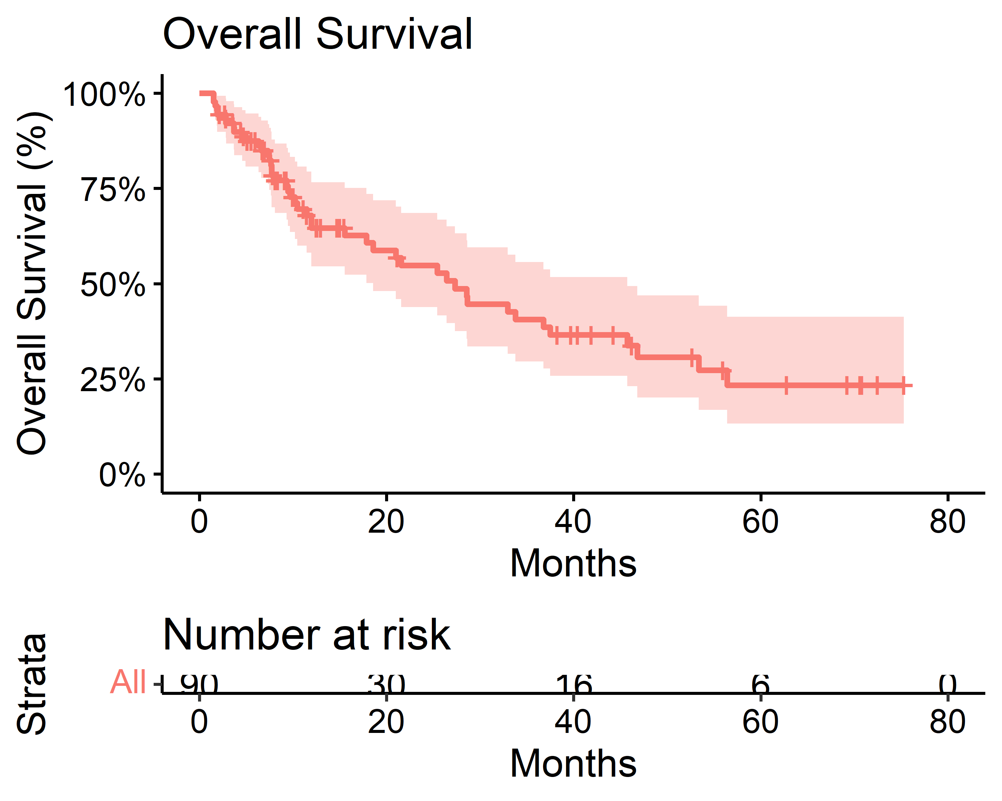

### Disease-Free Survival

| Quantile | Months | 95% CI1 |
| --- | --- | --- |
| 50% | 44.7 | 21.8, - |
| 1CI = Confidence Interval | | |

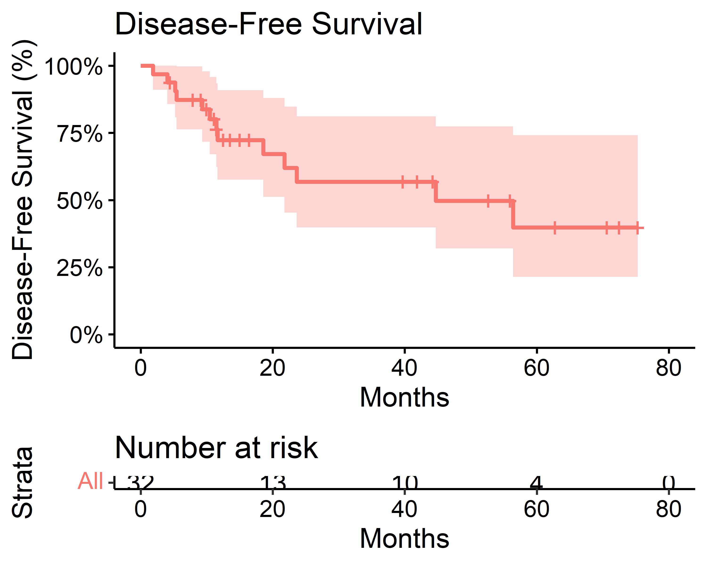

### Progression-Free Survival

| Quantile | Months | 95% CI1 |
| --- | --- | --- |
| 50% | 6.33 | 4.65, 10.4 |
| 1CI = Confidence Interval | | |

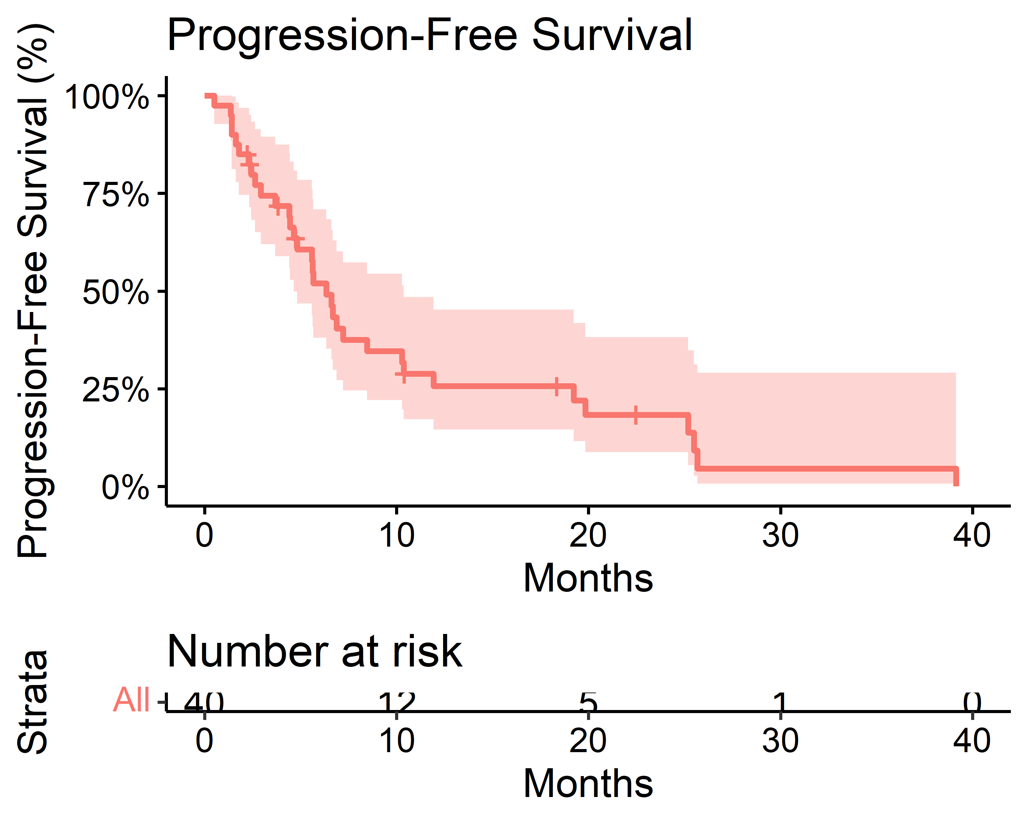

## Part 4: Survival Curves- Stratified Subgroups

### Overall Survival

#### Age

| Characteristic | Median Survival (Months) |
| --- | --- |
| Age_Cat |  |
| 75-80 | 37 (26, —) |
| 81-85 | 12 (7.7, —) |
| 86-90 | 25 (12, —) |

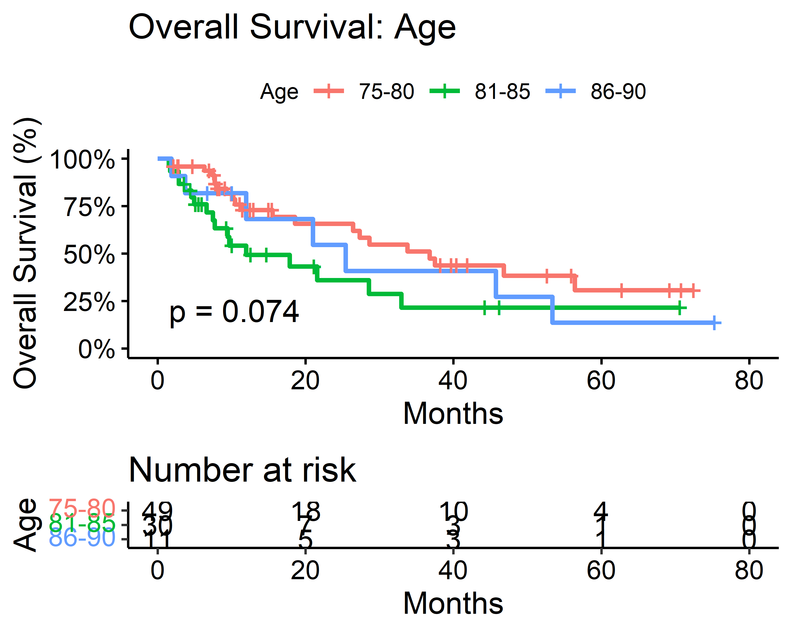

#### Sex

| Characteristic | Median Survival (Months) |
| --- | --- |
| Sex |  |
| Female | 27 (12, 46) |
| Male | 29 (18, —) |

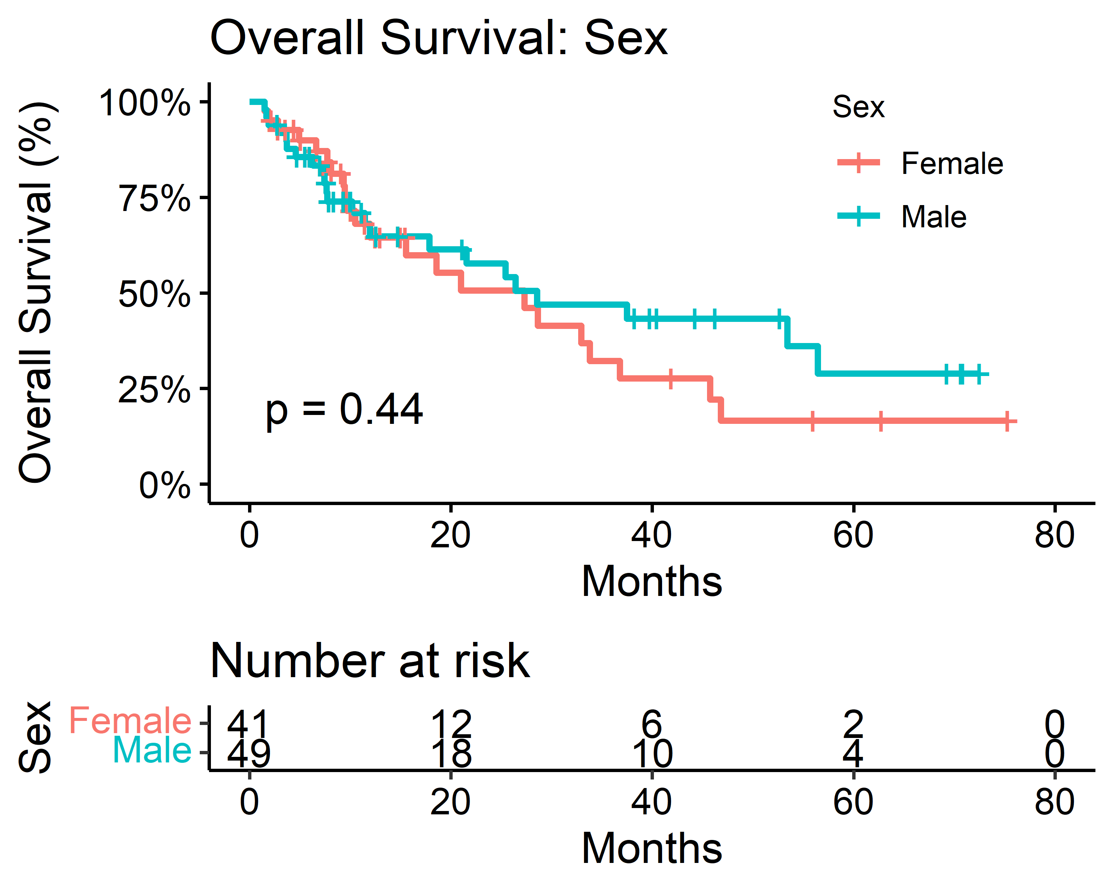

#### ECOG Scale

| Characteristic | Median Survival (Months) |
| --- | --- |
| ECOG |  |
| 0 | 29 (21, —) |
| 1 | 25 (10, —) |
| 2 | 20 (12, —) |

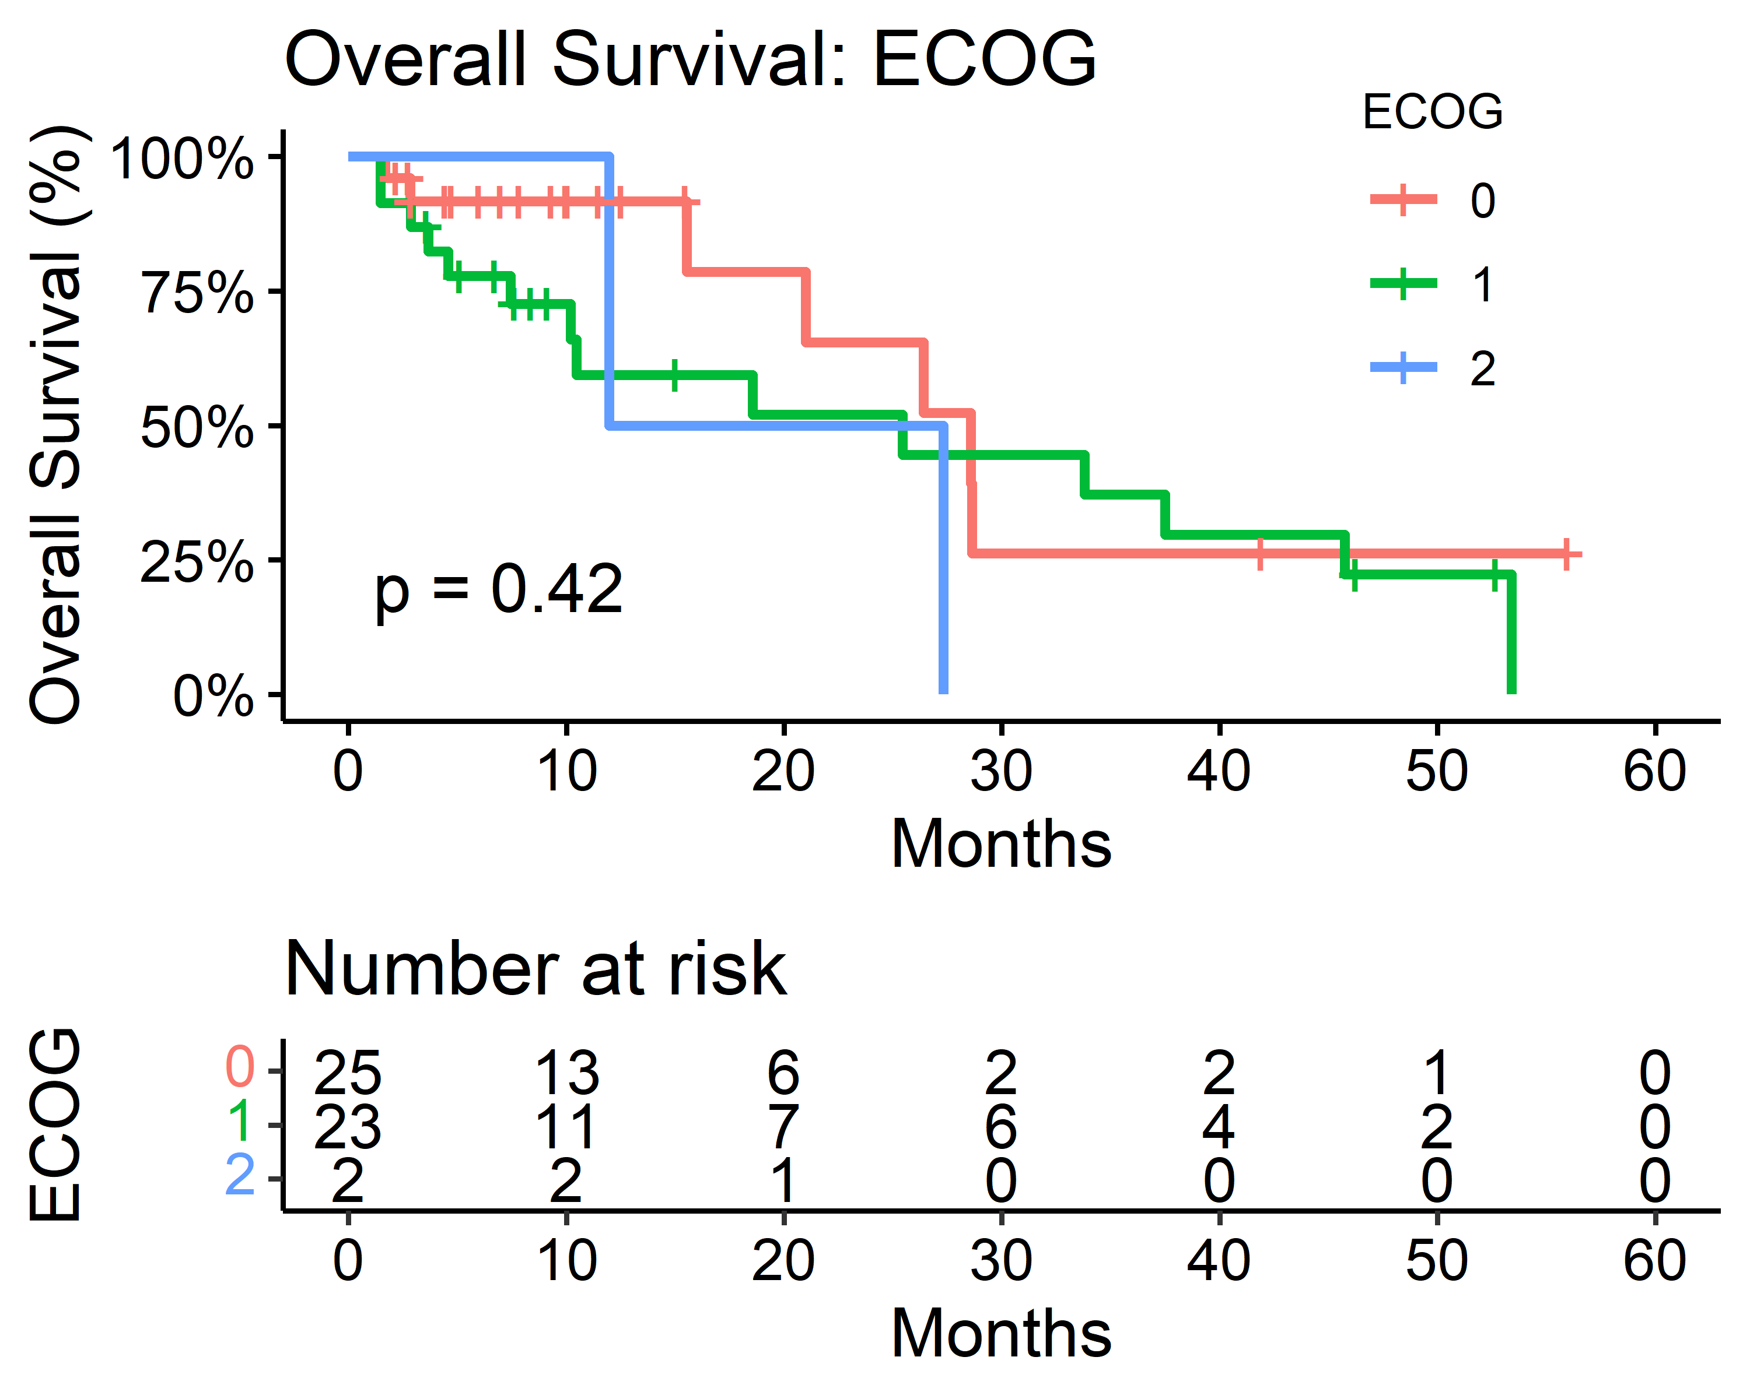

#### Smoking Status

| Characteristic | Median Survival (Months) |
| --- | --- |
| Smoker |  |
| Current | 37 (6.6, —) |
| Never | 29 (12, —) |
| Previous | 26 (19, —) |

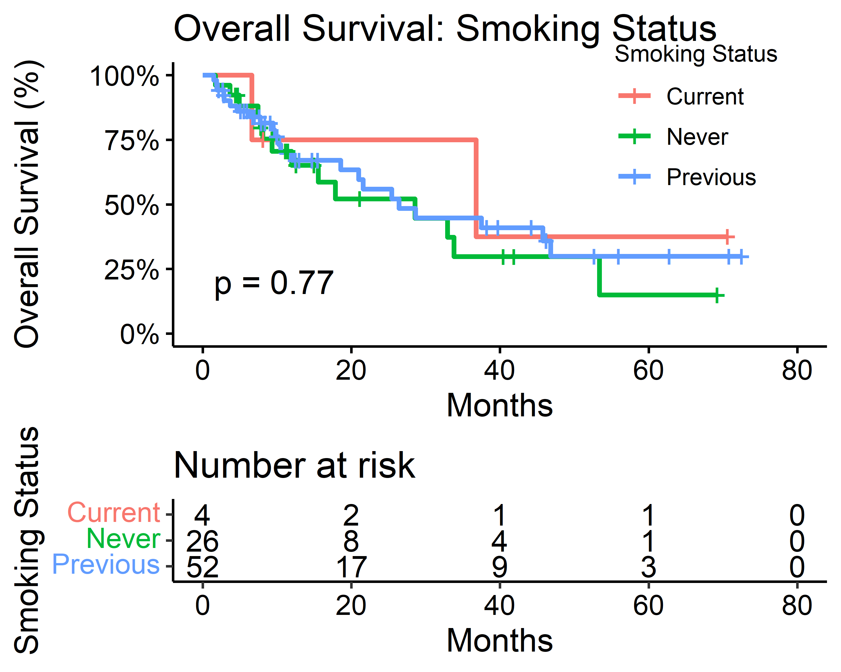

#### Comorbidities

| Characteristic | Median Survival (Months) |
| --- | --- |
| Comorbidities |  |
| 0 | 37 (4.9, —) |
| 1 | 22 (12, —) |
| 2 | 29 (12, —) |
| 3 | 16 (8.1, —) |
| 4 | 29 (9.5, —) |

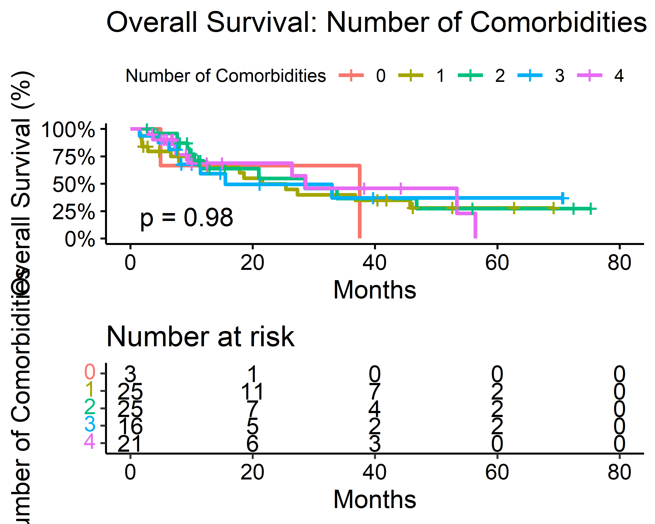

### Disease-Free Survival

#### Age

| Characteristic | Median Survival (Months) |
| --- | --- |
| Age_Cat |  |
| 75-80 | 56 (24, —) |
| 81-85 | — (5.4, —) |
| 86-90 | 22 (1.9, —) |

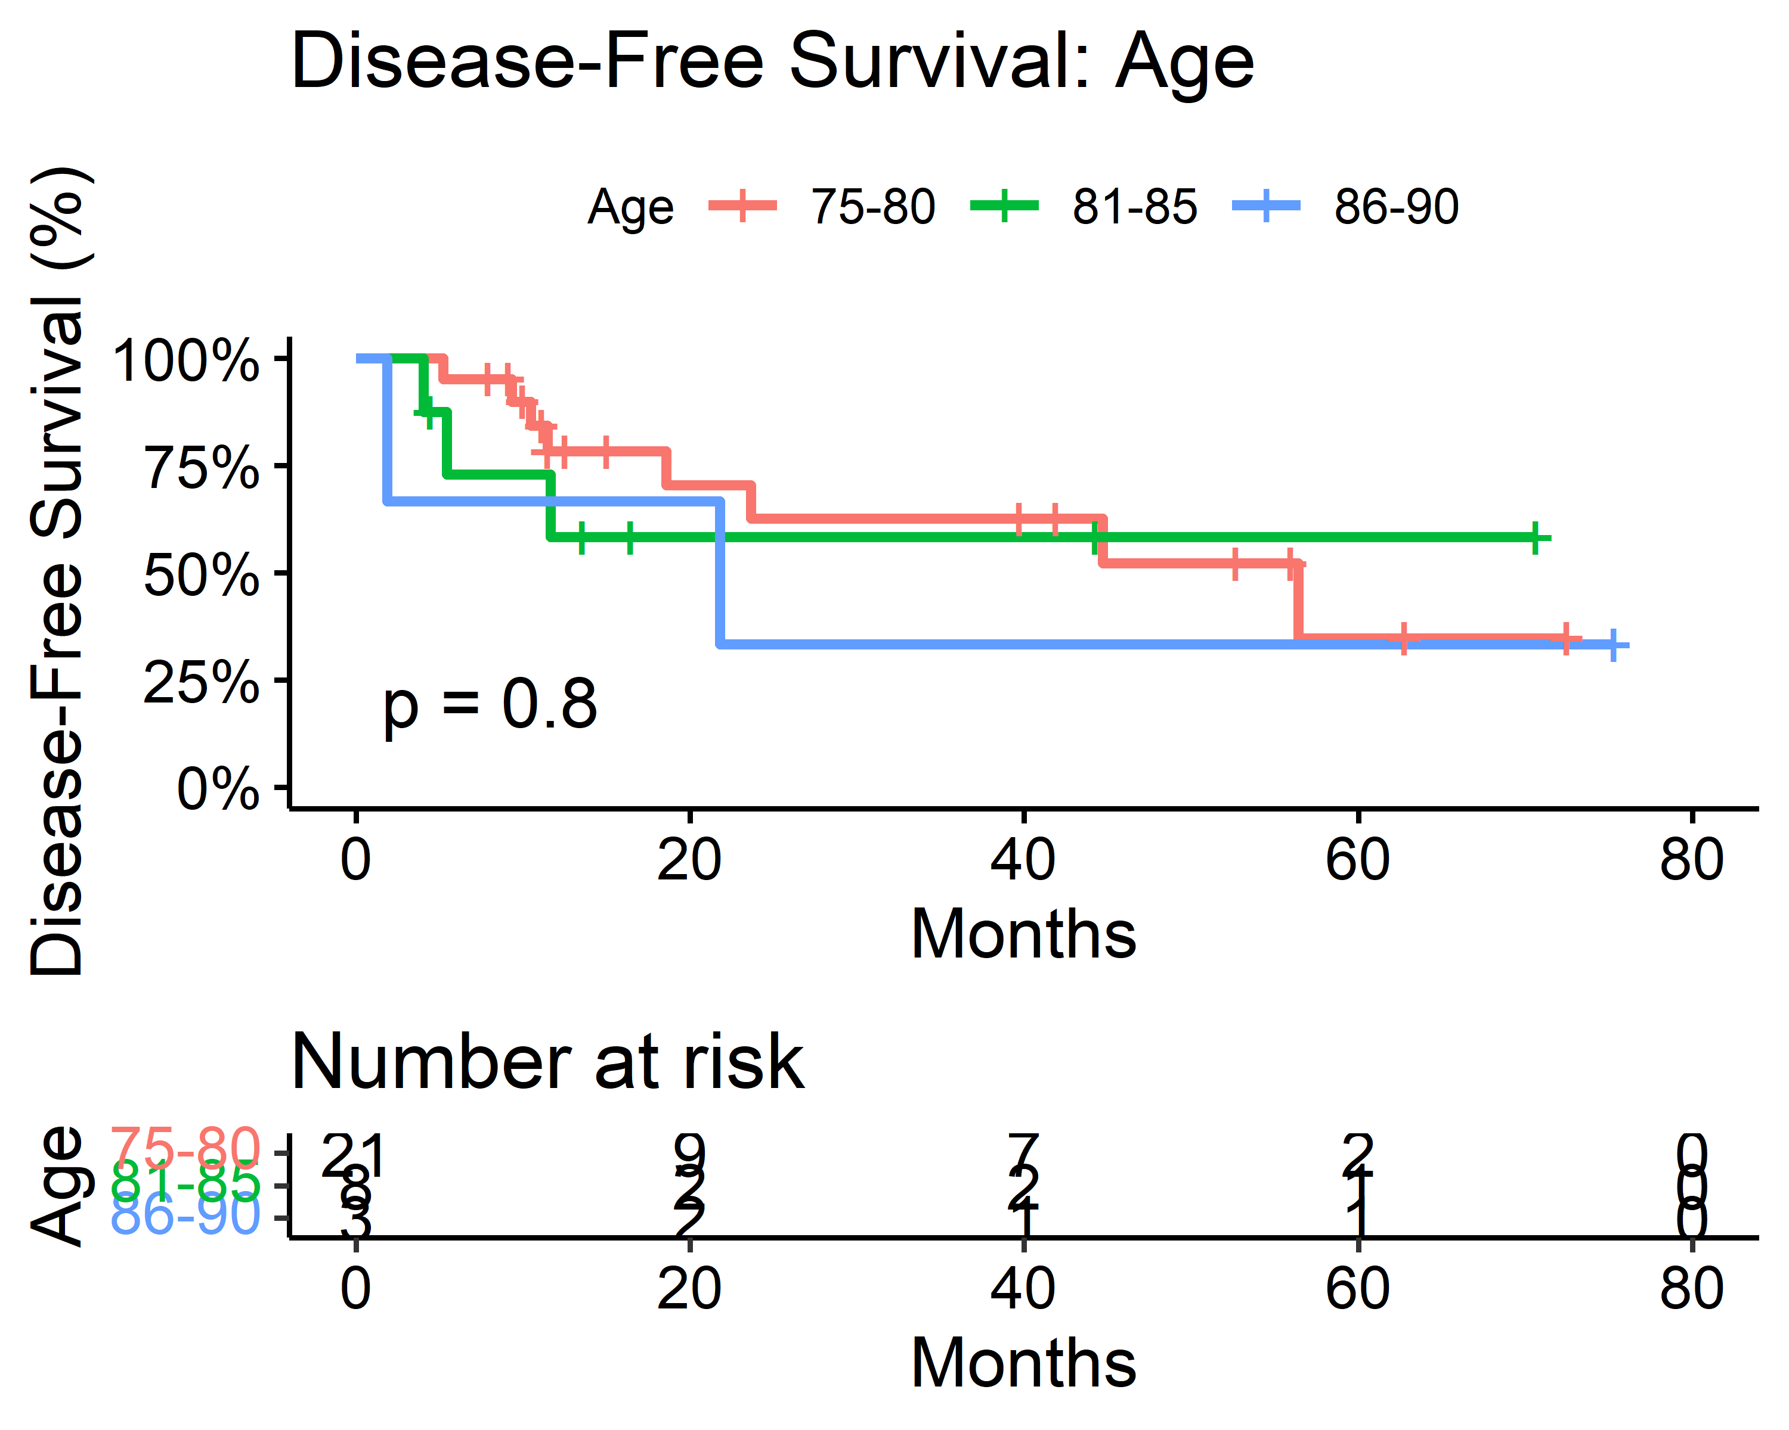

#### Sex

| Characteristic | Median Survival (Months) |
| --- | --- |
| Sex |  |
| Female | 45 (19, —) |
| Male | 56 (22, —) |

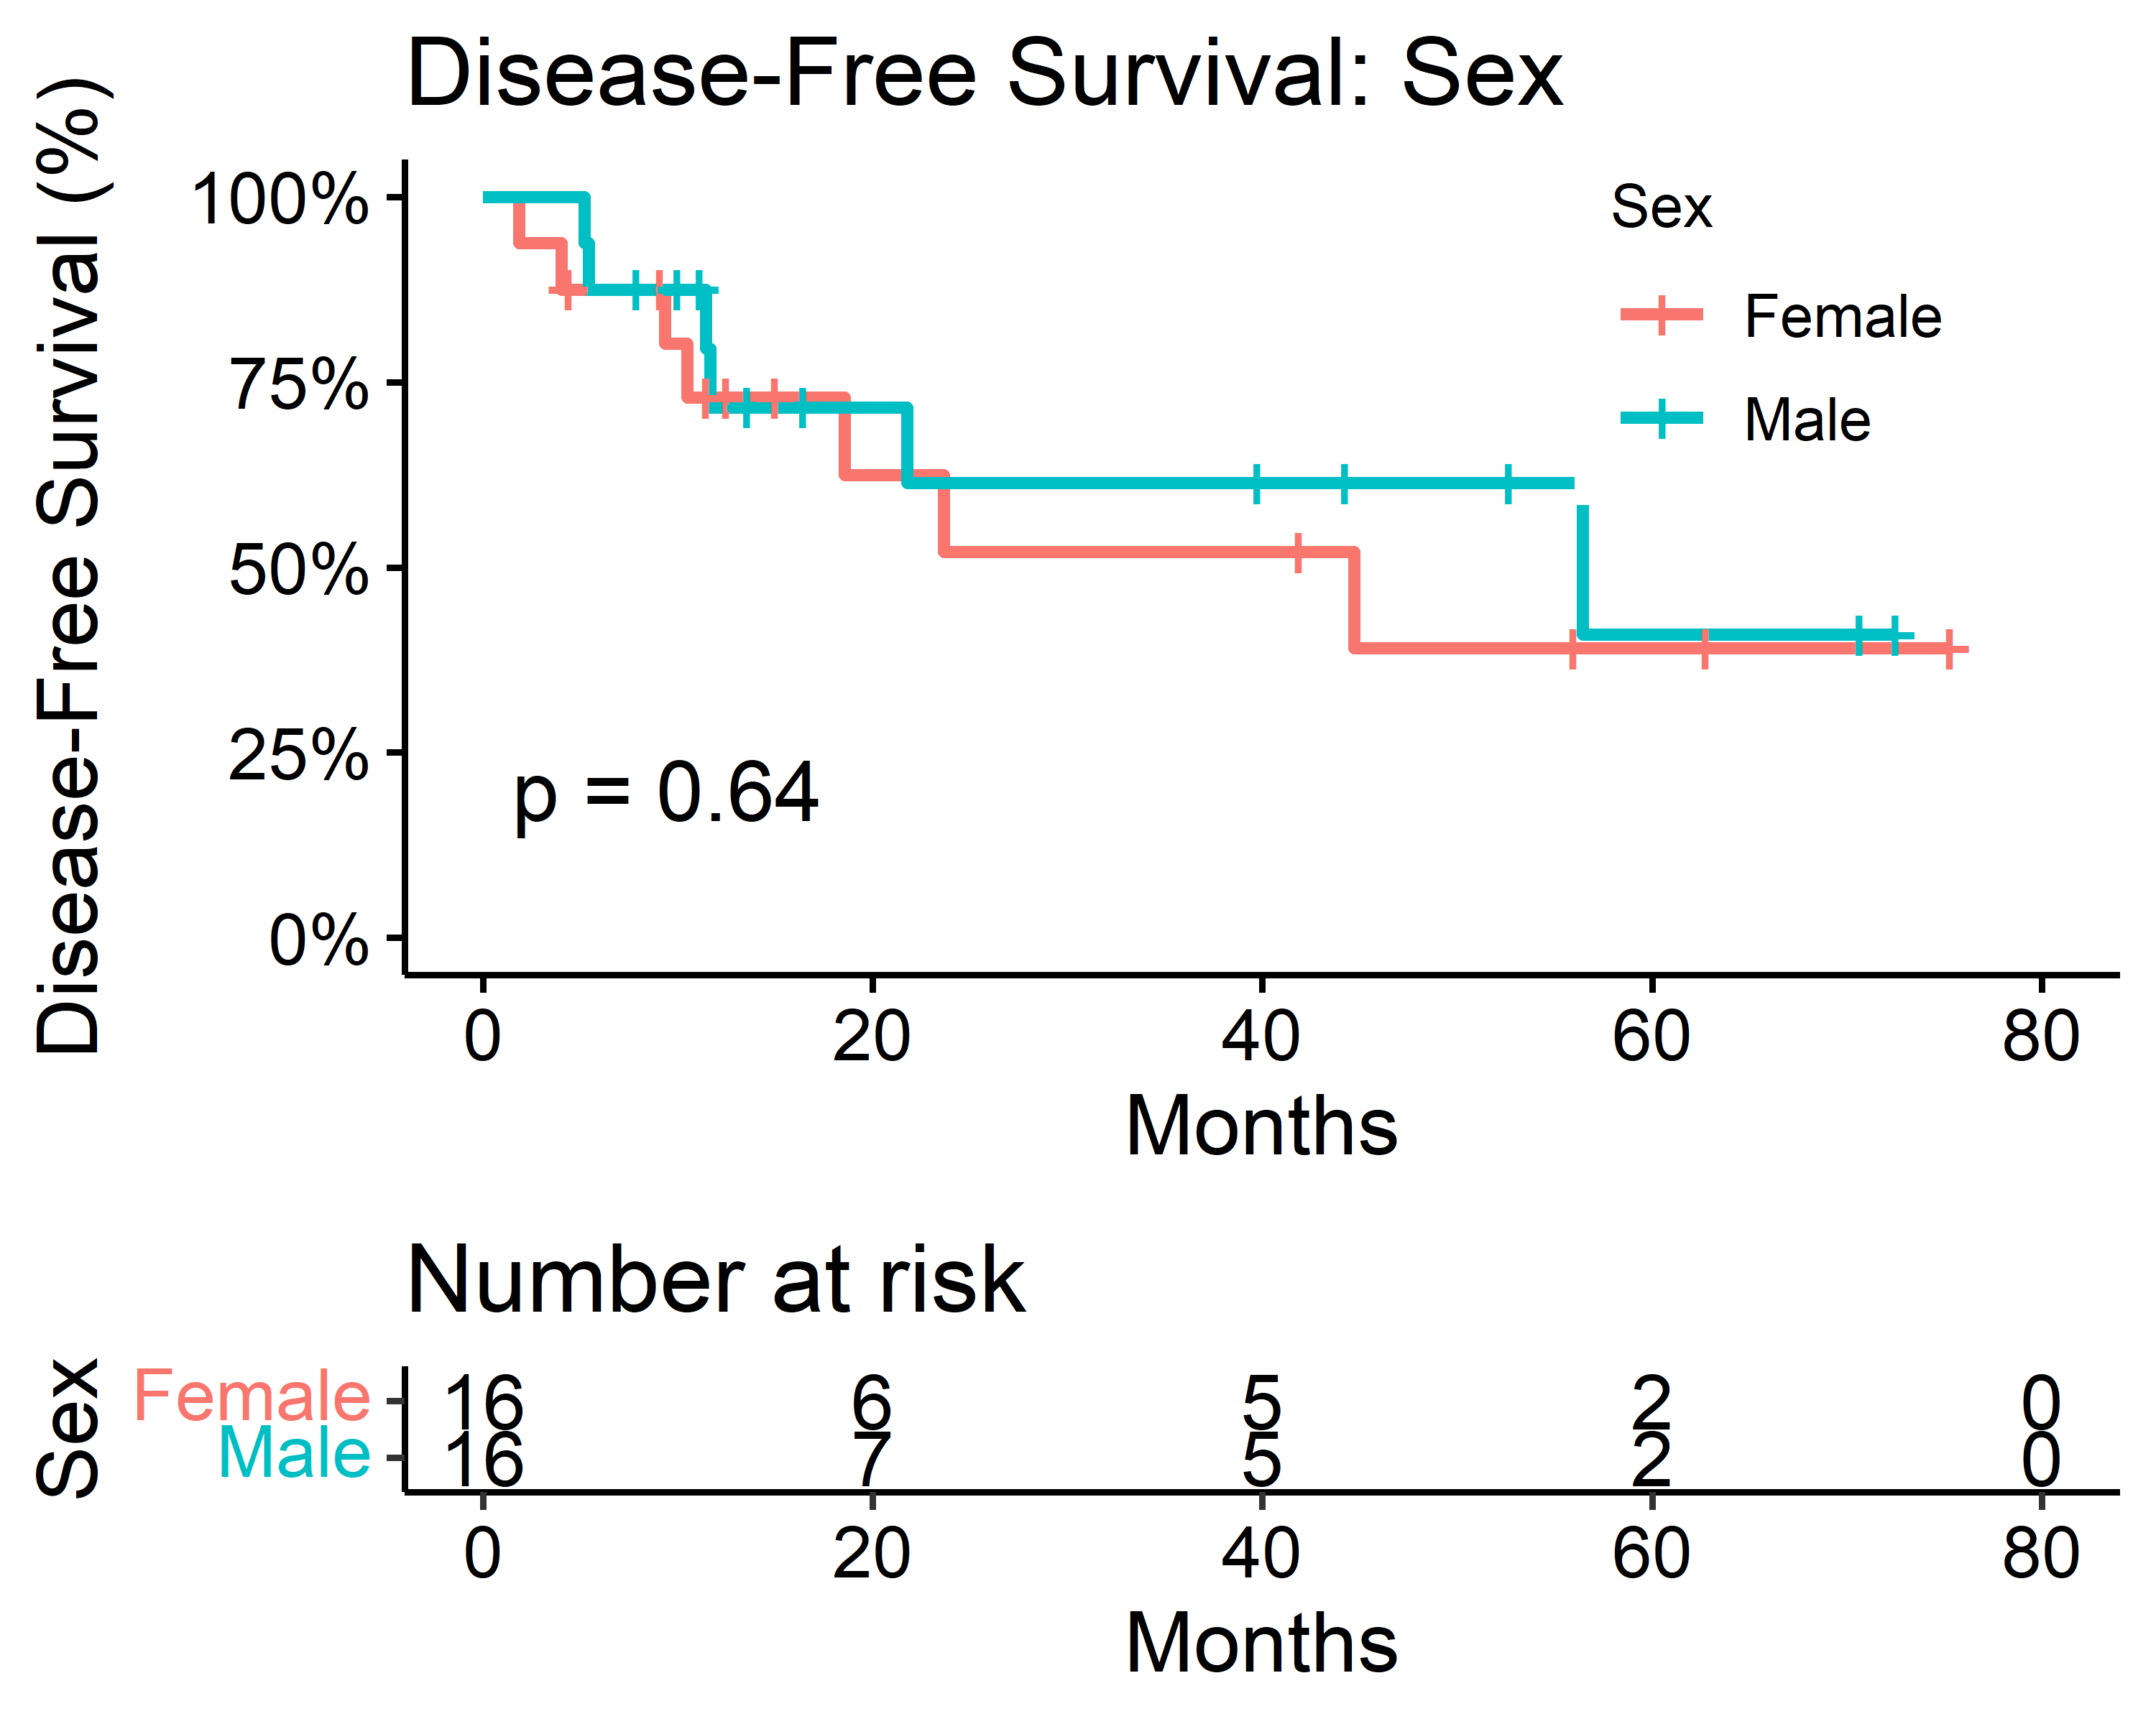

#### ECOG Scale

| Characteristic | Median Survival (Months) |
| --- | --- |
| ECOG |  |
| 0 | — (12, —) |
| 1 | 22 (19, —) |
| 2 | 5.4 (—, —) |

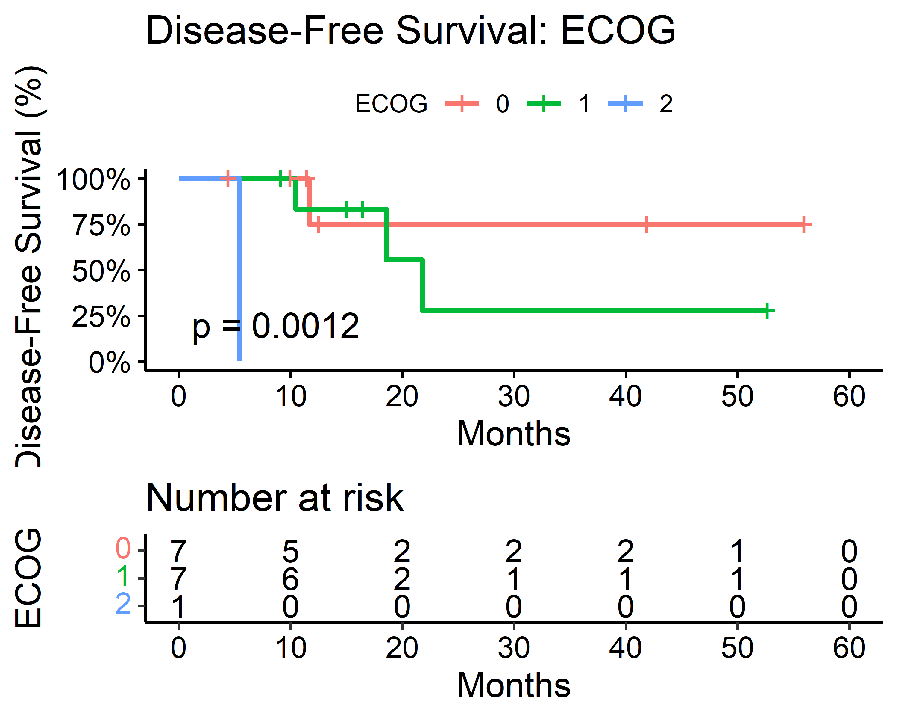

#### Smoking Status

| Characteristic | Median Survival (Months) |
| --- | --- |
| Smoker |  |
| Current | 47 (24, —) |
| Never | — (12, —) |
| Previous | — (22, —) |

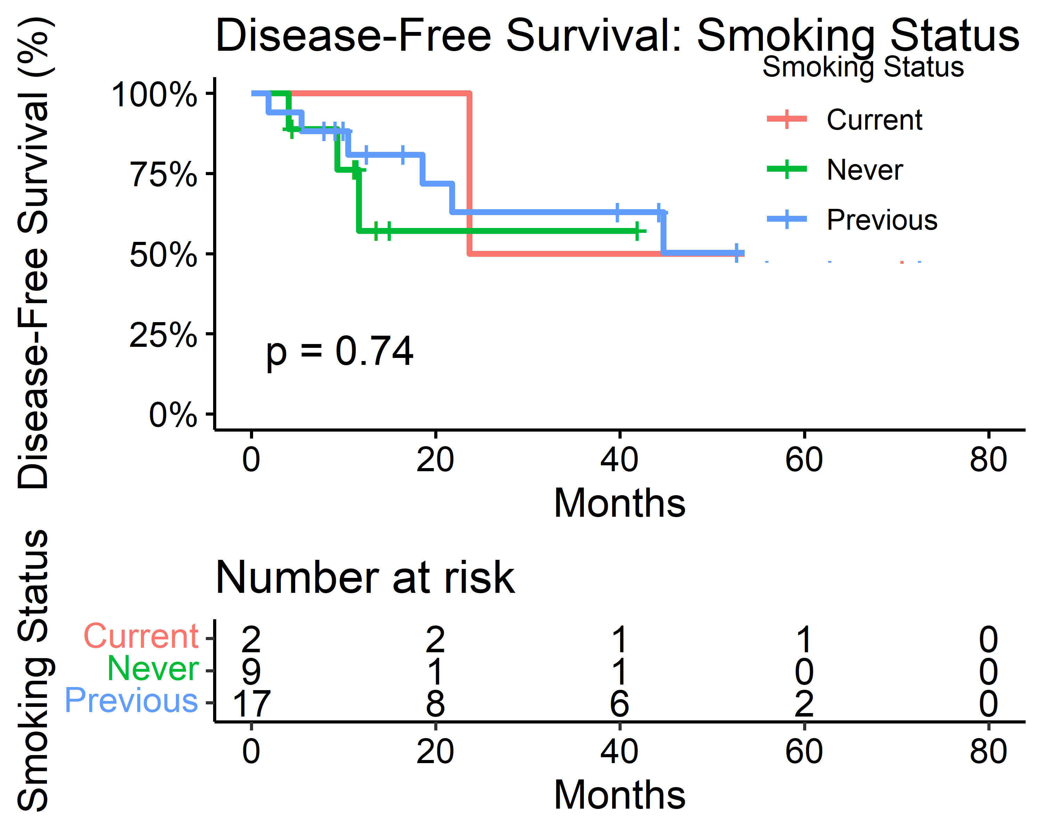

#### Comorbidities

| Characteristic | Median Survival (Months) |
| --- | --- |
| Comorbidities |  |
| 1 | 24 (19, —) |
| 2 | 45 (10, —) |
| 3 | — (11, —) |
| 4 | 56 (—, —) |

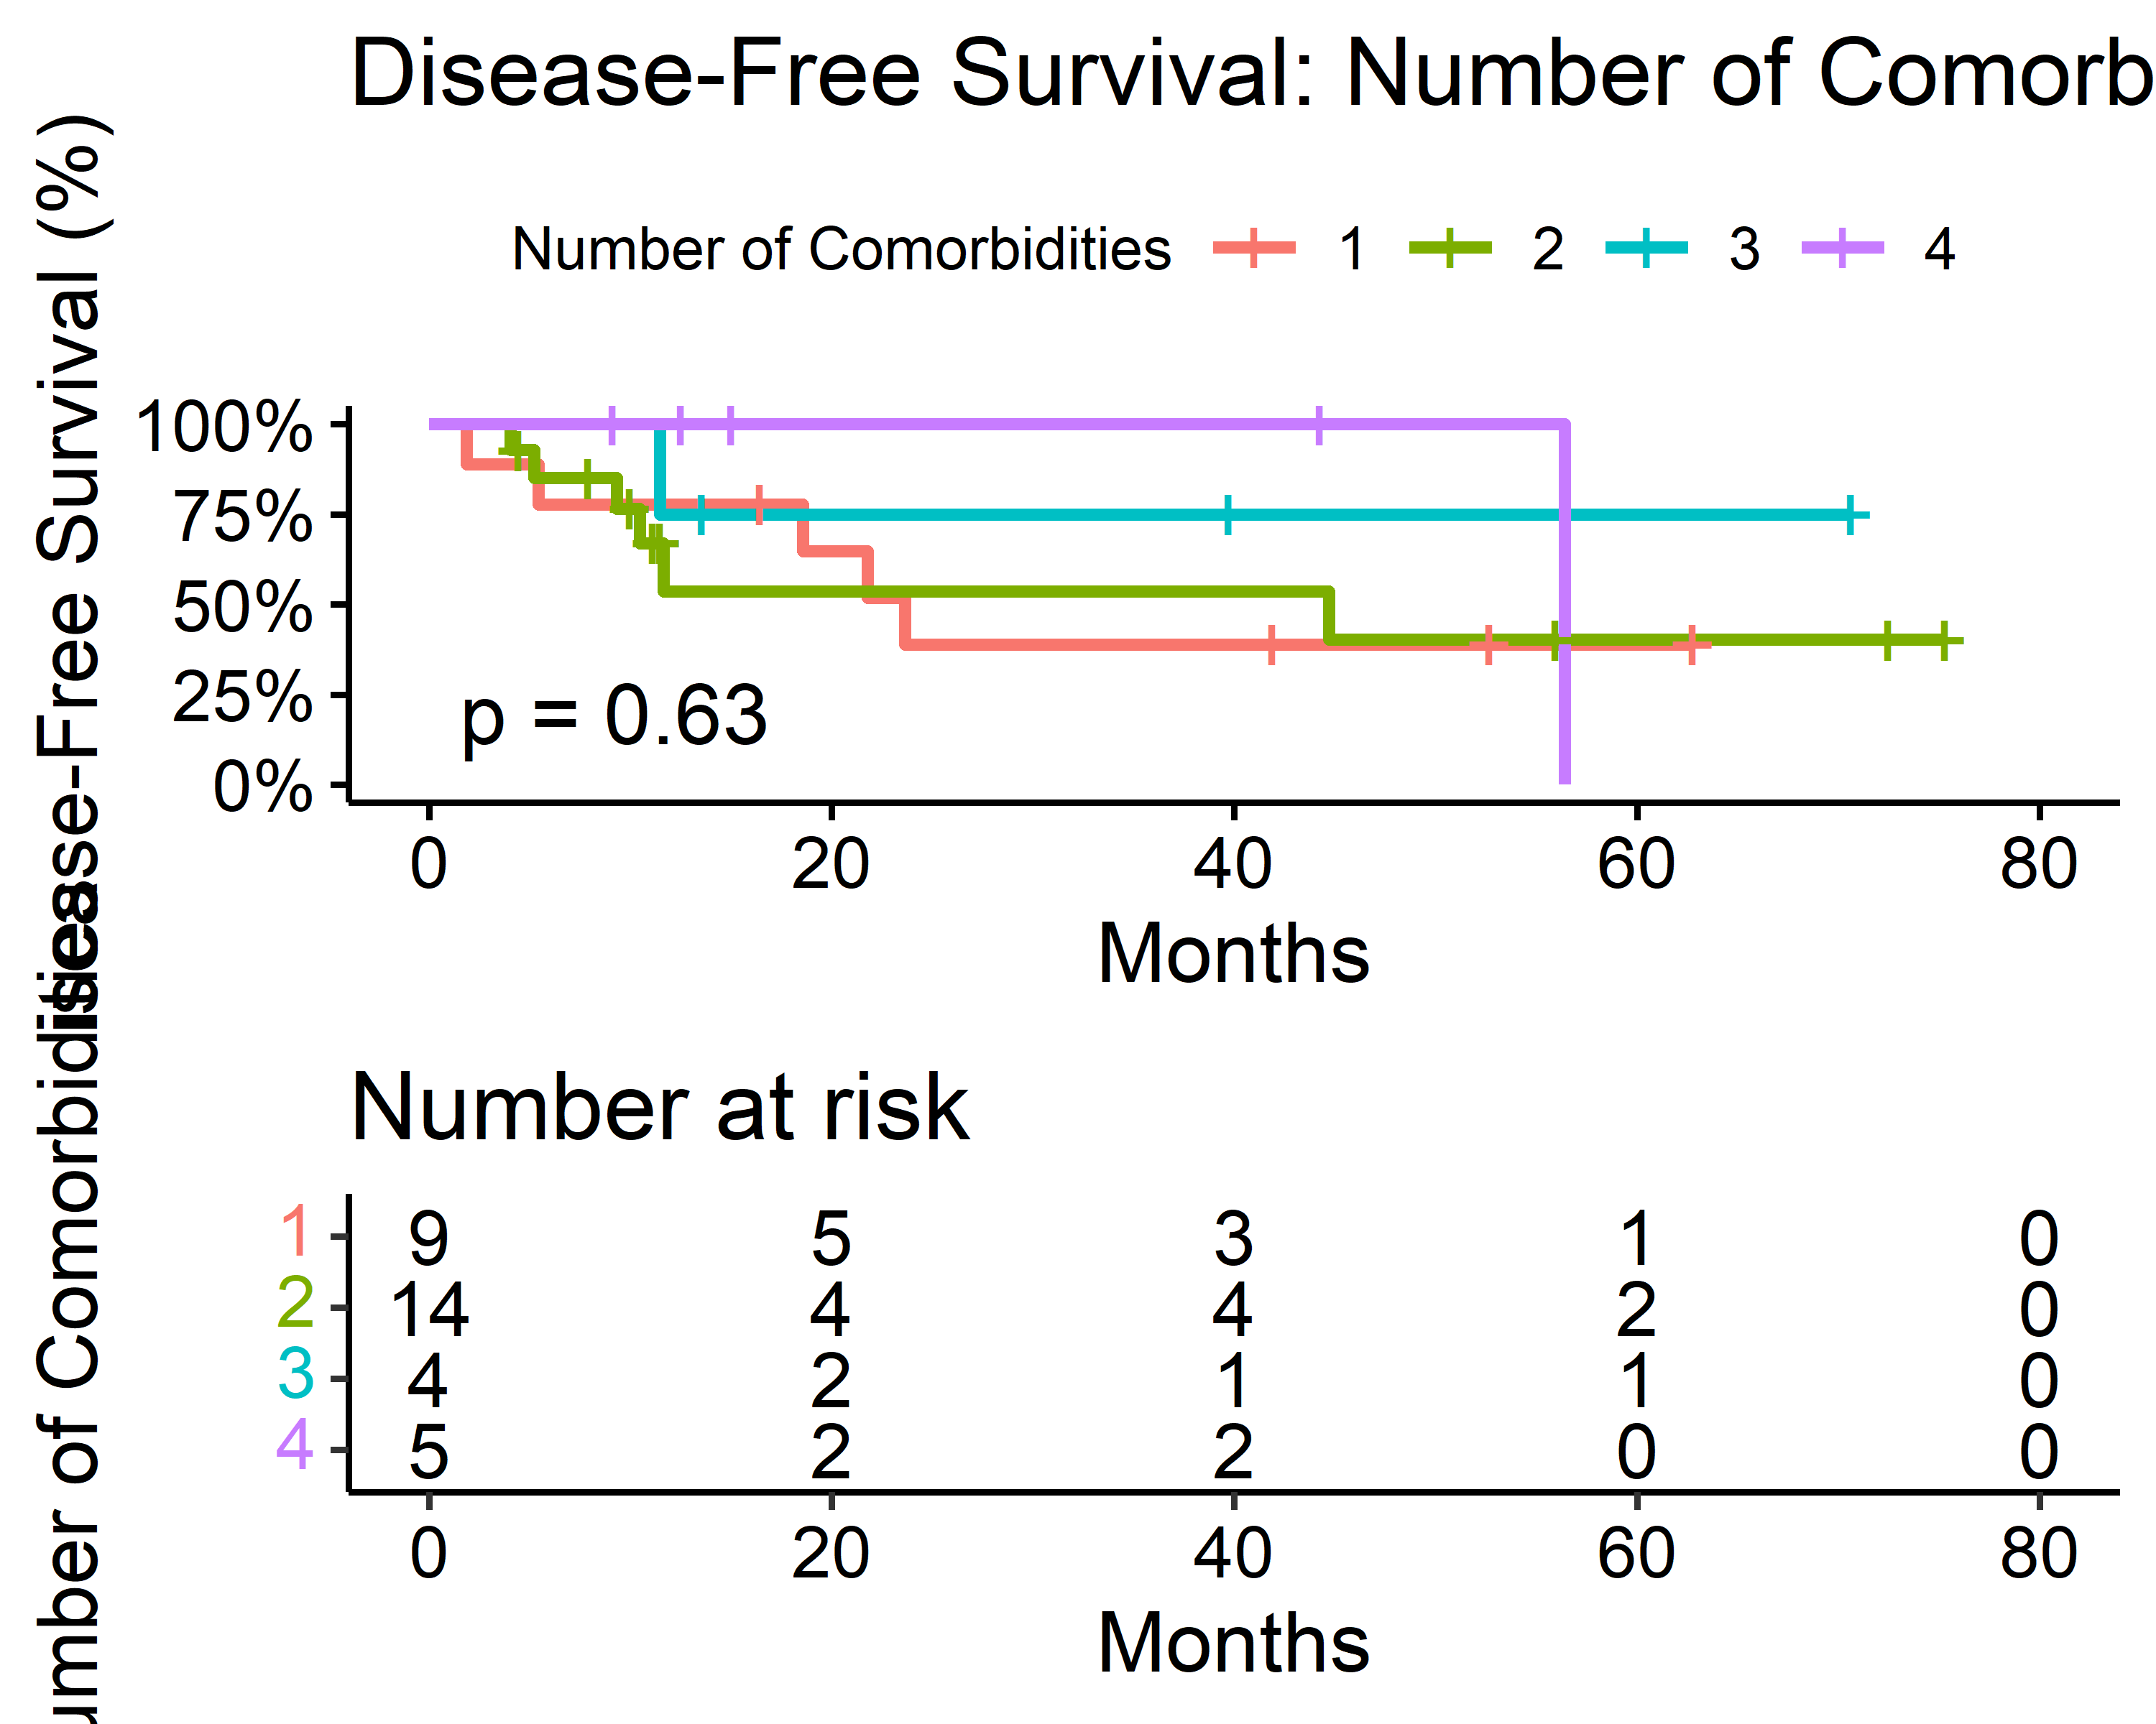

### Progression-Free Survival

#### Age

| Characteristic | Median Survival (Months) |
| --- | --- |
| Age_Cat |  |
| 75-80 | 7.2 (6.6, —) |
| 81-85 | 4.8 (2.6, —) |
| 86-90 | 5.1 (2.9, —) |

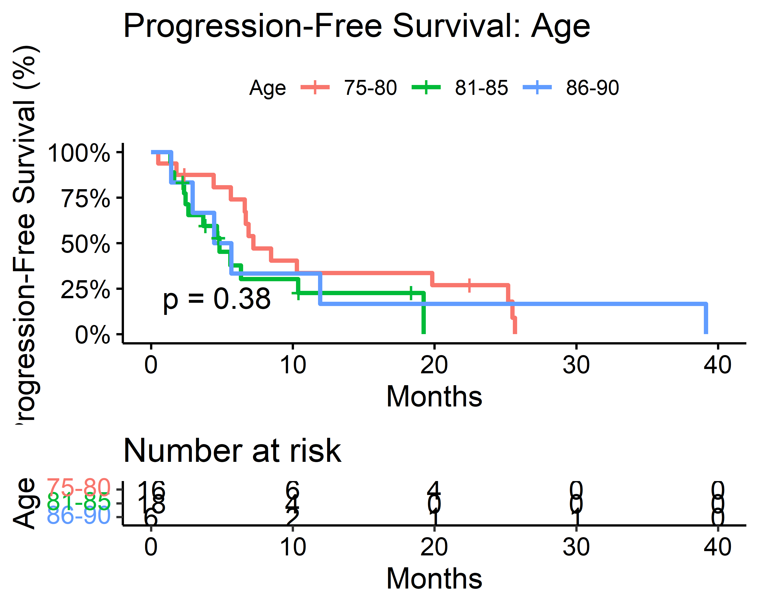

#### Sex

| Characteristic | Median Survival (Months) |
| --- | --- |
| Sex |  |
| Female | 6.3 (4.6, 20) |
| Male | 6.7 (4.4, —) |

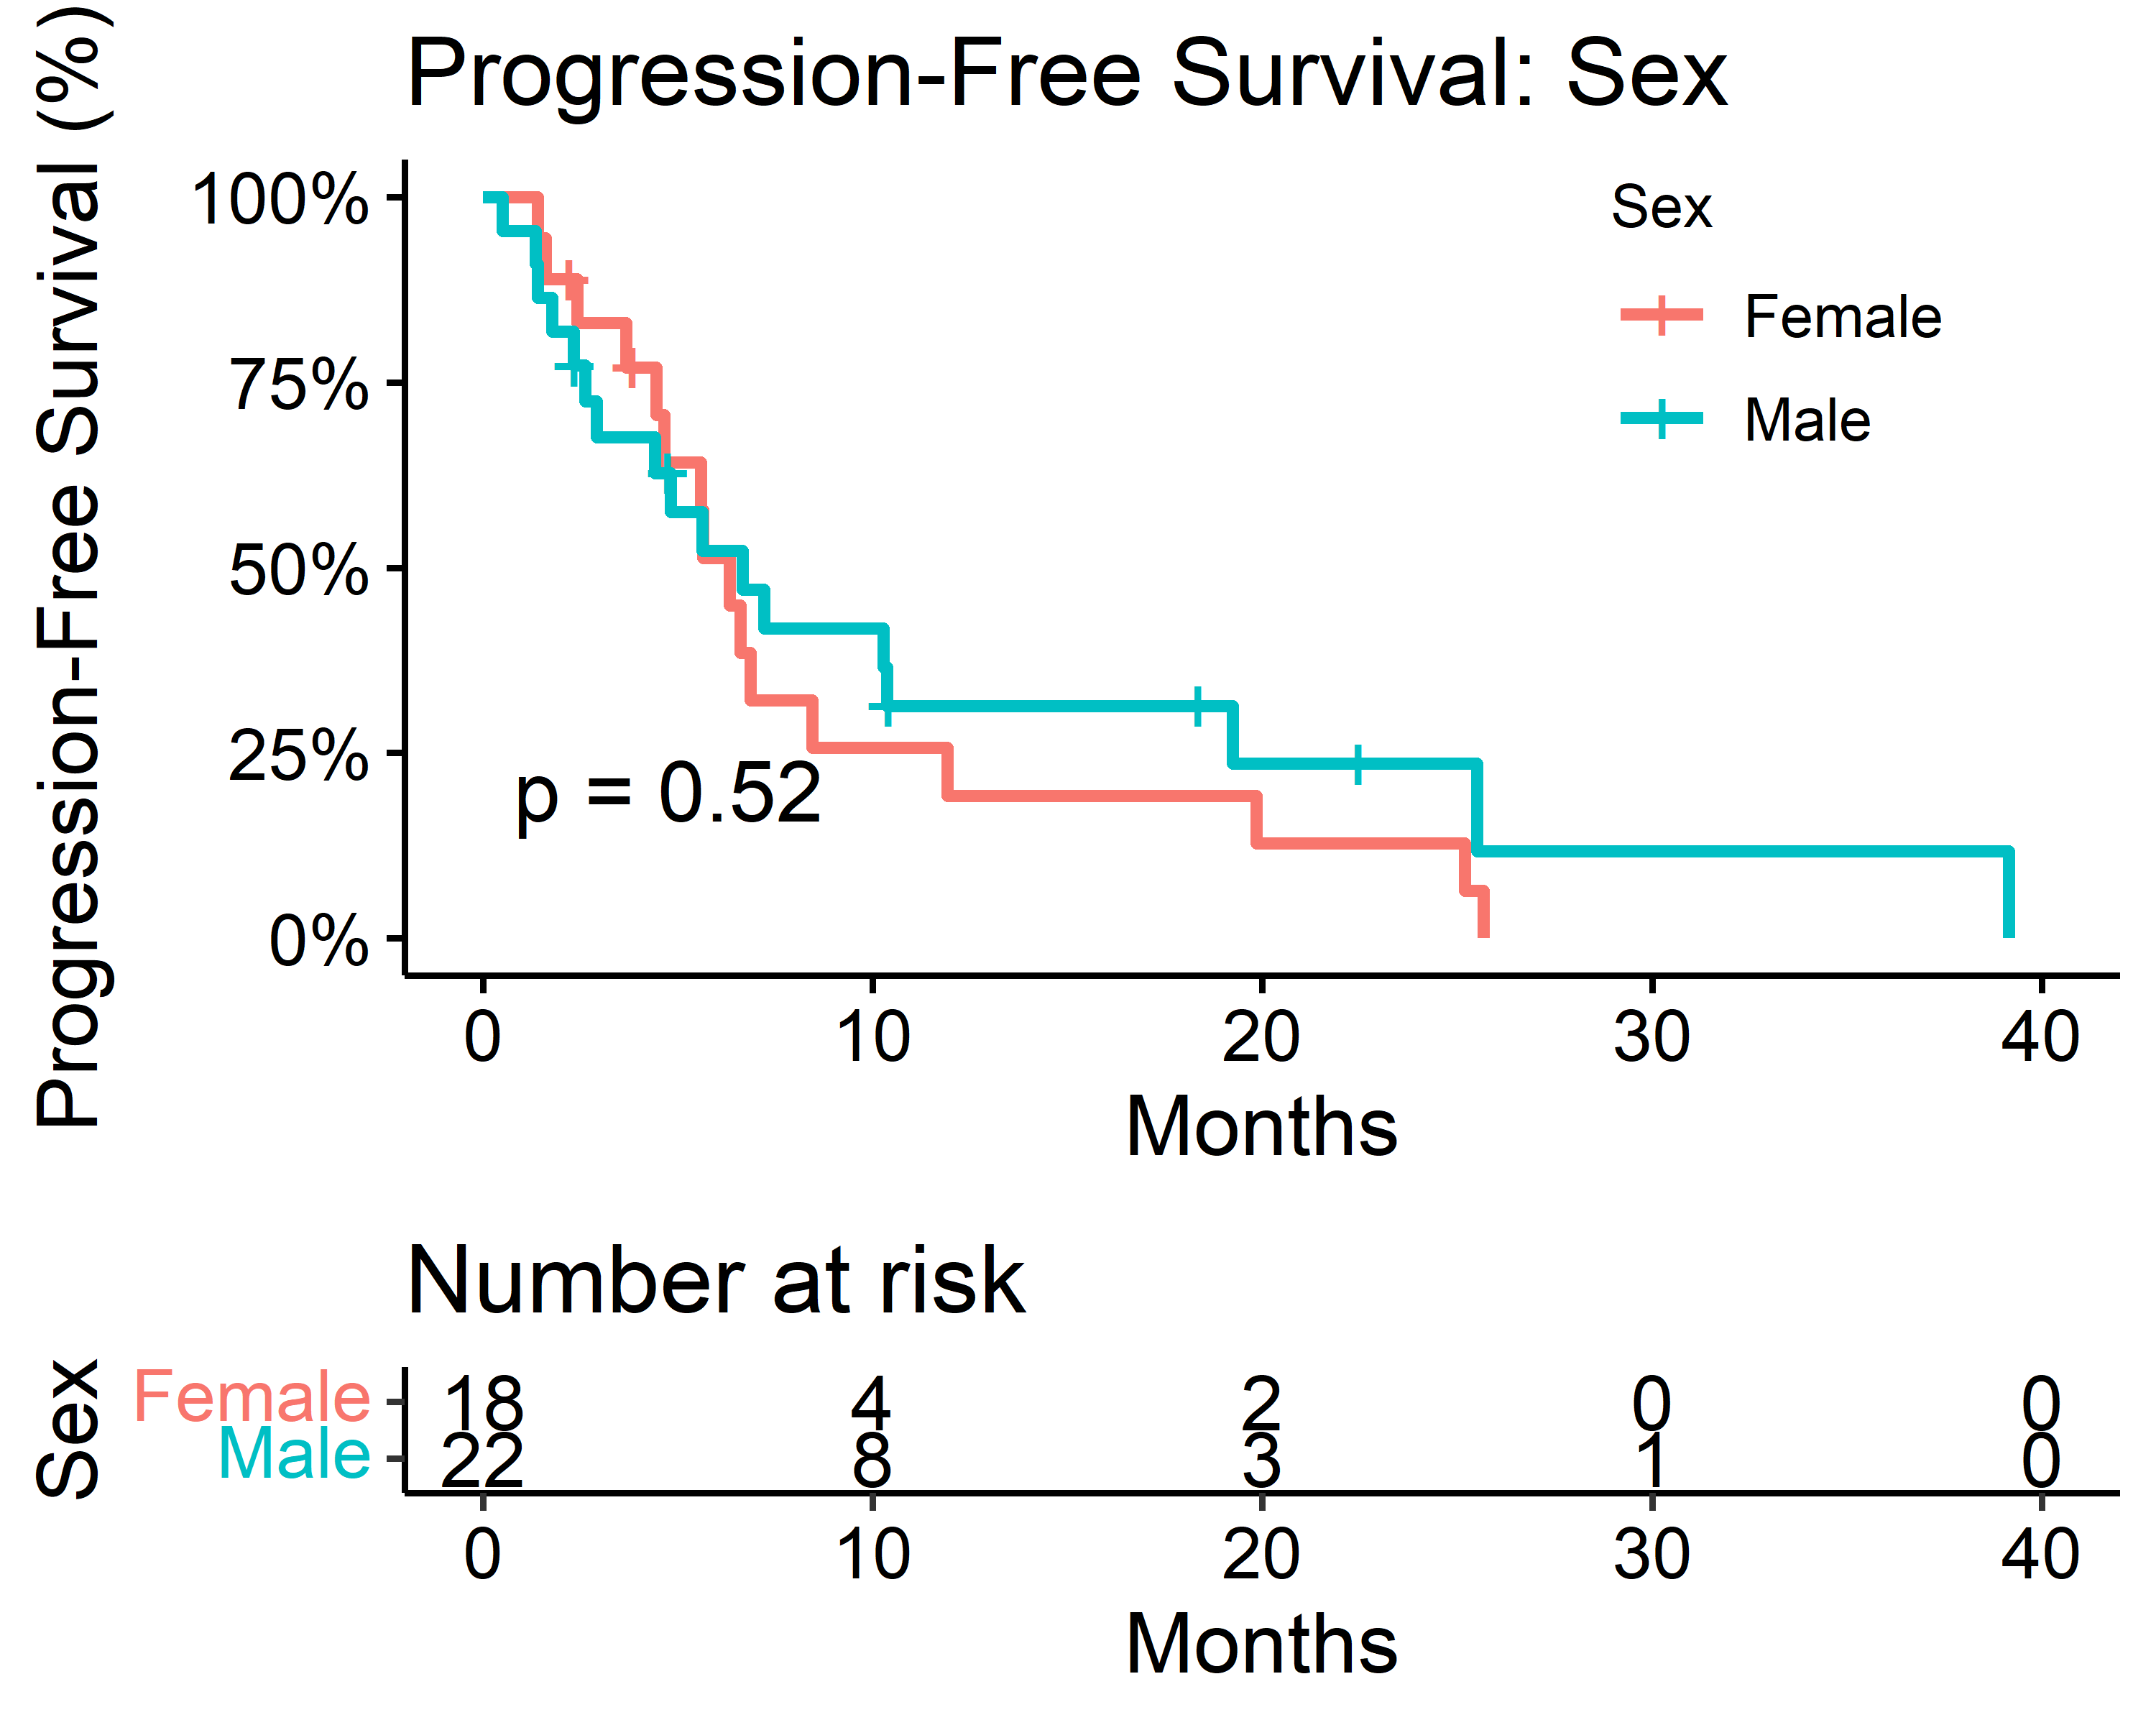

#### ECOG Scale

| Characteristic | Median Survival (Months) |
| --- | --- |
| ECOG |  |
| 0 | 6.6 (2.4, —) |
| 1 | 5.6 (2.6, —) |
| 2 | 25 (—, —) |

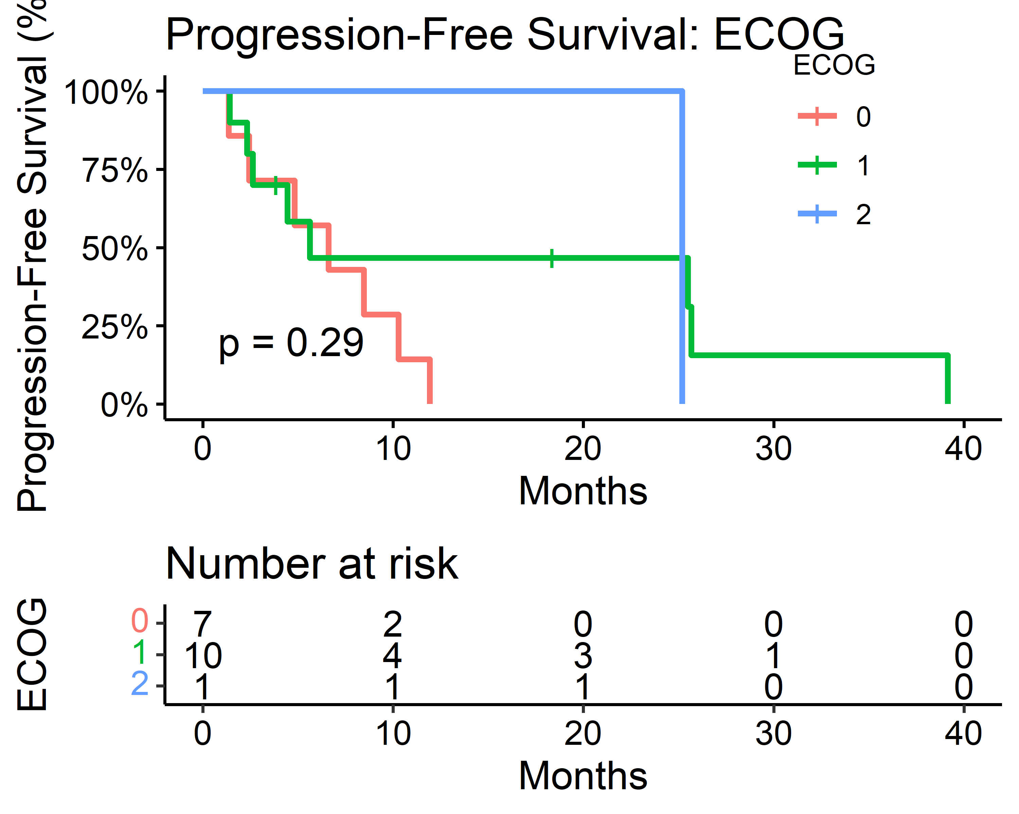

#### Smoking Status

| Characteristic | Median Survival (Months) |
| --- | --- |
| Smoker |  |
| Current | 3.7 (—, —) |
| Never | 6.3 (4.8, —) |
| Previous | 5.6 (4.4, —) |

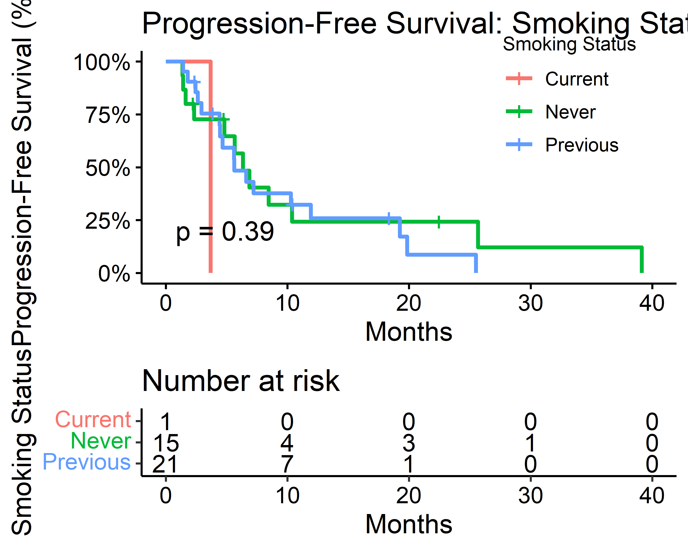

#### Comorbidities

| Characteristic | Median Survival (Months) |
| --- | --- |
| Comorbidities |  |
| 0 | 25 (1.6, —) |
| 1 | 5.0 (2.6, —) |
| 2 | 5.6 (2.9, —) |
| 3 | 7.0 (6.3, —) |
| 4 | 6.6 (4.6, —) |

