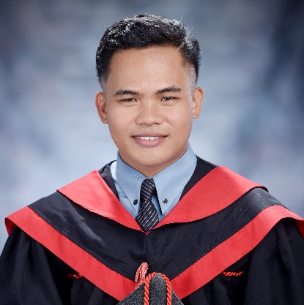
CARL BRYAN L. MANZANADEZ
Purok Subida, Brgy. Dao,
Pagadian City, Zamboanga del Sur
Contact number: +639460416992
manzanadez9@gmail.com

OBJECTIVE
To be able to equip and develop more about my skills in graphic designing, computer servicing and software development and to enhance my knowledge by doing good things in the field of my specialization.

PERSONAL INFORMATION
Name : Carl Bryan Leoncio Manzanadez
Birthdate : March 09, 2001
Birthplace : Pagadian City
Age : 23 years’ old
Sex : Male
Nationality : Filipino
Religion : Jehovah’s Witnesses
Civil Status : Single
Height : 5’5
Weight : 63
Mother : Liezel L. Manzanadez
Father : Oscar P. Manzanadez
Permanent Address : Purok Subida, Dao, Pagadian City, Zamboanga del Sur

EDUCATION
2022-2023 Tertiary
Eastern Mindanao College of Technology
Bachelor of Science in Information Technology
Purok Santan A, San Jose District, Pagadian City, Zamboanga del Sur

2018-2019 Secondary
(Senior High School)
Eastern Mindanao College of Technology
Purok Santan A, San Jose District, Pagadian City, Zamboanga del Sur
2016-2017 Secondary
(Junior High School)
Pagadian City National Comprehensive High School
Purok Mauswagon, Banale, Pagadian City, Zamboanga del Sur

2012-2013 Primary
Dao Elementary School
Purok Nagmahal, Dao, Pagadian City, Zamboanga del Sur
[

CERTIFICATES
Certificate of Participation
Leadership Training Seminar “Leadership Seminar. Translating Vision into Reality”, August 2017

National Certificate II
TESDA - Computer Systems Servicing, February 2019

Certificate of Participation
DOST Seminar - Workshop “Invent School Program”, August 2019

Certificate of Participation
25th Philippine Statistics Quiz, Provincial Eliminations, October 2019

Certificate of Participation
25th Philippine Statistics Quiz, Regional Championship, November 2019

Certificate of Completion
On the Job Training (OJT) – Province of Zamboanga del Sur, Sangguniang Panlalawigan (SP), January – June 2023

Proficiency in Programming
23rd Commencement of EMCOTECH at Chandler Suites, July 05, 2023

Proficiency in Computer System Servicing
23rd Commencement of EMCOTECH at Chandler Suites, July 05, 2023

Proficiency in Visual Graphic Design
23rd Commencement of EMCOTECH at Chandler Suites, July 05, 2023

SKILLS
- MS PowerPoint, Word, Excel up to the latest version available.
- Microsoft Visual Studio and MySQL Database.
- Knowledgeable in VB.Net with basic knowledge in Java and C#.
  - Computer Hardware, Software and Network Maintenance.
  - Knowledgeable in CorelDraw, Adobe Photoshop with basic knowledge in Illustrator.
  - Basic knowledge in Sketch-Up.
  - Basic video editing skills using Adobe Premiere, Movavi, Filmora and Cap-cut.

WORK EXPERIENCE
- IT Support at Expedite BPO
Since April 2021 to October 2021

- Community Affairs Assistant at Sangguniang Panlalawigan (SP)
Since January 2023 to July 2023

- Promo Merchandiser of Fujidenzo at EXATECH
Since August 2023 to April 2024

REFERENCES
- ROSITO D. ORQUESTA
Former Department Head and ICT Instructor
Eastern Mindanao College of Technology
09460022423

- MAPHILINDO Q. OBAOB
1st District Board Member
Province of Zamboanga del Sur
09688530912

