CIS 1202 Programming Assignment #9

Source Code Management 1
(Summer 2023 version)
Write a program that displays the text "Hello, World", check it into a source code management system, modify the program, and check in the update.
You are free to use any distributed source code management system (no centralized systems) and any hosting provider.
The instructions here will be using the Git source code management system, the GitHub online service, and Visual Studio. These are commonly used in businesses, so we'll use them here.
Note that online services and software applications change frequently, so be aware that these screen shots may be out of date. (This document was updated during the summer of 2023).
For most of this assignment, you'll just be following instructions. Please take some time to consider why you're doing what you're doing, instead of just blindly following along.

Requirements
- Sign up for a GitHub account at https://github.com/ There is no cost to use this service.
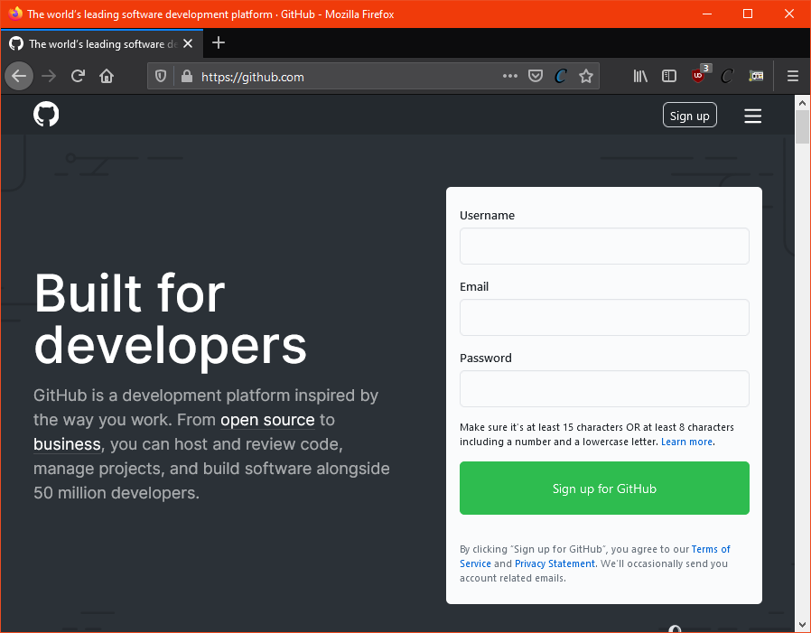

- In Visual Studio, write the "Hello, World" program.
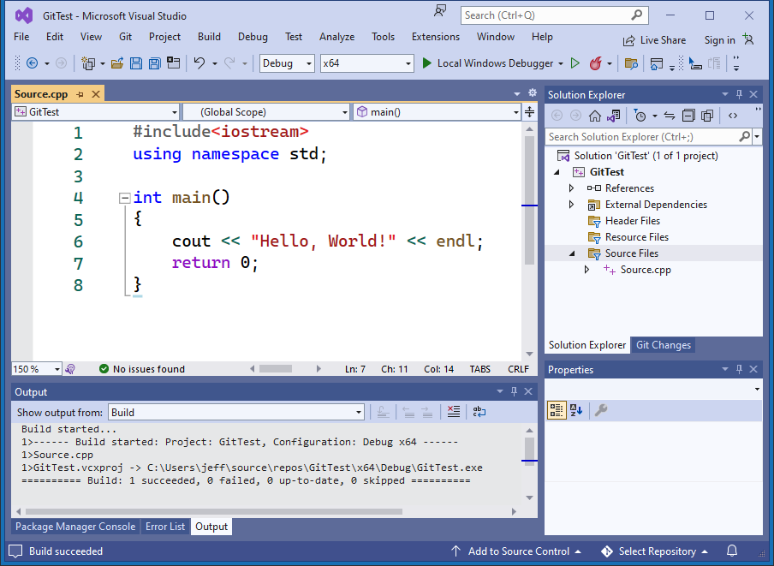
Add this program to a new local git repository. Press the "Add to Source Control" button at the bottom of Visual Studio. Choose "Git".
You'll get a popup window to sign in to GitHub. Be sure to un-check the "Private repository" option, otherwise your instructor won't be able to see your work.
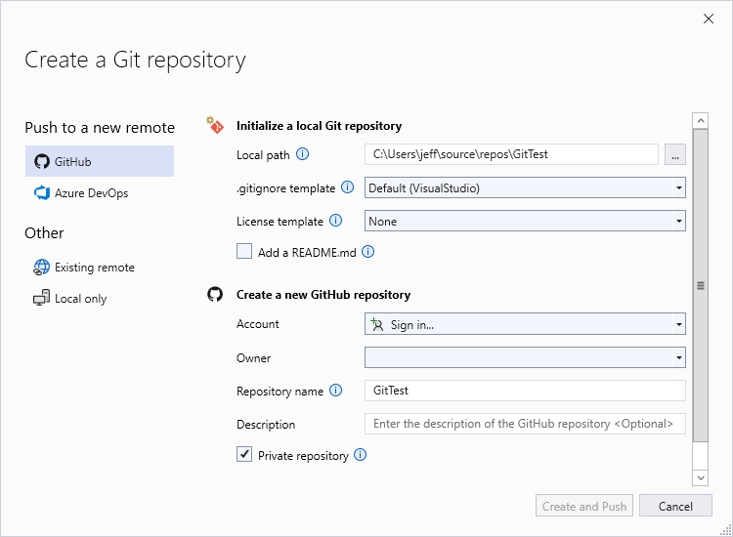
Press the dropdown arrow next to the account, and choose to add a GitHub account.

- Your web browser will open to an authorization page, confirming that you want to connect your Visual Studio installation to GitHub. Press the green "Authorize" button.
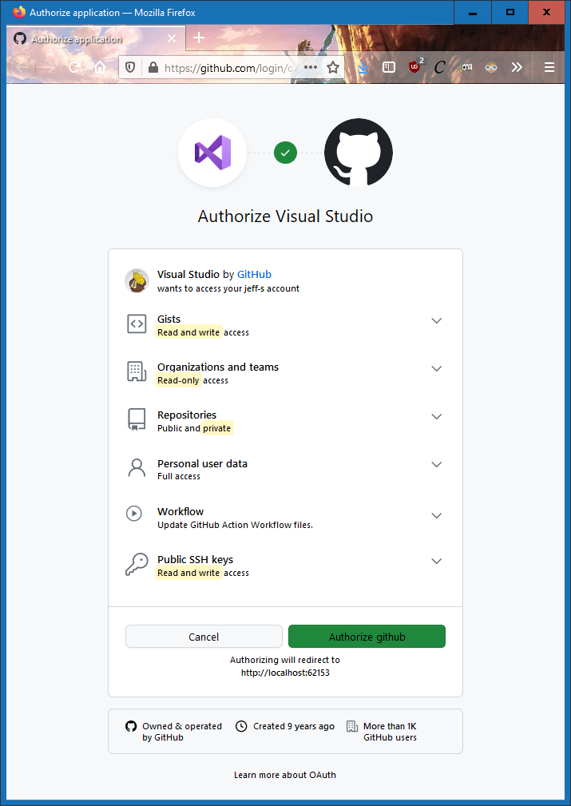
- Back in Visual Studio, you'll now see that you're connected. Press the "Create and Push" button.
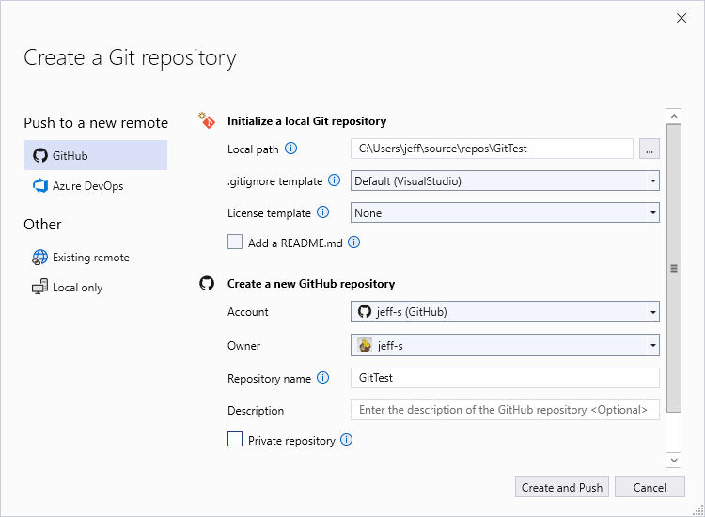

- Your source code and associated Visual Studio files have been uploaded to GitHub. This is called a "push" in source code management vocabulary. View your GitHub page in your web browser to see your new project listed.
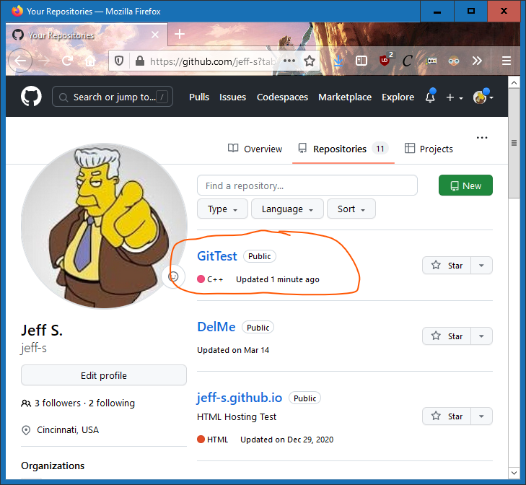
- Click into your newly created repository, and then into your program folder, and finally, find Source.cpp, where you can now see a copy of your program.
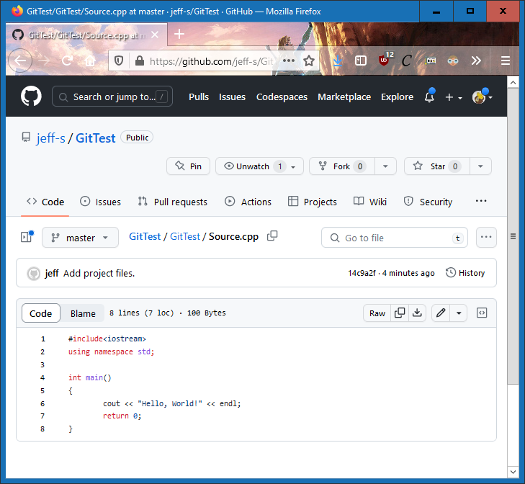
Your code exists in two places now: one on your computer, and another hosted in GitHub.

- Source code frequently changes as bugs are fixed or features are added. Let's modify your program. Press the little pencil button

- Make the program display "Hello, Universe!" instead.
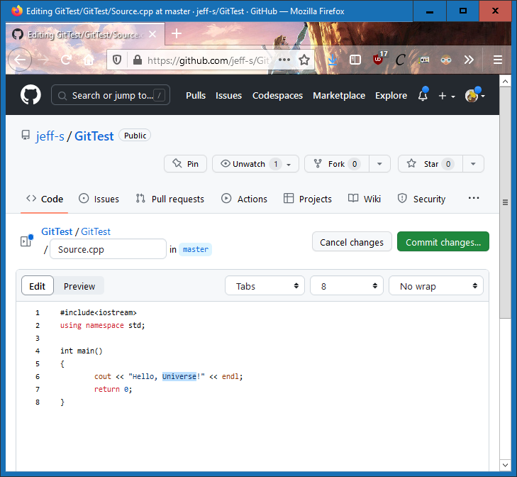
- When you're finished, press the "Commit changes..." button.

- You'll be prompted to enter a "commit message". Use this message to document what you changed. Like comments in your program, commit messages are helpful for others looking at your code, or for yourself in the future. Write good commit messages! The default given here is just terrible.
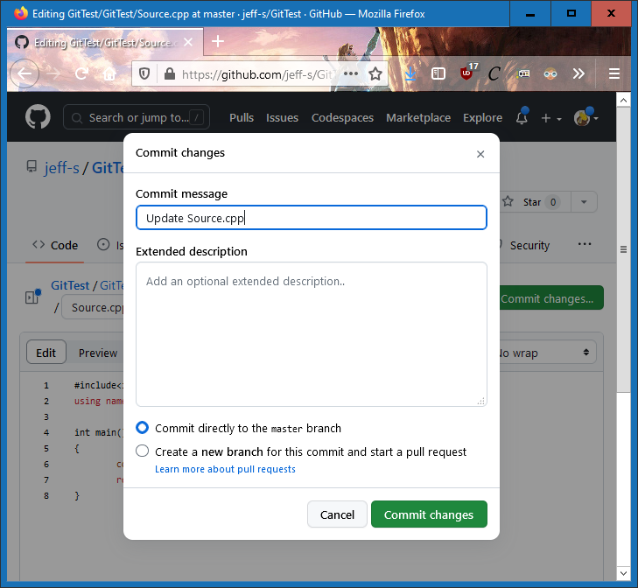
Commit messages, like comments, should describe the big-picture nature of the changes, and not the specific details. (We will be able to see the specific details later in this exercise.)
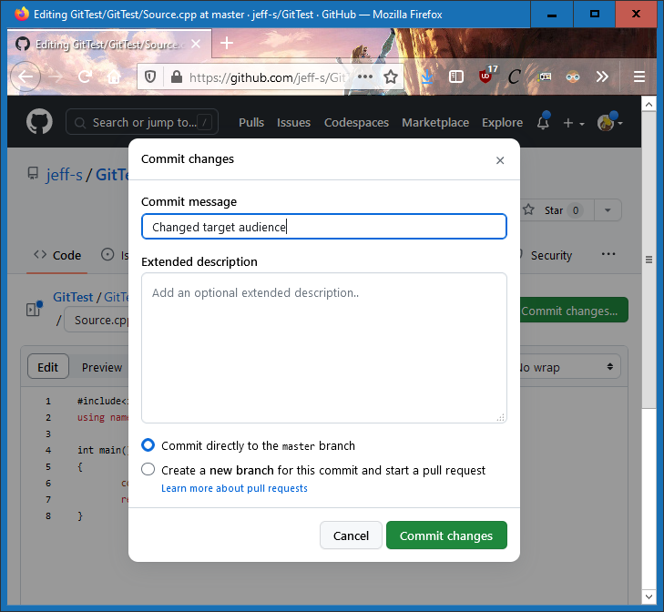

- Back in Visual Studio, let's get the updated source code from GitHub. This is called a "pull". Under the "Git" menu, choose the "Pull" option. You'll see your updated code.
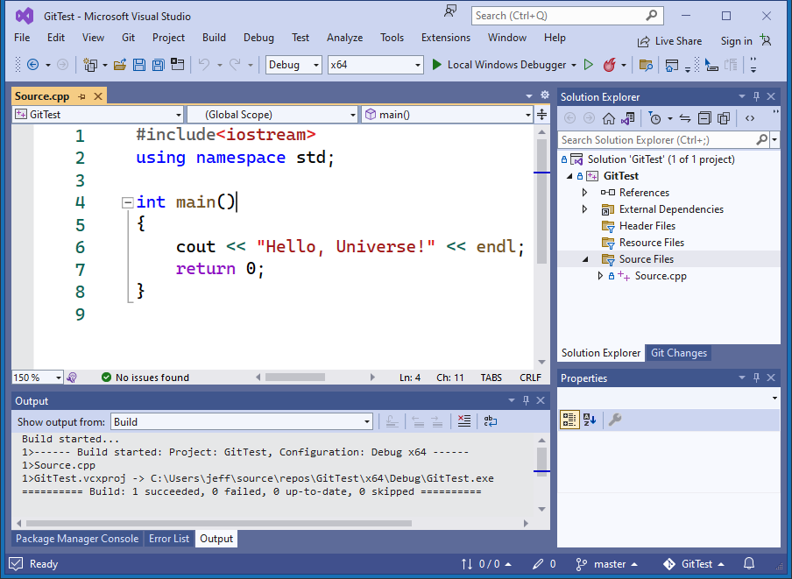
- Let's see the history of this repository. In the Solution Explorer, right-click on your Source.cpp and choose "Git", and then "View History".
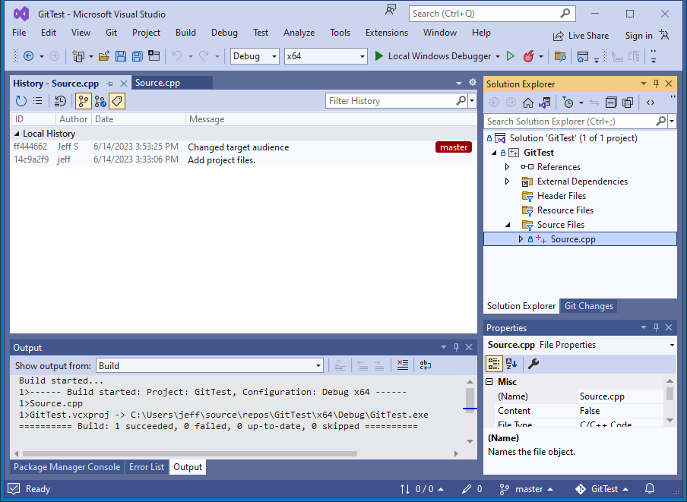

- Click on the most recent item in the history, then right-click on the source code file, then choose "Compare with previous" to see the differences between versions, in a color-coded side-by-side layout.
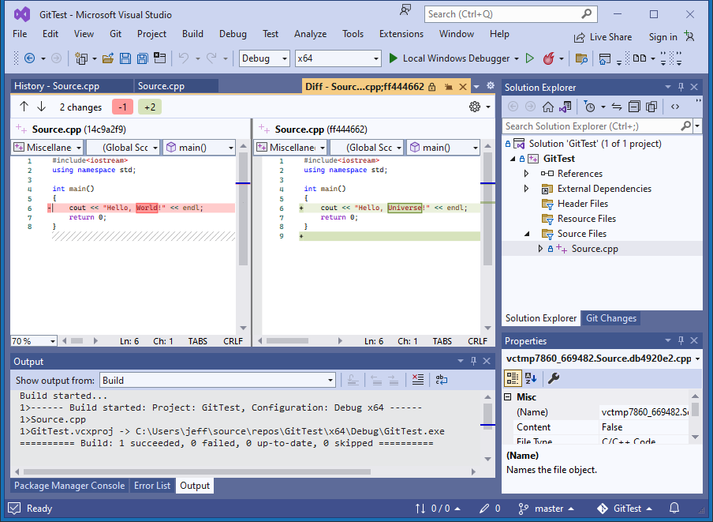

- Make your repository available to your instructor for grading. Switch back to GitHub and go back to the root of your repository.
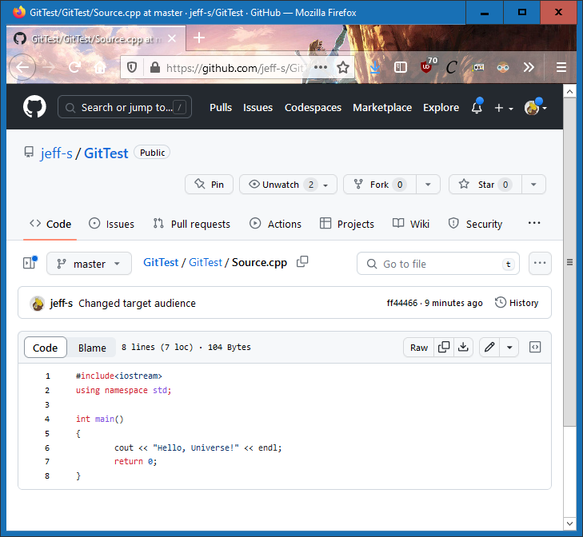
- Choose the green "Code" button, then choose "Use HTTPS", then copy the link to your repository.
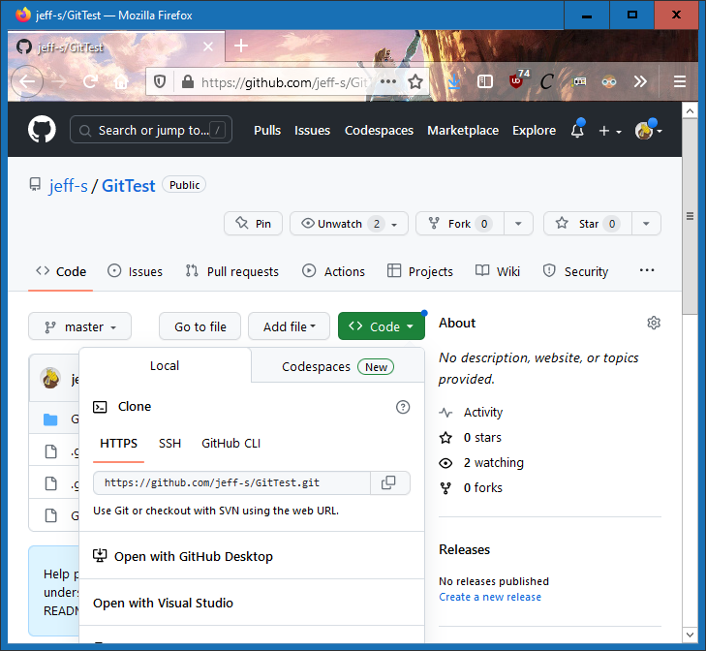
- Upload this link to the eLearn dropbox. No screen shots or other documentation are necessary. Just the link.

