//获取当前网址，如：

**var** curWwwPath=window.document.location.href;

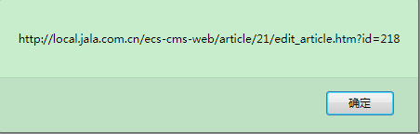

//获取主机地址之后的目录如：/Tmall/index.jsp

**var** pathName=window.document.location.pathname;

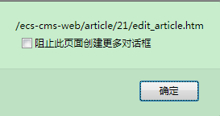

**var** pos=curWwwPath.indexOf(pathName);



//获取主机地址，如：//localhost:8080

**var** localhostPath = curWwwPath.substring(0,pos);

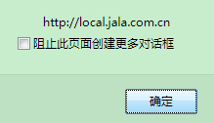

//获取带"/"的项目名，如：/Tmall

**var** projectName = pathName.substring(0,pathName.substr(1).indexOf('/')+1);

