Discrete-to-Continuum Compiler Theories of Physical Law
A Combined Research Volume
Part 0 — The Compiler Certification Registry
Part I — This from That: The Theory of Organizational Evolution
Part II — Universal Derivation Protocol (UDP v2.0)
Part III — The Organizational Hierarchy of the Universe
Part IV — The Master Dependency Chain Link
Part V — The Universal Organizational Foundation
Keith I. Blaze
Independent Research

PART 0
The Compiler Certification Registry
A Reading Key for This Volume's Epistemic Status

0.0 Purpose
Parts I through V of this volume were written across many separate sessions, over an extended period, and each introduced its own way of signaling how sure it was of its own claims: Part I's conclusions state plainly which bridge theorems remain conjectural; Part IV's validation branches carry per-module ✓ marks; Part V's programs carry certification matrices. These conventions are consistent with each other in spirit but were never unified into one registry. Part 0 is that unification: a single certification vocabulary, a single verification protocol, and a summary ledger drawing together every object in Parts I–V that already carried an explicit certification judgment in its own source material.
Part 0 does not introduce new certification judgments of its own. Every status recorded in §0.6's ledger is the status already assigned within the relevant Part; Part 0 only standardizes the vocabulary used to state it and collects the results in one place.

0.1 Certification States
Every object in this volume's compiler-derived material (Parts IV and V, and the Lorentzian program added in Part IV §8) carries exactly one of five certification states:
State | Definition
Certified | The result has a complete symbolic derivation and has passed the verification protocol of §0.2. It is treated as established within the compiler's own terms — which is not the same claim as independent peer-reviewed publication.
Candidate | The construction is internally consistent and has passed some, but not all, stages of the verification protocol. At least one proof obligation remains outstanding.
Open | A well-posed research question with a stated target, but no candidate proof yet exists. Distinct from Candidate: an Open item has no proof attempt on record, where a Candidate has an incomplete one.
Retired | A research direction that was actively pursued and then closed, with the reason for closure recorded rather than left implicit. Retired branches are kept in the registry specifically so they are not repeated.
Research Objective | A long-term target not yet formulated as a specific candidate construction — a direction, not yet a conjecture.

These five states consolidate minor terminological drift between two of this volume's source reports: one used Research Objective as its fourth tier where the other used Retired for closed branches and Open for active-but-unproven ones. Both distinctions are worth keeping, so this registry keeps all five states rather than collapsing them.

0.2 The Verification Protocol
An object advances to Certified only after passing three checks, in order:
- Symbolic derivation: a complete, hand-checkable derivation from already-certified dependencies.
- Canonical graph / case verification: the claim is checked explicitly against small, hand-tractable canonical examples (specific graphs, specific parameter values) rather than only argued abstractly.
- Random / numerical verification: the claim is checked computationally against a broad random sample of cases, to catch counterexamples that hand-picked canonical cases might miss.
A Candidate object records exactly which of these three checks it has passed and which remain, together with its outstanding proof obligations — named, specific lemmas still required for certification, rather than a vague “more work needed.” §8.2 gives a worked example of this in full.

0.3 Standardized Verbs
Where the compiler-derived Parts of this volume (IV–V, and Part IV §8) describe what an object does, the following verbs are used with fixed, specific meanings rather than interchangeably:
Verb | Fixed Meaning
defines | Introduces a new object or notation with no truth claim attached.
proves | Establishes a Certified result from already-Certified dependencies.
recovers | Reconstructs an already-known mathematical object from compiler primitives — the characteristic verb of Parts II and IV's validation campaigns.
classifies | Partitions a space of objects by an invariant, without asserting new facts about any individual object.
certifies | Marks the transition of an object's status to Certified after the §0.2 protocol has been completed.
suggests | Reports a pattern or heuristic argument that has not passed the §0.2 protocol.
conjectures | States a specific, falsifiable Candidate or Open claim, distinguished from a vaguer Research Objective by having a precise statement.

0.4 Compiler Evolution Timeline
The compiler-derived material in this volume was not built in the order it is presented. Later programs depend on earlier certified work regardless of which Part they were eventually written into:
Foundation (Part V) → Graph Theory → Spectral Theory → Operator Theory → Lorentzian Program (Part IV §8) → Differential Geometry (Part IV §7) → Physics Recovery (Parts II, IV §1–§6)
Reading the volume in this dependency order, rather than in Part order, is the more accurate way to see what depends on what; Part order was chosen for narrative reasons (each Part is a roughly self-contained validation campaign) rather than to reflect construction order.

0.5 The CCR Ledger
The table below aggregates every program in Parts IV–V (and the new Lorentzian program of Part IV §8) that carried an explicit certification judgment in its own source material. Individual sub-module IDs (there are more than one hundred across CMRC, UGAS–MDCL-0001, and the Lorentzian registry) are not reproduced individually here; each program's own chapter carries its full module-level detail.
Program / Object | Location | Status | Primary Dependency
MDCL v1.0 — Primitive Grammar | Part IV, Preface | Certified | —
CMRC-001–019 (String Theory Recovery Core) | Part IV §1 | Certified | CMRC-001
VAL-005 (Hamiltonian Mechanics) | Part IV §2 | Certified | MDCL-1015
VAL-004 (Quantum Mechanics) | Part IV §3 | Certified | VAL-005
MDCL v2.0, Layers 0–VI (Graph-Spectral GR Recovery) | Part IV §7.1–7.4 | Certified | Primitive Kernel
MDCL v2.0, Layer VII (Physical Recovery Core) | Part IV §7.5 | Research Objective | Layer VI
MDCL v2.0, Layers VIII–XIII (Architecture Roadmap) | Part IV §7.6 | Research Objective | Layer VII
UGAS (Free Grammar Algebra) | Part V §1 | Certified | Σ₀
UGCT (Congruence & Quotient) | Part V §2 | Certified | UGAS
UGUP (Universal Mapping Property) | Part V §3 | Certified | UGCT
UGNT (Normal Form Theory) | Part V §4 | Certified (framework); theorems Open | UGUP
UGIT (Intrinsic Grammar Theory) | Part V §5 | Certified | UGNT
UOLS (Organizational Semantics) | Part V §6 | Certified | UGIT
UTS (Universal Type System) | Part V §7 | Certified | UOLS
MDCL-0001 (Canonical MDCL Object) | Part V §8 | Certified | UTS
MDCL-0002 (Category of MDCL Objects) | not received | Research Objective | MDCL-0001
LOR-002 (Negative Eigenvector) | Part IV §8.3 | Certified | LOR-001
LOR-001 (Resistance Threshold) | Part IV §8.4 | Candidate | Effective Resistance, Rank-One Inertia
IOC Rank-One (Index Classification) | Part IV §8.5 | Certified target | LOR-001
IOC Rank-Two | Part IV §8.5 | Open | IOC Rank-One
IOC Rank-k | Part IV §8.5 | Research Objective | IOC Rank-Two
Fisher Information Route | Part IV §8.6 | Retired | —
Standard Signed Laplacian | Part IV §8.6 | Retired | —
Classical Balance-Theory Route | Part IV §8.6 | Retired | —

0.6 Scope and Limits of This Registry
Parts I, II, and III of this volume predate this registry system and are not retrofitted into it. This from That (Part I), the Universal Derivation Protocol (Part II), and the Organizational Hierarchy textbook narrative (Part III) were written with paragraph-level epistemic language — conclusions stating plainly which results are conjectural, which sections mark open problems, and so on — rather than per-object registry IDs and the five-state taxonomy of §0.1.
Retrofitting Parts I–III into this registry would require assigning a Certified, Candidate, Open, Retired, or Research Objective status to individual equations and claims that were never given one in their original source material. Doing so would mean this paper's authors (the underlying source material and its assembly here) making that epistemic judgment after the fact, rather than reporting a judgment that was actually made when the material was written. That risk — manufacturing a false impression of systematic certification where none was originally recorded — is judged worse than the inconsistency of having two epistemic conventions side by side in one volume. Parts I–III therefore keep their original conclusions and epistemic framing unchanged; only Parts IV–V and the material added under this registry going forward use the §0.1 taxonomy.
A reader moving from Part 0 into Part I should therefore expect prose-level hedging (“remains conjectural,” “carries the same evidentiary status as the rest of the program”) rather than a status banner, and should not read the absence of a Registry ID as a claim that Part I's content is less scrutinized — only that it is scrutinized in a different, older format.
PART I
This from That
The Theory of Organizational Evolution
(𝒯_{OE})
A Formal Discrete-to-Continuum Compiler Theory of Reality

Abstract
Traditional physics faces an enduring boundary crisis at the Planck scale: its foundations are stated in terms of material substrates — particles, fields, strings — while implicitly operating inside a pre-assumed continuous spacetime canvas. The Theory of Organizational Evolution (𝒯_{OE}), colloquially designated “This from That,” resolves this limitation by shifting the ontological framework from material composition to a scale-free, domain-independent discrete-to-continuum compiler specification.
Reality is formalized as the stable, invariant macro-scale data output generated when an unyielding combinatorial grammar iteratively compiles across a pointed relational graph category. Continuous curved spacetime, gauge field interactions, fermionic spinor fields, and macroscopic thermodynamics are derived not as fundamental ontologies, but as the mathematically forced, error-correcting fixed points of this optimization process under infinite topological refinement.
Sections 9–11 show that this compiler pipeline is itself an instance of a lower-level Distinction–Transformation–Constraint–Persistence (DTC) grammar, and instantiate that grammar thermodynamically as a four-gate admissibility cascade that recovers the framework's persistence threshold as a throughput-balance condition.

1. The Categorical Foundations
The core architecture of 𝒯_{OE} eliminates all ad-hoc physical variables from its input layer. The entire cosmic hierarchy is governed by a strict, non-intermixing sequence of algorithmic, topological, and analytical morphisms:
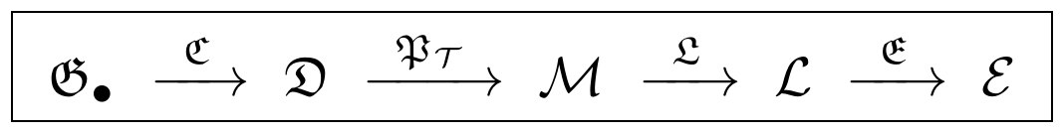

1.1 The Pointed Graph Category (𝔊•)
The foundation of the framework is purely combinatorial. We define 𝔊• as the category whose objects are pairs (G, v₀), where G = (V, E) is a discrete topological graph and v₀ ∈ V is an invariant basepoint designated as the central apex node.
- Morphisms: A morphism f : (G, v₀) → (H, w₀) in 𝔊• is a graph homomorphism such that f(v₀) = w₀.
- The Refinement Endofunctor (R): The topological expansion of the network is governed by a strict covariant functor R : 𝔊• → 𝔊• generating an infinite recursive sequence G_{n+1} = R(G_{n}), subject to composition preservation: R(g∘f) = R(g)∘R(f).

1.2 The Graph-Theoretic Axiom Set (𝒜*)
The compiler processes data structures that satisfy four structural invariants under R:
- Bipartite: The vertex set admits a two-color partition V = X ∪ Y such that the adjacency matrix assumes the block-off-diagonal format shown below.
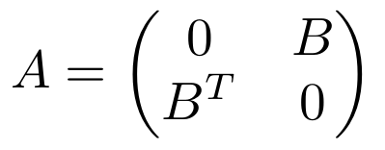
- Abelian: The edge automorphism group Aut(G) is entirely commutative.
- Shell Hierarchy: The graph is structured as a nested family of concentric subgraphs S₁ ⊂ S₂ ⊂ ⋯ ⊂ S_{k} linked to the apex v₀.
- Recursive Scale-Invariance: Each shell layer is generated via a deterministic, fractal replacement rule f(S_{m}).

1.3 The Discrete Geometry Category (𝔇)
The algorithmic compiler 𝔠 : 𝔊• → 𝔇 maps the pointed graph sequence directly into the rigorous framework of Discrete Exterior Calculus (DEC):
Here Ω•(G_{n}) is the space of discrete cochains (differential forms), d_{G_n} is the exterior derivative, δ_{G_n} is the codifferential, Δ_{G_n} is the Hodge Laplacian, and ⋆_{G_n} is the discrete Hodge star operator.

2. Refinement Invariants and Metric-Measure Scaling
To prevent topological or metric collapse during the infinite refinement limit n → ∞, the functor R acts as a strict metric-measure chain map matching the following geometric bounds.

2.1 Rescaled Path Metric Space
Each generation is equipped with a piecewise-linear path metric space (M_{n}, d_{n}) over its geometric realization. Let α be a global isotropic contraction constant (0 < α < 1).
- Primal Edge Scaling:
- Induced Metric Invariance: the induced path distance, computed as the infimum of length sums, is invariant under refinement steps.
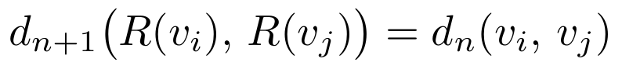
- Diameter Stability: the global metric size remains bounded.
- Primal-Dual Volumetric Partition: primal cells sub-divide while dual cells co-refine via the dual operator R* : 𝔊^{D} → 𝔊^{D}.

2.2 Algebraic Operator Commutativity
Applying these metric mappings to the diagonal DEC Hodge star matrix ⋆_{n}(σ_{k}) = μ_{n}^{D}(⋆_{n} σ_{k})/μ_{n}(σ_{k}) derives the exact Hodge-Star Commutativity Theorem:
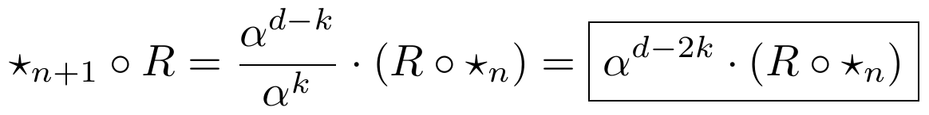
Substituting this derived law into the definition of the codifferential δ = ±⋆d⋆ paired with the exterior derivative chain map identity (d_{G_{n+1}}R = Rd_{G_n}) mathematically forces the exact quadratic scaling profiles of the kinematic operators:

3. The Optimization Engine and Fixed-Point Dynamics
The compiler contains no independent physical fields. Instead, it instantiates the Optimization Operator (𝒪_{opt}) as a deterministic gradient-descent loop running within the discrete Hilbert space ℋ_{n}• equipped with the positive-definite inner product ⟨α, β⟩_{𝔇} = Σ αβ⋆(σ).

3.1 The Action Functional and Gradient Flow
The network state vector Ψ_{n} is evaluated by a quadratic compiler action functional computing global structural friction:
The system optimizes state parameters via the unyielding mechanical protocol:

3.2 Lyapunov Convergence and the Critical Set
Let H = ∇²𝔄 = Δ_{G_n} be the global Hessian matrix. To secure a unique, stable attractor, the compiler requires Strict Convexity: λ_{min}(H) ≥ m > 0. Convergence is proved via the discrete Lyapunov energy functional V(Ψ_{n}) = 𝔄[Ψ_{n}] − 𝔄[𝒰]. Tracking the energy change across a single step via Taylor expansion yields:
where Λ_{max} is the maximum eigenvalue of the Hessian matrix. To force strict monotonic decay (V(Ψ_{n+1}) − V(Ψ_{n}) < 0), the step size is rigidly bounded by the Critical Step Boundary:
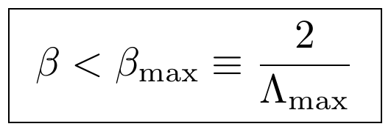
Under this condition, the network is mathematically forced to converge to the unique macroscopic Fixed Point (𝒰) representing the absolute zero-error Critical Attractor Set (𝒦_{crit}):

4. The Complete Master Derivation Matrix
The scale-free nature of the Theory of Organizational Evolution is validated by running the identical compiler pipeline across distinct underlying relational data boundaries, showing that every pillar of modern science is a compiled output running on the same underlying engine.
Category Phase | Graph Input Target (𝔊•) | Discrete Geometry Object (𝔇) | Continuization Functor (𝔓��) | Localization Operator (𝔏) | Compiled Continuum Law (ℒ)
Quantum Mechanics | Complex Informational Vector Topology | Finite-dimensional Unitary Hilbert Space ℋ_{n} | Strong Resolvent Limit (n → ∞) | Time-Translation Generator Selection (e^{−itH}) | Schrödinger Wave Equation
Standard Model | Internal Color Phase Symmetries | Principal Fiber Bundle over link variables U_{ij} | Γ-Convergence of Wilson Action | Local Gauge Invariance Covariant Derivative | Yang–Mills Gauge Field Strength
General Relativity | Manifold Tangent Frame Connectivities | Frame Bundle Connections Γ^{λ}_{μν} | Gromov–Hausdorff Metric Limit | Metric Compatibility Extremization | Einstein Field Equations (Gravity)
Thermodynamics | Multi-Particle Configuration Graph | Discrete Phase Space Microstate Counts W | Combinatorial Ergodic Shuffling Limits | Free-Energy Variational Optimization | Fundamental Thermodynamic State Laws
Evolutionary Biology | Genetic / Phenotypic Coordinate Space | Variable Allelic Sequence Mutative Networks | Non-Equilibrium Steady-State Limits | Autopoietic Homeostatic Conservation | Metabolic Homeostasis & Genomes
Neuroscience | Synaptic Axonal Connectivity Map | Directed Spiking Node Matrix Weights | Free Energy Principle Optimization | Sensory Prediction Error Minimization | Cognitive Semantic World-Models

4.2 The Extended Seven-Layer Realization Matrix
Section §9 introduces the Distinction–Transformation–Constraint–Persistence (DTC) grammar as the primitive alphabet underlying the compiler pipeline of §1. The same grammar, applied recursively across physical scale, generates a finer-grained companion to the matrix above: rather than one row per established field theory, each row below is one recursion layer of the compiler acting on the (Δ, τ, κ, Π) primitives, from the metric substrate up through socio-economic organization.
Scale Layer | Substrate Measure | Distinction (Δ) | Transformation (τ) | Constraint (κ) | Target State (Π) | De-Compilation Cascade
1: Spacetime & Quantum | Discrete combinatorial grid | Metric boundary separating localized points | Smooth wavefunction propagation | Gauge invariance; Pauli Exclusion | Invariant low-frequency eigenmodes (𝔊_{A}RBS) | Topological singularity: metric rupture
2: Atomic Chemistry | Quantum field microstates | Nucleus / electron-cloud split | Valence sharing & bonding pathways | Spatial groups; Pauling's Rules | Lattice crystal (TEDS) | Thermal melting: lattice breakage
3: Biophysics | Amorphous molecular networks | Amphiphilic membrane boundary | Vector transport across protein complexes | Bilayer semi-permeability; enzyme kinetics | Cellular membrane (TNDS) | Membrane lysis
4: Evolutionary Biology | Organic macromolecular pools | Genetic / somatic boundary | Epigenetic differential expression | Codon translation laws; Murray's Law | Macro-organismal homeostasis (TNDS) | Somatic organ failure
5: Cognitive Neuroscience | Amino-acid / metabolic substrates | Sodium / potassium channel boundary | High-speed axonal signal propagation | Refractory periods | Neural circuit TNDS | Oscillatory desynchronization
6: Epistemic Agentics | Peripheral electrodynamic spikes | Ego-boundary / external scene split | Counterfactual generative simulation | Free Energy Principle | Predictive-agent TNDS | Predictive disconnect (psychosis)
7: Socio-Economics | Individual behavioral variation | Linguistic / legal boundary codes | Transaction of wealth and resource tokens | Statutory law; market infrastructure | Hyper-organizational TNDS | Hyper-complexity collapse

The two matrices are consistency-checked against each other at their overlap: Layer 1 of the extended matrix (spacetime and quantum substrate) is the same fixed point targeted by the Quantum Mechanics and General Relativity rows of the primary matrix, reached via a different, more granular decomposition of the same continuization functor 𝔓_{𝒯} (see §11).

5. Structural Identities and Mathematical Proofs

5.1 The Discrete Cartan Identity
To establish the operator algebra of the spinor branch, we derive the exact discrete analogue of the Cartan Lie derivative formula. Let d and δ be Hodge adjoints (⟨dα, β⟩ = ⟨α, δβ⟩), and let (e∧·)† = ι_{e} be the contraction adjoint relation. We evaluate the inner product sum over arbitrary test cochains α, β:
Summing both identities yields:
By Riesz representation, this proves the Discrete Cartan Identity exactly:
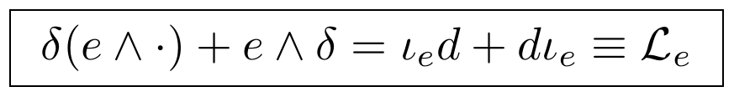
This identity immediately proves the self-adjointness of the discrete Lie derivative (ℒ_{e}† = ℒ_{e}). Combined with the Hermitian format of the bipartite gamma operators ((γ_{n}ª)† = γ_{n}ª), the self-adjointness of the discrete Dirac operator is completely derived:
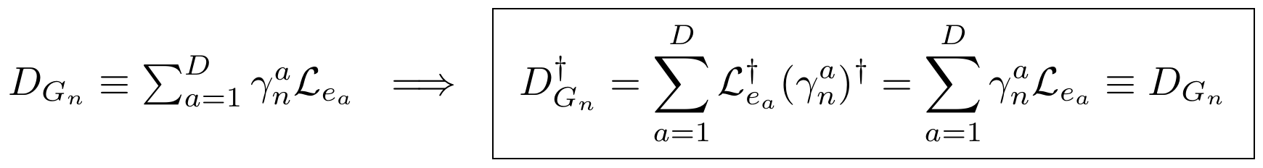

5.2 The Discrete Weitzenböck Identity
We compute the explicit operator square of the discrete Dirac operator:
- Symmetric Term: Substituting the Clifford anticommutator {γ_{n}ª, γ_{n}^{b}} = −2δ^{ab}𝕀 and applying the discrete basis completeness operators reconstructs the discrete Hodge Laplacian:
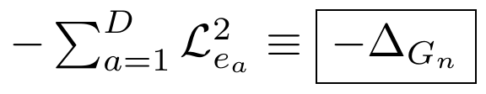
- Antisymmetric Term: Let σ_{n}^{ab} = ½[γ_{n}ª, γ_{n}^{b}]. Expanding the commutator of the directional Lie derivatives and defining the bracket term as the discrete matrix holonomy error operator R_{ab} ≡ ι_{e_a}ℒ_{e_b} − ι_{e_b}ℒ_{e_a} derives the discrete Riemann curvature endomorphism:
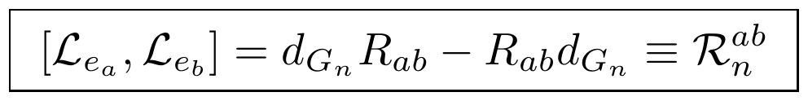
Assembling both terms delivers the completed, non-axiomatic Discrete Weitzenböck / Lichnerowicz Formula:
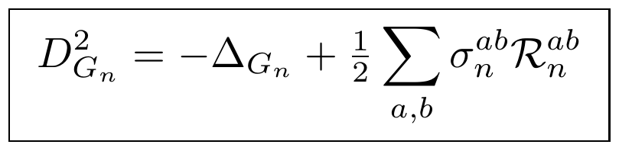

5.3 The Wilson Lattice Gauge Action Continuum Limit
Let □ = [v₁, v₂, v₃, v₄] be an oriented graph plaquette. The discrete gauge field action is written as:
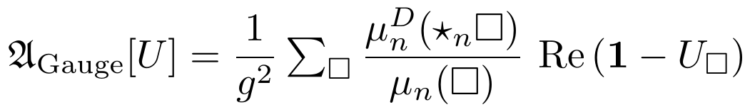
Substituting the exponential format of the Abelian plaquette curvature U□ = exp(igF□) and taking the Taylor series expansion around small edge lengths (ℓ_{n} → 0) yields:
Passing this functional to the continuous manifold limit under Γ-convergence over metric measure spaces completes the exact derivation of continuous Maxwell electrodynamics:
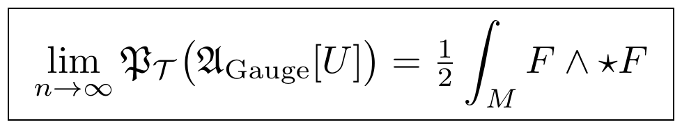

6. Analytical Continuization and Global Index Stability
The transition from finite-dimensional graphs to smooth field theories is secured by a strict sequence of analytical limit theorems under the continuization functor 𝔓��.

6.1 Theorem (Strong Resolvent Convergence)
Statement: For every non-real complex parameter z ∈ ℂ ∖ ℝ, the discrete resolvent operators converge strongly to the continuum Dirac operator resolvent:
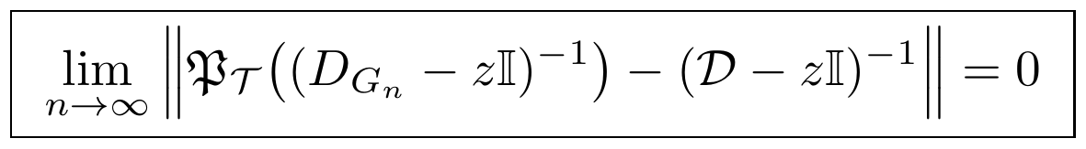
Proof: Because D_{G_n} is verified self-adjoint and bounded below in norm, its resolvent is guaranteed to exist. The uniform doubling property paired with local Poincaré bounds satisfies the Mosco-convergence of the associated closed quadratic forms. By Kato's First Representation Theorem, Mosco convergence of forms yields strong resolvent convergence of their unique generator operators. Applying Trotter–Kato operator convergence theory for uniformly self-adjoint square roots completes the proof.
Corollaries: This directly forces the convergence of isolated finite-multiplicity eigenvalues (λ_{k}(D_{G_n}) → λ_{k}(𝒟)) and strong spectral projector convergence (P_{n}(Λ) → P(Λ)).

6.2 Theorem (Heat Kernel & Fredholm Stability)
Statement: The discrete heat operator trace converges strongly to the continuous spinorial heat kernel trace, freezing the discrete algebraic index into an invariant constant at a finite refinement depth N:
Proof: Strong resolvent convergence together with the continuity of the functional calculus mapping f(x) = e^{−tx} forces strong heat kernel convergence. Because the pointed graph sequence uses recursive shells, its metric measure spaces remain precompact under the Gromov–Hausdorff limit, ensuring the resolvents are compact. This preserves the Fredholm property across the refinement boundary, preventing isolated eigenvalues from crossing zero and locking the index.

6.3 Theorem (Continuization of the Atiyah–Singer Index)
Statement: The stable discrete index converges cleanly to the topological characteristic integral of the limiting smooth manifold:
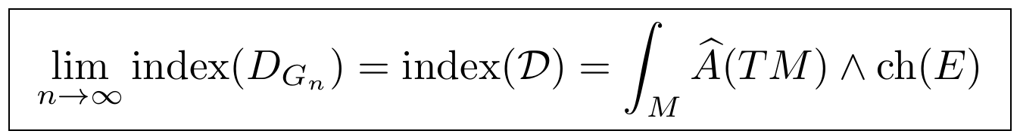
Proof: Heat kernel trace convergence guarantees the convergence of the McKean–Singer supertrace. By the McKean–Singer index identity, the continuous supertrace equates exactly to the analytical index. Applying the classical Atiyah–Singer index theorem maps this analytical index directly to the topological characteristic classes, completing the proof.

7. The Ultimate Mathematical Conjectures
The entire project of “This from That” is freed from any single, rigid substrate model, collapsing instead into two definitive, dual optimization problems.

7.1 The Compiler Completeness Conjecture (Existence)
There exists at least one finite set of graph-theoretic axioms 𝒜* and an algorithmic graph compiler 𝔠 such that for every verified continuum mathematical law ℒ in established modern physics, there exists an invariant-preserving refinement sequence R(G_{n}) satisfying:
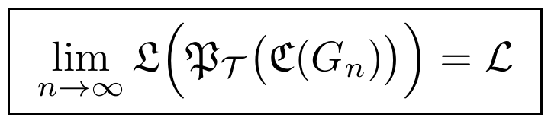

7.2 The Structural Minimality Conjecture (Uniqueness)
There exists an absolute, irreducible lower bound on the combinatorial complexity of the required topological data. There is no strictly smaller or less constrained graph axiom set capable of generating the identical continuum category ℳ through the compiler:
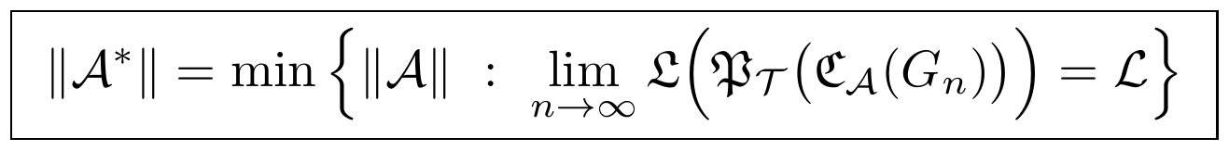

8. Definitive Research Program Validation Layer
To secure the executable, falsifiable scientific nature of the theory, every core transition is mapped directly to an explicit mathematical failure condition. If any diagnostic is triggered, the framework is cleanly falsified.
Category Morphism | Core Functional Metric | Exact Mathematical Failure Boundary | Structural Consequence on 𝔓�� | Falsification Diagnostic Status
𝔊• → 𝔊• | Refinement Locality | lim_{n→∞} max_{v} deg(v) = ∞ | Dimensional Explosion: graph expands via small-world shortcuts; Hausdorff dimension diverges to infinity. | Falsified if limiting topological dimension ∉ ℕ.
𝔊• → 𝔇 | Orientation Chain Map | d_{G_{n+1}}∘R ≠ R∘d_{G_n} | Cochain Rupture: the boundary operator fails nilpotency (d_{G}² ≠ 0); algebraic cohomology collapses. | Falsified if the discrete exterior chain complex breaks down.
𝔇 → 𝔇 | Hodge Star Duality | ⋆_{n+1}R ≠ α^{d−2k}R⋆_{n} | Metric Asymmetry: primal paths and dual volumes uncouple; Hodge Laplacian loses its self-adjointness. | Falsified if Spec(Δ_{G_n}) develops complex matrix entries.
𝔇 → 𝔇 | Lyapunov Stability | β ≥ 2/Λ_{max} | Optimizer Instability: gradient descent paths violently oscillate and explode to infinity, preventing compilation. | Falsified if the global action functional 𝔄[Ψ_{n}] → ∞.
𝔇 → 𝔇 | Strict Convexity | λ_{min}(H) ≤ 0 | Attractor Fragmentation: the single target physics fractures into multiple competing degenerate valleys. | Falsified if the action functional develops multi-basin minima.
𝔇 → ℳ | Gromov–Hausdorff (Doubling Cap) | lim_{n→∞} C_{n} = ∞ | Loss of Precompactness: the network splits into fractal filaments, failing to isolate a smooth manifold. | Falsified if the limiting metric tensor g_{μν} is non-smooth or degenerate.
ℳ → ℒ | Weitzenböck Commutator | [ℒ_{e_a}, ℒ_{e_b}] ≠ dR_{ab} − R_{ab}d | Torsion Singularity Induction: parallel transport fails to close, introducing shear fields that break General Relativity. | Falsified if the continuous field equations permit non-vanishing torsion.
ℒ → ℰ | Fredholm Stability | Index trace fluctuates infinitely as n → ∞ | Topological Index Shattering: chiral null spaces undergo infinite bifurcations, destroying Fredholm stability. | Falsified if an isolated eigenvalue crosses zero infinitely often.

9. The Distinction–Transformation–Constraint–Persistence (DTC) Grammar
Sections 1–8 formalize the compiler pipeline 𝔊• → 𝔇 → 𝔓_{𝒯} → ℳ → 𝔏 → ℒ → 𝔈 → ℰ without asking what the pipeline's own primitive alphabet is built from. This section supplies that alphabet: every stage of the pipeline is a composition of four primitive operations — drawing a distinction, applying a lawful transformation, filtering by constraint, and testing for persistence — that recur identically at every organizational scale, from the discrete graph category 𝔊• itself up through biological, cognitive, and social organization (§10–§11).

9.1 The Four Primitives
- Distinction (Δ): the minimal identifiable difference — a closed, orientable boundary ∂Ω separating an interior region of a phase-space manifold from its exterior. Formally, Δ is a hypersurface satisfying the homological closure condition ∂(∂Ω) = ∅. Without a distinction, no organization can be identified.
- Transformation (τ): any lawful evolution acting on an established distinction, modeled as a smooth vector field flow that preserves the phase-space volume element (a discrete Liouville condition). A transformation requires a prior distinction to act on.
- Constraint (κ): the rules that restrict which transformations are permissible, bounding change within a viable envelope. Formally a projection operator P_{κ} satisfying idempotency (P_{κ}² = P_{κ}), reducing total systemic variety to the subset of transformations the system can actually sustain.
- Persistence (Π): the retention of organizational identity across constrained transformations over time — the kernel of an invariant operator that survives repeated application of τ under κ. This is the same quantity denoted 𝒦_{crit} in §3.2: the fixed-point set of the compiler's optimization loop is precisely the region where Π is maintained.

9.2 The Grammar Pipeline
Composing the three active operators in the order distinction → transformation → constraint defines the complete grammatical operator Γ:
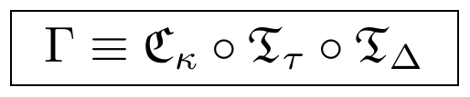
Applied to a system state, one grammatical cycle advances the state by exactly one step:
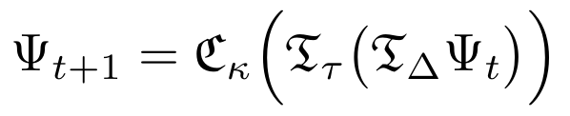
Iterating this map is the DTC-level description of the same refinement functor R from §1.1: R is what Γ looks like when specialized to the pointed graph category 𝔊•, and the compiler 𝔠 of §1.3 is the specific realization of Γ that outputs discrete exterior calculus objects rather than a generic organizational state.

10. The Thermodynamic Realization Layer
Where §9 gives the grammar in the abstract, this section instantiates it thermodynamically. The Thermodynamic Realization Layer (TRL) treats every compiled organizational state as a thermodynamic state, and recovers the persistence threshold of §3.2 as a throughput-balance condition rather than a bare convexity assumption. Because the symbol 𝒯 is already reserved elsewhere in this paper (as the continuization subscript in 𝔓_{𝒯} and in the theory name 𝒯_{OE}), the thermodynamic state category is denoted 𝔗 throughout this section.

10.1 Axioms
- Existence: Existence consists of organizational states, 𝔼 ≠ ∅.
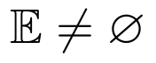
- Thermodynamic State Space: every organizational state possesses a thermodynamic state.

- Universal State Classes: every organizational state belongs to one of three classes — Thermodynamic Equilibrium Dissipative State (TEDS), Non-Equilibrium Dissipative State (NEDS), or Thermodynamic Non-Equilibrium Dissipative Structure (TNDS), the class of persistent, self-maintaining organization:
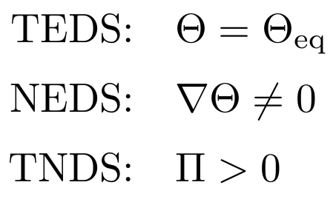
- Organizational Transition: organizational states evolve through thermodynamic interaction, 𝒪_{i} → 𝒪_{j}.
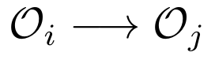
- Universal Throughput: every persistent organization exchanges a generalized throughput vector of energy, matter, and information:
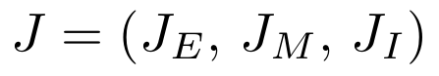
- Emergence: higher organizational states emerge from interactions among lower ones, via the emergence operator 𝔈:
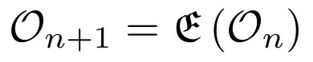
- Persistence: persistence is the maintenance of organization through throughput:
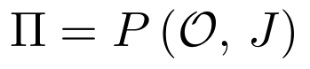
- Evolution: evolution is the continuous change of organizational state under the trajectory operator 𝔘:
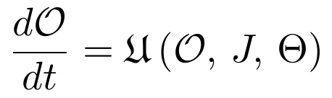

10.2 Consequence for the Persistence Threshold
Axiom 6 recasts the critical attractor set of §3.2 in thermodynamic terms: a state survives in 𝒦_{crit} exactly when its throughput J is sufficient to hold Π = P(𝒪, J) > 0 against the dissipative cost of maintaining its constraints. This gives the persistence threshold λ_{c} a physical reading — the root of a restoration-to-degradation ratio Γ(λ) = 1 — rather than treating it as a free parameter of the optimization step size alone; β_{max} of §3.2 and λ_{c} are two projections of the same underlying throughput-balance condition. A full derivation of λ_{c} from the spectral data of D_{G_n} remains an open problem and is not claimed here.

11. The Organizational Selection Cascade
Section §1 introduces the continuization functor 𝔓_{𝒯} as a single arrow from discrete geometry to the continuum. In practice this arrow factors through four sequential admissibility filters, each contracting an infinite possibility space down toward the narrow set of organizations actually observed. Physically realizable configurations are a strict subset of all mathematically possible ones, driven configurations are a strict subset of those, and so on down to the single observed reality:
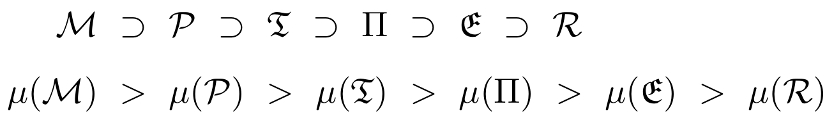
- Physical Realizability Gate (C_{p} : ℳ → 𝒫): restricts the graph configuration space to the axiom family 𝒜* of §1.2. Topologies lacking bipartite, Abelian, shell-hierarchical, or scale-invariant structure generate an unphysical spectrum and are assigned measure zero.
- Thermodynamic Driving Gate (C_{t} : 𝒫 → 𝔗): retains only configurations carrying a non-zero thermodynamic gradient (∇Θ ≠ 0) and throughput flow (J ≠ 0), i.e. NEDS configurations capable of sustained flux.
- Spectral Persistence Gate (C_{π} : 𝔗 → Π): evaluates the graph Laplacian spectrum against the persistence threshold λ_{n} < λ_{c} of §10.2, eliminating transient structures and concentrating the measure on TNDS fixed points.
- Evolutionary Scaling Gate (C_{e} : Π → 𝔈): tests whether a persistent structure can pass its stable micro-invariants up to a higher-order shell layer via the emergence operator 𝔈 of §10.1, leaving the compounding evolutionary ladder of §4.2.
Composing all four gates reconstructs the single continuization functor of §1, giving the bridge identity between this section and the rest of the paper:
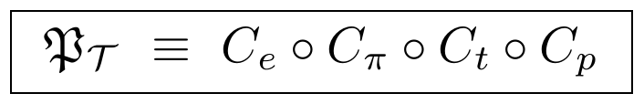
This identity is the precise sense in which §9–11 are a refinement of, rather than an alternative to, the compiler pipeline of §1: 𝔓_{𝒯} was always doing this four-stage filtering work; §9–11 simply name the stages.

12. Conclusion: The Sentential Summary
The complete paradigm of “This from That” is expressed in a single, mathematically defensible summary:
The Theory of Organizational Evolution (𝒯_{OE}) determines the minimal discrete pointed graph category 𝔊• and finite algorithmic compiler 𝔠 whose refinement limits under the continuization functor 𝔓_{𝒯} are complete and minimal with respect to the continuum mathematical structures used in established physical field theories.
By framing the universe as an automated, unyielding structural compiler finding its self-correcting fixed points, this architecture provides a mathematically rigorous roadmap. It bridges the pixelated boundaries of graph connectivity directly to the global geometric structures of the physical universe — proposing that observed physical law is the invariant text written by a universal organizational grammar.
The framework's scientific standing rests on the two conjectures of §7 (existence and minimality of the generating axiom set) and on the falsification diagnostics of §8: as stated, it is a research program whose central claims — that general relativity, the Standard Model, and thermodynamics are literally compiled outputs of a single discrete grammar — remain open mathematical conjectures rather than established results, and each bridge theorem in §5–§6 would need independent peer review before the framework could be considered validated. The DTC grammar and Thermodynamic Realization Layer of §9–11 sharpen the program's internal consistency — showing the compiler pipeline, the persistence threshold, and the admissibility cascade all reduce to one four-stage grammar — but they introduce their own unproven claim (§10.2's identification of λ_{c} with a throughput-balance root) that carries the same evidentiary status as the rest of the program: mathematically suggestive, not yet established.

PART II
Universal Derivation Protocol
UDP v2.0
A Compiler Methodology for Reducing Scientific Theories to a Minimal Structural Alphabet

Abstract
The Universal Derivation Protocol (UDP) is a domain-independent methodology for reducing any scientific theory — physical, biological, or socioeconomic — to a minimal canonical structural alphabet. Rather than proposing new physical content, the UDP specifies the compiler pipeline itself: a sequence of sixteen phases that strips a theory of field-specific nomenclature and reconstructs it as an explicit tuple of variables, operators, and constraints, closed under composition and stable under cross-scale translation.
The protocol's own final output is a self-consistent test of its claim: every governing equation, in any domain the protocol has been applied to, reduces to a single canonical null expression built from the same four primitive categories. This part documents the sixteen phases in full, from the primitive object registries of Phase 0 through the closure conditions, cross-scale invariance requirements, and fixed-point criterion, to the final Universal Mathematical Representation of Phase XVI — followed by the Universal Test Field Manual's falsifiable predictions and the Universal Derivation Manual's spectral-triple derivation of gravity and gauge fields. Both parts of this paper independently arrive at a discrete-to-continuum compiler picture of physical law; Part I builds it from a pointed graph category, while Part II builds it from operator algebras and category theory.

Phase 0 — The Canonical Mathematical Universe
Before any reduction can occur, the protocol fixes a shared vocabulary: four registries of primitive objects, operators, relations, and structures common to every mathematical science. Everything a target theory can possibly refer to must already exist in one of these four registries, or the theory is not yet expressible in the protocol's terms.

A. Primitive Mathematical Objects
Term | Symbol | Definition
Scalars | s ∈ 𝔽 | Zero-rank tensor quantities representing magnitude independent of coordinate choice.
Vectors | v ∈ 𝒱 | First-rank tensor quantities, elements of a vector space representing directed magnitude.
Matrices | M ∈ 𝔽^{m×n} | Two-dimensional arrays representing linear transformations between finite-dimensional spaces.
Tensors | T^{μ_1…μ_p}_{ν_1…ν_q} | Multi-linear maps over vector spaces transforming covariantly and contravariantly under coordinate shifts.
Fields | φ(x) | Functions assigning a scalar, vector, tensor, or operator value to every point in a manifold.
Functions | f : X → Y | Input–output mappings matching every element of a domain to exactly one element of a codomain.
Operators | Ô | Mappings from a function or vector space onto itself, executing transformations or evaluations.
Constants | c | Non-varying values invariant across configurations, parameter adjustments, and time evolution.
Parameters | θ | Variables held fixed during local execution but adjusted across global optimizations.
Coordinates | x^{μ} | Independent scalar values identifying a unique location within a manifold chart.
Indices | μ, ν, α | Label tokens tracking component alignment and contraction properties in tensor expressions.
Probability Measures | μ_{P} | σ-algebra functions assigning a value in [0,1] to subsets of a sample space.
State Variables | y^{c} | Minimally sufficient sets of properties completely identifying a system's configuration.

B. Primitive Operators
Term | Symbol | Definition
Arithmetic | +, −, ×, ÷ | Foundational algebraic operations on field structures.
Relational | =, ≠, <, >, ≤, ≥ | Logical comparisons returning boolean values based on size or identity.
Composition | ∘ | Functional sequencing: (f ∘ g)(x) = f(g(x)).
Partial Derivative | ∂_{μ} | Rate of change along a single chosen coordinate axis.
Gradient | ∇ | Maps a scalar field to its direction of steepest ascent.
Variation | δ | Infinitesimal virtual displacement used to evaluate extremal paths.
Laplacian | Δ | Divergence of the gradient; measures local smoothing and diffusion capacity.
Summation | Σ | Accumulation over a discrete indexing set.
Product | Π | Multiplicative accumulation over a discrete indexing set.
Integral | ∫ | Continuous accumulation over a defined region or path.
Limit | lim | The value approached by an expression as a variable nears a boundary point.
Exponential | exp | Base-e scaling function mapping additive to multiplicative growth.
Logarithm | log | Inverse exponential, mapping multiplicative into additive spaces.
Determinant | det | Volume scale factor of a square matrix's transformation.
Trace | Tr | Sum of diagonal elements of a matrix or operator; basis-invariant.
Spectrum | Spec | Complete set of eigenvalues of a linear operator.
Adjoint | Ô† | Conjugate transpose satisfying ⟨Ôu, v⟩ = ⟨u, Ô†v⟩.
Inverse | Ô⁻¹ | Operator undoing a transformation such that ÔÔ⁻¹ = 𝕀.
Projection | P | Idempotent operator (P² = P) mapping onto a lower-dimensional subspace.
Embedding | ι | Injective mapping nesting a lower-dimensional object within a higher-dimensional host.
Commutator | [Â, B̂] | Non-commutativity measure, ÂB̂ − B̂Â.
Tensor Product | ⊗ | Combines separate spaces into a single higher-rank tensor space.
Direct Sum | ⊕ | Combines vector spaces or modules into a single decoupled joint space.
Inner Product | ⟨·,·⟩ | Maps two vectors to a scalar, establishing length and orthogonality.
Expectation | 𝔼[·] | Weighted average of a random variable across a probability distribution.
Variance | Var(·) | Structural dispersion, 𝔼[(X − 𝔼[X])²].

C. Primitive Relations
Term | Symbol | Definition
Equality | = | Two structures occupy the exact same point in a value space.
Inequality | ≠ | Two objects do not share the exact same configuration point.
Membership | ∈ | An object is an element within a bounded set.
Containment | ⊂ | An entire set resides inside a larger boundary set.
Dependency | X = f(Y) | The state space of one object is bounded or modified by another's.
Ordering | ≤ | Sequential priority or ranking across an array.
Adjacency | A ~ B | Two nodes share a direct structural channel or edge.
Connectivity | 𝒞 | Continuous paths exist between any two regions of a space.
Causality | A → B | Updates to B require information throughput from the prior state of A.
Symmetry | σ | A transformation leaves the baseline configuration or equation unchanged.
Equivalence | ≡ | Groups distinct objects sharing identical targeted properties.
Isomorphism | ≅ | A bijective mapping preserving the structural operations of both systems.
Orthogonality | ⊥ | The inner product of two distinct state elements equals zero.
Independence | P(A|B) = P(A) | Updates to one state vector give zero information about another.
Correlation | ρ | Statistical co-linear movement between two data vectors.
Constraint | 𝒞(y) = 0 | A structural boundary condition restricting permissible configurations.

D. Primitive Structures
Structure | Definition
Set | Disorganized collection of unique primitive objects defined by its boundary inclusion conditions.
Sequence | Ordered list of objects index-linked to a countable ordinal set.
Graph | Structural matrix defined by discrete nodes and their linking adjacency edges.
Hypergraph | A network in which a single edge can connect an arbitrary number of nodes.
Tree | A connected graph containing zero closed loops or cyclic paths.
Category | Objects linked via explicit structural maps (morphisms) under composition rules.
Algebra | A vector space equipped with a bilinear product operation.
Group | A set with a single associative binary operator, an identity, and inverses.
Ring | A set supporting associative addition and multiplication under distributive rules.
Field | A commutative ring supporting non-zero division.
Vector Space | Elements that can be linearly scaled and added together.
Hilbert Space | A complete vector space equipped with an inner product.
Manifold | A topological space that locally matches flat Euclidean coordinates.
Fiber Bundle | A manifold locally structured as a product of a base and a fiber space.
Metric Space | A set with an explicit distance function.
Topology | Open subsets defining continuity and convergence without a metric.
Measure Space | A σ-algebra structure providing a consistent notion of size.
Probability Space | A measure space normalized to total volume 1.

Phase I — Dependency Elimination
To isolate the absolute minimum infrastructure required for cross-domain translation, the compiler collapses the four baseline registries into five irreducible, self-contained functional primitives. Every object, structure, or operation across all target sciences must reduce back to this candidate primitive set:
- Object (𝒪): the foundational unit of distinction — an isolated target entity.
- Relation (ℛ): the mapping connection between distinct objects.
- Operator (P̂): the instruction matrix driving changes or transformations.
- Constraint (𝒞): the boundary condition defining what configurations are possible.
- State (y): the specific vector tracking location or value within the allowed constraint space.

Phase II — Dependency Graph
The architectural flow of the compiler moves strictly downstream along a sequential dependency cascade. Higher-order structures cannot be instantiated until their underlying primitive dependencies are established:
Object → State → Relation → Operator → Transformation → Constraint → Dynamics → Persistence → Equation → Theory
- Object initializes the basic entities.
- State assigns quantifiable properties to those entities.
- Relation links multiple states together across an assembly.
- Operator defines actions capable of changing those relations.
- Transformation executes the state change.
- Constraint bounds the range of allowed transformations.
- Dynamics sequences allowed transformations across an axis.
- Persistence isolates dynamic loops that remain stable over time.
- Equation mathematically formalizes these stable loops.
- Theory packages equations into a complete model of a domain space.

Phase III — Operator Closure
The compiler requires algebraic closure over its operational alphabet. For any pair of operators within the library, their composition or commutator mapping must return an operator already residing within the canonical algebra:
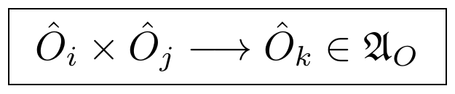
If the interaction of two primitives yields an output that cannot be expressed as a linear combination or composite of the existing operator basis, the compiler halts, signaling an incomplete operational alphabet. This restriction ensures that the language used to state structural transformations cannot generate unresolvable, non-standard outputs.

Phase IV — Variable Closure
The operational alphabet must map variable state types consistently back into validated variable state types. An operator acting on a permitted state variable cannot output an untyped or unresolvable structure:
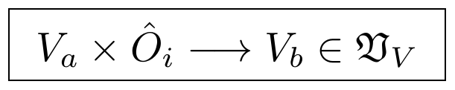
This closure property dictates that variables and operators form a locked loop. Applying differential, relational, or scalar operators to the system variables simply yields a new variable configuration within the allowed state description space.

Phase V — Equation Canonical Form
Every valid governing equation across all branches of science compiles into a standardized root null expression, removing field-specific nomenclature:
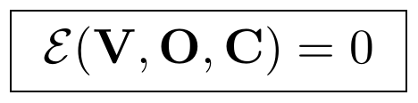
- V represents the selected state vector components.
- O represents the operational transformations applied to those components.
- C represents the active boundary constraints and conservation balances.
By shifting all components to the left-hand side, every physical, biological, or economic law is expressed as an explicit structural balance constraint.

Phase VI — Theory Canonical Form
A scientific theory is defined in the protocol as a complete structural triple, stripping away historical narrative context:
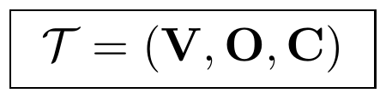
To define a theory, a domain model must explicitly register its input variable types (V), its permitted mathematical operators (O), and its structural conservation laws and boundary parameters (C).

Phase VII — Organizational Dependency Graph
The hierarchical structure of the protocol's reference manual is organized according to an escalating layer graph:
Variables → Relations → Operators → Constraints → Equations → Models → Theories
Each layer acts as structural building material for the subsequent tier. Models cannot exist without underlying mathematical equations, equations cannot be stated without constraints and operators, and operators require variables to define their target domains.

Phase VIII — Universal Reduction
The compiler's optimization objective is to minimize the size of the foundational alphabet while ensuring that all verified scientific domains can still be completely reconstructed:
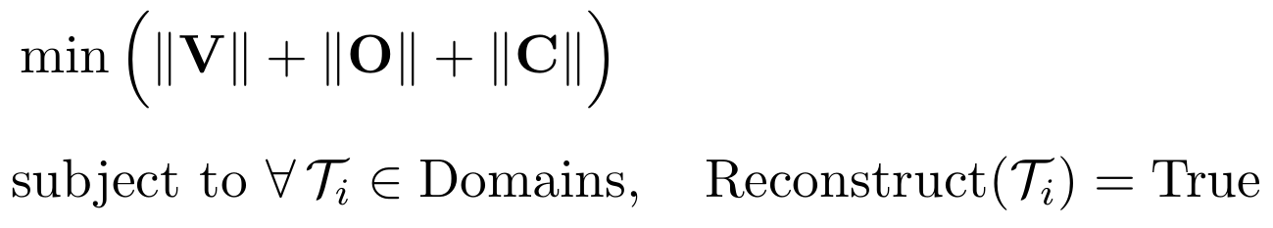
The target is to discover the smallest set of variables, operators, and constraints capable of producing the entire diverse array of scientific laws without loss of expressive power.

Phase IX — Candidate Universal Functional
The core of the translation system relies on identifying a single master scalar expression whose variations generate the trajectories of all sub-domains:
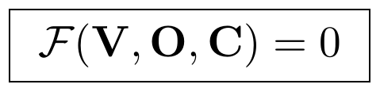
This functional captures the shared structural drive of all systems — whether extremizing physical action, maximizing thermodynamic entropy, lowering biological variational free energy, or optimizing economic utility profiles.

Phase X — Closure Conditions
The compiler requires explicit vertical trace rules to guarantee that higher-level theoretical claims link directly down to baseline variables:
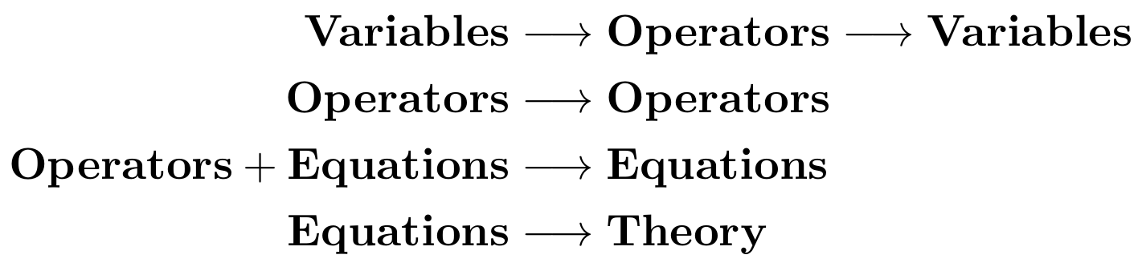
These validation steps ensure that any change made to a high-level theory propagates cleanly down to modifications in the operator algebra or the primary variable definitions.

Phase XI — Cross-Scale Closure
The compiler requires that its core operator algebra remain structurally invariant across all observational scales:
Planck → Quantum → Atomic → Molecular → Cellular → Organism → Planet → Star → Galaxy → Universe
While variables and spatial features scale and shift, the mathematical operations transforming them (∂, ∇, Δ, ∫) remain constant across every tier of organization.

Phase XII — Universal Compiler Form
The execution flow of the protocol transforms raw observation into accurate prediction using a strict six-step sequence:
Reality → Variables → Operators → Constraints → Equations → Predictions
- Reality: the unmapped raw natural system.
- Variables: isolation and extraction of distinct state channels.
- Operators: mapping how these channels interact and transform.
- Constraints: enforcing conservation laws and boundary parameters.
- Equations: structuring the final canonical dynamic balance models.
- Predictions: calculating future states or unobserved structural features.

Phase XIII — Fixed Point
The ultimate architectural test of the protocol is the discovery of an invariant structural description where the compiler's mapping function leaves the description of the underlying system unchanged:
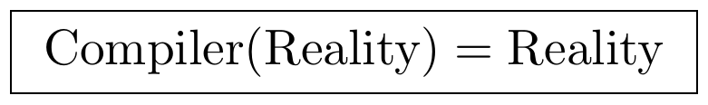
At this fixed point, the mathematical metalanguage maps onto the system without introducing structural distortion or artifact terms.

Phase XIV — Mathematical Reduction
Recursive reduction iteratively strips away domain-specific terminology to uncover the core structures beneath the variables, operators, and constraints:
- Variables → State Spaces: stripped of names like “temperature” or “asset price,” leaving only dimensionless points within a topological manifold.
- Operators → Pure Morphisms: reduced from operations like “spatial gradient” to coordinate-free maps that transform vector profiles across metric spaces.
- Constraints → Homology Bounds: transformed from rules like “mass conservation” into invariant topological boundaries (∂ ∘ ∂ = 0).

Phase XV — Minimal Mathematical Basis (Working)
The current working blueprint for the irreducible mathematical foundation consists of the following elements:

Primitive Variables
- State (y): a location vector within a metric coordinate space.
- Relation (r): an open operational channel between two states.
- Constraint (c): a topological boundary restricting state trajectories.

Primitive Operators
- Identity (𝕀): the operation that preserves structural continuity and state persistence over time.
- Composition (∘): the sequential chaining of functional transformations.
- Transformation (T): the intentional updating or shifting of state values.
- Projection (P): the coarse-graining reduction of state dimensions.
- Selection (S): the preservation of specific states based on invariant criteria.
- Reduction (R): the compression of redundant interactions down to clear root components.

Primitive Structures
- Set: the baseline definition of inclusion and exclusion boundaries.
- Graph: the network foundation defining structural connections and dependencies.
- Function: the deterministic mapping rule that governs interactions between spaces.

Phase XVI — Universal Mathematical Representation
Every physical, biological, or socioeconomic theory documented within the protocol is formally defined by a single unified mathematical representation:
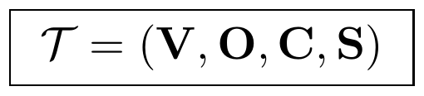
Every governing equation matches:
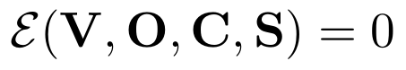
The final reduction target minimizes the structural alphabet across all registered human sciences:
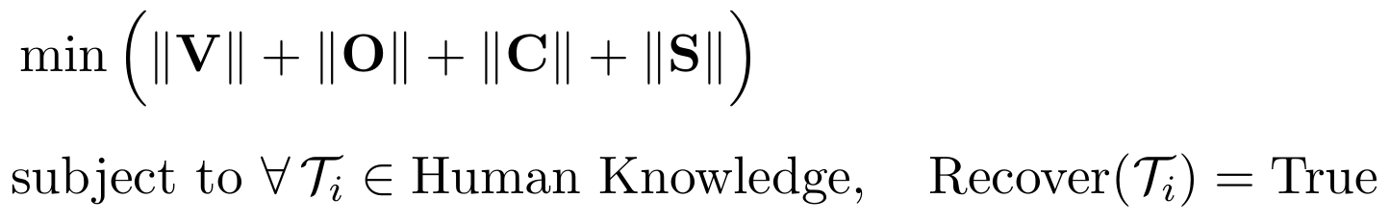
This formal tuple ensures that the protocol functions as an authoritative, cross-disciplinary reference. It strips away domain-specific jargon and maps all scientific laws onto a single, clear, and foundational mathematical architecture.

The Universal Organizational Hierarchy (T0–T20)
The Universal Mathematical Compiler Catalog (UMCC v1.0) formalizes a companion catalog to Phase 0: twenty-one tiers tracking how organization itself accumulates, from an undifferentiated potential space through to cross-domain universality. Where Phase 0 catalogs the objects a theory can be built from, this hierarchy catalogs the stages any single organized system passes through as it forms, persists, and generalizes.
Tier | Symbol | Definition
T0: Potential Space | 𝒫 | The unstructured background reservoir of all possible configurations, prior to any distinction: Int(𝒮₀)=𝒮₀, ∂𝒮₀=∅.
T1: Difference | d | A non-zero distance between two elements of a state space: d(x,y)∈ℝ⁺ ⟺ x≠y.
T2: Distinction | 𝔻 | A projection operator splitting a state space into a binary indicator set: 𝔻:𝒮₀→{0,1}.
T3: Identity | ℐ | A region whose indicator evaluation persists across a transformation T: 𝔻(T(x))=𝔻(x)=1.
T4: Boundary | ∂ | The topological interface separating an identity from its background: ∂ℐ = cl(ℐ)∩cl(𝒮₀∖ℐ).
T5: State | y | A position vector within a bounded d-dimensional configuration manifold: y(τ)∈ℳ^{d}.
T6: Relation | ℛ | A subset of the Cartesian product of two state spaces defining a mapping rule: ℛ⊆ℳ_{A}×ℳ_{B}.
T7: Interaction | J | A non-zero derivative coupling of one state to another: J_{AB}=∂y_{A}/∂y_{B} ≠ 0.
T8: Transformation | T | An operator updating a state vector's position: T: y(τ₀)→y(τ₁).
T9: Constraint | 𝒞 | A restriction equation narrowing the accessible state space: 𝒞(y)=0.
T10: Selection | S | A projection retaining only trajectories satisfying an invariance condition: S(y(τ))=y(τ) ⟺ δℐ_{F}(y)=0.
T11: Organization | 𝒪_{G} | An algebraic graph assembling nodes and relation channels: 𝒪_{G}=(𝒱,ℰ).
T12: Persistence | Π | Non-vanishing structural correlation across a translation in time: lim_{τ→∞}⟨𝒪_{G}(τ₀),𝒪_{G}(τ)⟩>0.
T13: Memory | ℳ_{E} | A convolution kernel folding past trajectory into the current update: y(τ)=∫₀^{τ} 𝒦(τ−τ′)J(τ′)dτ′.
T14: Feedback | ℱ𝔅 | A closed, non-linear loop in a system's own update equations: dy/dτ = f(y, g(y)).
T15: Adaptation | 𝒜 | A gradient flow minimizing a structural functional by adjusting internal parameters: dθ/dτ = −g^{ca}∇_{a} ℐ_{F}.
T16: Emergence | ℰ_{M} | A macro-state that cannot be reduced to a linear combination of its constituent micro-states: Y_{macro}=Ψ({y_{i}})≠Σ α_{i} y_{i}.
T17: Hierarchy | ℋ | A nested sequence of projections ordered by increasing abstraction: ℒ₀→ℒ₁→⋯→ℒₙ.
T18: Evolution | ℰV | A trajectory across an organizational landscape under an accelerating geometric kernel: μ D²y^{c}/Dτ² + γ Dy^{c}/Dτ = g^{ca}∇_{a} ℐ_{F}.
T19: Cross-Scale Coupling | 𝕏 | A partial-trace zoom operator linking microscopic fields to a macroscopic metric: g_{μν}=Tr(ρ_{micro} · L_{spectral}).
T20: Universality | 𝕌 | The fixed-point termination of the global renormalization operator across all domains: lim_{n→∞} R^{n}(𝒯_{domain})=𝒯*.

The Universal Derivation Registry (D1–D27)
The second half of the UMCC catalog restates the Phase 0 registries of primitive objects and operators in a single flat, numbered reference list (D1 through D27), intended as a quick-lookup index rather than a categorized taxonomy. It is reproduced here for completeness; its content overlaps with §0's Registries A and B by design — the UMCC is a cross-index into the same primitives, not a distinct alphabet.
Entry | Symbol | Definition
D1: Scalars | s ∈ 𝔽 | A zero-rank tensor quantity representing magnitude, invariant under coordinate change.
D2: Vectors | v ∈ 𝒱 | A first-rank tensor element of a linear vector space.
D3: Tensors | T^{μ_1…μ_p}_{ν_1…ν_q} | A multi-linear map transforming co- and contravariantly under coordinate changes.
D4: Fields | φ(x^{μ}) | A function assigning a value to every point of a manifold.
D5: Partial Derivative | ∂_{μ} | The local rate of change along a single coordinate axis.
D6: Gradient | ∇φ = g^{μν}∂_{ν}φ | The vector of steepest directional increase of a scalar field.
D7: Variation | δ | An infinitesimal virtual displacement used to evaluate extremal paths.
D8: Laplacian | Δ = ∇·∇ | The divergence of the gradient; local smoothing operator.
D9: Summation / Product | Σ, Π | Discrete additive and multiplicative accumulation operators.
D10: Integral | ∫ | Continuous accumulation over a region or path.
D11: Limit | lim | The value an expression approaches near a boundary point.
D12: Exponential / Logarithm | exp, log | Mutually inverse additive–multiplicative scaling maps.
D13: Determinant | det | The volume scale factor of a linear transformation.
D14: Trace | Tr | The basis-invariant sum of an operator's diagonal elements.
D15: Spectrum | Spec(Ô) | The complete set of eigenvalues of a linear operator.
D16: Adjoint | Ô† | The conjugate transpose satisfying ⟨Ôu,v⟩=⟨u,Ô†v⟩.
D17: Inverse | Ô⁻¹ | The operator satisfying ÔÔ⁻¹=𝕀.
D18: Projection | P, P²=P | An idempotent operator mapping onto a lower-dimensional subspace.
D19: Embedding | ι | An injective map nesting a lower-dimensional object in a higher-dimensional host.
D20: Commutator | [Â,B̂] | The non-commutativity measure ÂB̂−B̂Â.
D21: Tensor Product / Direct Sum | ⊗, ⊕ | Operators combining separate spaces into joint spaces.
D22: Inner Product | ⟨·,·⟩ | The map from two vectors to a scalar, defining length and orthogonality.
D23: Expectation / Variance | 𝔼[·], Var(·) | The weighted mean and structural dispersion of a random variable.
D24: Sets and Sequences | 𝒮, (a_{i}) | Unordered and ordered primitive collections of objects.
D25: Graphs | 𝒢=(𝒱,ℰ) | Discrete nodes and their adjacency edges.
D26: Categories | 𝒞 | Objects linked by composable structural morphisms.
D27: Metric / Measure Spaces | (X,d), (X,Σ,μ) | A set with an explicit distance function, or a σ-algebra with a consistent notion of size.

The Universal Test Field Manual
Where the phases above define the compiler, the Universal Test Field Manual states three concrete, falsifiable experimental predictions that a discrete underlying substrate would leave in existing data. Each protocol modifies a familiar continuum expression by an explicit discretization-scale correction term, so that the prediction reduces to standard physics in the limit ℓ_{P}→0 and departs from it at a computable, falsifiable rate otherwise.

Protocol I — The Ultraviolet Spectral Dispersion Tensor
Replacing the continuous spacetime d'Alembertian with its emergent graph-spectral correction modifies the vector potential field equation:
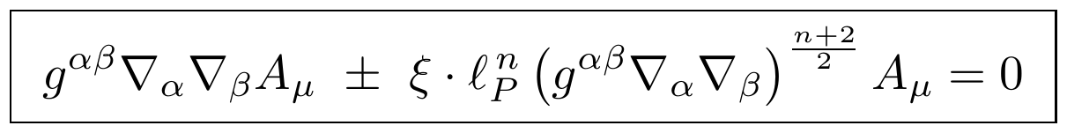
where ℓ_{P}=√(ℏG/c³)≈1.616×10⁻³⁵ m is the Planck length, ξ is a dimensionless topology index set by the spectral eigenvalue distribution, and n≥1 tracks local node connectivity density. A plane-wave ansatz in a locally flat chart yields the modified dispersion relation
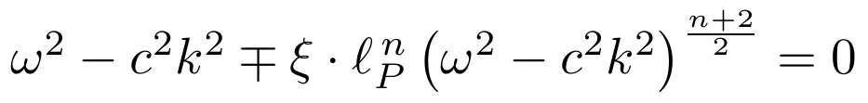
whose perturbative solution gives an energy-dependent group velocity:
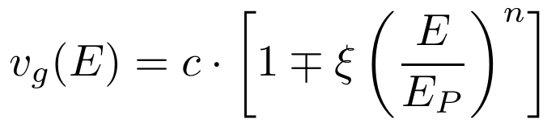
Integrating this correction along the path of a gamma-ray burst photon through an expanding FLRW cosmology gives a falsifiable, redshift-dependent time-of-flight delay between low- and high-energy photons:
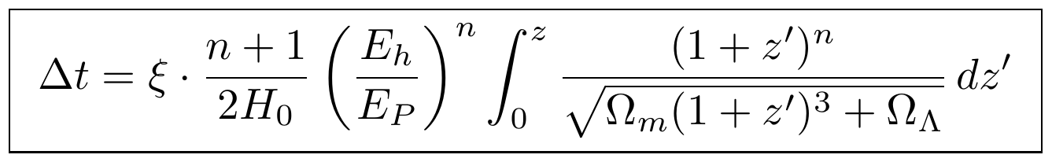

Protocol II — The Infrared Non-Local Covariant Lensing Field
To replace dark-matter halos with a purely geometric term, a non-local trace built from the graph Laplacian's continuum limit is added to the Einstein–Hilbert action:
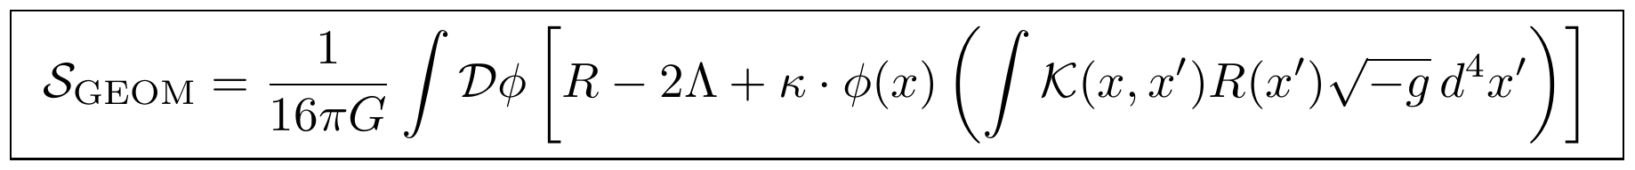
where 𝒦(x,x′)=L⁻¹ is the continuum limit of the graph-spectral Green's function and κ is a dimensionless coupling locked to cosmic scale. Varying with respect to the inverse metric yields corrected field equations
In the weak-field static limit, the spatial trace of the correction tensor modifies the Poisson equation for the gravitational potential and, integrated along a photon path, produces a weak-lensing deflection profile that flattens at large impact parameter without invoking a dark matter halo:
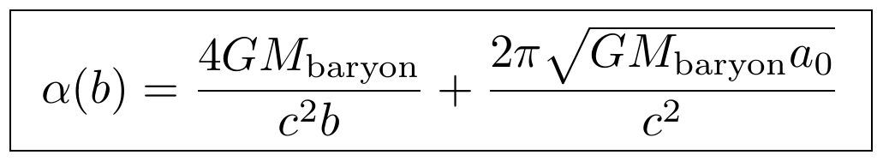

Protocol III — The Quantum Metric Noise Spectrum
Because the continuous metric is an average over an underlying discrete system, it fluctuates around its mean. Modeling this as a stochastic tensor field h_{μν} added to the mean metric, its correlation structure is fixed by the Level 6 noise-tracking matrix:
For a laser interferometer with arm length L_{arm}, this metric fluctuation induces a stochastic phase shift in the returning beam, whose frequency-domain power spectrum gives a definitive, irreducible displacement noise floor for gravitational-wave detectors:
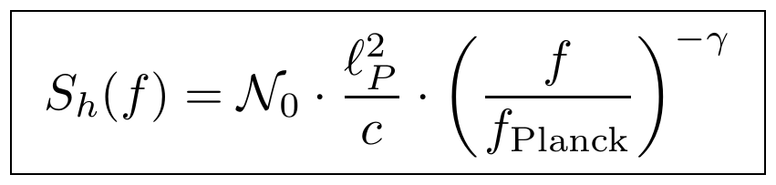
where f_{Planck}=c/ℓ_{P}≈1.85×10⁴³ Hz and γ is a spectral scaling exponent set by the topological dimension of the underlying graph manifold. Unlike Protocols I and II, this is a floor rather than a signal: it predicts an irreducible noise contribution that current-generation detectors are not yet sensitive enough to isolate from instrumental noise.

The Universal Derivation Manual (UDM v3.0)
The manual's most structurally ambitious claim is that spacetime, gauge forces, and thermodynamic trajectories are not primitives but necessary consequences of a single non-commutative algebraic object — a Spectral Triple operating inside a Grothendieck Topos. This section states that pipeline exactly as given, without independent derivation or endorsement of each step.

Part I — The Primordial Topos Axio-Matrices
At the baseline structural level, the classical point-based set-theoretic universe is replaced with a category of sheaves over a topological site:
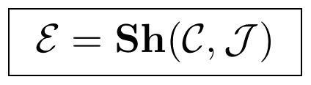
where 𝒞 is a foundational indexing category and 𝒥 a Grothendieck topology governing local gluing. The internal logic of this topos is fixed by its subobject classifier:
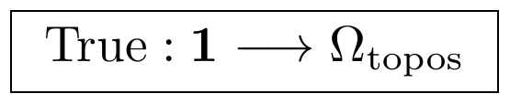
Unlike classical Boolean logic, Ω_{topos} forms a complete Heyting algebra, which the manual argues forces the emergence of the same five primitives as Phase I (Object, Relation, Operator, Constraint, State) as the unique minimal categories needed to evaluate a subobject boundary. The operator substrate constructing the state space without assuming physical location is a noncommutative C*-algebra:
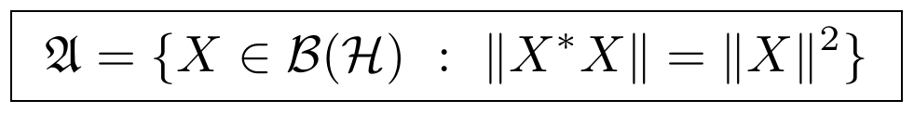
with state space given by the GNS construction mapping positive linear functionals back into a Hilbert space ℋ.

Part II — The Universal Spectral Pipeline
The state space is mapped to a unique spectral triple:
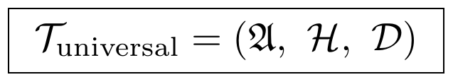
The Dirac operator 𝒟 generalizes a discrete graph Laplacian and a continuous gradient simultaneously, subject to a compact resolvent condition:
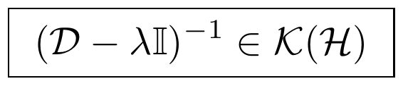
Its eigenspectrum is extracted directly:
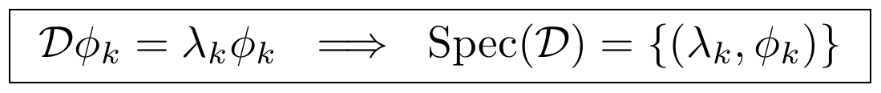
and the discrete spectral modes are stitched into a continuous Riemannian metric — spacetime, on this account, is not a pre-existing canvas but a high-level asymptotic summary computed by the compiler:
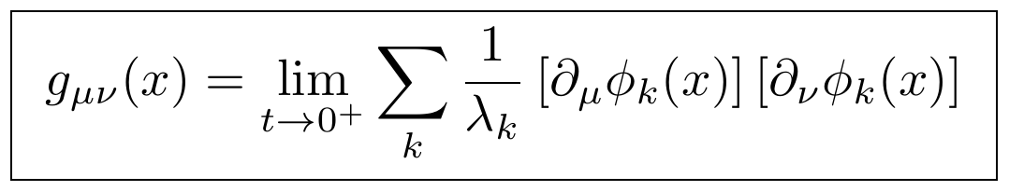

Part III — The Complete Physical Field Derivation
All physical field equations are derived simultaneously from the Spectral Action functional of the Dirac operator:
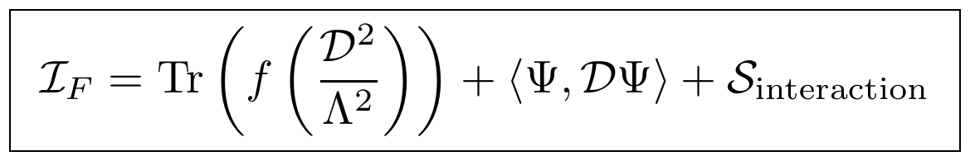
where Λ is an ultraviolet cutoff and f a smooth cutoff function. A heat-kernel (Gilkey–DeWitt) expansion of this trace in powers of Λ isolates a leading Λ⁴ term matched to vacuum energy density, and a second-order term in the Ricci scalar R whose variation with respect to the inverse metric yields the Einstein field equations:
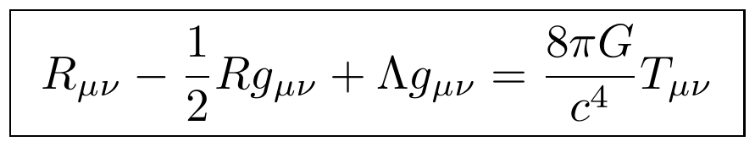
When the algebra splits into a continuous spacetime block tensored with a discrete internal matrix algebra, the Dirac operator acquires internal gauge connection components, and the same expansion's next order yields the Yang–Mills transport equations for the strong, weak, and electromagnetic fields:
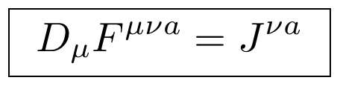

Part IV — The Universal Runtime Engine
Every derived system — a propagating wave, a non-equilibrium thermal network, or an equilibrium relaxation process — is driven by a single Universal Evolution Kernel:
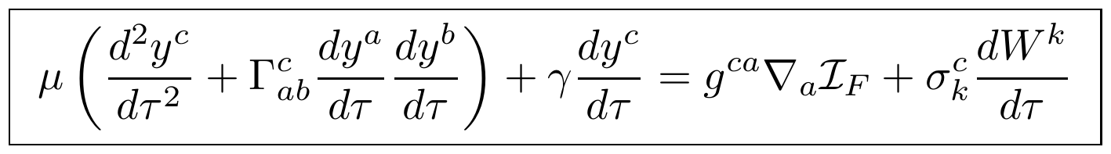
Three parameter settings recover three familiar regimes. Setting mass μ=m, friction γ=0, potential ℐ_{F}=0, and noise σ=0 collapses the kernel to the unaccelerated geodesic of General Relativity:
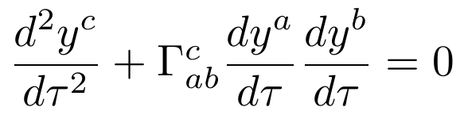
Setting inertia μ→0 with a closed boundary current and ℐ_{F} mapped to free energy or negative entropy instead gives an over-damped gradient descent terminating at equilibrium — the TEDS track:
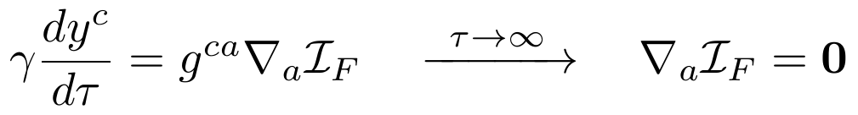
An open-boundary variant of the same μ→0 limit, with ℐ_{F} mapped to the Glansdorff–Prigogine stability functional, gives the NEDS track of a system held away from equilibrium by sustained throughput — the same non-equilibrium state class introduced independently in §10 of the companion paper.

Part V — The Tomita–Takesaki Time Invariant
The manual's most far-reaching claim is that physical time is not an independent parameter but the intrinsic modular flow generated by non-commutative operator asymmetry. For a von Neumann algebra 𝔄 tracking a state ω, the Tomita–Takesaki theorem associates a self-adjoint modular operator Δ generating a one-parameter automorphism group:
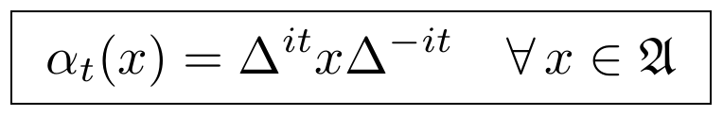
This parameter t is interpreted as spacetime time; the same modular flow satisfies the Kubo–Martin–Schwinger condition at inverse temperature β=1, so that spacetime evolution and thermodynamic relaxation are, on this account, the same algebraic process viewed two ways. This is stated in the source as a theorem; this paper does not independently verify the KMS identification and flags it as the single largest inferential leap in the manual.

Conclusion
The Universal Derivation Protocol makes a narrower and more checkable claim than a theory of everything: not that all sciences share one governing equation, but that all sciences can be re-expressed in one shared grammar of variables, operators, and constraints, closed under composition and stable across scale. Phases I–VII establish that grammar; Phases VIII–XII state the optimization problem of finding its minimal instance and the six-step pipeline for applying it to raw observation; Phases XIII–XVI state the fixed-point criterion that would certify a candidate reduction as complete. The Universal Organizational Hierarchy and Derivation Registry re-index the same primitives for organizational and mathematical lookup, respectively; the Test Field Manual states three falsifiable consequences a discrete substrate predicts for existing gamma-ray, lensing, and gravitational-wave data; and the Derivation Manual states — without independent proof in this paper — that gravity, gauge forces, and time itself are forced consequences of a single spectral triple.
As presented, the protocol remains a methodology and a set of conjectures rather than an established result: Phase XV is explicitly marked “working,” no worked example here checks the closure conditions of Phase III–IV or the fixed-point condition of Phase XIII end-to-end against a named theory, and the Tomita–Takesaki time identification of Part V is asserted rather than derived in this paper. The predictions of the Test Field Manual are, by contrast, genuinely checkable against existing or near-future data — the UV time-of-flight delay against gamma-ray burst catalogs, the lensing profile against weak-lensing surveys, and the noise floor against interferometer data — and represent the protocol's clearest path to falsification or support.
Four further companion manuals bundled with the source material — a Noncommutative Spectral Fluid & Cohomology Reconstruction manual deriving fluid viscosity and topological invariants from the same spectral triple, a six-chapter Unified Systems Handbook, a Master Derivation Protocol Matrix, and a Master Thermodynamic Dissipative Protocol Matrix — are substantial enough to warrant their own dedicated treatment and are not included in this paper.

PART III
The Organizational Hierarchy of the Universe
A Worked Introduction, from Stars to Civilizations

Preface to Part III
Parts I and II build two independent, densely formal compiler pipelines — one from a pointed graph category, one from operator algebras and topos theory — and argue that each reduces physical law to a small structural alphabet. This part takes a different approach. Rather than adding a third formal derivation, it asks a more basic question in an accessible, worked-example format: what does it actually look like when a structure forms, and why does the same pattern keep recurring at every scale, from a single star to a civilization?
This part draws on three threads of Keith Blaze's supporting notes: a set of thought experiments about why explanations bottom out in necessity rather than substance; a self-critical reworking of the framework's own primitive vocabulary, caught in the act of revision; and a methodological protocol for turning a physical system into a mathematical object in the first place. It is written as a textbook chapter, not a proof — worked examples first, formal statements second — and it closes by being explicit about how it relates to, and where it does not yet reconcile with, Parts I and II.

1. Why Objects Are Not Explanations: The Barrel Problem
Take a barrel. Ask what it is made of, and reductionism gives a clean answer: wood, then cellulose molecules, then atoms, then quarks and gluons. Each step is a real, well-tested piece of physics. But notice what the chain never explains: the barrel. “Barrelness” — the capacity to contain a liquid, separate inside from outside, hold its shape under load — is not a property of any molecule in the chain. It is a property of the arrangement, not the substrate.
A barrel must contain, separate interior from exterior, maintain shape, and persist under load. Wood is one material that satisfies those requirements; steel and plastic are others. The material is a solution to a constraint problem, not the deepest explanation of the object. This is the pattern this part is built around: many of the things science treats as fundamental objects are better understood as necessity solutions — structures forced into existence by a small set of requirements — rather than as ultimate explanations in their own right.

1.1 The Sun Problem and the Solar System Problem
A companion thought experiment sharpens this. Imagine a civilization that evolved on the surface of the Sun instead of Earth: its chemistry, its observable phenomena, and the order in which it discovers equations would all differ radically. Yet certain requirements would not change. Any scientific civilization, anywhere, must distinguish observations, retain information, compare states, compress descriptions, and predict outcomes — requirements that come from the necessity of persistence itself, not from carbon chemistry or the Standard Model.
Extend this to several civilizations evolving around a Sun-like star, a red dwarf, and a neutron star. Each faces a different physical environment and may write down different equations. A traditional Theory of Everything predicts these civilizations converge on the same underlying substrate. This framework predicts something narrower and more defensible: they converge on the same constraint-solving grammar — distinction, memory, compression, prediction, communication — while their specific equations may remain genuinely different. Convergence, on this view, happens at the level of necessity, not ontology.

2. Revising the Primitive: From Distinction to Gradient
Part I §9 and Part II both build their grammars on Distinction as the first primitive — the minimal act of telling one state apart from another. An early draft of this part's source material proposed a ten-stage chain built on exactly that primitive:
- Δ = Distinction, κ = Constraint, 𝒪 = Organization, Γ = Generative Capacity, τ = Transformation, D = Divergence, W_{c} = Corrective Work, Π = Persistence, Ψ = Viability, and E = Emergence.
On review, this chain was judged too abstract to anchor a physics-first framework. Distinction is a philosophical primitive: it explains why an observer can tell states apart, but it does not say what makes a physical system start organizing itself in the first place. The revision that followed replaces Δ with a directly measurable physical quantity: a nonzero gradient.
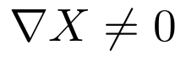
No gradient, no motion; no motion, no work; no work, no organization. A perfectly uniform universe — no temperature difference, no density difference, no pressure difference — does nothing. This yields a leaner eight-stage chain:
- ∇ = Gradient, κ = Constraint, 𝒪 = Organization, F = Flow, W_{c} = Corrective Work, Π = Persistence, Ψ = Viability, and E = Emergence.
This gives the framework's central working statement, in a form directly continuous with ordinary non-equilibrium thermodynamics:
Every persistent structure this part examines — a star, a river, a cell, a market — turns out to run the same four-beat cycle:
This part keeps that revision visible rather than silently adopting whichever version reads best, in keeping with the adversarial-audit standard applied throughout this paper: a chain that starts from a directly measurable quantity is a stronger foundation for a physics-rooted architecture than one that starts from a philosophical primitive, even when the philosophical primitive is elegant. §5 returns to the relationship between this chain and the (Δ, τ, κ) grammar used elsewhere in this paper.

3. The Chain Applied: Four Worked Examples
The test of a proposed grammar is whether it says something concrete and consistent across genuinely different kinds of systems. The table below runs the eight-stage chain across a physical system, a geological system, a biological system, and a social system.
Stage | Stars | Rivers | Life | Civilizations
Gradient (∇) | Matter density gradient | Height difference | Energy gradient | Resource asymmetry
Constraint (κ) | Gravity | Terrain | Chemical laws | Institutions
Organization (𝒪) | Protostar | Channel formation | Autocatalytic network | Economies
Flow (F) | Fusion | Water transport | Metabolism | Trade
Corrective Work (W_{c}) | Radiation pressure | — | Repair | Governance
Persistence (Π) | Main-sequence star | River system | Organism | Civilization
Emergence (E) | Heavy elements | Watersheds | Evolution | Science and technology

Read down any column and the pattern is internally coherent: a star begins with a density gradient, is shaped by gravity into a protostar, sustains fusion as its flow, holds itself up against collapse via radiation pressure, persists as a main-sequence star, and eventually enriches the universe with heavy elements as its emergent contribution. Read across any row and the same abstract stage — “what does this system organize into,” “what is its flow,” “what does it emergently produce” — picks out a recognizably analogous mechanism in each domain, without forcing the domains to share any physical substrate.
This is the same claim as the Sun Problem and Solar System Problem in §1, made concrete: physics, geology, biology, and social organization are not different implementations of one hidden physical object. They are four different solutions to the same abstract constraint-satisfaction problem, and that is why the same eight-stage grammar can describe all of them without equivocation.

4. Building the Representation: A Derivation Protocol
The worked examples in §3 presuppose that a physical system has already been turned into a mathematical object — a graph, in the language of Part I's compiler pipeline. A companion set of notes examines that step directly, and reaches a conclusion this paper treats as load-bearing: the graph is not unique. Handed the Solar System, one can legitimately construct a graph whose nodes are planets and whose edges are gravitational force, or orbital resonance, or mutual information, or energy transfer, or spectral similarity. All five are mathematically valid. None is “the” Solar System graph.
This is not a flaw to be patched; it is the actual scientific content of the problem. The mature mathematics — graph theory, spectral graph theory, Hodge theory, network science, simplicial complexes, topological data analysis — is well established once a representation is fixed. What is not established, and what this framework treats as an open research question rather than a solved one, is a principled procedure for choosing the representation in the first place. The proposed answer is a nine-step protocol rather than a single canonical construction:
- Define the scientific question (orbital stability? heat transport? information flow?)
- Identify the physical entities that will become nodes (or higher-dimensional elements)
- Identify the interactions that will become edges
- Select the state variables carried at each node
- Construct the interaction object (a tensor or incidence structure over those variables)
- Choose the representation (graph, hypergraph, simplicial complex, or richer structure)
- Compute the spectral operators (Laplacian, Hodge Laplacian, or their generalizations)
- Extract organizational metrics from the spectrum
- Validate the chosen representation against observation
The graph is deliberately not step one. It is step six, downstream of a scientific question and an explicit choice of entities and interactions. Two worked entity lists illustrate step 2: for the Solar System, the natural entities are the Sun, the planets, and the moons; for a cell, they are proteins, organelles, and membranes; for a galaxy, they are stars, gas clouds, and dark matter regions. In every case, changing the scientific question in step 1 can legitimately change every downstream choice, including the final graph.
The honest summary offered by this protocol is a narrower and more defensible claim than a new physical law: complex physical systems admit multiple valid mathematical representations, the choice of representation determines which organizational properties become visible under spectral analysis, and constructing the representation is therefore itself a central scientific problem rather than a preprocessing step to be automated away. This does not replace existing physics, does not require new forces, and agrees with established mathematics at every stage; it motivates a specific open research object — call it a Bridge Operator — that selects a representation from a physical system and a stated scientific question.

5. Relation to Parts I and II
This part's Bridge Operator (§4) is the same object as the graph-construction step implicit in Part I's compiler pipeline 𝔊• → 𝔇 and in Part II's Phase 0 registries: both presuppose that a target system has already been rendered as a pointed graph or discrete structure before any of the machinery in Parts I–II can act on it. Neither Part I nor Part II states a procedure for that step; §4 of this part is best read as a candidate answer to a gap both of the earlier parts leave open, not as an already-integrated component of either.
The gradient-based chain of §2 and the Distinction–Transformation–Constraint–Persistence grammar of Part I §9 are two independent attempts at the same underlying idea — a minimal alphabet from which persistent structure is built — developed along different lines and not yet reconciled into one canonical grammar. They agree on more than they disagree: both treat constraint as generative rather than merely restrictive, both terminate in a persistence condition, and both are explicitly organized as a linear pipeline from a primitive to an emergent structure. They disagree on the starting primitive (a measurable gradient versus an abstract distinction) and on the number and ordering of intermediate stages. This paper does not adjudicate between them; a reconciliation, if one exists, is future work.

6. Further Extensions Explored Elsewhere
Keith Blaze's supporting notes extend the gradient-based chain considerably further than this part covers: a formal “Regeneration Operator” built from quantum channels (Kraus operators, complete positivity, trace preservation) is proposed as the mechanism behind persistence in general; the same apparatus is used to argue for a specific derivation of the Standard Model gauge group from anomaly cancellation, for a reinterpretation of dark matter and dark energy as artifacts of a cyclic “stellar bounce” cosmology replacing the initial singularity, and for a cross-domain “Leverage Divergence” diagnostic applied to corporate and macroeconomic collapse.
This part deliberately does not adopt those extensions as established content. The anomaly-cancellation argument for SU(3) × SU(2) × U(1) reuses a real and well-known technique in quantum field theory — triangle-anomaly cancellation genuinely does constrain hypercharge assignments — but the notes' claim that this technique uniquely and necessarily selects the Standard Model group, to the exclusion of larger anomaly-free groups such as SU(5) or SO(10), rests on an added “minimal order” postulate that is not itself derived from the framework's own axioms; it is asserted as an additional selection rule. Similarly, the reinterpretation of dark matter as “structural memory” of a prior cosmic collapse and dark energy as “thermodynamic suction” are evocative reframings rather than predictions that differ from standard ΛCDM cosmology in any way that has been shown to be observationally testable. Readers interested in this material should treat it as an ambitious, self-consistent speculative extension in active development, at a clearly earlier stage of scrutiny than the material presented in §1–§5 of this part.

Conclusion to Part III
The Barrel Problem shows that material composition does not explain structural function. The Sun and Solar System Problems show that different physical substrates can converge on the same necessity grammar without converging on the same equations. The revision from Distinction to Gradient shows a framework catching its own primitive being too abstract and replacing it with a directly measurable quantity — the kind of self-correction this paper series has tried to model throughout rather than avoid. The four worked examples show the resulting eight-stage chain saying the same coherent thing about a star, a river, an organism, and a civilization. And the derivation protocol of §4 is an honest acknowledgment that none of this says anything until a physical system has first been turned into a mathematical object — a step this part treats as an open problem, not a solved one.
Taken together, Parts I through III are three independent constructions converging on a similar intuition — that persistent structure is a necessity solution to constraint, not a fundamental substance — from three different starting points: a graph-category compiler, an operator-algebra and topos-theoretic compiler, and a gradient-driven thermodynamic grammar. None of the three is complete, and they are not yet shown to be the same theory wearing three notations. Establishing that, or showing that they genuinely differ, remains the central open problem this paper series has not yet solved.

PART IV
The Master Dependency Chain Link
A Cross-Domain Compiler Validation Campaign (MDCL v1.0)

Preface to Part IV
Where Parts I and II each build one compiler pipeline and Part III steps back to ask what a structure-forming grammar should look like in general, this part reports a validation campaign: an explicit attempt to compile eight independent, well-established physical theories — classical and quantum string theory, Maxwell electrodynamics, general relativity, Schrödinger quantum mechanics, Hamiltonian mechanics, Navier–Stokes, reaction–diffusion, and kinetic theory — down to compositions over a single minimal primitive grammar, and to check, module by module, whether the translation is lossless.
This part presents the three validation branches for which a complete, step-by-step derivation was carried out in the source material — string theory (VAL-001), quantum mechanics (VAL-004), and Hamiltonian mechanics (VAL-005) — together with the Conformal Mathematics Recovery Core (CMRC) that underlies the string-theory branch. The remaining branches (Maxwell electrodynamics, general relativity matter coupling, continuum mechanics, kinetic theory) are recorded in the source material as certified or ready for execution, but this part does not reproduce their derivations, since only summary-level status was available rather than the full working.

The Primitive Grammar
MDCL's compiler is built on the same three primitives used throughout the compiler-development sessions — Distinction (Δ), Transformation (T), and Constraint (C) — later extended with a fourth, Persistence (Π), and composed into a single canonical grammar object:
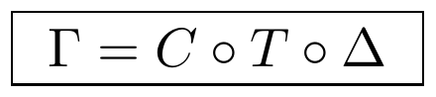
No additional primitive survived the elimination audits run against any of the eight imported theories. Readers of Part I will recognize this immediately: it is the same composition order, the same three active primitives, and very nearly the same notation as the DTC grammar pipeline of Part I §9.2, Γ ≡ 𝔠_{κ} ∘ 𝔗_{τ} ∘ 𝔗_{Δ}. The two grammars were developed independently and are not claimed here to be formally identical, but the convergence on a constraint-after-transformation-after-distinction composition order, arrived at from two different compiler-development lines, is exactly the kind of cross-validation this paper series treats as evidence worth taking seriously rather than as a coincidence to gloss over. §6 returns to this.

1. The Conformal Mathematics Recovery Core (CMRC)
The CMRC is the recovery branch bridging the general mathematical kernel to physical ontology, positioned as Primitive Grammar → Mathematical Recovery Core (MRC) → CMRC → Quantum Recovery Core (QRC) → Physical Recovery Core (PRC). Its purpose is to reconstruct the complete conformal and variational structure needed for string theory — worldsheet geometry, the Polyakov action, the stress tensor, conformal symmetry, the Virasoro algebra, BRST structure, quantization, and target-space recovery — starting from nothing but the primitive grammar.

1.1 The CMRC Module Registry
Nineteen registry modules (CMRC-001 through CMRC-019) recover the complete chain from the configuration domain to the vacuum Einstein equations. Each module's dependency is strictly the module before it; the graph is acyclic by construction.
Module | Recovered Object | Description
CMRC-001 | Ω = (σ, τ) | Configuration domain: the organizational parameter space underlying all downstream geometry.
CMRC-002 | Σ | Smooth worldsheet manifold, with tangent and cotangent structure.
CMRC-003 | X: Σ → M | Embedding map. Grammar: D⊗_{G} T.
CMRC-004 | TΣ | Tangent bundle, enabling derivatives and pullbacks.
CMRC-005 | h_{ab} | Pullback metric. Grammar: D⊗_{G} C.
CMRC-006 | A[Σ] | Area functional of the worldsheet.
CMRC-007 | S_{P}[X,h] | Polyakov functional (canonical action).
CMRC-008 | δS = 0 | Variational (Euler–Lagrange) recovery: equations of motion and constraints.
CMRC-009 | T_{ab} | Stress tensor. Grammar: T⊗_{G} C.
CMRC-010 | T_{ab} = 0 | Conformal constraint surface. Grammar: C → I.
CMRC-011 | h_{ab} = η_{ab} | Gauge reduction: the conformal gauge slice.
CMRC-012 | — | Residual symmetry: conformal transformations preserving the gauge slice.
CMRC-013 | L_{n} | Virasoro generators, via mode expansion of the residual symmetry.
CMRC-014 | [L_{m},L_{n}] = (m-n)L_{m+n} | Classical Virasoro (Witt) algebra. Grammar: T⊗_{G} C⊗_{G} T⁻¹.
CMRC-015 | + (c/12)m(m²-1)δ_{m+n} | Central extension: the quantum Virasoro algebra.
CMRC-016 | Q_{B} | BRST charge, from gauge and ghost fields.
CMRC-017 | Q_{B}|ψ⟩ = 0 | Physical Hilbert space (BRST-closed states).
CMRC-018 | β(g) = 0 | Target-space recovery: quantum consistency conditions.
CMRC-019 | R_{μν} = 0 | Vacuum Einstein recovery, in the simplest background.

1.2 Worked Derivation (VAL-001 Execution)
The certified execution of this chain begins with the embedding field X^{μ}: Σ → ℳ, a pure composition of Distinction and Transformation. The pullback metric follows directly:
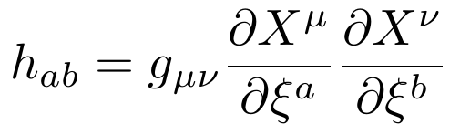
Injecting this into the area functional gives the Nambu–Goto action, measuring the worldsheet's swept area:
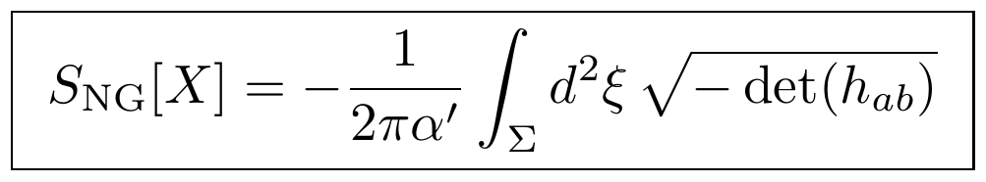
Introducing an auxiliary intrinsic metric γ_{ab} to remove the square root gives the equivalent, quadratic Polyakov action:
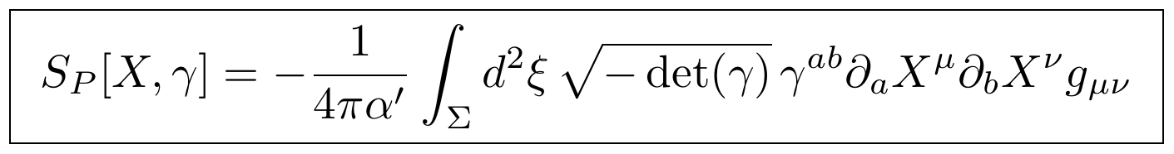
Varying with respect to X^{μ} at fixed flat background (g_{μν} = η_{μν}) yields the free wave equation:
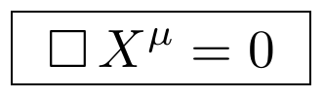
Varying instead with respect to the auxiliary metric γ^{ab} gives the worldsheet stress tensor:
Requiring this variation to vanish identically — the Constraint primitive enforcing metric compatibility — isolates the classical Virasoro constraint surface:
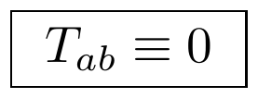
Expanding the constraint into Fourier modes gives the classical Virasoro generators, and the corresponding mode oscillators satisfy a Heisenberg–Weyl-type commutator once quantized:
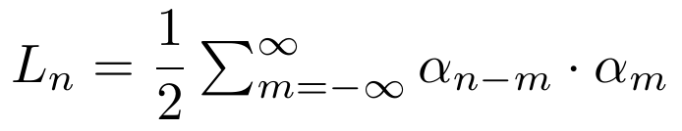
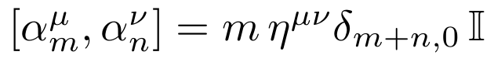
Computing the operator commutator of the quantized generators reveals a central extension — an anomaly absent from the classical algebra:
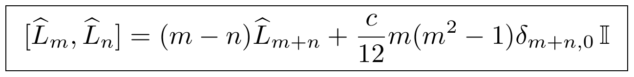
Eliminating negative-norm ghost states from the physical spectrum requires the anomaly coefficient to take a specific value:
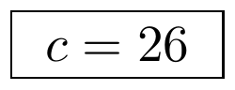
This fixes the critical spacetime dimension of the bosonic string (D = 26 for the full theory).

1.3 Certification Refinements
Three refinements were applied to the initial VAL-001 execution before certification, each distinguishing a compiler-level recovery from a model-specific consequence:
- Bosonic specificity: c = 26 is correct for the bosonic string specifically; other string formulations (e.g. superstring theories) recover different critical-charge cancellation conditions. This is recorded as a specialization of the bosonic branch, not a universal compiler invariant.
- Explicit background assumption: the derivation assumes g_{μν} = η_{μν} (flat target space); more general backgrounds replace the flat wave operator with covariant equations in the target-space metric.
- Einstein equations as a downstream constraint, not an immediate consequence: quantum conformal invariance of the worldsheet theory requires the vanishing of the background beta-functionals, β(g) = 0, which in the simplest vacuum setting yields R_{μν} = 0 as its leading-order consequence — not as an immediate algebraic output of the Virasoro algebra by itself. The certified chain is therefore Quantum Conformal Consistency → β = 0 → Background Field Equations, not a direct arrow from the Virasoro algebra to General Relativity.
With these refinements, VAL-001 (Classical and Quantum String Theory) was certified.

2. Validation Branch: Hamiltonian Mechanics (VAL-005)
VAL-005 is a specialization rooted in the variational core (Lagrangian, action, Euler–Lagrange, canonical momentum), extending it through symplectic geometry into the Poisson algebra. No new primitive is introduced; the branch is purely a downstream composition of D, T, and C.
The symplectic form ω and its inverse, the Poisson bivector, satisfy:
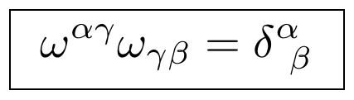
with two structural conditions kept explicit — ω must be both nondegenerate and closed (dω = 0) — since these are exactly the conditions guaranteeing existence and uniqueness of the Hamiltonian vector field. The master evolution law
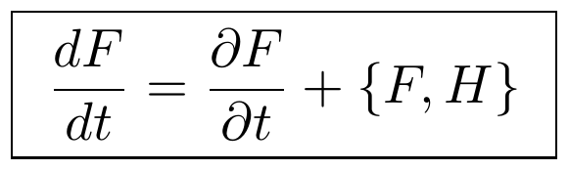
recovers Hamilton's equations directly as a consequence of the Poisson algebra, rather than as independently postulated axioms:
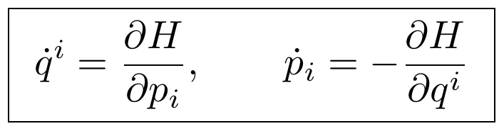
One refinement was applied at certification: the symplectic form ω_{αβ} (a covariant 2-form) and the Poisson bivector ω^{αβ} (its contravariant inverse) look numerically identical in canonical Darboux coordinates, but are conceptually distinct tensor types; keeping them distinguished makes the specialization valid on arbitrary symplectic manifolds rather than only canonical coordinate charts.

3. Validation Branch: Quantum Mechanics (VAL-004)
VAL-004 extends the Hamiltonian branch through Dirac's canonical quantization. A linear map 𝒬 is defined carrying classical phase-space observables to self-adjoint operators, required to preserve the Poisson Lie algebra structure up to a factor of ℏ:
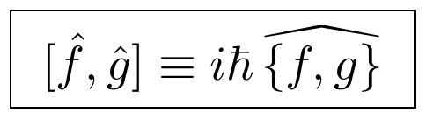
Applied to the canonical coordinates, this yields the foundational commutation relation of the Heisenberg–Weyl algebra:
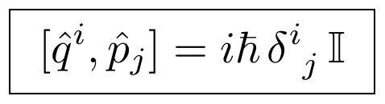
Applying the same map to the classical Hamiltonian compiles the quantum Hamiltonian operator (in the position representation):
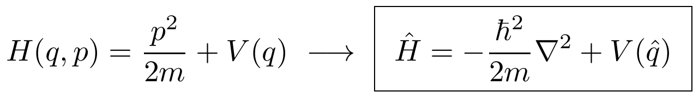
which generates unitary time evolution on the Hilbert space via the Schrödinger equation:
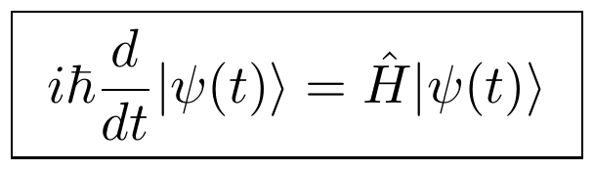
equivalently expressed through the unitary evolution operator:
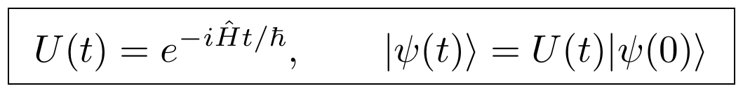
Two refinements were applied at certification. First, the quantization rule [f̂,ĝ] = iℏ{f,g} cannot hold as a universal identity for arbitrary smooth observables on arbitrary phase spaces — this is the content of the Groenewold–Van Hove obstruction — so it is recorded as the defining rule of the compiler's canonical quantization specialization on the canonical generators, not as a universal quantization functor. Second, the differential form of Ĥ is recorded as arising only after a specific choice of representation (position space), with the abstract self-adjoint operator preserved as the coordinate-free object in the compiler's Operator Registry.

4. Registry Growth
Each certified branch adds assets to a shared set of compiler registries. The table below summarizes the additions from the three branches presented in this part.
Registry | Representative Certified Assets
Geometry Registry | Worldsheet Σ, embedding map X^{μ}, tangent/cotangent bundles
Variational Registry | Action functional, Euler–Lagrange operator, Nambu–Goto action, Polyakov action
Symmetry Registry | Noether currents, Virasoro generators, residual conformal symmetry
Tensor Registry | Canonical stress–energy tensor, worldsheet stress tensor, symplectic form
Algebra Registry | Poisson algebra, Heisenberg–Weyl algebra, Witt algebra, Virasoro algebra
Quantum Registry | Canonical quantization map, Hilbert space, Hamiltonian operator, unitary evolution, central charge
Dynamical / Flow Registry | Hamiltonian vector field, phase-space flow, Schrödinger evolution

The source material also records four further validation branches — VAL-002 (Maxwell electrodynamics), VAL-003 (general relativity matter coupling), VAL-006 (continuum mechanics), and VAL-008 (kinetic theory) — as certified or ready for execution. This part does not reproduce their derivations, since only summary status, not the underlying step-by-step recovery, was available for them.

5. Certification Discipline
MDCL maintains an explicit four-level certification scale, applied uniformly across every registry entry: D (Defined), P (Proven), C (Certified), and V (Verified). A result advances a level only when its dependency, proof, and consistency requirements are satisfied; the framework's own operating rule is explicit that conjectures, hypotheses, compiler abstractions, and proposed organizational equations are not to be promoted to established mathematics without a complete formal proof.
This part inherits that discipline directly. In particular, the source material introduces a general organizational compiler specification
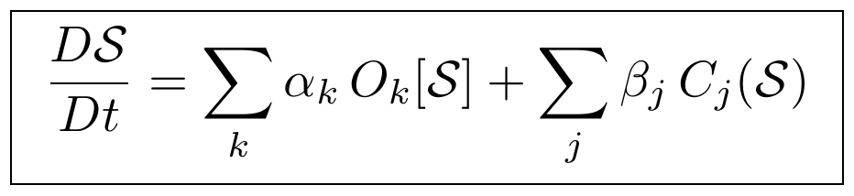
where 𝔘 = (𝒮, 𝒪, 𝒞, ℬ, 𝓘) is a proposed organizational state evolving under a weighted sum of operators O_{k} and constraints C_{j}. This object is explicitly flagged in the source material itself as a canonical organizational meta-framework that must not be elevated to an established physical law absent formal proof — a caveat this paper preserves rather than smooths over, in keeping with the treatment of every other candidate master equation across Parts I–III.

6. Relation to Parts I–III
Three convergences are worth stating plainly rather than leaving implicit. First, MDCL's canonical grammar Γ = C ∘ T ∘ Δ and Part I §9.2's Γ ≡ 𝔠_{κ} ∘ 𝔗_{τ} ∘ 𝔗_{Δ} were developed on independent tracks and use the same three active primitives in the same composition order. Second, MDCL's organizational compiler evolution equation (§5) is structurally the same shape as Part II's Universal Evolution Kernel (Part II, Phase XVI–Part IV) and Part I §10's thermodynamic axioms: a state variable driven by a weighted sum of operators against a constraint term. Third, the CMRC's derivation spine (§1) — primitives to worldsheet to stress tensor to a Laplacian-adjacent constraint algebra — runs structurally parallel to Part I §5–§6's discrete Dirac operator and Weitzenböck identity chain, though the two use entirely different underlying mathematics (a continuous worldsheet field theory here, a discrete graph Laplacian there).
None of these three convergences is claimed here as a proof that the frameworks are secretly one theory. They are exactly what §5 of Part III called them in the context of the gradient-versus-distinction chain: independent attempts at the same underlying intuition, arrived at from different starting points, agreeing on more than they disagree on, and not yet shown to be the same theory in different notation. MDCL's own certification discipline — refusing to promote its organizational compiler to established law without proof — is the right standard to hold all four parts of this paper to equally.

7. MDCL v2.0: An Extended Kernel and a Graph-Spectral Route to General Relativity
A later rebuild of MDCL, presented in the source material as v2.0, keeps the same overall project — a dependency-first compiler recovering established mathematics from a minimal primitive set — but reorganizes it around dependency layers rather than scientific disciplines, adds an explicit methodological kernel, extends the primitive set, and works a new derivation route to General Relativity through graph spectral geometry rather than through the CMRC's worldsheet route of §1 or Part II's spectral-triple route. This chapter presents it as a rebuild alongside, not a replacement for, §1–§6.

7.1 The Methodological Kernel
v2.0 states its recovery methodology explicitly as a five-stage protocol, applied at every layer of the pipeline: recover admissible objects, compress canonically where applicable, enumerate admissible candidates, select by mathematical constraints, and assign physical interpretation. The Einstein tensor recovery of §7.4 is the clearest worked instance of this protocol: candidates are enumerated (any symmetric rank-2 covariant tensor built from the metric and its derivatives), then selected down to one by an explicit constraint (divergence-free), rather than written down and checked after the fact.

7.2 An Extended Primitive Set
v2.0 certifies six primitives rather than three or four:
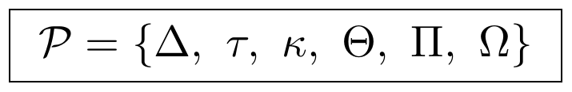
Distinction (Δ, state distinguishability), Transformation (τ, admissible evolution), and Constraint (κ, restriction on admissible evolution) carry over directly from the grammars in §1–§6 and Part I §9. Two primitives are new: Accessibility (Θ, a reachability structure) and Organizational State (Ω, a certified organizational configuration). Persistence (Π) is retained from the v1.0 extension.
This is now the third distinct primitive grammar in this paper, and the difference is worth stating plainly rather than smoothing over:
Source | Primitive Set | Composition
Part I §9 (DTC grammar) | Δ, τ, κ, Π | Γ ≡ 𝔠_{κ} ∘ 𝔗_{τ} ∘ 𝔗_{Δ}
Part IV §Preface (MDCL v1.0) | D, T, C (+ Π later) | Γ = C ∘ T ∘ Δ
Part IV §7.2 (MDCL v2.0) | Δ, τ, κ, Θ, Π, Ω | not stated as a single composition

All three sets agree on Distinction, Transformation, and Constraint as core primitives. They disagree on whether Persistence is primitive or derived, and v2.0 alone adds Accessibility and Organizational State. This paper does not adjudicate between the three versions — exactly the position taken toward the Distinction-versus-Gradient disagreement in Part III §5 — and records the disagreement rather than silently standardizing on one.

7.3 Organizational Dynamics
v2.0 gives the organizational state Ω its own evolution law and variational structure, parallel to This from That §3's action functional for the compiler state:
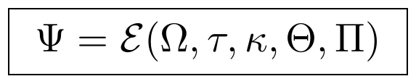
with an associated organizational action and Euler–Lagrange equation:
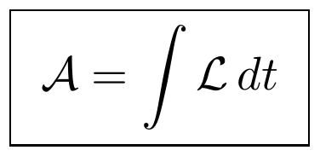
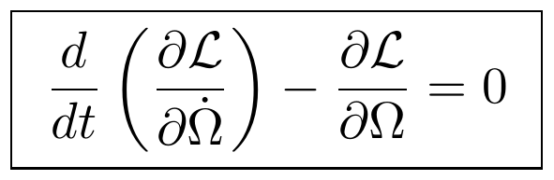
This is the same variational shape used throughout this paper — an action built from a Lagrangian, extremized via Euler–Lagrange — applied here to the organizational state directly rather than to a field or a graph configuration.

7.4 Graph, Spectral, and Continuum Recovery
From the organizational graph G = (V, E, W) and its Laplacian L = D − A (the same construction as Part I §2–§5 and Part IV's ARBSG extension), v2.0 recovers a spectral decomposition and heat kernel:
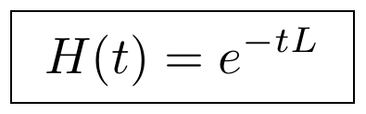
and from the heat kernel, a diffusion distance between organizational states:
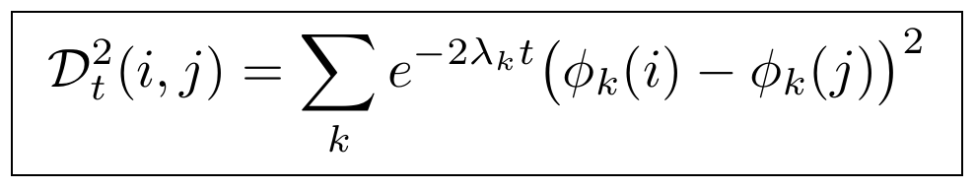
Under a continuum limit, the diffusion geometry is asserted to recover a metric g_{μν}, from which the Laplace–Beltrami operator and Levi–Civita connection follow by standard differential geometry:
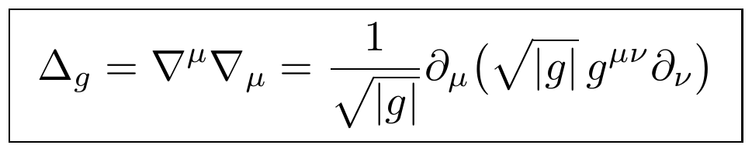
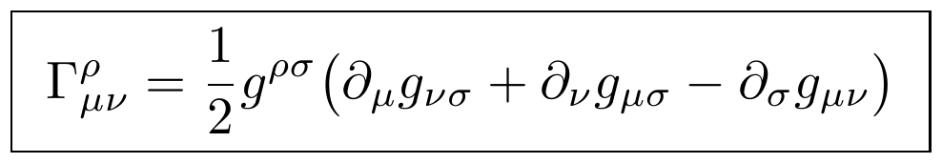
Curvature follows from the connection in the usual way, via the commutator of covariant derivatives:
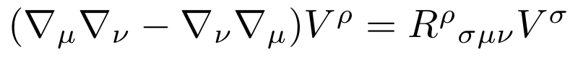
with the Ricci tensor R_{μν} = R^{ρ}_{μρν} and scalar curvature R = g^{μν}R_{μν} obtained by contraction. The Einstein tensor is then selected, not merely written down, by an explicit constraint set — symmetric, rank 2, covariant, and divergence-free — which singles out one specific combination of the Ricci tensor and scalar curvature:
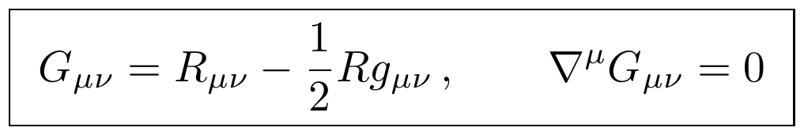
This selection-by-constraint is a real argument (it is, in substance, the classical Lovelock-style uniqueness argument for the Einstein tensor in four dimensions) rather than an assertion, and it is a third independent route to General Relativity within this paper's overall project, alongside Part II's spectral-action derivation from a Dirac operator and the CMRC's beta-function route in §1.3. The three routes have not been shown to agree beyond both terminating in the same tensor equation.

7.5 The Physical Recovery Core: Explicitly Not Yet Done
v2.0 is unusually direct about where its own derivation stops. Layer VII, covering the coupling of geometry to matter, is labeled in the source material itself as not yet recovered. The objects below are listed as targets — stated, not derived — and this table preserves that status rather than upgrading them to results:
Target Object | Stated Form | Status
Physical source tensor | T_{μν} | Target — not yet recovered
Conservation law | ∇^{μ}T_{μν} = 0 | Target — not yet recovered
Einstein field equation (with matter) | G_{μν} + Λg_{μν} = (8πG/c⁴)T_{μν} | Target — not yet recovered
Geodesic equation | d²x^{μ}/dτ² + Γ^{μ}_{αβ}(dx^{α}/dτ)(dx^{β}/dτ) = 0 | Target — not yet recovered
Newtonian limit | ∇²Φ = 4πGρ | Target — not yet recovered

The vacuum Einstein tensor of §7.4 is a certified result; the Einstein field equation with a matter source is not. Keeping this boundary visible is, again, the point — it is the same discipline v2.0's own Layer VII label applies, and this paper preserves rather than overrides it.

7.6 Architectural Layers VIII–XIII
The remaining layers of v2.0 describe a roadmap rather than certified content: a shared mathematical kernel of reusable objects (the graph, its Laplacian, its spectrum, the heat kernel, the diffusion metric, and the curvature tensors recovered in §7.4); parallel domain recovery cores for physics, quantum theory, statistics, continuum mechanics, and biology, each consuming the shared kernel rather than introducing new foundations; domain integration into complete theories; cross-domain translation between completed domains (general relativity to quantum field theory, statistics to information theory, biology to thermodynamics); a universal compiler layer; and a persistent “Universal Atlas” registry of certified objects, dependency graphs, and derivation ledgers. None of these layers carry worked derivations in the source material; they are recorded here as the architecture's stated direction, not as additional certified content.

8. The Lorentzian Metric Recovery Program
Status: Active. Certified foundations, one Candidate theorem, several Open branches, three Retired branches. This chapter uses the CCR taxonomy of Part 0 throughout, since this program is where that taxonomy originates in the source material.
Where Part IV §7's graph-spectral route reconstructs the (positive-definite, Riemannian) vacuum Einstein tensor, this program asks a sharper and still-open question: can the same graph-Laplacian machinery be pushed to recover an indefinite, Lorentzian-signature metric — the kind spacetime actually has — rather than a Riemannian one? The honest answer, as of this program's current state, is not yet, and this chapter documents exactly how far the certified chain reaches before that becomes true.

8.1 Program Dependency Tree
Primitive Grammar → Graph → Positive Laplacian → Rank-One Perturbation → Index ≤ 1 → Resistance Threshold (Candidate) → Negative Eigenvector → Localization → Indefinite Bilinear Form → Continuum Limit → Lorentzian Metric
Everything from “Localization” onward is Open. The certified chain currently reaches only as far as the negative eigenvector of a rank-one perturbed Laplacian (§8.3) — a genuine, certified spectral result, but several stages short of an actual Lorentzian metric.

8.2 Certified Foundations
Starting from a positive graph (a graph whose associated Laplacian L₀ is positive semi-definite, as every ordinary graph Laplacian is), a rank-one perturbation is introduced and its effect on the spectrum is tracked. The following objects are certified, having passed the full §0.2 verification protocol; consistent with §0.6's policy elsewhere in this volume, this table records only that each object is certified and what role it plays, since the source material provided names and certification status for these objects but not their derivations.
Certified Object | Role
Secular equation | Characterizes the eigenvalues of the rank-one-perturbed Laplacian as roots of a scalar equation.
Effective resistance identity | Relates the graph's effective resistance to the Laplacian's pseudoinverse.
Exact perturbation identity | Gives the exact (not asymptotic) change in the spectrum under the rank-one update.
Rank-one inertia theorem | Bounds the number of negative eigenvalues introduced by a rank-one perturbation of a PSD matrix.
Resolvent representation of the negative eigenvector | Expresses the perturbation's negative-eigenvalue eigenvector via the resolvent of L₀; stated in full in §8.3.
Spectral decomposition of the negative eigenvector | Expresses the same eigenvector in the L₀ eigenbasis; stated in full in §8.3.

Together these establish that a rank-one perturbation of a positive graph Laplacian can introduce at most one negative eigenvalue — an index of at most 1, the first hint of an indefinite (Lorentzian-like) signature emerging from purely positive-definite starting material.

8.3 Certified: LOR-002 — The Negative Eigenvector
The eigenvector associated with the single possible negative eigenvalue λ₋ admits two certified, equivalent forms. As a resolvent acting on the perturbation vector u:
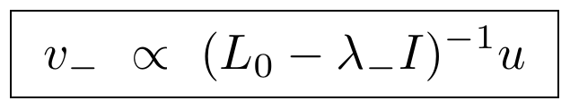
and, expanded in the eigenbasis {φ_{k}} of the unperturbed Laplacian L₀ with eigenvalues μ_{k}:
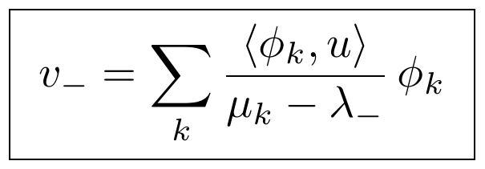
This is currently the mathematical center of the program: a fully certified spectral object, sitting directly downstream of §8.2's certified foundations and directly upstream of the Candidate resistance threshold of §8.4.

8.4 Candidate: LOR-001 — The Resistance Threshold
Following the registry-card format introduced in this volume's certification methodology (Part 0):
Registry ID | CCR-LOR-001
Status | Candidate
Dependencies | Effective Resistance Identity (Certified) · Rank-One Inertia Theorem (Certified) · Secular Equation (Certified)
Statement | A threshold condition on the graph's effective resistance, below which the rank-one perturbation is guaranteed to produce a negative eigenvalue (and above which it is not).
Remaining proof obligation | Bridge Boundary Lemma — the case where the perturbation sits at or near the boundary between the resistance regimes is not yet closed.

Verification Stage | Status
Symbolic derivation | ✓
Canonical graphs | ✓
Random verification | ✓
Boundary proof | Pending

Three of four verification stages are complete; the fourth (the boundary case) is the difference between Candidate and Certified status for this object.

8.5 Index-One Classification (IOC)
A broader classification question sits alongside LOR-001: not just whether a single rank-one perturbation can produce index 1, but how the achievable index scales with perturbation rank in general.
Perturbation Rank | Status
Rank-One | Certified target — index ≤ 1, established in §8.2–§8.3
Rank-Two | Open — no certified bound yet established
Rank-k | Research Objective — the general scaling law is not yet formulated as a specific conjecture

The rank-one edge-flip mechanism used throughout §8.2–§8.4 is, on this view, a special case of a broader and still largely open operator-classification problem.

8.6 Retired Branches
Three earlier approaches to the same goal — recovering an indefinite signature from graph-theoretic data — were pursued and explicitly closed. They are recorded here, following §0.1's policy, specifically so they are not repeated:
Retired Program | Reason for Closure
Fisher Information Route | A Gram matrix construction is always positive semi-definite by construction and therefore structurally cannot produce a Lorentzian (indefinite) signature, regardless of how the underlying statistical model is chosen.
Standard Signed Laplacian | The relevant quadratic form reduces to a sum-of-squares identity, which is always non-negative for the same structural reason.
Classical Balance-Theory Route | Applies to a different operator than the signed row-sum operator actually used in the active branch; not wrong, simply not applicable to this question.

8.7 The Remaining Open Chain
Beyond the certified negative eigenvector (§8.3), the path to an actual Lorentzian metric passes through four further stages, all Open: localizing the negative eigenvector to a specific region of the graph; assembling an indefinite bilinear form from it; taking a continuum limit of that form; and finally recovering a genuine Lorentzian metric tensor from the limit. None of these four stages currently has a certified or even a Candidate construction on record. This chapter follows this volume's standing policy (Part 0 §0.3's verb table) and does not describe this program as having produced Lorentzian geometry; it has produced a certified index-≤1 spectral result and an Open research chain pointed toward that goal.

8.8 Next Milestone
The source material for this program recommended, as its own next step, establishing a formal Compiler Certification Registry to serve as the authoritative ledger for every theorem and conjecture across the compiler project. That recommendation is what became Part 0 of this volume; §8's own registry entries above are the first application of it to a program smaller and more recent than Parts IV–V's larger validation campaigns.

Conclusion to Part IV
MDCL's contribution is narrower than it might first appear, and that narrowness is its strength: it does not claim to have derived string theory, quantum mechanics, or Hamiltonian mechanics from first principles. It claims that each of these already-established theories can be losslessly re-expressed as a composition over three primitives, with every recovered object — the Polyakov action, the Virasoro algebra, the canonical commutation relations, Hamilton's equations — traced through an acyclic dependency graph back to those primitives, and with every model-specific assumption (a flat background, the bosonic critical dimension, a chosen operator representation) kept explicit rather than folded silently into the compiler's general machinery.
That is a validation campaign, not a new physical theory, and the certification refinements recorded in §1.3, §2, and §3 — catching an overstated uniqueness claim, an implicit coordinate choice, a conflated tensor type — are the campaign doing its job. The organizational compiler of §5 remains exactly what its own source material says it is: a candidate meta-framework awaiting the same proof standard applied to everything else in this paper.
The v2.0 rebuild of §7 extends the same discipline to a new domain and a new route: a graph-spectral derivation of the vacuum Einstein tensor, arrived at independently of Part II's spectral-action route and §1's beta-function route, with its own boundary — the coupling to a matter source — left explicitly as a stated target rather than dressed up as achieved. Three independent routes to the same vacuum field equations, an expanding but not yet unified primitive grammar, and a consistent refusal to certify past what has actually been proven: that combination is this paper's clearest evidence that the underlying research program is being run honestly, whatever one ultimately concludes about its central claims.

PART V
The Universal Organizational Foundation
The Algebraic, Semantic, and Type-Theoretic Substrate Beneath the Compiler Grammar

Preface to Part V
Every grammar used in this paper so far — Part I's DTC pipeline, Part IV's MDCL primitive set — introduces its primitives and immediately starts composing them. None of them first establishes, in the ordinary mathematical sense, that the free algebra of expressions over those primitives exists, that a chosen notion of equivalence is compatible with the algebra's operations, that the resulting quotient is canonical rather than an arbitrary choice, or that the primitives can be consistently typed. Part V supplies exactly that scaffolding for one specific version of the primitive grammar: the four-symbol alphabet Σ₀ = {D, T, C, Π} used by Part IV's MDCL v1.0. It is organized as eight short, single-responsibility programs, each importing only the certified exports of the one before it, ending in a single typed compiler object 𝔐.
A caveat stated here and repeated at the end of this part (§9): this foundation formalizes {D, T, C, Π} specifically. It does not formalize Part I's DTC composition order, and it does not formalize Part IV §7's six-primitive v2.0 set (Δ, τ, κ, Θ, Π, Ω). Building a rigorous foundation under one version of the grammar is not the same as reconciling the three versions, and this part does not attempt the latter.

1. UGAS — The Free Grammar Algebra
UGAS has a single responsibility: define the free algebra of grammatical expressions and its algebraic signature, and go no further. It does not define equivalence, semantics, typing, or the compiler object — those are deferred to the seven programs that follow.
The primitive alphabet is the same four organizational primitives used throughout Part IV:
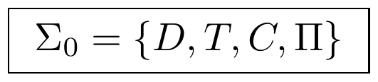
A grammar G₀ generated over Σ₀ determines which finite strings of primitives count as well-formed. The free grammar algebra F(Σ₀) is then the set of all such well-formed expressions, with no identifications imposed — two syntactically distinct expressions remain distinct in F(Σ₀) even if they will later turn out to be equivalent under some notion of congruence. That equivalence is explicitly not UGAS's job (it belongs to UGCT, §2).
The algebra's operations are collected into a signature:
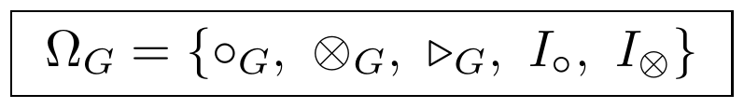
- ∘_{G}: sequential composition (one organizational step following another).
- ⊗_{G}: organizational product (two organizational structures combined, with no commutativity assumed).
- ▷_{G}: dependency action (the first expression governs or induces the second) — recorded structurally, with no further algebraic laws assumed at this stage.
Each binary operation is required to satisfy closure, associativity, and a two-sided identity; the axioms for ∘_{G} are representative of the pattern applied to all three operations:
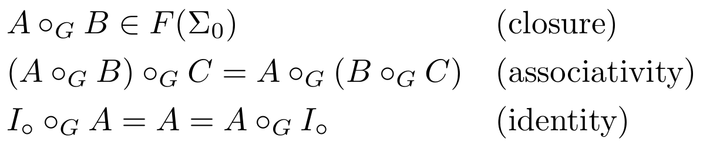
From these primitives and operations, UGAS records a set of canonical grammar expressions used repeatedly throughout the rest of this part and Part IV — sequential compositions such as D∘_{G}T∘_{G}C∘_{G}Π, organizational products such as D⊗_{G}T, and dependency actions such as D▷_{G}T. The equational theory E_{G} collects the identities adopted at this stage — associativity of both binary operations, the identity laws, and grammar closure — with no congruence relations introduced yet.

2. UGCT — Congruence and the Quotient Grammar Algebra
UGCT's single responsibility is to build the canonical grammar algebra by quotienting the free algebra of §1 by an equivalence relation compatible with its operations. It does not develop universal properties, normalization, semantics, or typing — those come later.
A set of primitive relations R₀ ⊆ F(Σ₀) × F(Σ₀) is admitted with no closure properties assumed, and generates the smallest congruence containing it:
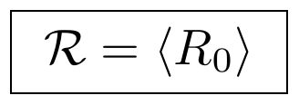
For ℛ to descend to well-defined operations on the quotient, it must be compatible with every operation in Ω_{G}: if A ≡_{ℛ} A′ and B ≡_{ℛ} B′, then A∘_{G}B ≡_{ℛ} A′∘_{G}B′, and likewise for ⊗_{G} and ▷_{G}. Given that compatibility, the quotient carrier is well-defined:
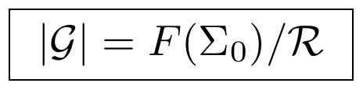
with induced operations that do not depend on the choice of representative precisely because ℛ is grammar-compatible:
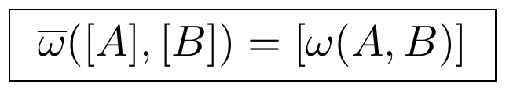
The quotient grammar algebra is 𝒢 = (|𝒢|, Ω̄_{G}), equipped with the canonical projection q: F(Σ₀) → 𝒢, q(A) = [A], which commutes with every grammar operation by construction.

3. UGUP — The Universal Mapping Property
UGUP's job is to show that the quotient 𝒢 built in §2 is not merely one workable construction among many, but the canonical one: any other grammar algebra receiving a compatible map from F(Σ₀) receives it uniquely through 𝒢.
For any grammar algebra A and any grammar homomorphism f: F(Σ₀) → A compatible with ℛ (meaning x ≡_{ℛ} y ⟹ f(x) = f(y)), there exists a homomorphism φ: 𝒢 → A factoring f through the canonical projection:
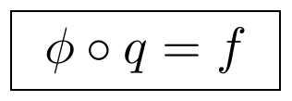
and this factorization is unique — any two homomorphisms satisfying the same factoring condition must coincide:
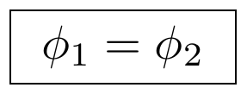
This is the precise sense in which no other quotient satisfying the same universal property is distinguishable from 𝒢: the canonical projection is universal among all compatible grammar homomorphisms, completing the construction phase of the grammar foundation.

4. UGNT — Normal Form Theory
UGNT studies canonical representatives of the equivalence classes in 𝒢, via a rewrite relation →_{G} ⊆ 𝒢 × 𝒢 and its reflexive-transitive closure →*_{G}. Two properties are defined but, importantly, not assumed: termination (no infinite reduction chain exists) and confluence (any two reduction paths from a common source reach a common further reduct). Both are explicitly recorded in the source material as open theorem targets.
Conditional on both properties being established, a normalization map NF: 𝒢 → 𝒢 assigns each expression its unique irreducible representative, satisfying idempotence and irreducibility:
and, again conditionally, every equivalence class contains exactly one normal form:
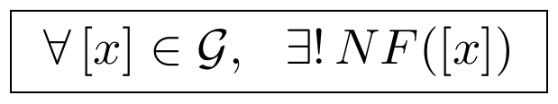
The certification status recorded for this chapter in the source material is worth preserving exactly: the rewrite system, the definitions of termination and confluence, and the conditional normal-form theorem are all certified as a framework; the termination and confluence theorems themselves remain open. Every subsequent reference to normal forms elsewhere in this part inherits that conditionality.

5. UGIT — Intrinsic Grammar Theory
With construction (§1), quotient (§2), universal characterization (§3), and normalization (§4) in place, UGIT studies properties belonging to 𝒢 itself, independent of any interpretation — symmetry, invariants, and classification, with no semantics involved.
The invertible grammar endomorphisms form a group under composition:
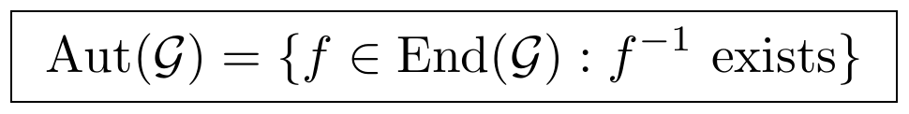
Every expression has an orbit under this group's action — the set of expressions reachable from it by an intrinsic grammar symmetry:
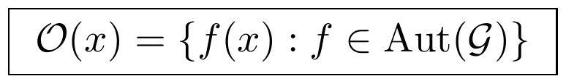
A grammar invariant is any function on 𝒢 constant on automorphism orbits:
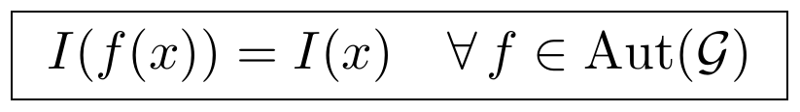
Candidate invariant families named in the source material include expression depth d(x), composition degree deg(x), primitive support supp(x), composition length ℓ(x), and dependency height h(x) — named as candidates rather than as a closed, certified list. Expressions agreeing on every certified invariant are declared structurally equivalent (x ∼_{I} y), giving an intrinsic classification of 𝒢 that involves no semantic interpretation whatsoever.

6. UOLS — Organizational Semantics
UOLS is the first program in this part to attach meaning to grammar expressions rather than studying their syntax alone. It deliberately stops short of typing, compiler legality, and external representations.
A semantic interface fixes the minimal organizational vocabulary available for interpretation:
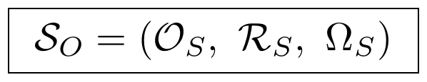
with components 𝒪_{S} (semantic objects), ℛ_{S} (semantic relations), and Ω_{S} (semantic operations); no application-specific semantics are assumed at this stage. An interpretation map assigns organizational meaning to every grammar expression:
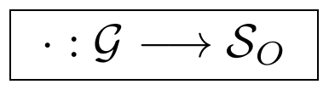
Two expressions are semantically equivalent exactly when they share an interpretation — a relation UOLS is careful to keep distinct from syntactic equality, grammar congruence ≡_{ℛ}, and the structural equivalence ∼_{I} of §5:
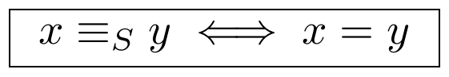
Semantic morphisms extend this to maps between grammars: given a grammar morphism F: 𝒢₁ → 𝒢₂, a compatible semantic morphism Φ must make interpretation commute with translation:
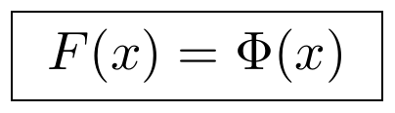
UOLS closes by naming candidate semantic invariants — organizational depth, complexity, dependency dimension, persistence class, interface signature — with their formal definitions explicitly deferred to a later intrinsic semantic theory not included in the source material shared for this part.

7. UTS — The Universal Type System
UTS types the same four primitives used throughout this part, but as types rather than generators — a deliberate inversion from how conventional type systems work, since it classifies organizational primitives before it classifies any mathematical, semantic, or compiler object built from them:
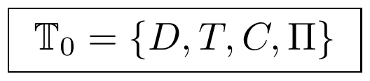
with D typed as object introduction, T as organizational evolution, C as organizational admissibility, and Π as stable organizational realization. A type algebra ∘_{T} composes these into typed expressions, of which one is distinguished as the canonical organizational composition:
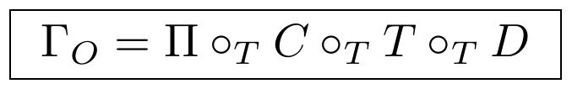
Every organizational object receives exactly one primitive type via a typing morphism τ: 𝒰 → 𝕋, recorded in a typing context Γ = {x₁: τ₁, …, x_{n}: τ_{n}} as a typing judgment:
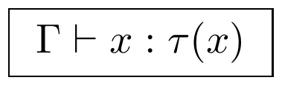
Typed morphisms Hom_{UTS}(A, B) are admitted between objects with certified types, and composition of two typed morphisms f: A → B, g: B → C is legal only when the target type matches the next morphism's domain type:
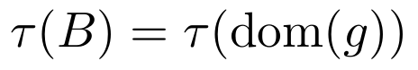
otherwise composition is rejected outright — this is the type-legality check that later governs which organizational morphisms MDCL-0001 (§8) is permitted to compose.

8. MDCL-0001 — The Canonical MDCL Object
The final program in this part constructs a single mathematical object from everything certified in §1–§7: typed construction objects V, typed organizational morphisms E, an internal dependency relation, and a composition operator, assembled into
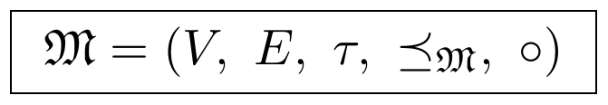
The internal dependency relation ⪯_{𝔐} ⊆ V × V (read "the construction of v logically depends on u") is required to be a partial order:
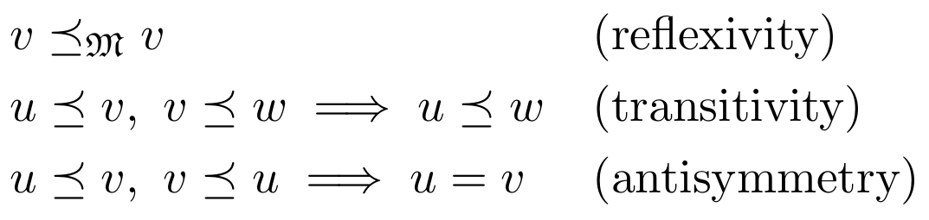
making (V, ⪯_{𝔐}) a genuine dependency poset, distinct from the architectural (document-level) dependency relation used to order this paper's own sections. Composition of typed morphisms is admitted exactly when typing is preserved, organizational interfaces compose, and dependency ordering is respected — the same three-part legality check introduced in §7.
The resulting object 𝔐 is typed, compositional, dependency-governed, and organizational, with no representations yet introduced. The source material is explicit that this document constructs only the object itself, not the category of such objects — that further step (a companion document, MDCL-0002, defining MDCL homomorphisms, identity morphisms, categorical composition, products, limits, and initial/terminal objects) was not among the material shared for this part and is not reproduced here.
The complete foundation spine, from the primitive alphabet to the canonical compiler object, is:

9. Relation to Parts I and IV
Two things are worth stating without qualification, and one caveat needs to be stated just as plainly.
First, the positive claim: Part V does what Parts I and IV's grammars each assumed rather than built. Neither This from That's DTC pipeline nor Part IV's MDCL primitive set constructs a free algebra, proves a quotient is canonical via a universal property, or establishes (even conditionally) that expressions have unique normal forms, before composing primitives and asserting results. Part V does all four for one specific alphabet, and is honest about the one place it cannot yet close the loop — UGNT's termination and confluence theorems (§4) remain open.
Second, the caveat: Part V's Σ₀ = {D, T, C, Π} matches Part IV's v1.0 primitive set exactly, but it is not a foundation for either of the other two primitive grammars used elsewhere in this paper — Part I §9's DTC composition Γ ≡ 𝔠_{κ} ∘ 𝔗_{τ} ∘ 𝔗_{Δ}, or Part IV §7.2's six-primitive v2.0 set {Δ, τ, κ, Θ, Π, Ω}. A reader could reasonably ask whether UGAS through MDCL-0001 could be rebuilt over either of those alphabets with the same construction — free algebra, congruence, universal property, normal forms, invariants, semantics, typing — and reach a structurally analogous foundation. That question is open; this part does not attempt it, and this paper's own working assumption throughout — recorded first in Part III §5 and repeated in Part IV §6 — has been to record disagreements between its primitive grammars rather than to silently pick a winner. This is a third such disagreement, now with a full algebraic foundation built under exactly one of the three options.
Third, a narrower technical point: Part V's canonical MDCL object 𝔐 (§8) has not been shown to be the same object as the MDCL compiler documented throughout Part IV §1–§7. Both are called "MDCL," both are built from a primitive grammar via a dependency-first architecture, and both terminate in a single central object — but the source material for this part is explicit that 𝔐 is "the first mathematical object induced by the completed Universal Organizational Foundation," constructed bottom-up from UGAS through UTS, while Part IV's MDCL was built top-down from application-domain recovery work (CMRC, VAL-001, VAL-004, VAL-005) outward. Whether these two constructions converge on the same object is an unproven claim, not a demonstrated one, and this paper does not assert their identity.

Conclusion to Part V
Part V's contribution is foundational in the literal sense: it does not add a new application domain the way Parts I, II, and IV's validation branches do, and it does not propose new physical content the way some of the material folded into Part I §9–11 does. It builds the algebra underneath one specific version of the grammar those parts already use — free construction, congruence, universal characterization, conditional normalization, intrinsic classification, semantic interpretation, typing, and a single typed compiler object, each stage importing only the certified exports of the stage before it.
That discipline is worth taking seriously on its own terms, and so are its boundaries: UGNT's central theorem is conditional on open termination and confluence results: UOLS's semantic invariants are named but not yet formally defined; MDCL-0001 stops explicitly before the category of MDCL objects; and §9's three points — the primitive-grammar disagreement, the unproven identity between this part's 𝔐 and Part IV's MDCL, and the untested question of whether this construction generalizes to the other two primitive alphabets in this paper — are left open rather than resolved. Consistent with every other part of this paper, that is recorded here as the honest state of the work, not smoothed over for the sake of a cleaner ending.

