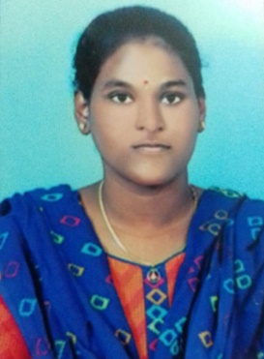BHUPALAM LAHARI

Email: bhupalamlahari1414@gmail.com

Mobile no:8247391227

# CAREER OBJECTIVE :

To pursue a job in challenging environment that encourages creativity and provides exposure to new technology to achieve professional and personal growth along with the organization**.**

# ACADEMIC QUALIFICATION:

|  |  |  |  |  |
| --- | --- | --- | --- | --- |
| **Course** | **Institution** | **Board/University** | **Year Of Passing** | **Percentage(%)** |
| B.Tech  Electronics and communication  Engineering | Annamacharya Institute of Technology and Sciences, Rajampet. | Jawaharlal Nehru Technological University, Anantapuram | pursuing | 8.96  (CGPA)  Upto3-1 |
| Intermediate with Maths,Physics, Chemistry. | Narayana Junior college  Nellore | State Board of Intermediate education, Andhra Pradesh | 2021 | 9.1  (GPA) |
| Secondary Education | Little scholars  English Medium High School Mydukur | Board of Secondary Education | 2019 | 9.8  (GPA) |

**INTERNSHIPS:**

* PLC Programming

# TECHNICAL SKILLS

* Programming Languages : Basics of C, PYTHON and JAVA

# ACHIEVEMENTS AND CERTIFICATES:

* + Certified in “MATLAB PROGRAMMING”

# PERSONAL DETAILS:

* Date of Birth : 14-06-2004
* Father’s Name :Bhupalam Satyanarayana
* Current Address : 10/70-1 Badvel Road ,Mydukur ,Kadapadist
* Hobbies :Playing games, listening music
* Nationality :Indian
* Languages Known :English,Telugu
* Any kind of disability :No
* Willingness to Relocate :Yes

# DECLARATION

I here by declare that all the above-mentioned information is true and correct to the best of my knowledge.

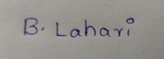**PLACE** : Rajampet Signature: