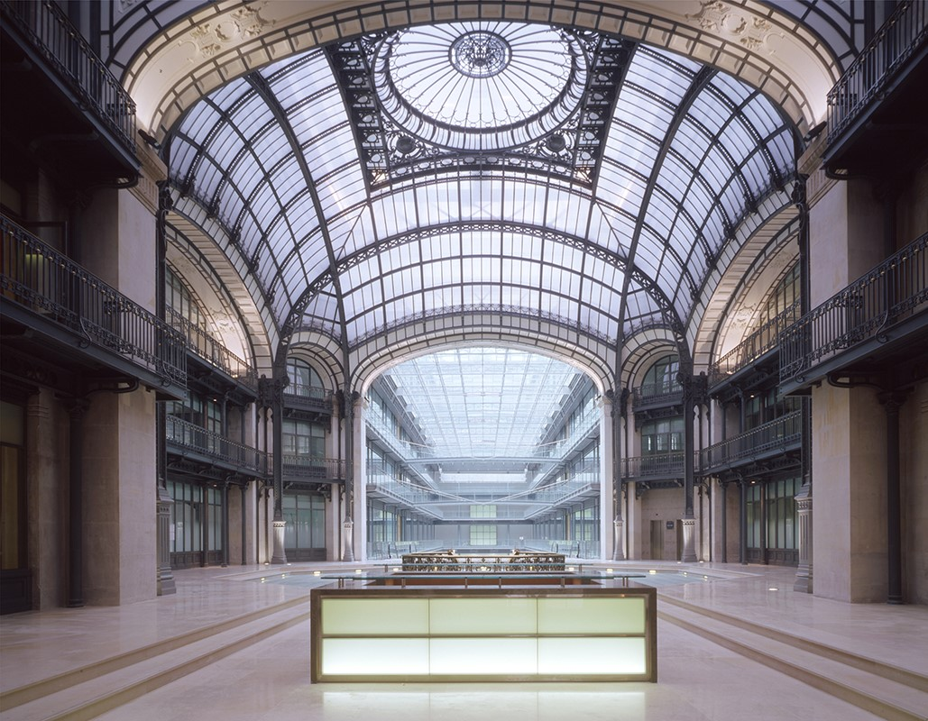

**Predix Training Session**

December 12 - 16 2016

GE Digital – European Foundry – Paris, France

**Monday, December 12 2016** Location

Foundry Annexe Room

8:30 – 8:45 *Arrival to the Digital Foundry*

Welcome and introductions Herve SABOT

**Startup and Ingestion Lvl 1**

8:45 – 10:45 Architectural Overview & Predix Tooling Benoit LAURENT

10:45 – 11:00 Break

11:00 – 12:45 Machine Setup (Devp environment) Benoit LAURENT

12:45 – 13:45 Lunch Break

13:45 – 14:45 Security Model & UAA Benoit LAURENT

14:45 – 15:00 Break

15:00 – 17:00 Time Series Benoit LAURENT

17:00 – 17:30 Q&A Benoit LAURENT

**Tuesday, December 13 2016** Location Foundry Annexe Room

**Ingestion Lvl 2 and Descriptive Analytics**

8:45 – 10:45 Blob & SQL Benoit LAURENT

10:45 – 11:00 Break

11:00 – 12:45 Asset & Key-Value Benoit LAURENT

12:45 – 13:45 Lunch Break

13:45 – 14:45 Predix UI : Tooling Review & Vis Introduction Benoit LAURENT

14:45 – 15:00 Break

15:00 – 17:00 Data Visualization Lvl 1 Benoit LAURENT

17:00 – 17:30 Q&A Benoit LAURENT

**Wednesday, December 14 2016** Location Foundry Annexe Room

**Data Vis Lvl 2 and Prescriptive Analytics Lvl1**

8:45 – 10:45 Make it real-time Benoit LAURENT

10:45 – 11:00 Break

11:00 – 12:45 Deployment Benoit LAURENT

12:45 – 13:45 Lunch Break

13:45 – 14:45 Data Science Methodology Benoit LAURENT

Jean-Pierre YIN

14:45 – 15:00 Break

15:00 – 17:00 Data Science Tooling & Predix Analytics Architecture Benoit LAURENT

Jean-Pierre YIN

17:00 – 17:30 Q&A Benoit LAURENT

**Thursday, December 15 2016** Location Foundry Annexe Room

**Analytics go to production**

8:45 – 10:45 Predix Analytics it Lvl 1 : Runtime, UI Benoit LAURENT

10:45 – 11:00 Break

11:00 – 12:45 Catalog Benoit LAURENT

12:45 – 13:45 Lunch Break

13:45 – 15:45 Predix Analytics Lvl2 : Model Deployment (Orchestration) Benoit LAURENT

15:45 – 16:00 Break

16:00 – 17:00 Predix Analytics Lvl2 : Model Deployment (Orchestration) Benoit LAURENT

17:00 – 17:30 Q&A

**Friday, December 16 2016** Location Foundry Annexe Room

**Integration and Scalability**

8:45 – 10:45 Data Vis: Analytics Integration Benoit LAURENT

10:45 – 11:00 Break

11:00 – 12:45 Data Vis: Analytics Integration Benoit LAURENT

12:45 – 13:45 Lunch Break

13:45 – 14:45 Access Control (ACS) Benoit LAURENT

14:45 – 15:00 Break

15:00 – 16:30 Sass Model (Tenancy) Benoit LAURENT

16:30 – 17:00 Conclusion