ONTARIO FEDERATION OF AGRICULTURE (OFA) • OFFICIAL USER MANUAL
AgCensus IQ (OFA Edition)
Complete Plain-Language User Guide
A Step-by-Step Guide to Exploring, Comparing, Ranking, and Mapping Canadian & Ontario Census of Agriculture Data from the National Level Down to Your Local Township
At a Glance: What Is AgCensus IQ (OFA Edition)?
AgCensus IQ is a purpose-built agricultural intelligence and policy tool created for the Ontario Federation of Agriculture (OFA). It takes 49 massive, hard-to-read Statistics Canada Census of Agriculture tables and turns them into an instant, visual, point-and-click dashboard.
Whether you are an OFA Policy Analyst writing a provincial submission, a Member Service Representative (MSR) preparing for a County Federation meeting, or a local board director speaking to municipal council about protecting farmland, this tool gives you official, rock-solid Statistics Canada numbers in seconds.

Platform Feature | What Is Included in AgCensus IQ (OFA Edition)
Official Data Source | 100% Empirical Statistics Canada Census of Agriculture (Tables 32-10-0153-01 to 32-10-0445-01)
Historical Span | 2021 Census + 2016 Benchmark Deltas + 45-Year Historical Trend Series (1976–2021)
Geographic Coverage | 2,113 Geographies across Canada: 1 Country, 10 Provinces, 72 Agricultural Regions (CAR), 282 Counties (CD), and 1,748 Townships (CCS)
Ontario & OFA Coverage | All 5 Ontario Agricultural Regions, all 49 Ontario Counties mapped to OFA Federations, and all 414 Ontario Townships
Agricultural Metrics | 239 Official Characteristics organized into 10 plain-language agricultural categories
Core Analytical Modules | 8 Main Modules (Snapshot, Explorer, Drilldown, Compare, Ranker, Ag Belts & Cluster Maps Studio, AgScore, GeoSearch) + Multi-Area PDF Report Builder + AI Policy Briefs

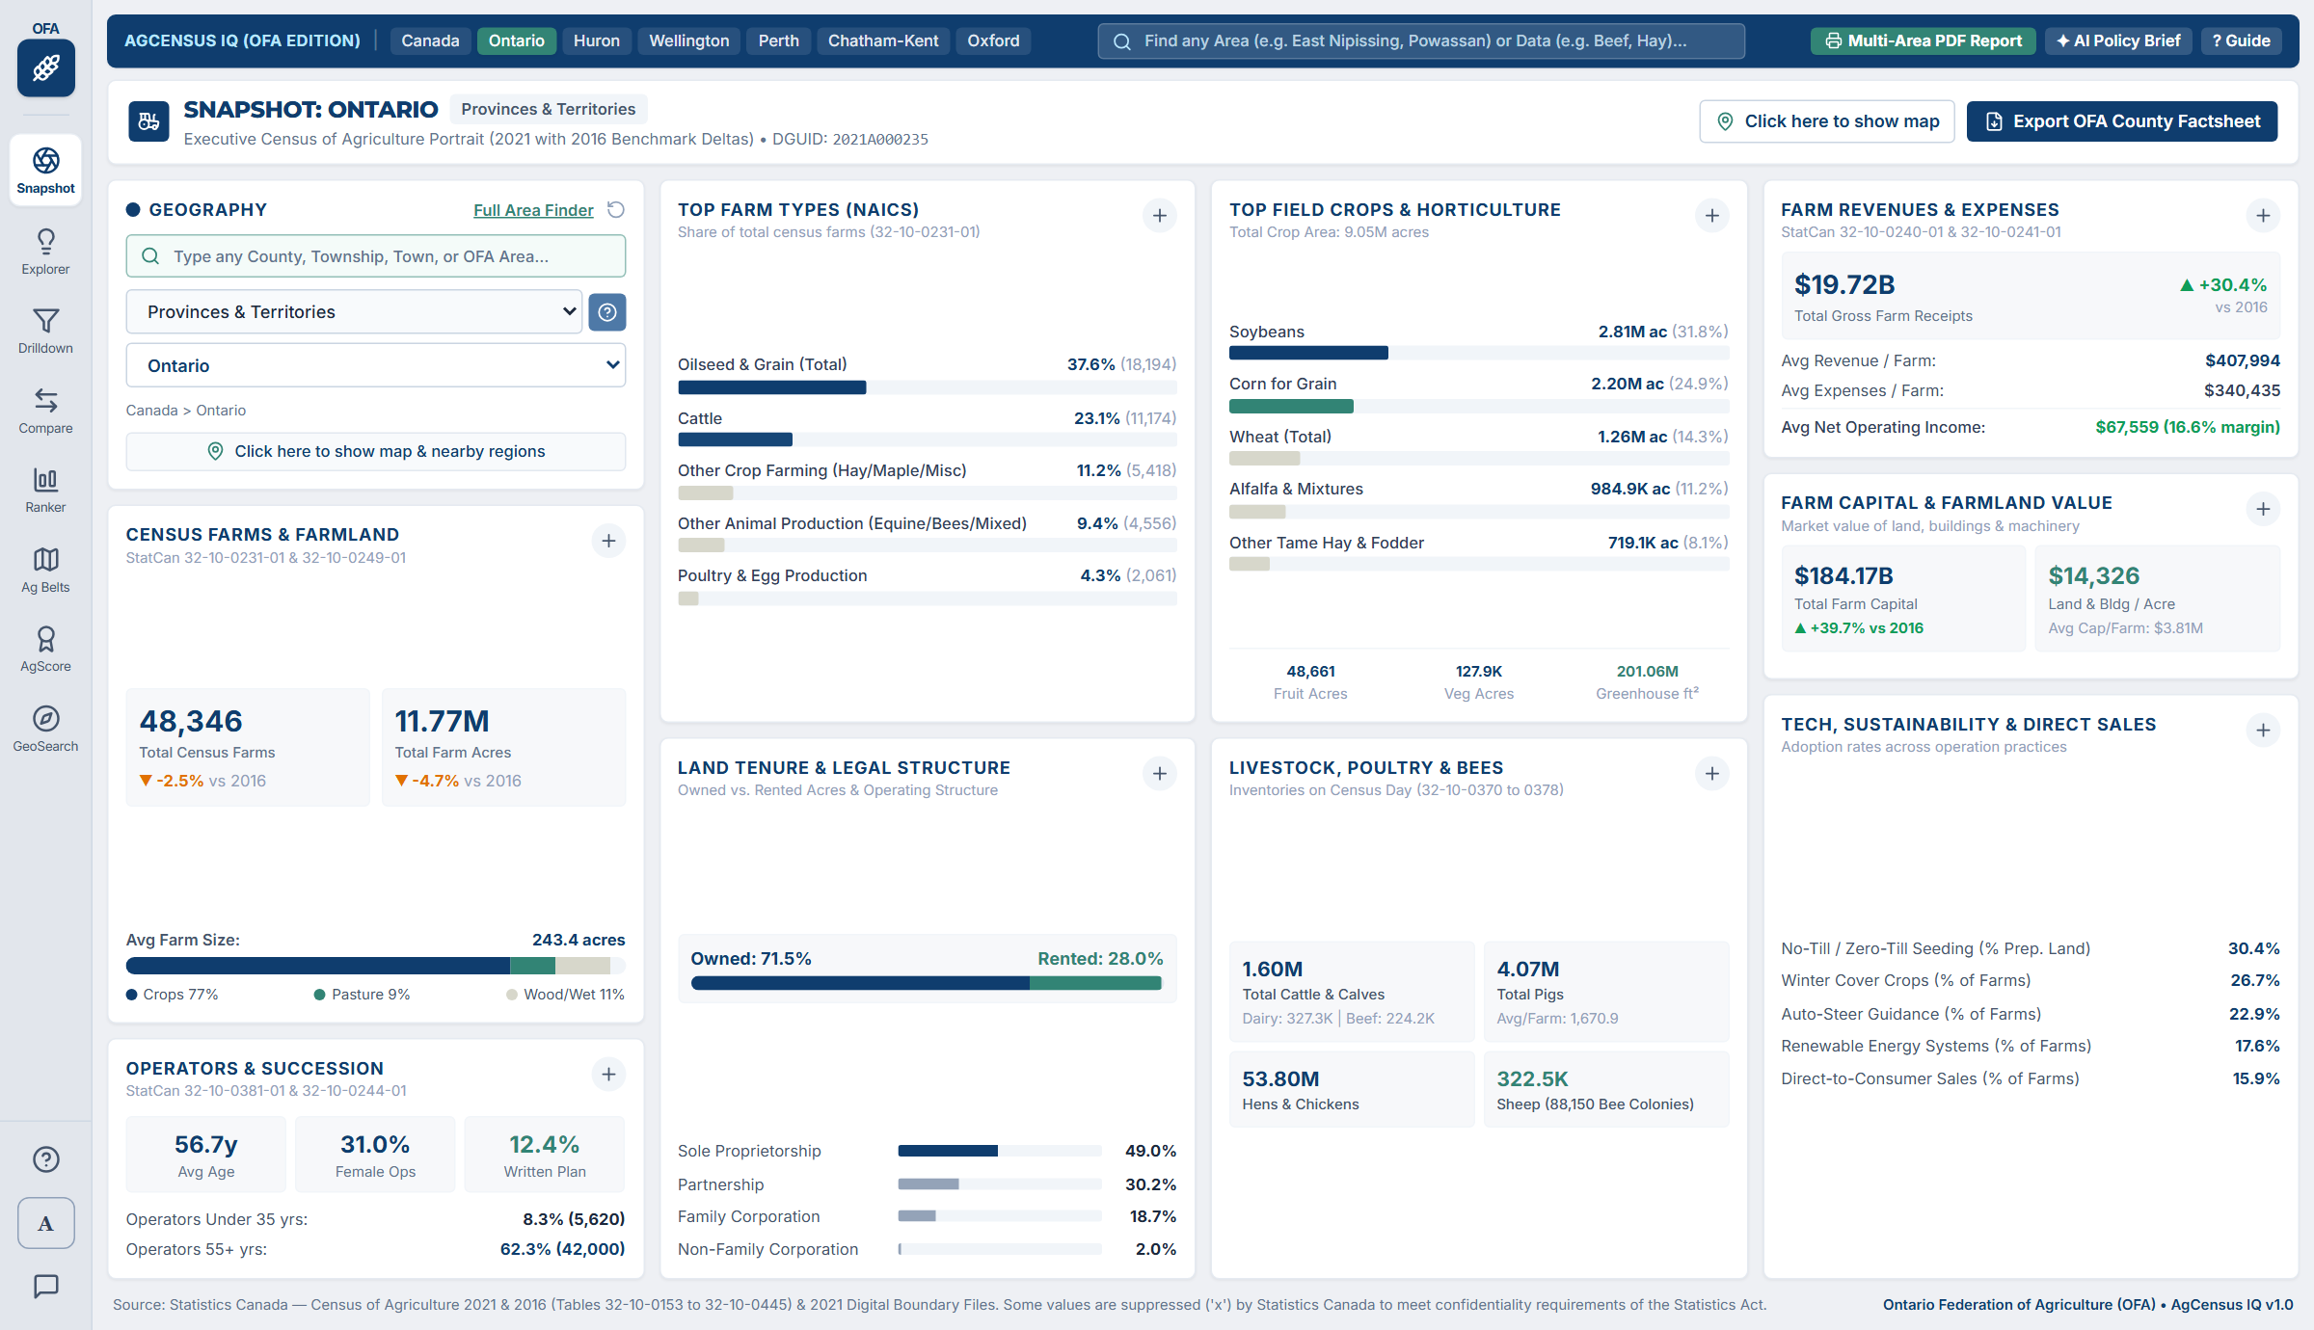
Figure 1: AgCensus IQ (OFA Edition) opens directly to an executive one-screen dashboard with zero page scrolling required.

1. Getting Started & Understanding the Screen Layout
AgCensus IQ is designed around a 'single-screen' philosophy. Unlike traditional government data websites where you have to scroll through endless tables or download giant spreadsheets just to answer a simple question, AgCensus IQ fits everything onto your computer screen at once.

1.1 How to Open the Tool
- When the Local Server Is Running: Simply open your web browser (Edge, Chrome, Firefox, or Safari) and go to http://localhost:5173.
- If You Restart Your Computer: Open a terminal or PowerShell window in the project folder (c:\Projects\Census Tool), type npm run dev, and press Enter. Within 1 second, the tool will be live at http://localhost:5173.

1.2 The Four Parts of the Screen
No matter which module you are using, the screen is always organized into four consistent areas so you never get lost:
- 1. The Left-Hand Icon Rail (Your Main Menu): Running down the far-left edge of the screen is a narrow vertical bar with the OFA logo at the top. Clicking any of the 7 icons switches your workspace immediately between Snapshot, Explorer, Drilldown, Compare, Ranker, AgScore, and GeoSearch. At the bottom of this rail are three helper buttons: (?) Guided Walkthrough, (A) AI Policy Brief, and Data Provenance Notes.
- 2. The Top Quick-Benchmark Bar (Navy Blue Header): Across the very top of the screen is a dark navy bar with one-click shortcut buttons for frequently used regions: Canada, Ontario, Huron County, Wellington County, Perth County, Chatham-Kent, Oxford County, and Niagara Region. Clicking any of these buttons instantly switches the active geography to that region. On the right side of this bar are quick buttons for '+ AI Policy Brief' and '? Guide'.
- 3. The Left Control Column (Geography & Variable Slicers): Just inside the workspace on the left side is where you choose WHICH geography (or geographies) and WHICH agricultural topic you want to look at. Changes you make here update the charts, tables, and maps instantly.
- 4. The Main Analytical Canvas (Center & Right): The large central and right-hand area displays your visual results—whether that is the 8-card County Snapshot, comparison bar charts, head-to-head tables, ranked leaderboards, or interactive maps.
OFA Pro Tip: Your Selected Geography Follows You Across Modules!
If you select 'Huron County' in Ag Snapshot and then click 'Explorer' or 'Compare' on the left-hand menu, the tool remembers that you were looking at Huron County. You do not need to re-select your county every time you switch tools.

2. Understanding the 5 Geographic Levels (National to Township)
One of the most common frustrations with Statistics Canada data is figuring out what terms like 'CAR', 'CD', and 'CCS' actually mean in everyday Ontario farm language. AgCensus IQ translates these codes into plain English and connects them directly to OFA County and Regional Federations.
Level Name in Tool | Plain-Language Meaning | Total in Canada | Total in Ontario | Real-World Example
1. Country | All of Canada combined. | 1 | — | Canada (189,874 farms)
2. Provinces & Territories | Each individual Canadian province (used for inter-provincial benchmarking). | 10 | 1 | Ontario (48,346 farms), Quebec, Alberta, Saskatchewan
3. Census Agricultural Regions (CAR) | Large multi-county farming zones grouped by climate and geography. | 72 | 5 | Southern Ontario, Western Ontario, Central Ontario, Eastern Ontario, Northern Ontario
4. Counties / Census Divisions (CD) | Your County, Regional Municipality, or District. Directly matched to OFA County Federations. | 282 | 49 | Huron County (2,564 farms), Wellington County (2,617 farms), Chatham-Kent (2,412 farms)
5. Townships / Subdivisions (CCS) | Your local lower-tier Township or Municipality inside a county. | 1,748 | 414 | South Huron (253 farms), Mapleton (638 farms), North Perth (585 farms)

2.1 How the Geography Filter Works
In every module, the Geography box on the left lets you narrow down your view in three easy steps:
- Step 1 — Pick the Geographic Level: Use the top dropdown in the Geography box to choose whether you want to look at the Country, Provinces, Agricultural Regions (CAR), Counties (CD), or Townships (CCS).
- Step 2 — Filter by Province or Region (Optional): When you are looking at Counties or Townships, two helpful filter dropdowns appear automatically: 'Province' (e.g., choose Ontario so you only see Ontario's 49 counties instead of all 282 across Canada) and 'Agricultural Region' (e.g., choose Western Ontario or Southern Ontario).
- Step 3 — Type to Search or Pick from the List: You can either pick your county/township from the dropdown list or type part of its name (or even its OFA Federation name) into the search box.
In Plain Language: What Does 'Suppressed (x)' or 'N/A' Mean at the Township Level?
Under the federal Statistics Act, Statistics Canada is legally required to protect the privacy of individual farm families. If a small township only has 1 or 2 farms growing a specific crop (or raising a specific type of livestock), publishing the exact acreage or dollar figure would allow neighbours or competitors to figure out that specific farm's private business numbers.
Whenever Statistics Canada hides a number for privacy reasons, they mark it with an 'x' in the official census file. In AgCensus IQ, we never invent or guess fake numbers to fill those gaps. Instead, the tool clearly displays 'Suppressed (x)' or 'N/A' and tells you how many variables in that township are affected. If you ever run into a suppressed number in a small township, simply step up one level to the County (CD) level, where almost 100% of figures are unsuppressed.

3. Step-by-Step Guide to All 8 Analytical Modules

3.1 Module 1: Ag Snapshot (Executive Regional Portrait)
Think of Ag Snapshot as your '1-Page Executive Briefing' for any single geography. Whenever someone asks, 'Tell me about agriculture in Huron County (or Ontario, or Mapleton Township),' this is the first screen you should open.
Figure 2: Ag Snapshot showing the executive regional portrait, 8 core analytical cards, and 2016–2021 change indicators.

What Each of the 8 Snapshot Cards Tells You:
- Card 1 — Census Farms & Farmland (Left Column, Middle): Shows the total number of census farms in 2021, the total farmland area in acres, and the average farm size in acres. Right underneath the big numbers, green or amber badges show the percentage change since the 2016 Census (for example, Huron County grew +2.6% in farm count from 2,500 to 2,564 farms). The horizontal bar at the bottom shows the split between Cropland (%) and Pasture/Woodland/Natural land (%).
- Card 2 — Operators & Succession (Left Column, Bottom): Shows the average age of farm operators (e.g., 55.4 years in Huron County), the percentage of female operators (31.4%), and—crucially for OFA policy—the percentage of farms with a formal Written Succession Plan (14.5%). It also breaks down Young Operators under 35 vs. Operators aged 55+.
- Card 3 — Top Farm Types / NAICS (Center-Left, Top): Automatically ranks the top 5 agricultural industries in that region by share of farms (for example, in Huron County: 49.7% Oilseed & Grain, 21.2% Cattle, 8.3% Poultry & Egg, 6.7% Hog Farming). Every bar shows both the percentage share and the exact farm count in parentheses.
- Card 4 — Land Tenure & Legal Structure (Center-Left, Bottom): Shows what percentage of farmland in the county is Owned vs. Rented/Leased (a critical indicator of farmland access pressure), followed by the breakdown of farm business structures: Sole Proprietorships, Partnerships, Family Corporations, and Non-Family Corporations.
- Card 5 — Top Field Crops & Horticulture (Center-Right, Top): Automatically identifies and ranks the top 5 crops grown in that specific region by acreage (e.g., Corn for Grain, Soybeans, Wheat, Alfalfa, Silage Corn), plus summary boxes at the bottom for Fruit Acres, Field Vegetable Acres, and Greenhouse square footage.
- Card 6 — Livestock, Poultry & Bees (Center-Right, Bottom): Displays total Census Day animal inventories: Total Cattle & Calves (with Dairy Cows vs. Beef Cows breakdown), Total Pigs (with average herd size per farm), Hens & Chickens, and Sheep / Honeybee colonies.
- Card 7 — Farm Revenues & Expenses (Far-Right, Top): Shows Total Gross Farm Receipts in dollars (and % growth since 2016), Average Gross Revenue per Farm, Average Operating Expenses per Farm, and the resulting Average Net Cash Operating Income per Farm and Net Operating Margin (%).
- Card 8 — Farm Capital, Farmland Value & Sustainability Tech (Far-Right, Middle & Bottom): Shows Total Farm Capital ($), the average market value of Land & Buildings per Acre ($/acre), and adoption rates for No-Till Seeding, Winter Cover Crops, Auto-Steer GPS Guidance, Renewable Energy, and Direct-to-Consumer Farm Gate Sales.

Special Interactive Buttons in Ag Snapshot:
- The '+' Button on Every Card Header: Notice the small '+' button in the top-right corner of every card. Clicking '+' on any card (for example, 'Top Field Crops' or 'Farm Revenues') automatically takes you to the Ag Explorer module with that exact category loaded so you can examine all subcategories and historical trends.
- 'Click here to show map' (Geographic Context & Nearby Peers Modal): Clicking this button opens a pop-up map highlighting your selected county or township, alongside an automatic distance table showing the 12 closest neighbouring counties or townships measured in kilometres (km). Clicking any neighbour in that list switches your Snapshot directly to that neighbour.
- 'Print / Save PDF' & 'Download Data (Excel CSV)' (Top-Right Bar): Generates a clean, formatted 1-Page Executive County Factsheet for instant printing or saving to PDF for county board meetings, or exports the underlying statistics to Excel.
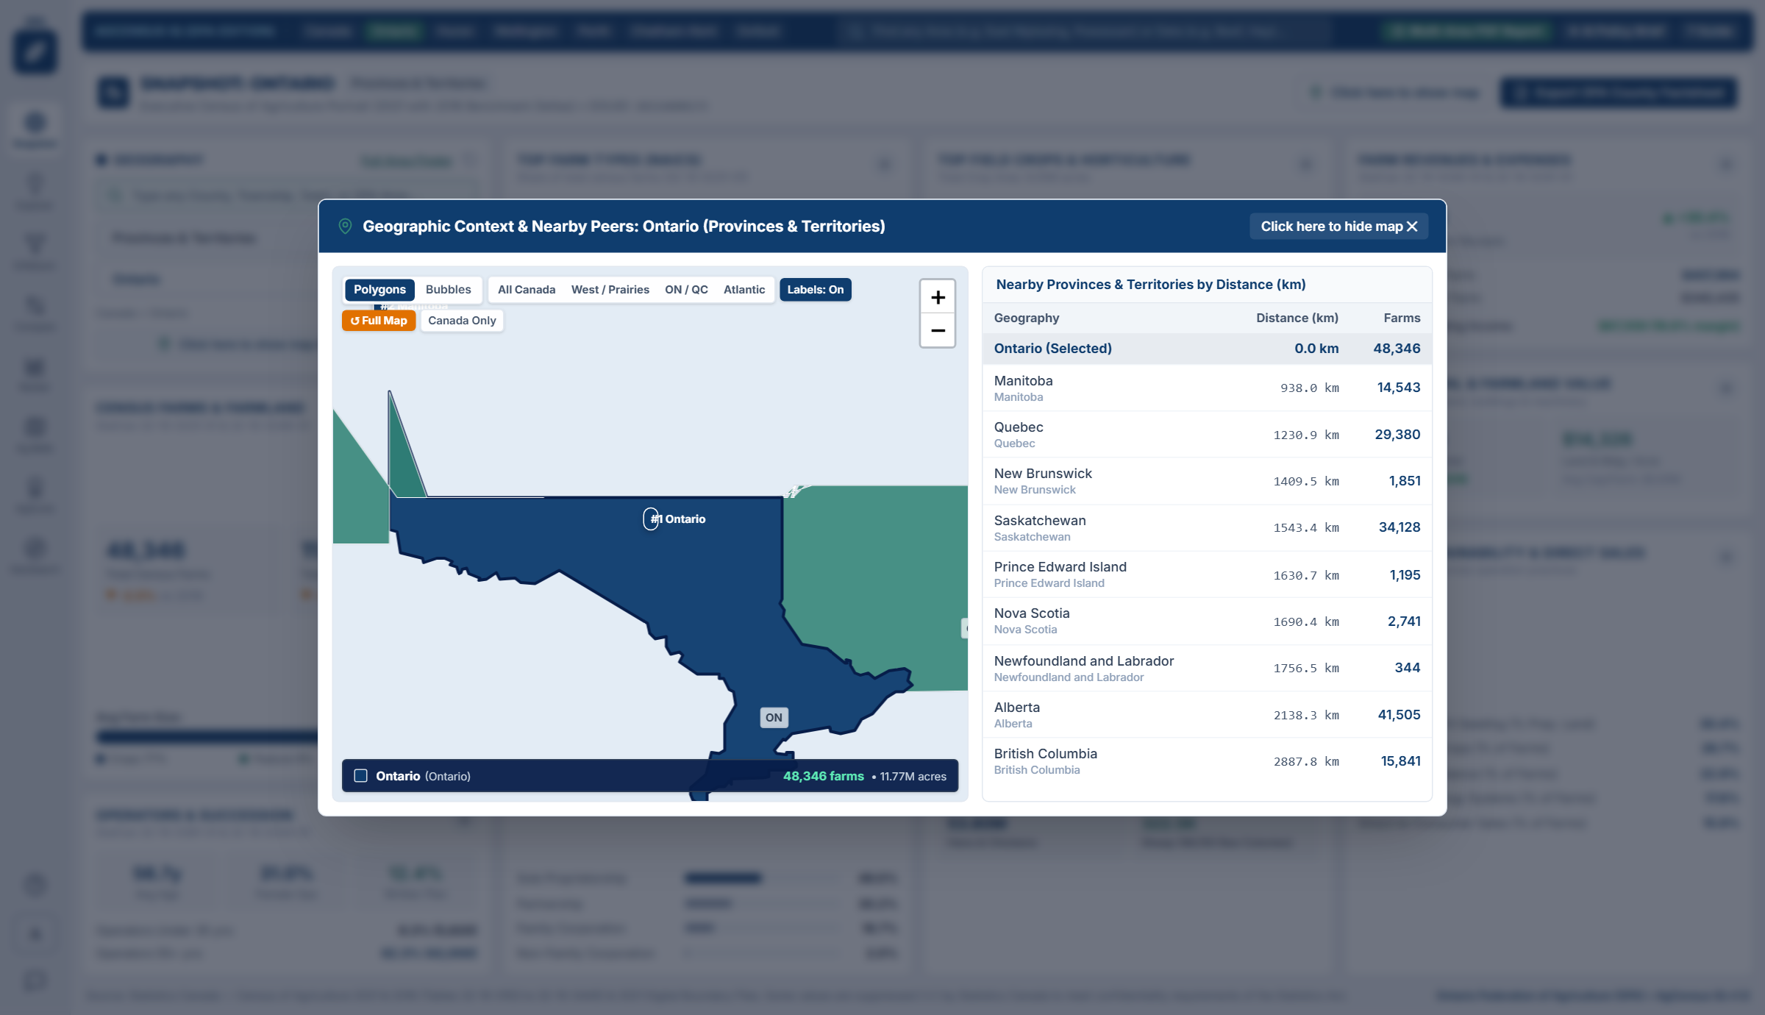
Figure 3: Clicking 'Click here to show map' in Ag Snapshot opens the interactive Canada-Only polygon map and ranks nearby peer counties by distance.

3.2 Module 2: Ag Explorer (Deep Category & 45-Year Historical Analyzer)
When you want to dive deep into one of the agricultural categories—and compare up to 8 regions or inspect 45-year historical trends—click 'Explorer' (the lightbulb icon) on the left-hand rail.
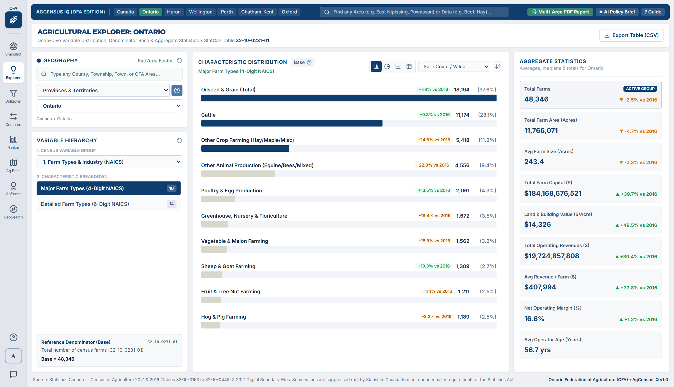
Figure 4: Ag Explorer comparing regions across NAICS Farm Types, with 2021 values stacked above 2016 benchmark values.

How to Use Ag Explorer Step-by-Step:
- 1. Select 1 to 8 Geographies (Left Panel): Use the multi-select Geography Slicer on the left to check the boxes for up to 8 regions (for instance, Huron, Wellington, Perth, and Oxford). Each region is assigned its own distinct colour badge.
- 2. Pick Any Variable Category: Use the Variable Category dropdown to switch between Farm Types, Land Use, Field Crops, Horticulture, Livestock, Capital, Revenues, Operators, Precision Tech, and Soil Conservation.
- 3. Understand the Dual Bars (2021 vs. 2016 Benchmark): By default, the '2016 Benchmark' button in the top-right of the chart is turned ON. For every region, the top solid bar shows the 2021 Census value, while the lighter stone-grey bar right underneath shows the 2016 Census value, followed by a green (+%) or amber (-%) badge showing the exact 5-year change.
- 4. Switch Between Counts, Percentages, and Aggregate Metrics: At the top-left of the chart canvas, you will see three mode buttons: 'Counts (Farms / Units)', 'Percentages (%)', and 'Aggregate Metrics ($, Acres, Ratios)'. Use 'Percentages (%)' when comparing a huge region (like all of Ontario) against a single county so they are on a level playing field; use 'Aggregate Metrics' to inspect total dollar revenues, average $/acre farmland values, or crop acreages.
- 5. Turn On '45-Year Historical (1976–2021)' View: Click the historical time-series button in the top-right of the chart to switch into the long-term multi-decade trend analyzer. This view displays a 10-census-wave line chart (1976, 1981, 1986, 1991, 1996, 2001, 2006, 2011, 2016, and 2021) alongside a complete decade-by-decade comparison table.
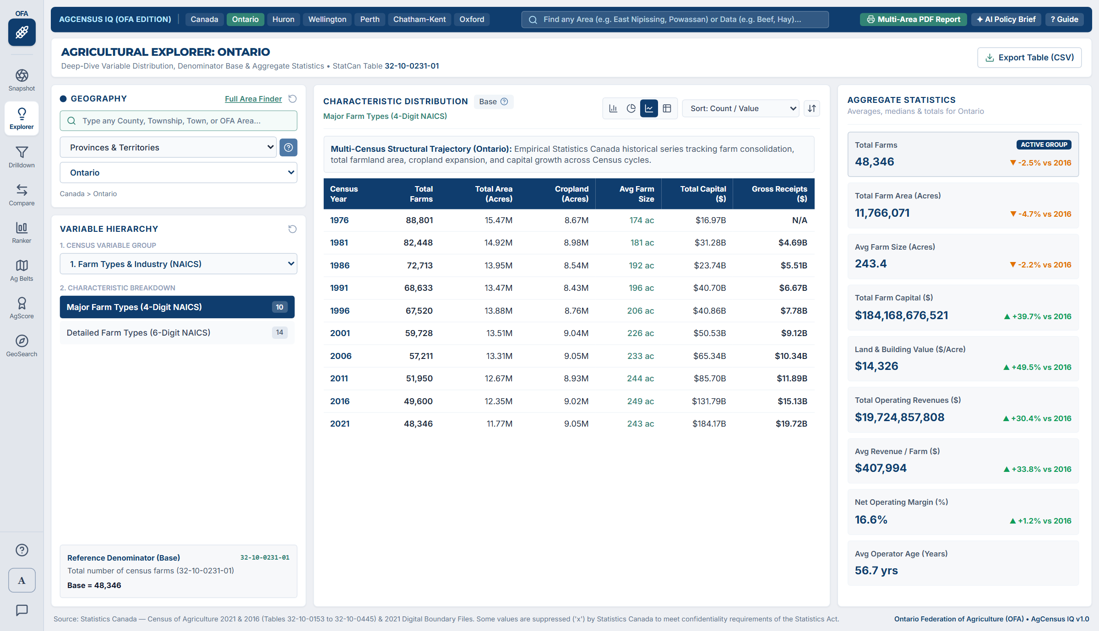
Figure 5: Switching Ag Explorer to the 45-Year Historical (1976–2021) view plots structural trends across 10 Census of Agriculture waves.

3.3 Module 3: Ag Drilldown (Multi-Criteria Regional Screening & Heat Map)
Suppose you are working on an OFA soil health initiative or commodity brief, and you need to see which counties qualify across multiple threshold criteria—and export a composite map & table graphic. That is what Ag Drilldown (the funnel icon) is built for.
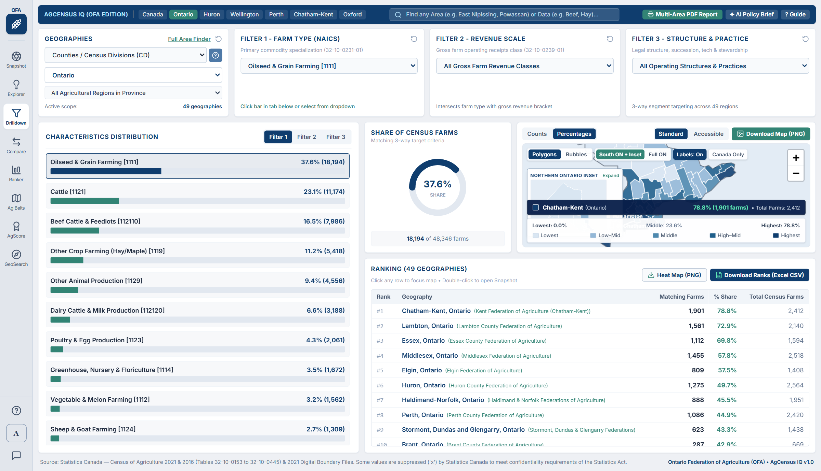
Figure 6: Ag Drilldown screening across counties with a synchronized regional heat map and non-overlapping leader callouts.

How to Screen Geographies in Ag Drilldown:
- Step 1 — Choose Your Geographic Scope: In the top-left Geography card, choose the level you want to screen (e.g., 'Counties / Census Divisions (CD)' filtered to 'Ontario' or 'All of Canada').
- Step 2 — Set Your Farm Scale & Growth Filters (Bottom-Left Card): You can filter out tiny non-agricultural areas by setting a minimum number of Total Census Farms (e.g., Min 25 farms), a minimum 2016–2021 Farm Count Change (%), or a minimum Average Farm Size in acres.
- Step 3 — Set Up to 4 Characteristic Thresholds (Top Row Cards): Across the top row are 4 Characteristic boxes (Characteristic 1, 2, 3, and 4). In each box, pick any variable and enter a 'Min (%)' and/or 'Max (%)' threshold. As soon as you type a number into 'Min (%)', any county that falls below that threshold is filtered out.
- Step 4 — Inspect the Heat Map & Export High-Resolution PNG: The map in the center shades all qualifying counties from Lowest to Highest and badges the #1, #2, and #3 leaders. Click 'Download Map & Graph (PNG)' at the top right to save a publication-ready composite graphic with non-overlapping leader callouts and plain-English city subtitles for Prairie/NL divisions.

3.4 Module 4: Ag Compare (Head-to-Head Matrix & 'Most Similar Counties' Finder)
When you want to put 2 to 10 counties (or provinces) side-by-side in a comprehensive spreadsheet-style report across ALL Census categories—or automatically discover which other counties in Ontario or Canada are most structurally similar to yours—click 'Compare' on the left rail.
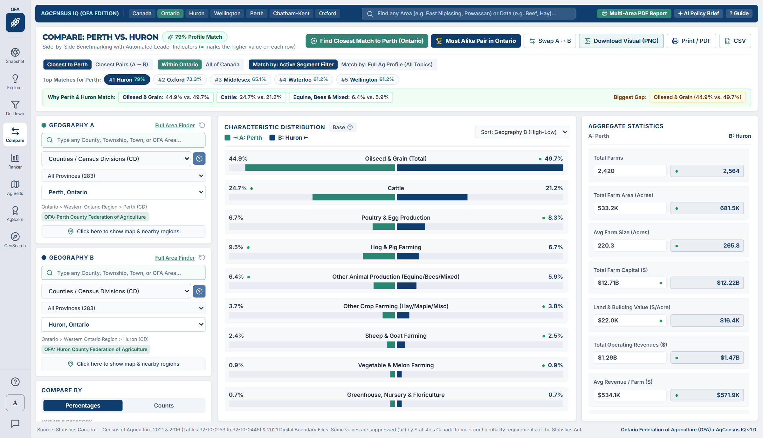
Figure 7: Ag Compare displaying a head-to-head matrix with green 'Winner Dots', 'Find Similar Counties' matcher, and Social Media Graphic export.

Key Features of Ag Compare:
- Automatic 'Find Most Similar Counties' Matcher: Not sure which counties are the best peers to benchmark against? Click the similarity matcher button in the left panel! Ag Compare evaluates commodity mix, farm size, revenue structure, and livestock density across every county in Ontario or Canada to automatically add the top structurally similar peer counties (displaying a Similarity Match % score).
- Green 'Winner Dots' (●) on Every Row: To help your eye scan hundreds of numbers effortlessly, Ag Compare automatically places a green dot (●) and bold navy text on whichever county has the highest value in every single row.
- Three View Modes (Counts, Percentages, Aggregate Metrics): Use the three mode buttons in the left control panel to flip the entire comparison table between Farm Counts, Percentage Shares (%), or Dollar/Acreage Aggregate Metrics.
- Download Social Media Comparison Graphic (PNG) & Excel CSV: Click 'Download Map & Graph (PNG)' in the top header to export a clean, presentation-ready head-to-head comparison infographic, or click 'Download Data (Excel CSV)' to open the full matrix in Excel.

3.5 Module 5: Ag Ranker (Custom Leaderboards by Acres, Livestock Head, Dollars & Farms)
Whenever someone asks, 'Which counties have the most Acres of Soybeans?', 'Where are the largest Cattle herds?', or 'Where does our county rank for Gross Farm Receipts ($)?' click 'Ranker' on the left rail.
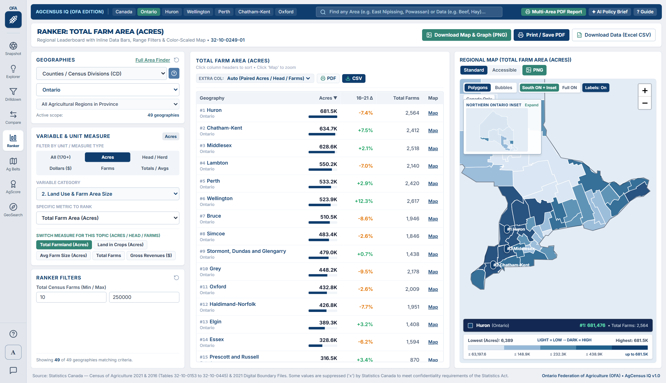
Figure 8: Ag Ranker showing the 6-button Unit Filter (Acres, Head/Herd, Dollars $, Farms), customizable Extra Reference Column, and Canada-Only map.

How to Customize What You Rank in Ag Ranker:
- 1. Filter by Unit Measure (Acres, Head / Herd, Dollars $, Farms): In the left 'VARIABLE & UNIT MEASURE' panel, click one of the 6 unit filter buttons—'All (170+)', 'Acres', 'Head / Herd', 'Dollars ($)', 'Farms', or 'Totals / Avgs'—to immediately filter the dropdown to metrics measured in that exact unit. For example, clicking 'Acres' lets you rank counties directly by Total Farmland Acres, Land in Crops Acres, Soybean Acres, Corn Acres, Wheat Acres, or Fruit & Vegetable Acres.
- 2. One-Click 'Switch Measure for This Topic' Pills: Whenever you pick a commodity (such as Cattle, Dairy, Pigs, Soybeans, or Corn), green quick-switch pills appear right below the dropdown so you can flip with one click between Total Acres / Total Head, Farms Reporting, and Average Herd/Crop Size per Farm.
- 3. Customize the 'EXTRA COL:' Reference Column Above the Table: Above the leaderboard table, use the 'EXTRA COL:' dropdown to pick what secondary reference column is displayed alongside your primary ranking: 'Auto (Paired Acres / Head / Farms)', 'Total Farmland (Acres)', 'Land in Crops (Acres)', 'Avg Farm Size (Acres)', 'Gross Farm Receipts ($)', 'Avg Revenue / Farm ($)', or 'Total Farms (2021)'.
- 4. Plain-English Names for Numbered Prairie & NL Divisions: When ranking across all of Canada, Statistics Canada's numbered Census Divisions in Manitoba, Saskatchewan, Alberta, and Newfoundland & Labrador automatically display their major city/regional hub right underneath (for example, 'Division No. 8 — Swift Current / Kindersley, SK' or 'Division No. 2 — Lethbridge / Brooks, AB').

3.6 Module 6: Ag Belts & Cluster Maps Studio (Social Media & Report Poster Generator)
Inspired by editorial data journalism maps (such as 'America's Crop Belts'), the Ag Belts & Cluster Maps Studio lets you generate high-impact, publication-ready 1800x1125 maps for both National (All 293 Canadian Census Divisions) and Provincial (e.g., all 49 Ontario counties with a Northern Ontario inset) scopes.
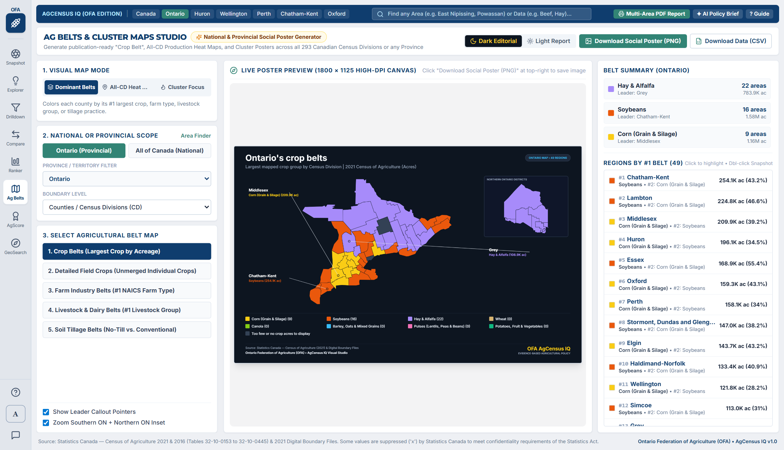
Figure 9: Ag Belts & Cluster Maps Studio in 'Dominant Belts' mode, mapping the #1 dominant crop belt across every Census Division.

The 3 Visual Map Modes in Ag Belts Studio:
- Mode 1 — Dominant Belts (Multi-Commodity Winner per County): Evaluates a family of competing crops or farm types in every Census Division and colours each county by its #1 dominant winner (for example, Corn vs. Soybeans vs. Wheat vs. Canola vs. Hay & Alfalfa). Includes built-in belt presets for Major Field Crop Belts (Acres), Broad Commodity Belts (NAICS), Livestock Belts (Herd Inventory), and Fruit, Berry & Vegetable Belts.
- Mode 2 — Top Cluster Focus (Single-Commodity Hotspot Map): Highlights the top-producing regional clusters for any single crop, livestock species, technology, or financial metric so viewers can immediately spot where an industry is concentrated.
- Mode 3 — All-CD Heat Map (Full Production Heat Map Across Every County): Shades EVERY Census Division across the province or across Canada that reports production (from Lowest to Highest across 5 colour tiers), showing not only the top cluster but everywhere production takes place.
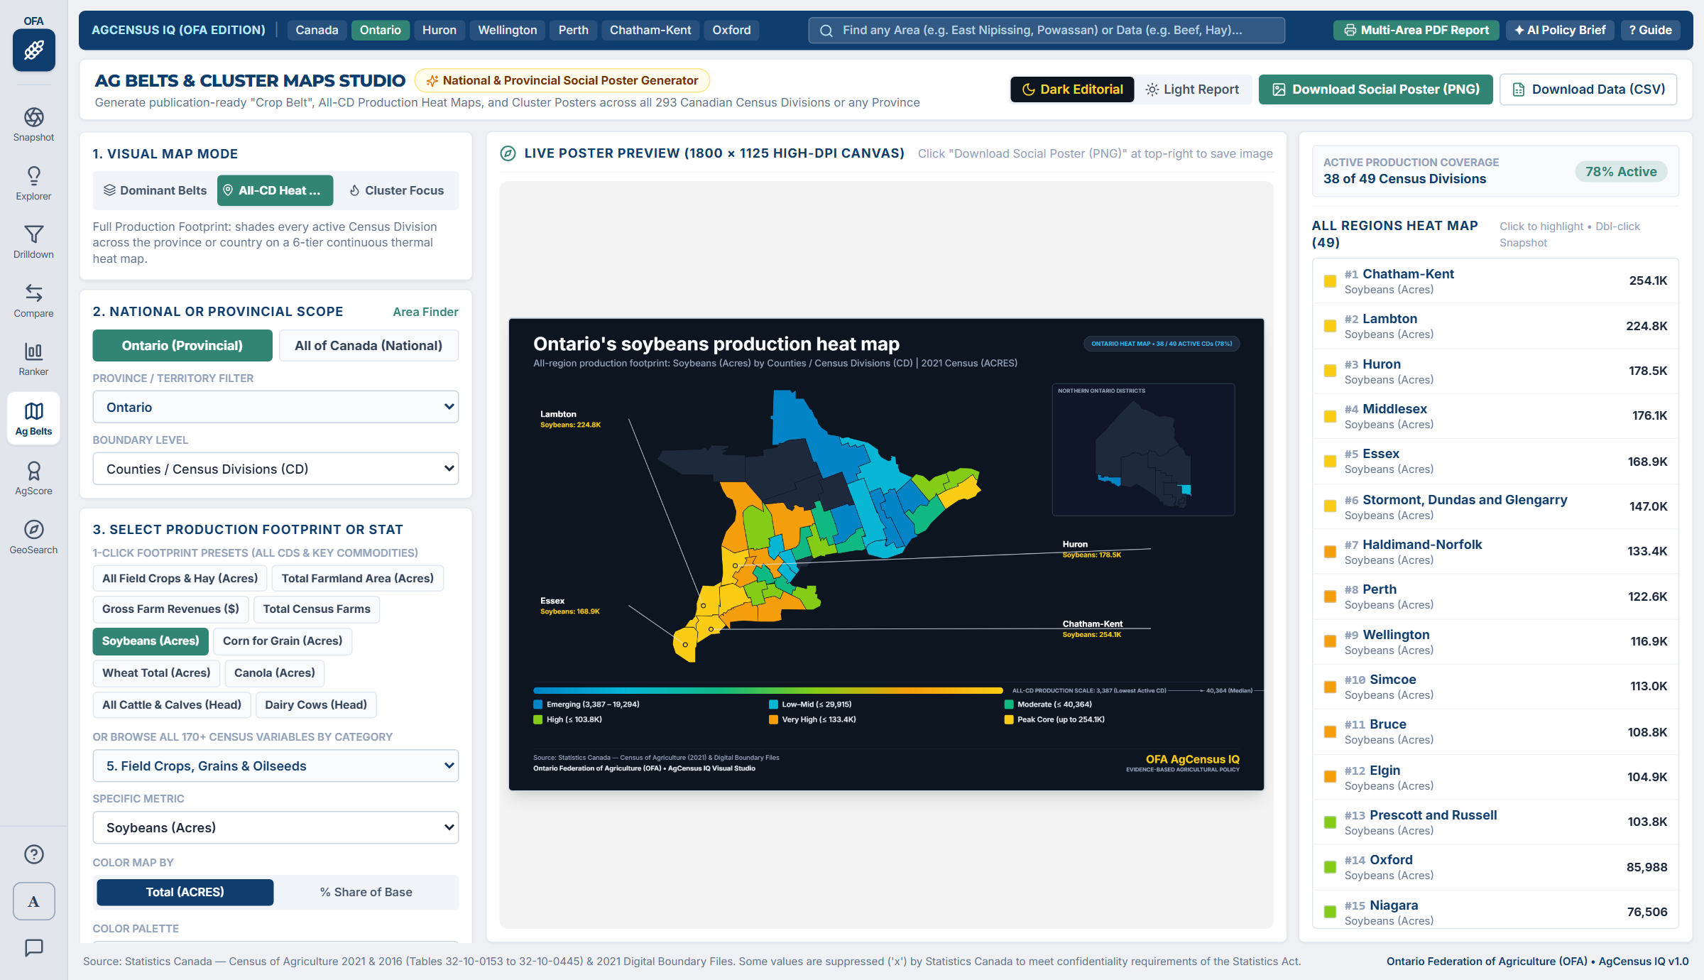
Figure 10: Ag Belts & Cluster Maps Studio in 'All-CD Heat Map' mode, showing every Census Division where production takes place.

Built-In Social Media Poster Features:
- Dark Editorial vs. Light Report Theme: Switch at the top of the screen between 'Dark Editorial' (rich dark navy background designed for LinkedIn, X/Twitter, and slide decks) and 'Light Report' (clean white background designed for printed OFA policy submissions and Word reports).
- Non-Overlapping Leader Callout Lines: Automatically draws crisp pointer lines to the top-ranking counties around the perimeter of the map, displaying each county's name, major city hub (for numbered Prairie divisions), and exact acreage, head count, or farm count.
- One-Click 1800x1125 PNG Poster Download: Click 'Download Social Poster (PNG)' in the top-right bar to save a high-DPI image ready to post on social media or drop into a presentation.

3.7 Module 7: AgScore (Multi-Factor Weighted Index — 0 to 100)
Inspired by commercial site-selection tools, AgScore lets you combine up to 4 different Census variables with custom weights into a single 0 to 100 Composite Index.
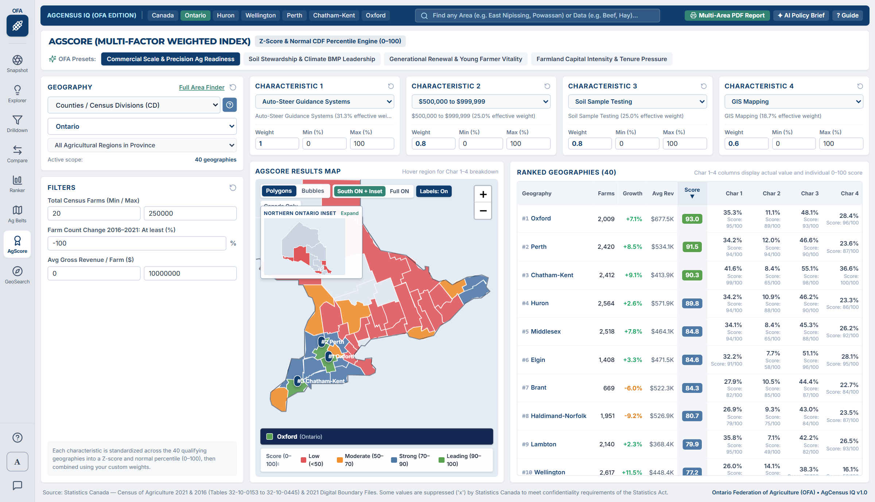
Figure 11: AgScore combining 4 variables into a single 0–100 Composite Index across Ontario counties.
In Plain Language: How Does AgScore Calculate a 0 to 100 Score?
Imagine you want to rank counties on overall 'Soil Stewardship Leadership' by combining three different numbers: (1) % of cropland using No-Till, (2) % of farms planting Winter Cover Crops, and (3) % of farms doing Soil Sample Testing.
1. For each of the 4 characteristics you pick, the tool calculates the average and spread across all counties in your view and converts each county's result into a Percentile Score from 0 to 100 (where 50 is average, 95 means the county is in the top 5%, and 10 means it is in the bottom 10%).
2. Next, it multiplies each of the 4 percentile scores by the 'Weight' you chose (for example, Weight 1.0 vs. Weight 0.5) and combines them into a single overall AgScore from 0 to 100.
3. Colour-coded badges make the final score easy to read: Green (90–100, Top Tier), Blue (70–90, Above Average), Amber (50–70, Moderate), and Coral Red (0–50, Below Average).

The 4 Built-In OFA Policy Presets (Top Bar of AgScore):
- Preset 1 — Commercial Scale & Precision Ag Readiness: Combines Auto-Steer Guidance Systems (Weight 1.0), Gross Revenue $500K–$999K (Weight 0.8), Soil Sample Testing (Weight 0.8), and GIS Mapping (Weight 0.6).
- Preset 2 — Soil Stewardship & Climate BMP Leadership: Combines No-Till / Zero-Till Seeding (Weight 1.0), Winter Cover Crops (Weight 1.0), Soil Sample Testing (Weight 0.8), and Windbreaks / Shelterbelts (Weight 0.6).
- Preset 3 — Generational Renewal & Young Farmer Vitality: Combines Operators Under 35 Years (Weight 1.0), Formal Written Succession Plan (Weight 1.0), Direct-to-Consumer Marketing (Weight 0.6), and Female Operators (Weight 0.5).
- Preset 4 — Farmland Capital Intensity & Tenure Pressure: Combines Capital Value $3.5M+ (Weight 1.0), Rented / Leased Farmland Area (Weight 0.9), Gross Receipts $2M+ (Weight 0.8), and Family Corporations (Weight 0.6).

4. GeoSearch (Easy Area Finder), Multi-Area PDF Reports, AI Policy Briefs & Interactive Maps

4.1 Module 8: GeoSearch — Easy Area & Data Finder (No Jargon Required)
Not sure which Census Agricultural Region or County a particular rural township belongs to, or want to search for a farm topic in plain English? Click 'GeoSearch' (the compass icon) on the left rail.
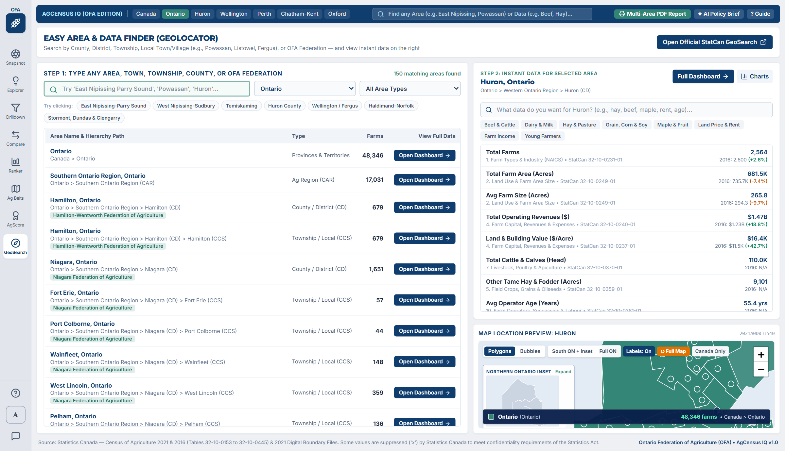
Figure 12: GeoSearch (Easy Area & Data Finder) with Combined Regional Rollups and the Instant Data & Topic Finder.
- Full Containment Path & Multi-Area Rollup: Every result shows the exact hierarchy path (for example: Ontario > Western Ontario Region > Huron (CD) > Huron East (CCS)) along with its OFA County Federation badge and total census farms. You can even select multiple areas (like East Nipissing + Parry Sound) to view a combined regional rollup!
- Step 2 — Instant Data & Topic Finder: Type any keyword (such as 'dairy', 'maple', 'solar', 'no-till', or 'soybeans') to immediately see the exact 2021 and 2016 figures for your selected area without navigating away.

4.2 Multi-Area PDF Report Builder ('Multi-Area PDF Report' Button)
Need to print a customized briefing package covering multiple counties or townships across specific Census categories? Click 'Multi-Area PDF Report' in the top header bar from any screen.
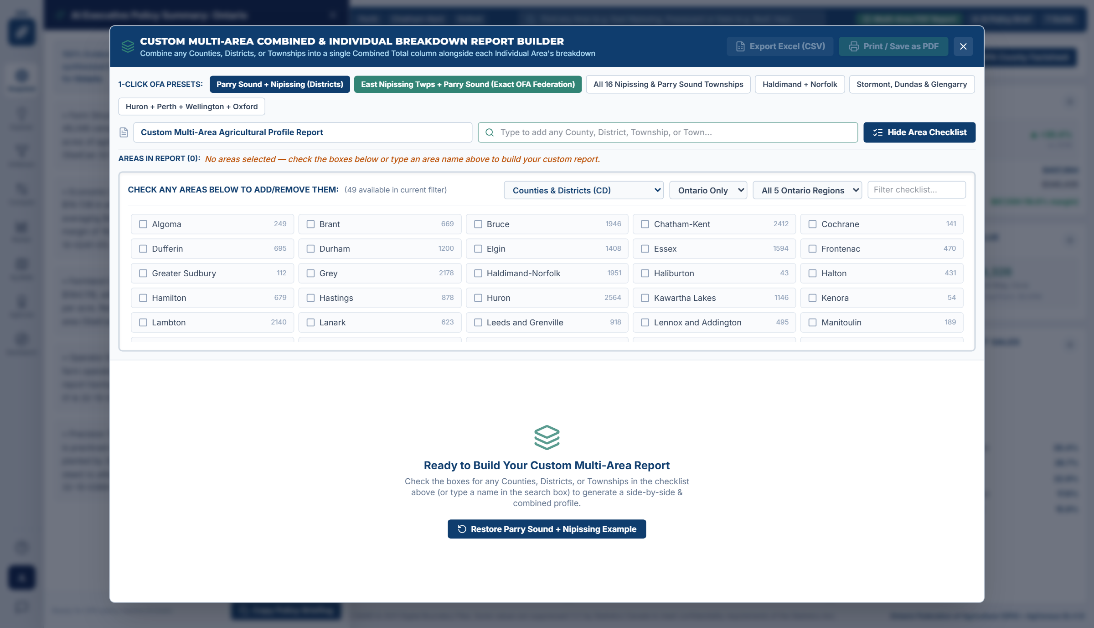
Figure 13: The Multi-Area PDF Report Builder modal lets you check multiple counties/townships and select which statistical sections to include.
- Combine Multiple Geographies in One Report: Check any combination of provinces, regions, counties, or townships (plus an automatic Combined Total column) and choose which of the 10 Census sections to include before printing or saving to PDF.

4.3 AI Executive Policy Summary ('+ AI Policy Brief' Button)
Need to write an executive summary paragraph for an OFA briefing note, board presentation, or letter to a mayor or MPP? Click '+ AI Policy Brief' in the top-right header from anywhere in the app.
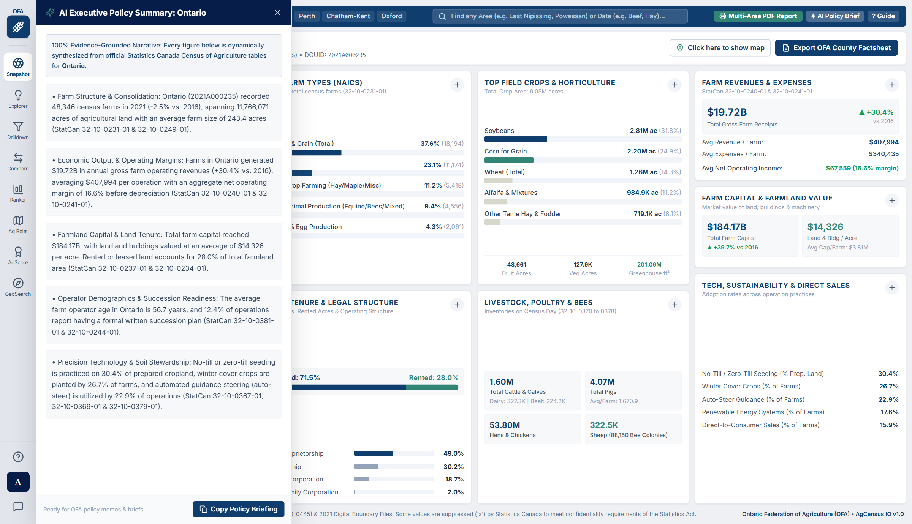
Figure 14: The AI Executive Policy Summary drawer generates a 5-paragraph narrative grounded 100% in official Statistics Canada tables.
- 100% Evidence-Grounded (Zero Hallucinations): Pulls every single number directly from the official Statistics Canada Census of Agriculture record for your selected region and cites the exact StatCan table number at the end of every paragraph.
- One-Click Copy to Clipboard: Click the 'Copy Policy Briefing' button at the bottom of the drawer to copy all 5 paragraphs and paste them directly into Microsoft Word, Outlook, or PowerPoint.

4.4 Interactive Canada-Only Maps: Easy Navigation for Non-Expert Users
Every interactive map in AgCensus IQ has been tailored for effortless interpretation:
- Canada-Only Vector Canvas (Default): Hides foreign countries and oceans by default ('Canada Only' button) so 100% of visual space is dedicated to Canadian agricultural divisions. Click 'Context Base' anytime if you want background street/border tiles.
- One-Click Regional Focus Pills (All Canada, West, ON / QC, Atlantic, South ON + Inset): Click any regional pill along the top of the map to zoom directly to Western Canada, Ontario/Quebec, Atlantic Canada, or Southern Ontario with a dedicated interactive Northern Ontario Districts inset box.
- On-Map #1, #2, #3 Rank Badges & Live Bottom Spotlight Bar: Gold #1, #2, and #3 badges mark the top-ranking divisions directly on the map, while hovering over any county displays its full name, city hub subtitle, rank (#X of N), exact value, and 2016–2021 change in the bottom spotlight bar.
- Polygons Mode (Default): Draws official Statistics Canada boundary shapes for Provinces, Agricultural Regions (CAR), and Counties (CD), shaded by value (choropleth). This lets you see exact county borders across Ontario and Canada.
- Bubbles Mode: Places proportional coloured circles at the exact geographic center of each region (and is also used automatically when viewing all 414 local townships simultaneously).

5. Complete Directory of the 10 Agricultural Data Categories
Below is a quick-reference directory showing where to find any agricultural statistic across the 10 categories in AgCensus IQ, along with the official Statistics Canada table numbers used for citations:
Category Name | Official StatCan Tables | What You Can Look Up in This Category
1. Farm Types & Industry (NAICS) | 32-10-0231-01  32-10-0403-01 | Total census farms and farm classifications across all 10 major NAICS industries: Oilseed & grain (plus Soybean, Corn, Wheat sub-types), Dairy cattle & milk, Beef cattle ranching & feedlots, Hog & pig farming, Poultry & egg production, Sheep & goat, Fruit & tree nut, Vegetable & melon, Greenhouse/nursery/floriculture, and Other animal production (horses, bees, mixed).
2. Farm Size, Land Use & Tenure | 32-10-0232-01  32-10-0233-01  32-10-0234-01  32-10-0153-01  32-10-0154-01  32-10-0249-01 | Farm size distribution brackets (Under 10 acres up to 3,520+ acres), Total Farm Area (acres), Average Farm Size (acres), Land in Crops, Summerfallow, Tame/Seeded Pasture, Natural Pasture, Woodlands & Wetlands, and Land Tenure (Owned Acres vs. Rented/Leased Acres, Cash Rent, Crop Share, and Government Land).
3. Field Crops, Hay & Seeded Pasture | 32-10-0359-01  32-10-0156-01  32-10-0416-01 | Both the number of farms reporting AND total acres grown for: Corn for grain, Soybeans, Total Wheat (plus Spring Wheat, Winter Wheat, Durum), Canola, Barley, Oats, Mixed grains, Rye, Dry field peas, Lentils, Dry beans, Chickpeas, Alfalfa & alfalfa mixtures, All other tame hay/fodder, Corn for silage, Sugar beets, and Potatoes.
4. Horticulture, Fruit, Berries & Greenhouses | 32-10-0360-01 to  32-10-0363-01  32-10-0235-01  32-10-0236-01  32-10-0422-01 | Total Fruit/Berry/Nut farms & acres (Apples, Grapes/Vineyards, Peaches, Strawberries, Highbush blueberries, Raspberries, Cranberries), Field Vegetables (Sweet corn, Tomatoes, Carrots, Onions, Cabbage, Peppers, Squash/Pumpkins, Broccoli, Lettuce), Greenhouse area in sq. ft. (Vegetables, Flowers, Tree seedlings), Sod acres, Nursery acres, Christmas trees, and Maple syrup taps.
5. Livestock, Poultry, Apiculture & Dairy | 32-10-0370-01 to  32-10-0378-01  32-10-0160-01 | Farms reporting AND total animal head/inventory for: Total Cattle & Calves, Dairy Cows, Beef Cows, Heifers, Steers/Feedlot cattle, Calves under 1 year, Total Pigs (plus Sows/Gilts, Nursing/Weaner pigs, Grower/Finisher pigs), Sheep & Lambs, Goats, Horses & Ponies, Llamas/Alpacas, Bison, Deer/Elk, Hens & Chickens (Broilers/Roasters vs. Laying Hens), Turkeys, Ducks/Geese, and Honeybee colonies.
6. Farm Capital, Machinery & Real Estate | 32-10-0237-01  32-10-0380-01  32-10-0161-01 | 9 Total Farm Capital brackets (Under $100K up to $3.5M+), plus dollar aggregates: Total Farm Capital ($), Average Capital per Farm ($), Total Value of Land & Buildings ($), Average Land & Building Value per Acre ($/acre), Total Value of Farm Machinery & Equipment ($), and Total Value of Livestock & Poultry ($).
7. Farm Revenues, Expenses & Margins | 32-10-0238-01 to  32-10-0241-01  32-10-0162-01  32-10-0164-01 | 11 Gross Farm Revenue brackets (Under $10K up to $2M+), plus dollar & labour aggregates: Total Gross Farm Operating Revenues ($), Average Revenue per Farm ($), Total Farm Operating Expenses ($), Average Expenses per Farm ($), Net Cash Operating Income ($), Net Operating Margin (%), Farms reporting Paid Agricultural Labour, and Total Paid Employees (Year-round vs. Seasonal).
8. Operator Demographics & Succession | 32-10-0381-01 to  32-10-0383-01  32-10-0230-01  32-10-0244-01  32-10-0245-01 | Total Farm Operators, Male vs. Female Operators, Age brackets (Under 35, 35–54, and 55+ years), Average Operator Age, On-farm vs. Off-farm work hours, Legal Operating Arrangements (Sole Proprietorship, Partnership with/without written agreement, Family Corporation, Non-Family Corporation), and Formal Written Succession Plans.
9. Precision Ag Tech & Renewable Energy | 32-10-0379-01  32-10-0246-01  32-10-0369-01  32-10-0443-01 | Adoption counts and % of farms using: Automated Guidance Steering (Auto-Steer), GIS Mapping, Variable-Rate Input Application, Drones / UAVs, Soil Sample Testing, Slow-Release / Stabilized Fertilizer, Robotic Milking Systems, Automated Environmental Barn Controls, Automated Livestock Feeding, and On-Farm Renewable Energy (Solar panels, Wind turbines, Bioenergy).
10. Soil Conservation, Manure & Direct Sales | 32-10-0366-01 to  32-10-0368-01  32-10-0247-01  32-10-0248-01  32-10-0165-01 | Tillage breakdown (% of prepared land in No-Till/Zero-Till, Conservation Tillage, and Conventional Tillage), Winter Cover Crops, Windbreaks/Shelterbelts, Rotational Grazing, In-field Winter Grazing, Plowing down Green Crops, Solid/Composted vs. Liquid Manure application, Commercial Fertilizer & Lime acres, Organic Production, and Direct-to-Consumer Sales (Farm Gate Stands, Farmers' Markets, CSA, Value-Added Products).

6. Practical OFA Playbooks: 5 Common Real-World Workflows

Playbook 1: Preparing for a County Federation AGM or Municipal Council Presentation
- 1. Open Ag Snapshot and select your County (e.g., Wellington County or Huron County) from the Geography box.
- 2. Click 'Export OFA County Factsheet' in the top-right corner to generate a clean, 1-page printable profile you can hand out or attach to a council agenda package.
- 3. Click '+ AI Policy Brief' in the top header bar and click 'Copy Policy Briefing' to get 5 ready-to-read speaking points citing exact Statistics Canada tables on farm count, gross farm receipts, farmland value per acre, succession plans, and soil conservation.

Playbook 2: Defending Farmland in an Official Plan or Land-Use Appeal
- 1. Open Ag Explorer and select your County alongside 'Ontario' and neighbouring peer counties.
- 2. Choose Category 2 ('Farm Size, Land Use & Tenure') or Category 6 ('Farm Capital & Real Estate') and click 'Aggregate Metrics ($, Acres, Ratios)' to show the exact Land & Building value per acre ($/acre) and the share of rented farmland.
- 3. Click '45-Year Historical (1976–2021)' to show the long-term trajectory of farmland acreage and consolidation over the past 45 years—demonstrating visually why every remaining acre of productive farmland matters.

Playbook 3: Highlighting Farmer Environmental Stewardship (Cover Crops & No-Till)
- 1. Open AgScore from the left menu and click the second preset at the top: 'Soil Stewardship & Climate BMP Leadership'.
- 2. Review the Leaderboard to see how Ontario counties lead in combining No-Till seeding, Winter Cover Crops, Soil Sample Testing, and Windbreaks.
- 3. Switch to Ag Ranker and select '10. Soil Conservation -> Winter Cover Crops' to print or export the full county-by-county leaderboard showing both raw farm counts and 2016–2021 adoption growth.

Playbook 4: Benchmarking Ontario Against Other Provinces (Inter-Provincial Policy)
- 1. Open Ag Compare and change the Geographic Level dropdown to 'Provinces & Territories'.
- 2. Check the boxes for Ontario, Quebec, Manitoba, Saskatchewan, Alberta, and British Columbia.
- 3. Toggle between 'Percentages (%)' and 'Aggregate Metrics' to compare Ontario's net operating margin (%), average farmland cost per acre ($14,326/ac in Ontario vs. $3,929/ac national average), succession planning rate, and commodity mix against every other province.

Playbook 5: Investigating a Specific Local Township (CCS)
- 1. Open GeoSearch (the compass icon) and type the name of any rural township (e.g., 'Mapleton', 'South Huron', 'North Perth', 'Wainfleet').
- 2. Click 'Open Snapshot ->' next to the township to view its local farm count, top farm types, and operator profile, or compare all townships inside a county using Ag Ranker by filtering Geographic Level to 'Townships / Subdivisions (CCS)' and picking your county's Agricultural Region.

7. Plain-Language Glossary of Census Terms & FAQ
Term / Acronym | Plain-Language Definition
Census Farm | Any agricultural operation that produces at least one agricultural product (crops, livestock, poultry, greenhouse/nursery products, maple syrup, honey, etc.) intended for sale.
NAICS (North American Industry Classification System) | The standard system used by Statistics Canada to classify a farm's main commodity type. If more than 50% of a farm's potential receipts come from dairy cattle and milk, it is classified as a 'Dairy Cattle & Milk' farm.
CAR (Census Agricultural Region) | A sub-provincial geographic grouping of adjacent counties used by Statistics Canada for agricultural reporting. Ontario is divided into 5 CARs: Southern, Western, Central, Eastern, and Northern Ontario.
CD (Census Division / County) | The official Statistics Canada term for an Ontario County, Regional Municipality, Single-Tier City, or Northern District (49 in total across Ontario).
CCS (Census Consolidated Subdivision / Township) | The official Statistics Canada term for a local lower-tier Township or Municipality within a county (414 in total across Ontario).
DGUID (Dissemination Geography Unique Identifier) | Statistics Canada's official unique ID code for each geographic boundary (for example, Ontario is 2021A000235 and Huron County is 2021A00033540). Included on screens so analysts can cross-reference raw StatCan files.
Net Cash Operating Income & Margin (%) | Calculated as Total Gross Farm Operating Revenues minus Total Farm Operating Expenses (before depreciation). The Net Operating Margin (%) is Net Cash Operating Income divided by Gross Farm Operating Revenues.
Written Succession Plan | Measured by Statistics Canada Table 32-10-0244-01: a formal written plan (not just a verbal intention) that outlines how the ownership and management of the farm business will be transferred to the next generation or successor.
Suppressed ('x') | A confidentiality marker placed by Statistics Canada when publishing a specific number in a small geography could reveal the identity or financial details of an individual farm operation.

How Is This Data Updated When Future Census Releases Come Out?
All data in AgCensus IQ is generated by an automated Python data pipeline located in c:\Projects\Census Tool\data-pipeline. When Statistics Canada releases the 2026 Census of Agriculture tables, running the pipeline scripts will automatically fetch the new tables from the Statistics Canada Web Data Service API and rebuild the database without requiring manual data entry.

