**01418212-65 การโปรแกรมภาษาซี**

**Lab Sheet 23 ก.ค. 67 – ตอนที่ 2**

**การทดลองที่ 1**

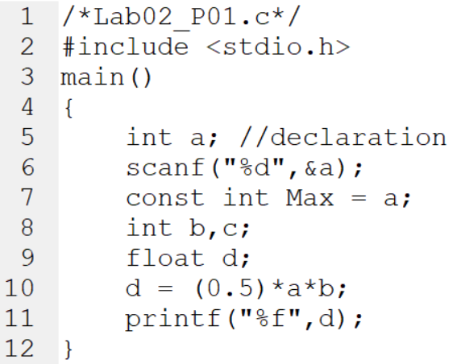

* 1. จงอธิบายพร้อมแก้ไขโปรแกรมให้ถูกต้องสมบูรณ์ (อธิบายคร่าวๆ อย่างเข้าใจ)

---------------------------------------------------------------------------------------------------------------------------------------------------------------------------------------------------------------------------------------------------------------------------------------------------------------------------------------------------------------------------------------------------------------------------------------------------------------------------------------------------------------------------------------------------------------------------------------------------------------------------------------------------------------------------------------------------------------------------------------------------------------------------------------------------------------------------------------------------------------------------------------------

---------------------------------------------------------------------------------------------------------------------------

* 1. จงแสดงผลลัพธ์ของโปรแกรมก่อนการแก้ไขและหลังการแก้ไข

---------------------------------------------------------------------------------------------------------------------------------------------------------------------------------------------------------------------------------------------------------------------------------------------------------------------------------------------------------------------------------------------------------------------------------------------------------------------------------------------------------------------------------------------------------------------------------------------------------------------------------------------------------------------------------------------------------------------------------------------------------------------------------------------------------------------------------------------------------------------------------------------

---------------------------------------------------------------------------------------------------------------------------

**การทดลองที่ 2**

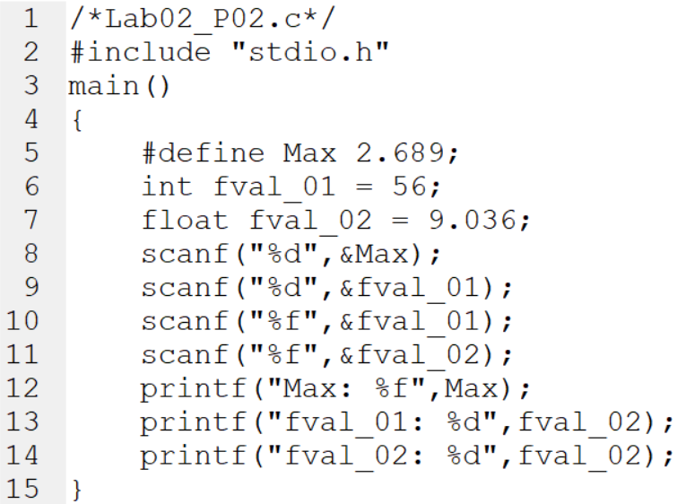

* 1. จงอธิบายพร้อมแก้ไขโปรแกรมให้ถูกต้องสมบูรณ์ (อธิบายคร่าวๆ อย่างเข้าใจ)

---------------------------------------------------------------------------------------------------------------------------------------------------------------------------------------------------------------------------------------------------------------------------------------------------------------------------------------------------------------------------------------------------------------------------------------------------------------------------------------------------------------------------------------------------------------------------------------------------------------------------------------------------------------------------------------------------------------------------------------------------------------------------------------------------------------------------------------------------------------------------------------------

---------------------------------------------------------------------------------------------------------------------------

---------------------------------------------------------------------------------------------------------------------------

* 1. จงแสดงผลลัพธ์ของโปรแกรมก่อนการแก้ไขและหลังการแก้ไข

---------------------------------------------------------------------------------------------------------------------------------------------------------------------------------------------------------------------------------------------------------------------------------------------------------------------------------------------------------------------------------------------------------------------------------------------------------------------------------------------------------------------------------------------------------------------------------------------------------------------------------------------------------------------------------------------------------------------------------------------------------------------------------------------------------------------------------------------------------------------------------------------

---------------------------------------------------------------------------------------------------------------------------

---------------------------------------------------------------------------------------------------------------------------

**การทดลองที่ 3**

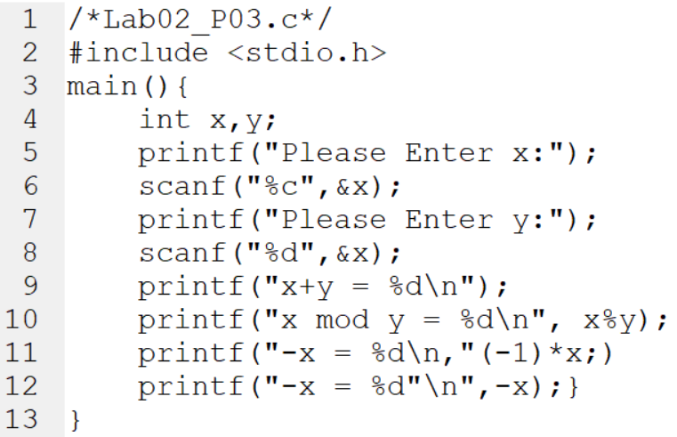

* 1. จงอธิบายพร้อมแก้ไขโปรแกรมให้ถูกต้องสมบูรณ์ (อธิบายคร่าวๆ อย่างเข้าใจ)

---------------------------------------------------------------------------------------------------------------------------------------------------------------------------------------------------------------------------------------------------------------------------------------------------------------------------------------------------------------------------------------------------------------------------------------------------------------------------------------------------------------------------------------------------------------------------------------------------------------------------------------------------------------------------------------------------------------------------------------------------------------------------------------------------------------------------------------------------------------------------------------------

---------------------------------------------------------------------------------------------------------------------------

---------------------------------------------------------------------------------------------------------------------------

* 1. จงแสดงผลลัพธ์ของโปรแกรมก่อนการแก้ไขและหลังการแก้ไข

---------------------------------------------------------------------------------------------------------------------------------------------------------------------------------------------------------------------------------------------------------------------------------------------------------------------------------------------------------------------------------------------------------------------------------------------------------------------------------------------------------------------------------------------------------------------------------------------------------------------------------------------------------------------------------------------------------------------------------------------------------------------------------------------------------------------------------------------------------------------------------------------

---------------------------------------------------------------------------------------------------------------------------

---------------------------------------------------------------------------------------------------------------------------

**การทดลองที่ 4**

จงเขียนโปรแกรมเพื่อประมวลผลนิพจน์ต่อไปนี้  
กำหนดให้ a = 2; b = 7; x = 5;

(คำแนะนำ : เริ่มต้นด้วย a = 2; b = 7; x = 5; ในทุกข้อ และทำการเขียนโปรแกรมประมวลผลนิพจน์จะได้จำนวน 11 โปรแกรม พร้อมอธิบายการคำนวณคร่าวๆ พอเข้าใจได้)

1. x = b--;

---------------------------------------------------------------------------------------------------------------------------------------------------------------------------------------------------------------------------------------------------------------------------------------------------------------------------------------------------------------------------------------------------------------------------------------------------------------------------------------------------------------------------------------------------------------------------------------------------------------------------------------------------------------------------------------------------------------------------------------------------------------------------------------------------------------------------------------------------------------------------------------------

1. a =+ 7;

---------------------------------------------------------------------------------------------------------------------------------------------------------------------------------------------------------------------------------------------------------------------------------------------------------------------------------------------------------------------------------------------------------------------------------------------------------------------------------------------------------------------------------------------------------------------------------------------------------------------------------------------------------------------------------------------------------------------------------------------------------------------------------------------------------------------------------------------------------------------------------------------

1. b *= x++;

---------------------------------------------------------------------------------------------------------------------------------------------------------------------------------------------------------------------------------------------------------------------------------------------------------------------------------------------------------------------------------------------------------------------------------------------------------------------------------------------------------------------------------------------------------------------------------------------------------------------------------------------------------------------------------------------------------------------------------------------------------------------------------------------------------------------------------------------------------------------------------------------

1. x += a % b;

---------------------------------------------------------------------------------------------------------------------------------------------------------------------------------------------------------------------------------------------------------------------------------------------------------------------------------------------------------------------------------------------------------------------------------------------------------------------------------------------------------------------------------------------------------------------------------------------------------------------------------------------------------------------------------------------------------------------------------------------------------------------------------------------------------------------------------------------------------------------------------------------

1. b = --b + x;

---------------------------------------------------------------------------------------------------------------------------------------------------------------------------------------------------------------------------------------------------------------------------------------------------------------------------------------------------------------------------------------------------------------------------------------------------------------------------------------------------------------------------------------------------------------------------------------------------------------------------------------------------------------------------------------------------------------------------------------------------------------------------------------------------------------------------------------------------------------------------------------------

1. a %= (a+b) % x;

---------------------------------------------------------------------------------------------------------------------------------------------------------------------------------------------------------------------------------------------------------------------------------------------------------------------------------------------------------------------------------------------------------------------------------------------------------------------------------------------------------------------------------------------------------------------------------------------------------------------------------------------------------------------------------------------------------------------------------------------------------------------------------------------------------------------------------------------------------------------------------------------

1. x /= 6;

---------------------------------------------------------------------------------------------------------------------------------------------------------------------------------------------------------------------------------------------------------------------------------------------------------------------------------------------------------------------------------------------------------------------------------------------------------------------------------------------------------------------------------------------------------------------------------------------------------------------------------------------------------------------------------------------------------------------------------------------------------------------------------------------------------------------------------------------------------------------------------------------

1. a <<= x;

---------------------------------------------------------------------------------------------------------------------------------------------------------------------------------------------------------------------------------------------------------------------------------------------------------------------------------------------------------------------------------------------------------------------------------------------------------------------------------------------------------------------------------------------------------------------------------------------------------------------------------------------------------------------------------------------------------------------------------------------------------------------------------------------------------------------------------------------------------------------------------------------

1. x >>= a;

---------------------------------------------------------------------------------------------------------------------------------------------------------------------------------------------------------------------------------------------------------------------------------------------------------------------------------------------------------------------------------------------------------------------------------------------------------------------------------------------------------------------------------------------------------------------------------------------------------------------------------------------------------------------------------------------------------------------------------------------------------------------------------------------------------------------------------------------------------------------------------------------

1. b ^= (x+a)--;

---------------------------------------------------------------------------------------------------------------------------------------------------------------------------------------------------------------------------------------------------------------------------------------------------------------------------------------------------------------------------------------------------------------------------------------------------------------------------------------------------------------------------------------------------------------------------------------------------------------------------------------------------------------------------------------------------------------------------------------------------------------------------------------------------------------------------------------------------------------------------------------------

1. --a *= ++b;

---------------------------------------------------------------------------------------------------------------------------------------------------------------------------------------------------------------------------------------------------------------------------------------------------------------------------------------------------------------------------------------------------------------------------------------------------------------------------------------------------------------------------------------------------------------------------------------------------------------------------------------------------------------------------------------------------------------------------------------------------------------------------------------------------------------------------------------------------------------------------------------------

**การทดลองที่ 5**

ตึกนวัตกรรมคอมพิวเตอร์มีลักษณะเป็นสี่เหลี่ยมและถูกสร้างอยู่บนพื้นที่สี่เหลี่ยมเช่นเดียวกัน โดยพื้นที่ล้อมรอบตัวตึกเป็นพื้นที่ว่างเปล่า ถ้าหากต้องการปูกระเบื้องหินอ่อนโดยช่างที่ชำนาญการ ซึ่งสามารถปูกระเบื้องหนึ่งแผ่นที่มีขนาด 4 ตารางเมตร เสร็จภายในเวลา 2 นาที จงเขียนโปรแกรมเพื่อคำนวณหาพื้นที่และเวลาที่ต้องใช้ในการปูกระเบื้องล้อมรอบตึกนวัตกรรมฯ แห่งนี้ พร้อมทั้งคำนวณหาราคากระเบื้องที่ใช้ทั้งหมดและค่าแรงช่างเหมาจ่าย

--------------------------------------------------------------------------------------------------------------------------------------------------------------------------------------------------------------------------------------------------------------------------------------------------------------------------------------------------------------------------------------------------------------------------------------------------------------------------------------------------------------------------------------------------------------------------------------------------------------------------------------------------------------------------------------------------------------------------------------------------------------------------------------------------------------------------------------------------------------------------------------------------------------------------------

--------------------------------------------------------------------------------------------------------------------------------------------------------------------------------------------------------------------------------------------------------------------------------------------------------------------------------------------------------------------------------------------------------------------------------------------------------------------------------------------------------------------------------------------------------------------------------------------------------------------------------------------------------------------------------------------------------------------------------------------------------------------------------------------------------------------------------------------------------------------------------------------------------------------------------

--------------------------------------------------------------------------------------------------------------------------------------------------------------------------------------------------------------------------------------------------------------------------------------------------------------------------------------------------------------------------------------------------------------------------------------------------------------------------------------------------------------------------------------------------------------------------------------------------------------------------------------------------------------------------------------------------------------------------------------------------------------------------------------------------------------------------------------------------------------------------------------------------------------------------------

--------------------------------------------------------------------------------------------------------------------------------------------------------------------------------------------------------------------------------------------------------------------------------------------------------------------------------------------------------------------------------------------------------------------------------------------------------------------------------------------------------------------------------------------------------------------------------------------------------------------------------------------------------------------------------------------------------------------------------------------------------------------------------------------------------------------------------------------------------------------------------------------------------------------------------

--------------------------------------------------------------------------------------------------------------------------------------------------------------------------------------------------------------------------------------------------------------------------------------------------------------------------------------------------------------------------------------------------------------------------------------------------------------------------------------------------------------------------------------------------------------------------------------------------------------------------------------------------------------------------------------------------------------------------------------------------------------------------------------------------------------------------------------------------------------------------------------------------------------------------------

--------------------------------------------------------------------------------------------------------------------------------------------------------------------------------------------------------------------------------------------------------------------------------------------------------------------------------------------------------------------------------------------------------------------------------------------------------------------------------------------------------------------------------------------------------------------------------------------------------------------------------------------------------------------------------------------------------------------------------------------------------------------------------------------------------------------------------------------------------------------------------------------------------------------------------

--------------------------------------------------------------------------------------------------------------------------------------------------------------------------------------------------------------------------------------------------------------------------------------------------------------------------------------------------------------------------------------------------------------------------------------------------------------------------------------------------------------------------------------------------------------------------------------------------------------------------------------------------------------------------------------------------------------------------------------------------------------------------------------------------------------------------------------------------------------------------------------------------------------------------------

--------------------------------------------------------------------------------------------------------------------------------------------------------------------------------------------------------------------------------------------------------------------------------------------------------------------------------------------------------------------------------------------------------------------------------------------------------------------------------------------------------------------------------------------------------------------------------------------------------------------------------------------------------------------------------------------------------------------------------------------------------------------------------------------------------------------------------------------------------------------------------------------------------------------------------