3.3.1中的Shell命令

ls

查看指定路径的当前目录结构

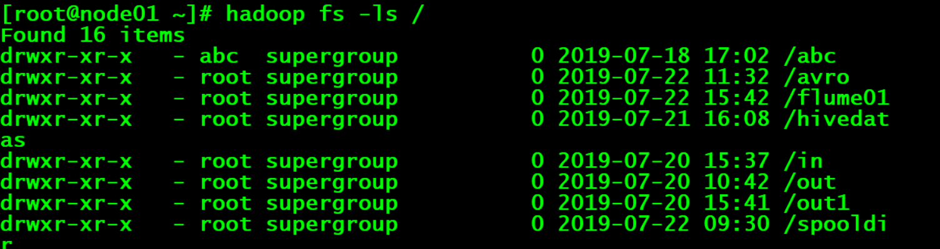

Mkdir

在指定路径下创建子目录

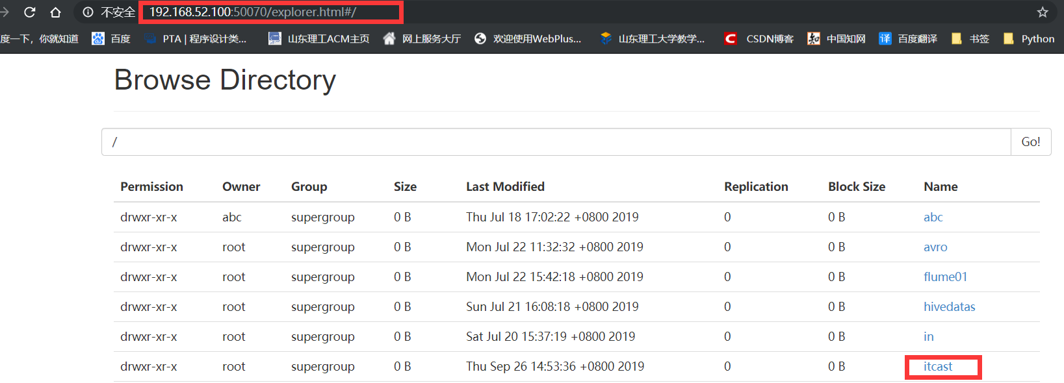

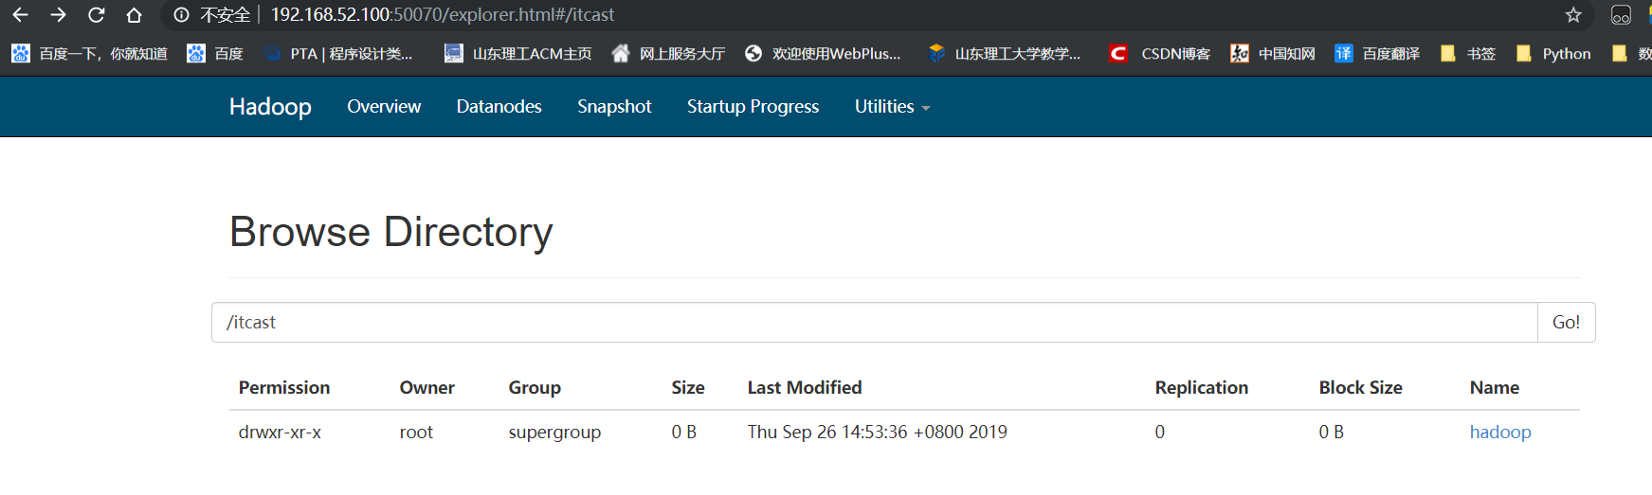

Put

将本地系统的文件或文件夹复制到HDFS上



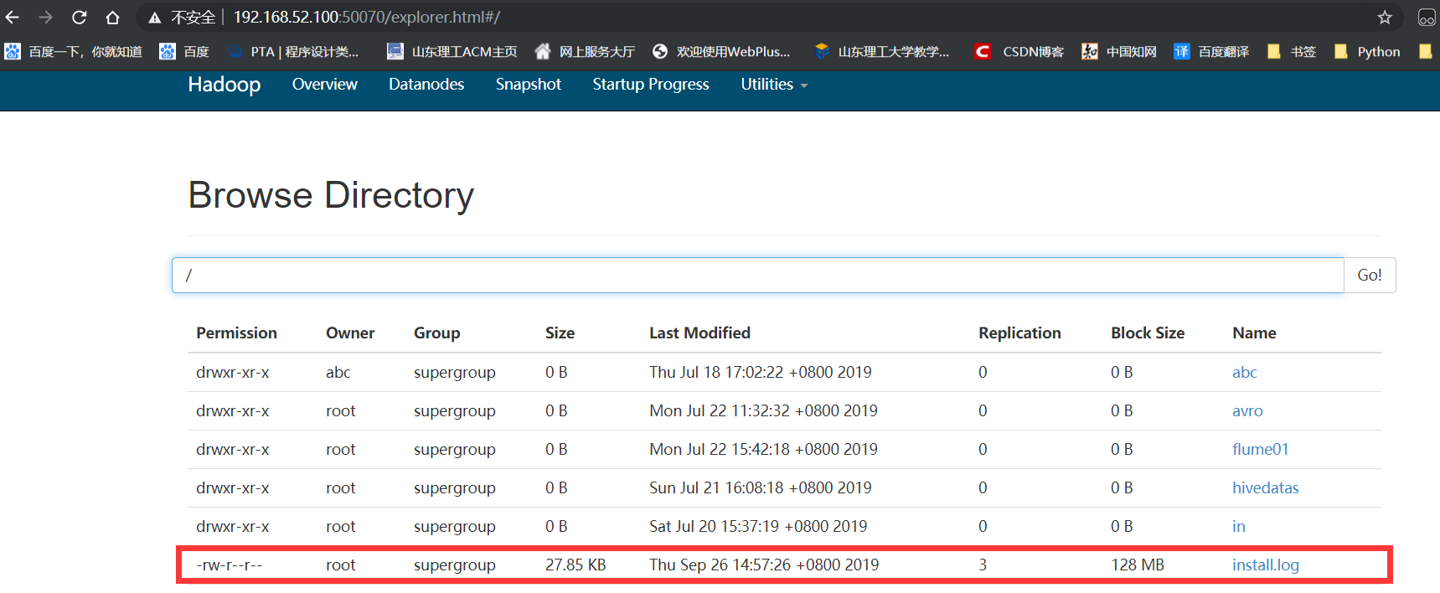

3.4.2中的代码

Pom.xml

<project xmlns="http://maven.apache.org/POM/4.0.0" xmlns:xsi="http://www.w3.org/2001/XMLSchema-instance"  
 xsi:schemaLocation="http://maven.apache.org/POM/4.0.0 http://maven.apache.org/xsd/maven-4.0.0.xsd">  
 <modelVersion>4.0.0</modelVersion>  
 <groupId>com.itcast</groupId>  
 <artifactId>HadoopDemo</artifactId>  
 <version>0.0.1-SNAPSHOT</version>  
 <dependencies>  
 <dependency>  
 <groupId>org.apache.hadoop</groupId>  
 <artifactId>hadoop-common</artifactId>  
 <version>2.7.4</version>  
 </dependency>  
 <dependency>  
 <groupId>org.apache.hadoop</groupId>  
 <artifactId>hadoop-hdfs</artifactId>  
 <version>2.7.4</version>  
 </dependency>  
 <dependency>  
 <groupId>org.apache.hadoop</groupId>  
 <artifactId>hadoop-client</artifactId>  
 <version>2.7.4</version>  
 </dependency>  
 <dependency>  
 <groupId>org.apache.hadoop</groupId>  
 <artifactId>hadoop-mapreduce-client-core</artifactId>  
 <version>2.7.4</version>  
 </dependency>  
 <dependency>  
 <groupId>junit</groupId>  
 <artifactId>junit</artifactId>  
 <version>4.12</version>  
 </dependency>  
 </dependencies>  
</project>

HDFS_CRUD.java

初始化客户端对象

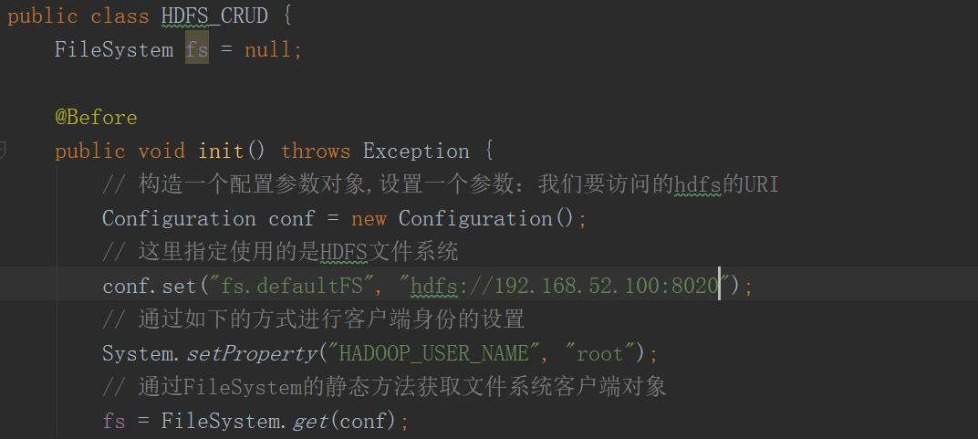

上传文件到hdfs

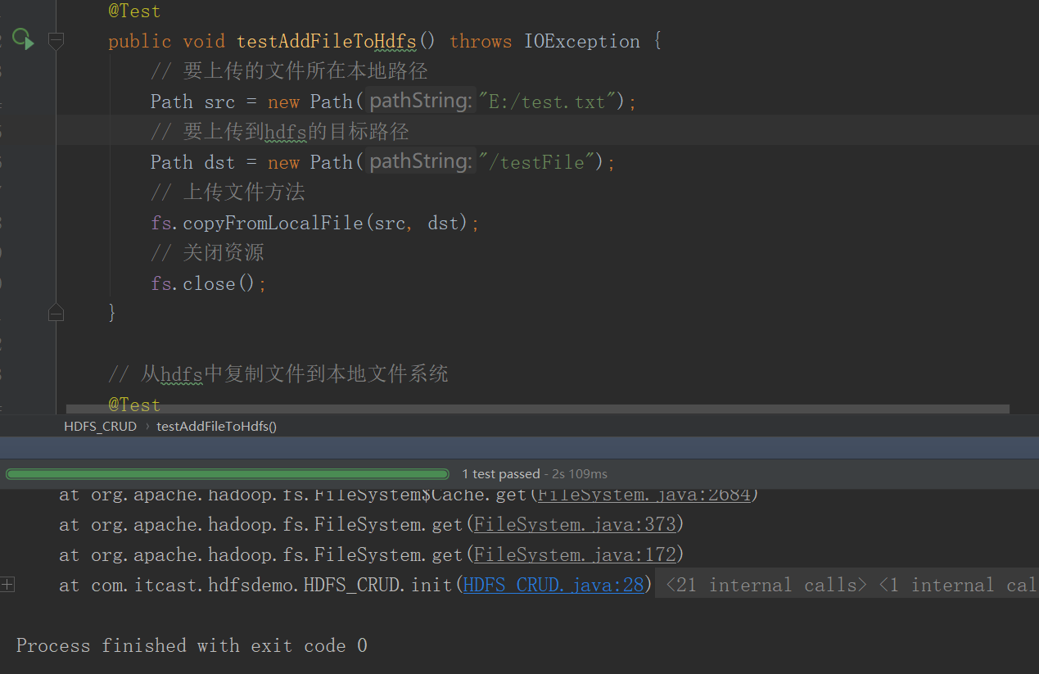

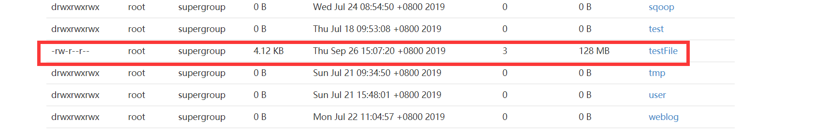

从hdfs下载文件到本地

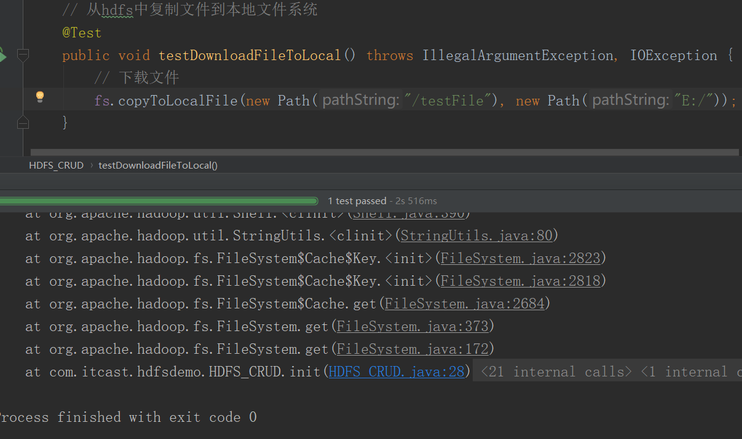

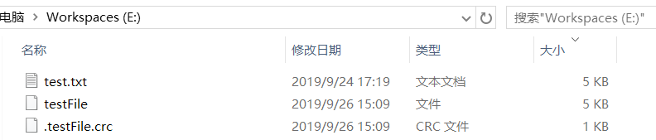

目录操作

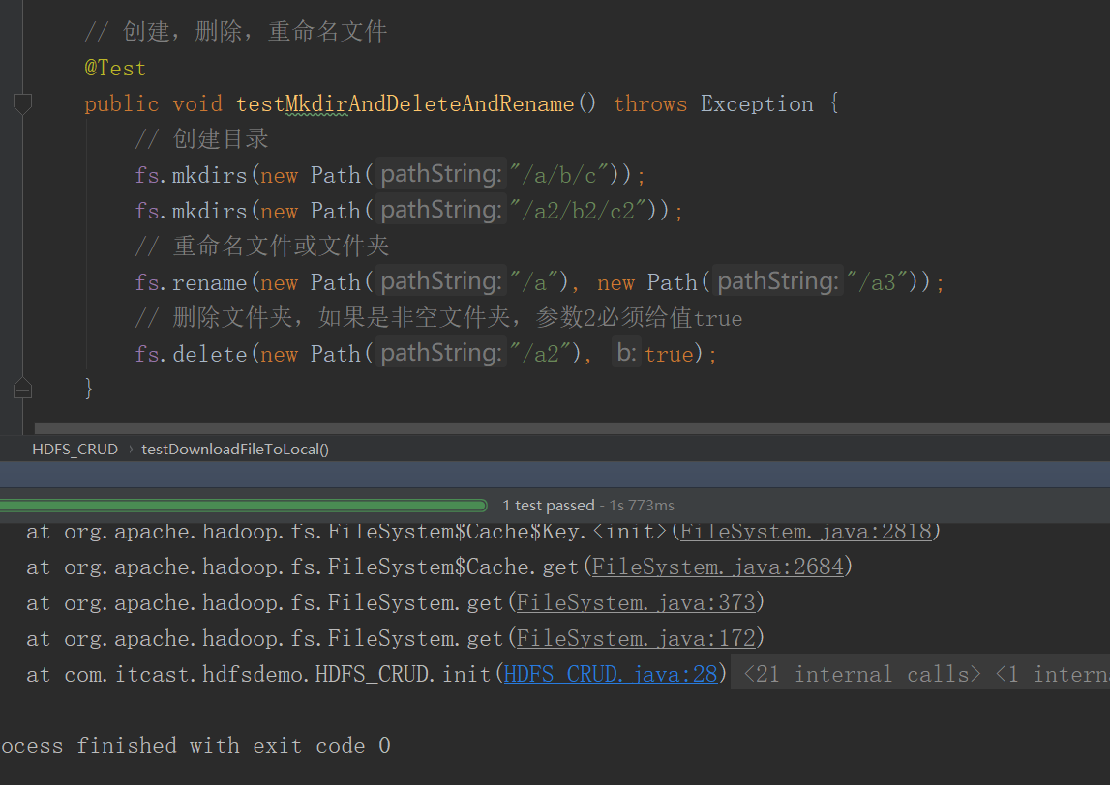

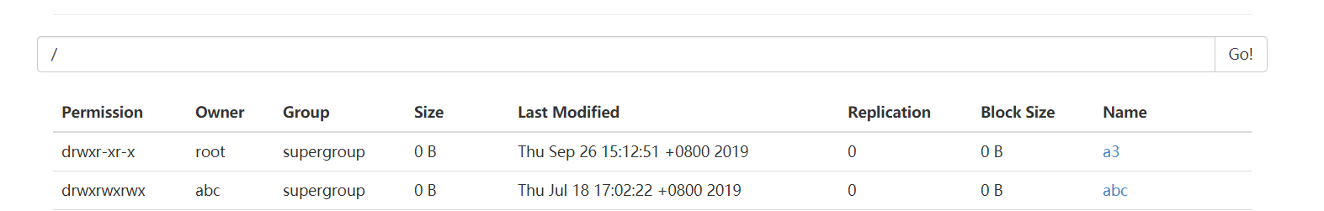

查看目录信息

