Paper Title* (use style: paper title)
*Note: Sub-titles are not captured in Xplore and should not be used

line 1: 1st Given Name Surname
line 2: dept. name of organization
(of Affiliation)
line 3: name of organization
(of Affiliation)
line 4: City, Country
line 5: email address or ORCID
line 1: 4th Given Name Surname
line 2: dept. name of organization
(of Affiliation)
line 3: name of organization
(of Affiliation)
line 4: City, Country
line 5: email address or ORCID
line 1: 2nd Given Name Surname
line 2: dept. name of organization
(of Affiliation)
line 3: name of organization
(of Affiliation)
line 4: City, Country
line 5: email address or ORCID
line 1: 5th Given Name Surname
line 2: dept. name of organization
(of Affiliation)
line 3: name of organization
(of Affiliation)
line 4: City, Country
line 5: email address or ORCID
line 1: 3rd Given Name Surname
line 2: dept. name of organization
(of Affiliation)
line 3: name of organization
(of Affiliation)
line 4: City, Country
line 5: email address or ORCID
line 1: 6th Given Name Surname
line 2: dept. name of organization
(of Affiliation)
line 3: name of organization
(of Affiliation)
line 4: City, Country
line 5: email address or ORCID

Abstract—In this paper we propose a novel iterative method, based on digit detection, to solve the problem of ruler scale detection on the images, which provides the ability to use rulers as a reference object for the further image analysis. We focus on the medical domain images, but our method can be used in many others domains like criminology, museum business, etc. We received mean absolute error of 6.63 px and median absolute error of 4 px on high resolution images (3104x1746) compared with manual measurement results. Proposed method consists of few loosely coupled steps, first of which can be replaced and tuned by the end user, which brings flexibility.
Keywords—component, formatting, style, styling, insert (key words)

Introduction (Heading 1)
The task of determining the size of certain objects on the images is quite common and well known in multiple areas. Different methods allow to solve it quickly and with a sufficient accuracy. However, their application usually requires knowledge of the distance to the object, as well as the parameters of the lens of camera, at least the focal length. If this information is not available – this task can be solved using reference object with known size and distance to it. The reference object should be placed near the object of interest, be on the same plane and on the same distance from the camera. In most practical cases, approximate manual methods are used, which are largely characterized by a large amounts of subjective errors. For example, in medicine, doctors place a measuring ruler next to the patients wound. This allows to estimate the size of the object under study. Moreover, it is important to note that currently there are different archives and various databases with a huge number of such images. The main problem here is that such an assessment is performed manually and is very subjective and inaccurate. This creates an important task – accurately and automatically estimate the size of a certain objects in the images, if the images contain the reference ruler. Obviously, such a task is divided into at least two subtasks. The essence of the first is that it is necessary to identify the numerical scale of the ruler, and at the same time it is necessary to determine the price of all divisions plotted on this ruler. The second task is to determine the geometric dimensions of the object of study by comparing it with an already identified ruler. The main goal of this work is to describe a new method that solves the first task – identification of the ruler scale on the image, to determine the DPC (dots per centimeter) or DPI (dots per inch), where dots is used s synonym to pixels.
Mainly we focus on the medical images as the task of wound measurements is very important for checking the effectiveness of treatment and during performing surgical interventions, but proposed method is applicable to lots of spheres, where the task is to determine the real size of the object on the image and the ruler is used as a reference.

Materials and methods
The proposed method can be divided into three loosely coupled stages:
- Digits detection
- Detection of laying on the same line digits
- Ruler scale detection

Digits detection
The overall idea of this method is to perform object detection task in order to detect and identify digits, that are present on the image. Our hypothesis is that at least some of the detected digits are placed above or below scale marks on the ruler and can be used as a reference points for scale detection. Please, refer to Fig.1, presented earlier, for visual understanding.
The main output of this step is a set of bounding boxes. Each bounding box should be represented in a specific format, with `xmin`, `ymin`, `xmax`, `ymax` and `name` properties (Fig.1), where first four tokens hold corresponding min/max bounding box coordinates and `name` holds a detected digit label.
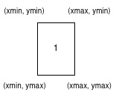Figure 1: Bounding box in YOLO format

The task of object detection can be completed in multiple ways. Presented method does not require very high accuracy in digit identification, because it has iterative nature and False Positives (Type 1 error) in digit identification (e.g. model detected image in bounding box as 5, but it is actually 3) can be eliminated if there are other objects, that are correctly identified. But this method requires high precision of bounding box detection, as their coordinates will be essential for the scale detection. As an opposite to the first requirement, we need object detection method not to be very computationally expensive, because in the long run we want to use proposed method on the portable devices (tablets, smartphones). Taking these two requirements we decided to use pretrained YOLO[7] model family, in particular YOLOv5 and train it on our own data.
Currently, in deep learning, there are two major classes of object detection algorithms: one-stage and two-stage object detectors. Two-stage object detectors uses separate calculations for localization – detecting possible object regions and for classification of these regions, Faster R-CNN[8] is one of the best-known architectures of this kind. One-stage detectors do localization and classification in one go. A single neural network predicts bounding boxes and class probabilities directly from full images in one evaluation[7]. YOLO[7] belongs to the one-stage object detectors and it is the first well known network of this kind. The biggest advantage of YOLO is its speed, according to the original paper of first version of this network, it is able to process images in real-time with 45 frames per second[7]. Despite of that there are others important advantages of YOLO approach, like using the entire image during training and testing, but not only some regions and learning generalizable representation of objects[7]. While also having some disadvantages and limitations, YOLO passed a long path of development and the 5-th version we use[9] has lots of them fixed and overall performance greatly improved.
Lastly, YOLO is not the only possible, and possibly not the best model, that can be used as a backand for our method. But, all the beauty, from the software engineering perspective, is that method can use any possible algorithm of digit detection, just feed it with data in the right format.
Mean average precision is the most commonly used metric in object detection. But it is not just an average Precision (Precision measures, which percentage of the model predictions are correct and decreases False Positives in predictions), as may be deducted from the name. Object detection performs two tasks: classification and bounding box localization. Moreover, there may be few objects on the image, that are needed to be localized and classified. While Precision is a possible, and for some use cases, very good classification metric, mAP is more complex and uses a combination of metrics:
- precision
- recall
- IOU
Intersection over Union (IOU) metric, which can be also referred as Jaccard index[10] is used to measure the overlap between the predicted bounding box and the truth one:
$J\left(B_{p},B_{t}\right)=\frac{area\left(B_{p}∩B_{t}\right)}{area\left(B_{p}∪B_{t}\right)},$
where B_{p} and B_{t} refer to the predicted and truth bounding boxes correspondingly.
IOU threshold is used to determine whether bounding box localization prediction should be considered as True Positive or False Positive.
Recall is highly correlated with Precision, but decreases False Negatives. Their correlation can be visualized by a Precision-Recall curve[11].
To calculate average precision (AP), area under this curve is calculated:
$AP=\int_{0}^{1}{P}\left(R\right)d\left(R\right),$
where P is Precision, R is Recall.
MAP is calculated as following:
$mAP=\frac{1}{N}\sum_{i=1}^{N}{{AP}_{i}},$
where N is number of classes
Also different or multiple IOU thresholds can be used. For example, not only mAP_0.5, but mAP_0.5-0.95. In case of multiple thresholds are used, we consider not only mean of average precision across all classes, but mean of AP across all classes for every IOU threshold.
For our method it is very important not to rely only on mAP_0.5, during model training, but to consider higher threshold or range of thresholds, because in our case bounding box localization accuracy is crucial and more important than digit identification.
  - Detection of laying on the same line digits
We labeled 184 wound images with different rulers, collected from[12]. To maintain patients privacy we blurred all sensitive information. We used 159 of them for model training and 25 for validation. These two sets contained images with different rulers and different wounds (some images contained photo of the same wound and ruler, but with different time and label). Also, we used images with different quality. Most of the images contained rulers with [0-9] range of digits, but there where also larger ones (10+ centimeters), which is also taken into account in our algorithm.

We used Google Colaboratory and their GPU for YOLOv5 training on our custom dataset and Weights & Biases to track metrics. Initial experiment setup was: 2000 epochs, batch size 16 and image size 1280x1280. Because of loss function stopped decreasing, we stopped training after 459 epoch with the best loss on 358 and the best mAP_0.5 – 0.84841 but the best mAP_0.5-0.95 is much lower – only 0.473. On the Fig.2 below you can see how Mean Average Precision, with IOU threshold 0.5 has changed during epochs and on the Fig.3, you can see this information for mAP_0.5-0.95.
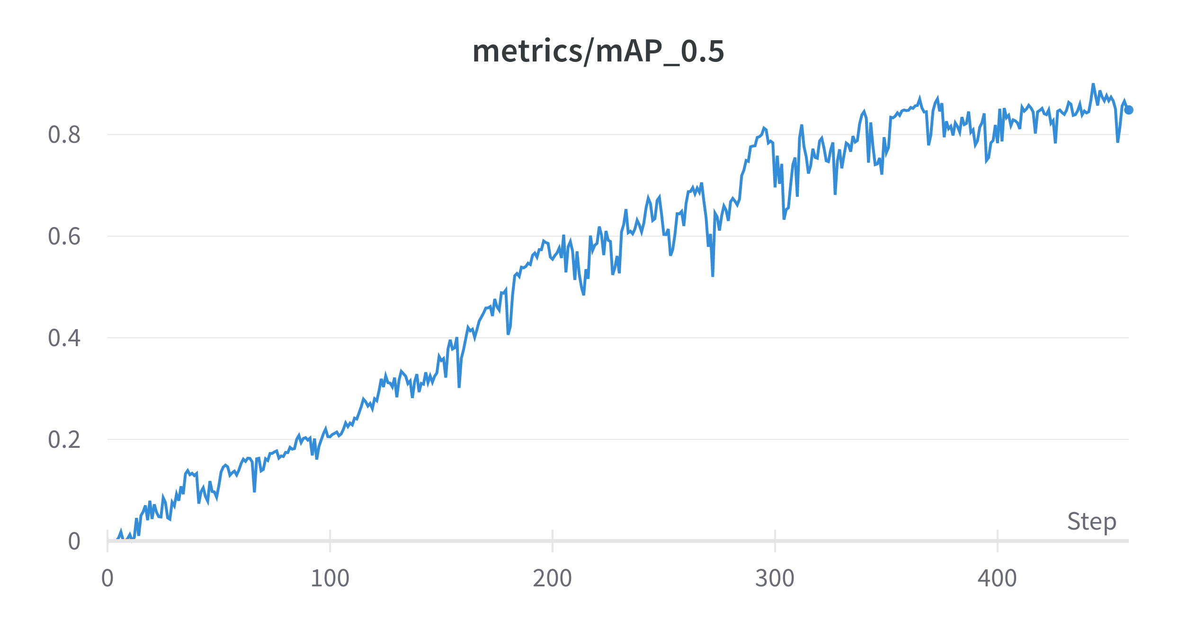Figure 2: mAP for IOU 0.5 after every epoch

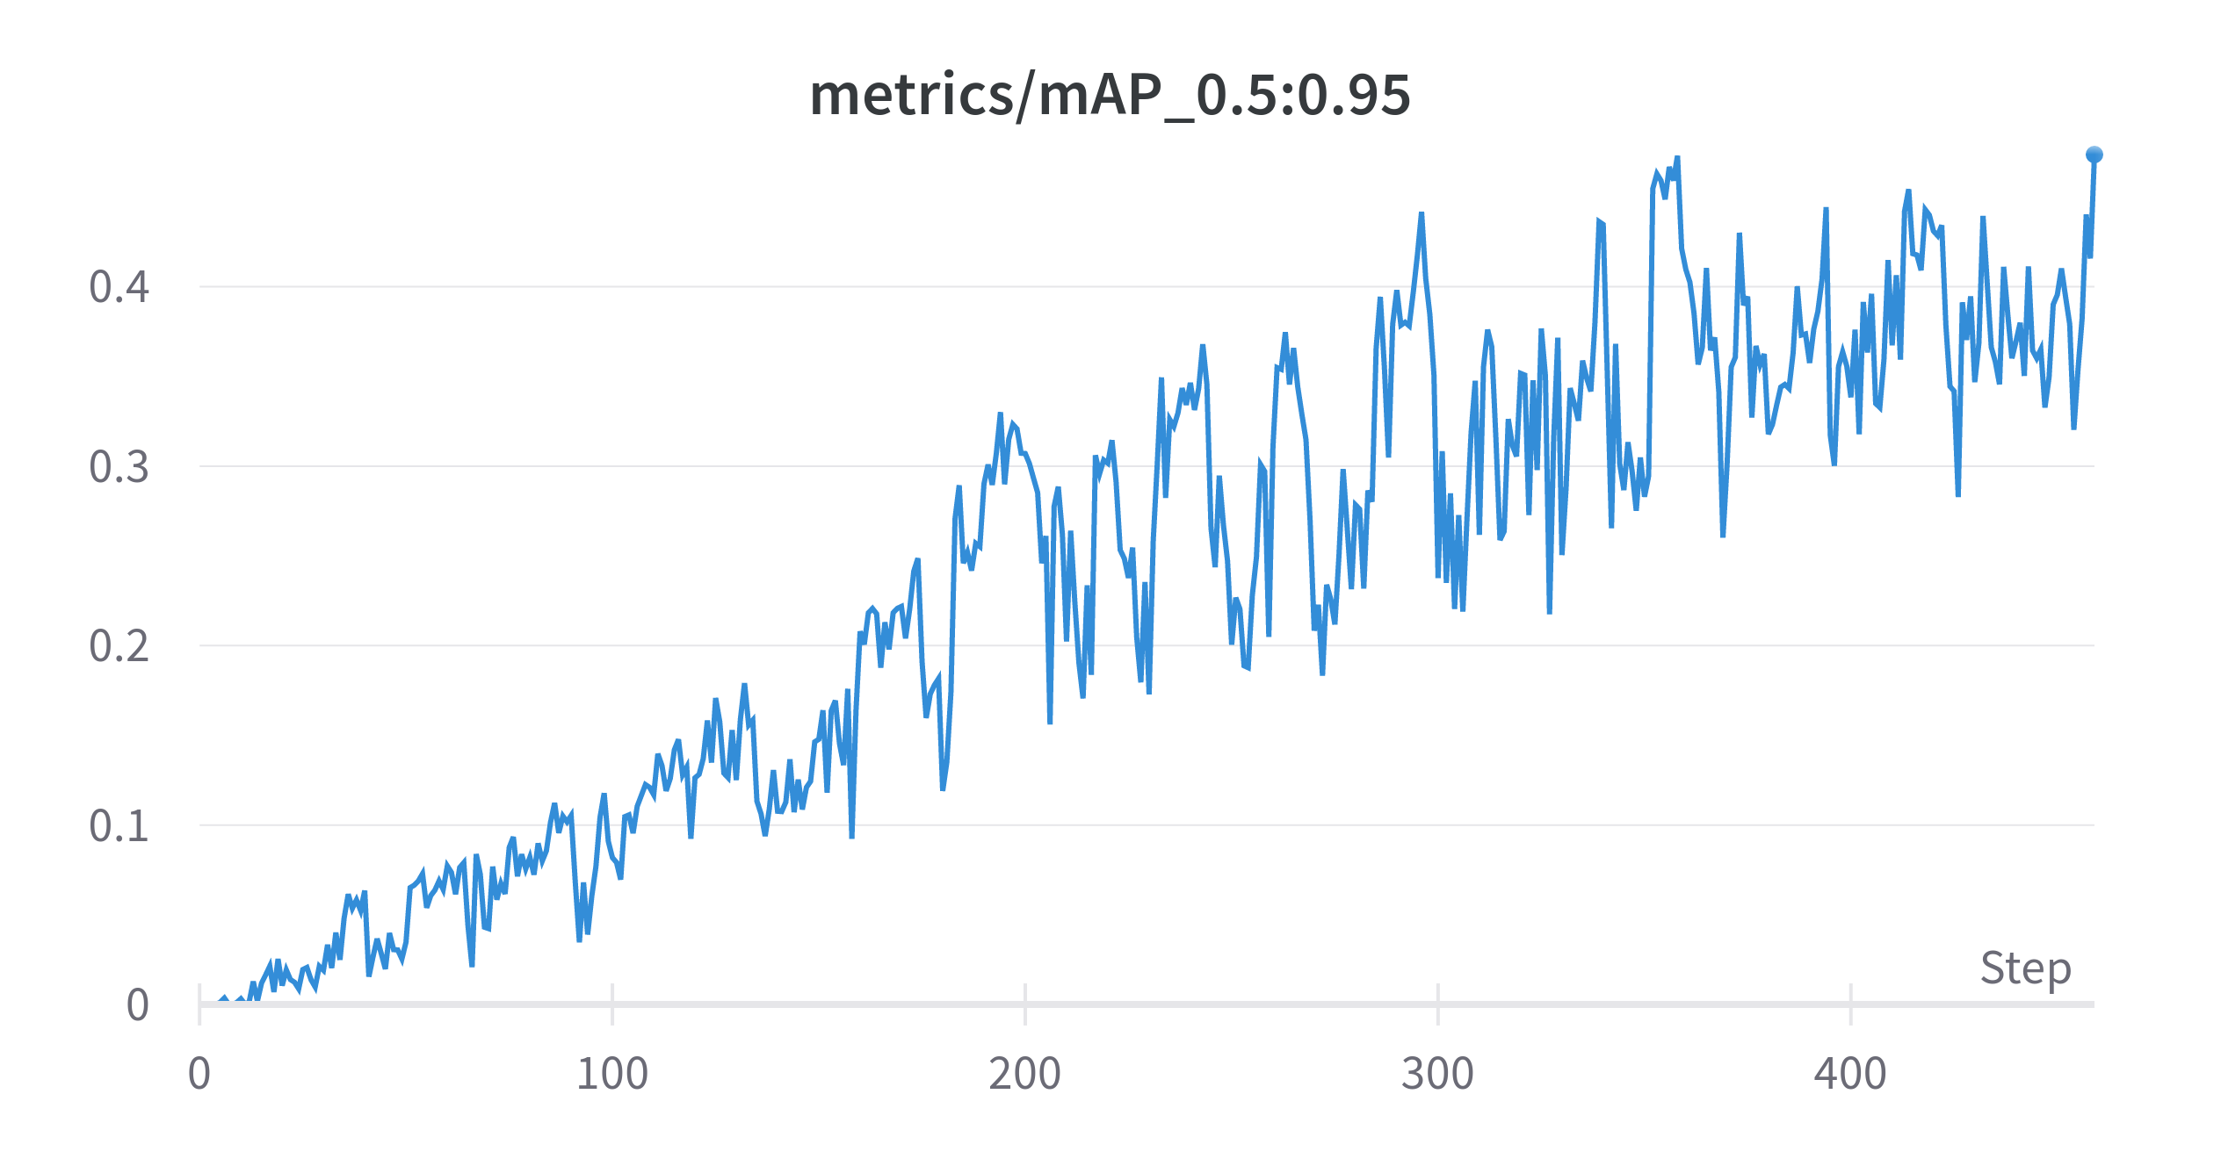Figure 3: mAP for IOU 0.5-0.95 after every epoch

Based on the results we can make a conclusion, that current pretrained model does not show significant performance, but it is enough to test the proposed scale detection method, even more, it represents the real-world case, when there is lack of training data and it may be of a bad quality. Possible steps to improve the model performance include, but are not limited to:
- get more well-labeled data;
- use all data for training and do not perform train/validation, as current validation data amount is not enough to state that validation results are statistically significant;
- use the largest possible image size during model training, as resizing may cause important data loss;
- develop method to automatically setup initial anchor boxes or limit image area, where digit detection should be performed, though this may not be a trivial task.
On the Fig.4 you can see one of the detection results from the validation set. Most part of the image with wound was cropped, to emphasize on the ruler itself. It shows detected bounding boxes and digit labels with confidence score. There is one false positive detection on the skin, detected as 6. Further we describe how we prevent such false positives and gather only valid digits.

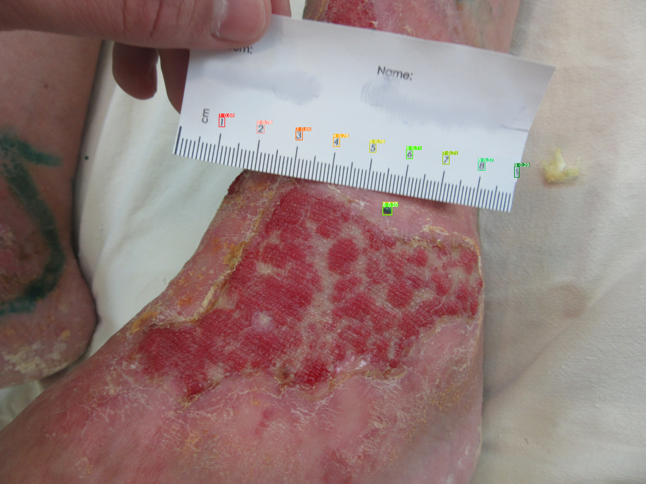Figure 4: Result of digit detection

Ruler scale detection
The very heart of the method is the following. Taking digit object detection model as input, and using simple linear algebra equations and few iterations, produce candidate points as outputs for the third step.
The overall algorithm idea consists of few steps:
- select two candidate digits (D1 and D2) from the detected ones
- using Eq.1, (lets call it `q`) get equation of line (L1), that goes through the center points (P1, P2) of D1 and D2 respectively
$\frac{x−x_{1}}{x_{2}−x_{1}}=\frac{y−y_{1}}{y_{2}−y_{1}}$,

where x₁, x₂, y₁, y₂ – corresponding coordinates of D1 and D2 centers
- from the rest of the digits, using modification of ray casting algorithm, search for those, whose bounding boxes are intersected by L1. Visual illustration is on Fig.5:

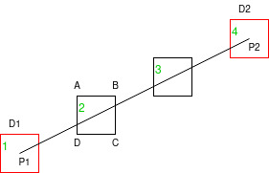Figure 5: Visual illustration of method
D1 and D2 are candidate digits (with labels 1 and 4), with P1 and P2 being their centers,
L1 is a line, created using Eq.1, that goes through points P1 and P2. Next we check if this line intersects the other digits, 2 and 3, according to the example on Fig.n. Lets consider digit 2, which is represented by four points A, B, C, D from which edges AB, BC, CD and DA can be created using Eq.1. Considering L1 equation as `q` and DA equation as `w`, by solving a system of linear equations formed by these lines, we can find intersection point and then check if it is in range of points A and D. The same goes for the rest of the digits, that are being tested. We continue testing with different candidate digits D1 and D2, until we find that at least few digits lay on the one line, this allows us to reject the wrongly detected `6` from Fig.4. We consider received digits as candidates for being ruler scale marks.

With digits, that lay on the one line, calculation of distance in pixels can be as simple as getting distance between two consecutive digits and is formulated in few steps:
- Find consecutive digits (not-consecutive digits are not taken into consideration).
- Measure the pairwise distance between digit centers. For example if we detected digits: [1, 2, 3, 4], we create segments [(1-2), (2-3), (3-4)] and measure length of each of them.
- To handle 2-digit numbers (10, 11, 12, etc) that can be also present on the ruler, for each segment, created on the previous step, we perform a special check, as on the Fig.6.

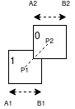Figure 6: Detection of two-digit numbers
Where P1 and P2 correspond to bounding box of detected digit 1 and bounding box of digit 0 centers, A1B1 – width (height) of digit 1 and A2B2 – of digit 0.
If |A1B1| + |A2B2| > |P1P2| – we consider these two digits as one two-digit number. We check both digits width sum and digits height sum and if at least one is longer, than distance between these digits centers – decision that this is two-digit number is taken. After that, this two digits are processed as one.
4. Use clustering, to separate falsely detected segments and perform digit detection only if we have at least 2 segments, that have similar length (taking into consideration tolerance `eps`, selected selected experimentally)

Results and discussion
On the Fig.7 digits 1 and 9, that are in red bounding boxes, are D1 and D2, that form a line L1, which is in orange, and other digits [2; 8] (in green bounding boxes) are intersected by L1.

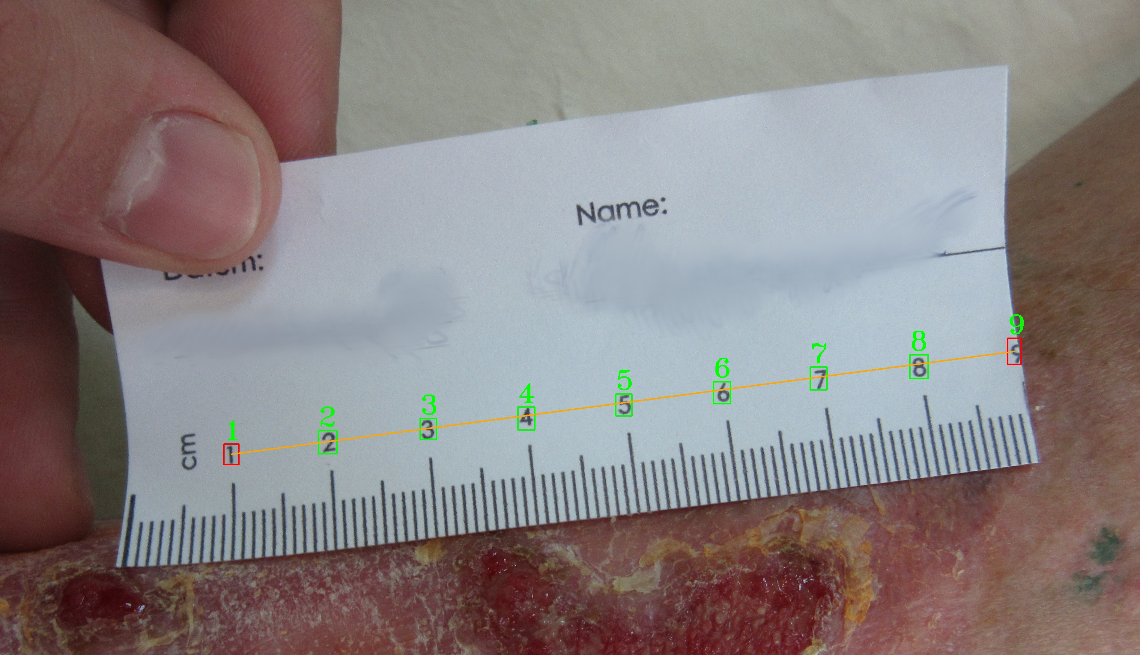Figure 7: Example of line, created by two candidate digits, that intersects other digits
On Fig.8 you can see the method result. The number above the blue line represents the number of pixels per 1cm on the original image. This is a typical example of a `good case`, when all digits are identified correctly and there are not two-digit numbers.
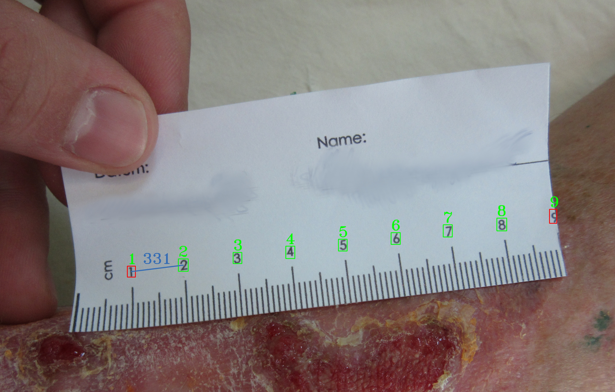Figure 8: Example of pixel per cm detection
Results are worse when image is of bad quality, our method is still able to recognize the pixel per unit ration, but we can not guarantee any accuracy, as even for manual annotation these images are not suitable. Example is on Fig.9.

If digits are blurred, model still manages to recognize them correctly and detect px per cm. More complex case is when two-digit numbers are present. Experiments show, that it is more complex for the digit detection model, to detect digits in the 2-digit numbers. This can be slightly eliminated using method from fig.6. Important note is that we should not consider only one segment length as the suitable for decision making result, more than 1 distance should be present. Result of worse case scale detection with the 2-digit detection is present on Fig.10.
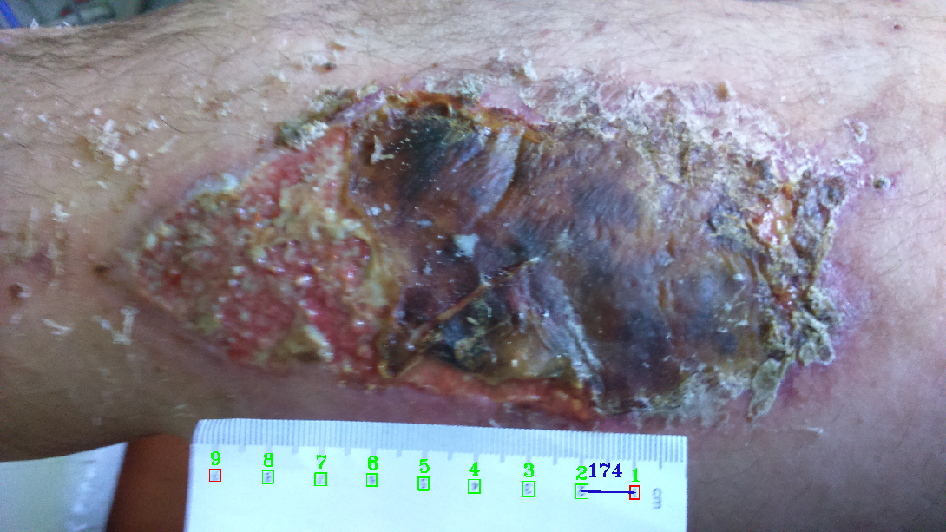Figure 9: Figure 8: Example of pixel per cm detection on blurry image
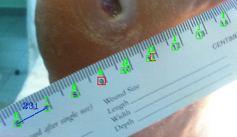Figure 10: Figure 10. Detection of ruler scale on the ruler with the two-digit numbers
Results were received just because of one digit numbers being present. Better digit detection model training should be introduced to improve the results.
We used Gimp photo editor and manually measured px to cm ratio for all available 184 images. To ensure good measurement accuracy, we measured distance between digit marks that are close to the center of the image and where ruler is as close to the wound, as possible and without any folds. Important point is that most of images, we are working with have large resolution of 3104x1746, and difference between manual measurement between different digit marks on the one image may differ sometimes in range of [0-20] px. Next we computed px to cm using our method and compared these results with our manual measurements. Our method was able to process 128 images from 184 available, others where not suitable, because of bad digit detection model performance. We received mean absolute error of 6.63 px and median absolute error 4. Which we consider to be a good result, taking into account error of manual measurement and inaccuracy of digit detection model. Maximal received error – 59 and minimal – 0. On the Fig.11 below, histogram of absolute errors is shown.

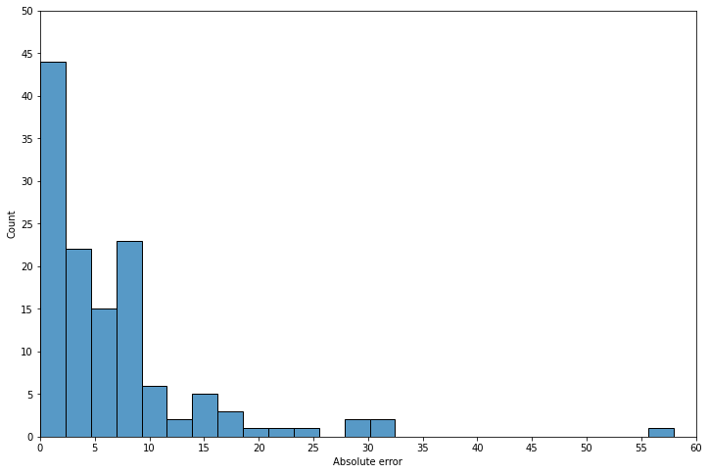Figure 11: Histogram of absolute errors between manual measurement and proposed method
This figure shows, that vast majority of errors is between 0 and 10 pixels, that is a suitable result, comparing with the manual measurement and isolated cases have large errors of more than 30px.

Proposed method of ruler scale detection, unlike others methods that solve similar problem mostly using transformation of image into frequency domain, utilizes digit detection as a first step. Experiment results show, that achieved accuracy of mean absolute error equal to 6.63px (compared to manual measurement) can compete and overcome manual measurement results, thus method can be used to automate the process of ruler scale detection on the image in the variety of areas. During the development of the method, we found that introduction of clustering of the created segment lengths, together with iterative search of the segments, that are used to calculate distance in px, can significantly improve the accuracy of calculations and reject misidentified segments. Although this makes it impossible to determine the scale on some rulers, where the number of correctly detected digits is very small. It follows from the first step – digit detection. We used YOLOv5 trained and validated on the small dataset of 184 manually annotated images, which was enough to test and develop method, however, we found that there are few issues with it:
- model poorly detects separate digits that ly close to each other (when digits represent two-digit numbers)
- it has problems detecting digits on the rotated images
While these problems can be easily fixed by improving model training, by introducing data augmentations, using different transformations or just by using more images or increasing training data resolution, they also reveal one of the advantages of our method – ability to use any digit detection method as a backend. This and also the fact, that method uses both one and two-digit numbers on the ruler, gives users the ability to tune it for the domain they want and to receive desired accuracy.

References
The template will number citations consecutively within brackets [1]. The sentence punctuation follows the bracket [2]. Refer simply to the reference number, as in [3]—do not use “Ref. [3]” or “reference [3]” except at the beginning of a sentence: “Reference [3] was the first ...”
Number footnotes separately in superscripts. Place the actual footnote at the bottom of the column in which it was cited. Do not put footnotes in the abstract or reference list. Use letters for table footnotes.
Unless there are six authors or more give all authors’ names; do not use “et al.”. Papers that have not been published, even if they have been submitted for publication, should be cited as “unpublished” [4]. Papers that have been accepted for publication should be cited as “in press” [5]. Capitalize only the first word in a paper title, except for proper nouns and element symbols.
For papers published in translation journals, please give the English citation first, followed by the original foreign-language citation [6].

- G. Eason, B. Noble, and I. N. Sneddon, “On certain integrals of Lipschitz-Hankel type involving products of Bessel functions,” Phil. Trans. Roy. Soc. London, vol. A247, pp. 529–551, April 1955. (references)
- J. Clerk Maxwell, A Treatise on Electricity and Magnetism, 3rd ed., vol. 2. Oxford: Clarendon, 1892, pp.68–73.
- I. S. Jacobs and C. P. Bean, “Fine particles, thin films and exchange anisotropy,” in Magnetism, vol. III, G. T. Rado and H. Suhl, Eds. New York: Academic, 1963, pp. 271–350.
- K. Elissa, “Title of paper if known,” unpublished.
- R. Nicole, “Title of paper with only first word capitalized,” J. Name Stand. Abbrev., in press.
- Y. Yorozu, M. Hirano, K. Oka, and Y. Tagawa, “Electron spectroscopy studies on magneto-optical media and plastic substrate interface,” IEEE Transl. J. Magn. Japan, vol. 2, pp. 740–741, August 1987 [Digests 9th Annual Conf. Magnetics Japan, p. 301, 1982].
- M. Young, The Technical Writer’s Handbook. Mill Valley, CA: University Science, 1989.

IEEE conference templates contain guidance text for composing and formatting conference papers. Please ensure that all template text is removed from your conference paper prior to submission to the conference. Failure to remove template text from your paper may result in your paper not being published.

