*Autism Friendly Social Stories*

Doctor’s Office

This story is about how I will get to my doctor’s appointment.



I need to go see my doctor so I can be healthy and strong.



I will first arrive at the building.



I will go inside and walk to the elevator.

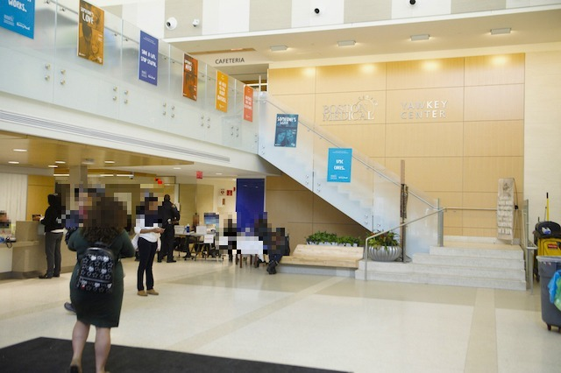

I will take the elevator to the floor that the office is on.

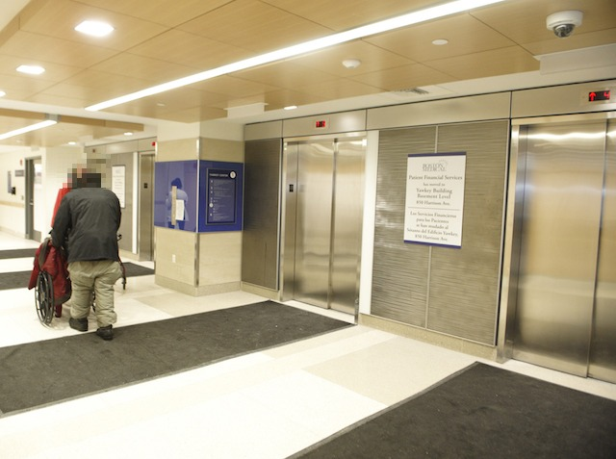

I will walk to the doctor’s office.

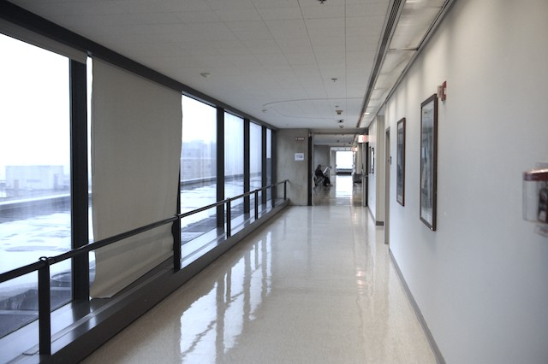

I will go to the front desk. Then I will tell the person my name and that I am here to see my doctor.

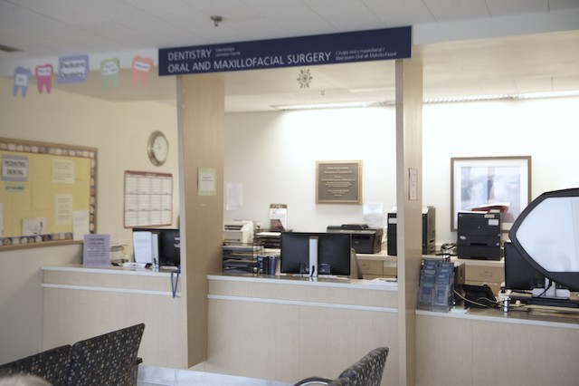

I will sit in the waiting room and wait for my name to be called. I can choose to do an activity.

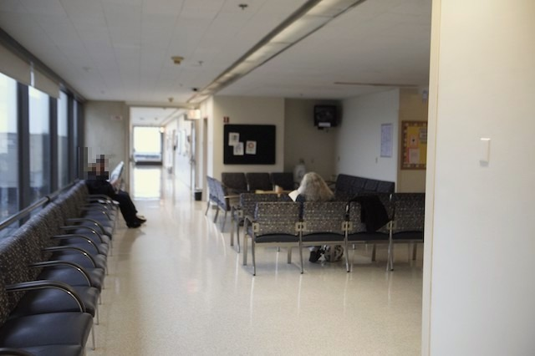

When my name is called, I will follow the nurse.

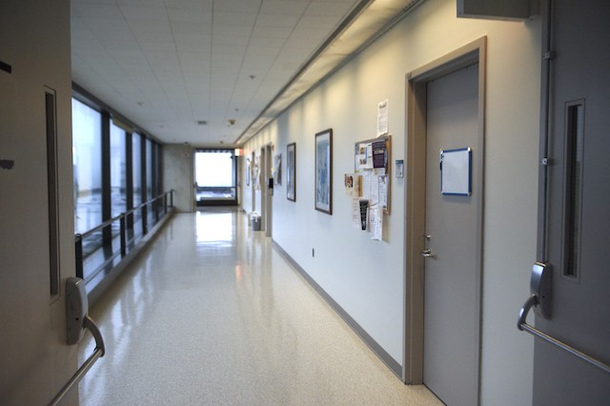

I did a great job learning how to get to my doctor’s appointment!

