Since its invention in 1982 by IBM scientists Gerd Binning and Heinrich Rohrer, atomic force microscopy (AFM) has found widespread applications in various fields ranging from semiconductor science to polymer physics. The simplicity of the underlying concept allows for implementation in a variety of challenging experimental setups including high-energy physics1 and live cell biology2. The AFM technology has particularly been used not only to obtain high-resolution topographic images (with resolution of up to 1 nm) but also to measure extremely low forces that occur for example during molecular interactions. In this way, major achievements, like first topologies of single atoms and small molecules and their connecting electron bonds, have been made possible3. As AFM is a non- destructive imaging technique and large fields of view can be scanned on appropriate time scales, it has found more and more application in the study of living cells and organisms (Figure 1). Here, it enables even for high resolution studies of the interactions between single cell membrane receptors and ligand drugs4. Moreover, as nanotechnological approaches are becoming increasingly popular, AFM has gained attention for quality control purposes in industry and academia.

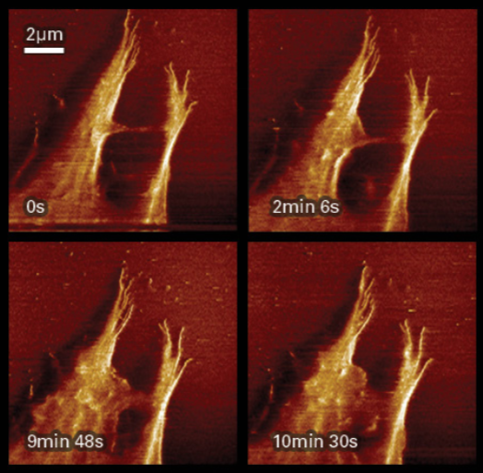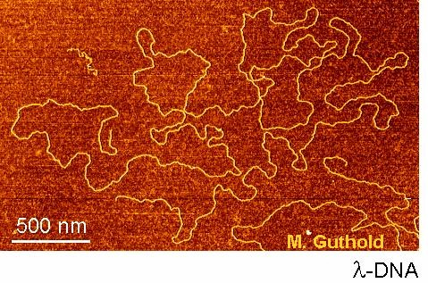

Figure 1: AFM image of a complete λ phage genome with single strand resolution. Colors represent cantilever tip deflection32. AFM image of a living cell showing filopodia rearrangement. Colors represent cantilever tip deflection34.

However, automated evaluation of AFM images has remained challenging, especially when highly diverse biological structures, such as DNA molecules, are studied. Mostly because high background and varying morphologies hinder accurate automated evaluations. We here present an image processing algorithm, designed for automated quantification of AFM data to further study DNA histone interactions in higher throughput.

**Atomic force microscopy concept:**

The heart of an AFM setup consists of a sharp silicon tip with an ending radius of curvature of up to 1 nm attached to a flexible micro cantilever (Figure 2). The cantilever is mounted onto a Piezo controlled z-stage for precise lifting and dipping. With this, the cantilever tip is brought into (close) contact to the surface to be examined. The tip is then further scanned over the surface with constant z-stage deflection and thereby bended by topographic heterogeneities of the sample according to the mechanics described by Hook for simple springs. To precisely measure and amplify these minimal deflections, a focused laser beam is projected onto the cantilevers reflecting top. Redirected onto a four photodiode detector, x- and y- deflection of the elastic cantilever can be recorded as potential differences between pairing photodiodes. Small bendings are thereby amplified by the laser deflection and can be used to compute topographic images. Although being extremely simple, high resolutions can be achieved that are mostly limited by the tips radius and shape (Figure 3). However, to preserve the integrity of the examined specimens, which is of particular importance when observing living systems where harsh perturbations are likely to cause artifacts, the AFM is run in a so called tapping mode7. Here, an alternating current is applied to the supporting Piezo element thus oscillating the cantilever over the surface. By this, the tip/surface interaction is minimized and sample can be scanned with less interference.

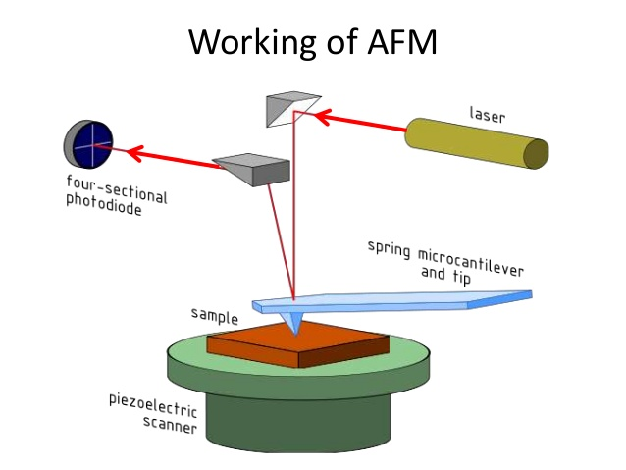

Figure 2: Schematic representation of an AFM setup with optical path of the laser beam in red and xy-controllable Piezo scanner34.

The core setup has been further modified and extended to even measure intermolecular forces8. For this, the cantilever tip is slowly approached to a surface. At a specific distance, electrostatic forces will lead to an attraction of the tip and thus a bending of the cantilever. The kinetics of this bending are characteristic for differing molecular interactions9. By attaching molecules of interest to the AFM tip, specific interaction between these and molecules located at a surface can be measured. Using this concept, the interplay between drug molecules and G-protein-coupled receptors on cell surfaces could be quantified10. Furthermore, by using conductive tips, the electric properties of materials were studied, an approach that has found wide applications in semiconductor and microprocessor science11.

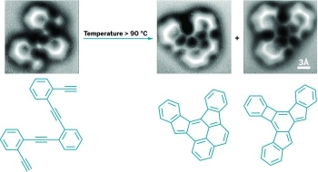

Figure 3: Single atom resolution AFM image and corresponding structural formula of an enediyne compound before and after induction of cyclisation by heating35.

**Epigenetics and histones:**

Genetic information is mostly encoded within the DNA sequence and its modular components known as genes. However, during the last decades epigenetic mechanisms that regulate genetic information processing, have been recognized as key players in gene regulation. To date, several mechanisms of epigenetic regulation have been found in eukaryotic cells12. Two of the most prominent examples are DNA methylation and chromatin rearrangement. While methylation is a direct chemical modification of DNA that leads to impaired recognition by DNA interacting proteins13, chromatin remodeling mechanisms are versatile14, 15, 16. Here, the accessibility of specific sequences which are crucial for DNA processing are altered. The central elements of chromatin structures are large heteromeric protein complexes known as histones17. These highly alkaline proteins are exclusive to eukaryotic cells and some archaea, where they act as spools around which DNA can bind. In this way, histones do not only alter DNA accessibility but also condense the genetic information within the nucleus, a critical steps especially during cell division.

**Chromatin and histone structure:**

Histone complexes consist of five major components, the histones proteins H1/H5, H2B, H2A, H3 and H417. The histone core is formed between H2A, H2B, H3 and H4 while H1/5 is known to serve as a linking element. The core histones exist as homodimers; all possessing a histone fold domain that is crucial for the interaction between the different dimers. This domain is comprised of three alpha helices that interact as handshake motifs with corresponding domains on the dimer partner. Thus, the histone complex is an octameric aggregate with an approximate diameter of 63 Å where 147 DNA base pairs can wrap around in 1,65-left handed turns. The histone protein H1 binds to the entering and exiting DNA strand thereby stabilizing the DNA histone complex. H1 is also crucial for the formation of higher order chromatin complexes as it mediates the arrangement of histone fibers in which several histone-DNA complexes pair to highly condensed chromatin (Figure 4).

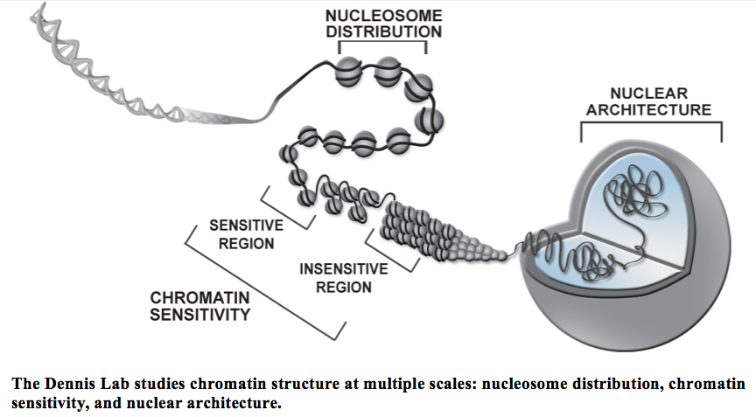

Figure 4: Chromatin structure from a single DNA double helix (left) to the fully evolved nuclear DNA architecture (right). DNA bound single histones are depicted in their modification sensitive conformation, where epigenetic mechanisms regulate gene transcription, and their insensitive condensed form36.

**Histone modifications:**

Together with DNA methylation, chemical modifications of histone complexes are a key process in epigenetic regulation as with this, interactions between DNA and nuclear proteins such as transcription factors, polymerases or other regulatory elements can be altered18. As histones represent complex macromolecular structures, the possible chemical modifications are diverse and yet not fully understood. However, some key players have been identified. Most modifications occur at the tails of histone proteins H3 and H4, which protrude from the DNA-histone complex19 (Figure 5). Here, acetylations, methylations, phosphorylations, ubiquitinations and citrullination have been reported. Additionally, the histone core can also be modified leading to highly complex modification patterns as several modification combinations can occur. By this, either the direct interaction between the DNA and a histone is sterically hampered or the modification acts as a recognition element for other regulatory proteins. For example, lysine acetylation in histone complexes is responsible for the loss of one positive charge and therefor reduces the electrostatic interaction strength to the negatively charged DNA backbone20. Therefor, acetylated histones are thought to form less condensed and thus more accessible chromatin structures. On the other hand, gene promoter regions that are bound to non-acetylated histones are known to be responsible for gene down regulation. Another prominent example for histone modification is lysine methylation. Here, up to three methyl groups can be added to a lysine residue at the histone tail. Although this does not diminish the positive lysine charge and thus no direct inhibition of the DNA-histone complex formation is observed (even if the small methyl groups slightly sterically alter this interaction), it serves as a recognition motive for other nuclear responsive elements with Tudor or PHD domains21. The underlying mechanisms appear to be extremely sensitive, as opposite effect between mono- and demethylation have been reported22.

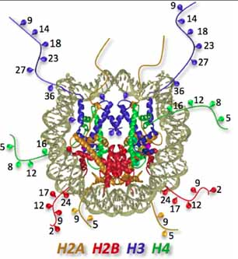

Figure 5: Crystal structure of a histone complex with a modeled double helical DNA strand wrapped around. Colors represent histone dimers (H2A yellow, H2B red, H3 blue, H4 green). Numbers correspond to amino acid sequence position and show frequent modification sites37.

Some well-studied histone modifications that promote gene transcription are triple methylation of H3 lysine 4, which mostly occurs in the promoter region of highly transcribed genes23, and triple methylation of H3 lysine 36, which is frequently observed in the gene bodies of upregulated genes as it recruits histone deacetylase thereby ensuring proper gene transcription24. Prominent examples for modifications that repress gene transcription are trimethylation at lysine 27 of H325, which induced histone acetylation, and trimethylation of H4 lysine 2026.

Hence, histone modification is a generally accepted epigenetic mechanism to regulate gene transcription, where the interaction strength between histones and DNA is of major importance. Mutations within histone complexes that alter this interaction have been associated with various diseases like cancer and chronic inflammations27.

**Studying DNA – histone complexes by AFM:**

As DNA-histone configuration is of major importance for epigenetic regulation, a profound understanding of the regulatory mechanisms and crucial structural features that conquer this interaction is highly desirable and of special interest for drug design. Here, the AFM technology is preferentially suited to study the molecular configuration with sufficient resolution. AFM is not only able to easily resolve single DNA strands but also to image the volume of single DNA-histone complexes (and thereby the number of DNA turns per histone) and the entering/exiting angle of bound DNA, which gives insides into the bonding strength between DNA and histone.

An automated evaluation of DNA structure is not only of interest to study DNA-protein interaction but also to evaluate cancerogenic compounds that alter the DNA architecture. Here, correlations between the cancerogenicity and the geometrical deformation of the compound bound DNA have been observed28. Therefor, quantitative screening of pharmaceutical compounds for their ability to influence DNA structure with AFM resolution could be highly interesting for toxicity studies.

Moreover, many modern technologies used within the life science sector are based on DNA molecules. For example DNA bound antibodies have been used for immunohistochemical stainings where a DNA bound fluorophore enhances the fluorescence signal29. Other applications include DNA microarrays to study and compare gene expression30. Here, DNA molecules with specific gene complementary sequences are spot printed onto glass cover slips to quantify the amount of specific cDNA present in probes. This widely used technique can monitor slight changes in gene expression. However, quality control of the microarrays themselves has remained challenging. Specialized ventures already test for DNA microarray quality by AFM imaging but are yet not able to provide single DNA strand resolution as automated evaluation of this has been elusive31. With the here presented algorithm we tackle current restrictions in DNA – protein interaction analysis and DNA morphology quantification by AFM.

Referenzen:

1: E. Fischbach, D. E. Krause, V. M. Mostepanenko, M. Novello. New constraints on ultrashort-ranged Yukawa interactions from atomic force microscopy. arXiv, 2001. doi: [10.1103/PhysRevD.64.075010](https://arxiv.org/ct?url=http%3A%2F%2Fdx.doi.org%2F10%252E1103%2FPhysRevD%252E64%252E075010&v=5f8f7ad4)

2: Evans, Evan A.; Calderwood, David A. (25 May 2007). "Forces and Bond Dynamics in Cell Adhesion". Science 316 (5828): 1148–1153.

3: M. Hoffmann, Ahmet Oral, Ralph A. G, Peter (2001). "Direct measurement of interatomic-force gradients using an ultra-low-amplitude atomic-force microscope". Proceedings of the Royal Society A 457 (2009): 1161–1174.

4: Oscar H. Willemsen, Margot M.E. Snel, Alessandra Cambi, Jan Greve, Bart G. De Grooth and Carl G. Figdor "Biomolecular Interactions Measured by Atomic Force Microscopy" Biophysical Journal, Volume 79, Issue 6, December 2000, Pages 3267-3281.

5: <http://me.engineering.tufts.edu/sokolov/JInsectPhys.pdf>

6: Theobald Lohmueller, Eva Bock, Joachim P. Spatz “ Synthesis of Quasi-Hexagonal Ordered Arrays of Metallic Nanoparticles with Tuneable Particle Size“ Advanced Materials, Volume 20, Issue 12, June 2008, Pages 2297 - 2302

7: Binnig, G.; Quate, C. F.; Gerber, Ch. (1986). "Atomic-Force Microscope". Physical Review Letters 56 (9): 930–933.

8: Hinterdorfer, P; Dufrêne, Yf (May 2006). "Detection and localization of single molecular recognition events using atomic-force microscopy". Nature Methods 3 (5): 347–55.

9: Cappella, B; Dietler, G (1999). "Force-distance curves by atomic-force microscopy" (PDF). Surface Science Reports 34 (1–3): 1–104.

10: Radmacher, M. (1997). "Measuring the elastic properties of biological samples with the AFM". IEEE Eng Med Biol Mag 16 (2): 47–57.

11: Lang, K.M.; D. A. Hite; R. W. Simmonds; R. McDermott; D. P. Pappas; John M. Martinis (2004). "Conducting atomic-force microscopy for nanoscale tunnel barrier characterization". Review of Scientific Instruments 75 (8): 2726–2731.

12: Bird A (May 2007). "Perceptions of epigenetics". Nature 447 (7143): 396–8.

13: Cuozzo C, Porcellini A, Angrisano T, Morano A, Lee B, Di Pardo A, Messina S, Iuliano R, Fusco A, Santillo MR, Muller MT, Chiariotti L, Gottesman ME, Avvedimento EV (July 2007). "DNA damage, homology-directed repair, and DNA methylation". PLoS Genet. 3 (7).

14: Jenuwein T, Laible G, Dorn R, Reuter G (January 1998). "SET domain proteins modulate chromatin domains in eu- and heterochromatin". Cell. Mol. Life Sci. 54 (1): 80–93.

15: Gottschalk AJ, Timinszky G, Kong SE, Jin J, Cai Y, Swanson SK, Washburn MP, Florens L, Ladurner AG, Conaway JW, Conaway RC (August 2009). "Poly(ADP-ribosyl)ation directs recruitment and activation of an ATP-dependent chromatin remodeler". Proc. Natl. Acad. Sci. U.S.A. 106 (33): 13770–4.

16: Lin JC, Jeong S, Liang G, Takai D, Fatemi M, Tsai YC, Egger G, Gal-Yam EN, Jones PA (November 2007). "Role of nucleosomal occupancy in the epigenetic silencing of the MLH1 CpG island". Cancer Cell 12 (5): 432–44.

17: Mariño-Ramírez L, Kann MG, Shoemaker BA, Landsman D (Oct 2005). "Histone structure and nucleosome stability". Expert Review of Proteomics 2 (5): 719–29.

18: Mersfelder EL, Parthun MR (19 May 2006). "The tale beyond the tail: histone core domain modifications and the regulation of chromatin structure". Nucleic Acids Research 34 (9): 2653–62.

19: Lorch Y, LaPointe JW, Kornberg RD (Apr 1987). "Nucleosomes inhibit the initiation of transcription but allow chain elongation with the displacement of histones". Cell 49 (2): 203–10.

20: Ozdemir A, Spicuglia S, Lasonder E, Vermeulen M, Campsteijn C, Stunnenberg HG, Logie C (Jul 2005). "Characterization of lysine 56 of histone H3 as an acetylation site in Saccharomyces cerevisiae". The Journal of Biological Chemistry 280 (28): 25949–52.

21: Schotta G, Lachner M, Sarma K, Ebert A, Sengupta R, Reuter G, Reinberg D, Jenuwein T (Jun 2004). "A silencing pathway to induce H3-K9 and H4-K20 trimethylation at constitutive heterochromatin". Genes & Development 18 (11): 1251–62.

22: Kourmouli N, Jeppesen P, Mahadevhaiah S, Burgoyne P, Wu R, Gilbert DM, Bongiorni S, Prantera G, Fanti L, Pimpinelli S, Shi W, Fundele R, Singh PB (May 2004). "Heterochromatin and tri-methylated lysine 20 of histone H4 in animals". Journal of Cell Science 117 (Pt 12): 2491–501

23: Krogan NJ, Dover J, Wood A, Schneider J, Heidt J, Boateng MA, Dean K, Ryan OW, Golshani A, Johnston M, Greenblatt JF, Shilatifard A (Mar 2003). "The Paf1 complex is required for histone H3 methylation by COMPASS and Dot1p: linking transcriptional elongation to histone methylation". Molecular Cell 11 (3): 721–9.

24: Strahl BD, Grant PA, Briggs SD, Sun ZW, Bone JR, Caldwell JA, Mollah S, Cook RG, Shabanowitz J, Hunt DF, Allis CD (Mar 2002). "Set2 is a nucleosomal histone H3-selective methyltransferase that mediates transcriptional repression". Molecular and Cellular Biology 22 (5): 1298–306.

25: Cao R, Wang L, Wang H, Xia L, Erdjument-Bromage H, Tempst P, Jones RS, Zhang Y (Nov 2002). "Role of histone H3 lysine 27 methylation in Polycomb-group silencing". Science 298 (5595): 1039–43.

26: Schotta G, Lachner M, Sarma K, Ebert A, Sengupta R, Reuter G, Reinberg D, Jenuwein T (Jun 2004). "A silencing pathway to induce H3-K9 and H4-K20 trimethylation at constitutive heterochromatin". Genes & Development 18 (11): 1251–62.

27: Carla Sawan, Zdenko Herceg (2010) “Histone Modifications and Cancer” Advances in Genetics 70: 57 – 85.

28: Aleksandre Japaridze, Alexander Benke, Sylvain Renevey, Giovanni Dietler (2015) “Influence of DNA Binding Dyes on Bare DNA Structure Studied with Atomic Force Microscopy” Macromolecules 48(6): 1860 – 1865

29: Chen, F.; Tillberg, P. W.; Boyden, E. S. (15 January 2015). "Expansion microscopy". Science 347 (6221): 543–548.

30: Adomas A; Heller G; Olson A; Osborne J; Karlsson M; Nahalkova J; Van Zyl L; Sederoff R; Stenlid J; Finlay R; Asiegbu FO (2008). "Comparative analysis of transcript abundance in Pinus sylvestris after challenge with a saprotrophic, pathogenic or mutualistic fungus". Tree Physiol. 28 (6): 885–897.

31: <http://cp.literature.agilent.com/litweb/pdf/5989-9946EN.pdf>

32:http://images.google.de/imgres?imgurl=http%3A%2F%2Fusers.wfu.edu%2Fgutholdm%2Fimages%2Flambda.jpg&imgrefurl=http%3A%2F%2Fusers.wfu.edu%2Fgutholdm%2FAFM%2520imaging.html&h=317&w=479&tbnid=xghvDWoOHwPdCM%3A&docid=ai0l9BzuAcdT8M&ei=I9x6V575DqzagAb_uqN4&tbm=isch&iact=rc&uact=3&dur=195&page=1&start=0&ndsp=16&ved=0ahUKEwjelqOM59rNAhUsLcAKHX_dCA8QMwgcKAAwAA&bih=633&biw=1263

33:http://images.google.de/imgres?imgurl=https%3A%2F%2Fwww.bruker.com%2Ffileadmin%2Fuser_upload%2F1Products%2FSurfaceAnalysis%2FAFM%2FMigrating-stemcell.png&imgrefurl=https%3A%2F%2Fwww.bruker.com%2Fproducts%2Fsurface-and-dimensionalanalysis%2Fatomicforcemicroscopes%2Fcampaigns%2Fbioafms-andbiologicalapplications%2Fbiodynamicswithafm.html&h=513&w=1047&tbnid=fadnScu8gsBSkM%3A&docid=SnmJ3JZaha3RUM&ei=atx6V97bHIvEgAbi8paQBA&tbm=isch&iact=rc&uact=3&dur=633&page=1&start=0&ndsp=16&ved=0ahUKEwjeuJ6u59rNAhULIsAKHWK5BUIQMwguKAgwCA&bih=633&biw=1263

34:http://images.google.de/imgres?imgurl=http%3A%2F%2Fimage.slidesharecdn.com%2Fatomicforcemicroscopejoy-151111135643-lva1-app6892%2F95%2Fatomic-forcemicroscopefundamentalprinciples4638.jpg%253Fcb%253D1447483306&imgrefurl=http%3A%2F%2Fwww.slideshare.net%2Fjoybiitk%2Fatomic-force-microscope-fundamentalprinciples&h=479&w=638&tbnid=5dZocdAf_V6h5M%3A&docid=obf2iF7WwYHJaM&ei=5dx6V4bqBYfCgAaz7p6gAg&tbm=isch&iact=rc&uact=3&dur=157&page=1&start=0&ndsp=18&ved=0ahUKEwjG8Nro59rNAhUHIcAKHTO3ByQQMwgkKAQwBA&bih=633&biw=1263

35:http://cen.acs.org/articles/91/i51/AtomicForceMicroscopyProvidesAstonishing.html

36:http://images.google.de/imgres?imgurl=http%3A%2F%2Fchromatin.bio.fsu.edu%2Fdennislab_files%2Fmultiplescale.jpg&imgrefurl=http%3A%2F%2Fchromatin.bio.fsu.edu%2F&h=477&w=864&tbnid=tbeAaAQxilq6tM%3A&docid=bIBakx0ZzNjm0M&ei=SN16V8XSH4jDgAbKvpDABg&tbm=isch&iact=rc&uact=3&dur=211&page=2&start=11&ndsp=22&ved=0ahUKEwjFloY6NrNAhWIIcAKHUofBGgQMwhVKBEwEQ&bih=633&biw=1263

37:https://www.researchgate.net/figure/43356318_fig1_Figure-4-Acetylation-sites-are-located-on-the-histone-tails-and-on-the-structured