Joint forces and torques when walking in shallow water
Maria Isabel Veras Orselli and Marcos Duarte

Estimation of the drag force
For the estimation of the drag force on the subjects’ foot, leg, and thigh of the right side and on the submerged part of their trunk, we modeled the body-fluid interaction as a stationary flow and we ignored any non-inertial effects such as added-mass terms. Simplifications like this are justifiable given the small contribution of the inertial forces to the total drag during movement at low speeds such as walking (Newman, 1992). Newman (1992) estimated that the extra metabolic consumption in walking on an underwater treadmill when considering the added-mass terms was lower than 3.6% of the total metabolic consumption. In addition, for the estimation of the drag force, we neglected the drag due to friction between the skin and water, and we only considered the pressure drag. These are valid approximations considering the low Reynolds’ number (between 0.17 x 10³ to 2.37x10⁵) found for the segments of the body during underwater treadmill walking (Newman, 1992).
Accordingly, the drag force (F_{D}) was modeled as:
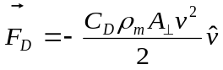
Where v² is the square of the segment velocity, A⊥ is the projection of the frontal area in a plane perpendicular to the segment velocity, ρ_{m} is the water density, C_{D} is the drag coefficient, and is a unitary vector in the direction of the segment velocity.
To calculate A⊥, we modeled the segments as geometric solids of known shapes using a modified version proposed by Kwon (1993) of the Hanavan model (Hanavan, 1964). The foot was modeled as an elliptical solid with circular base, the leg as truncated circular cone, the thigh as an elliptical solid with circular top, and the submerged part of the trunk was divided in two parts: lower trunk as an elliptical column and mid trunk as an elliptical solid (Kwon, 1993). A total of 20 geometrical measurements were taken from the foot, leg, and thigh of the right side and trunk of each subject to calculate the dimensions of each solid.
While walking in the water, the segments of the body simultaneously translate and rotate and this results in different velocities for different parts of the same segment; consequently, different drag forces act on each of these parts. Hence, to calculate the resultant force and torque on a segment, we have to sum the forces acting on each part of the segment and the torques generated by these forces. We employed the strip theory to compute the drag force under this rationale (Newman, 1977). In the strip theory, each body is divided into many thin strips on which the drag can be calculated, and the total drag is given as the sum of these individual drags. Accordingly, each solid used to model the body segment was divided in transverse sections in relation to the longitudinal axis. For each strip of frontal area dA⊥, the infinitesimal drag force 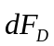is given by (Figure 1):
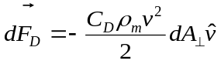
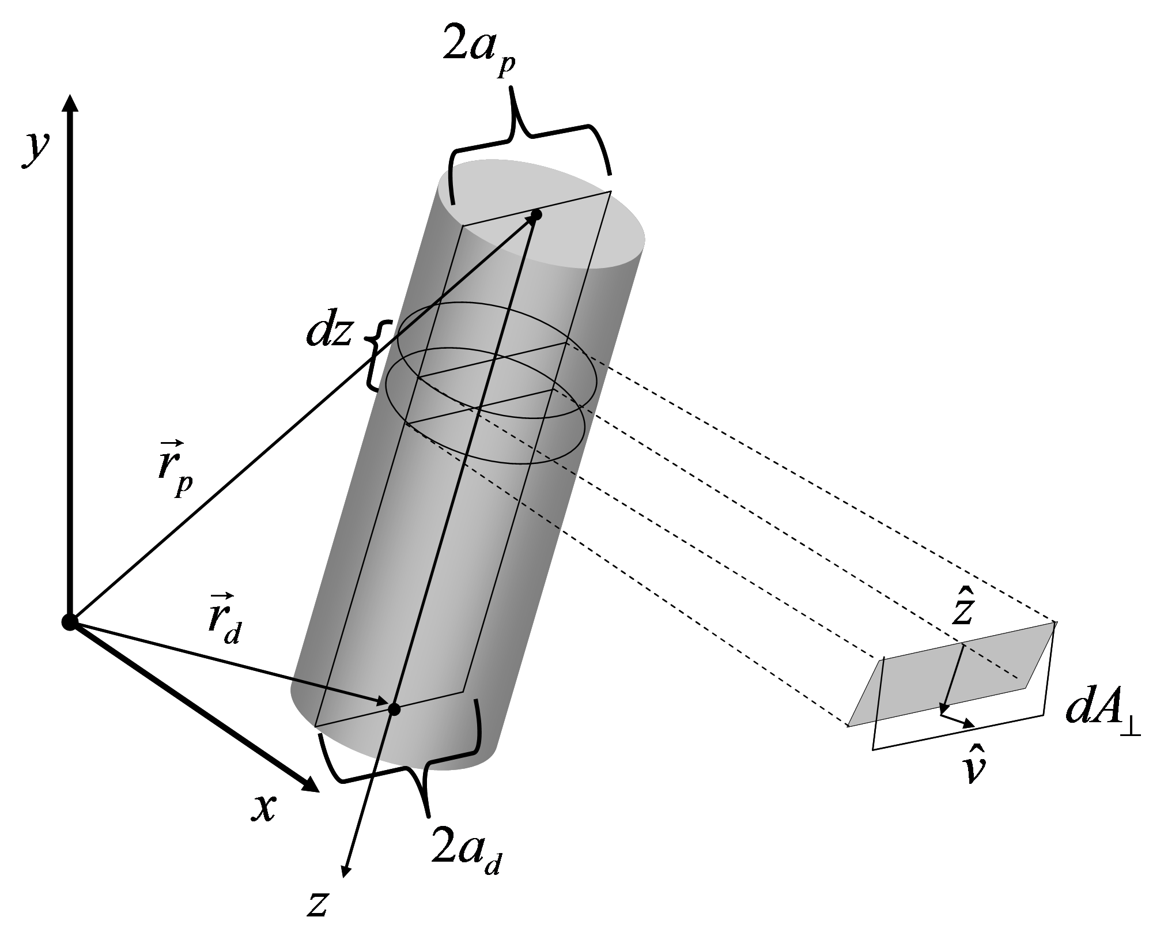
Figure 1. Representation of a segment modeled as a truncated circular cone moving in space. dA⊥ represents the projection of the frontal area perpendicular to the velocity on that point of an infinitesimal strip. The x and y axes are given in the laboratory coordinate system and the z axis is the longitudinal axis in the local coordinate system with its origin at the proximal joint (the point around the torque is calculated for the distal segment).

For the solid represented in Figure 1, the frontal area has the shape of a trapezium with a height of L and base widths of 2a_{p} and 2a_{d}. An infinitesimal strip positioned at a distance z from the proximal joint will have the following frontal area:
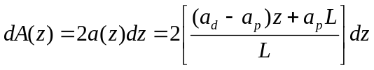
The velocity at a distance z from the proximal joint is given by:
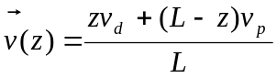
Where v_{p} and v_{d} are the velocities at the proximal and distal joints, respectively.
The projection of the frontal area perpendicular to the velocity on that point will then be given by:
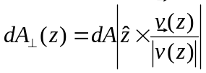
Where represents a unitary vector at the direction of the z axis.
Substituting the two former equations in the equation for the infinitesimal drag force, we have:
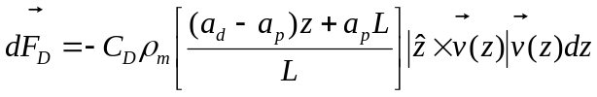
The correspondent drag torque around the proximal joint due to this force is given by:
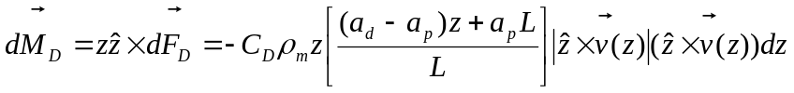
Finally, the resultant drag force and torque acting on the segment can be found by integrating the two former equations with respect to the segment length:
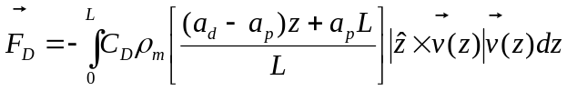
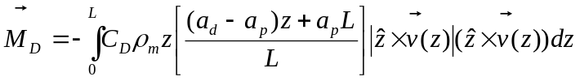
For the C_{D} coefficient, we adopted the value of 1. For the water density (ρ_{m}), we adopted the value of 1000kg/m³.
To verify the accuracy of the method for estimating the drag force, we compared the mechanical impulse on the body at the anterior posterior direction due to the estimated total drag force (F_{Dap}) with the impulse of the anterior posterior component of GRF (GRF_{ap}), adopted as the reference, in relation to the actual change of the body’s momentum due to these forces. For walking in water, the following equation expresses the relation between the mechanical impulse of the resultant force in the anterior-posterior direction and the change in body’s momentum during the single support phase of the stride:
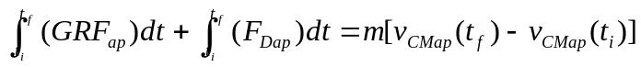
Where m is the participant’s mass, v_{CMap}(t_{i}) and v_{CMap}(t_{f}) are respectively the initial and final velocities of the body’s center of mass at the anterior-posterior direction in the single support phase. We used the single support phase of the stride because only the ground reaction force on the right foot was recorded. To carry out this validation, we had to estimate the water drag force on the entire submerged body during the support phase of the right lower limb, which includes the drag force on the left lower limb during its swing phase. Since we did not measure the left lower limb, we considered the walking symmetric and the drag force on the left lower limb during its swing phase was estimated as the drag force on the right lower limb during its swing phase. The v_{CMap} was estimated from the mass and center of mass velocity of each segment of right lower limb and trunk. The same considerations presented above were used to estimate the velocities at the left lower limb.
If the estimation of the total drag force is accurate, we expect to find at the anterior-posterior direction an identity relation between the absolute value of the impulse due to the drag force and the impulse due the GRF minus the change in the bodies’ momentum.
The experimental arrangement used to analyze subjects walking in water is shown on Figure 2.
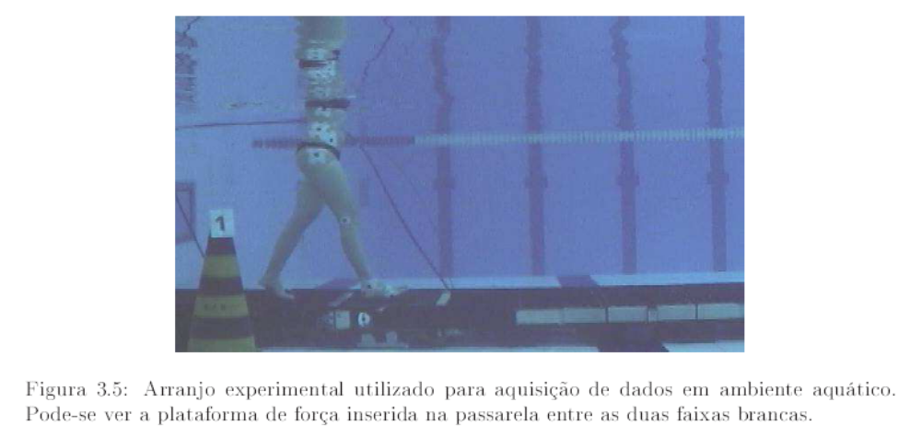
Figure 2. Partial view of a participant walking in water with the water at the Xiphoid process level.

The resultant drag forces on each segment while subjects were walking in water are shown in figure 3. The values observed for the drag forces on the inferior limb were larger in the swing phase where the segments presented higher velocities. The maximum magnitudes of the resultant drag forces when walking in water at comfortable speed were 3.2±0.4 %N/BW, 2.9±0.5 %N/BW, 3.3±0.6 %N/BW, and (3.4±0.6) %N/BW on the foot, shank, thigh, and trunk, respectively. The maximum values of torque on the ankle, knee, and hip joints due to the drag force acting on its distal segment were: 0.48±0.09 %N∙m/(BW∙LL) in the direction of extension, 0.74±0.11 %N∙m/(BW∙LL) in the direction of flexion, and 1.04±0.21 %N∙m/(BW∙LL) in the direction of extension, respectively

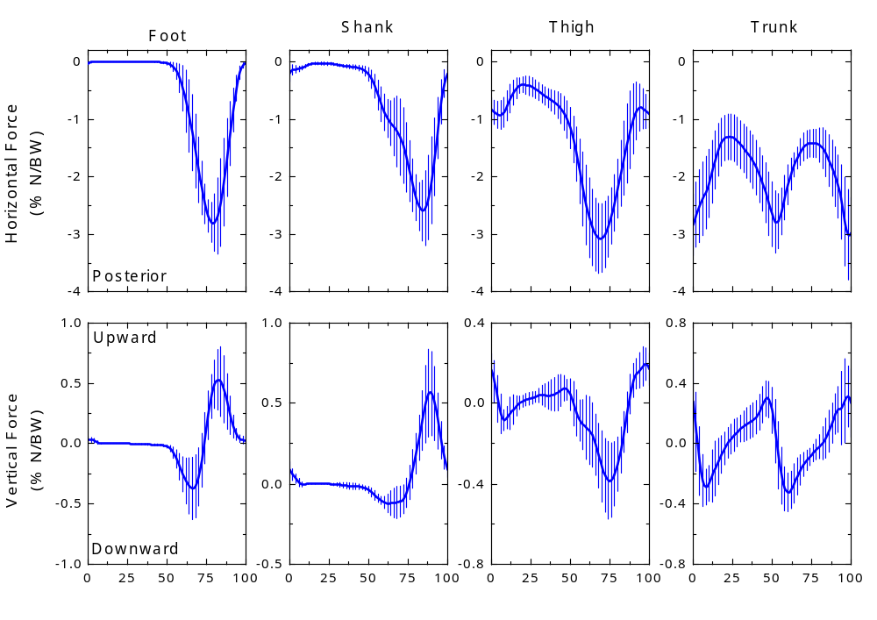
Figure 3. Mean and standard deviation across subjects of resultant drag forces acting on each segment while subjects were walking in water.

In order to visualize the relative changes in the biomechanical variables in both environments we plotted the same graphs presented in the paper but we normalized the kinetic variables by the apparent body weight (body weight minus buoyancy). Those results are shown in Figures 4 to 6.

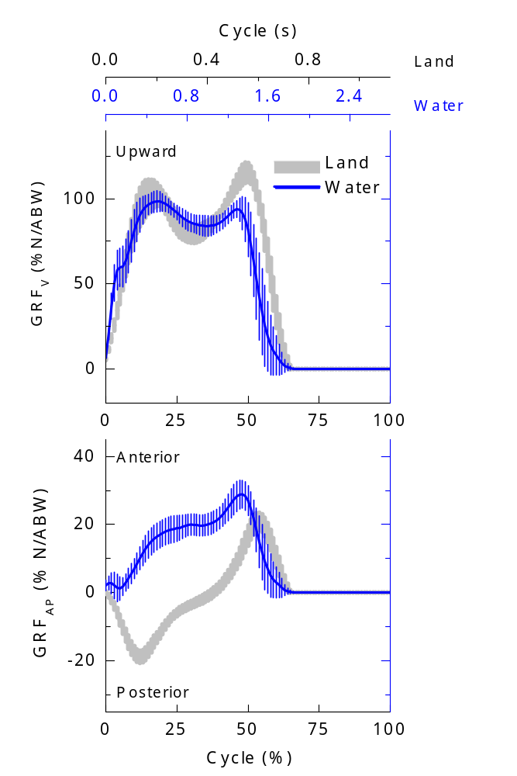
Figure 4. Mean and standard deviation across subjects of the vertical (GRF_{V}) and anterior-posterior (GRF_{AP}) ground reaction forces while walking on land and in water. Note that the ABW (apparent body weight) used in the normalization means the true body weight for the land condition and body weight minus buoyancy force for the water condition.

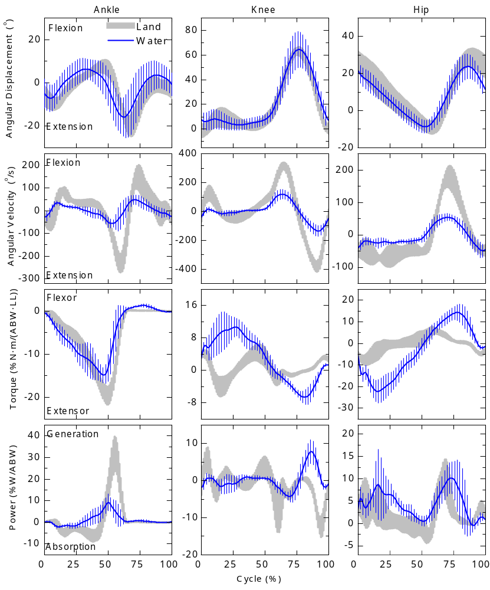
Figure 5. Mean and standard deviation across subjects of the angular displacement, angular velocity, joint torque, and joint power of the ankle, knee, and hip joints at the sagittal plane while walking on land and in water. Note that the ABW (apparent body weight) used in the normalization means the true body weight for the land condition and body weight minus buoyancy force for the water condition.

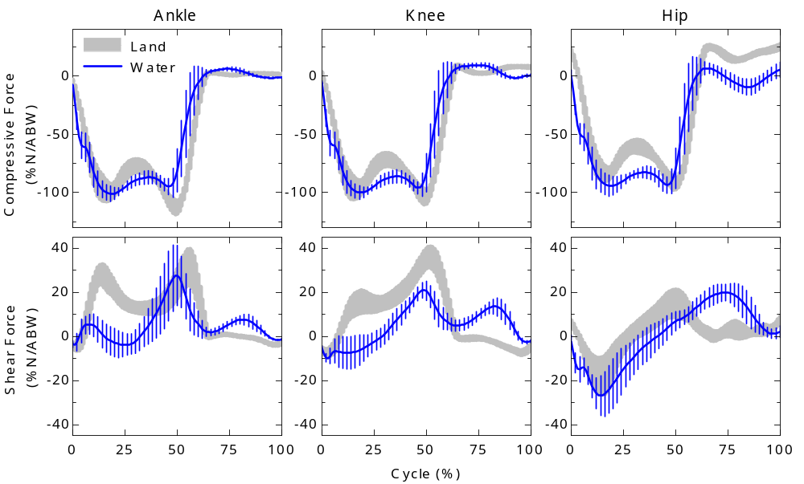
Figure 6. Mean and standard deviation of the ankle, knee, and hip joint forces while walking on land and in shallow water. The components were calculated in the local frame of the distal segment and are decomposed in compressive and shear forces. Note that the ABW (apparent body weight) used in the normalization means the true body weight for the land condition and body weight minus buoyancy force for the water condition.

Relation between joint torques and electromyography data
Our results concerning joint torques showed an increase on ankle peak flexor torque and a decrease on knee and ankle peak extensor torque. No differences were verified between the environments on knee peak flexor torque or on hip peak flexor and extensor torques. These findings are attributed to the action of buoyant and resistive forces as well as to the reduction of velocity while walking on water and are consistent with results on muscle activation patterns obtained in a previous study performed with the same experimental conditions (Barela et al., 2006).
Barela et al. (2006) reported a tonic pattern of activation in the tibialis anterior muscle during all the swing phase of walking in water compared with walking on land. This result is consistent with the increase in ankle peak flexor torque observed in our study. In order to maintain the ankle in a flexed position, the tibialis anterior acts concentrically and in a continuous way since the drag force tends to extend the ankle joint during almost all of the swing phase. The ankle torques during the stance phase showed a similar pattern in water and on land; however, the extensor torques on ankle in this phase of gait in water were extremely reduced when compared to land. The fact that the ankle torque pattern was similar in both environments agrees with the observation that there were no differences between land and water conditions in the gastrocnemius medialis muscle activation pattern (Barela et al., 2006). The reduction in ankle torque is due to the action of buoyancy and is consistent with the understanding that the major role of the ankle joint is for the support function of the body rather than to push the body forward while walking (Sutherland et al., 1980).
The main reduction on the knee extensor torque occurred during the support phase in water. This reduction is partly attributable to the smaller apparent body weight in water, since one of the functions of extensor torques during the stance is to prevent the knee flexion by the action of gravitational force, and partly attributable to the diminished walking speed, which also contributes to the reduction of the impact. As a consequence in water, the knee joint torque during the support phase is predominantly flexor, while on land it alternates between flexor and extensor. The knee torque pattern observed in this study during the support phase in water agrees with the flatter vastus lateralis muscle activation pattern instead of the phasic one observed on land described by Barela et al. (2006). In addition, the tonic activation of biceps femoris muscle summed with the contribution of gastrocnemius medialis during support in water can explain the predominance of flexor torque on knee and the similarity between knee peak flexor torque in water and on land.
Despite the fact that the subjects walked slower in water than on land, the hip torque peaks were not different between the environments, indicating that the drag force while walking in water demanded more from the hip joint in order to execute its function. In the swing phase of walking in water, an internal flexor torque acts on the hip against the external extensor one due to the action of drag force. In the same phase, a continuous and tonic activation of the tensor fasciae latae muscle was observed by Barela et al. (2006). A continuous and tonic activation pattern was also verified in the activation of vastus lateralis on the swing phase of walking in water. This is consistent with the results observed for the knee joint torques in the swing phase and indicates that in water the quadriceps muscle acts concentrically to overcome the drag forces during the knee extension (see power curves).

References
Barela, A. M., Stolf, S. F., & Duarte, M., 2006. Biomechanical characteristics of adults walking in shallow water and on land. J Electromyogr Kinesiol 16, 250-256.
Hanavan, E. P., Jr., 1964. A Mathematical Model of the Human Body. Amrl-Tr-64-102. Amrl Tr 1-149.
Kwon, Y.-H. (1993). The effects of body segment parameter estimation on the experimental simulation of a complex airborne movement. Unpublished Thesis (Ph.D.), Pennsylvania State University.
Newman, D. J. (1992). Human locomotion and energetics in simulated partial gravity. Unpublished Thesis Ph. D. Massachusetts Institute of Technology.
Newman, J. N., 1977. Marine hydrodynamics. Cambridge, Mass.: MIT Press.
Sutherland, D. H., Cooper, L., & Daniel, D., 1980. The role of the ankle plantar flexors in normal walking. J Bone Joint Surg Am 62, 354-363.

