**Supplementary material for “Effects of transporting an infant on the posture of women during walking and standing still”**

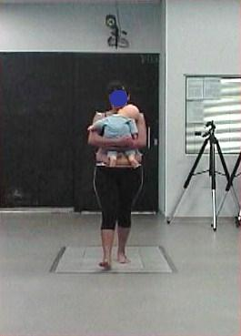

Figure 1. A photo of one of the subjects carrying the doll and the laboratory settings used in this study.

Table 1. Age, height, mass, and body-mass index of the non-mothers (N=44) and mothers (N=20) groups and statistical results for the comparisons (independent T-test for the means of samples and Cohen’s effect size).

|  |  |  |  |
| --- | --- | --- | --- |
| **Variables** | **Group** | | **Statistics** |
|  | Non-mothers | Mothers | t, p value, effect size |
| Age (years) | 28.24±3.13 | 31.00±6.31 | -1.66, 0.11, 0.55 |
| Height (m) | 1.66±0.08 | 1.63±0.07 | 1.39, 0.17, 0.37 |
| Mass (kg) | 59.05±7.46 | 59.57±11.57 | -0.21, 0.83, 0.06 |
| BMI (kg/m2) | 21.39±2.03 | 22.92±5.03 | -1.74, 0.09, 0.47 |

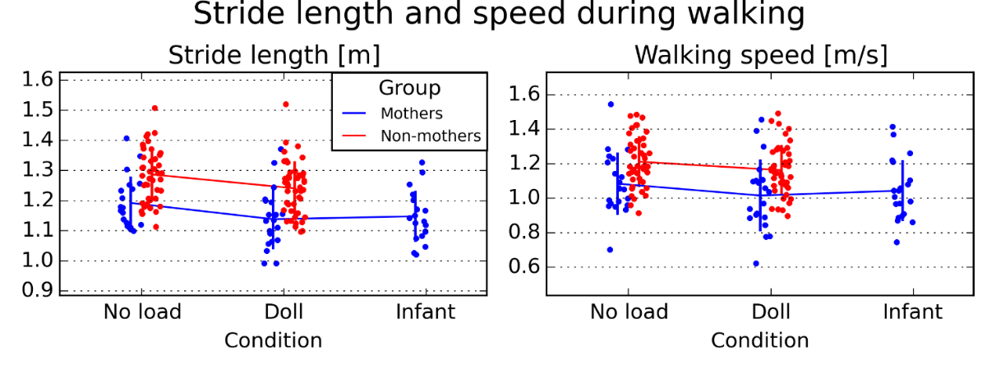

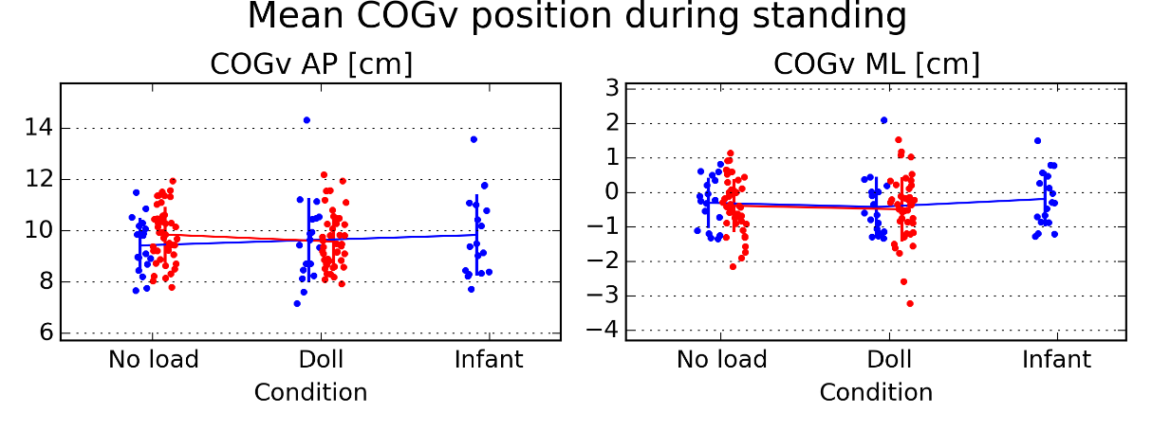

Figure 2. Interaction plots and scatterplots for stride length and walking speed during walking and of the center of gravity position of the subject’s body plus load (COGv) in relation to the mean position of the heels at the anterior-posterior (AP) and medio-lateral (ML) directions during standing still.

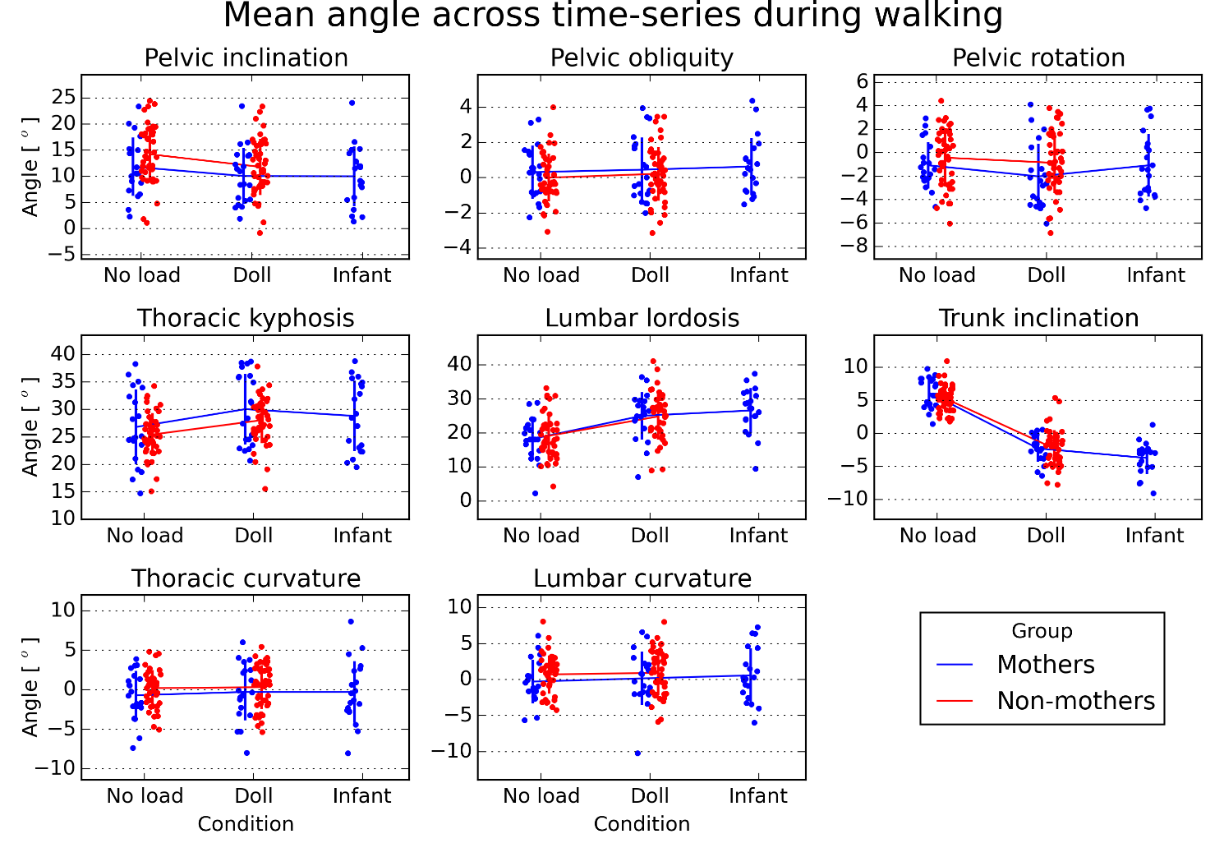

Figure 3. Interaction and scatter plots for the mean value of the angular variables across the time series during walking.

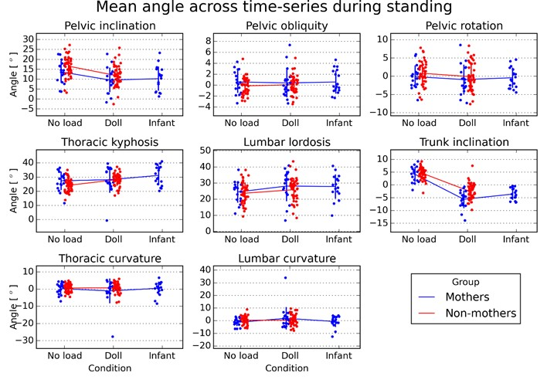

Figure 4. Interaction and scatter plots for the mean value of the angular variables across the time series during standing still.

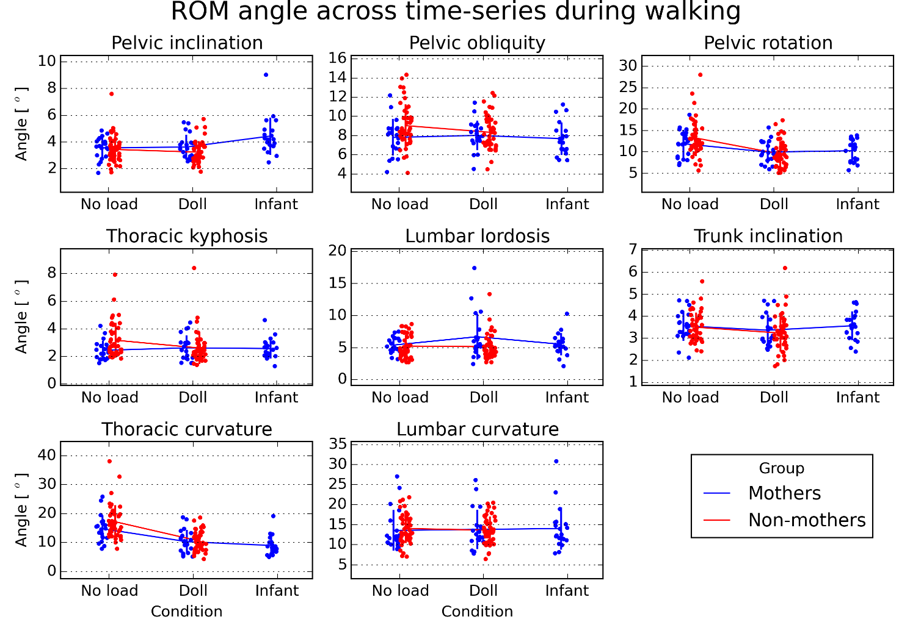

Figure 5. Interaction and scatter plots for the range of motion (ROM) of the angular variables across the time series during walking.

Table 2. Mean±1SD values of the angular variables across subjects at each condition of the range of motion (ROM) value of the time series during walking. The last column indicate significant main effects of group (G) and condition (C) and significant differences between infant and no-load (NI) or doll (DI) conditions for the mothers.

|  |  |  |  |  |  |  |
| --- | --- | --- | --- | --- | --- | --- |
| Variable | Group | | | | | Statistics |
|  | Non-mothers | | Mothers | | | (F, p value, ges)  (p value, d)  (p value, d) |
|  | No load | Doll | No load | Doll | Infant |  |
| Pelvic inclination (o) | 3.4±1.0 | 3.2±0.8 | 3.6±0.8 | 3.6±0.9 | 4.5±1.4 |  |
| Pelvic obliquity (o) | 9.0±2.2 | 8.4±1.8 | 7.8±1.9 | 8.0±1.5 | 7.7±1.7 |  |
| Pelvic rotation (o) | 13.2±4.3 | 9.5±3.0 | 11.9±3.3 | 10.0±2.6 | 10.2±2.6 |  |
| Thoracic kyphosis (o) | 3.2±1.3 | 2.6±1.2 | 2.4±0.7 | 2.6±0.9 | 2.6±0.7 |  |
| Lumbar lordosis (o) | 5.2±1.7 | 5.1±2.0 | 5.4±1.2 | 6.7±3.6 | 5.5±1.7 |  |
| Trunk inclination (o) | 3.5±0.7 | 3.2±0.8 | 3.6±0.7 | 3.4±0.7 | 3.6±0.6 |  |
| Thoracic curvature (o) | 17.2±5.7 | 10.5±3.4 | 14.8±4.7 | 10.3±4.0 | 9.0±3.3 | C (146, <0.001, 0.25)  N-I (<0.001, 1.4)  D-I (0.01, 0.36) |
| Lumbar curvature (o) | 14.0±3.6 | 13.6±3.5 | 13.6±5.1 | 13.8±4.9 | 14.0±5.3 |  |

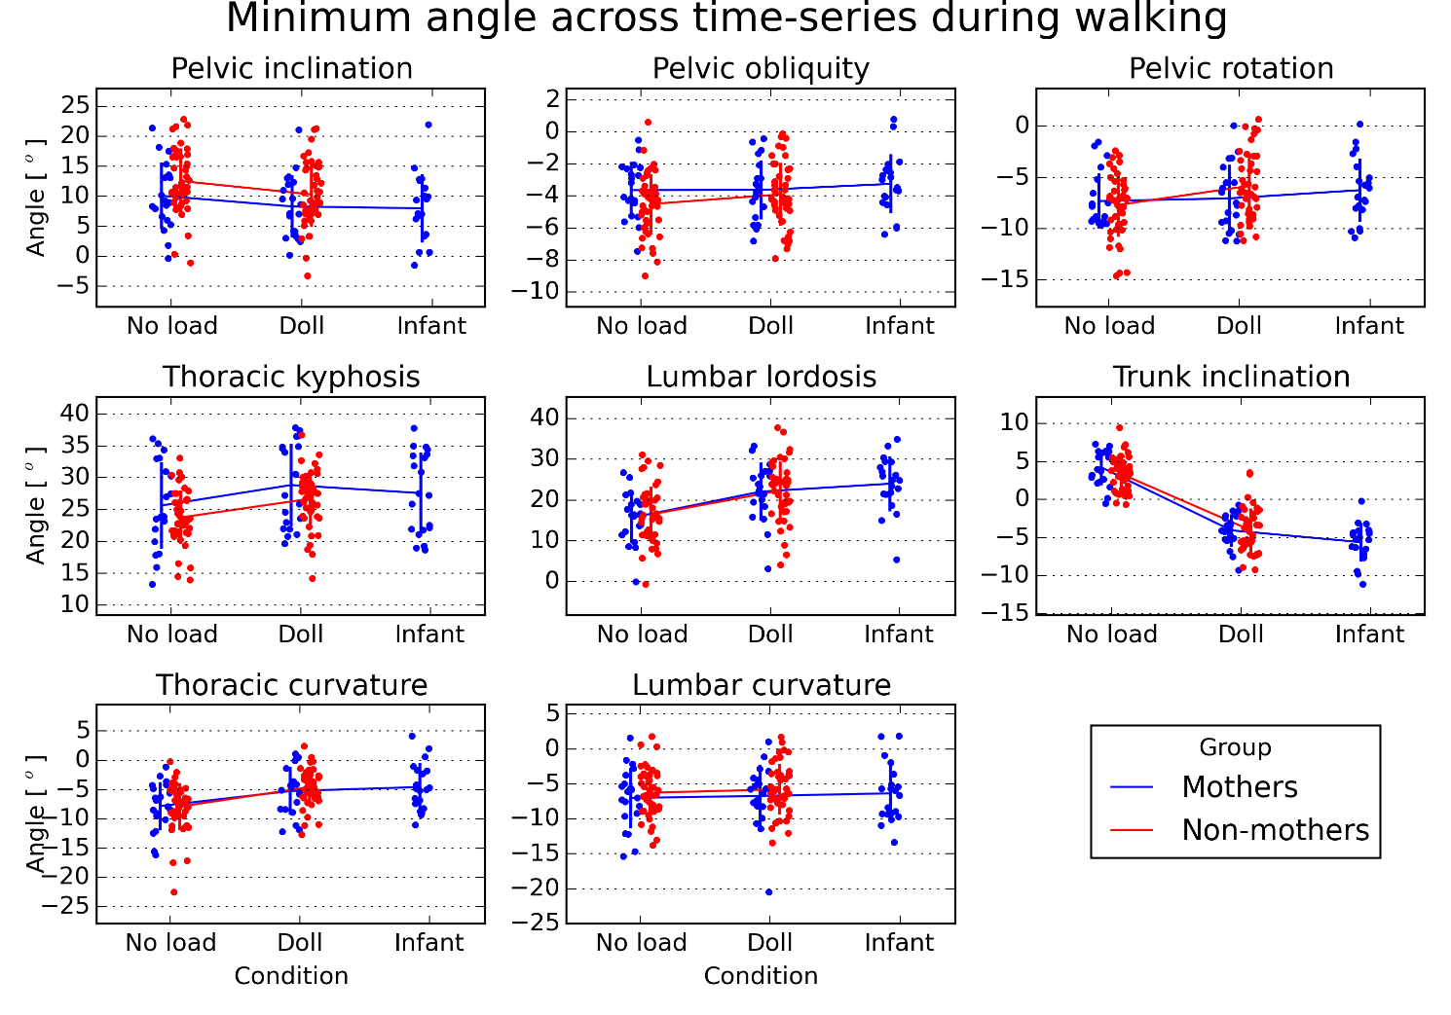

Figure 6. Interaction and scatter plots for the minimum value of the angular variables across the time series during walking.

Table 3. Mean±1SD values of the angular variables across subjects at each condition of the minimum value of the time series during walking. The last column indicate significant main effects of group (G) and condition (C) and significant differences between infant and no-load (NI) or doll (DI) conditions for the mothers.

|  |  |  |  |  |  |  |
| --- | --- | --- | --- | --- | --- | --- |
| Variable | Group | | | | | Statistics |
|  | Non-mothers | | Mothers | | | (F, p value, ges)  (p value, d)  (p value, d) |
|  | No load | Doll | No load | Doll | Infant |  |
| Pelvic inclination (o) | 12.5±5.4 | 10.3±5.4 | 10.1±5.6 | 8.3±5.2 | 8.0±5.8 | C (74, <0.001, 0.03)  N-I (0.013, 0.37) |
| Pelvic obliquity (o) | -4.5±1.9 | -3.9±2.0 | -3.6±1.8 | -3.6±1.9 | -3.2±1.8 |  |
| Pelvic rotation (o) | -7.7±3.1 | -5.8±3.2 | -7.3±2.7 | -7.1±3.3 | -6.3±3.1 |  |
| Thoracic kyphosis (o) | 23.8±4.2 | 26.7±4.4 | 25.6±6.8 | 28.9±6.5 | 27.6±6.4 | C (59, <0.001, 0.07)  N-I (0.002, 0.29)  D-I (0.036, 0.20) |
| Lumbar lordosis (o) | 16.5±6.9 | 22.4±7.1 | 15.7±6.3 | 22.1±7.1 | 24.0±6.8 | C (150, <0.001, 0.15)  N-I (<0.001, 1.28)  D-I (<0.001, 0.28) |
| Trunk inclination (o) | 3.4±2.2 | -4.1±2.9 | 4.2±2.3 | -4.1±2.1 | -5.6±2.5 | C (811, <0.001, 0.70)  N-I (<0.001, 4.0)  D-I (<0.001, 0.67) |
| Thoracic curvature (o) | -7.9±4.0 | -4.6±3.1 | -7.8±4.1 | -5.3±4.1 | -4.6±4.1 | C (65, <0.001, 0.12)  N-I (<0.001, 0.80) |
| Lumbar curvature (o) | -6.3±3.5 | -5.8±3.6 | -7.0±4.4 | -6.7±4.5 | -6.4±4.1 |  |

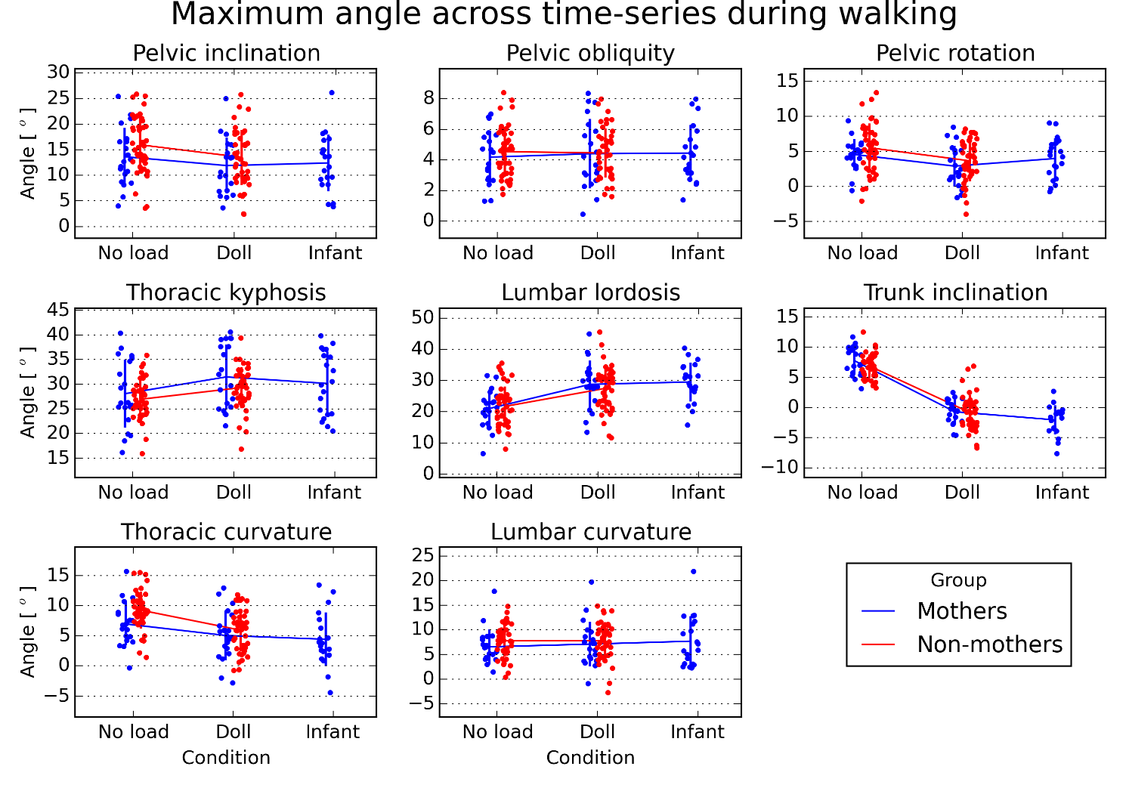

Figure 7. Interaction and scatter plots for the maximum value of the angular variables across the time series during walking.

Table 4. Mean±1SD values of the angular variables across subjects at each condition of the maximum value of the time series during walking. The last column indicate significant main effects of group (G) and condition (C) and significant differences between infant and no-load (NI) or doll (DI) conditions for the mothers.

|  |  |  |  |  |  |  |
| --- | --- | --- | --- | --- | --- | --- |
| Variable | Group | | | | | Statistics |
|  | Non-mothers | | Mothers | | | (F, p value, ges)  (p value, d)  (p value, d) |
|  | No load | Doll | No load | Doll | Infant |  |
| Pelvic inclination (o) | 16.0±5.5 | 13.5±5.4 | 13.6±5.6 | 11.9±5.4 | 12.4±5.6 | C (76, <0.001, 0.03) |
| Pelvic obliquity (o) | 4.5±1.6 | 4.5±1.6 | 4.2±1.7 | 4.4±2.3 | 4.4±1.8 |  |
| Pelvic rotation (o) | 5.5±3.5 | 3.7±2.9 | 4.6±2.2 | 2.9±2.9 | 4.0±2.9 |  |
| Thoracic kyphosis (o) | 26.9±3.9 | 29.3±4.2 | 28.1±6.9 | 31.5±6.6 | 30.2±6.5 | C (47, <0.001, 0.07)  N-I (0.03, 0.31)  D-I (0.006, 0.20) |
| Lumbar lordosis (o) | 21.7±6.4 | 27.5±7.0 | 21.1±6.0 | 28.8±7.6 | 29.5±6.3 | C (172, <0.001, 0.18)  N-I (,).001, 1.38) |
| Trunk inclination (o) | 6.9±2.0 | -0.8±2.8 | 7.8±2.4 | -0.7±2.0 | -2.1±2.4 | C (857, <0.001, 0.72)  N-I (<0.001, 4.1)  D-I (<0.001, 0.61) |
| Thoracic curvature (o) | 9.3±3.1 | 5.9±3.4 | 7.0±3.6 | 5.0±4.2 | 4.4±4.5 | C (53, <0.001, 0.11)  N-I (0.005, 0.63) |
| Lumbar curvature (o) | 7.8±3.2 | 7.8±3.7 | 6.5±3.6 | 7.1±4.5 | 7.7±5.1 |  |