## CHAPTER 1

**Introduction and background**

## Preamble

This chapter firstly discusses background regarding deep level mining in South Africa. Next, the need to reduce costs of operation in the mining sector is examined. From this, a focus on reducing the energy consumption of compressed air systems is developed. Next, background on compressed air operation and energy interventions are discussed. Simulations and their value in the industry are discussed leading to a problem statement and objectives of the study. Finally, an overview for the dissertation is provided.

## Background on deep level mining

### Mining profitability

Various technical, economic, social and operational challenges are posing a risk to the profitability of the South African mining sector. One of the challenges the sector faces is a rise in the cost of operation [1].

A considerable factor that is contributing to the increase in operational costs in South African gold mines has been the rise of electricity costs. As shown in fig. 1.1, the general cost of electricity has increased at a rate greater than inflation since 2008 [2].

40

35

30

25

20

15

10

5

0

2008

% increase

31.3

27.5

24.8

25.8

16.0

9.35

8.0

8.0

8.0

6.04

6.41

5.71

8.0

7.07

8.0

6.2

3.37

2010

5.3

5.32 5.18

2012

Year

2014

2016

Eskom tariff increases (%) Inflation rate (%)

Figure 1.1: Electricity price increases between 2007 and 2017 [2] compared to the inflation rate in South Africa1.

In addition to rising electricity costs, gold ore grades of South African mines have fallen

1 inflation.eu, ”Historic inflation South Africa.” [Online] [http://www.inflation.eu/inflation-rates/](http://www.inflation.eu/inflation-rates/south-africa/historic-inflation/cpi-inflation-south-africa.aspx) [south-africa/historic-inflation/cpi-inflation-south-africa.aspx](http://www.inflation.eu/inflation-rates/south-africa/historic-inflation/cpi-inflation-south-africa.aspx), [Accessed 25 March 2017].

substantially over the last few decades [3]. As ore grades decline, the energy utilised per unit of metal increases exponentially [4]. Therefore, mines require significantly more energy per unit of metal produced. This combination of tariff increases and increased energy usage per unit have led to significant rises in mining operation costs.

### Process of a deep level mine

South Africa’s mines are some of the deepest in the world Some mine shafts are reaching depths deeper than 4000*m* below the surface [5]. The process of extracting ore at this depth is dependent on the essential services, mainly cooling and ventilation, pumping, compressed air and hoisting, as shown in fig. 1.2.

Cooling and ventilation systems are required to maintain a safe working temperature underground. Pumping is critical to remove service and fissure water, preventing flooding. Compressed air is needed to power underground drills and machines safely. Finally, hoisting systems are used to bring the ore to the surface and to transport workers in the mine.



BAC Tower

Processing plant

Fridge Plant

Compressors

PCT

Ventilation Fan

Surface

V-101

Level 1

Pump

Dam

Level 2

...

...

...

Pumping

Processing plant Hoisting Compressed air

Ventilation and cooling

Level N-2

Level N-1

Level N

Shaft

Dam

Pump

Figure 1.2: A schematic showing the mining processes.

#### Energy usage of mining services

The mining industry uses extensive amounts of energy. In South Africa, the industry utilises approximately 15% of the national electricity supplier’s yearly output, of which, gold and platinum mines use 80%.[6]

fig. 1.3 illustrates the division of energy within the mining industry. The chart indicates that compressed air systems utilise the most energy within mine. Therefore, energy can be most effectively reduced through the implementation of energy interventions on compressed air systems.

25

20

15

10

5

0

Compressed Mining air processes

Ventilation Buildings Processing

and cooling

Pumping

and hostels

plant

Hoisting

Other

% of total energy consumption

Figure 1.3: The energy consumption for each mining system [7].

## Compressed air systems in mining

### Compressed air in operation

Largely due to their reliability, versatilely and ease of use, the South African mining industry has installed extensive compressed air networks. These systems can have compressors with capacities of up to 15 Megawatt (*M W* )[8]. However, the supply of compressed air is a high energy demanding and costly process [9]. The energy used for compressed air production contributes to between 9% and 20% of the total mining energy consumption [6], [10].

Large compressed air systems are likely inefficient. Internationally, the expected energy savings potential of a large compressed air network is 15% [11]. Marais [12] showed that energy efficiency interventions could lead to energy and cost savings of up to 30% and 40%.

### Characteristic inefficiencies of compressed air systems

Compressed air distribution networks in the mining industry consist of multiple compressors and working areas up to eight kilometres away from the source [8]. Due to their size and complexity, these systems are prone to significant energy losses.

Compressed air leakage accounts for as much as 35% of the energy losses of a compressed air network [13]. Other systemic losses include, faulty valves, pipe diameter fluctuations,

obstructed air compressor intake filters and inefficient compressors.

Leakage and inefficiency detection strategies are not often pursued in the South African mining industry [14]. Many mines do however perform leak inspections either internally or by an outside company. In these inspections, an ultrasonic detector is used to locate the leak. Alternatively, some mines employ the “walk and listen” method to identify leaks from the audible sound that it produces [14]. Once the inspection is completed, the findings, including the locations and estimated costs of all identified leaks, are reported.

### Compressed air savings interventions

Energy interventions to reduce energy on compressed air systems designed using the following strategies [15]:

* + - * Reduce leaks
      * Reduce demand
      * Reduce unauthorised air usage
      * Increase supply efficiency
      * Optimise supply

Often a combination of energy strategies will lead to the most savings [8]. In chapter 2, Successfully compressed air interventions on mining systems will be discussed from literature.

Once an energy saving measure has been identified, it is most often necessary to make estimations to determine the potential costs and benefits of the intervention. The estimations have typically been performed using first principle calculations, simplified mathematical models and practical tests if possible. However, new tools have enabled quick, accurate compressed air model development. Through simulations, accurate estimations can be obtained quickly, with no risk and at comparatively low resource requirement.

## Use of simulation in industry

### Background in industrial simulation

Continuous improvements in computing hardware have led to major advancement in software technology. Consequently, the use of computational simulation has become an increasingly valuable tool for many industries.[16]

In *Handbook of Simulation: Principles, methodology, advances, applications, and practice*,

the advantages of the use of simulation in the industry are discussed as follows [17]:

* + - * The ability to test new policies, operating procedures and methods without disrupting the actual system.
      * The means to identify problems in complex systems by gathering insight in the interactions within the system.
      * The facility to compress or expand time to investigate phenomena thoroughly.
      * The capability to determine the limits and constraints within a system.
      * The potential to build consensus about proposed designs or modifications.

### Simulation usage in compressed air optimisation

Simulation has been used to test and identify energy and operational improvements in mining compressed air systems. In the past producing complex models for mining systems was not feasible as simulation software required difficult to obtain data inputs [12].

Due to the lack of data inputs, previous studies have typically had to develop simplified system models. The models cannot provide results with a high amount of accuracy and limited the types of scenarios that can be simulated.

However, the use of planned manual measurements, estimations and new software technologies can overcome this challenge [18], [19]. Using a structured procedure may allow for the development of more detailed and accurate mining compressed air simulations.

## Problem statement and objectives

### Problem statement

Rising costs and falling ore grades are driving the mining industry to reduce operational costs. The industry can save significant energy cost through interventions in compressed air systems. However, manual testing of these interventions is risky and cumbersome.

Computer modelling and simulation of compressed air systems can be used to quantify and prioritise operational interventions with minimal risk. However, simulations have not been used to their full potential in compressed air systems. With new tools and more detailed simulation models, the energy and operation efficiency of mining compressed air systems can be improved, leading to significant energy and cost savings as well as other potential improvements for a mine’s operation.

Therefore, a need exists for a structured approach to develop and implement compressed air system simulations to improve the energy and operational efficiency.

### Research objectives

The main aim of this dissertation is to obtain energy savings through the identification of operational improvements in mining compressed air systems. A simulation process to will be developed to achieve this goal.

## 1.6 Dissertation overview

**Chapter 1** This chapter serves as an introduction to the dissertation. The chapter provides the relevant background in mining, compressed air and simulation to establish the problem statement. The objectives of the study are then outlined.

**Chapter 2** Chapter 2 provides a review of the literature and necessary background relevant to the study. The chapter firstly provides background on mining compressed air networks. A review of compressed air energy interventions is then performed. A review of simulation usage in the mining industry then follows. Finally, a review of simulation usage in mining compressed air systems.

**Chapter 3** Chapter 3 provides a simulation methodology. The method outlines the processes used to investigate a compressed air system, develop and calibrate simulation models and finally to implement simulations and obtain results.

**Chapter 4** Chapter 4 provides validation of the methodology through case study results. Results of three case studies are provided. Finally, the impact of large scale implementation of the simulation methodology is discussed.

**Chapter 5** Chapter 4 concludes the dissertation. The chapter also provides recommendations for further studies regarding compressed air simulation.

## CHAPTER 2

**Overview of simulation and compressed air**

**applications**

## Introduction

This chapter will firstly provide relevant background on the operation and subcomponents of compressed air networks. A review of the literature regarding compressed air energy interventions will then be performed. This review will summarise previous work to improve to improve the supply and demand efficiency of mining compressed air networks.

The use of simulation in mining systems will then be reviewed. This section will summarise the usage of mathematical estimation and simulations tools in the mining industry. From the literature, available simulation tools, as well as simulation and verification procedures, will be discussed.

Finally, simulation usage in compressed air systems will be discussed. The section will summarise the work, as well as the successes and shortfalls, that has already been performed regarding simulation of large compressed air networks.

## Background on mining compressed air networks

### Preamble

Compressed air is used extensively in a mine in surface and underground operations. This section provides background regarding mining compressed air networks. The section firstly discusses the components that make up a mining compressed air system. The typical functioning of the system is then examined. Finally, the instrumentation that is typically installed in compressed air networks is discussed.

### Compressor air network components

#### Compressors

Compressed air in mining is most commonly supplied by a centrifugal-type dynamic compressor [20], [21]. These machines achieve compression as a result of the centrifugal force from the high-speed rotation of impellers in the air. An electric motor drives the rotating impeller.

Multi-stage impeller compressor designs, as shown in fig. 2.11, are used to obtain higher pressure ratios [20]. The compression process is inefficient. Only about 5% to 10% of the

1 Abc oil refining, ”How centrifugal compressors operate” [Online] [http://abcoilrefining.blogspot.co.](http://abcoilrefining.blogspot.co.za/2012/03/how-centrifugal-compressors-operate.html) [za/2012/03/how-centrifugal-compressors-operate.html](http://abcoilrefining.blogspot.co.za/2012/03/how-centrifugal-compressors-operate.html), [Accessed 15 August 2017].

input energy of the process is converted into energy that is used [22].

Discharge

Suction

Figure 2.1: A schematic of a multi-stage centrifugal compressor1.

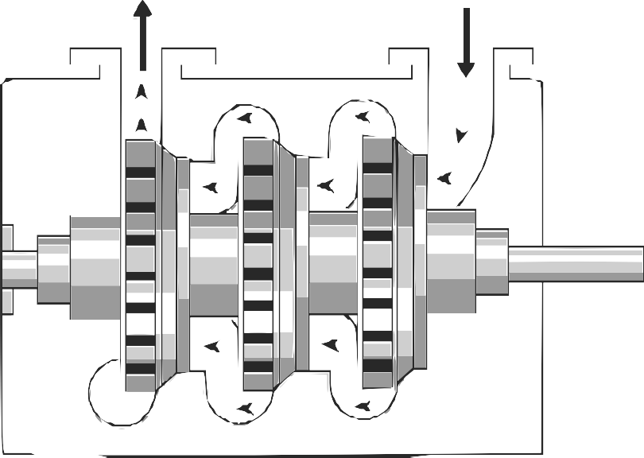

Rotor

Stage 3 Stage 2 Stage 1

#### Pneumatic rock drills

Drilling is mainly performed in the production areas or stopes of a mine. Drill machines are used to drill holes into the rock face. Once the holes have been drilled, explosives are then installed to break up the rock [23].

Compressed air is used to power pneumatic rock drills within a mine. Pneumatic rock drills run at an efficiency of 2%. The efficiency is low when compared to alternative rock drills such as electric, oil electro-hydraulic and hydro-powered drills that convert energy at an efficiency of between 20-31% [24], [14].

#### Refuge bays

Refuge bays are installed underground in deep level mines to provide safety to miners in the event of an emergency. Due safety regulations, most mines will utilise compressed air to deliver chilled air to the chamber [25]. fig. 2.2 shows an example of a compressed air inlet at an underground refuge bay. A muffler is installed to the end of the inlet air pipe to reduce noise.

The provision of 1.42 *l/s* of air per person at a pressure between 200 and 300 kilopascals is required to provide oxygen and prevent any poisonousness gas entering the refuge [25].

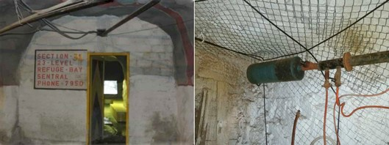

Figure 2.2: An example of compressed air inlet in an underground refuge bay chamber of a mine.

Airflow in the refuge bays is controlled by a manual valve within the room. The manual valves are often misused by mine workers to cool the bay through decompression of the air.

#### Processing plants

Processing plants are constructed near gold and mines. They are used when extracting metal from the ore that is obtained from the mining operation. These plants use compressed air for various systems, processes and equipment.

Processing plants often share compressed air network with mine to save costs[8]. The plants use relatively small amounts of air compared to mines. However, plant processes have pressure requirements that differ from the rest of the air network. If the plant air supply is not isolated from the shaft’s air system, energy optimisations can be complicated.

#### Other compressed air users

Due to the availability underground, compressed air is utilised for several other applications. These usages include, pneumatic loaders or rock shovels, pneumatic cylinders, dam sediment agitation, cooling and ventilation and many other applications. This vast variety of applications also leads to misuse of compressed air. This leads to inefficient operation.

### Operation schedule

On a typical mine, various operations are scheduled different times of the day. Depending on the activity taking place, many mines will control the pressure to meet the requirements of the tasks [26], [8]. fig. 2.3 shows the schedule and pressure requirement on a typical deep level mine.

As shown in fig. 2.3, the pressure requirement changes depending on the activity taking place. The drilling shift typically has the highest pressure requirement while blasting shift requires the lowest. Schedules and operation philosophies can differ between mines. Different operational schedules require alternative pressure requirement profiles.

Drilling

Blasting

560

540

520

500

480

460

440

420

400

Time of day Pressure requirement (kPa)

Pressure (kPa)

Sweeping and

cleaning

Workers travel to working areas

Explosive charge up

Sweeping and

cleaning

Figure 2.3: The typical operation schedule of a deep level mine [26].

00:00

01:00

02:00

03:00

04:00

05:00

06:00

07:00

08:00

09:00

10:00

11:00

12:00

13:00

14:00

15:00

16:00

17:00

18:00

19:00

20:00

21:00

22:00

23:00

### Instrumentation

For large industrial systems, thorough instrumentation is necessary to monitor performance and equipment conditions throughout the system. In a mining compressed air network, instrumentation is installed to monitor flows, pressures, temperatures and other process parameters. Electrical instrumentation is also installed for sensing currents, power factors, voltages and power. Parameters that are often measured include valves input/output pressures and flows, valve and guide vane positions and air condition metrics are usually measured with instrumentation.

Supervisory control and data acquisitions (SCADAs) systems are used to monitor and control processes throughout the mine. The instrumentation and SCADA are connected on a communication network. This communication between the underground Programmable logic controllers (PLCs) and surface SCADA is achieved using a substantial fibre optic netw[ork27]. The SCADA centralises instrumentation data from PLCs and instrumentation in the mine. The SCADA is also used to control machines and control instrumentation by transmitting control signals over the network.

### Summary

In this section, various subcomponents of compressed air networks were discussed. These sub-components included compressors, processing plants as well as underground air users. The daily process scheduling and the effect on compressed air requirements were then reviewed. Finally, the typical instrumentation found in a mining compressed air system was summarised.

## Review of compressed air energy interventions in industry

### Preamble

Compressed air improvement can be obtained through intervention in either the supply or demand processes of a compressed air system [26]. Improvements in supply are achieved by increasing the efficiency of compressed air supply. Examples of these types of intervention include Dynamic Compressor Selection (DCS), compressor relocation, repairs and maintenance.

Due to the size of mining compressed air networks, there is often a larger scope for improvement in air demand. Improving the air usage is achieved by optimising air flow consumers, reducing leaks and through other interventions.

This section will review compressed air supply and demand interventions that have improved energy or operation efficiency the mining industry. From the literature, successes and shortcomings in studies will be discussed and analysed.

### Strategies to improve compressed air supply

#### Optimising compressor control

Compressors types and numbers can differ widely from mining compressed air systems. Compressor selection is crucial in these systems to match the correct compressors with the requirements of the system [28].

In a study by Booysen [21] found that many mines control compressors using fixed target pressure points that are much higher than required. In one system, compressor controllers were set to target 650 *kP a* to ensure pressure underground did not fall below 500 *kP a*. Use

of high set-points can lead to excessive, wasteful blow-off air flow when the pressure exceeds maximum points.

[29] showed through dynamic pressure set-point control1 and optimal compressor selection, energy savings can be achieved. In a case study, an average power reduction of 1.07 MW was achieved. The lead to an estimated energy cost saving of R3M.

Optimising control of compressors to match the demand of the system can be complicated. Variable Speed Drives (VSDs) and guide-vane are used to control the capacity of the network. More effective power reductions can be achieved through the use of VSD control. Running compressors at part load reduce efficiency. From literature, it has been shown electric motors will typical use 60-80% of their rated power when operating at less than 50% load [30].

#### Reconfiguring compressed air networks

Some old mining compressed air systems have not been adequately maintained and improved. Often they cannot sufficiently supply air to meet the demand or air is provided from nonoptimal sources. In a study by Bredenkamp [31], reconfiguring of the air network was investigated to improve these systems.

In the study, Bredenkamp investigated interconnecting the compressed air systems of two mining shafts and relocating of a compressor. This strategy leads to an average power reduction of 1.7 MW and an estimated annual energy cost saving of R8.9M at the time.

### Strategies to reduce compressed air demand

Reducing the airflow demand is achieved by reducing air unnecessary airflow such as leaks, optimising the operating pressure to match the demand2 and by improving the efficiency of air usage or replacing equipment with non-pneumatic alternatives [15].

#### Leakage detection

Air leaks are a major inefficiency in mining compressed air systems. Improving leaks is a relatively easier method to reduce air demand and improve the efficiency of the system [32]. Air leaks occur as a result of open pipes, fissure and breaks. Losses depend on the size of the leak and pressure in the network. fig. 2.4 shows the theoretical airflow of through a

1 Matching the supplied pressure with the specific required air demand.

2 Matching the supplied pressure with the required air demand. Optimising the supply is achieved by identifying the minimum required operating pressure for all times of the day as illustrated in fig. 2.3

pipe orifice as a function of leakage area and pressure1. [32] showed that the system power consumption linearly increases with the amount of air leakage. Therefore, energy savings can be achieved through either reducing pressure or detecting and fixing leaks.

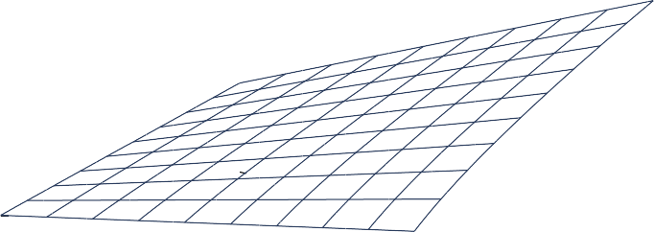

4*.*5

3

1*.*5

0

Flow (kg/s)

Figure 2.4: The leakage flow as a function of inlet pressure and leakage area3.

Leaks are often not easily detected through visual methods. In industry, many techniques can be employed to detect air leaks. Pascoe [33] and van Tonder [14] summarised these techniques as follows:

* + - * Audible detection (Walk and report)
      * Ultrasonic detection
      * Intelligent systems2
      * ”Pigging”3
      * Soap water/visible dyes

These methods are time and resource intensive, and many mines do not actively employ dedicated leakage detection and repair teams. Marais *et al.* [34] investigated streamlining the leakage detection and repair process to increase energy savings through the use of Compressed Air Leakage Documentation System (CALDS). The system was developed to allow centralised mobile leakage reporting. Usage of CALDS in mines resulted in an increased leak detection rate. One mine reported 24 leaks in a single month. It was noted in the study that there difficulty quantifying the actual energy savings of the leakage repairs due to other

3 efunda, ”Orifice Flowmeter Calculator.” [Online] [http://www.efunda.com/formulae/fluids/calc_](http://www.efunda.com/formulae/fluids/calc_orifice_flowmeter.cfm) [orifice_flowmeter.cfm](http://www.efunda.com/formulae/fluids/calc_orifice_flowmeter.cfm), [Accessed 18 October 2016].

2 Leakage detection by using strategically placed measurement equipment and smart computer systems.

3 The use of a device, ”pig”, within the pipe to perform inspections.

interventions co-occurring.

#### Underground control valves optimisation

Many mines utilise automated valves at critical locations or levels in the compressed air network. These valves control the pressure, restricting airflow from that point in the air network. Restricting airflow reduces losses resultant from network inefficiencies and leaks.

Kleingeld and Marais [35] found that optimising control valve control on mining levels can conservatively lead to between 20% on mines where no control valves are installed. For systems that already have some form of network control, between 10 and 15% savings can conservatively be achieved.

From literature, the advantage of control valve optimisation is the significant savings that can be achieved with relatively short set-up up time. Savings can be reached incrementally with each control valve installation. Studies did not look at accurate estimations of savings or the shaft pressure improvements that result from control valve optimisation.

#### Improving pneumatic rock drill efficiency

Pneumatic rock drills are one of the largest air consumers in a mine. However, Pneumatic drilling systems convert energy very inefficiently. Replacing pneumatic drills with more efficient alternatives such as hydraulic or pneumatic drills would lead to large energy savings [33]. Alternatively improving the efficiency of pneumatic drilling can have a significant energy impact on the system, without the cost and safety concerns of alternative drilling technologies.

In a study by Bester *et al.* [36] looking at the effect of compressed air pressure on energy demand. Bester showed that between 2002 and 2013 compressed air and energy consumption per tonne of ore produced had steadily increased. The shift in Energy and air volume per tonne of produced ore over time is illustrated in fig. 2.5.

The increase of air consumption per Tonne was a result of reduced air pressure at the mining areas. The pressure reduction caused a drop in the drilling rate, leading to higher air consumption. Pressure measurements as low as 300 kilopascals were recorded in these regions. Before 2002 the drilling pressure at the mining section (stopes), was maintained above 500 kilopascals at most mines.

*kW h/t*

*m*3*/t*

40

35

30

25

20

15

10

5

0

2002

2004

2006

2008

Year

2010

2012

400

350

300

250

200

150

100

50

0

2014

Energy per Ton (kWh/t)

Volume per Ton (*m*3/t)

Figure 2.5: The Compressed air energy and flow consumed per T of ore produced. Adopted from Bester *et al.*[36].

From literature, it is shown that lowering the pressure reduces the efficiency and drill rate of rock drilling, leading to higher air consumption. Interventions that reduce systemic air losses or optimise supply can increase the pressure operating pressure. Increased pressure, during the drilling shift, may add more value than the energy cost savings that can be achieved at a lower pressure.

### Summary

This section reviewed previous studies that had achieved energy improvements in compressed air. The literature was divided into studies that focus on improving the supply of compressed air and those that optimised the compressed air demand.

Compressed air supply interventions included optimising compressor control and reconfiguring compressor networks. On the demand side, studies that investigated reducing leaks, optimising underground valve control and improving rock drill efficiency were discussed.

## Use of simulations to identify improvements in mining systems

### Preamble

The value of simulation in the mining industry has been widely shown through its usage in Demand Side Management (DSM) initiatives. Simulation and estimation procedures have been widely applied to identify, and pre-emptively quantify the effect of energy interventions

strategies for water reticulation cooling, compressed air and ventilation systems.

The purpose of this section is to summarise and discuss the work that has been done concern ing estimation and simulation of mining systems. This section will also discuss simulation development procedures and verification methodologies that have been applied in literature.

### Estimating energy savings on mining systems

Estimation has been a vital tool in literature to obtain the potential energy impact that can be achieved from interventions on a mining system. Before new tools allowed for the quick development of simplified simulation models, estimation techniques were frequently used to determine the feasibility of energy interventions. The shortcomings of the estimation approach are that they typically rely on simplified system models that lead to high prediction error, limit the complexity of scenarios and input/output variables.

Snyman [15] used mathematical estimation to determine the expected power savings from initiatives on mining compressed air systems. Due to uncertainty in the estimations, 1[5] predicted results were provided as a range between conservative and best-case estimates. The actual achieved energy impact would fall between these estimations. Snyman’s model only estimated the average energy impact and could not provide a resultant power profile or other output variables such as pressure.

#### Benchmark modelling

Cilliers [37] developed “best practice models” using the Corrected Ordinary Least Square (COLS) benchmarking method. These models provide an energy benchmark that can be used to identify the scope for energy improvement on mining systems. An example of a benchmark model for a mining compressed air system is shown in fig. 2.6. The model can be used to estimate optimal energy required as a function of the quantity of ore mined(T) and the depth of the mining shaft (Z). [37] also developed benchmark models for mine cooling, water reticulation and ventilation systems.

### Value of simulation in mining DSM

Van Niekerk [38], [39] investigated the value of simulation models in mine DSM projects. [38], [39] developed simulation models for compressed air and water reticulation systems using KYPipes’s gas simulation engine.

Simulation has been used in studies as a tool to improve mine cooling. Holman [40] in-

Figure 2.6: Energy benchmark model for a mining compressed air system, adapted from Cilliers [37]

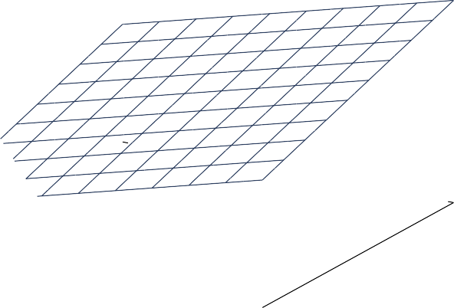

120

140

100

1

80

2

3

4

0 20

4060

10

8

6

4

2

0

160

0

*Ecomp* = 1*.*51 · *Z* + 33*.*36 · *T* − 1930*.*21

Benchmark energy (GWhr)

vestigated improvements to mine cooling systems that improve performance and efficiency. In the study [40] used simplified Process Toolbox (PTB) simulation models to investigate cooling interventions.

The scenario Holman simulated showed potential average power reduction of 136 kW which would lead to an annual energy cost saving of R0.55M. The study could be improved by increasing accuracy of the simulation. Power difference of as high as 31% between the simulation and actual was observed for some time periods.

Simulation has added great value for mining compressed air DSM. A detailed literature discussion of compressed air simulation applications is discussed in Section 2.5.

### Simulation procedure

A structured simulation procedure is required to achieve the objectives of the study. Previous studies from literature have focussed on how simulation software tools work rather the simulation procedure that was followed [41].

Bouwer [42] developed a software tool that he used to investigate extensive thermal and energy systems. Bouwer used the following procedure to implement simulations:

* + - 1. Create a detailed schematic of the system
      2. Obtain data from installed instrumentation
      3. Perform manual measurements where necessary
      4. Gather data for a typical operational period
      5. Convert data into useful formats
      6. Setup the simulation model
      7. Calibrate the model until simulated outputs match measured data

Bouwer’s simulation procedure provides a good guideline for mining system simulation. The procedure could be simplified by merging steps. For example step 1 to 4 could be merged into 1 step “Gather system data and information”.

#### Periodic/repeated simulation

The concept of periodic or repeated simulation procedure the execution a simulation multiple times or on a recurring schedule while altering various input parameters. [15] used repeated estimation to determine an upper and lower bound for the expected result. Another example from industry is real time simulation or estimation systems.

Van Heerden *et al.* [43] developed a dynamic control system for a mine compressed air network. The controller utilised repeated simulation to estimate unmeasured and future parameters of the network. The estimated results were used to optimise the compressor control.

Hollander and Lui [44] used repeated simulations to estimate travel time distributions for traffic networks. [44] developed the following methodology for the repeated simulations:

1. Gather input parameters
2. Run simulations
3. Read simulation outputs
4. Repeat for desired iterations

### Available simulation tools

A software tool is required to create and execute the compressed air simulations. In literature variety software tools have been used to simulate industrial systems. A suitable software system for this study must be capable of producing accurate models of complex compressed air network. The system should be able to solve for transient compressed air simulation scenarios with dynamic data and control inputs.

The development of system models should also not be excessively time-consuming. The software tools should also be able to handle missing data inputs and information that in common in mining systems. These were shortfalls of simulation tools noted by van Tonder

1. and Marais [41].

The following simulation tools that may meet the criteria were identified :

* + PTB
  + Flownex
  + KYPipe GAS
  + AirSim
  + REMS

Of these tools, PTB was recognised as the most suitable software system for this study. While it may be possible to use other packages, PTB was developed specifically for simulation of mining systems. The design allows simpler and speedier development of system components as many components such as compressor mathematical models have already been pre-built [41].

### Simulation model verification strategies

Due to lack of instrumentation, measurement inaccuracies and other non-ideal aspects of mining systems. It is impossible for a simulation model to match the actual system’s performance perfectly. From the literature, methods of verifying simulation precision were investigated. The verification techniques identified from literature were the Mean residual difference, Mean Absolute Error (MAE), the coefficient of determination or correlation and Mean Square Error (MSE).

#### Mean residual difference method

The average difference method looks at the mean of the actual and simulated time series. Relative error is then calculated with eq. (2.1). The simulation percentage error from the physical system is then calculated by dividing the error by the Actual data-points, eq. (2.2).

*R*¯ = 1

*N*

*N*

*n*=1

(*An* − *Sn*) (2.1)

The equation is rewritten to get a relative error percentage:

Where:

*Err*%

= 1

*N*

*n*=1

*An* − *Sn*

*An*

(

× 100% (2.2)

*A* Actual system time series

*N*

*S* Simulation time series

*n* Data point

*N* Number of Data point in simulation period

A major disadvantage of this method is that for transient simulation, the positive and negative errors for individual points can cancel out. This leads to a smaller resultant error than would be expected. The resultant error value can therefore not direct to any conclusive statements regarding the accuracy of the model [46]. This strategy is not recommended if used alone to verify transient simulations.

Yu-jie Xu *et al.* [47] developed a steady state simulation of an absorption chiller. In the study [47] utilised residual difference to measure the steady state error of an absorber model. The accepted margin of accuracy in the study was a relative steady state error of 5%.

#### Mean absolute error method

The MAE verification method follows a similar calculation as in the Average residual difference method. However, as shown in eq. (2.4), the error is calculated individually for each point in the series. The average of the individual errors is the resultant error, eq. (2.3). The relative error percentage is obtained by dividing each error is by the Actual value at that time step as in eq. (2.4).

1

*M AE* =

*N*

*N*

|*An*

*n*=1

− *Sn*

| (2.3)

The equation is rewritten to get a relative error percentage:

1

*N*

*An* − *Sn*

*n*

*Err*% = *N*

*n*=1

*A* × 100% (2.4)

Where:

*A* Actual system time series

*S* Simulation time series

*n* Data point

*N* Number of Data point in simulation period

#### Coefficient of determination

The Coefficient of correlation is the measure of how accurately a data series (*x*) can be represented in a linear relationship with Data series (*y*), i.e. *y* = *mx* + *c*. The value for the coefficient ranges between −1 and 1 where a value of 1 indicates a perfect linear relationship between the series and a value of -1 represents a perfect negative linear relationship. A value of 0 indicates that there is no connection between the data series. The correlation coefficient can be calculated using equation eq. (2.5).[46]

*r* = I),*N*

*N*

*n*=1

),

*n*=1(*An* − *A*¯)2 ·

(*An* − *A*¯)(*Sn* − *S*¯)

),*N*

*n*=1(*Mn* − *A*¯)2

(2.5)

Where

*A* Actual system time series

*S* Simulation time series

*n* Data point

*N* Number of Data point in simulation period

The coefficient of determination or R-Square value can be calculated by squaring the correlation coefficient (r).

Kurnia *et al.* [48], [49] developed a simulation for a novel underground mining ventilation system. [48], [49] selected the mathematical model with the highest precision when compared with historical data points. The chosen model had an R-Square value of 0.96 and a relative error 30 %, using the mean absolute error method.

#### Mean squared error

In statistics, the MSE or Root Mean Square Error (RMSE) is the average of the square of the error between the actual and estimated value. The value is always positive. A smaller

value relates to a more accurate model.4

1

*M SE* =

*N*

*N*

(*An*

*n*=1

* *Sn*

)2 (2.6)

|  |  |  |
| --- | --- | --- |
| Where: |  | |
|  | *A S*  *n N* | Actual system time series Simulation time series Data point  Number of Data point in simulation period |
| **Other methods** |  |  |

Many alternative methods or variations of the methods discussed are available to verify transient simulations. As an example, [50] looked at the percentage of relative errors under certain limits as well as a maximum relative error. The method is an improvement compared to the residual difference in ensuring transient simulation accuracy however the results are difficult to interpret.

Sarin *et al.* [46] compared many methods. Some methods that have not been discussed in this study include:

* + Vector Norms.
  + Sprague and Geers Metric [51], [52]
  + Russells error Measure [53], [54]
  + Normalized Integral Square Error
  + Dynamic Time Warping (DTW).

The calculations in the above methods are relatively complex. However, they provide additional metrics such as Phase, magnitude and slope errors. These metrics could add value in verifying simulations.

#### Comparing verification methods

The difference between the strategies is best shown using an example. Figure fig. 2.7 shows the output and actual power of a simulation of a mining system for a 24-hour duration. In the study [41] used mean residual difference, eq. (2.2), to determine the accuracy of a simulation model.

4 University of Kentucky Department of Mathematics, ”Estimators, Mean Square Error, and Consistency” [Online] [http://www.ms.uky.edu/~mai/sta321/mse.pdf](http://www.ms.uky.edu/%7Emai/sta321/mse.pdf), [Accessed 3 March 2017].

Positive and negative differences between the simulated and actual profiles cancelled out, meaning the average value of the two power profiles were very similar. The calculated residual difference relative error was therefore calculated as 1.17%. However, Using the relative error, eq. (2.4), applied to the same data series results in a relative error of 15.2%. The results of the verification strategies on the example are provided in section 2.4.6.

10

9

8

7

6

5

4

3

2

1

0

10

9

8

7

6

5

4

3

2

1

0

02:00 04:00 06:00 08:00 10:00 12:00 14:00 16:00 18:00 20:00 22:00 00:00

Time of Day

AE % Actual power

SE % Simulated power

MAE % Average Actual

MSE % Average Simulation

Power (*M W* )

Relative *Err*%

Residual difference

MSE

MAE

Figure 2.7: Example of simulation error calculations. Data adapted from Mar`e [41]

|  |  |  |
| --- | --- | --- |
| Verification method  Residual Difference | Result  0.06 MW difference | *Err*%  1.17% |
| MAE | 0.778 MW error | 15.2% |
| MSE | 1.236 | - |
| Coefficient of determination | *r*2 = 0*.*857 | - |

Table 2.1: Results of the comparison of verification methods.

Willmott [55] studied the Advantages of the use of mean absolute error MAE over the RMSE method in assessing model accuracy. In the study [55] concluded that the MSE measure is a function of MAE and therefore does not describe average error alone. From the analysis, MAE was described as the most natural and unambiguous measure of average error magnitude.

#### Verification usage in previous simulation studies

Previous studies verified simulation accuracy through different methods and varying degrees of precision. table 2.2 summarises these approaches. The majority of local literature utilised the mean residual difference to determine the estimation accuracy. However, from the literature it clear that the mean residual difference does not necessarily indicate model accuracy.

*Err*% *<* 10% and

|  |  |  |  |
| --- | --- | --- | --- |
| Study | Year | Verification method | Accepted margin |
| Arndt [50] | 2000 | Mean and maximum absolute % error | % of time where  *Err*% *<* 5% |
| Bouwer [42] | 2004 | Mean residual % difference | *Err*% *<* 10% |
| Marais [8] | 2012 | Mean residual % difference | Not specified |
| Van Niekerk [39] | 2012 | Mean residual % difference | *Err*% *<* 10% |
| Bredenkamp [31] | 2013 | Mean residual % difference | *Err*% *<* 10% |
| Holman [40] | 2014 | Mean residual % difference | Not specified |
| Kriel [8] | 2014 | Mean residual % difference | *Err*% *<* 10% |
| VanTonder [45] | 2014 | Mean residual % difference | *Err*% *<* 3% |
| Kurnia *et al.* [48], [49] | 2014 | Coefficient of determination Mean absolute error | *r*2 *>* 0*.*95  *Err*% *<* 30% |
| Dominic [56] | 2014 | Mean squared error | *<* 1*.*7*e−*3 |
| Du Plessis *et al.*[57] | 2015 | Mean residual % difference | *Err*% *<* 7% |
| Pascoe [33] | 2016 | Mean residual % difference | *Err*% *<* 5% |
| Peach [58] | 2016 | Mean residual % difference | Not specified |
| Mare [41] | 2016 | Mean residual % difference | *Err*% *<* 5% |
| Yu-jie-Xu *et al.* [47] | 2016 | Mean residual % difference | *Err*% *<* 5% steady state |

Table 2.2: Simulation verification methods that were implemented in previous studies.

### Summary

In this section, the use of simulation and estimation techniques to identify improvements in the mining industry was reviewed. Estimation and benchmark procedures in literature were first discussed. A review of simulation usage in mining DSM for water, compressed air and cooling systems were then reviewed.

Simulation procedures in literature were examined. Various simulation software tools used in industry were then compared. Finally, an analysis and comparison of verification procedures were performed.

## Use of simulation in mining compressed air optimisation

### Preamble

This section will focus on discussion of literature regarding simulation usage in optimising mining compressed air systems. Shortcomings identified from the literature that can be improved upon in this study will be addressed.

### Simplified compressed air simulation models

#### Simplified ”vessel” model

Before new software tools allowed for the development of detailed mining compressed air simulation models, Marais [8], [12] created a simplified compressed air model to estimate and quantify the performance of potential energy interventions. [8] simplified the mining compressed air system, comparing the network to an air source and a vessel with many leaks. The simplified model is illustrated in fig. 2.8.

Figure 2.8: Simplified compressed air network model. Adapted from Marais [8].



Compressed air supply (S)

Productive leaks (P)

Non-productive leaks (N)

S = P+N

A calculation methodology was developed to estimate the expected energy savings impact on the system quickly. From this, energy saving estimations rules were designed as listed in table 2.3.

There is not a high degree of precision in this approach as specific details regarding the air

Intervention Estimation rule

∝ ·

Reducing compressor deliver pressure

*x*% pressure reduction (1.6 to 1.8) *x*% power reduction

Reduce control valve pressure *x*% pressure reduction *p x*% power reduc-

∝ ·

tion.

Where p is the valves’ relative flow contribution to the system

Reduction of flow *x*% flow reduction ∝ *x*% power reduction

Table 2.3: Summary of energy saving estimation rules[8].

network are not taken into account. The simplified approach cannot be used to estimate more complex scenarios. The method also does not estimate other potential benefits of interventions such as pressure delivery improvements.

#### Simplified air network model

Kriel [26] used simulation to estimate the performance of energy projects on mining compressed air. The KYPipe GAS software tool was utilised to develop simulation models for the systems. [26] simplified the air networks for the simulations to a single compressor representing the supply processes and an outlet flow to each underground level in the network. The model is shown graphically in fig. 2.9

The simulation was performed to quantify the savings from underground network interventions. The interventions were designed to reduce flow to the network. The estimated savings from the simulations varied between 10 and 25% compared to the actual performance of the interventions. Like the vessel model discussed previously, the simplified air network model can not be used to estimate the energy savings potential of more complex scenarios. The simulation procedure in this study could be improved by using a more detailed model and a more precise verification method. The method would lead to savings predictions with higher accuracy.

Pin

F1 F2 F3 F4

F5

Figure 2.9: Simplified system model. Adapted from Kriel [26].



Compressors

FTotal

Pout

P1 P2 P3 P4

P5

### Complex compressed air simulation models

#### Compressor relocation

Simulating compressor relocation requires air supply details that were neglected in the simplified simulation such models discussed in this section. Bredenkamp [31] therefore developed simulation models to test such compressor relocation scenarios.

The model takes into account the location, supply capacity of each compressor, as well as the surface pipe distances. The model, as visualised in fig. 2.10, simplifies the air demand to an outlet flow per shaft.

[31] utilised the residual difference to calibrate and verify the model parameters. Therefore, the simulation precision and estimation confidence could be improved through the use of the other verification methods discussed in section 2.4.6.

Increasing the complexity of the demand components would provide more detailed results, showing more particular effects that result from the simulated scenarios. Additionally, more complex scenarios could be simulated with potentially greater savings.

1750 m

Figure 2.10: Compressor relocation simulation model. Adapted from Bredenkamp [31].

5# compressors

4# compressor

5# Flow

1720 m

400 m

Air flow

Compressor

4# Flow

#### Compressed air ring

Pascoe [33] developed a simulation model for a compressed air ring. The purpose of the simulation was to identify the benefits of reducing pressure during the blasting shift period through valve control.

The model required complex supply side detail including modelling of the individual compressor, locations of compressors and pipe lengths and control valves. The demand aspect of the system was simplified to a single flow per shaft, decline or processing plant. A schematic of the simulation model is shown in fig. 2.11.

As was the case with Bredenkamp [31], [33] utilised the residual difference to calibrate and verify the model parameters.The precision could therefore also be improved through the use of the other verification methods discussed in section 2.4.6. Increasing the complexity of the demand components could also be beneficial.

#### Mine complex

Mar´e *et al.* [19] developed a compressed air simulation for a mining complex. In the study

[19] simulated and prioritised several scenarios with the goal of reducing energy and other

Figure 2.11: Simplified compressed air ring model. Adapted from Pascoe [33]. operational costs.



Decline A

Shaft D

Closed Decline

Decline B

Smelter plant

Shaft C

Shaft B

Air flow

Compressor

Shaft A

Mar´e accurately modelled the individual compressors at each shaft in the mining complex. The detailed flow consumption at individual mining levels was found to be inaccurate. [19] therefore selected the process boundary for the model to include only the air flow consumption at the shaft. A process schematic for the simulation mode is shown in fig. 2.12.

55L

Compressor



Shaft N

Shaft P

Shaft T

Mine shaft

Control valve

Air flow

66L

66L

Bottom levels

Figure 2.12: Simulation model for a complex air network. Adapted from Mar´e *et al.* [19].

Eight scenarios were simulated using the model. The combined results showed that there was a potential energy saving of R1.5M as well as an additional pressure improvement of 51

kPa. The infrastructure and resource costs were estimated to prioritise the interventions for the greatest financial benefit to the mines.

[19] used the residual difference to calibrate and verify the accuracy of the transient simulations. Therefore, the actual estimation error is greater than what is shown in the study. Through on site inspections and strategic measurements, the detail of the simulation model could be improved this could allow for more accurate simulations and more simulation scenarios.

### Summary

Previous work in compressed air simulation was summarised and discussed in this section. Simplified and complex simulation models were reviewed separately. Some of the shortcomings for simplified simulations was that they only provided generalised power saving results from the simulation.

The complex simulation models focus on the details required for the scenarios that were simulated. Other aspects of the models were simplified as much as possible. The simplifications resulted in accurate, detailed results compared to the simplified models. However, adding further complexity and detail could increase the accuracy and allow for more simulation scenarios.

## Conclusion

In Chapter 2, a comprehensive study of relevant literature was performed. The literature study aimed to:

* + - Provide background on mining compressed air networks
    - Review compressed air energy interventions in industry
    - Review the usage of simulation in the mining industry
    - Review the usage of simulation in the mining compressed air

Compressed air background was provided. This included background regarding various compressed air sub-components, the operational schedules and the effect on compressed air requirements and finally, the typical instrumentation found in a mining compressed air system.

A review of previously achieved energy improvements in the compressed air was the performed. The literature was divided into studies that focus on improving the supply of compressed air and those that optimised the compressed air demand.

The use of simulation and estimation in the mining industry was then reviewed. Estimation and benchmark procedures in literature were first discussed. The discussion was followed by a review of simulation usage in mining DSM. Simulation procedures from the literature were then reviewed. Various simulation software tools used in industry were compared. Finally, an analysis and comparison of verification procedures were performed.

Finally, the use of compressed air simulation was reviewed. The review included a discussion of simplified and complex simulation models. The shortcomings and success of previous studies were discussed.

## CHAPTER 3

**Developing a simulation methodology**

## Introduction

This chapter details the implementation methodology of simulations to optimise mining compressed air systems. The method developed uses in insights gathered from the literature reviewed in section 4.2.3.

Implementation of a simulation is divided into three steps as shown in the flow diagram, fig. 3.1. Firstly, an investigation on the specific air network to is performed. The data acquired from the system survey is then utilised to develop and verify a simulation model. In the final step, scenarios are tested using simulations. The results are then quantified and prioritised. After the process has been reviewed, a simulation report is then produced and given to the responsible mine personnel.

Investigation the system

Develop a simulation model

Verify the simulation model

Execute the simulation

Analyse the results

Correct errors

Apply scenarios

Review the process

Prioritise operational interventions

Report results to the mine

Figure 3.1: Flow diagram of the methodology for this study.

## Investigate the system

### Preamble

Developing a detailed simulation model of a compressed air network requires thorough comprehension of the inner workings of the system. This section will discuss the investigations needed to obtain the required understanding.

### Acquire data

The first step of the system investigation is to acquire the data and understanding that will be required to model compressed air system’s function. This system survey will need access to resources such as data storage systems, instrumentation, and communication with

relevant engineers and personnel.

Comprehensive and up to date process layouts illustrate a compressed air network’s unique set-up, scale and location of instrumentation. More detailed layouts can provide per-level air consumption breakdowns of the network, refuge bays areas, mining cross-sections and identified inefficiencies. The layouts are vital to understand the system process and identify what data parameters will be required for the model.

A baseline period that best represents the typical operation of the mine. Additionally, availability of data should be considered. The length of the baseline period is selected based on the scenarios that are to be tested; this can be changed later. For calibrating a compressed air system a 24 hours period of normal operation is usually sufficient. A longer period may be needed to verify the model.

### Investigate mining schedules

A critical aspect of developing an accurate model of a mining compressed air system is the apprehension of the operational philosophy of the mine. The schedule for operations such as drilling, blasting or cleaning can have a major impact on compressed air requirements at different times of the day. By utilising the operational schedule, simulation scenarios can be optimised for the air requirements throughout the day.

### Verify data accuracy

Data verification is the process where data is evaluated to ensure accuracy. It is important to verify data that is used for model development as an accurate representation of the operation of a system can only be achieved utilising data of high quality [59]. The factors that influence a dataset’s quality, accuracy and integrity summarised as follows:

* + - * Conversion of measurement value [60]
      * Storage and collection of the system [61],[62]
      * Traceability of measurement sources [62]
      * Measurement equipment accuracy and malfunctions [59]
      * Data abnormalities [59]

Therefore, a data verification methodology is utilised to ensure datasets are of high quality.

### Resolve unavailable data

Parameters that are required to develop the simulation model, such as flows, pressures, may not be actively logged by mine systems. It is often necessary to investigate alternative sources and methods to obtain the data. For example, for process elements where instrumentation is absent, estimations can be made from assumptions made using instrumentation on the network or spot inspections.

Air network specifications such as piping sizes, technical layouts, major leak locations or specifications are often outdated or not recorded. Critical data should be obtained through audits and inspections of the system. If a manual inspection is not possible, estimations should be made from the available data.

### Summary

This section discussed the method to investigate a compressed air system. The procedure described the processes for acquiring data and information regarding the specific compressed air network, process to evaluate and authenticate data accuracy as well as procedures to deal with situations where no data is available.

## Develop and verify a simulation model

### Preamble

Compressed air networks are comprised of components such as compressors, valves, pipes and other components. This section will discuss the development, calibration and verification of component models that make up a compressed air simulation.

### Select the process boundaries and simulation parameters

The simulation boundaries determine the detail that the system process is modelled. For a simple compressed air model, the boundaries can be set around the compressor house. This model would then only include the compressor components, inlet and outlet air flows. Alternatively, a more complex model can be developed by choosing boundaries to include more aspects of the process such as specific flows on mining levels.

The boundaries should be selected based on the input data available, accuracy targets and available time and resources. A more detailed model will lead to more accurate simulation. However, it may take more time and resources to obtain the data required to calibrate the

Boundary 1

Boundary 2

Boundary 3

Air In

Figure 3.2: Selecting boundaries for the simulation model.

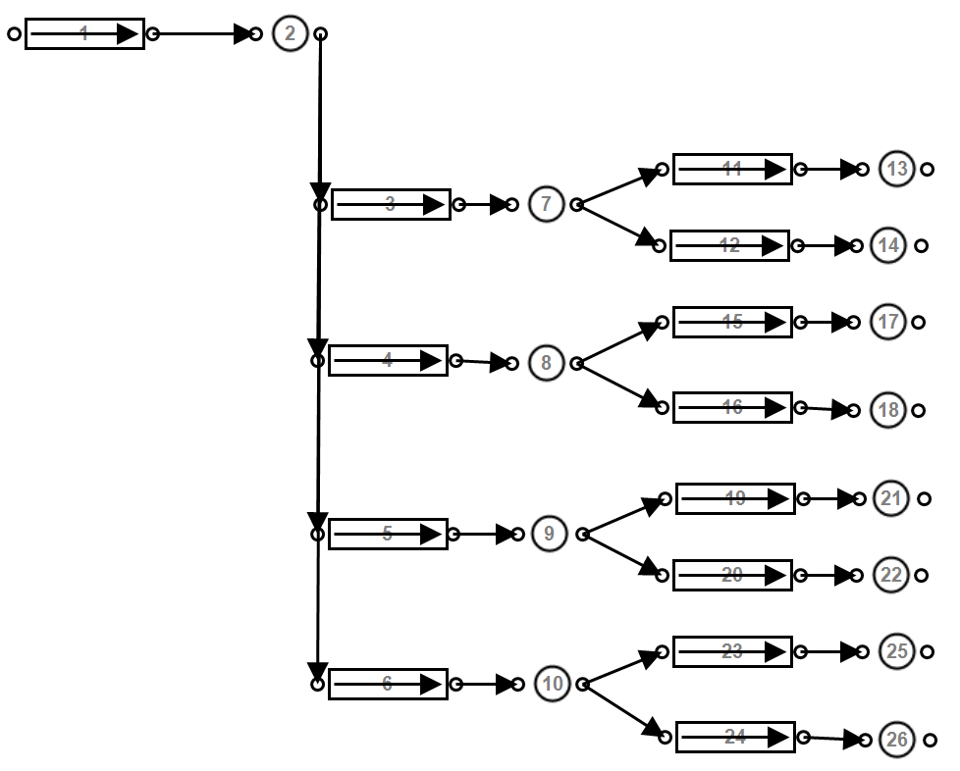

model. Figure 3.2 shows an example of different boundary selection for the same system.

Period and data step sizes of the simulation is just as important. The period or duration of the simulation should be determined to ensure that the effects of a scenario are fully tested. Most commonly, previous studies have simulated a ”typical” 24 hour period of operation. Most mining compressed air systems follow daily trends and patterns. Therefore, there is no need to simulate a longer period as day to day results would be very similar. A longer simulation may be required for cases where the system operation varies from day to day.

The simulation step size indicates the data resolution. A lower step size will result in a more accurate simulation of the system. However, the processing and data analysis is effected. In this study, the smallest available step size1 is selected to ensure that the simulated results achieve the desired precision. Higher step sizes (30+ min.) makes replication of the process control more difficult as quick changes such as opening/closing valves the or compressors stopping or starting may occur within minutes or seconds.

A higher time-step resolution allows for more precise tuning of controllers and dynamic components. If input data is not available at the desired resolution, the data can be interpolated using the appropriate method. An example of the application of linear interpolation to in-

1 The minimum step size is determined from the logging interval of the input data instrumentation. For example, if all input data is logged at 10-minute intervals, the minimum step size would also be 10 minutes.

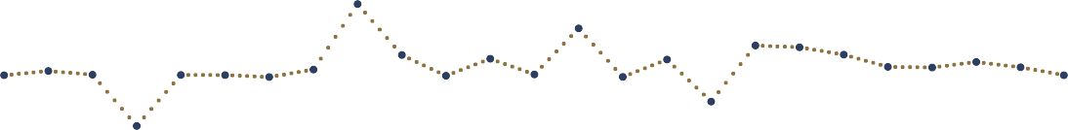creasing the time-step resolution as shown in fig. 3.3. However, incorrectly estimating the “in-between” time-step value may adversely affect the simulation accuracy.

14

12

10

8

6

4

2

0

00:00

04:00

08:00

12:00

Time of Day

16:00

20:00

00:00

Interpolated datset Orginal dataset

c/kWhr

|  |  |  |  |  |  |
| --- | --- | --- | --- | --- | --- |
|  |  |  |  |  |  |
|  |  |  |  |  |  |
|  |  |  |  |  |  |
|  |  |  |  |  |  |
|  |  |  |  |  |  |
|  |  |  |  |  |  |
|  |  |  |  |  |  |
|  |  |  |  |  |  |

Figure 3.3: Interpolating input data to increase time-step resolution.

### Model compressed air network components

#### Air pipes

Pressure losses occur over compressed air networks due to friction within the pipe; these losses should be taken into account in the simulation for large piping sections. A pipe model is used to account for these losses which are defined by the *Darcy-Weissman equation*2:

∆*P* =

*f LρV* 2

2*D*

Where the pressure difference ∆*P* is a function of:

Parameter Definition

*f* Friction coefficient

*L* Pipe length (*m*)

*D* Pipe diameter (*m*)

*ρ* Air density (*kg/m*3)

*V* Average velocity (*m/s*)

Table 3.1: Air pipe component model parameters.

The pipe component may be used as a valve by controlling the open fraction between 0 and

2 B. Glenn, ‘The Darcy–Weisbach Equation,’[Online] [https://bae.okstate.edu/faculty-sites/Darcy/](https://bae.okstate.edu/faculty-sites/Darcy/DarcyWeisbach/Darcy-WeisbachEq.htm) [DarcyWeisbach/Darcy-WeisbachEq.htm](https://bae.okstate.edu/faculty-sites/Darcy/DarcyWeisbach/Darcy-WeisbachEq.htm), [Accessed 20-05-2017]

1. Modelling the valve flow characteristics is discussed in section 3.3.3 *Controllers*.

#### Ambient conditions

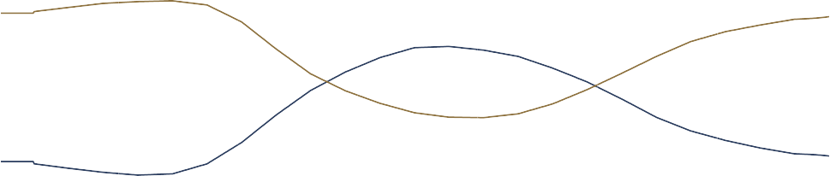Ambient air condition underground and on the surface change the characteristics of the air, affecting the operation of the system. Figure 3.4 shows the average summer air conditions. If no data is available for the specific simulation period, the conditions can be estimated by scaling this profile. The assumption is made that underground conditions remain constant

35

100

30

80

25

60

20

40

15

20

10

00:00

04:00

08:00

12:00

Time of Day

16:00

20:00

0

00:00

Temperature Relative Humidity

Relative Humidity (%)

Temperature ()*◦C*)

|  |  |  |  |  |  |
| --- | --- | --- | --- | --- | --- |
|  |  |  |  |  |  |
|  |  |  |  |  |  |
|  |  |  |  |  |  |
|  |  |  |  |  |  |
|  |  |  |  |  |  |

Figure 3.4: Average summer ambient air conditions at a South African gold mine.

at each mining level. Pressure and temperature increase with depth as a result of auto compression and rock face temperature. Therefore, the conditions can be estimated using only the depth at each level.

#### Compressors

Three compressor models were investigated, each with varying complexity. The models are:

* + Air compressor
  + Dynamic compressor
  + Positive displacement compressor

The air compressor is a general, simplified model. It requires minimal user inputs by making several assumptions. This model is useful when parameters for a compressor are not available. Alternatively, the air compressor model is ideal when doing a quick or preliminary simulation. However, it is not ideal for detailed simulations which require more precision.

The dynamic compressor components are more complex, taking into account factors such as heat generated by polytropic

coefficient and inefficiencies within the process. Hence, the model can be used more accurately and for more complex simulations than the general compressor model. However, it should be noted that the dynamic compressor is simplified by several assumptions, for example, a constant efficiency at varying loads.

For most scenarios, the dynamic compressor model is most suitable. This component is modelled by fitting a quadratic curve through three points of operation to obtain an equation for corrected mass flow as a function of the pressure ratio. This characteristic curve of a compressor s shown in fig. 3.5 can be accurately estimated even when only one data point is available by making approximations for the zero flow and pressure points on the curve.

Once the flow characteristics of the compressors are set, the efficiency and polytropic coefficient parameters are calibrated such that the output power and air temperature match the actual or estimated outputs of the compressor. Once the models are accurately cali-



500

400

300

200

100

0

0

2

4

6

8

Pressure ratio

10

12

14

16

Mass flow (*kg*3*/s/*/(*k*)*/Bar*)

|  |  |  |  |  |  |  |  |
| --- | --- | --- | --- | --- | --- | --- | --- |
|  |  |  |  |  |  |  |  |
|  |  |  |  | *f* (*x*) | = −2*.*586 | *x*2 + 7*.*78 | 8*x* + 494 |
|  |  |  |  |  |  |  |  |
|  |  |  |  |  |  |  |  |
|  |  |  |  |  |  |  |  |
|  |  |  |  |  |  |  |  |

Figure 3.5: Estimating the characteristic curve of a compressor by fitting a quadratic function to points of operation.

brated, the compressor component integrates into the air network in the arrangement shown in fig. 3.6. The Compressor is connected to the inlet air source via an inlet pipe and air node and the rest of the network via an air node and outlet pipe. The additional pipe components allow the inlet and outlet conditions to be monitored and controlled in the simulation.

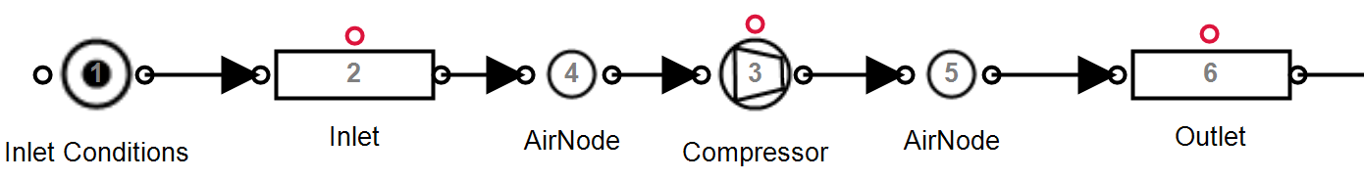

Figure 3.6: Integrating the compressor component into the simulation.

#### Demand/leak

A flow demand represents any air flow leaving the network. Flows leaving the network include any air consuming equipment such as drills and agitators as well as losses like air leaks and open pipes. The air flow is dependent on pressure and the specific resistance to flow of the outlet.

The resistance of the flow demand can be obtained using the inlet pressure, outlet pressure and flow. If the flow is not known, a reasonably accurate estimation can be made by calculating the expected flow from the size of the outlet. The air demand may vary throughout the day. For example, a mining section may utilise more machines during certain periods of the day. A schedule is used to replicate this in the simulation. fig. 3.7 shows how a calibrated air demand or leak is integrated into the simulation.

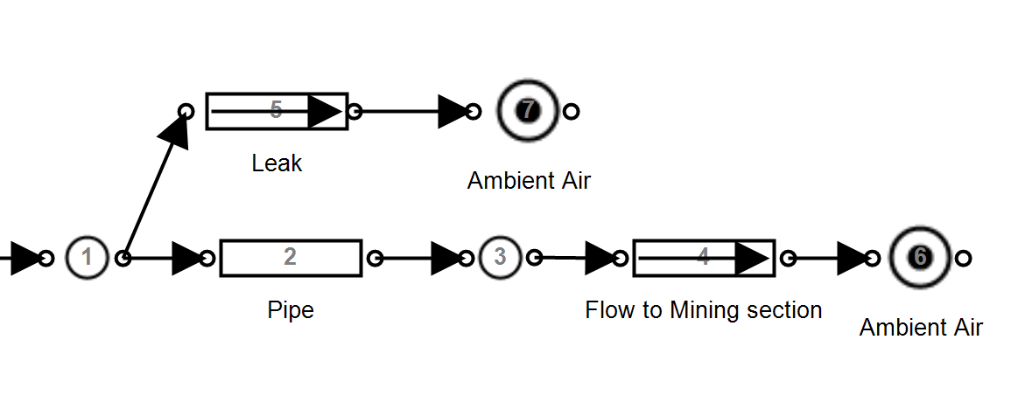

Figure 3.7: Implementing flow demands and leaks into the simulation.

#### Compressed air control

Simulation components require dynamic control to replicate the operation of the actual air network. Control is typically implemented on compressors and valves throughout the network to follow setpoints and schedules. It is important to not only include the controllers in the simulation but to replicate any nonlinearities, limitations and response delays related to specific types of control. Implementing these control factors will ensure the model reacts in the same way the actual network would, improving accuracy.

On a typical mine, compressors power is controlled to ensure that the discharge pressure matches a specified setpoint. This control is achieved through either VSDs (or Variable Frequency Drives (VFDs)) and guide vane control. VFDs provide a broad range of power control and can be estimated using a Proportional-Integral (PI) controller as shown in fig. 3.8. The discharge pressure is used as feedback for the control system.

Guide vanes are most commonly used in mining to control compressors. Guide vane control entails controlling the position of the inlet guide vane. The guide vane is opened or closed to

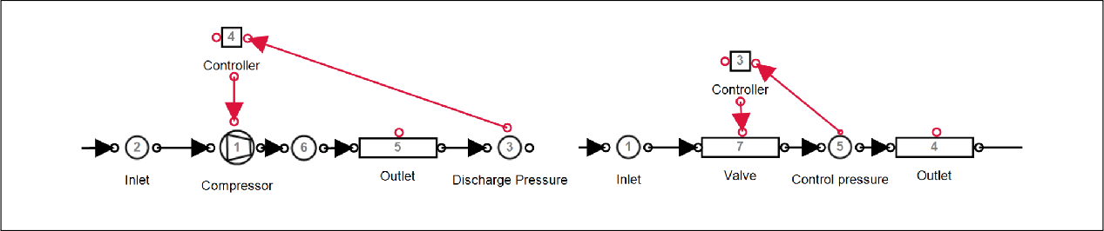

Figure 3.8: Control components in PTB.

control the compressors discharge pressure. Manipulating the guide vane position will affect the power the compressor inputs into the system.

fig. 3.9 shows the relationship between power and guide vane position. The relationship can be estimated as a linear function where a guide vane position of 40% relates to an output power of about 60% of the maximum power. When more pressure is required than can be obtained with the guide vanes fully opened, another compressor is needed to operate.

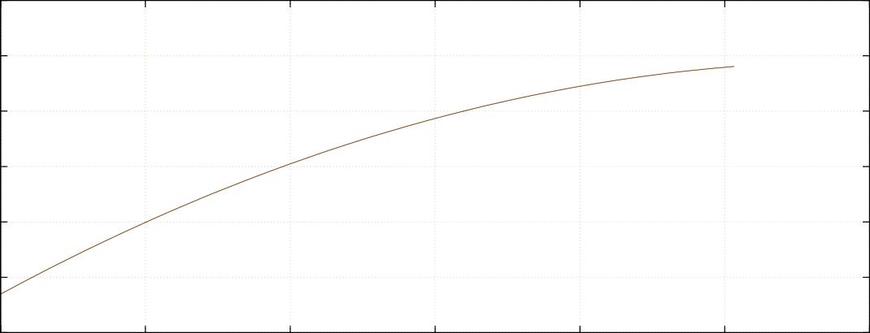

Output power (%)

120

100

80

60

40

20

0

0

20

40

60

80

100

120

Guide Vain Position (%)

Figure 3.9: Modelling the compressor control from a guide vane1.

A guide vane controller is modelled using a PI controller. However, the nonlinear limitations of guide vane control, as represented in fig. 3.9, must be implemented in the controller. The control limitation is applied in the model by using a minimum control output limit that matches the minimum power reduction achieved by closing the guide vane to its minimum position. For example, a PI controller for the compressor from fig. 3.9 would have a minimum control output of approximately 60%.



1 Data recorded from a guide vane controlled compressor on a mine over a period of six months.

Mines utilise control valves at underground sections to adjust the pressure at individual mining stations independently [63]. Controlling of valve components is performed similarly as control of the compressor components. Figure 3.8 shows the outlet pressure is used as feedback for a PI controller. The control output is mapped to the valve fraction of a pipe component.

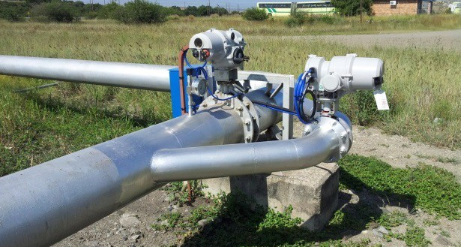

Figure 3.10: An example of a compressed air control valve[64].

#### Compressed air after-cooling

The air compression process generates significant heat. Compressed air at high temperatures contains a significant amount of water vapour. After-coolers are installed on compressed air systems to prevent condensation in the air network, improve the system capacity and to protect equipment from excessive heat [27].

After-cooling reduces the compressed air temperature out of the compressors. This cooling can affect the operation of the network. Hence, including after-cooling to the simulation model should improve accuracy.

Modelling the after-cooling is achieved using a heat transfer node can be added to the outlet of the compressor component. The heat transfer parameters shown in table 3.2 should be calibrated such that the air temperature matches after-cooled air temperature measurements. An assumption of 40 *◦*Celcius can be used if no measurements are available. Depending on the accuracy requirement, after-cooling can be excluded from the simulation. Post after-cooling, compressed air is usually still warmer than ambient conditions. Air temperatures underground can be accurately matched by including heat transfer for compressed air pipelines.

Parameter Definition Unit

*A* The heat transfer area *m*2

*U A* Heat transfer coefficient *kW/◦C*

*Tamb* Ambient air temperature *◦C*

Table 3.2: The input parameters for the after-cooling simulation model.

### Verify the simulation model

From the review of literature in section 2.4.6, it was determined that MAE and the coefficient of determination are the most effective methods of measuring model accuracy. Therefore, for this study, both measures are utilised in the model verification. These measures are obtained by comparing the major simulation outputs (Total system power, flow and pressure) to actual data from the system. R-sqaured and MAE are calculated by applying the applicable methodologies discussed in section 2.4.6.

For this study, the selected verification constraints were selected as :

*r*2 *>* 0*.*9 and *Err*% *<* 5%

If these limits are met for the power, flow and pressure of the system, the model is considered accurate. As an extra measure relative error of the output for the minor model components should be *>* 85% of the actual data.

### Select simulation inputs

The inputs of a simulation are any parameters that do not remain static or follow the same profile in day to day operation of the system. Examples of such parameters in a compressed air simulation are:

* + - * Surface ambient conditions
      * Machine operation schedules
      * Air demands
      * Operational changes

Changing the simulation baseline period for a calibrated simulation should only require the updating of the input parameters. fig. 3.11 shows an example of a changing compressor schedule where an input parameter would need to be updated in the simulation.

|  |  |  |  |  |  |
| --- | --- | --- | --- | --- | --- |
|  |  |  |  |  |  |
|  |  |  |  |  |  |
|  |  |  |  |  |  |
|  |  |  |  |  |  |
|  |  |  |  |  |  |
|  |  |  |  |  |  |
|  |  |  |  |  |  |
|  |  |  |  |  |  |
|  |  |  |  |  |  |

Figure 3.11: An example of two baseline periods, showing a changed compressor schedule.

8

7

6

5

4

3

2

1

00:00

04:00

08:00

Period 1

12:00

Time of Day

Period 2

16:00

20:00

00:00

Compressor

### Periodic simulation

Periodic simulation refers to the repetition of simulations over subsequent periods to determine the sequential accuracy of the model. Sequential accuracy is important to verify the model is valid in general and not just a single period. This simulation will also indicate where operation changes have occurred as the simulation accuracy will be reduced.

The following process is followed to implement periodic simulation: Simulation input data is collected periodically for each simulation interval, this information includes only inputs that vary days to days such as schedules, air conditions and measured flows. Once the input values are collected, they limitations into the compressed air model. The simulation performed, and the output data is exported for analysis. The simulated data is then compared with the actual operation of the system and major discrepancies are identified. This process is triggered periodically.

### Summary

In this section, the subprocesses required for the simulation model development and verification were discussed. First, a method for selection of the model boundaries and parameters were discussed. A discussion on modelling procedure for compressed air sub components then followed. The verification process and the selection of accuracy limits were then discussed concerning the analysis performed in section section 2.4.6. The simulation input selection procedure was then reviewed. Finally, a procedure for repeated/periodic simulation was provided.

Figure 3.12: The periodic simulation process that was followed in this analysis.

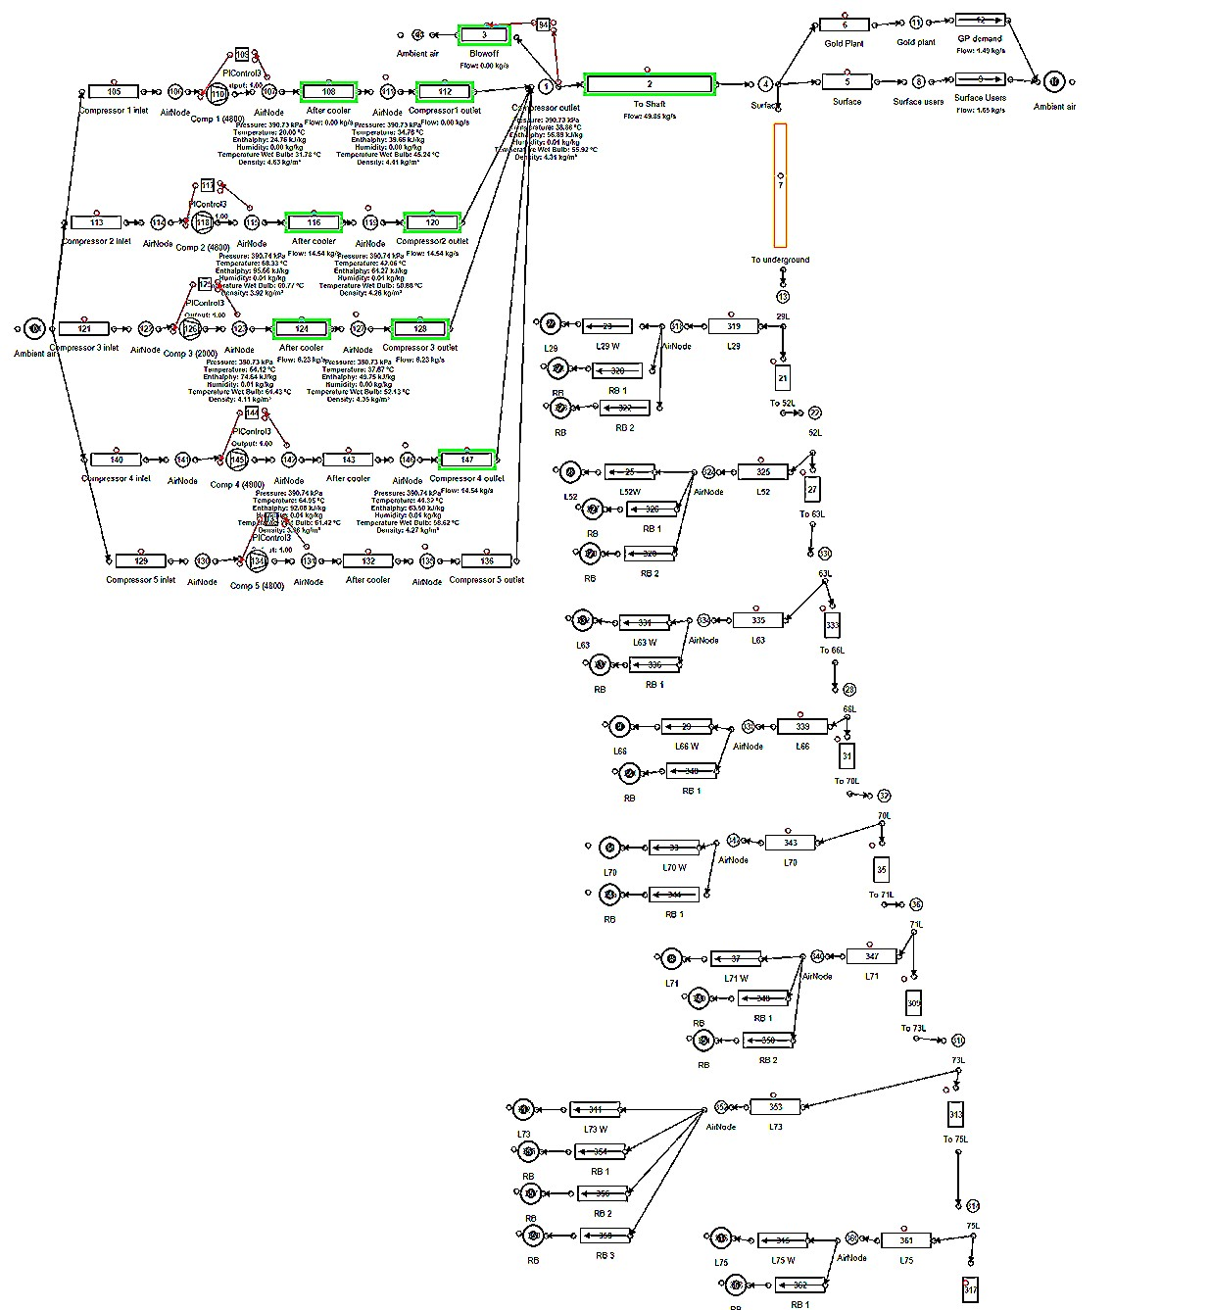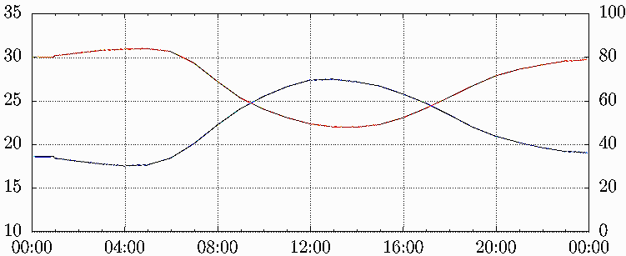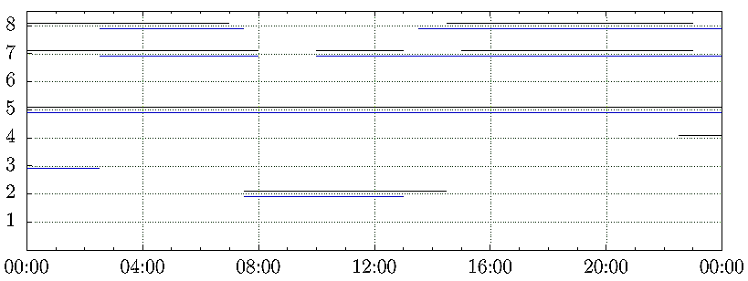

Analysis

Data sources

Update simulation inputs

Repeat periodically

Import into simulation model

Solve simulation

Export Simulation output data

## Implement the simulation

### Preamble

Once a simulation has been developed and verified, the implementation of interventions and scenarios then follows. In this section, the approach of implementation the simulation methodology, and analysis of interventions will be discussed.

### Execute simulation scenarios

At this point, the simulation model has been verified using historical data. The verified output data series is now used as baseline upon which the success of improvements scenarios can be quantified. The simulation inputs of the model are now adjusted to create the desired scenario. For example to create a scenario where a specific compressor is shut down over a period, the input schedule of the compressor is adjusted in the simulation model.

The simulation is then executed, and this process is repeated for each of the scenarios. For each scenario, the desired output parameters must be exported for further analysis.

### Quantify operational benefit

With the data for each of the simulated scenarios exported, the relative improvement compared with the baseline should now be quantified. This comparison is achieved by analysing the differences between the baseline and optimised data series as shown visually in fig. 3.13.

Power (*M W* )

Power Saving (*M W* )



0

00:00

04:00

08:00

12:00

16:00

20:00

0

00:00

Figure 3.13: An example of a baseline vs. optimised power comparison.

12

1

0*.*75

8

0*.*5

4

0*.*25

Time of Day

Baseline

Scenario Power saving

For power data, the expected annual energy cost saving can be calculated using average weekday energy saving and the tariff structure provided by Eskom. The energy supplier’s weekday Time Of Use (TOU)tariffs for both the high demand (Jun Aug) and low demand (Sep May) seasons are shown in fig. 3.14.

Estimating the cost benefit for improvements in pressure delivery is harder to quantify. Instead, the average pressure benefit should for a period be provided in kPa. For example, “The simulation indicated an *x* MW saving with an additional pressure improvement of *y* kPa during the drilling shift.”.

### Report results to the mine

Once the benefits for each simulated scenario has been calculated and quantified, the interventions should be prioritised in the order of greatest benefit for the mine. The implementation costs and pay back periods of the interventions can also be considered in this process.

1 Eskom, ”2017/18 Tariffs and charges” [Online] [http://www.eskom.co.za/CustomerCare/](http://www.eskom.co.za/CustomerCare/TariffsAndCharges/Pages/Tariffs_And_Charges.aspx) [TariffsAndCharges/Pages/Tariffs_And_Charges.aspx](http://www.eskom.co.za/CustomerCare/TariffsAndCharges/Pages/Tariffs_And_Charges.aspx), [Accessed 28 June 2017].

c/kWhr

300

250

200

150

100

50

0

00:00

04:00

08:00

12:00

16:00

20:00

00:00

Figure 3.14: Eskom’s weekday TOU tariff structure.1

Time of Day

High demand season Low demand season

The results and recommendations should be submitted to responsible mine personal in the form of a report. At this point, the process of implementation becomes the mine’s responsibility. The mine may require further validation of the results through practical testing.

### Summary

This section discussed the of implantation of the simulation procedure. Implementation involves execution of the simulation scenarios, followed by the numerical calculation and quantification of energy cost savings and other benefits. Finally, the procedure to report findings to the mine is given.

## Conclusion

The aim of chapter 3 was to provide a methodology to develop compressed air simulations. The method was broken into three steps:

* + 1. Investigate the system
    2. Develop and verify a simulation model
    3. Execute the simulated scenarios and quantify the benefits

This investigation step involved obtaining and verifying data and information regarding the compressed air network. Processes to resolve scenarios where data can not be obtained were also provided.

In the next step, a simulation model development and verification procedure were provided. This procedure also described the selection of model and simulation parameters, the development of subcomponent models as well as a verification procedure A methodology for repeated/periodic simulation was also provided.

The final step involved the execution of the simulation followed by the methods to calculate, quantify and report potential benefits of the simulated scenarios.

## Introduction

This section will validate the simulation methodology through case studies. Mining compressed air systems were chosen as case studies based on the availability of data and the scope for energy and operational improvement. Two different mines were selected for the studies.

Three case studies were performed. In case study 1 and 2, improvements were simulated on mine A and mine B respectively. In Case study three periodic simulation analysis is implemented using the simulation developed for case study 2. From the results of the case studies, the potential benefits compressed air simulations for the South Africa mining industry is estimated and discussed.

## Case study 1. Simulated improvements on mine A

### System investigation

Mine A represents a group of three gold mining shafts and a gold processing plant in the Free state province. The mine shafts and gold plant share a compressed network. Before this study, efforts had been made to optimise the system through DSM energy projects. However, there may still be potential for further optimisation. An investigation was performed to gather data and understanding of the system and to identify potential energy and operation improvement strategies.

An air flow distribution layout was developed for the system; a simplified layout is shown in fig. 4.1. From the schematic along with information and data, an understanding of the air network’s operation was obtained. The system typically utilises 5 *M W* of power. During the drilling shift, the demand increases to 6 *M W* . fig. 4.2 shows the average weekday power profile between January and May 2016.

Inlet air

VK32 6

VK10 1

VK10 2

VK32 1

VK32 2

VK32 3

VK32 4

VK32 5

Gold Plant

#2 Shaft

#1 Shaft

#3 Shaft

22L

23L

24L

25L

14L

15L

16L

17L

18L

19L

20L

21L

22L

23L

Online Standby Air flow Compressor



Control valve

24L

25L

26L



Figure 4.1: Simplified process flow chart of the compressed air network.

|  |  |  |  |  |  |  |
| --- | --- | --- | --- | --- | --- | --- |
|  |  |  |  |  |  | |
|  |  |  |  |  |  |  |
|  |  |  |  |  |  | |
|  |  |  |  |  |  | |
|  |  |  |  |  |  | |
|  |  |  |  |  |  | |

Figure 4.2: Average power profile

6

5

4

3

2

1

0

00:00

04:00

08:00

12:00

Time of Day

16:00

20:00

00:00

Power (*M W* )

Seven compresses are available in the system. Five large compressors (VK32) rated at 2.9 *M W* each and two smaller compressors (VK10) with a power rating of 1.1 *M W* each. No more than four compressors are required at any time; the other compressors are therefore on standby. Air is supplied to the sections in three mining shafts as well as a gold processing plant on the surface.

The mine normally operates the compressors with a constant pressure setpoint of 500 *kP a*. The setpoint is kept this high as the gold processing plant requires constant high pressure throughout the day. This makes it difficult to reduce the setpoints of the compressor. It is possible to control the air supply pressure to the gold plant independently from the rest of the network. The supply to the gold plant by controlled by the surface valves.

The evening Eskom energy peak time was identified as a period where savings could be obtained. During this time, air is not required underground as blasting is scheduled. Due to the energy tariff structure, interventions during the energy peak also maximise the financial benefit for the mine. Compressor setpoint control and underground valve control were identified as strategies to achieve these savings. Due to the risk of loss of production, the mine would not allow practically testing the scenario on the actual system. The simulation was therefore required to accurately calculate and analyse the benefits of the of compressor set points. A model was developed to test these scenarios.

### Model development

With the data and understanding of the gathered from the investigation, a model was developed using the PTB software tool and the methodology discussed in Chapter 3. First, the simulation boundary was selected to include the measured flows to each level underground, as well as the surface processing plant. For highest accuracy, the simulation step size was

set to 30 minutes to match the available data resolution.

The simulation component models were developed and calibrated using the respective methods discussed in chapter 3. The following assumptions were made to simplify the model development:

* + - * The effect of compressed air after-cooling is negligible
      * Heat transfer over the pipe length is negligible
      * Underground temperature and humidity remained constant for each level
      * Surface ambient air conditions followed normal summer trend

The model components were calibrated so that the simulated outputs matched data from the real system. The process flow diagram for the simulation is shown in fig. I.1. The model data inputs and outputs are described in table 4.1.

Inputs Outputs

Level measured flows Compressor powers

Compressor schedules Network flows

Compressor setpoints Network pressures Underground valve setpoints

Table 4.1: Data inputs and outputs for the Case study 1 simulation model

### Verification of model

Verification was performed to ensure that simulated output accuracy was *>* 95%. fig. 4.3, fig. 4.3 and fig. 4.5 show the to total simulated power, flow and outlet pressure of the compressors compared to the system. The average accuracy for the power and total flow was 97.34% and 97.01% respectively. Both these parameters were well within the target relative error of 5% relative error. The accuracy of the outlet pressure was 99.1%.

The accuracy of the model was checked in more detail to ensure that each modelled parameter matched the actual measurement with high accuracy. table II.1 shows the accuracy each measured simulation output in the model.

### Scenario 1. Compressor set points

The Eskom evening peak tariff time occurs during the blasting shift. During this time, the pressure requirements underground are lower than the rest of the day. Reducing pressure in the network reduces power as less work is required from the compressors. Additionally, losses caused by air leaks are reduced. However, lowering the pressure setpoint of the compressors

10

%*error*



Verification method Result *Err*%

#### Total Flow

|  |  |  |
| --- | --- | --- |
| Residual Difference | 0.25 kg/s | 2.73% |
| MAE | 0.27 kg/s error | 3.0% |
| Coefficient of determination | *r*2 = 0*.*99 | - |

**Total power**

|  |  |  |
| --- | --- | --- |
| Residual Difference | 0.02 MW | 0.57% |
| MAE | 0.14 MW error | 2.78% |
| Coefficient of determination | *r*2 = 0*.*91 | - |

|  |  |  |
| --- | --- | --- |
| **Compressor outlet pressure** |  | |
| Residual Difference | 0.03 kPa | 0.01% |
| MAE | 0.21 kPa error | 0.03% |
| Coefficient of determination | *r*2 = 0*.*99 | - |



Table 4.2: Case study 1: Verification of simulation model.

20

8

7

6

5

4

3

2

1

0

00:00

Baseline power

Simulated power

Rel. Error

Figure 4.3: The simulated power compared to the actual measurement requires independently controlling the air to the gold plant.

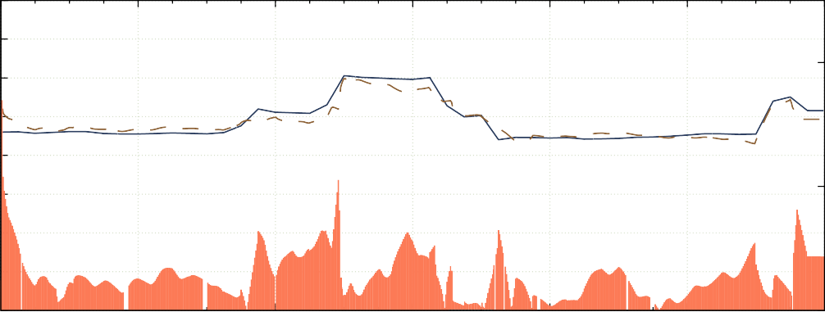

04:00

08:00

12:00

16:00

20:00

0

00:00

Time of Day

Power (*M W* )

The compressor set-points were reduced for the simulation model to 420 *kP a*, the minimum allowed compressor set-point during the drilling shift. The compressor schedule was changed to allow independent control of the gold plant pressure. Gold plant pressure was maintained

10

5

10

%*error*

15

20

0

00:00

04:00

08:00

12:00

16:00

20:00

0

00:00

Baseline flow

Simulated flow

Error

Figure 4.4: The simulated flow compared to the actual measurement

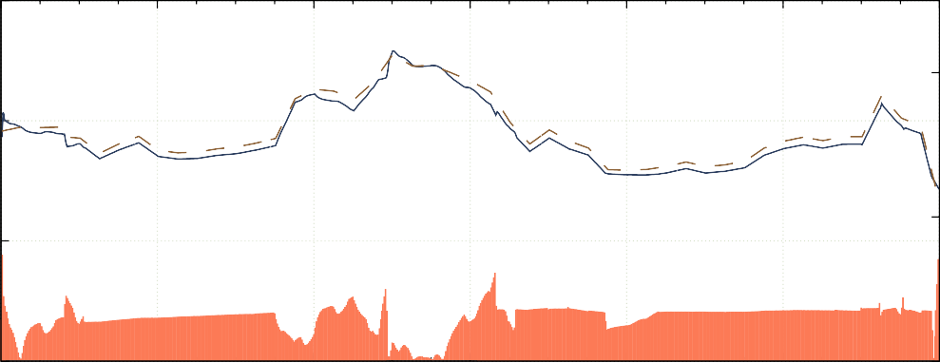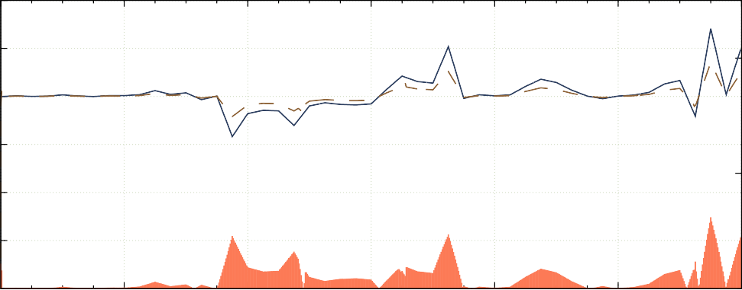

Time of Day

600

550

20

500

450

10

400

350

Pressure (*kP a*)

Flow (*kg/s*)

%*error*

300

00:00

04:00

08:00

12:00

16:00

20:00

0

00:00

Baseline press.

Simulated press.

Rel. Error

Figure 4.5: The simulated Pressure compared to the actual measurement at 490 *kP a*.

Time of Day

The results of the simulation, shown, in fig. 4.6, indicated an average power reduction of

0.46 MW Peak-clip (P.C.). This energy optimisation relates to a R0.37 M Per annum (p.a) energy cost saving to the mine.

### Scenario 2. Control valves set points

An alternative scenario is to reduce the pressure at the control valves at each level. By reducing pressure at the control, setpoints can be lowered to the minimum requirement per level. This reduction can lead to higher savings than could be achieved through compressor setpoint reduction. This scenario would be relatively easy to implement as it does not require any changes to the compressor control schedule.



0

00:00

04:00

08:00

12:00

16:00

20:00

0

00:00

Figure 4.6: Energy savings by reducing compressor setpoints

6

2

1*.*5

4

1

2

0*.*5

Baseline

Intervention

Time of Day

Power saving

Power (*M W* )

Power Saving (*M W* )

Air pressure setpoints were reduced to 300 kPa at the underground control valves during the evening peak period. Analysis of the simulation results showed a 1MW average P.C. saving. The intervention would lead to an annual cost saving of R0.91M.

6

2

1*.*5

4

1

2

0*.*5

Time of Day

Baseline

Scenario Power saving

Power (*M W* )

Power Saving (*M W* )

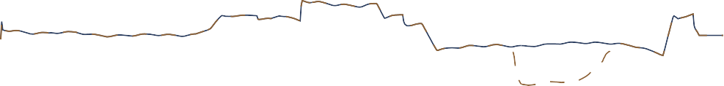

0

00:00

04:00

08:00

12:00

16:00

20:00

0

00:00

Figure 4.7: Power savings

### Comparison of scenario results

Comparing the scenarios in table 4.3 showed that Scenario 2 had a larger peak energy impact than scenario 1. Further savings could be achieved through a combination of the two scenarios as well as investigating setpoint reductions during other periods of the day.

### Validation of results

Scenario 2 was implemented on the actual compressed air system. An energy saving of just under 1 MW P.C. was recorded when compared with the 2016 power baseline profile. These results matched the simulated scenario closely. fig. 4.8 shows the practical result compared

|  |  |  |
| --- | --- | --- |
| Scenario | Power saving | Cost saving p.a |
| **Scenario 1 results**  Reducing compressor setpoints | 0*.*46 MW P.C. | R0.37M |

#### Scenario 2 results

Reducing underground pressure during evening peak 1*.*0 MW P.C. R0*.*91M

Table 4.3: Comparison of Mine A’s simulated scenarios with the simulated and baseline power profiles.

6

2

4

1*.*5

1

2

0*.*5

Power (*M W* )

Power Saving (*M W* )

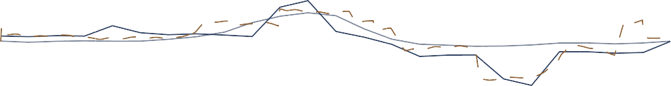

0

00:00

04:00

08:00

12:00

Time of Day

16:00

20:00

0

00:00

Baseline Actual

Simulation

Power saving

Figure 4.8: Actual power savings achieved on the system

### Summary

A case study was implemented on a mine compressed air network in the Freestate. Following the simulation methodology, An investigation was performed to gather data and identify potential interventions. A simulation model was developed to test scenarios. The tested interventions showed a P.C. saving of 1 MW which would result in a cost saving of R0.9M. The simulated was validated by implementation on the actual system leading to similar results.

## Case study 2: Simulated improvements on mine B

### System investigation

Case study B was performed on a large South African gold mine. The mine utilises five compressors supply compressed air to various surface and underground operations. An investigation was carried out to gather the data and information required to build a simulation

model of the network as well as to identify potential cost saving simulation scenarios.

A basic air distribution layout was developed for the system. fig. 4.9 Illustrates the sys tem process in detail, indicating the flow distribution to the three mining shafts and gold processing plant.

Data related to the mines scheduling as well as critical limits and setpoints of the compressed air system was obtained from various mine personnel. From this, a general understanding of the operation was obtained. Critical data parameters such as Power, pressures and flows of the system were gathered from the SCADA as well other data measurement sources. This information will be used to develop and calibrate the simulation model

Strategic level investigations were performed on the significant mining levels to map and measure the locations and air usage for the cross-sections, refuge bays, major leaks and other compressed air consumers on each level. An example of a resultant schematic from the underground investigation is shown in fig. III.1. The information gathered from the system investigations was then utilised to develop and calibrate a simulation model.

Inlet air

Gold plant



Comp. 1

Comp. 2

Comp. 3 Comp. 4

Comp. 5

Main shaft

Sub Shaft

73L

76L

78L

80L

82L

85L

88L

92L

Online Standby Air flow Compressor

Control valve

Manual valve

95L

98L

102L

105L

190L

113L

29L

52L

66L

70L

71L

Figure 4.9: Process schematic of the compressed air network.

### Model development

From the investigation, a simulation model was developed in PTB. The methodology described in Chapter 3 was utilised in this process. The following assumptions made to simplify the model development:

* + - * After cooling reduced compressed air temperature from 60*o* Celcius to 40*o* Celcius
      * Underground temperature and humidity remained constant for each level

The boundaries of the baseline simulation were selected based on the available data for the network. The developed simulation model is shown in fig. I.2. For maximum accuracy, the simulation step size was set to the two minutes to match the resolution available from the data source. The model components were calibrated so that the simulated outputs matched data from the real system. The process flow diagram for the simulation is shown in fig. I.2. The model data inputs and outputs are described in table 4.1.

Inputs Outputs

Level measured flows Compressor powers

Compressor schedules Network flows

Set-points Network pressures

Table 4.4: Simulation inputs and outputs

#### Verification of baseline simulation

Using the verification methodology, the simulation model verified by comparing the simulation outputs to actual measured values. The compressors outlet pressure often does not match the set-point. The measured outlet pressure was used as set points for the compressors to verify the power and flow outputs. The setpoints ensured that the pressure in the network is identical to that of the actual system as shown in fig. 4.10.

With the simulated pressure identical to the actual, the power and air flow outputs were compared with outputs from the physical system. fig. 4.11 shows the comparison of the total power and flow of the system with the physically measured values for that same period. The accuracy of these parameters compared to the real system was 98*.*7% and 99*.*0% respectively. This was within the acceptable error limits.

Once the power and flow parameters were verified with an acceptable error, the actual pressure set-point profile was imported to the compressor controllers. The simulated outlet pressure was then compared to the actual measured pressure and setpoint, this is shown

%*error*

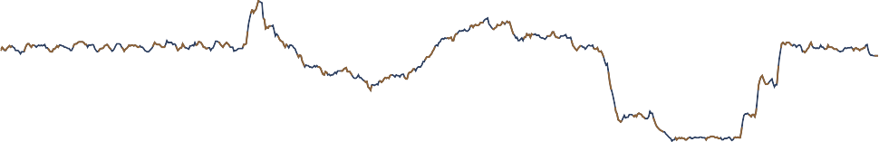

300

00:00

04:00

08:00

12:00

16:00

20:00

0

00:00

Figure 4.10: Comparing the pressure response of simulation to the actual measured pressure Verification method Result *Err*%

450

20

400

350

10

Baseline press.

Simulated press.

Time of Day

Rel. Error

Pressure (*kP a*)

#### Total Flow

|  |  |  |
| --- | --- | --- |
| Residual Difference | 0.22 kg/s | 0.53% |
| MAE | 0.43 kg/s error | 1.02% |
| Coefficient of determination | *r*2 = 0*.*99 | - |

**Total power**

|  |  |  |
| --- | --- | --- |
| Residual Difference | 0.05 MW | 0.39% |
| MAE | 0.16 MW error | 1.36% |
| Coefficient of determination | *r*2 = 0*.*91 | - |

|  |  |  |
| --- | --- | --- |
| **Compressor outlet pressure** |  | |
| Residual Difference | 2.79 kPa | 0.71% |
| MAE | 3.85 kPa error | 0.98% |
| Coefficient of determination | *r*2 = 0*.*890 | - |

Table 4.5: Verification of simulation model.

in fig. 4.12. The accuracy of the compressor outlet pressure was acceptable at 99.02 %. The measured flows for all measured subcomponents were independently verified to ensure system accuracy. A comparison between simulation outputs and physical measurements is shown in table II.3.

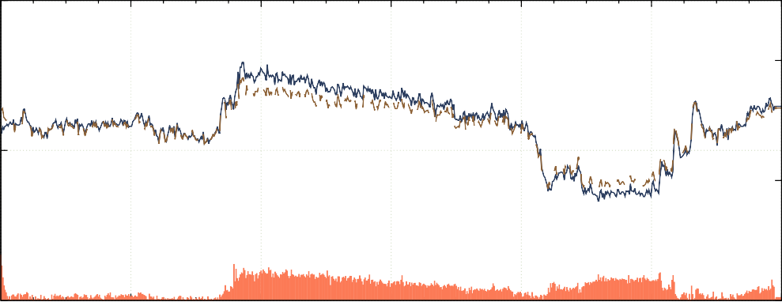

Time of Day

15

14

13

12

20

10

Power (*M W* )

flow (*kg/s*)

%*error*

%*error*

50

20

40

10

30

00:00

04:00

08:00

12:00

16:00

20:00

0

00:00

Baseline flow

Simulated flow

Rel. Error

(a)

Baseline power

Simulated power

Rel. Error

(b)

Figure 4.11: Verification of the total (a) flow and (b) power of the system using the actual pressure profile.

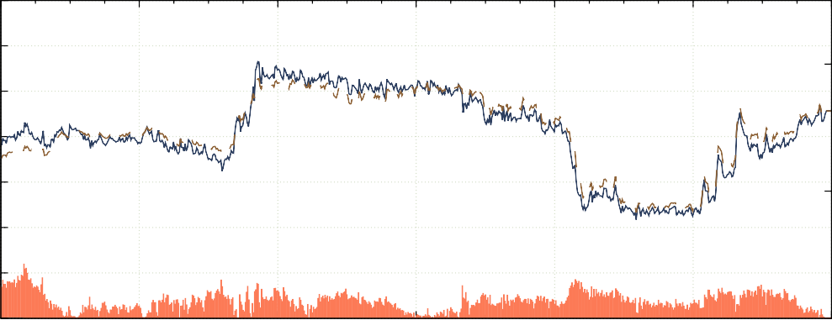

11

10

9

8

00:00

04:00

08:00

12:00

16:00

20:00

0

00:00

Time of Day

### Scenario 1. Refuge bay optimisation

After an underground investigation, unnecessary refuge bay leaks were identified as a significant inefficiency that can be reduced. A test on a single mining level was performed to measure the potential flow saving of reducing refuge bay leaks. The test showed that by reducing refuge bay leaks, by closing the valves, would lead to an average air saving of 0*.*05 *kg/s* per refuge bay at normal operational pressures. This measurement was conservative as it was not possible to close all the refuge bays on the level for the test.

Due to the size of the mine, extending these tests to include the rest of the mining sections was not practical. Therefore, the benefits of an intervention on the entire mine could not

%*error*

300

00:00

04:00

08:00

12:00

Time of Day

16:00

20:00

0

00:00

Actual

Set-point Rel. Error

Figure 4.12: Verifying the Pressure response of the system given the pressure set points as inputs

450

20

400

350

10

Simulation.

Pressure (*kP a*)

accurately be determined from practical tests. Using simulation the typical operation with can be accurately compared with the intervention scenario to quantify the potential financial and operational benefits throughout a given period.

The simulation model boundaries were updated to include refuge bay leaks on each level. For each refuge chamber, a air leak was added to the model by utilising per level layouts indicating locations of refuge bays. These leaks were modelled as flow demands using the data from the initial refuge bay tests. The overall mass flow of the system was maintained to ensure model accuracy. T By adding the flow component in the actual location in the process, the pressure to each chamber is correctly modelled. The full simulation model is shown in fig. I.7. The updated simulation model was re-checked to ensure accuracy. This model was used as a baseline to quantify saving for the scenario.

Recreating the optimised scenario was modelled by setting the refuge bay flow components to 0 *kg/s*. The simulation was performed and the output data compared to the baseline. fig. 4.13 shows the baseline power compared to the optimised scenario. The comparison showed a potential 0.92 MW improvement in Energy efficiency (E.E.) through optimisation of refuge bay leaks. The optimised scenario would lead to a R5.13M energy cost saving for the mine.

An additional pressure benefit was identified during the drilling shift, shown in fig. 4.14. The reduced flow leads to a pressure increase of about 15 *kP a*. The pressure increase could lead to an increase in drilling efficiency.

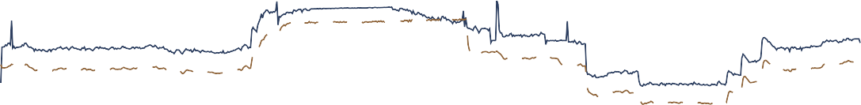

0

00:00

04:00

08:00

12:00

16:00

20:00

00:00

Figure 4.13: The Baseline system power compared to the system power when refuge bay leaks are reduced.

15

10

5

Baseline

Optimised

Time of Day

Power saving

440

420

400

380

Pressure (*kP a*)

Power (*M W* )

11 15 15 15 15 14 19 9 7

360

00:00

04:00

08:00

12:00

Time of Day

16:00

20:00

00:00

Baseline

Optimisation

Figure 4.14: The Baseline system pressure relative to the system pressure when refuge bay leaks are reduced.

### Scenario 2. Closing off levels and inactive work areas

The largest impact on energy costs can be achieved during the energy peak times. At mine B, blasting coincides with the evening energy peak. Typically, the air requirement during this period is lowered. However, due to the high prevalence of compressed air misuse, leaks and open valves, significant amounts of air is still used during these periods. Reducing pressure to areas during these times may lead to a major power and cost saving.

Closing off stope valves and reducing station pressure were identified as two strategies to reduce airflow during the evening peak. The station can not be closed completely as some services still require the air supply.

Simulations were performed to identify the most suitable strategy and to quantify the effect of each on a single mining level. The level was modelled to include all the main leaks, refuge bays and drilling sections.

The components of the modelled were calibrated using manual measurements from an investigation of the level. The simulation schematic for the level is shown in the simulation diagram shown in fig. 4.15. The results of the single level simulation can be expanded to other levels to obtain the total potential improvement that can be achieved.

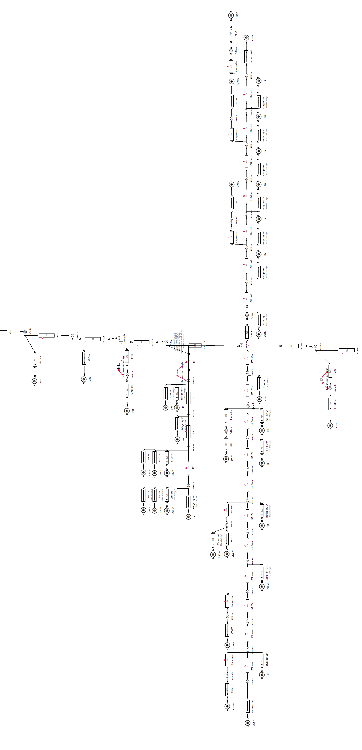

Figure 4.15: Underground level layout.

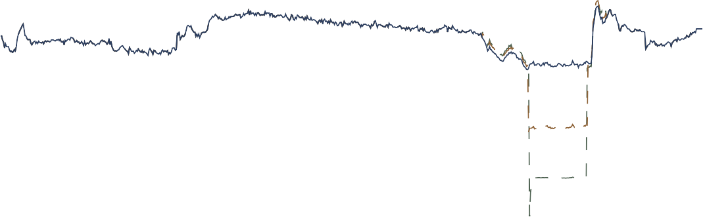Station control, in-stope control and a combination were simulated were all simulated for 105L. Station control means control of the pressure of at the station of the level. In-stope control is control of the is cut the airflow to the mining section during certain periods. fig. 4.16 shows the effect the various interventions have on the flow for 105L compared to the baseline.

4*.*5

4

3*.*5

3

2*.*5

2

1*.*5

1

0*.*5

0

00:00

04:00

08:00

12:00

16:00

20:00

00:00

Station control

In-stope control

Time of Day

Baseline

Flow (*kg/s*)

|  |  |  |  |  |  |
| --- | --- | --- | --- | --- | --- |
|  |  |  |  |  |  |
|  |  |  |  |  |  |
|  |  |  |  |  |  |
|  |  |  |  |  |  |
|  |  |  |  |  |  |
|  |  |  |  |  |  |
|  |  |  |  |  |  |
|  |  |  |  |  |  |
|  |  |  |  |  |  |

Figure 4.16: Flow reduction during blasting period for 105 level

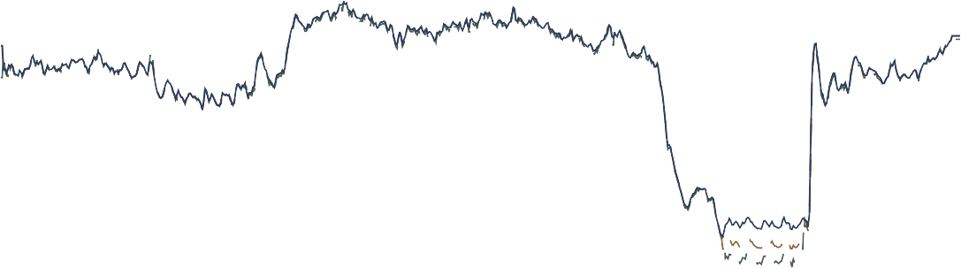Station control had the largest impact on the flow usage for the level. This reflects the power reduction achieved by each intervention shown in fig. 4.17. The impact was 0.4 and 0.7 MW for the stope and station intervention respectively.

14

12

10

8

00:00

04:00

08:00

12:00

16:00

20:00

00:00

Station control

In-stope control

Time of Day

Baseline

Power (*M W* )

|  |  |  |  |  |  |
| --- | --- | --- | --- | --- | --- |
|  |  |  |  |  |  |
|  |  |  |  |  |  |
|  |  |  |  |  |  |
|  |  |  |  |  |  |

Figure 4.17: Comparing simulated flow interventions on 105L.

A simulation was done to estimate the potential savings of extending the evening station control to other levels. This was performed by updating the flow demands for levels 95115 to match the flow saving obtained in the 105L simulation. The savings achieved for general

station control were 2.0 MW P.C., shown in fig. 4.18. It was calculated that this would lead to a annual energy cost saving of R2.5M.

12

8

4

Power (*M W* )

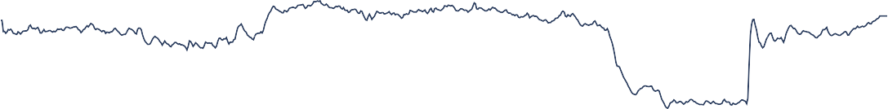

0

00:00

04:00

08:00

12:00

Time of Day Power Savings

16:00

20:00

00:00

Intervention

Baseline

Figure 4.18: Energy saving achieved by general peak time Station control

### Comparison of interventions

The interventions were then compared to feedback to the mine. The refuge bay intervention is recommended as it will achieve the highest energy cost saving. These results were used to produce a report that was sent to the responsible personnel at Mine B.

Scenario Power saving

|  |  |  |  |
| --- | --- | --- | --- |
|  | | (p.a) |  |
| **Scenario 1 results** |  |  |  |
| Refuge bay leakage reduction | 0*.*92 MW E.E. | R5.17M | Increase in drilling pressure |
| **Scenario 2 results** |  |  |  |
| 105L peak time in-Stope control | 0*.*4 MW P.C. | R0*.*3M | - |
| 105L peak time Station control | 0*.*7 MW P.C. | R2*.*5M | - |
| General peak time Station control | 2*.*0 MW P.C. | R2*.*5M | - |

Cost saving

Additional benefit

Table 4.6: Comparison of the simulated scenarios

### Summary

A second case study was implemented on a mine compressed air network. An investigation was performed to gather data and identify potential interventions. This included under-

ground spot checks and measurements.

A simulation model was developed to test scenarios. Two scenarios (refuge bay optimisations and per level flow optimisations) were simulated. The simulated interventions showed a E.E. saving of up to 0.92 MW which would result in a cost saving of R5.17M with an additional pressure improvement for scenario 1. The results for scenario 2 showed a P.C. impact of up to 2 MW with an annual energy cost saving of R2.5M. The results of the simulations were reported to the mine.

## Case study 3: Periodic simulation analysis

### Preamble

Periodically Updating the inputs of a simulation could be used to verify simulation model accuracy. If the precision of simulation outputs remains for subsequent days, this would indicate that the model is correctly calibrated. Additionally, this process could be used to identify significant operational changes that occur within the system. This would cause the simulation outputs to differ from the actual measured parameters.

A daily periodic simulation analysis was implemented between 2016/11/01 and 2016/11/30 using the periodic simulation methodology discussed in Chapter 3. The simulation model developed for case study A was used for the analysis. The simulation receives the data inputs shown in table 4.7.

Inputs Outputs

Ambient air conditions Compressor power Measured flows Flows

Compressor schedules Pressures

Table 4.7: Data inputs and outputs for the simulation

### Results

The process was triggered daily. For each period, data inputs shown in table 4.7 were imported into the model, the simulation was then processed, and the outputs are compared with the real system parameters. fig. 4.19 shows the average daily accuracy of the simulated total system power, flow and the shaft pressure per period.

The accuracy of the process parameters of the simulation was within 5% for the duration

|  |  |  |  |  |
| --- | --- | --- | --- | --- |
|  |  |  |  |  |
|  |  |  |  |  |
|  |  |  |  |  |
|  |  |  |  |  |

Figure 4.19: The flow, pressure and power error percentages for daily periodic simulations over a month.

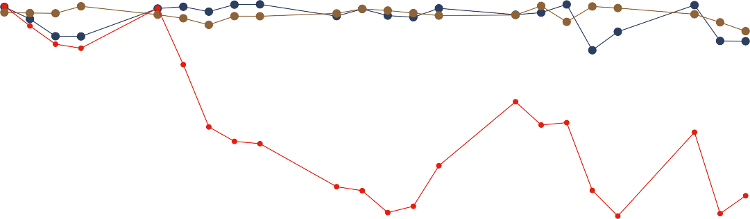

100

95

90

85

80

2016/11/01

2016/11/07

2016/11/13

2016/11/19

2016/11/25

Date of simulation

Flow Pressure Power

Accuracy (%)

of the periodic simulation. However, From the 2016/11/07, the accuracy of the simulated power dropped by between 10 and 15 percent. The daily average power of the system up to the point was approximately 12.5 MW. A 15% simulation error then relates to 1.9 MW difference between simulated and actual values. This suggests a major shift in operation of the system.

An analysis was done to try to determine the source of the discrepancy. From the data, it was identified that the simulated power for compressor 1 was the source of the different A look at the actual power measurement for compressor one show drop compared to normal operation by almost 2 MW. At the same time, the power used per kg/s of air seemed to have dropped. Figure 4.20 shows the average daily power for compressor 1 (blue), compared to the air mass flow per Watt(yellow).

A 2 MW shift in power is not likely; the results likely indicate that there was a fault in the power metering starting from 2016/11/07. A measurement error explains the perceived increase in efficiency over the same period as less power is measure than is being provided. In this situation, the simulated power measurement is a more accurate metric for compressor 1’s power over this period.

### Validation

To validation of misreadings from the power meter from comparing independent power data for the substation to the combined individual compressors meters.fig. 4.21 shows the measured power from the two sources. By comparing the compressor power to the independent

Figure 4.20: Supply efficiency and Compressor 1’s average power output over the time of the periodic analysis.



Periodic simulation

1000

2016/09/01

2016/10/01

2016/11/01

Date

2016/12/01

Compressor 1 average power System efficiency

4000

5

3500

4*.*5

3000

4

2500

3*.*5

2000

3

1500

2*.*5

2

Power (kW)

*F lowperW att*(*kg/s/W* )

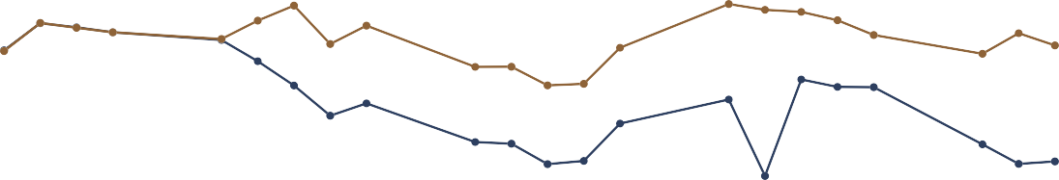data, it is clear that there is an error in measurement as hypothesised.

Power (MW)

|  |  |  |  |  |  |
| --- | --- | --- | --- | --- | --- |
|  |  |  |  |  |  |
|  |  |  |  |  |  |
|  |  |  |  |  |  |
|  |  |  |  |  |  |

Figure 4.21: Comparison using alternative power source.

14

12

10

8

05/11/2016 10/11/2016 15/11/2016 20/11/2016 25/11/2016 30/11/2016

Date

Compressor power measrement Independant measurement

### Summary

An investigation into periodic or repeated simulation was performed. Using the simulation model for Mine B, the periodic simulation methodology was implemented. The results indicated that the model was valid for consecutive days in the test range and identified an error in power measurement. Further analysis is recommended to determine how long a simulation model can remain valid before calibration is required.

## Potential benefit for SA mines

There are aproximately 75 operational gold and Platinum group metal (PGM) mines in South Africa, as illustrated in fig. 4.22 1*,*2. Each mine utilises compressed air for underground processes. By utilising the compressed air simulation methodology in this study, the mines could collectively achieve significant energy and cost savings for the industry.

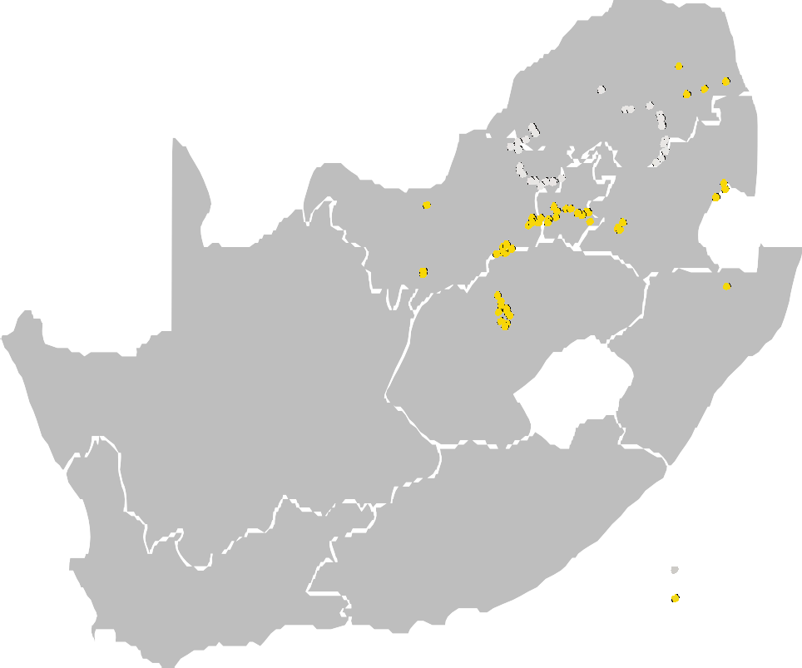

PGM mines Gold mines

Figure 4.22: Gold and PGM mines in South Africa1*,*2.

In this study, the simulated interventions resulted in savings of (on average) 0.69 MW E.E. or 1.025 *M W* P.C.. Assuming similar intervention were identified, through simulation for all gold and platinum mines. A potential energy saving of approximately 50 MW E.E. or 75 *M W* P.C. could be achieved. The combined cost saving for these interventions would amount to up to R400M p.a.

1 Chamber of Mines, [Online] <http://www.chamberofmines.org.za/sa-mining/gold>, [Accessed 16-062017]

2 Chamber of Mines, [Online] <http://www.chamberofmines.org.za/sa-mining/platinum>, [Accessed 1606-2017]

## Conclusion

Chapter 4 aimed to validate the methodology developed in Chapter 3. This validation was achieved through the implementation of two case studies South African gold mines. A third case study was performed to analyse and validate the value repeated/periodic simulation.

In case study 1, the compressed air network for gold mining complex consisting of three mining shafts was investigated. A simulation model was then developed, and the accuracy was verified using typical operation from historical data. Two scenarios were simulated, Optimising compressor set-points and reducing pressure during the evening energy peak.

The results showed that there was a potential P.C. power reduction of 0.46 and 1.0 MW respectively. The reduction in power during the energy peak times could lead to a potential cost reduction of up to R0.91M. The result was validated using results of actual tests on the system.

In case study 2, the same procedure was applied to another gold mine. The mine consisted of a main and sub-shaft. An investigation was done to gather data and identify potential interventions. The investigation included underground spot checks and measurements.

A simulation model was developed for the system. Two scenarios were simulated using the developed model. The simulations showed an E.E. saving of up to 0.92 MW for scenario 1 and a P.C. impact of up to 2 MW for scenario 2. The intervention could lead to an energy cost saving of R5.17M for the mine. Additional pressure improvements were identified in case study 1. The results were reported to the mine.

A third case study was performed to validate the periodic or repeated simulation methodology. The results showed that the simulation model remained valid for consecutive days in the tested date range. Faulty power measurements were also identified from the results. Further analysis was recommended to determine how long a simulation model can remain valid before calibration is required.

Finally the the result of large scale implementation of compressed air simulation in South African gold and PGM mines. A conservative estimation showed that a potential power reduction of 50 MW E.E. or 75 *M W* P.C. could be obtained. This energy improvement would lead to a significant total energy cost saving of R400M p.a.

## CHAPTER 5

**Conclusion**

## Preamble

Chapter 5 serves as a conclusion for this dissertation. An overview of the complete dissertation will be provided. This overview will summarise the work done in the proceeding chapters. The limitations of the study will then be discussed. This will lead to discussion and recommendations for future work that can be done in the field.

## Dissertation overview

The South African mining sector is currently facing significant challenges that pose a risk to profitability of the industry. A pivotal challenge that faces the industry is that of rising operational costs. Energy costs pertain a significant portion of the cost increases as energy tariff increases have constantly surpassed inflation over the passed 10 years.

Compressed air systems consume the largest portion of energy used in a mine. Compressed air has also been shown to be largely inefficient. It is there for reasoned that the largest energy impact can be achieved through compressed air interventions.

Energy intervention in mining compressed air have been performed in the passed. However, compressed air simulation has not been used to its full potential. Using new computer modelling and simulation tools for compressed air systems, the detailed effects of interventions can be identified with minimal risk. This will lead to further energy and cost reductions as well as other potential improvements for a mines operation.

An review of background and literature was performed. The purpose of the review was to provide background on mining compressed air networks and to evaluate literature in pertaining to compressed air energy interventions, simulation usage the mining industry and specifically simulation usage in compressed air systems.

Using the findings in from the literature review, a methodology was developed for compressed air simulation. The methodology describes the a simulation procedure in three steps summarised as: investigate the system, develop a simulation model and execute the simulation scenarios.

The simulation methodology was then validated through implementationon case studies. The studies were implemented on two separate mine compressed air systems. A full system investigation was performed in each study. From the data and understand obtained for the

investigation, simulation models were developed for both systems.

*...Incomplete....*

## Limits of this study