**Recipes**

**Japanese Chicken Curry**

Ingredients:

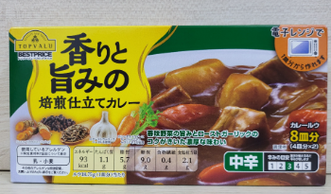

* Top Valu curry paste (Green one)
* Chicken breast or thigh
* Onion
* Carrot, Potato (optional)
* Hiroshi broth paste
* 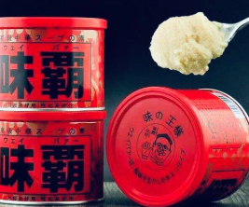

Steps:

1. Clean chicken with water
2. Put spoon of seasoned salt(bot canh) and SMG, olive oil and mix it up, leave it for 10 minutes
3. Heat the saucepan, put olive oil, add onion then add chicken into with a pack of curry paste it and stir it up with high heat for 5 minutes.
4. Add water(a bowl) into it, stir a bit and leave the saucepan low heat for 15 minutes.
5. Add the broth paste ( half tablespoon) into it and taste and adjust the flavour.

No need to use sugar