**Lab 3&4 Hand tracking using MediaPipe and OpenCV**

**Experimental purpose:**

1. Master the methods of python development and Linux system

2. Master the methods of MediaPipe and OpenCV installation and configuration

3. Built own application based on the MediaPipe and OpenCV methods

**Experimental contents：**

1. MediaPipe and OpenCV installation and development environment configuration

2. Tracing hand/hands using web camera

3. Built own application based on the MediaPipe and OpenCV methods

**Procedures:**

**1. MediaPipe introduction（linux）**

**(**[**https://github.com/google/mediapipe**](https://github.com/google/mediapipe)

**https://mediapipe.readthedocs.io/en/latest/)**

MediaPipe is a framework for building multimodal (eg. video, audio, any time series data) applied ML pipelines. With MediaPipe, a perception pipeline can be built as a graph of modular components, including, for instance, inference models (e.g., TensorFlow, TFLite) and media processing functions：



**2. Installing MediaPipe on Linux（Ubuntu 18.04）: （**[**https://github.com/google/mediapipe/blob/master/mediapipe/docs/install.md**](https://github.com/google/mediapipe/blob/master/mediapipe/docs/install.md)**）**

Note: To interoperate with OpenCV, OpenCV 3.x and above are preferred. OpenCV 2.x currently works but interoperability support may be deprecated in the future.

**(1)** **Checkout MediaPipe repository.**

git clone <https://github.com/google/mediapipe.git>

cd mediapipe

**(2)** **Install Bazel (0.24.1 and above required)**

sudo apt-get install bazel

**(3)** **Install OpenCV and FFmpeg**

Use package manager tool to install the pre-compiled OpenCV libraries. FFmpeg will be installed via libopencv-video-dev.

sudo apt-get install libopencv-core-dev libopencv-highgui-dev \

libopencv-imgproc-dev libopencv-video-dev

***(4****)* ***For running desktop examples on Linux only (not on OS X) with GPU acceleration***

# Requires a GPU with EGL driver support.

# Can use mesa GPU libraries for desktop, (or Nvidia/AMD equivalent).

sudo apt-get install mesa-common-dev libegl1-mesa-dev libgles2-mesa-dev

# To compile with GPU support, replace

--define MEDIAPIPE_DISABLE_GPU=1

# with

--copt -DMESA_EGL_NO_X11_HEADERS

# when building GPU examples.

**(5)** **Run the Hello World desktop example**

export GLOG_logtostderr=1

# if you are running on Linux desktop with CPU only

bazel run --define MEDIAPIPE_DISABLE_GPU=1 \

mediapipe/examples/desktop/hello_world:hello_world

# If you are running on Linux desktop with GPU support enabled (via mesa drivers)

bazel run --copt -DMESA_EGL_NO_X11_HEADERS \

mediapipe/examples/desktop/hello_world:hello_world

**3.**  **Hand Tracking on Desktop**

(https://github.com/google/mediapipe/blob/master/mediapipe/docs/hand_tracking_desktop.md )

**TensorFlow Lite Hand Tracking Demo with Webcam (CPU)**

# Video from webcam running on desktop CPU

bazel build -c opt --define MEDIAPIPE_DISABLE_GPU=1 \

mediapipe/examples/desktop/hand_tracking:hand_tracking_cpu

# It should print:

#Target //mediapipe/examples/desktop/hand_tracking:hand_tracking_cpu up-to-date:

# bazel-bin/mediapipe/examples/desktop/hand_tracking/hand_tracking_cpu

#INFO: Build completed successfully, 12517 total actions

# This will open up your webcam as long as it is connected and on

# Any errors is likely due to your webcam being not accessible

GLOG_logtostderr=1 bazel-bin/mediapipe/examples/desktop/hand_tracking/hand_tracking_cpu --calculator_graph_config_file=mediapipe/graphs/hand_tracking/hand_tracking_desktop_live.pbtxt

**TensorFlow Lite Hand Tracking Demo with Webcam (GPU)**

# Video from webcam running on desktop GPU

# This works only for linux currently

bazel build -c opt --copt -DMESA_EGL_NO_X11_HEADERS \

mediapipe/examples/desktop/hand_tracking:hand_tracking_gpu

# It should print:

# Target //mediapipe/examples/desktop/hand_tracking:hand_tracking_gpu up-to-date:

# bazel-bin/mediapipe/examples/desktop/hand_tracking/hand_tracking_gpu

#INFO: Build completed successfully, 22455 total actions

# This will open up your webcam as long as it is connected and on

# Any errors is likely due to your webcam being not accessible,

# or GPU drivers not setup properly.

GLOG_logtostderr=1 bazel-bin/mediapipe/examples/desktop/hand_tracking/hand_tracking_gpu \

--calculator_graph_config_file=mediapipe/graphs/hand_tracking/hand_tracking_mobile.pbtxt

**4. Other Examples:**

(https://github.com/google/mediapipe/blob/master/mediapipe/docs/examples.md)

Object Detection, Face Detection, Multi-Hand Tracking

**5. Installing on Windows Subsystem for Linux (WSL)** (https://github.com/google/mediapipe/blob/master/mediapipe/docs/install.md#installing-on-windows-subsystem-for-linux-wsl)

**Run on preinstalled virtual machine:**

(1) Install VMware-player-15.5.0

(2) load the virtual machine image

(3) Connect the web camera：

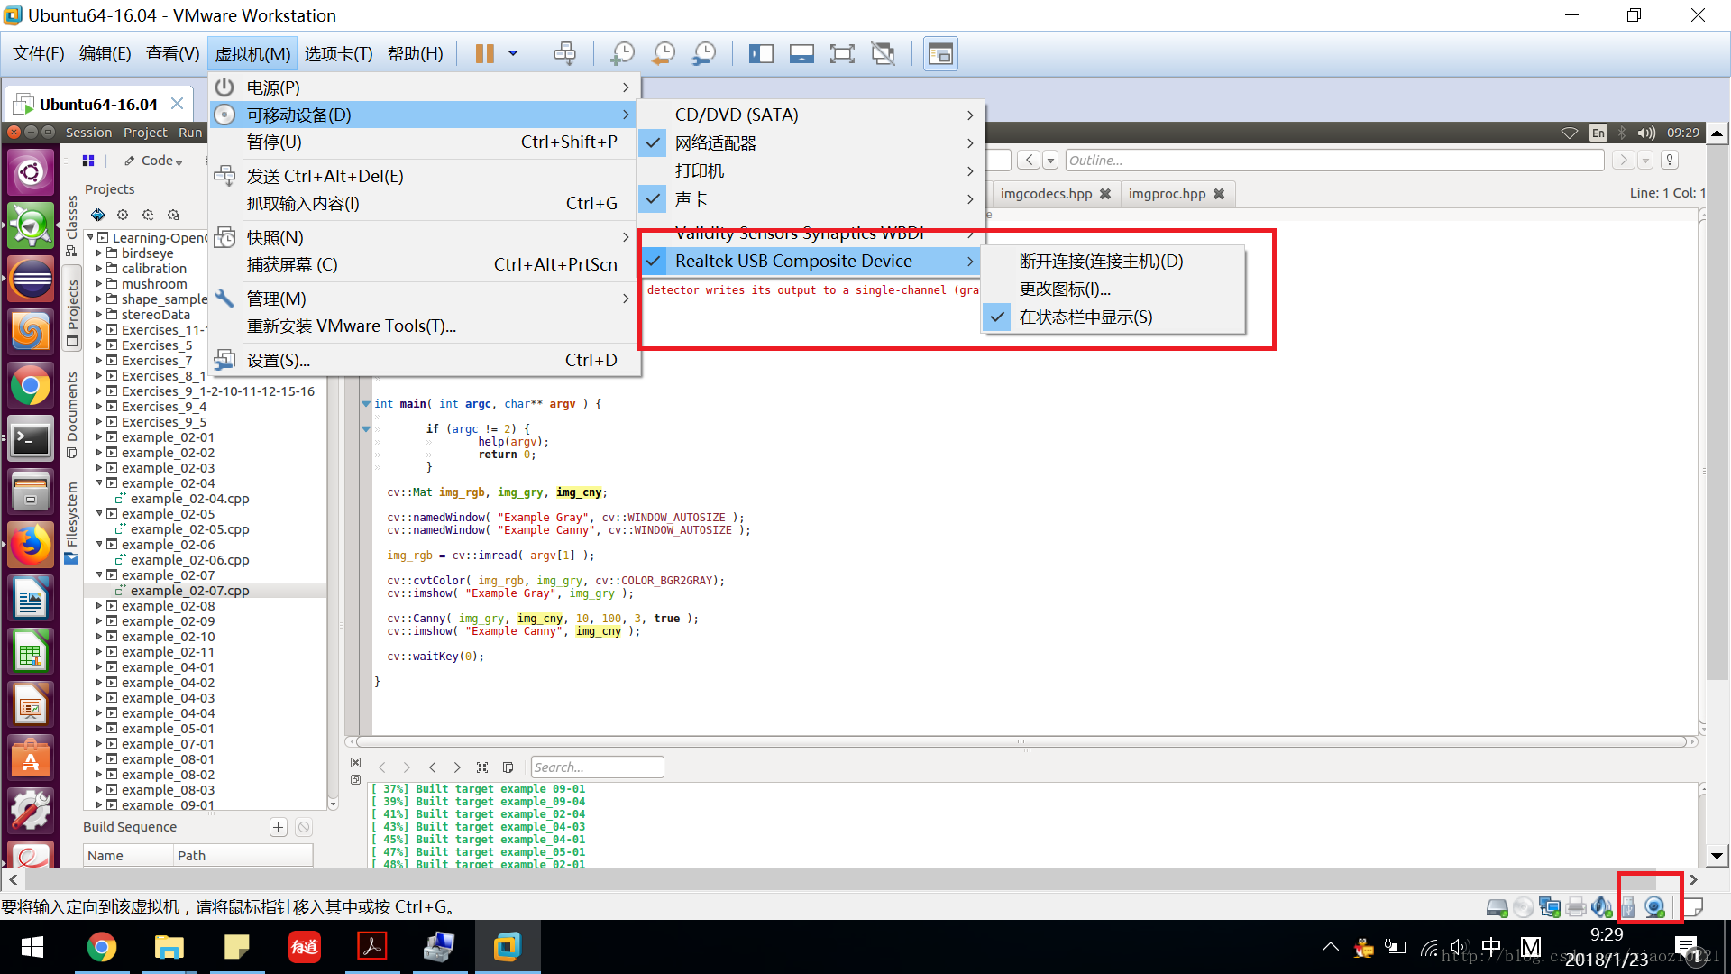

Verify the camera installation:

ls /dev/

**要求： 3~4人/组，实现视频（相机/文件）人脸识别，人脸坐标输出（数组/文件）**

**实验报告：手写，报告纸，“目的，内容，步骤，结果”**