Anchored image: side=left, wrap=square.
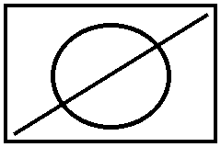
Text around the image. This deterministic paragraph is long enough to exercise flow and placement decisions on the target page. Text around the image. This deterministic paragraph is long enough to exercise flow and placement decisions on the target page. Text around the image. This deterministic paragraph is long enough to exercise flow and placement decisions on the target page.

